Chapter 5 Infection Control:
Principles and Practices

Chapter Outline

Why Study Infection Control?

Regulation

Principles of Infection

Principles of Prevention

Universal Precautions

The Professional Salon Image

Procedures

Consider this scenario: You are a new employee of a salon that offers hair and nail services. At the end of the day, the salon manager asks you to help clean and disinfect the counters, workstations, tools, implements,

and pedicure equipment. Your manager also tells you to enter the cleaning and disinfection information in the salon’s logbook. You know how important it is to follow the proper cleaning and disinfection procedures in the salon. This chapter will give you the principles and practices you need to complete those tasks.

Why Study Infection Control:
Principles and Practices?

Cosmetologists should study and have a thorough understanding of infection control principles and practices because:

- To be a knowledgeable, successful, and responsible professional

in the field of cosmetology, you are required to understand the types of infections you may encounter in the salon.

- Understanding the basics of cleaning and disinfecting and following federal and state rules will safeguard you and your clients and ensure that you have a long and successful career as a cosmetologist.

- Understanding the chemistry of the cleaning and disinfecting products that you use and how to use them will help keep you, your clients, and your salon environment safe.

Regulation

Many different federal and state agencies regulate the practice of cosmetology. Federal agencies set guidelines for the manufacturing, sale, and use of equipment and chemical ingredients. These guidelines also monitor safety in the workplace and place limits on the types of services you can perform in the salon. State agencies regulate licensing, enforcement, and your conduct when you are working in the salon.

Federal Agencies

Occupational Safety and Health Administration (OSHA)

The Occupational Safety and Health Administration (OSHA) was created as part of the U.S. Department of Labor to regulate and enforce safety and health standards to protect employees in the workplace. Regulating employee exposure to potentially toxic substances and informing employees about the possible hazards of materials used in the workplace are key points of the Occupational Safety and Health Act of 1970. This regulation created the Hazard Communication Standard (HCS), which requires that chemical manufacturers and importers assess and communicate the potential hazards associated with their products. The Material Safety Data Sheet (MSDS) is a result of the HCS.

You can find an EPA-approved

list of hospital and tuberculocidal

disinfectantsby goingtothe EPA’s Websiteathttp://www.epa.gov and
entering a search onthehomepage forEPA-registered disinfectants.
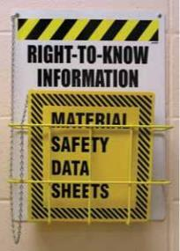

did you know?

The term Hospital Grade is not a term used by the EPA. The EPA does not grade disinfectants; a product is either approved by the EPA as a hospital disinfectant or it is not.

The standards set by OSHA are important to the cosmetology industry because of the products used in salons. OSHA standards address issues relating to the handling, mixing, storing, and disposing of products; general safety in the workplace; and your right to know about any potentially hazardous ingredients contained in the products you use and how to avoid these hazards.

Material Safety Data Sheet (MSDS)

Both federal and state laws require that manufacturers supply a Material Safety Data Sheet (MSDS) for all products sold. The MSDS contains information compiled by the manufacturer about product safety, including the names of hazardous ingredients, safe handling and use procedures, precautions to reduce the risk of accidental harm or overexposure, and flammability warnings. The MSDS also provides useful disposal guidelines and medical and first aid information. When necessary, the MSDS can be sent to a medical facility, so that a doctor can better assess and treat the patient. OSHA and state regulatory agencies require that MSDSs be kept available in the salon for all products. Both OSHA and state board inspectors can issue fines for salons not having MSDSs available during regular business hours.

Federal and state laws require salons to obtain MSDSs from the product manufacturers and/or distributors for each professional product that is used. MSDSs often can be downloaded from the product manufacturer’s or the distributor’s Web site. Not having MSDSs available poses a health risk to anyone exposed to hazardous materials and violates federal and state regulations. All employees must read the information included on each MSDS and verify that they have read it by adding their signatures to a sign-off sheet for the product. These sign-off sheets must be available to state and federal inspectors upon request.

Environmental Protection Agency (EPA)

The Environmental Protection Agency (EPA) registers all types of disinfectants sold and used in the United States. Disinfectants (dis-in-FEK-tents) are chemical products that destroy all bacteria, fungi, and viruses (but not spores) on surfaces. The two types that are used in salons are hospital disinfectants and tuberculocidal disinfectants.

- Hospital disinfectants (HOS-pih-tal dis-in-FEK-tents) are effective for cleaning blood and body fluids. They can be used on any nonporous surface in the salon. Nonporous (nahn-POHW-rus) means that an item is made or constructed of a material that has no pores or openings and cannot absorb liquids. Hospital disinfectants control the spread of disease (dih-ZEEZ), an abnormal condition of all or part of the body, or its systems or organs, that makes the body incapable of carrying on normal function.

- Tuberculocidal disinfectants (tuh-bur-kyoo-LOH-sy-dahl dis-in-FEK-tents) are proven to kill the bacteria that cause tuberculosis

5

(tuh-bur-kyoo-LOH-sus), a disease caused by bacteria that are transmitted through coughing or sneezing. These bacteria are capable of forming spores so they are difficult to kill. Tuberculocidal disinfectants are one kind of hospital disinfectant. The fact that tuberculocidal disinfectants are more powerful does not mean that you should automatically reach for them. Some of these products can be harmful to salon tools and equipment, and they require special methods of disposal. Check the rules in your state to be sure that the product you choose complies with state requirements.

It is against federal law to use any disinfecting product contrary to its labeling. Before a manufacturer can sell a product for disinfecting surfaces, tools, implements, or equipment, it must obtain an EPA-registration number that certifies that the disinfectant may be used in the manner prescribed by the manufacturer’s label. For example, pedicure tub disinfectants must be approved for that specific use or the manufacturer will be breaking federal law by marketing them for disinfecting pedicure tubs. This also means that if you do not follow the label instructions for mixing, contact time, and the type of
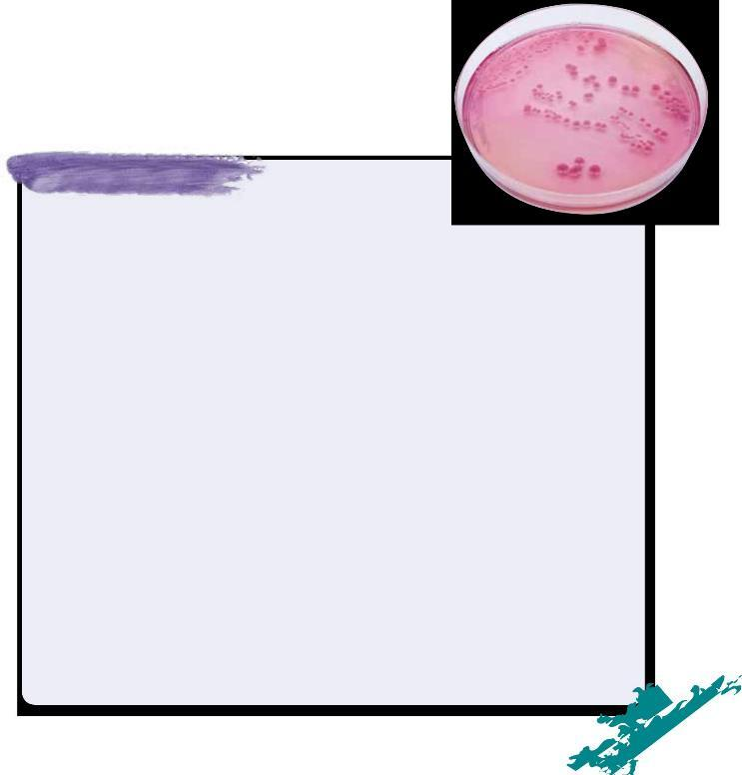

did you know?

Cosmetologists can put themselves and their clients at risk unless stringent infection

control guidelines are performed every day. A case in point was the spread of a bacterium called Mycobacterium fortuitum (MY-koh-bak-TIR-ee-um for-TOO-i-tum), a microscopic germ that normally exists in tap water in small numbers. Until an incident occurred, health officials considered the germ to be completely harmless and not infectious (in-FEK-shus), caused by or capable of being transmitted by infection.

In 2000, over 100 clients from one California salon developed serious skin infections on their legs after getting pedicures. The infection caused ugly sores that lingered for months, required the use of strong antibiotics, and permanently scarred some of the clients’ legs. The source of the infection was traced to the salon’s whirlpool foot spas. Salon staff did not clean and disinfect the foot spas properly, resulting in a build-up of hair and debris in the foot spas that created the perfect breeding ground for bacteria.

The outbreak was a catalyst for change in the cosmetology industry. As a result, the state of California issued specific requirements for pedicure equipment in the hope of preventing future outbreaks. In spite of their efforts, there have been other outbreaks affecting hundreds of clients in California and other states. In Texas, family members of a paraplegic woman who died after receiving a pedicure sued a salon. They charged that the woman, who had no feeling in her feet, died because of an improperly disinfected implement that caused an infection on her foot that spread throughout her body and resulted in a fatal heart attack.

While many of the stories in the news have been about diseases caused by manicures or pedicures, not all incidents are related to the nail industry. Take the case of a barber who unintentionally transmitted an infectious disease through a shaving razor. The barber used a disinfectant on the razor, but it was not the proper disinfectant. Several of his clients contracted hepatitis B because the wrong disinfectant was used. This incident demonstrates how important it is for cosmetologists to use the proper disinfectants on tools, such as razors, scissors, and clippers. When in doubt about the disinfectant you should use, consult federal and state regulations.

Media scrutiny has made clients more aware of the infection control practices of salons, and the cosmetology industry has become more enlightened about the importance of cleaning and disinfection practices.

Remember: Salon professionals are not allowed to treat or recommend treatments for infections, diseases, or abnormal conditions. Clients with such problems should be referred to their physicians.

surface the disinfecting product can be used on, you are not complying with federal law. If there is a lawsuit, you can be held responsible.

State Regulatory Agencies

State regulatory agencies exist to protect salon professionals and to protect consumers’ health, safety, and welfare while they receive salon services. State regulatory agencies include licensing agencies, state boards of cosmetology, commissions, and health departments. Regulatory agencies require that everyone working in a salon or spa follow specific procedures. Enforcement of the rules through inspections and investigations of consumer complaints is also part of an agency’s responsibility. An agency can issue penalties against both the salon owner and the cosmetologist’s license. Penalties vary and include warnings, fines, probation, and suspension or revocation of licenses. It is vital that you understand and follow the laws and rules of your state at all times. Your salon’s reputation, your license, and everyone’s safety depend on it.
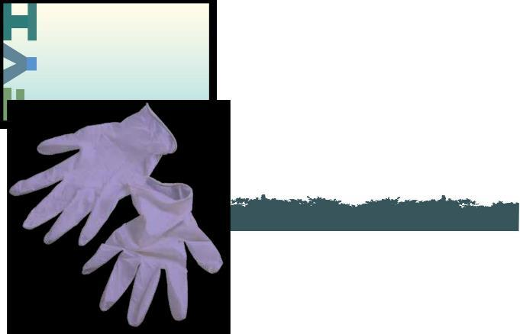

Laws and Rules—What is the Difference?

Laws are written by both federal and state legislatures that determine the scope of practice (what each license allows the holder to do) and that establish guidelines for regulatory agencies to make rules. Laws are also called statutes.

Rules and regulations are more specific than laws. Rules are written by the regulatory agency or the state board, and they determine how the law must be applied. Rules establish specific standards of

conduct and can be changed or updated frequently. Cosmetologists must be aware of any changes or updates to the rules and regulations, and they must comply with them. LO1

Principles of Infection
Being a salon professional is fun and rewarding, but it is also a great responsibility. One careless action could cause injury or infection (in-FEK-shun), the invasion of body tissues by disease-causing pathogens. If your actions result in an injury or infection,

you could lose your license or ruin the salon’s reputation. Fortunately, preventing the spread of infections is easy when you know proper procedures and follow them at all times. Prevention begins and ends with you (Figure 5–1).

Infection Control

Infection control are the methods used to eliminate or reduce the transmission of infectious organisms. Cosmetologists must understand and remember the following four types of potentially harmful organisms:

 | • | Bacteria | • | Fungi
 | • | Viruses | • | Parasites
5

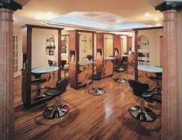

Figure 5–1

A sparkling clean salon gains your clients’ confidence.

Under certain conditions, many of these organisms can cause infectious disease. An infectious disease (in-FEK-shus dih-ZEEZ) is caused by pathogenic (harmful) organisms that enter the body. An infectious disease may or may not be spread from one person to another person.

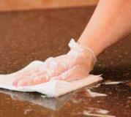
In this chapter, you will learn how to properly clean and disinfect the tools and equipment you use in the salon so they are safe for you and your clients. To clean (cleaning) is a mechanical process (scrubbing) using soap and water or detergent and water to remove all visible dirt, debris, and many disease-causing germs from tools, implements, and equipment. The process of disinfection (dis-in-FEK-shun) destroys most, but not necessarily all, harmful organisms on environmental surfaces. Disinfection is not effective against bacterial spores.

Cleaning and disinfecting procedures are designed to prevent the spread of infection and disease. Disinfectants used in salons must be bactericidal (back-teer-uh-SYD-ul), capable of destroying bacteria; virucidal (vy-ru-SYD-ul), capable of destroying viruses; and fungicidal (fun-jih-SYD-ul), capable of destroying fungi. Be sure to mix and use these disinfectants according to the instructions on the labels so they are safe and effective.

Contaminated salon tools and equipment can spread infections from client to client if the proper disinfection steps are not taken after every service. You have a professional and legal obligation to protect clients from harm by using proper infection control procedures. If clients are infected or harmed because you perform infection control procedures incorrectly, you may be found legally responsible for their injuries or infections.

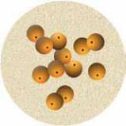

- Figure 5–2 Cocci.

Bacteria

Bacteria (bak-TEER-ee-ah) (singular: bacterium, back-TEER-ee-um) are one-celled microorganisms that have both plant and animal characteristics. A microorganism (my-kroh-OR-gah-niz-um) is any organism of microscopic or submicroscopic size. Some bacteria are harmful and some are harmless. Bacteria can exist almost anywhere: on skin, in water, in the air, in decayed matter, on environmental surfaces, in body secretions, on clothing, or under the free edge of nails. Bacteria are so small they can only be seen with a microscope.

- Figure 5–3 Staphylococci.
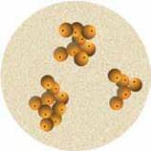
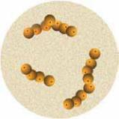

- Figure 5–4 Streptococci.
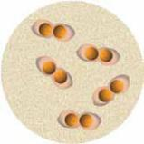

- Figure 5–5 Diplococci.

Types of Bacteria

There are thousands of different kinds of bacteria that fall into two primary types: pathogenic and nonpathogenic. Most bacteria are nonpathogenic (non-path-uh-JEN-ik); in other words, they are harmless organisms that may perform useful functions. They are safe to come in contact with since they do not cause disease or harm. For example, nonpathogenic bacteria are used to make yogurt, cheese, and some medicines. In the human body, nonpathogenic bacteria help the body break down food and protect against infection. They also stimulate the immune system.

Pathogenic (path-uh-JEN-ik) bacteria are harmful microorganisms that can cause disease or infection in humans when they invade the body. Salons and schools must maintain strict standards for cleaning and disinfecting at all times to prevent the spread of pathogenic microorganisms. It is crucial that cosmetologists learn proper infection control practices while in school to ensure that you understand the importance of following them throughout your career. Table 5–1, Causes of Disease, presents terms and definitions related to pathogens.

Classifications of Pathogenic Bacteria

Bacteria have three distinct shapes that help to identify them.

Pathogenic bacteria are classified as described below.

- Cocci (KOK-sy) are round-shaped bacteria that appear singly (alone) or in groups (Figure 5–2):

  - Staphylococci (staf-uh-loh-KOK-sy) are pus-forming bacteria that grow in clusters like bunches of grapes. They cause abscesses, pustules, and boils (Figure 5–3). Some types
of staphylococci (or staph as many call it) may not cause infections in healthy humans.

  - Streptococci (strep-toh-KOK-sy) are pus-forming bacteria arranged in curved lines resembling a string of beads. They cause infections such as strep throat and blood poisoning (Figure 5–4).

  - Diplococci (dip-lo-KOK-sy) are spherical bacteria that grow in pairs and cause diseases such as pneumonia (Figure 5–5).

- Bacilli (bah-SIL-ee) are short rod-shaped bacteria. They are the most common bacteria and produce diseases such as tetanus (lockjaw),

5

T e r m

Bacteria

Direct Transmission

Indirect Transmission

Infection

germs

Microorganism

Parasites

Toxins

Virus

Table 5–1 Causes of Disease.

CAUSES OF DISEASE

D e f i n i t i o n

One-celled microorganisms having both plant and animal characteristics. Some are harmful and some are harmless.

Transmission of blood or body fluids through touching (including shaking hands), kissing, coughing, sneezing, and talking.

Transmission of blood or body fluids through contact with an intermediate contaminated object, such as a razor, extractor, nipper, or an environmental surface.

Invasion of body tissues by disease-causing pathogens.

Nonscientific synonym for disease-producing organisms.

Any organism of microscopic to submicroscopic size.

Organisms that grow, feed, and shelter on or in another organism (referred to as the host), while contributing nothing to the survival of that organism. Parasites must have a host to survive.

Various poisonous substances produced by some microorganisms (bacteria and viruses).

A parasitic submicroscopic particle that infects and resides in cells of biological organisms. A virus is capable of replication only through taking over the host cell’s reproductive function.

© Milady, a part of Cengage Learning.

typhoid fever, tuberculosis, and diphtheria (Figure 5–6).

- Spirilla (spy-RIL-ah) are spiral or corkscrew-shaped bacteria. They are subdivided into subgroups, such as treponema papillida, which causes syphilis, a sexually transmitted disease (STD), and borrelia burgdorferi, which causes Lyme disease (Figure 5–7).

Movement of Bacteria

Different bacteria move in different ways. Cocci rarely show active motility (MOH-til-eh-tee), which means self-movement. Cocci are transmitted in the air, in

▲ Figure 5–6 ▲ Figure 5–7
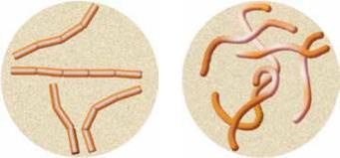
Bacilli. Spirilla.

.

dust, or within the substance in which they settle. Bacilli and spirilla are both capable of movement and use slender, hair-like extensions called flagella (fluh-JEL -uh) for locomotion (moving about). You may also hear people refer to cilia (SIL-ee-uh) as hair-like extensions on cells. Cilia are shorter than flagella, however. Both flagella and cilia move cells, but they have a different motion. Flagella move in a snake-like motion while cilia move in a rowing-like motion.

Bacterial Growth and Reproduction

When seen under a microscope, bacteria look like tiny bags. They generally consist of an outer cell wall that contains liquid called protoplasm. Bacterial cells manufacture their own food through what they absorb from the surrounding environment. They give off waste products, grow, and reproduce. The life cycle of bacteria consists
of two distinct phases: the active stage and the inactive or spore-forming stage.

Active stage. During the active stage, bacteria grow and reproduce. Bacteria multiply best in warm, dark, damp, or dirty places. When conditions are favorable, bacteria grow and reproduce. When they reach their largest size, they divide into two new cells. This division is called binary fission (BY-nayr-ee FISH-un). The cells that are formed are called daughter cells and are produced every twenty to sixty minutes, depending on the bacteria. The infectious pathogen staphylococcus aureus undergoes cell division every twenty -seven to thirty minutes. When conditions become unfavorable and difficult for them to thrive, bacteria either die or become inactive.

Inactive or spore-forming stage. Certain bacteria, such as the anthrax and tetanus bacilli, coat themselves with wax-like outer

shells. These bacteria are able to withstand long periods of famine, dryness, and unsuitable temperatures. In this

stage, spores can be blown about and are not harmed by disinfectants, heat, or cold. When favorable conditions are restored, the spores change into the active form and begin

to grow and reproduce.

Bacterial Infections

There can be no bacterial infection without the presence of pathogenic bacteria. Therefore, if pathogenic bacteria are eliminated, clients cannot become infected. You

may have a client who has tissue

inflammation (in-fluh-MAY-shun), a

condition in which the body reacts

to injury, irritation, or infection.

An inflammation is characterized

by redness, heat, pain, and

swelling. Pus is a fluid created by

5

infection. It contains white blood cells, bacteria, and dead cells. The presence of pus is a sign of a bacterial infection. A local infection , such as a pimple or abscess, is confined to a particular part of the body and appears as a lesion containing pus. Staphylococci are among the most common bacteria that affect humans and are normally carried by about a third of the population. Staph bacteria can be picked up on doorknobs, countertops, and other surfaces, but in the salon they are more frequently spread through skin- to-skin contact (such as shaking hands) or through the use of unclean tools or implements. If these bacteria get into the wrong place, they can be very dangerous. Although lawsuits are rare considering the number of services performed in a salon, every year many salons are sued for allegedly causing staph infections.
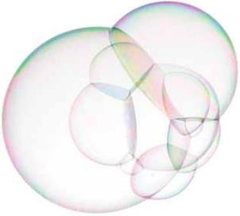

Staph is responsible for food poisoning and a wide range of diseases, including toxic shock syndrome. Some types of infectious staph bacteria are highly resistant to conventional treatments such as antibiotics. An example is the staph infection called methicillin-resistant staphylococcus aureus (MRSA) (METH-eh-sill-en-ree-ZIST-ent staf-uh-loh-KOK-us OR-ee-us). Historically, MRSA occurred most frequently among persons with weakened immune systems or among people who had undergone medical procedures. Today, it has become more common in otherwise healthy people. Clients who appear completely healthy may bring this organism into the salon where it can infect others. Some people carry the bacteria and are not even aware of their infection, but the people they infect may show more obvious symptoms. MRSA initially appears as a skin infection, such as pimples, rashes, and boils that can be difficult to cure. Without proper treatment, the infection becomes systemic and can have devastating consequences that can result in death. Because of these highly resistant bacterial strains, it is important to clean and disinfect all tools and implements used in the salon. You owe it to yourself and your clients! Also, do not perform services if the client’s skin, scalp, neck, hands, or feet show visible signs of abrasion or infection. Cosmetologists are only allowed to work on healthy hair, skin, and nails.

When a disease spreads from one person to another person, it is said to be a contagious disease (kon-TAY-jus dih-ZEEZ), also known as communicable disease (kuh-MYOO-nih-kuh-bul dih-ZEEZ). Some of the more common contagious diseases that prevent a salon professional from servicing a client are the common cold, ringworm, conjunctivitis (pinkeye), viral infections, and natural nail, toe, or foot infections.

The most common way these infections spread is through dirty hands, especially under the fingernails and in the webs between the fingers. Be sure to always wash your hands after using the restroom and before eating. Contagious diseases can also be spread by contaminated implements, cuts, infected nails, open sores, pus, mouth and nose discharges, shared drinking cups, telephone receivers, and towels. Uncovered coughing or sneezing and spitting in public also spread germs. LO2

TERMS RELATED TO DISEASE

T e r m

Allergy

Contagious Disease

Contamination

Decontamination

Diagnosis

Disease

Exposure Incident

Infectious Disease

Inflammation

Occupational Disease

Parasitic Disease

Pathogenic Disease

Systemic Disease

D e f i n i t i o n

Reaction due to extreme sensitivity to certain foods, chemicals, or other normally harmless substances.

Also known as communicable disease; disease that is spread from one person to another person. Some of the more contagious diseases are the common cold, ringworm, conjunctivitis (pinkeye), viral infections, and natural nail or toe and foot infections.

The presence, or the reasonably anticipated presence, of blood or other potentially infectious materials on an item’s surface or visible debris or residues such as dust, hair, and skin.

The removal of blood or other potentially infectious materials on an item’s surface and the removal of visible debris or residue such as dust, hair, and skin.

Determination of the nature of a disease from its symptoms and/or diagnostic tests. Federal regulations prohibit salon professionals from performing a diagnosis.

An abnormal condition of all or part of the body, or its systems or organs, that makes the body incapable of carrying on normal function.

Contact with nonintact (broken) skin, blood, body fluid, or other potentially infectious materials that is the result of the performance of an employee’s duties.

Disease caused by pathogenic (harmful) microorganisms that enter the body. An infectious disease may or may not be spread from one person to another person.

Condition in which the body reacts to injury, irritation, or infection. An inflammation is characterized by redness, heat, pain, and swelling.

Illnesses resulting from conditions associated with employment, such as prolonged and repeated overexposure to certain products or ingredients.

Disease caused by parasites, such as lice and mites.

Disease produced by organisms, including bacteria, viruses, fungi, and parasites.

Disease that affects the body as a whole, often due to under-functioning or over-functioning internal glands or organs. This disease is carried through the blood stream or the lymphatic system.

Table 5–2 Terms Related to Disease.

5

Table 5–2, Terms Related to Disease, lists terms and definitions that are important for a general understanding of disease.

Viruses

A virus (VY-rus) (plural: viruses) is a parasitic submicroscopic particle that infects and resides in the cells of a biological organism. A virus is capable of replication only through taking over the host cell’s reproductive function. Viruses are so small that they can only be seen under the most sophisticated and powerful microscopes. They cause common colds and other respiratory and gastrointestinal (digestive tract) infections. Other viruses that plague humans are measles, mumps, chicken pox, smallpox, rabies, yellow fever, hepatitis, polio, influenza, and HIV, which causes AIDS.

One difference between viruses and bacteria is that a virus can live and reproduce only by taking over other cells and becoming part of them, while bacteria can live and reproduce on their own. Also, bacterial infections can usually be treated with specific antibiotics, but viruses are not affected by antibiotics. In fact, viruses are hard to kill without harming the body’s own cells in the process. Vaccinations prevent viruses from growing in the body. There are many vaccines available for viruses, but not all viruses have vaccines. There is a vaccine available for hepatitis B, however, and you should strongly consider receiving this vaccine. Health authorities recommend that service providers in industries with direct contact to the public—including cosmetologists, teachers, florists, and bank tellers—ask their doctor about getting vaccinated for hepatitis B.

did you know?

An example of a common viral infection often seen in salons is the human papilloma virus (HPV), also known as plantar warts. This virus can infect the bottom of the foot and resembles small black dots, usually in clustered groups. HPV is highly contagious, difficult to kill, and can be passed from pedicure client to pedicure client by dirty implements and foot baths. If the client shows signs of HPV infection, do not perform a pedicure service. Instead, refer the client to a physician.

Bloodborne Pathogens

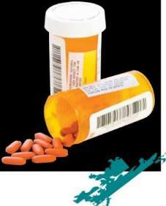
Disease-causing microorganisms that are carried in the body by blood or body fluids, such as hepatitis and HIV, are called bloodborne pathogens. In the salon, the spread of bloodborne pathogens is possible through haircutting, chemical burns, shaving, nipping, clipping, facial treatments, waxing, tweezing, or whenever the skin is broken. Use great care to avoid cutting or damaging clients’ skin during any type of service.

Cutting living skin is considered outside the scope of the cosmetologist’s licensed and approved practices. Federal law allows only qualified medical professionals to cut living skin, since this is considered a medical procedure. This means that cosmetologists are not allowed to trim or cut the skin around the nail plate. Cutting hardened tissue and removing a callus are both considered medical procedures. Even if the client insists, cosmetologists may not intentionally cut any living skin for any reason.

Hepatitis

Hepatitis (hep-uh-TY-tus), is a bloodborne virus that causes disease and can damage the liver. In general, it is difficult to contract hepatitis. However, hepatitis is easier to contract than HIV because hepatitis can be present in all body fluids of those who are infected. In

addition, unlike HIV, hepatitis can live on a surface outside the

body for long periods of time. For this reason, it is vital that all surfaces that contact a client are thoroughly cleaned and disinfected.

There are three types of hepatitis that are of concern in the salon: hepatitis A, hepatitis B, and hepatitis C. Hepatitis B is the most difficult to kill on a surface, so check the label of the disinfectant you use to be sure that the product is effective against hepatitis B. Hepatitis B and C are spread from person to person through blood and, less often, through other body fluids, such as semen and vaginal secretions.

HIV/AIDS

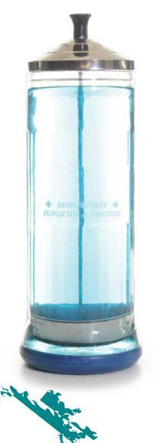
Human immunodeficiency virus (HIV) (HYOO-mun ih-MYOO-noh-di-FISH-en-see VY-rus), abbreviated HIV, is the virus that causes acquired immune deficiency syndrome (AIDS) (uh-KWY-erd ih-MYOON di-FISH-en-see sin-drohm), abbreviated AIDS. AIDS is a disease that breaks down the body’s immune system. HIV is spread from person to person through blood and, less often, through other body fluids, such as semen and vaginal secretions. A person can be infected with HIV for many years without having symptoms, but testing can determine whether a person is infected within six months after exposure to the virus. Sometimes, people who are HIV-positive have never been tested and do not know they have the potential to infect other people.

The HIV virus is spread mainly through the sharing of needles by intravenous (IV) drug users and by unprotected sexual contact. Less commonly, HIV is spread through accidents with needles in healthcare settings. The virus is less likely to enter the bloodstream through cuts and sores. It is not spread by holding hands, hugging, kissing, sharing food, or using household items such as the telephone or toilet seats. There are no documented cases that indicate the virus can be spread by food handlers, insects, or casual contact during hair, skin, nail, and pedicure salon services.

If you accidentally cut a client who is HIV-positive, the tool will be contaminated. You cannot continue to use the implement without cleaning and disinfecting it. Continuing to use a contaminated implement without cleaning and disinfecting it puts you and others in the salon at risk of infection. LO3

Fungi

Fungi (FUN-jI) (singular: fungus, FUN-gus) are microscopic plant parasites that include molds, mildews, and yeasts. They can produce contagious diseases, such as ringworm. Mildew (MIL-doo), another fungus, affects plants or grows on inanimate objects but does not cause human infections in the salon.

The most frequently encountered fungal infection resulting from hair services is tinea barbae (TIN-ee-uh BAR-bee), also known as barber’s itch. Tinea barbae is a superficial fungal infection that commonly affects the skin. It is primarily limited to the bearded areas of the face

5

The body prevents and controls infections with:
• healthy, unbroken skin—the body’s first line of defense.
• body secretions, such as perspiration and digestive juices.
• white blood cells that destroy bacteria.
• antitoxins that counteract the toxins.

Pathogenic bacteria, viruses, or fungi can enter the body through:
• broken or inflamed skin, such as a cut or a scratch. They also can enter through a bruise or a rash. Intact skin is an effective barrier to infection.
• the mouth (contaminated water, food, or fingers).
• the nose (inhaling different types of dust or droplets from a cough or sneeze).
• the eyes or ears (less likely, but possible).
• unprotected sex.

and neck or around the scalp. This infection occurs almost exclusively in older adolescent and adult males. A person with tinea barbae may have deep, inflamed or noninflamed patches of skin on the face or the nape of

the neck. Tinea barbae is similar to tinea capitis (TIN-ee-uh KAP-ih-tis), a fungal infection of the scalp characterized by red papules, or spots, at the opening of hair follicles. For more information on tinea capitis, see Chapter 11, Properties of the Hair and Scalp.

Hair stylists must clean and disinfect clipper blades to avoid spreading scalp

and skin infections. The risk of spreading skin and scalp infections can be reduced by first removing all visible hair and debris from clippers. This can be done effectively and quickly by using compressed air. Then the nonelectrical parts can be cleaned and disinfected properly. Always refer to the manufacturer’s directions for proper cleaning and disinfecting methods and recommendations.

Nail infections can be spread by using dirty implements or by not properly preparing the surface of the natural nail before enhancement products are applied. Nail infections can occur on both hands and feet. Fungal infections are much more common on the feet than on the hands, but bacterial infections commonly occur on both hands and feet. The most frequently encountered infection on the foot resulting from nail services is tinea pedis (TIN-ee-uh PED-us), a ringworm fungus of the foot. Both bacterial and fungal infections can be spread to an infected client’s other nails or to other salon clients unless everything that touches clients is either properly cleaned and disinfected before reuse or is thrown away after use (Figure 5–8).

Parasites

Parasites are organisms that grow, feed, and shelter on or in another organism (referred to as a host), while contributing nothing to the survival of that organism. They must have a host to survive. Parasites can live on or inside of humans and animals. They also can be found in food, on plants and trees, and in water. Humans can acquire internal parasites by eating fish or meat that has not been properly cooked. External parasites that affect humans on or in the skin include ticks, fleas, and mites.

Head lice are a type of parasite responsible for contagious diseases and conditions (Figure 5–9). One condition caused by an infestation of head lice is called pediculosis capitis (puh-dik-yuh-LOH-sis KAP-ih-tus). Scabies (SKAY-beez) is also a contagious skin disease and is caused

- Figure 5–8 Nail fungus.
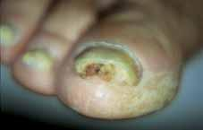
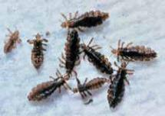

- Figure 5–9 Head lice.

Courtesy of Godfrey F. Mix, DPM Sacramento, CA.

Courtesy of The National Pediculosis Association®, Inc.

Part 2: General Sciences

did you know?

In most states cosmetology professionals are not allowed to use needles, lancets, and probes that penetrate the skin, nor are they allowed to offer any invasive services, such as callous removal. You should check your state’s regulations about using any implement that may penetrate the skin. If you are allowed to use these implements in your state, be sure to receive the proper training before using them in the salon.

by the itch mite, which burrows under the skin. Contagious diseases and conditions caused by parasites should only be treated by a doctor. Contaminated countertops, tools, and equipment should be thoroughly cleaned and then disinfected with an EPA-registered disinfectant for the time recommended by the manufacturer or with a bleach solution for ten minutes.

Immunity

Immunity is the ability of the body to destroy and resist infection. Immunity against disease can be either natural or acquired and is a sign of good health. Natural immunity is partly inherited and partly developed through healthy living. Acquired immunity is immunity that the body develops after overcoming a disease, through inoculation (such as flu vaccinations), or through exposure to natural allergens, such as pollen, cat dander, and ragweed.

Principles of Prevention

Proper decontamination can prevent the spread of disease caused by exposure to potentially infectious materials on an item’s surface. Decontamination also will prevent exposure to blood and visible debris or residue such as dust, hair, and skin.

Decontamination (dee-kuhn-tam-ih-NAY-shun) is the removal of blood or other potentially infectious materials on an item’s surface and the removal of visible debris or residue such as dust, hair, and skin. There are two methods of decontamination.
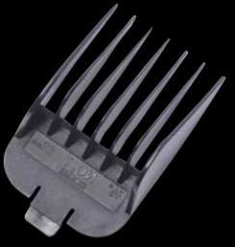

- Decontamination Method 1: Cleaning and then disinfecting with an appropriate EPA-registered disinfectant.

- Decontamination Method 2: Cleaning and then sterilizing.

Many state regulatory agencies believe there is a lower risk of infection in salons than in medical facilities, where sterilizing is a major concern. Therefore, most salons are only concerned with Decontamination Method 1: cleaning and disinfecting. Some states have upgraded their infection control standards in salons that perform nail services to Decontamination Method 2: cleaning and sterilizing. When done properly, Decontamination Method 2 results in the destruction of all microbes through heat and pressure in an autoclave.

Decontamination Method 1

Decontamination Method 1 has two steps: cleaning and disinfecting. Remember that when you clean, you must remove all visible dirt and debris from tools, implements, and equipment by washing with liquid soap and warm water and by using a clean and disinfected nail brush to scrub any grooved or hinged portions of the item.

5
.

© yummy, 2010; used under license from Shutterstock.com.

A surface is properly cleaned when the number

of contaminants on the surface is greatly

reduced. In turn, this reduces the risk of

infection. The vast majority of contaminants and

pathogens can be removed from the surfaces of

tools and implements through proper cleaning. This is why cleaning is an important part of disinfecting tools and equipment. A surface must be properly cleaned before it can be properly disinfected. Using a disinfectant without cleaning first is like using mouthwash without brushing your teeth—it just does not work properly!

Cleaned surfaces can still harbor small amounts of pathogens, but the presence of fewer pathogens means infections are less likely to be spread. Putting antiseptics on your skin or washing your hands with soap and water will drastically lower the number of pathogens on your hands. However, it does not clean them properly. The proper cleaning of the hands requires rubbing hands together and using liquid soap, warm running water, a nail brush, and a clean towel. (See Procedure 5–3, Proper Hand Washing, later in this chapter.) Do not underestimate the importance of proper cleaning and hand washing. They are the most powerful and important ways to prevent the spread of infection.

There are three ways to clean your tools or implements:

- Washing with soap and warm water, then scrubbing them with a clean and properly disinfected nail brush.

- Using an ultrasonic unit.

- Using a cleaning solvent (e.g., on metal bits for electric files).

The second step of Decontamination Method 1 is disinfection. Remember that disinfection is the process that eliminates most, but not necessarily all, microorganisms on nonliving surfaces. This process is not effective against bacterial spores. In the salon setting, disinfection is extremely effective in controlling microorganisms on surfaces such as shears, nippers, and other multiuse tools and equipment (multiuse and single-use tools are discussed later in this chapter). Any disinfectant used in the salon should carry an EPA-registration number and the label should clearly state the specific organisms the solution is effective in killing when used according to the label instructions.

Remember that disinfectants are products that destroy all bacteria, fungi, and viruses (but not spores) on surfaces. Disinfectants are not for use on human skin, hair, or nails. Never use disinfectants as hand cleaners since this can cause skin irritation and allergy (AL-ur-jee), a reaction due to extreme sensitivity to certain foods, chemicals, or other normally harmless substances. All disinfectants clearly state on the label that you should avoid skin contact. This means avoid contact with your skin as well as the client’s. Do not put your fingers directly into any disinfecting solution.

Benefits of Sterilizing Not every tool or implement can be sterilized. Therefore, most state regulatory agencies do not require salons to sterilize tools and implements. However, Texas is one exception. The Texas
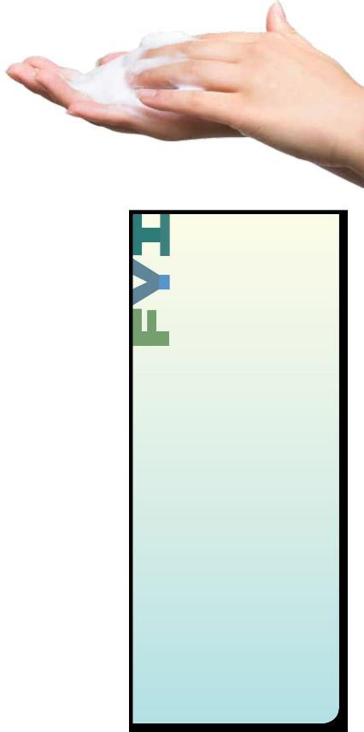
Department of Licensing and Regulation requires sterilization of nonporous manicure and pedicure tools and implements before each service. Other states may follow. Check with your state regulatory agency to determine whether sterilization of tools and implements is required in your state.

The benefits of sterilization are:

- Sterilization is the most reliable means of infection control.

- Sterilized tools and implements in sealed bags assure clients that you are using fresh instruments during the service. The bag should be opened just before the service to show clients that the tools and implements have been sterilized and that the salon cares about the safety of their clients.

it.

caution

Read labels carefully! Manufacturers take great care to develop safe and highly effective products. However, when used improperly, many otherwise safe products

can be dangerous. If you do not follow proper guidelines and instructions, any professional salon product can be dangerous. As with all products, disinfectants must be used exactly as the label instructs.

caution

Disinfectants must be registered with the EPA. Look for an EPA-registration number on the label.

caution

Improper mixing of disinfectants—to be weaker or more concentrated than the manufacturer’s instructions— can dramatically reduce their effectiveness. Always add the disinfectant concentrate to the water when mixing and always follow the manufacturer’s instructions for proper dilution.

Safety glasses and gloves should be worn to avoid accidental contact with eyes and skin.

Disinfectants are pesticides and can be harmful if absorbed through the skin. If you mix a disinfectant in a container that is not labeled by the manufacturer, the container must be properly labeled with the contents and the date it was mixed. All concentrated disinfectants must be diluted exactly as instructed by the manufacturer on the container’s label.

Decontamination Method 2

Decontamination Method 2 also has two steps: cleaning and sterilizing. The word sterilize is often used incorrectly. Sterilization is the process that completely destroys all microbial life, including spores.

The most effective methods of sterilization use high-pressure steam equipment called autoclaves. Simply exposing instruments to steam is not enough. To be effective against disease-causing pathogens, the steam must be pressurized in an autoclave so that the steam penetrates the spore coats of the spore-forming bacteria. Dry heat forms of sterilization are less efficient and require longer times at higher temperatures. Dry heat sterilization is not recommended for use in salons.

Most people without medical training do not understand how to use an autoclave. For example, dirty implements cannot be properly sterilized without first being properly cleaned. Autoclaves need regular maintenance and testing to ensure they are in good working order. Color indicator strips on autoclave bags can provide false readings so they should never be used solely to determine whether instruments have been sterilized. These strips are only an indication, not verification that the autoclave is working.

The Centers for Disease Control and Prevention (CDC) requires that autoclaves be tested weekly to ensure they are properly sterilizing implements. The accepted method is called a spore test. Sealed packages containing test organisms are subjected to a typical sterilization cycle and then sent to a contract laboratory that specializes in autoclave performance testing. You can find laboratories to perform this type

of test by simply doing an Internet search for autoclave spore testing. Other regular maintenance is also required to ensure the autoclave reaches the correct temperature and pressure. Keep in mind that an autoclave that does not reach the intended temperature for killing microorganisms may create a warm, moist place where pathogenic organisms can grow and thrive.

Salons should always follow the autoclave manufacturer’s recommended schedule for cleaning, changing the water, service visits, replacement parts, and any required maintenance. Be sure to keep a logbook of all usage, testing, and maintenance for the state board to inspect. Showing your logbook to clients can provide them with peace of mind and confidence in your ability to protect them from infection. LO4

5

Choosing a Disinfectant |  |  | did you know?
You must read and follow the manufacturer’s instructions
whenever you are using a disinfectant. Mixing ratios |  |  | The EPA has recently approved a new disinfectant
(dilution) and contact time are very important. Not all |  |  | that can be used in the salon and is available in
disinfectants have the same concentration, so be sure to mix |  |  | a spray and an immersion form, as well as wipes.
the correct proportions according to the instructions on the |  |  | • Accelerated hydrogen peroxide (AHP). This
label. If the label does not have the word concentrate on it, |  |  | disinfectant is based on stabilized hydrogen
the product is already mixed. It must be used directly from |  |  | peroxide. AHP disinfectant needs to be changed
the container and must not be diluted. All EPA-registered |  |  | only every 14 days and is nontoxic to the skin
disinfectants, even those sprayed on large surfaces, will |  |  | and the environment. There is an AHP formula
specify a contact time in their directions for use. Contact |  |  | that is available for disinfecting pedicure tubs.
time is the amount of time the surface must stay moist with |  |  | Read the labels of all types of disinfectants
disinfectant in order for the disinfectant to be effective.
 |  |  | closely. Choose the one that is most appropriate
Disinfectants must have efficacy (ef-ih-KUH-see) claims |  |  | for its intended use and is the safest for you and
on the label. Efficacy is the ability to produce an effect. |  |  | your clients.
As applied to disinfectant claims, efficacy means the
effectiveness with which a disinfecting solution kills
organisms when used according to the label instructions.
Professionals have many disinfectants available to them and |  |  |  | caution
should choose the one best suited for their specialty. The ideal
disinfectant would:
• Maintain efficacy in the presence of bioburden, the number of viable
 |  |  |  | Bleach is not a magic potion!
 | organisms in or on an object or surface or the organic material on |  |  | All disinfectants, including
 | the surface of an object before decontamination or sterilization. |  |  | bleach, are inactivated (made
• Require that it be changed after a longer length of time (at least a |  |  |  | less effective) in the presence
 |  |  |  | of many substances, including
 | week or more, not daily).
 |  |  |  | oils, lotions, creams, hair, skin,
• | Be inexpensive.
 |  |  |  | nail dust, and nail filings. If
• Be nontoxic and nonirritating. |  |  |  | bleach is used to disinfect
• Include strips for checking effectiveness. |  |  |  | equipment, it is critical to use
 |  |  |  | a detergent first to thoroughly
• Be readily available from multiple manufacturers. |  |  |  | clean the equipment and
• | Be EPA approved. |  |  | remove all debris. Never mix
 |  |  |  | detergents with the bleach.

- Be environmentally friendly (can be disposed down the salon drain).

- Have no odor.

- Be noncorrosive.

Salons and cosmetologists must be aware of the types of disinfectants that are on the market and any new products that become available.

Salons pose a lower infection risk when compared to hospitals. For this reason, hospitals must meet much stricter infection control standards. They often use disinfectants that are too dangerous for the salon environment. Even though salons pose a lower risk of spreading certain types of infections, it is still very important to clean and then disinfect

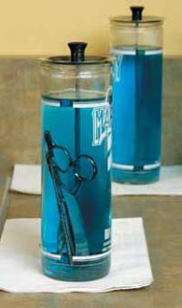

- Figure 5–10

Completely immerse tools in disinfectant.

all tools, implements, surfaces, and equipment correctly. When salon implements accidentally contact blood, body fluids, or unhealthy conditions, they should be properly cleaned and then completely immersed in an EPA-registered hospital disinfectant solution that shows effectiveness against HIV, hepatitis, and tuberculosis. They also can

be immersed in a 10 percent bleach solution. Always wear gloves and follow the proper Universal Precautions protocol for cleaning up after an exposure incident (described later in this chapter).

Proper Use of Disinfectants

Implements must be thoroughly cleaned of all visible matter or residue before being placed in disinfectant solution. This is because residue will interfere with the disinfectant and prevent proper disinfection. Properly cleaned implements and tools, free from all visible debris, must be completely immersed in disinfectant solution. Complete immersion means there is enough liquid in the container to cover all surfaces of the item being disinfected, including the handles, for ten minutes or for the time recommended by the manufacturer (Figure 5–10).

Disinfectant Tips

- Use only on precleaned, hard, nonporous surfaces—not on single-use abrasive files or buffers.

- Always wear gloves and safety glasses when handling disinfectant solutions.

- Always dilute products according to the instructions on the product label.

- An item must remain submerged in the disinfectant for ten minutes unless the product label specifies differently.

did you know?

Not all household bleaches are effective as disinfectants. To be effective, the bleach must have an EPA-registration number and contain at least 5 percent sodium hypochlorite and be diluted properly to a 10 percent solution—9 parts water to 1 part bleach.

- To disinfect large surfaces such as tabletops, carefully apply the disinfectant onto the precleaned surface and allow it to remain wet for ten minutes, unless the product label specifies differently.

- If the product label states, “Complete Immersion,” the entire implement must be completely immersed in the solution.

- Change the disinfectant according to the instructions on the label. If the liquid is not changed as instructed, it will no longer be effective and may begin to promote the growth of microbes.

- Proper disinfection of a whirlpool pedicure spa requires that the disinfecting solution circulate for ten minutes, unless the product label specifies otherwise.

5

Types of Disinfectants

Disinfectants are not all the same. Some are appropriate for use in the salon and some are not. Some disinfectants should be used on tools and implements that are immersed and some should be used on nonporous surfaces. You should be aware of the different types of disinfectants and the ones that are recommended for salon use.

Disinfectants Appropriate for Salon Use

Quaternary ammonium compounds (KWAT-ur-nayr-ree uh-MOH-neeum KAHM-powndz), also known as quats (KWATZ), are disinfectants that are very effective when used properly in the salon. The most advanced type of these formulations is called multiple quats. Multiple quats contain sophisticated blends of quats that work together to dramatically increase the effectiveness of these disinfectants. Quat solutions usually disinfect implements in ten minutes. These formulas may contain anti-rust ingredients, so leaving tools in the solution for prolonged periods can cause dulling or damage. They should be removed from the solution
after the specified period, rinsed (if required), dried, and stored in a clean, covered container.

Phenolic disinfectants (fi-NOH-lik dis-in-FEK-tents) are powerful tuberculocidal disinfectants. They are a form of formaldehyde, have a very high pH, and can damage the skin and eyes. Phenolic disinfectants can be harmful to the environment if put down the drain. They have been used reliably over the years to disinfect salon tools; however, they do have drawbacks. Phenol can damage plastic and rubber and can cause certain metals to rust. Phenolic disinfectants should never be used to disinfect pedicure tubs or equipment. Extra care should be taken to avoid skin contact with phenolic disinfectants. Phenolics are known carcinogens.

Bleach

Household bleach, 5.25 percent sodium hypochlorite (SOH-dee-um hy-puh-KLOR-ite), is an effective disinfectant and has been used extensively as a disinfectant in the salon. Using too much bleach can damage some metals and plastics, so be sure to read the label for safe use. Bleach can be corrosive to metals and plastics and can cause skin irritation and eye damage.

To mix a bleach solution, always follow the manufacturer’s directions. Store the bleach solution away from heat and light. A fresh bleach solution should be mixed every twenty-four hours or when the solution has been contaminated. After mixing the bleach solution, date the container to ensure that the solution is not saved from one day to the next. Bleach can be irritating to the lungs, so be careful about inhaling the fumes.

caution

Some disinfectants are not appropriate for salon use. The following disinfectants should not be used in the salon:

- Fumigants

Years ago, formalin tablets, or paraformaldehyde, were used as fumigants (a gaseous substance capable of destroying pathogenic bacteria) in dry-cabinet sanitizers. This was before EPA-registered disinfectants came on the market and before it was known that paraformaldehyde slowly releases low concentrations of formaldehyde gas.

The release of this gas can cause eye, nose, and lung irritation or allergic inhalation sensitivity in individuals who repeatedly breathe these gases. Although the level of formaldehyde gas produced does not cause more serious health problems, these fumigants are no longer used in the salon.

- Glutaraldehyde Glutaraldehyde is a powerful chemical used to sterilize surgical instruments in hospitals. It produces fumes that are irritating to the lungs, eyes, and skin. While other professions use glutaraldehyde, it is not safe for salon use.

Another word that is used (most often in marketing and sales copy) to describe multiuse items is disinfectable, which means these items can be disinfected and used again.

- Figure 5–11

Wear gloves and safety glasses while handling disinfectants.

caution
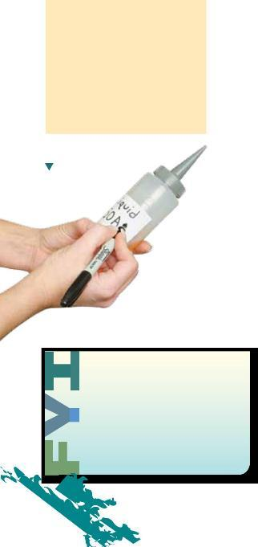

Porous or absorbent items must be disposed of properly if the skin is accidentally cut during the service or if they come into contact with unhealthy skin or nails. Remember: When in doubt, throw it out!

Figure 5–12

All containers should
be labeled.
by

Disinfectant Safety

Disinfectants are pesticides (a type of poison) and can cause serious skin and eye damage. Some disinfectants appear clear while others, especially phenolic disinfectants, are a little cloudy. Always use caution when handling disinfectants, and follow the safety tips below.

Safety Tips for Disinfectants

Always

- Keep an MSDS on hand for the disinfectant(s) you use.

- Wear gloves and safety glasses when mixing disinfectants (Figure 5–11).

- Avoid skin and eye contact.

- Add disinfectant to water when diluting (rather than adding water to a disinfectant) to prevent foaming, which can result in an incorrect mixing ratio.

- Use tongs, gloves, or a draining basket to remove implements from disinfectants.

- Keep disinfectants out of reach of children.

- Carefully measure and use disinfectant products according to label instructions.

- Follow the manufacturer’s instructions for mixing, using, and disposing of disinfectants.

- Carefully follow the manufacturer’s directions for when to replace the disinfectant solution in order to ensure the healthiest conditions for you and your client. Replace the disinfectant solution every day—more often if the solution becomes soiled or contaminated.

Never

- Let quats, phenols, bleach, or any other disinfectant come in contact with your skin. If you do get disinfectants on your skin, immediately wash the area with liquid soap and warm water. Then rinse the area and dry the area thoroughly.

- Place any disinfectant or other product in an unmarked container. All containers should be labeled (Figure 5–12).

Jars or containers used to disinfect implements are often incorrectly called wet sanitizers. The purpose of disinfectant containers is to

disinfect, not to clean. Disinfectant containers must be covered, but not airtight. Remember to clean the container every day and to wear gloves when you do. Always follow the manufacturer’s label instructions for disinfecting products. LO5

Disinfect or Dispose?

How can you tell which items in the salon can be disinfected and reused? There are two types of items used in salons: multiuse (reusable) items, and single-use (disposable) items.

5

Multiuse, also known as reusable, items can be cleaned, disinfected, and used on more than one person even if the item is accidentally exposed to blood or body fluid. These items must have a hard, nonporous surface. Examples of multiuse items are nippers, shears, combs, metal pushers, some nail files, rollers, and permanent wave rods.

Single-use, also known as disposable, items cannot be used more than once. These items cannot be properly cleaned so that all visible residue is removed—such as pumice stones used for pedicures—or they are damaged or contaminated by cleaning and disinfecting. Examples of single-use items are wooden sticks, cotton balls, sponges, gauze, tissues, paper towels, and some nail files and buffers. Single-use items must be thrown out after each use.

Porous means that an item is made or constructed of a material that has pores or openings. These items are absorbent. Some porous items can be safely cleaned, disinfected, and used again. Examples of porous items are towels, chamois, linens, and some nail files and buffers.

If a porous item contacts broken skin, blood, body fluid, or any unhealthy skin or nails, it must be discarded immediately. Do not try to disinfect the item. If you are not sure whether an item can be safely cleaned, disinfected, and used again, throw it out.

Keep a Logbook

Salons should always follow manufacturers’ recommended schedules for cleaning and disinfecting tools and implements, disinfecting foot spas and basins, scheduling regular service visits for equipment, and replacing parts when needed. Although your state may not require you to keep a logbook of all equipment usage, cleaning, disinfecting, testing, and maintenance, it may be advisable to keep one. Showing your logbook to clients provides them with peace of mind and confidence in your ability to protect them from infection and disease.

Disinfecting Nonelectrical Tools and Implements

State rules require that all multiuse tools and implements must be cleaned and disinfected before and after every service—even when they are used on the same person. Mix all disinfectants according to the manufacturer’s directions, always adding the disinfectant to the water, not the water to the disinfectant (Figure 5–13).

Procedure Disinfecting
5-1 | Nonelectrical Tools
 | and Implements | See page 96

Disinfecting Electrical Tools and Equipment

Hair clippers, electrotherapy tools, nail drills, and other types of electrical equipment have contact points that cannot be immersed in liquid. These items should be cleaned and disinfected using an EPA-

- Figure 5–13
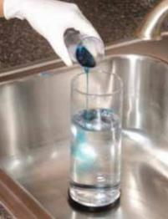
Carefully pour disinfectant into the water when preparing disinfectant solution.

caution

Ultraviolet (UV) sanitizers are useful storage containers, but they do not disinfect or sterilize.

caution

Electric sterilizers, bead sterilizers, and baby sterilizers cannot be used to disinfect or sterilize implements. These devices can spread potentially infectious diseases and should never be used in salons. Also, UV light units will not disinfect or sterilize implements. State rules require that you use liquid disinfecting solutions! Autoclaves are effective sterilizers. If you decide to use an autoclave, be sure that you know how to operate it properly.

- Figure 5–14

Clean and disinfect manicure tables regularly.

caution

Products and equipment that have the word sanitizer on the label are merely cleaners. They do not disinfect. Items must be properly cleaned and disinfected after every use before using them on another client.

caution

Some states require that all procedures for cleaning and disinfecting tools, implements, and equipment must be recorded in a salon logbook. Check with your state’s regulatory agency to determine whether you are required to do so. It is a good practice to complete a logbook, even if not required, as it shows clients you are serious about protecting their health.

registered disinfectant designed for use on these devices. Follow the procedures recommended by the disinfectant manufacturer for preparing the solution and follow the item’s manufacturer directions for cleaning and disinfecting the device.

Disinfecting Work Surfaces

Before beginning every client service, all work surfaces must be cleaned and disinfected. Be sure to clean and disinfect tables, styling stations, shampoo sinks, chairs, arm rests and any other surface that a customer’s skin may have touched (Figure 5–14). Clean doorknobs and handles daily to reduce transferring germs to your hands.

Cleaning Towels, Linens, and Capes

Clean towels, linens, and capes must be used for each client. After a towel, linen, or cape has been used on a client, it must not be used again until it has been properly laundered. To clean towels, linens, and capes, launder according to the directions on the item’s label. Be sure that towels, linens, and capes are thoroughly dried. Items that are not dry may grow mildew and bacteria. Store soiled linens and towels in covered or closed containers, away from clean linens and towels, even if your state regulatory agency does not require that you do so. Whenever possible, use disposable towels, especially in restrooms. Do not allow capes that are used for cutting, shampooing, and chemical services to touch the client’s skin. Use disposable neck strips or towels. If a cape accidentally touches skin, do not use the cape again until it has been laundered.

Disinfecting Foot Spas and Pedicure Equipment

All equipment that contains water for pedicures (including whirlpool spas, pipe-less units, foot baths, basins, tubs, sinks, and bowls) must be cleaned and disinfected after every pedicure, and the information must be entered into a logbook. Inspectors may issue fines if there is no logbook. Some state regulatory agencies allow single-use tub liners in pedicure equipment. Check with your state agency. If single-use liners are allowed in your state, be sure that you clean and disinfect all surfaces of the equipment that are not covered by the liner after every client.

Soaps and Detergents

Chelating soaps (CHE-layt-ing SOHPS), also known as chelating detergents, work to break down stubborn films and remove the residue of pedicure products such as scrubs, salts, and masks. The chelating agents in these soaps work in all types of water, are low-sudsing, and are specially formulated to work in areas with hard tap water. Hard tap water reduces the effectiveness of cleaners and disinfectants. If your area has hard water, ask your local distributor for pedicure soaps that are effective in hard water. This information will be stated on the product’s label.

5

Additives, Powders, and Tablets

There is no additive, powder, or tablet that eliminates the need for you to clean and disinfect. Products of this type cannot be used instead of EPA-registered liquid disinfectant solutions. You cannot replace proper cleaning and disinfection with a shortcut. Water sanitizers do not properly clean or disinfect equipment. They are designed for Jacuzzis and hydrotherapy tubs where no oils, lotions, or other enhancements are used. Therefore, water sanitizers do not work well in a salon environment. Never rely solely on water sanitizers to protect your clients from infection. Products that contain Chloramine T, for example, are not effective disinfectants for equipment. These products only treat the water and have limited value in the salon. They do not replace proper cleaning and disinfection. Remember: There are no shortcuts!

Procedure Disinfecting Foot 5-2 Spas or Basins See page 97

Dispensary

The dispensary must be kept clean and orderly, with the contents of all containers clearly marked. Always store products according to the manufacturer’s instructions and away from heat and out of direct sunlight. Keep the MSDSs for all products used in the salon in a convenient, central location for the employees.

Handling Single-Use Supplies

All single-use supplies, such as wooden sticks, cotton, gauze, wipes, porous nail files and buffers, and paper towels should be thrown away after one use. Anything exposed to blood, including skin care treatment debris, must be double-bagged and marked with a biohazard sticker, separated from other waste, and disposed of according to OSHA standards.

caution

Most pedicure spas hold 5 gallons of water; check with the manufacturer and be sure that you use the correct amount of disinfectant. Also be sure that you are using a disinfectant that is appropriate for the pedicure spa.

Remember:

1 gallon = 128 ounces

5 gallons = 640 ounces

If you are working with a pedicure spa that holds 5 gallons of water, you will have to measure the correct amount of water needed to cover the jets and then add the correct amount of disinfectant.

caution

Never place a client’s feet in water that contains a disinfectant.

Hand Washing

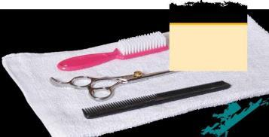
Properly washing your hands is one of the most important actions you can take to prevent spreading germs from one person to another. Proper hand washing removes germs from the folds and grooves of the skin and from under the free edge of the nail plate by lifting and rinsing germs and contaminants from the surface.

caution

Follow this rule for all tools and supplies: If you cannot disinfect your tools or supplies, you must discard them.

caution

When washing hands, use liquid soaps in pump containers. Bar soaps can grow bacteria.

caution

Taking the time to conduct a thorough hair and scalp analysis will enable you to determine whether a client has any open wounds or abrasions. If the client does have an open wound or abrasion, do not perform services of any kind for the client.

You should wash your hands thoroughly before and after each service. Follow the hand washing procedure in this chapter. And, if you perform nail services, your client should first wash his or her hands using a clean and disinfected nail brush before the service begins.
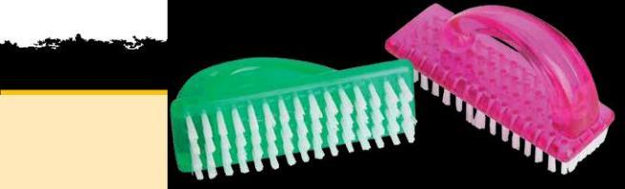

Antimicrobial and antibacterial soaps can dry the skin, and medical studies suggest that they are no more effective than regular soaps or detergents. Therefore, it is recommended that you minimize the use of antimicrobial and antibacterial soaps. Repeated hand washing can also dry the skin, so using a moisturizing hand lotion after washing is a good practice. Be sure the hand lotion is in a pump container, not a jar.

Avoid using very hot water to wash your hands because this is another practice that can damage the skin. Remember: You must wash your hands thoroughly before and after each service, so do all you can to reduce any irritation that may occur.

Procedure Proper Hand
5-3 Washing See page 102

Waterless Hand Sanitizers

Antiseptics (ant -ih- SEP-tiks) are chemical germicides formulated for use on skin and are registered and regulated by the Food and Drug Administration (FDA). Antiseptics can contain either alcohol or benzalkonium chloride (ben-ZAHL-khon-ee-um KLOHR-yd), which is less drying to the skin than alcohol. Neither type of antiseptic can clean the hands of dirt and debris; this can only be accomplished with liquid soap, a soft-bristle brush, and water. Use hand sanitizers only after properly cleaning your hands. Never use an antiseptic to disinfect instruments or other surfaces. They are ineffective for that purpose.

Universal Precautions

Universal Precautions are guidelines published by OSHA that require the employer and employee to assume that all human blood and body fluids are infectious for bloodborne pathogens. Because it may not be possible to identify clients with infectious diseases, strict

infection control practices should be used with all clients. In most instances, clients who are infected with the hepatitis B virus or other bloodborne pathogens are asymptomatic, which means that they show no symptoms or signs of infection. Bloodborne pathogens are more difficult to kill than germs that live outside the body.

OSHA sets safety standards and precautions that protect employees in situations when they could be exposed to bloodborne pathogens. Precautions include proper hand washing, wearing gloves, and properly handling and disposing of sharp instruments and any other items that may have been contaminated by blood or other body fluids.

It is important that specific procedures are followed if blood or body fluid is present.

An Exposure Incident: Contact with Blood or Body Fluid

You should never perform a service on any client who comes into the salon with an open wound or an abrasion. Sometimes accidents happen while a service is being performed in the salon, however.

An exposure incident is contact with nonintact (broken) skin, blood, body fluid, or other potentially infectious materials that is the result of the performance of an employee’s duties. Should the client suffer a cut or abrasion that bleeds during a service, follow these steps for the client’s safety, as well as your own:

- Stop the service.

- Put on gloves to protect yourself from contact with the client’s blood.

- Stop the bleeding by applying pressure to the area with a clean cotton ball or piece of gauze.

- When bleeding has stopped, clean the injured area with an antiseptic wipe. Every salon must have a first aid kit.

- Bandage the cut with an adhesive bandage.

- Clean and disinfect your workstation or styling station, using an EPA-registered disinfectant designed for cleaning blood and body fluids.

- Discard all single-use contaminated objects such as wipes or cotton balls by double-bagging (place the waste in a plastic bag and then in a trash bag). Place a biohazard sticker (red or orange) on the bag, and deposit the bag into a container for contaminated waste. Deposit sharp disposables in a sharps box (Figure 5–15).

- Before removing your gloves, make sure that all multiuse tools and implements that have come into contact with blood or other body fluids are thoroughly cleaned and completely immersed
in an EPA-registered disinfectant solution designed for cleaning blood and body fluids or 10 percent bleach solution for at least ten minutes or for the time recommended by the manufacturer

caution

Since cosmetologists work with an array of sharp implements and tools, cutting yourself is a very real possibility. If you do suffer a cut and blood is present, you must follow the steps for an exposure incident outlined in this chapter for your safety and the safety of your client.
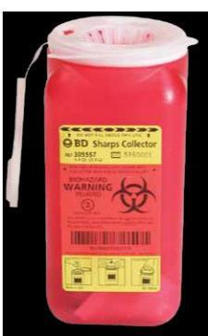

© Milady, a part of Cengage Learning. Photography by Paul Castle, Castle Photography.

- Figure 5–15

Always use a sharps box to dispose of sharp, disposable implements.

it.

did you know?

You should never attempt to clean or disinfect any used tool or implement at your workstation. Proper cleaning and disinfecting should only be accomplished in a specified area of the salon and requires the use of clean, warm running water,

a scrub brush, and liquid soap for cleaning and disinfectant solution for disinfecting. Tools and implements must also be completely rinsed after being disinfected and then dried and kept in a dry, covered container until use.

of the product. Be sure that you do not touch other work surfaces in the salon, such as faucets and counters. If you do, these areas must also be properly cleaned and disinfected. Remember: Blood may carry pathogens, so you should never touch an open sore or a wound.

- Remove your gloves and seal them in the double bag along with the other contaminated items for disposal. Thoroughly wash your hands and clean under the free edge of your nails with soap and warm water before returning to the service.

- Recommend that the client see a physician if any signs of redness, swelling, pain, or irritation develop. LO6

Professional Salon Image

Infection control practices should be a part of the normal routine for you and your coworkers so that the salon and staff project a steadfast professional image. The following are some simple guidelines that will keep the salon looking its best.

- Keep floors and workstations dust-free. Sweep hair off the floor after every client. Mop floors and vacuum carpets every day.

- Control dust, hair, and other debris.

- Keep trash in a covered waste receptacle to reduce chemical odors and fires.

- Clean fans, ventilation systems, and humidifiers at least once each week.

- Keep all work areas well-lit.

- Clean and disinfect restroom surfaces, including door handles.

- Provide toilet tissue, paper towels, liquid soap, properly disinfected soft-bristle nail brushes, and a container for used brushes in

the restroom.

- Do not allow the salon to be used for cooking or living purposes.

- Never place food in the same refrigerator used to store salon products.

- Prohibit eating, drinking, and smoking in areas where services are performed or where product mixing occurs (e.g., back bar area). Consider having a smoke-free salon. Even when you do not smoke in the service areas, the odor can flow into those areas.

- Empty waste receptacles regularly throughout the day. A metal waste receptacle with a self-closing lid works best.

- Make sure all containers are properly marked and properly stored.

- Never place any tools or implements in your mouth or pockets.

- Properly clean and disinfect all multiuse tools before reusing them.

- Store clean and disinfected tools in a clean, covered container. Clean drawers may be used for storage if only clean items are stored in the drawers. Always isolate used implements away from disinfected implements.

- Avoid touching your face, mouth, or eye areas during services.

- Clean and disinfect all work surfaces after every client.

- Have clean, disposable paper towels for each client.

- Always properly wash your hands before and after each service.

- Use clean linens and disposable towels on clients. Keep soiled linens separate from clean linens. Use single-use neck strips or clean towels to avoid skin contact with shampoo capes and cutting or chemical protection gowns. If a cape touched the client’s skin, do not reuse that cape until

it is properly laundered.

- Never provide a nail service to clients who have not properly washed their hands and carefully scrubbed under the free edge of their nails with a disinfected nail brush.

- Use effective exhaust systems in the salon. This will help ensure proper air
quality in the salon.

Your Professional Responsibility

You have many responsibilities as

a salon professional, but none is

more important than protecting your

clients’ health and safety. Never take

shortcuts for cleaning and disinfecting.

You cannot afford to skip steps or save

money when it comes to safety.

- It is your professional and legal responsibility to follow state and federal laws and rules.

- Keep your license current and notify the licensing agency if you move or change your name.

- Check your state’s Web site weekly for any changes or updates to rules and regulations.
LO7

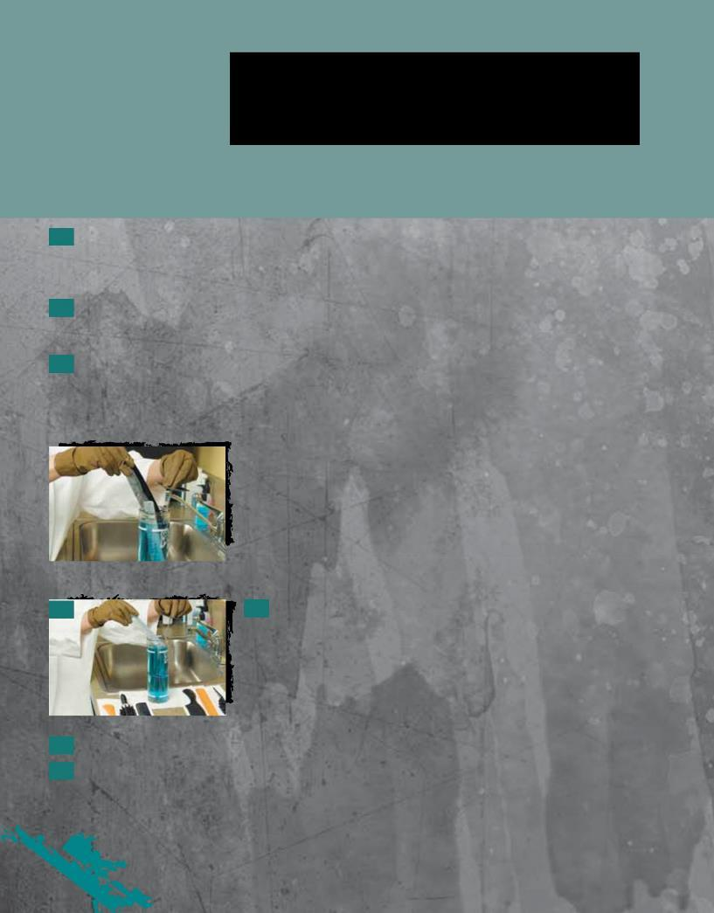
Procedure5-Disinfecting Nonelectrical
Tools and Implements

Nonelectrical tools and implements include items such as combs, brushes, clips, hairpins, metal pushers, makeup brushes, tweezers, and nail clippers.

- It is important to wear safety glasses and gloves while disinfecting nonelectrical tools and implements to protect your eyes from unintentional splashes of disinfectant and to prevent possible contamination of the implements by your hands and to protect your hands from the powerful chemicals in the disinfectant solution.

- Rinse all implements with warm running water, and then thoroughly clean them with soap,

a nail brush, and warm water. Brush grooved items, if necessary, and open hinged implements to scrub the revealed area.

- Rinse away all traces of soap with warm running water. The presence of soap in most disinfectants will cause them to become inactive. Soap is most easily rinsed off in warm, not hot, water. Hotter water is not more effective. Dry implements thoroughly with a clean or disposable towel, or allow them to air dry on a clean towel. Your implements are now properly cleaned and ready to be disinfected.

 |  |  | 4 | It is extremely important that your implements be completely clean
4
 |  |  | before | you place them in the disinfectant solution. If implements are not
 |  |  | clean, your disinfectant may become contaminated and ineffective.
 |  |  | Immerse cleaned implements in an appropriate disinfection container
 |  |  | holding an EPA-registered disinfectant for the required time (at least ten
 |  |  | minutes or according to the manufacturer’s instructions). Remember to
 |  |  | open hinged implements before immersing them in the disinfectant. If the
 |  |  | disinfection solution is visibly dirty, or if the solution has been
 |  |  | contaminated, it must be replaced.
5 |  |  | 5 After the required disinfection time has passed, remove tools and
implements from the disinfection solution with tongs or gloved hands, rinse the tools and implements well in warm running water, and pat them dry.

- Store disinfected tools and implements in a clean, covered container until needed.

- Remove gloves and thoroughly wash your hands with warm running water and liquid soap. Rinse and dry hands with a clean fabric or disposable towel. LO8

Procedure 5-2

Disinfecting Foot Spas
or Basins
Whirlpool Foot Spas and Air-Jet Basins

After every client:

- Put on gloves. Drain all water from the basin.

- Scrub all visible residue from the inside walls of the basin with a clean, disinfected brush and liquid soap and clean, warm water. Use a clean, disinfected brush with a handle. Brushes must be cleaned and disinfected after each use.

- Rinse the basin with clean, warm water and drain.

- Refill the basin with enough clean, warm water to cover the jets and circulate the correct amount (as indicated in the mixing instructions on the label) of the EPA-registered disinfectant specified by the manufacturer through the basin for ten minutes or for the time recommended by the manufacturer.

- Drain, rinse with clean, warm water, and wipe the basin dry with a clean paper towel.

At the end of every day:

- Put on gloves. Remove the screen and any other removable parts. (You may need a screwdriver.)

- Clean the screen and other removable parts and the areas behind them with a clean, disinfected brush and liquid soap and clean, warm water to remove all visible residue. Replace properly cleaned screen and other removable parts.

- Fill the basin with clean, warm water and a chelating detergent (cleansers designed for use in hard water). Circulate the chelating detergent through the system for ten minutes or for the time recommended by the manufacturer. If excessive foaming occurs, discontinue circulation, and let the basin soak for the remainder of the time, as instructed.

t.

Procedure

5-2Disinfecting Foot Spas or Basins
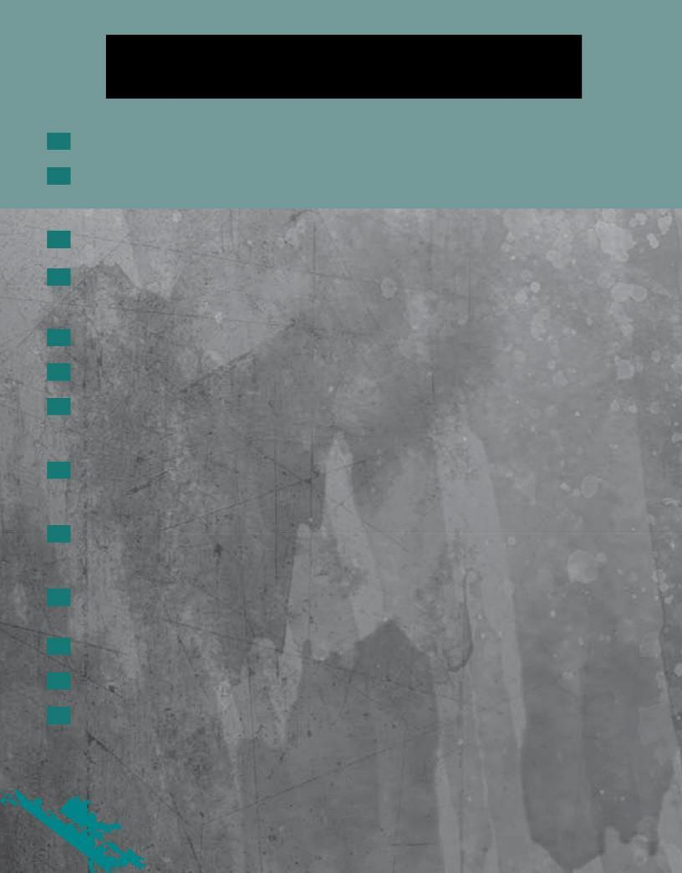

continued

- Drain the soapy solution, and rinse the basin with clean, warm water.

- Refill the basin with clean, warm water and circulate the correct amount (as indicated in the mixing instructions on the label) of the EPA-registered disinfectant through the basin for ten minutes or for the time recommended by the manufacturer.

- Drain, rinse with clean, warm water, and wipe the basin dry with a clean paper towel.

- Allow the basin to dry completely.

At least once each week:

- Put on gloves. Drain all water from the basin.

- Remove the screen and any other removable parts. (You may need a screwdriver.)

- Clean the screen and other removable parts and the areas behind them with a clean, disinfected brush and liquid soap and clean, warm water to remove all visible residue. Replace properly cleaned screen and other removable parts.

- Scrub all visible residue from the inside walls of the basin with a brush and liquid soap and clean, warm water. Use a clean, disinfected brush with a handle. Brushes must be cleaned and disinfected after each use.

- Refill the basin with clean, warm water and circulate the correct amount (as indicated in the mixing instructions on the label) of the EPA-registered disinfectant through the basin for ten minutes or for the time recommended by the manufacturer.

- Do not drain the disinfectant solution. Instead, turn the unit off and leave the disinfecting solution in the unit overnight.

- In the morning, put on gloves, then drain and rinse the basin with clean, warm water.

- Refill the basin with clean, warm water and flush the system.

- Drain, rinse with clean, warm water, and wipe the basin dry with a clean paper towel.

ng.
.

© Dave Wetzel, 2010; used under license from Shutterstock.com.

Disinfecting Pipe-less Foot Spas
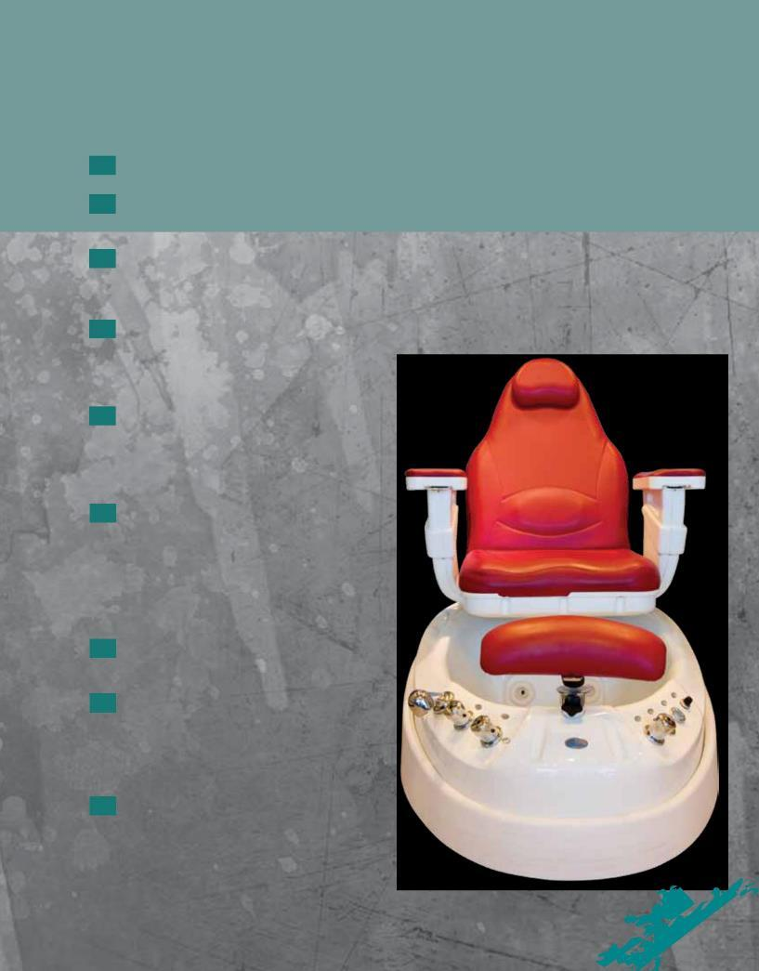

For units with footplates, impellers, impeller assemblies, and propellers.

After every client:

- Put on gloves. Drain all water from the basin.

- Remove impeller, footplate, and any other removable parts according to the manufacturer’s instructions.

- Thoroughly scrub impeller, footplate, and other parts and the areas behind each with a liquid soap, clean, disinfected brush and clean, warm water to remove all visible residue. Reinsert impeller, footplate, and other parts.

- Refill the basin with clean, warm water and circulate the correct amount

(as indicated in the mixing instructions on the label) of the EPA-registered disinfectant through the basin for ten minutes or for the time recommended by the manufacturer.

- Drain, rinse with clean, warm water, and wipe the basin dry with a clean paper towel.

At the end of every day:

- Put on gloves. Fill the basin with clean, warm water and chelating detergent, and circulate the chelating detergent through the system for ten minutes or for the time recommended by the manufacturer. If excessive foaming occurs, discontinue circulation and let soak for the remainder of the time recommended by the manufacturer.

- Drain the soapy solution and rinse the basin with clean, warm water.

- Refill the basin with clean, warm water and circulate the correct amount (as indicated in mixing instructions on the label) of the EPA-registered disinfectant through the basin for ten minutes or for the time recommended by the manufacturer.

- Drain, rinse with clean, warm water, and

wipe the basin dry with a clean paper towel.

it.

Procedure 5-2Disinfecting

continued

At least once each week:

- Put on gloves. Drain all water from the basin.

Foot Spas or Basins
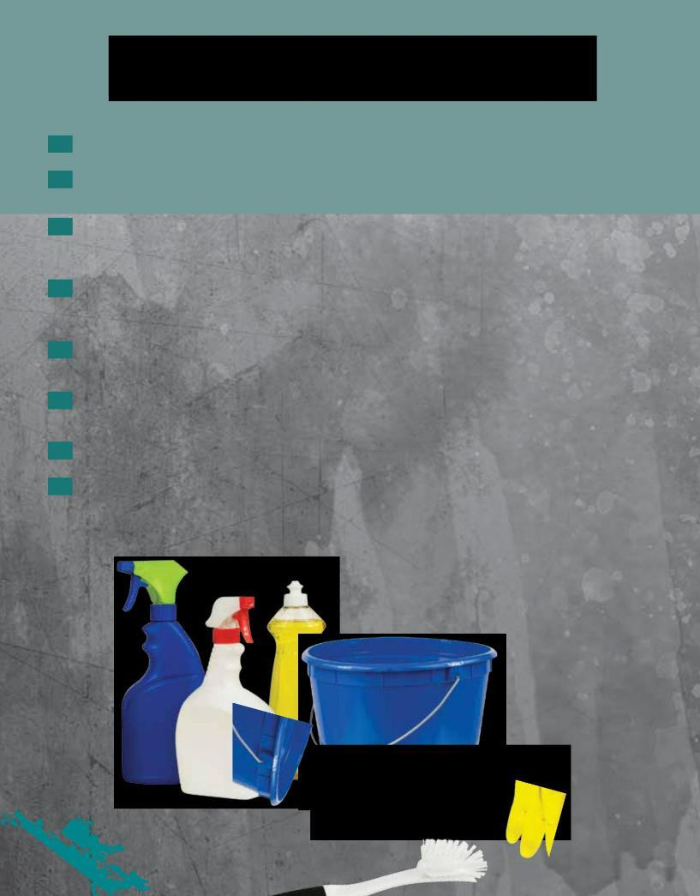

- Remove impeller, footplate, and any other removable parts according to the manufacturer’s instructions.

- Thoroughly scrub impeller, footplate, and other parts and the areas behind each with a liquid soap and clean, warm water to remove all visible residue. Reinsert impeller, footplate, and other parts.

- Refill the basin with clean, warm water and circulate the correct amount (as indicated in mixing instructions on the label) of the EPA-registered disinfectant through the basin for ten minutes or for the time recommended by the manufacturer.

- Do not drain the disinfectant solution. Instead, turn the unit off and leave the disinfecting solution in the unit overnight.

- In the morning, put on gloves, then drain and rinse the basin with clean,

warm water.

- Refill the basin with clean, warm water and flush the system.

- Drain, rinse with clean, warm water, and wipe the basin dry with a clean paper towel.

5

Disinfecting Nonwhirlpool Foot Basins or Tubs

This includes basins, tubs, footbaths, sinks, and bowls—all nonelectrical equipment that holds water for a client’s feet during a pedicure service.

After every client:

- Put on gloves. Drain all water from the foot basin or tub.

- Clean all inside surfaces of the foot basin or tub to remove all visible residue with a clean, disinfected brush and liquid soap and clean, warm water.

- Rinse the basin or tub with clean, warm water and drain.

- Refill the basin with clean, warm water and the correct amount (as indicated in mixing instructions on the label) of the EPA-registered disinfectant. Leave this disinfecting solution in the basin for ten minutes or for the time recommended by the manufacturer.

- Drain, rinse with clean, warm water, and wipe the basin dry with a clean paper towel.

At the end of every day:

- Put on gloves. Drain all water from the foot basin or tub.

- Clean all inside surfaces of the foot basin or tub to remove all visible residue with a clean, disinfected brush and liquid soap and clean, warm water.

- Fill the basin or tub with clean, warm water and the correct amount (as indicated in mixing instructions on the label) of the EPA-registered disinfectant. Leave this disinfecting solution in the basin for ten minutes or for the time recommended by the manufacturer.

- Drain, rinse with clean water, and wipe the basin dry with a clean

paper towel.

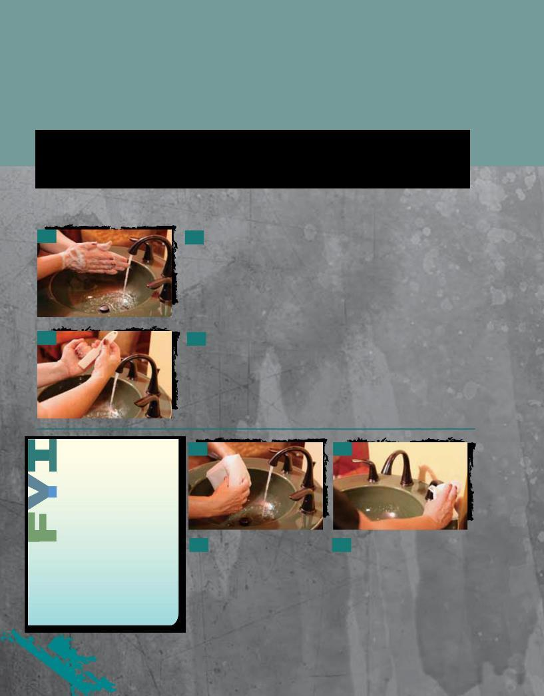
Procedure 5-3

Proper Hand
Washing

Hand washing is one of the most important procedures in your infection control efforts and is required in every state before any service.

1

2

- Turn on the warm water, wet your hands, and then pump soap from a pump container onto the palm of your hand. Rub your hands together, all over and vigorously, until a lather forms. Continue for a minimum of twenty seconds.

- Choose a clean, disinfected nail brush. Wet the nail brush, pump soap on it, and brush your nails horizontally back and forth under the free edges. Change the direction of the brush to vertical and move the brush up and down along the nail folds of the fingernails. The process for brushing both hands should take about sixty seconds to finish. Rinse hands in running warm water.

Dirty nail brushes should be stored together in a closed container until you are ready to clean and disinfect them. Then nail brushes should be properly cleaned, rinsed, dried, and immersed for the required disinfection time, in a disinfectant that does not

harm plastics. After they have been disinfected, rinse the brushes in clean, warm water, dry them, and place them in a clean storage location.

3

- Use a clean cloth or paper towel, according to the salon policies, for drying your hands.

4

- After drying your hands, turn off the water with the towel and dispose of the towel.

Questions

1. What is the primary purpose of regulatory agencies?

2. What is an MSDS? Where can you get it?
- List the four types of organisms that cosmetologists must know about and remember.

4. What are bacteria?

5. Name and describe the two main classifications of bacteria.

6. What are some of the beneficial functions performed by nonpathogenic bacteria?

7. Name and describe the three forms of pathogenic bacteria.

8. What is a contagious disease?

9. Is HIV a risk in the salon? Why or why not?

10. What is the difference between cleaning, disinfecting, and sterilizing?

11. What is complete immersion?

12. List at least six precautions to follow when using disinfectants.

13. How do you know if an item can be disinfected?

14. Can porous items be disinfected?

15. How often should disinfectant solutions be changed?

16. What are Universal Precautions?

17. What is an exposure incident?

- Describe the procedure for handling an exposure incident in the salon.

- Explain how to clean and disinfect nonelectrical tools and implements, and electrical tools and equipment.

- List the steps for cleaning and disinfecting whirlpool foot spas and air-jet basins after each client.

Glossary

acquired immune Abbreviated AIDS; a disease that breaks down the body’s immune system. AIDS is caused

deficiency syndrome by the human immunodeficiency virus (HIV).

acquired immunity Immunity that the body develops after overcoming a disease, through inoculation (such

as flu vaccinations), or through exposure to natural allergens, such as pollen, cat dander, and ragweed.

allergy Reaction due to extreme sensitivity to certain foods, chemicals, or other normally harmless

substances.

antiseptics Chemical germicides formulated for use on skin; registered and regulated by the Food and

Drug Administration (FDA).

asymptomatic Showing no symptoms or signs of infection.

bacilli Short rod-shaped bacteria. They are the most common bacteria and produce diseases such

as tetanus (lockjaw), typhoid fever, tuberculosis, and diphtheria.

bacteria (singular: One-celled microorganisms that have both plant and animal characteristics. Some are

bacterium) harmful; some are harmless.

bactericidal Capable of destroying bacteria.

binary fission The division of bacteria cells into two new cells called daughter cells.

bioburden The number of viable organisms in or on an object or surface or the organic material on a
surface or object before decontamination or sterilization.

bloodborne Disease-causing microorganisms carried in the body by blood or body fluids, such as

pathogens hepatitis and HIV.

chelating soaps Also known as chelating detergents; detergents that break down stubborn films and remove

the residue of pedicure products such as scrubs, salts, and masks.

clean (cleaning) A mechanical process (scrubbing) using soap and water or detergent and water to remove all

visible dirt, debris, and many disease-causing germs. Cleaning also removes invisible debris that interferes with disinfection. Cleaning is what cosmetologists are required to do before disinfecting.

cocci Round-shaped bacteria that appear singly (alone) or in groups. The three types of cocci are

staphylococci, streptococci, and diplococci.

contagious disease Also known as communicable disease; disease that is spread from one person to

another person. Some of the more contagious diseases are the common cold, ringworm, conjunctivitis (pinkeye), viral infections, and natural nail or toe and foot infections.

contamination The presence, or the reasonably anticipated presence, of blood or other potentially infectious

materials on an item’s surface or visible debris or residues such as dust, hair, and skin.

decontamination The removal of blood or other potentially infectious materials on an item’s surface and the

removal of visible debris or residue such as dust, hair, and skin.

diagnosis Determination of the nature of a disease from its symptoms and/or diagnostic tests. Federal

regulations prohibit salon professionals from performing a diagnosis.

diplococci Spherical bacteria that grow in pairs and cause diseases such as pneumonia.

direct transmission Transmission of blood or body fluids through touching (including shaking hands), kissing,

coughing, sneezing, and talking.

disease An abnormal condition of all or part of the body, or its systems or organs, that makes the

body incapable of carrying on normal function.

disinfectants Chemical products that destroy all bacteria, fungi, and viruses (but not spores) on surfaces.

disinfection A chemical process that uses specific products to destroy harmful organisms (except

(disinfecting) bacterial spores) on environmental surfaces.

efficacy The ability to produce an effect.

exposure incident Contact with nonintact (broken) skin, blood, body fluid or other potentially infectious materials

that is the result of the performance of an employee’s duties.

flagella Slender, hairlike extensions used by bacilli and spirilla for locomotion (moving about). May

also be referred to as cilia.

fungi (singular: Microscopic plant parasites, which include molds, mildews, and yeasts; can produce
fungus) contagious diseases such as ringworm.

fungicidal Capable of destroying fungi.

hepatitis A bloodborne virus that causes disease and can damage the liver.

hospital disinfectants Disinfectants that are effective for cleaning blood and body fluids.

human Abbreviated HIV; virus that causes aquired immune deficiency syndrome (AIDS).
immunodeficiency

virus

human papilloma Abbreviated HPV and also known as plantar warts; a virus that can infect the bottom of the

virus foot and resembles small black dots, usually in clustered groups.

immunity The ability of the body to destroy and resist infection. Immunity against disease can be either

natural or acquired and is a sign of good health.

indirect transmission Transmission of blood or body fluids through contact with an intermediate contaminated

object such as a razor, extractor, nipper, or an environmental surface.

infection The invasion of body tissues by disease-causing pathogens.

infection control Are the methods used to eliminate or reduce the transmission of infectious organisms.

infectious Caused by or capable of being transmitted by infection.

infectious disease Disease caused by pathogenic (harmful) microorganisms that enter the body. An infectious

disease may or may not be spread from one person to another person.

inflammation A condition in which the body reacts to injury, irritation, or infection; characterized by

redness, heat, pain, and swelling.

local infection An infection, such as a pimple or abscess, that is confined to a particular part of the body

and appears as a lesion containing pus.

Material Safety Data Abbreviated MSDS; information compiled by the manufacturer about product safety,

Sheet including the names of hazardous ingredients, safe handling and use procedures, precautions

to reduce the risk of accidental harm or overexposure, and flammability warnings.

methicillin-resistant Abbreviated MRSA; a type of infectious bacteria that is highly resistant to conventional

staphylococcus treatments such as antibiotics.

aureus

microorganism Any organism of microscopic or submicroscopic size.

mildew A type of fungus that affects plants or grows on inanimate objects, but does not cause

human infections in the salon.

motility Self-movement.

multiuse Also known as reusable; items that can be cleaned, disinfected, andused onmore than
one person, even if the item is accidentally exposed to blood or body fluid.

mycobacterium A microscopic germ that normally exists in tap water in small numbers.

fortuitum

natural immunity Immunity that is partly inherited and partly developed through healthy living.

nonpathogenic Harmless microorganisms that may perform useful functions and are safe to come in contact

with since they do not cause disease or harm.

nonporous An item that is made or constructed of a material that has no pores or openings and cannot

absorb liquids.

occupational disease Illness resulting from conditions associated with employment, such as prolonged and
repeated overexposure to certain products or ingredients.

parasites Organisms that grow, feed, and shelter on or in another organism (referred to as the host),

while contributing nothing to the survival of that organism. Parasites must have a host to survive.

parasitic disease Disease caused by parasites, such as lice and mites.

pathogenic Harmful microorganisms that can cause disease or infection in humans when they invade

the body.

pathogenic disease Disease produced by organisms, including bacteria, viruses, fungi, and parasites.

phenolic Powerful tuberculocidal disinfectants. They are a form of formaldehyde, have a very high pH,

disinfectants and can damage the skin and eyes.

porous Made or constructed of a material that has pores or openings. Porous items are absorbent.

pus A fluid created by infection.

quaternary Also known as quats; disinfectants that are very effective when used properly in the salon.

ammonium

compounds

sanitation Also known as sanitizing; a chemical process for reducing the number of disease-causing

germs on cleaned surfaces to a safe level.

scabies A contagious skin disease that is caused by the itch mite, which burrows under the skin.

single-use Also known as disposable; items that cannot be used more than once. These items cannot

be properly cleaned so that all visible residue is removed—such as pumice stones used for pedicures—or they are damaged or contaminated by cleaning and disinfecting.

sodium hypochlorite Common household bleach; an effective disinfectant for the salon.

spirilla Spiral or corkscrew-shaped bacteria that cause diseases such assyphilis and Lyme disease.

staphylococci Pus-forming bacteria that grow in clusters like a bunch of grapes. They cause abscesses,

pustules, and boils.

sterilization The process that completely destroys all microbial life, including spores.

streptococci Pus-forming bacteria arranged in curved lines resembling a string of beads. They cause
infections such as strep throat and blood poisoning.

systemic disease Disease that affects the body as a whole, often due to under-functioning or over-functioning

of internal glands or organs. This disease is carried through the blood stream or the lymphatic system.

tinea barbae Also known as barber’s itch; a superficial fungal infection that commonly affects the skin.

It is primarily limited to the bearded areas of the face and neck or around the scalp.

tinea capitis A fungal infection of the scalp characterized by red papules, or spots, at the opening of the

hair follicles.

tinea pedis A ringworm fungus of the foot.

toxins Various poisonous substances produced by some microorganisms (bacteria and viruses).

tuberculocidal Disinfectants that kill the bacteria that causes tuberculosis.

disinfectants

tuberculosis A disease caused by bacteria that are transmitted through coughing or sneezing.

Universal A set of guidelines published by OSHA that require the employer and the employee to

Precautions assume that all human blood and body fluids are infectious for bloodborne pathogens.

virucidal Capable of destroying viruses.

virus (plural: viruses) A parasitic submicroscopic particle that infects and resides in cells of biological organisms.

A virus is capable of replication only through taking over the host cell’s reproductive function.

