Chapter 22 Hair Removal

Chapter Outline

Why Study Hair Removal?

Client Consultation

Contraindications for

Hair Removal

Permanent Hair Removal

Temporary Hair Removal

Procedures

One of the fastest growing services in the salon and spa businesses is hair removal. Once restricted to an occasional lip or brow service, a growing number of clients want to have their entire

face, arms, and legs bare of hair.

Bikini hair removal has also evolved into its own art form, with different designs becoming sought-after services by many clients. Brazilian bikini waxing, a waxing technique that requires the removal of all the hair from the front and the back of the bikini area, is a popular style of waxing. The method was named for the completely hairless look required when wearing a Brazilian style bikini. Brazilian bikini waxing requires more specific training than offered in this book. Ask your instructor about advanced courses in Brazilian bikini waxing.

Many men are now frequently requesting hair removal services. It has become a fashion trend for men to have hairless legs, arms, and even chests. Men who participate in sports such as cycling, swimming, body building, and soccer often remove hair from the legs and arms, and occasionally the entire body. The nape of the neck, chest, and back are the most frequent removal requests for men.

The most common form of hair removal in salons and spas is waxing, but with the popularity of these services on the rise, many different methods are now coming into play.

Hirsuties (hur-SOO-shee-eez), also known as hypertrichosis (hy-pur-trih-KOH-sis), refers to the growth of an unusual amount of hair on parts of the body normally bearing only downy hair, such as the faces of women and the backs of men. Hirsutism (HUR-suh-tiz-um) is an excessive growth or cover of hair, especially in women. Clients with an overabundance of hair are certainly the best candidates for hair removal, although many clients with even just a few unwanted hairs on their arms or legs are now requesting these services.

Facial and body hair removal has become increasingly popular as evolving technology makes it easier to perform with more effective results. All
of the various approaches to hair removal fall into two major categories: permanent and temporary. Salon techniques are generally limited to temporary methods.

Why Study Hair Removal?
Cosmetologists should study and have a thorough
understanding of hair removal because:

  - Removing unwanted hair is a primary concern for many clients, and being able to advise them on the various types of hair removal will enhance your ability to satisfy your clients.

- Offering clients hair removal services that meet their needs and can be scheduled while they are already in the salon can be a valuable extra service you can offer.

22 688 C h a p

- Learning the proper hair removal techniques and performing them safely makes you an even more important part of a client’s beauty regimen.

Client Consultation
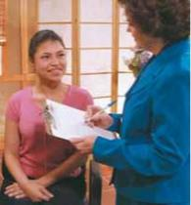

Before performing any hair removal service, a consultation is always necessary. Ask the client to complete a health screening form. Similar to an intake form, a health screening form is frequently used in skin care services and is a questionnaire that discloses all medications, both topical (applied to the skin) and oral (taken by mouth), along with any known skin disorders or allergies that might affect treatment (Figure 22–1). Allergies or sensitivities must be noted, highlighted, and documented on the service record card—­the client’s permanent progress record of services received, and products purchased or used. Keep in mind that many changes can occur between client visits. Since a client’s last visit, he or she
may have been prescribed medications such as antidepressants, hormones, | Figure 22–1
 | Filling out a service record card.
cortisone, medicine for blood pressure or diabetes, or topical prescriptions
such as Retin-A®, Renova®, and hydroquinone. A client using any one
of these prescriptions may not be a candidate for hair removal. See
Figure 22–2 for a sample health screening form. | Figure 22–2
 | Health Screening Form.

HEALTH SCREENING FORM

Date __________

Name ______________________________ Sex __________

Address _______________________________________________________________________

City ________________________________ State __________ Zip __________

- 1. Have you been seen by a dermatologist? Yes_____ No_____ If yes, for what reason? ___________

______________________________________________________________________________

- 2. Please list all medications that you take regularly. Include hormones, vitamins, and other similar supplements: ___________________________________________________________________
- 3. Do you take steroid drugs or prednisone? Yes _____ No _____

- 4. Have you ever used Accutane® (isotretinoin)? Yes _____ No _____ If yes, when did you stop taking Accutane® (isotretinoin)? _______

- 5. Do you use or have you recently used Retin-A®, Renova®, Tazorac®, Differin®, Azelex®, or any other medical peeling agent? Yes_____ No_____ If yes, for how long? ______________

- 6. Do you have any allergies? Are you allergic to any medications? Yes_____ No_____

 | If yes, please list allergies: __________________________________________________________
7. Are you pregnant or lactating? Yes_____ No_____
8. | Have you had any of the following procedures?
 | Laser resurfacing: Yes_____ Date_____ No_____ | Learning.
 | Light chemical peel: Yes_____ Date____ No_____
 | Medium/heavy chemical peel: Yes_____ Date_____ No_____ | of Cengage
 | Any microdermabrasion? Yes_____ Date_____ No_____
9. | Do you ever experience tightness or flaking of your skin? Yes____ No_____ | a part
10. | Do you frequent tanning booths? Yes_____ No_____ | © Milady,
11. | Do you have a history of fever blisters or cold sores? Yes_____ No_____

© Milady, a part of Cengage Learning. Photography by Larry Hamill.

689 22

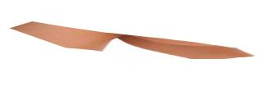
Many of these medications cause changes in the skin that can cause epidermal skin to lift during waxing treatment. In other words, the epidermal skin can peel off along with the wax and the hair.

Clients who have autoimmune diseases such as lupus can have reactions to the inflammation caused by waxing, electrolysis, or other hair removal methods.

Clients with conditions such as rosacea or eczema

can experience severe inflammation, because these skin

conditions are likely to already be inflamed before treatment.

It is imperative that every client fill out a release form for the hair removal service you are going to provide. This should be completed prior to every service. It serves as a reminder to the client to really think about any topical or oral medication they might have started since their last visit. See Figure 22–3 for a sample release form.
LO1

Contraindications for Hair Removal

One of the main purposes of a client consultation is to determine the presence of any contraindications for hair removal. Some medical conditions and medications may cause thinning of the skin or make the skin more vulnerable to injury. Waxing clients with these conditions could cause unnecessary inflammation or severe injuries to the skin. Clients should not have any waxing or
Figure 22–3

Sample release form.

RELEASE FORM FOR HAIR REMOVAL

 | I, |  |  |  |  |  | , am |  |  | am not |  | presently using:
 |  |  |  | Retin-A, or any other topical prescription medication
 |  |  |  | Accutane: (isotretinoin)
 |  |  |  | any alphahydroxy-based products
 |  |  |  | any medications such as cortisone, blood thinners, or diabetic medication
 |  |  |  | I understand that if I begin using any of the above products and do not inform my
Learning. |  |  |  | esthetician/cosmetologist prior to hair removal, I am accepting full responsibility for any skin reactions.
 |  |  |  | The hair removal process has been thoroughly explained to me, and I have had an opportunity to ask
ofCengage |  |  |  | questions and receive satisfactory answers.
a part | Client’s Signature |  |  |  |  |  |  |  |  |  |  |  | Date
 | Technician’s Signature |  |  |  |  |  |  |  |  |  |  |  | Date
© Milady,

© Ra 2 Studio, 2010; used under license from Shutterstock.com.

22 690

hair removal performed anywhere on the body if one or more of the following is the case, without first obtaining written permission from their physician:

- Client is using or has used isotretinoin (Accutane) in the last six months.

- Client is taking blood-thinning medications.

- Client is taking drugs for autoimmune diseases, including lupus.

- Client is taking predisone or steroids.

- Client has psoriasis, eczema, or other chronic skin diseases.

- Client has a sunburn.

- Client has pustules or papules in area to be waxed.

- Client has recently had cosmetic or reconstructive surgery within the previous three months.

- Client has recently had a laser skin treatment on the body.

- Client has severe varicose leg veins.

- Client has any other questionable medical condition.

Facial waxing should not be performed on clients with any of the following conditions, without first obtaining permission from their physician:

- Client has rosacea or very sensitive skin.

- Client has a history of fever blisters or cold sores. (Waxing can cause a flare-up of this condition without medical pretreatment.)

- Client has had a recent chemical peel using glycolic, alpha hydroxy, or salicylic acid, or other acid-based products.

- Client has recently had microdermabrasion.

- Client uses any exfoliating topical medication, including Retin-A®, Renova®, Tazorac®, Differin®, Azelex®, or other medical

peeling agent.

- Client has recently had laser skin treatment or surgical peel.

- Client uses hydroquinone for skin lightening. LO2

22

Permanent Hair Removal

Although permanent hair removal services are not often offered in salons, it is useful to know the options that exist. Permanent hair removal methods include electrolysis, photoepilation (light-based hair removal), and laser hair removal.

Electrolysis

Electrolysis is the removal of hair by means of an electric current that destroys the growth cells of the hair. The current is applied with
a very fine, needle-shaped electrode that is inserted into each hair follicle.

This technique must only be performed by a licensed electrologist.

Photoepilation

Photoepilation, also known as Intense Pulsed Light (IPL), uses intense light to destroy the growth cells of the hair follicles. This treatment
has minimal side effects, requires no needles, and thus minimizes the risk of infection. Clinical studies have shown that photoepilation can provide 50 to 60 percent clearance of hair in twelve weeks. This method can be administered in some salons by cosmetologists and estheticians, depending on state law. Manufacturers of photoepilation equipment generally provide the special training necessary for administering this procedure.

Laser Hair Removal

Lasers are another method for the rapid removal of unwanted hair. In laser hair removal, a laser beam is pulsed on the skin, impairing hair growth. It is most effective when used on follicles that are in the growth or anagen phase.

The laser method was discovered by chance when it was noted that birthmarks treated with certain types of lasers became permanently devoid of hair. Lasers are not for everyone; an absolute requirement is that one’s hair must be darker than the surrounding skin. Coarse, dark hair responds best to laser treatment. For some clients, this method produces permanent hair removal. For other

clients, laser hair removal treatments simply slow down regrowth.

In certain states, cosmetologists or estheticians are allowed to perform laser hair removal under a doctor’s supervision. This method requires specialized training, most commonly offered

by laser equipment manufacturers.

Laws regarding photoepilation and laser hair removal services vary by state, so be sure to check with your regulatory agency for guidelines. LO3

22 692

© Maksim Toome, 2010; used under license from Shutterstock.com.

Temporary Hair Removal

Temporary methods of hair removal, some of which may be offered in the salon or spa, are discussed below.

Shaving

The most common form of temporary hair removal, particularly of men’s facial hair, is shaving. The targeted area should be softened by applying a warm, moist towel, and then applying a shaving cream or lotion that has excellent lubrication qualities and calms the skin. An electric clipper may also be used, particularly to remove unwanted hair at the nape of the neck. The application of a preshaving lotion helps to reduce any irritation. An electric trimmer can also make short work of unwanted hair at the nape of the neck.

did you know?

Contrary to popular belief, shaving does not cause the hair to grow thicker or stronger. It only seems that way because the razor blunts the hair ends and makes them feel stiff.

© Marc Dietrich, 2010; used under license from Shutterstock.com.

Tweezing

Tweezing is using tweezers to remove hairs, commonly used to shape the eyebrows, and can also be used to remove undesirable hairs from around the mouth and chin. Eyebrow arching is often done as part of a professional makeup service. Correctly shaped eyebrows have
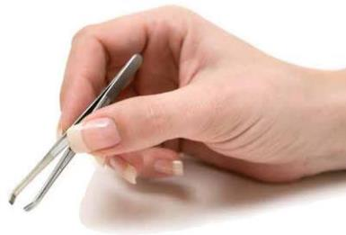
a strong, positive impact on the overall attractiveness of the face. The natural arch of the eyebrow follows the orbital bone, or the curved line of the eye socket, but hair can grow both above and below the natural line. These hairs should be removed to give a clean and attractive appearance.

Procedure Eyebrow
22-3 Tweezing See page 701

Depilatories

A depilatory is a substance, usually a caustic alkali preparation, used for the temporary removal of superfluous hair by dissolving it at the skin’s surface. It contains detergents to strip the sebum from the hair and adhesives to hold the chemicals to the hair shaft for the five to ten minutes necessary to remove the hair. During the application time, the hair expands and the disulfide bonds break. Finally, such chemicals

as sodium hydroxide, potassium hydroxide, thioglycolic acid, or calcium thioglycolate destroy the disulfide bonds. These chemicals turn the hair into a soft, jelly-like mass that can be scraped from the skin. Although depilatories are not commonly used in salons, you should be familiar with them in the event that your clients have used them.

Depilatories can be inflammatory to skin, and should not be used on sensitive skin types or on clients who have contraindications for waxing. It is a good idea to patch test any depilatory on your client’s skin prior to treatment the first time. Select a hairless part of the arm, apply a small

693 22

© Milady, a part of Cengage Learning.

 |  |  | Appropriate Hair Removal Procedures
B o d y a r e a
 |  |  | W a x i n g |  |  |  | T w e e z i n g |  |  | D e p i l a t o r i e s
Face/Upper |  |  | x |  |  |  | x
Lips/Eyebrows
Underarms |  |  | x
Arms |  |  | x |  |  |  |  |  |  | x
Bikini line |  |  | x |  |  |  | x
Back/shoulders |  |  | x |  |  |  | x |  |  | x
 |  |  |  |  |  |  | (after waxing or sugaring)
Legs |  |  | x |  |  |  |  |  |  | x
Tops of feet/toes |  |  | x |  |  |  |  |  |  | x

Table 22–1 Appropriate Hair Removal Procedures.

Client
Consultation –

Eyebrow Design

As with any procedure, always perform a client consultation prior to tweezing or waxing the eyebrows. Determine the client’s wishes for final eyebrow shape. If you remove too much hair, it will generally grow back, but regrowth may take several months. You will also end up with an unhappy client who is not likely to return for your services. Conducting a thorough consultation beforehand will help you avoid such mistakes.

amount according to the manufacturer’s directions, and leave it on the skin for seven to ten minutes. If there are no signs of redness, swelling, or rash, the depilatory can probably be used safely over a larger area of the skin. Follow the manufacturer’s directions for application.

For an easy reference guide for which type of hair removal procedure is appropriate for various areas of the body, refer to Table 22–1.

Epilators

An epilator removes the hair from the bottom of the follicle. Wax is a commonly used epilator, applied in either hot or cold form as recommended by the manufacturer. Both products are made primarily of resins and beeswax. Cold wax is somewhat thicker and does not require fabric strips for removal. Because waxing removes the hair from the bottom of the follicle, the hair takes longer to grow back. The time between waxings is generally four to six weeks.

Wax may be applied to various parts of the face and body, such as the eyebrows, cheeks, chin, upper lip, arms, and legs. On male clients, wax may be used to remove hair on the back and nape of the neck. The hair should be at least ¼-inch (0.6 centimeters) long for waxing to be effective. Hair shorter than ¼ inch may not adhere to the wax. If hair is more than ½-inch long, it should be trimmed before waxing.

Be aware that removing vellus (lanugo) hair may cause the skin to temporarily feel less soft. When waxing is done properly, the hair will not feel like beard stubble as it grows out.

Before beginning a wax treatment, be sure that the client completes a health screening form, and have the client sign a release form. Wear disposable gloves to prevent contact with bloodborne pathogens.

22

© Luba V Nel, 2010; used under license from Shutterstock.com.

Safety Precautions for Hot and Cold Waxing

- To prevent burns, always test the temperature of the heated wax before applying to the client’s skin. Use a professional wax heater for warming wax. Never heat wax in a microwave or on a stove top. Wax can become overheated and burn the client’s skin.

- Use caution so that the wax does not come in contact with the eyes.

- Do not apply wax over warts, moles, abrasions, or irritated or inflamed skin. Do not remove hair protruding from a mole, because the wax could cause trauma to the mole.

- The skin under the arms is sometimes very sensitive. If so, use cold wax.

- Redness and swelling sometimes occur after waxing sensitive skin. Apply an aloe gel and cool compresses to calm and soothe the skin.

Procedure | Eyebrow
22-4 | Waxing | See page 703
Procedure | Body
22-5 | Waxing | See page 705

Threading

Threading is a temporary hair removal method whereby cotton thread is twisted and rolled along the surface of the skin, entwining the hair in the thread and lifting it from the follicle. The technique is still practiced in many Eastern cultures today. Threading has become increasingly popular in the United States as an alternative to other methods. It requires specialized training.

Sugaring

Sugaring is another temporary hair removal method that involves the use of a thick, sugar-based paste and is especially appropriate for more sensitive skin types. Sugaring is becoming more popular and produces the same results as hot or cold wax. One advantage with sugaring is the hair can be removed even if it is only ⅛-inch long.

Removing the residue from the skin is simple, as it dissolves with warm water. LO4

Threading, sugaring, and specialty waxing, such as Brazilian waxing, are advanced techniques that require additional training and experience. Check with your instructor about advanced training that is often available at trade shows and seminars, as well as through videos.

caution

Beeswax can sometimes cause allergic reactions. Always give a small patch test of the product to be used prior to the service.

695 22

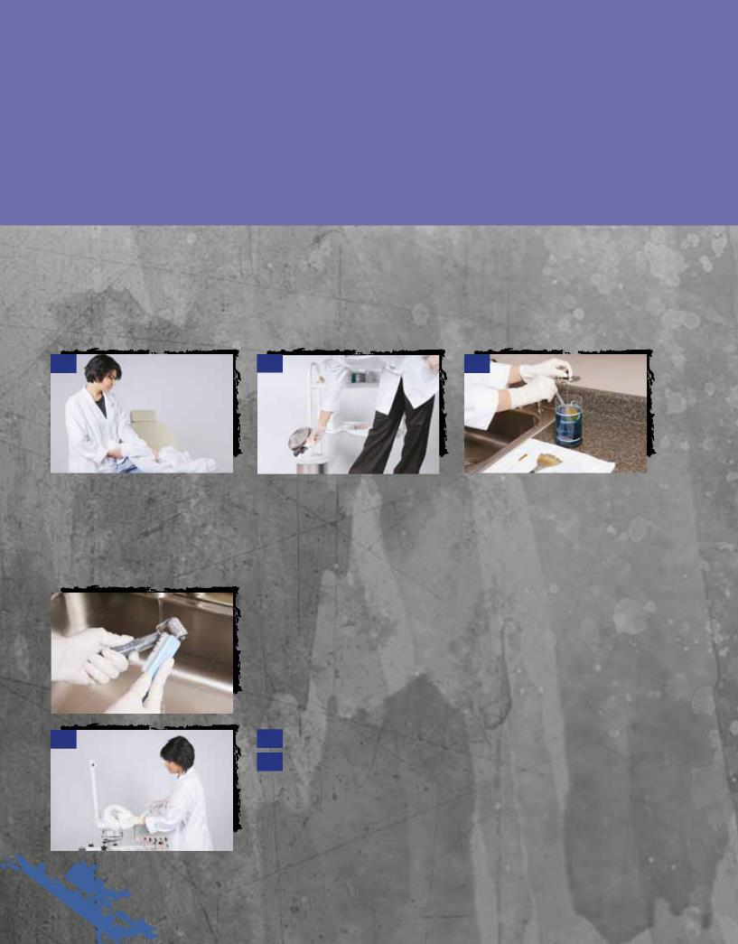
22 Procedure -1

Pre-Service Procedure

A. Preparing the Facial Room

Check your room supply of linens (towels and sheets) and replenish as needed.

1 2 3

1 | Change the bed or treatment |  | 2 | Throw away any disposables | 3 | Clean and disinfect any used
chair | linens. |  | used | during the previous service. | brushes or implements, such as
 |  |  |  |  | mask brushes, comedo extractors,
 |  |  |  |  | tweezers, machine attachments,
 |  |  |  |  | and electrodes.
4
 |  |  | 4 | Clean and disinfect any machine parts used during the
 |  |  | previous service.

5 5 Clean and disinfect counters and magnifying lamp or lens.

- Check water level on vaporizer as needed.

© Milady, a part of Cengage Learning. Photography by Yanik Chauvin.

22 696

© Milady, a part of Cengage Learning. Photography by Yanik Chauvin.

7 7 Replace any disposable
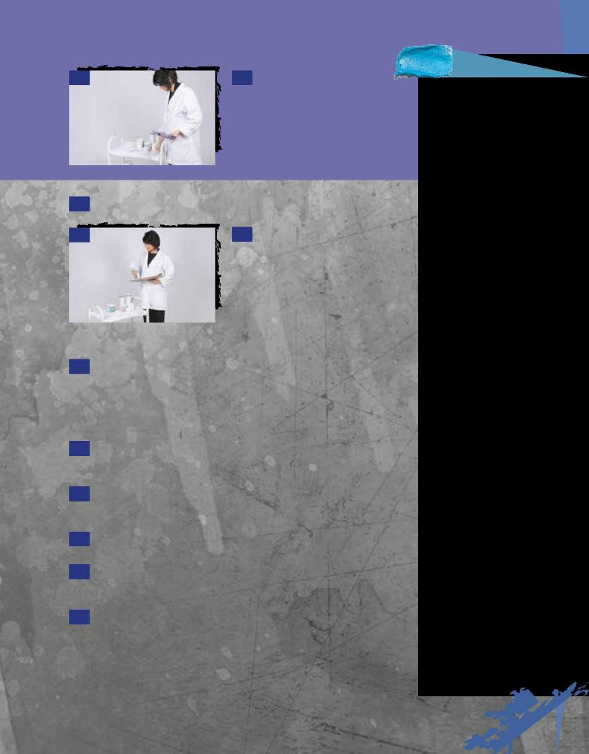
implements you may need, such as

gloves, sheet cotton, gauze squares,

sponges for cleansing and makeup,

disposable makeup applicators

(mascara wands, lip brushes, other

brushes), spatulas and tongue-

depressor wax applicators, cotton

swabs, facial tissue, and wax strips.

- Prepare to greet your next client.

9 9 Review your client schedule for the day

and decide which products you are likely to

need for each service. Make sure you have

enough of all the products you will be using

that day. You may have to retrieve additional

product from the dispensary. This is also a

good time to refresh your mind about each

repeat client you will be seeing that day and

his or her individual concerns.

- Your room should be ready to go from the previous night’s thorough cleaning and disinfecting. (See “At the End of the Day” in Procedure 22–2, Post-Service Procedure.)

B. Preparing for the Client

- Retrieve the client’s intake form or service record card and review it. If the appointment is for a new client, let the receptionist know that the client will need an intake form.

- Organize yourself by taking care of your personal needs before the client arrives—use the restroom, get a drink of water, return a personal call—so that when your client arrives, you can place your full attention on her needs.

- Turn off cell phone, pager, or PDA. Be sure that you eliminate anything that can distract you from your client while she is in the salon.

- Take a moment to clear your head of all your personal concerns

and issues. Take a couple of deep breaths and remind yourself that you are committed to providing your clients with fantastic service and your full attention.

- Wash your hands following Procedure 5–3, Proper Hand Washing, before going to greet your client.

Service Tip

Before servicing a client, take a moment to sit on your bed or facial chair and take a good look around. Based on what you see, hear, and feel, ask yourself this question: What kind of an experience will my client have while she is here?

Answering the following questions will enable you to provide your client with a positive experience:
- Is my room clean and organized or cluttered and messy?

- Will the music and

the temperature be

comfortable for the

client?

- Am I wearing too much perfume/cologne? Am I carrying an unpleasant

food or tobacco odor? Is my breath pleasant smelling?

• When I look at myself in the mirror, do I see the professional I want to be? Does my personal grooming—my hair, makeup, and clothing— look professional?

- Do I look as if I am happy and enjoying my work?

• Is there some problem bothering me today that is affecting my ability to concentrate on the needs of my client?

Remember the old adage:

You only get one chance to make a good first impression. Stack the odds in your favor!

697 22

Procedure

22-1Pre-Service Procedure
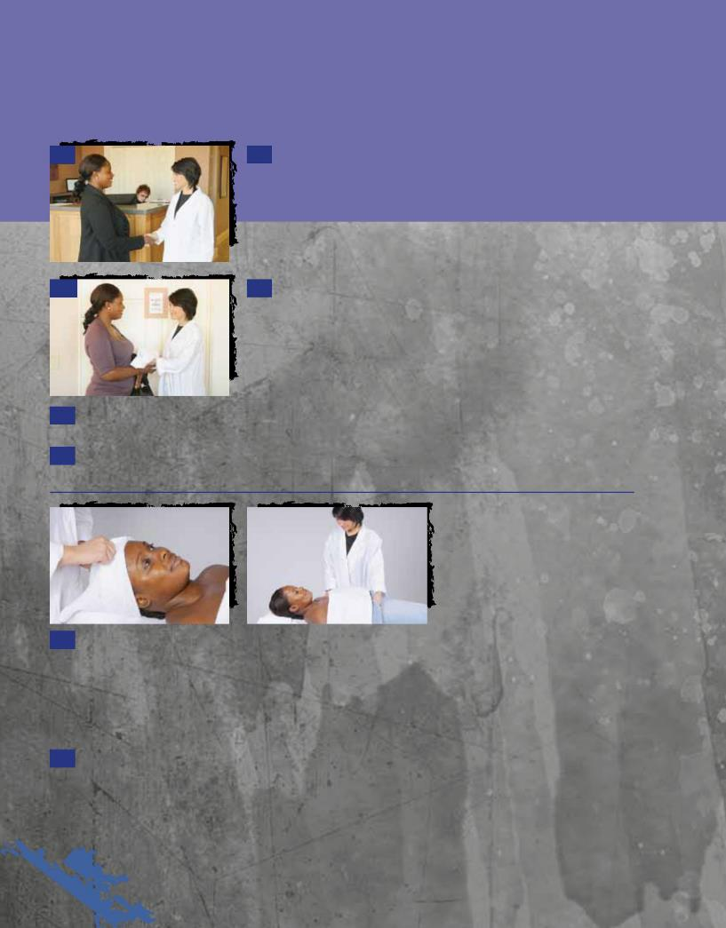

C. Greet Client

continued

16 16 Greet your client in the reception area with a warm smile and in a professional manner. Introduce yourself if you’ve never met, and shake hands. The handshake is the first acceptance by the client of your touch, so be sure your handshake is firm and sincere. If the client is new, ask her for the intake form she filled out in the reception area.

17 17 Escort the client to the changing area for her to change into a smock or robe. Make sure you tell her where to securely place her personal items. If you do not have a changing room or lockers, she will need to change in the treatment room.

- Ask the client to remove all jewelry and put it in a safe place, because you do not want to stop the service for her to remove the jewelry later.

- Invite her to take a seat in the treatment chair or to lie down on the treatment table.

20a 20b

- Drape the client properly and either place her hair in a protective cap or use a headband and towels to drape her hair properly. Give her a blanket and make sure she is comfortable before beginning the service. Remember, the client is not just a waxing or another service, but a person you want to build a relationship with. By first showing clients respect, you will begin to gain their trust in you as a professional. Openness, honesty, and sincerity are always the most successful approach in winning clients’ trust, respect, and, ultimately, their loyalty.

- Perform a consultation before beginning the service. If you are servicing a returning client, ask how her skin has been since her last treatment. If the client is new, discuss the information on the intake form, and ask any questions you have regarding her skin or any conditions listed on the form. Determine a course of action for the treatment, and briefly explain your plan to the client.

22 698

© Milady, a part of Cengage Learning. Photography by Yanik Chauvin.

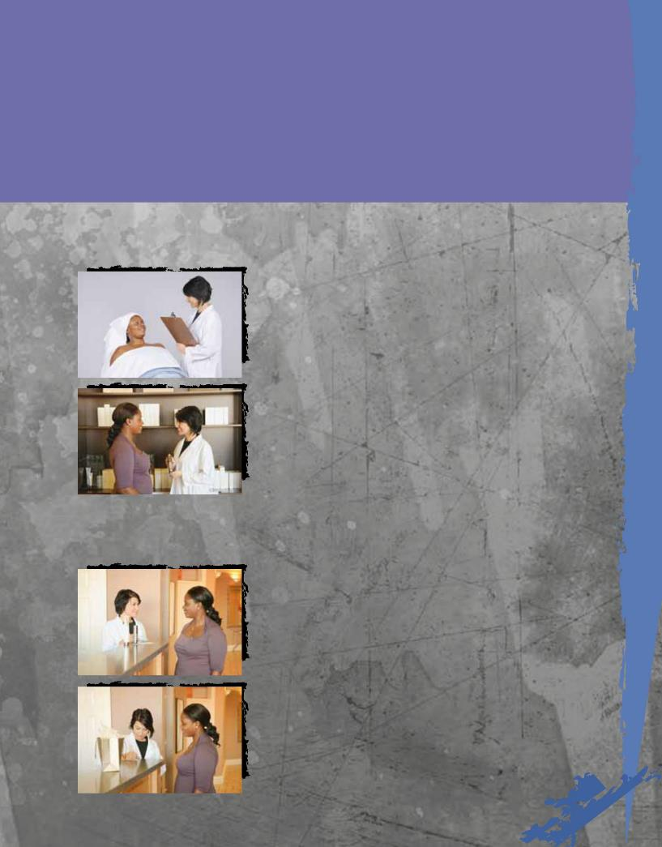
22 Procedure -2
2Post-Service Procedure

A. Advise Clients and Promote Products

1 |  |  | 1 | Before your client leaves your treatment area, ask her how she feels
 |  |  | and if she enjoyed the service. Explain the conditions of her skin and your
 |  |  | ideas about how to improve them. Be sure to ask if she has any questions
 |  |  | or anything else she wishes to discuss. Be receptive and listen. Never be
 |  |  | defensive. Determine a plan for future visits. Give the client ideas to think
 |  |  | over for the next visit.
2 |  |  | 2 | Advise client about proper home care and explain how the
 |  |  | recommended professional products will help to improve any skin
 |  |  | conditions that are present. This is the time to discuss your retail product
 |  |  | recommendations. Explain that these products are important and explain
 |  |  | how to use them.

© Milady, a part of Cengage Learning. Photography by Yanik Chauvin.

B. Schedule Next Appointment and Thank Client

3 |  |  | 3 | Escort the client to the reception desk and write up a service ticket
 |  |  | for the client that includes the service provided, the recommended home
 |  |  | care, and the next visit/service that needs to be scheduled. Place all
 |  |  | recommended professional retail home-care products on the counter for
 |  |  | the client. Review the service ticket and the product recommendations
 |  |  | with your client.
4 |  |  | 4 | After the client has paid for her service and take-home products,
 |  |  | ask if | you can schedule her next appointment. Set up the date, time, and
 |  |  | type of service for this next appointment, write the information on your
 |  |  | business card, and give the card to the client.

699 22

Procedure

22-2Post-Service Procedure
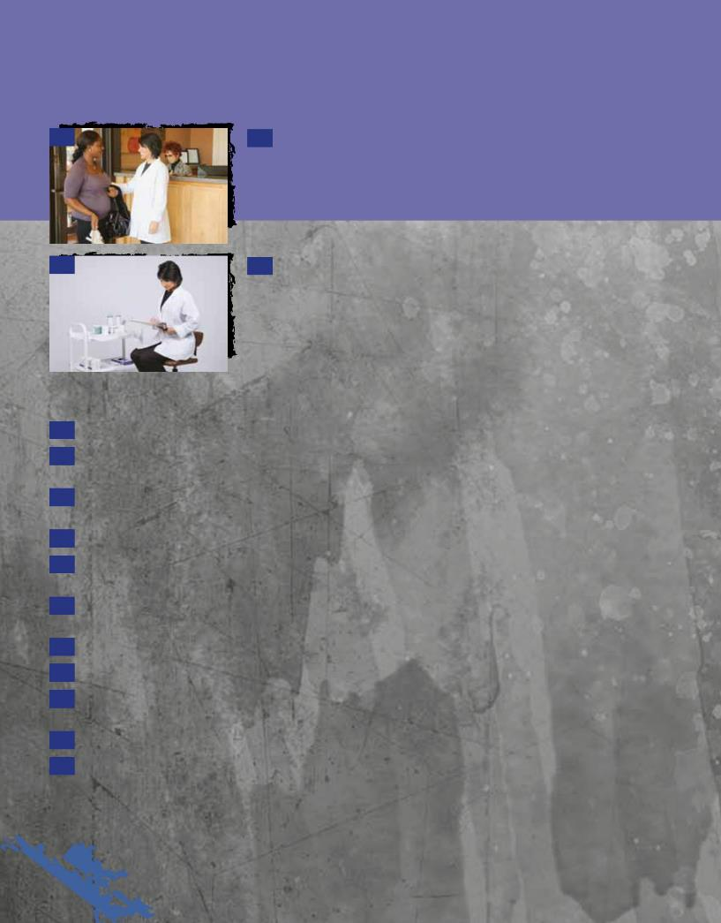

continued

5

6

- Thank the client for the opportunity to work with her. Express

an interest in working with her in the future. Invite her to contact you should she have any questions or concerns about the service provided. If the client seems apprehensive, offer to call her in a day or two in order to check in with her about any issues she may have. Genuinely wish her well, shake her hand, and wish her a great day.

- Be sure to record service information, observations, and product recommendations on the service record card, and be sure you return it to the proper place for filing.

At the End of the Day

- Put on a fresh pair of gloves to protect yourself from contact with soiled linens and implements.

- Remove all dirty laundry from the hamper. Spray the hamper with a disinfectant aerosol spray or wipe it down with disinfectant. Mildew grows easily in hampers.

- Remove all dirty spatulas, used brushes, and other utensils. Most of these should have been removed between clients during the day.

- Thoroughly clean and disinfect all multiuse tools and implements.

- Clean then disinfect all counters, the facial chair, machines, and other furniture with disinfectant. The magnifying lamp should be cleaned and disinfected on both sides in the same manner.

- Replenish the room with fresh linens, spatulas, utensils, and other supplies, so it is ready

for the next day.

- Change disinfection solution.

- Maintain vaporizer as necessary.

- Check the room for dirt, smudges, or dust on the walls, on the baseboards, in corners, or on air vents. Vacuum and mop the room with a disinfectant.

- Spray the air in the room with a disinfectant aerosol spray.

- Replenish any empty jars. If you are reusing jars for dispensing creams from a bulk container, always use up the entire content of the small jar and thoroughly clean and disinfect the jar before replenishing. Never add cream to a partially used jar. Rinse the empty jar well with hot water and then disinfect, rinsing thoroughly. Allow the jar to dry before refilling.

22 700

© Milady, a part of Cengage Learning. Photography by Yanik Chauvin.

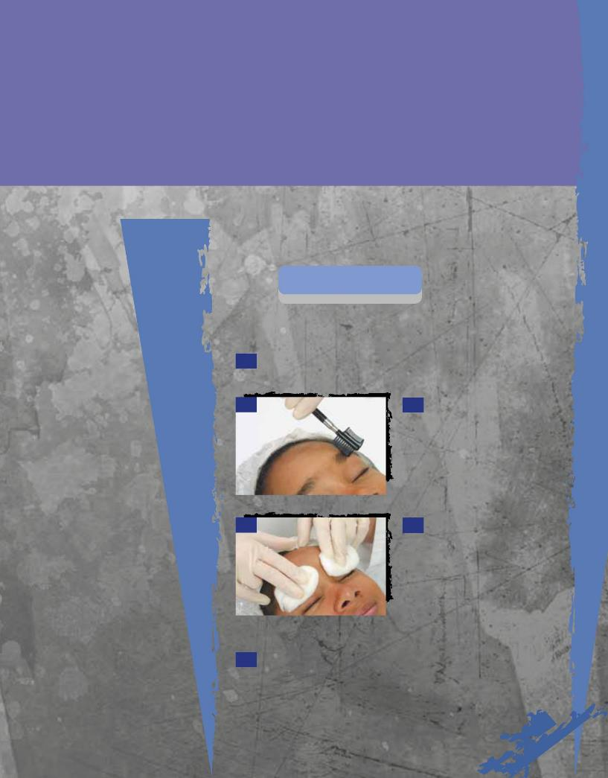
22 Procedure -3

Eyebrow Tweezing

© Milady, a part of Cengage Learning. Photography by Paul Castle, Castle Photography.

Implements and Materials

You will need all of the following implements, materials, and supplies:

• Antiseptic lotion

• Cotton balls

- Disposable gloves

- Emollient cream

- Eyebrow brush

• Gentle eye makeup remover

• Soothing toner

• Towels

• Tweezers

Preparation
Procedure | Pre-Service
• Perform 22-1 | Procedure | See page 696

Procedure

- Cleanse the eyelid area with cotton balls moistened with gentle eye makeup remover.

2 2 Brush the eyebrows with a

small brush to remove any powder

or scaliness.

3 3 Soften brows. Saturate two

pledgets (tufts) of cotton, or a towel

with warm water, and place over the

brows. Allow them to remain on the

brows one to two minutes to soften

and relax the eyebrow tissue. You

may soften the brows and

surrounding skin by rubbing a small

amount of emollient cream into them.

- Apply a mild toner on a cotton ball prior to tweezing.

701 22

Procedure

Eyebrow Tweezing continued
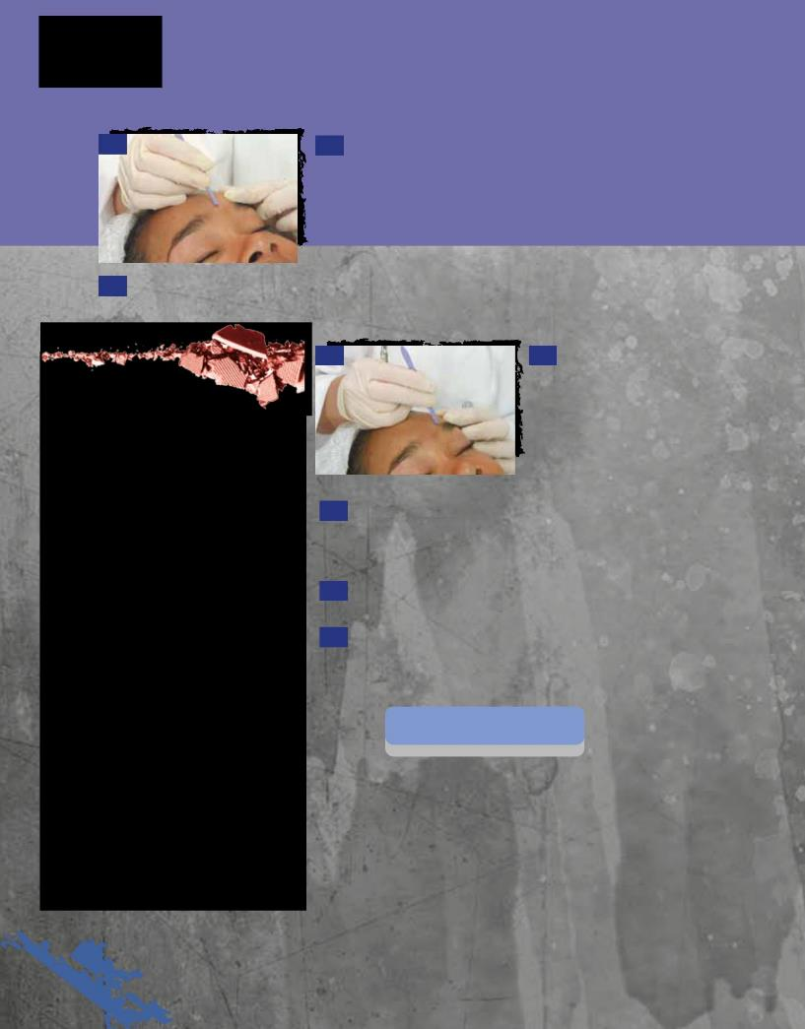

5 5 Remove the hairs between the brows. When tweezing, stretch the skin taut with the index finger and thumb (or index and middle fingers) of your nondominant hand. Grasp each hair individually with tweezers and pull with a quick motion, always in the direction of growth. Tweeze between the brows and above the brow line first, because the area under the brow line is much more sensitive.

- Sponge the tweezed area frequently with cotton moistened with an antiseptic lotion to avoid infection.

Here’s
a Tip

To determine the best shape for the brow, hold the base of a comb or spatula against the corner of the nose, with the other end of the comb or spatula extending straight upward toward the eyebrow. This is where the brow should begin. Hold the comb or spatula so it extends from the corner of the nose to the outside corner of the eye and then across the eyebrow. This is where the brow should end.

The high point of the arch of the brow should be near the outside corner of the iris, if the client is looking straight ahead.

Just like a good haircut, the arch and shape of the eyebrows should be well blended and flow in a natural line. Remove the excess brow hair in an even fashion to avoid sharp angles or obvious thinner areas in the brow line. If the client has an uneven brow line, encourage her to allow the eyebrows in the thin area to grow back, so that you can help her achieve a smoother, well-blended, and more natural-looking line.

7 7 Brush the hair downward.

Remove excessive hairs from

above the eyebrow line, being

careful to not create a hard line

with top of the brow. Shape the

upper section of one eyebrow, and

then shape the other. Frequently

sponge the area with toner.

- Brush the hairs upward. Remove hairs from under the eyebrow line. Shape the lower section of one eyebrow, and then shape the other. Sponge the area with toner. Optional: Apply emollient cream and massage the brows. Remove cream with cool, wet cotton pads.

- After tweezing is completed, sponge the eyebrows and surrounding skin with a toner to soothe the skin.

- Brush the eyebrow hair to its normal position.

Post-Service
Procedure | Post-Service
• Complete 22-2 | Procedure | See page 699

© Milady, a part of Cengage Learning. Photography by Paul Castle, Castle Photography.

22 702

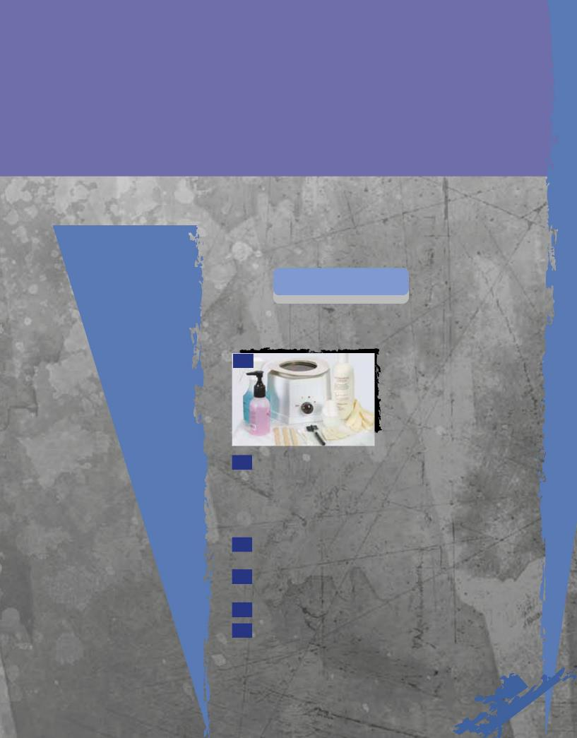
22 Procedure -4

Eyebrow Waxing

© Milady, a part of Cengage Learning. Photography by Paul Castle, Castle Photography.

Implements and Materials

You will need all of the following implements, materials, and supplies:

• Disposable gloves

- Fabric strips for hair removal

- Facial chair

• Hair cap or headband

• Mild skin cleanser

• Roll of disposable paper

• Single or double

wax heater

- Small disposable spatula or small wooden applicators

• Soothing emollient or antiseptic lotion

- Towels for draping

- Wax

- Wax remover

Preparation
Procedure | Pre-Service
• Perform 22-1 | Procedure | See page 696

Procedure

1

1 Melt the wax in the heater. The length of time it takes to melt the wax depends on how full the wax holder is—fifteen to twenty-five minutes if it is full, and ten minutes if it is one-quarter to one-half full. Be sure it is not too hot or too thin. The hotter the wax is, the thinner the wax becomes. Thin wax is more likely to drip and may cause accidents. Wax should have the thickness of caramel sauce. It should not be runny.

2 Lay a clean towel over the top of the facial chair, and then a layer of disposable paper.

3 Place a hair cap or headband on the client’s head to keep hair out of her face.

4 Put on disposable gloves.

- Remove the client’s makeup, cleanse the area thoroughly with a mild cleanser, and dry.

703 | 22

Procedure

Eyebrow Waxing continued
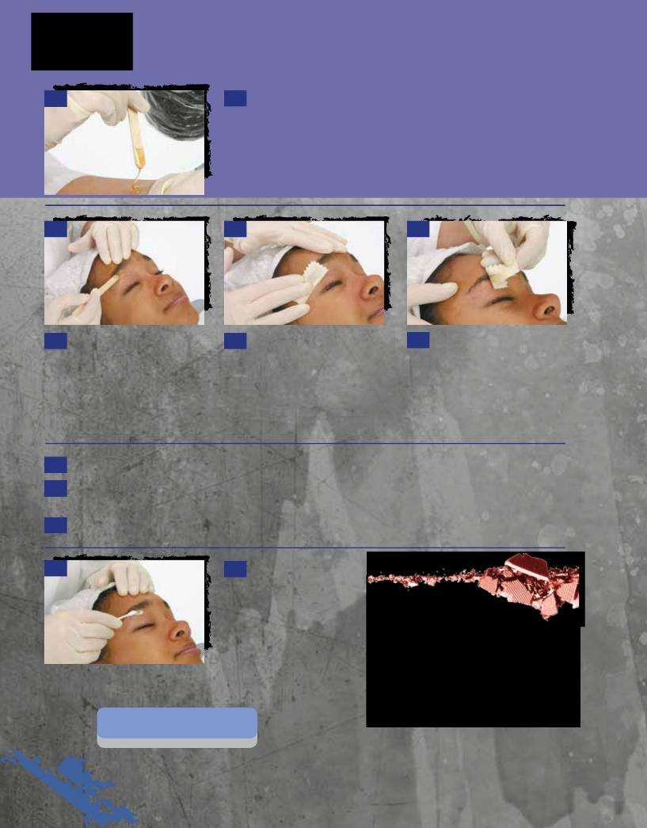

6 6 Test the temperature and consistency of the heated wax by applying a small drop on your inner wrist. It should be warm but not hot, and it should drip smoothly off the spatula.

7 8 9

- With the spatula or wooden applicator, spread a thin coat of the warm wax evenly over the area to be treated, going in the same direction as the hair growth. Be sure not to put the spatula in the wax more than once. No double dips!

- Apply a fabric strip over the waxed area. Press gently in the direction of hair growth, running your finger over the surface of the fabric three to five times, always in the direction of the hair growth.

- Gently applying pressure to hold the skin taut with one hand, quickly remove the fabric strip and the wax that sticks to it by pulling it in the direction opposite the hair growth. Do not pull straight up on the strip.

- Lightly massage the treated area.

- Remove any remaining wax residue from the skin with a gentle wax remover.

- Repeat procedure on the area around the other eyebrow.

13 13 Cleanse the skin with

a mild emollient cleanser

and apply an emollient or

antiseptic lotion.

Post-Service
Procedure | Post-Service
• Complete 22-2 | Procedure | See page 699

Here’s
a Tip

Be sure not to use an excessive amount of wax, as it will spread when the fabric is pressed and may spread to hair you do not wish to remove.

© Milady, a part of Cengage Learning. Photography by Paul Castle, Castle Photography.

22 704

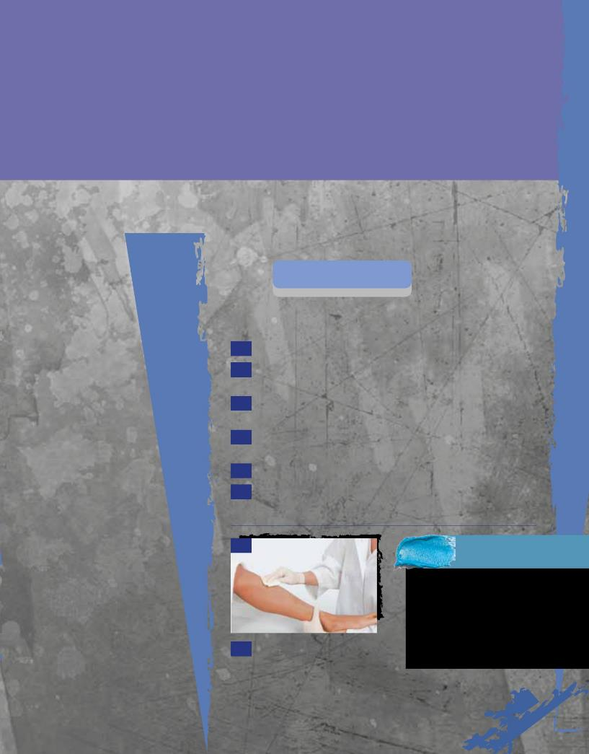
22 Procedure -5

Body waxing

Photography.

Implements and Materials

You will need all of the following implements, materials, and supplies:

• Disposable gloves

- Fabric strips for hair removal

- Facial chair

• Mild skin cleanser

• Dusting powder

• Roll of disposable paper

- Single or double wax heater

- Small disposable spatula or small wooden applicators

Preparation
Procedure | Pre-Service
• Perform 22-1 | Procedure | See page 696

Procedure

- Melt the wax in the heater.

- Drape the treatment bed with disposable paper or a bed sheet with paper over the top.

3 If bikini waxing, offer the client disposable panties or a small clean towel.

- If waxing the underarms, have the client remove her bra and put on a terry wrap. Offer a terry wrap when waxing the legs as well.

5 Assist the client onto the treatment bed and drape with towels.

- Thoroughly cleanse the area to be waxed with a mild cleanser and dry.

© Milady, a part of Cengage Learning. Photography by Paul Castle, Castle

• Soothing emollient or antiseptic lotion

• Towels for draping

• Wax

• Wax remover

7

- Apply a light covering of dusting powder.

32 0 3607

Never leave the wax heater on overnight. Doing so presents a fire hazard and can damage the wax. Wax should be covered with a lid when not warm or heating.

705 22

Procedure

22-5Body Waxing

continued
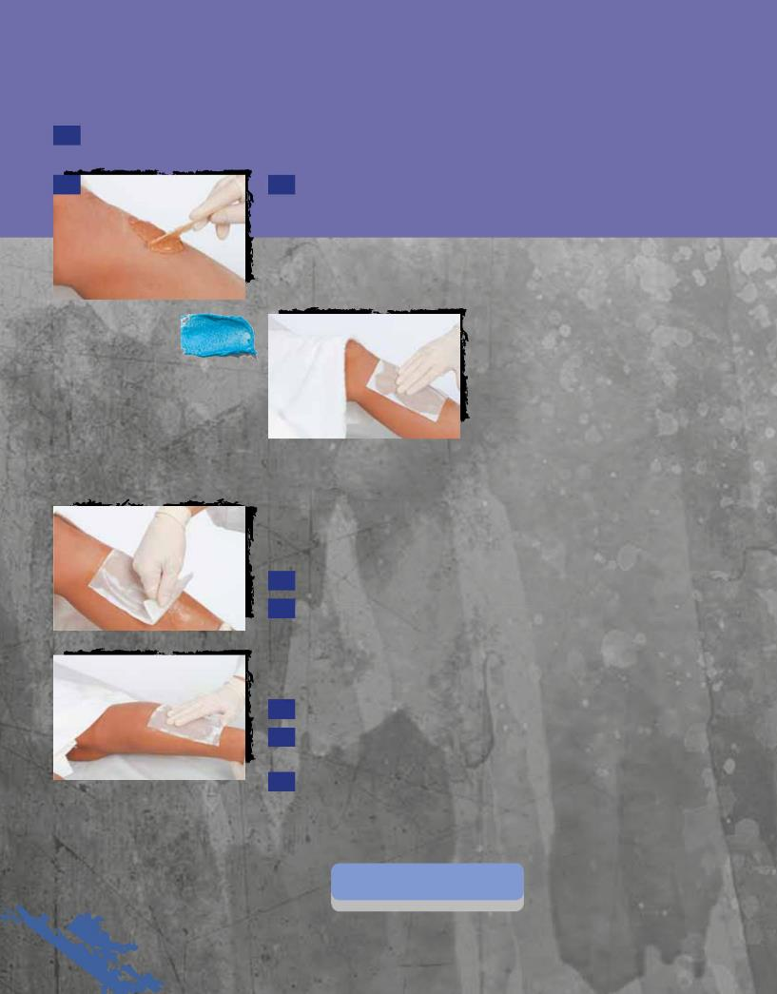

- Test the temperature and consistency of the heated wax by applying a small drop to your inner wrist.

9 9 Using a disposable spatula, spread a thin coat of the warm wax evenly over the skin surface in the same direction as the hair growth. Be sure not to put the spatula in the wax more than once. If the wax strings and lands in an area you do not wish to treat, remove it with lotion designed to dissolve and remove wax.

 | Service Tip |  |  |  | 10 |  |  | 10 | Apply a fabric strip in
 |  |  |  |  |  |  |  | the | same direction as the hair
 |  |  |  |  |  |  |  | growth. Press gently, running your
 | When waxing sensitive areas,
 |  |  |  |  |  |  |  | hand over the surface of the fabric
 | such as underarms or bikini |  |  |  |  |  |  | three to five times.
 | lines, be sure the wax is not too
 | hot. Trim the hair with scissors
 | if it is more than ½-inch (1.25
 | centimeters) long.
 | 11
 |  |  |  |  | 11 | Gently apply pressure to hold the skin taut with one hand and
 |  |  |  |  | quickly remove the adhering wax in the opposite direction of the hair
 |  |  |  |  | growth. Do not pull the fabric strip straight upwards.

- Apply gentle pressure and lightly massage the treated area.

- Repeat, using a fresh fabric strip every time.

14 |  | 14 | If waxing the legs, have the client turn over, and repeat the
 |  | procedure on the backs of her legs.

- Remove any remaining residue of powder from the skin.

- Cleanse the area with a mild emollient cleanser and apply an emollient or antiseptic lotion.

- Undrape the client and escort her to the dressing room.

Post-Service
 | Procedure | Post-Service
 | • Complete 22-2 | Procedure | See page 699
22 | 706

© Milady, a part of Cengage Learning. Photography by Paul Castle, Castle Photography.

Questions

- What information should be entered on the health screening form during the consultation?

- What conditions, treatments, and medications contraindicate hair removal in thesalon?

3. What are the two major types of hair removal? Give examples of each.

4. Define electrolysis, photoepilation, and laser removal.

- Which hair removal techniques should not be performed in the salon without special training?

6. What is the difference between a depilatory and an epilator?

7. Why must a patch test be given before waxing?

8. List safety precautions that must be followed for hot and cold waxing.

9. Define threading and sugaring.

Glossary

Brazilian bikini A waxing technique that requires the removal of all the hair from the front and the back of the

waxing bikini area.
depilatory Substance, usually a caustic alkali preparation, used for the temporary removal of
Chapter Glossarysuperfluoushairbydissolving it at the skin surface level.

electrolysis Removal of hair by means of an electric current that destroys the root of the hair.

epilator Substance used to remove hair by pulling it out of the follicle.

health screening A questionnaire that discloses all medications, both topical (applied to the skin) and

form oral (taken by mouth), along with any known skin disorders or allergies that might affect

treatment.

hirsuties Also known as hypertrichosis; growth of an unusual amount of hair on parts of the body

normally bearing only downy hair, such as the faces of women or the backs of men.

hirsutism Condition pertaining to an excessive growth or cover of hair, especially in women.

laser hair removal Permanent hair removal treatment in which a laser beam is pulsed on the skin, impairing the

hair growth.

photoepilation Also known as Intense Pulsed Light; permanent hair removal treatment that uses intense light

to destroy the growth cells of the hair follicles.

sugaring Temporary hair removal method that involves the use of a thick, sugar-based paste.

threading Temporary hair removal method that involves twisting and rolling cotton thread along the

surface of the skin, entwining the hair in the thread, and lifting it from the follicle.

tweezing Using tweezers to remove hairs.

707 22

