Chapter 23 Facials

Chapter Outline

Why Study Facials?

Skin Analysis and Consultation

Determining Skin Type

Skin Care Products

Client Consultation

Facial Massage

Facial Equipment

Electrotherapy and Light Therapy

Facial Treatments

Aromatherapy

Procedures

Good skin care can make a big difference in the way skin looks and in the way a client feels about his or her appearance. Besides being very relaxing, facial treatments can offer

many improvements to the appearance of the skin (Figure 23–1).

© Milady, a part of Cengage Learning. Photography by Larry Hamill.
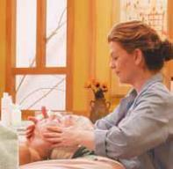

Figure 23–1

A facial is a soothing, pleasurable experience for the client.

F

Sharpening Your Personal Skills

The importance of following hygiene and infection control guidelines when performing facials cannot be overemphasized. As often as possible, perform your cleaning and disinfection procedures in the presence of your

clients. When they

see you doing

this, they will feel

more confident

in you as a

professional.

Proper skin care can make oily skin look cleaner and healthier, dry skin look and feel more moist and supple, and aging skin look smoother, firmer, and less wrinkled. A combination of good salon facial treatments and effective, individualized home care will show visible results.

WHY STUDY FACIALS?

Cosmetologists should study and have a thorough understanding of facials because:

- Providing skin care services to clients is extremely rewarding, helps busy clients to relax, improves their appearance, and helps clients feel better about themselves.

- Knowing the basics of skin analysis and basic information about skin care products will enable you to offer your clients advice when they ask you for it.

- Although you will not treat a skin disease, you must be able to recognize adverse skin conditions and refer clients to seek medical advice from a physician.

- Learning the basic techniques of facials and facial massage will give you a good overview of, and an ability to perform, these foundational services.

- You may enjoy this category of services and may consider specializing in skin care services. This study will create a perfect basis for making that decision.

Skin Analysis and
Consultation

Skin analysis is a very important part of the facial treatment because it determines what type of skin the client has, the condition of the skin, and what type of treatment the client’s skin needs. Consultation allows you
the opportunity to ask the client questions about his or her health and skin care history, and it allows
you to advise the client about appropriate home-care products and treatments. LO1

Health Screening Form

Before beginning the analysis, you must have the client fill out a health screening

23

form (Figure 23–2). Similar to the form used for waxing, the main purpose of the health screening form is to determine whether the client has any contraindications that might prohibit certain skin treatments.

A contraindication (kahn-trah-in-dih-KAY-shun) is a condition that requires avoiding certain treatments, procedures or products to prevent

Department of Skin Care

Health Screening Form

Client History

Name

Address

City |  |  |  |  |  |  |  |  |  |  |  |  |  |  |  |  |  |  |  |  |  |  | State |  |  |  |  |  |  |  |  |  |  |  |  |  |  |  |  |  |  |  |  |  |  |  |  |  |  |  |  |  |  |  | Zip Code
Home phone |  |  |  |  |  |  |  |  |  |  |  |  |  |  |  |  |  |  |  |  |  |  |  |  |  |  |  |  |  | Work Phone
Occupation |  |  |  |  |  |  |  |  |  |  |  |  |  | Referred by |  |  |  |  |  |  |  |  |  |  |  |  |  |  |  |  |  |  |  |  |  |  |  |  |  |  |  |  |  |  |  |  |  |  |  |  |  |  |  |  |  |  |  |  |  | Date of Birth
Is this your first facial treatment? |  |  |  |  |  |  |  |  |  |  |  |  |  |  |  |  |  |  | YES |  |  |  |  |  |  |  |  |  |  |  |  |  |  |  |  |  | NO
Have you ever used:
Retin-A®? YES |  |  |  |  |  |  |  |  | NO
Accutane®: (isotretinoin)? |  |  |  |  |  |  |  |  |  |  |  | YES |  |  |  |  |  |  |  |  |  |  |  |  |  |  |  | NO
Are you using glycolic or alphahydroxy acids? YES |  |  |  |  |  |  |  |  |  |  |  |  |  |  |  |  |  |  |  |  |  |  |  |  |  |  |  |  |  |  |  |  |  |  |  |  |  |  |  |  |  |  |  |  |  |  |  |  |  |  |  |  |  | NO
Do you smoke? YES |  |  |  |  |  |  |  |  |  |  | NO
Are you pregnant? |  |  |  |  |  | YES |  |  |  |  |  |  | NO |  |  |  |  |  |  |  |  |  |  |  |  |  |  |  |  |  |  |  |  | YES |  |  |  |  |  |  |  |  |  |  |  |  |  |  |  |  | NO
Do you have acne or frequent blemishes?
Are you nursing? |  |  |  |  |  | YES |  |  |  |  |  | NO
Taking birth control pills? |  |  |  |  |  |  |  |  |  |  |  | YES |  |  |  |  |  |  |  |  |  |  |  |  |  | NO |  |  |  |  |  |  |  |  |  |  |  |  |  |  | If so, how long?
Have you had skin cancer? |  |  |  |  |  |  |  |  |  |  |  |  | YES |  |  |  |  |  |  |  |  |  |  |  |  |  |  |  |  |  |  | NO
Do you experience stress? |  |  |  |  |  |  |  |  |  |  |  | YES |  |  |  |  |  |  |  |  |  |  |  |  |  |  |  |  | NO |  |  |  |  |  |  |  |  |  |  |  |  |  | If so, how often?
Do you wear contact lenses? YES |  |  |  |  |  |  |  |  |  |  |  |  |  |  |  |  |  |  |  |  |  |  |  |  |  |  |  |  |  |  |  |  | NO
Are you under a physician’s care? |  |  |  |  |  |  |  |  |  |  |  |  |  |  |  |  |  |  |  | YES |  |  |  |  |  |  |  |  |  |  |  |  |  |  |  |  |  |  | NO
Physician’s Name
Do you have any allergies to cosmetics, foods, or drugs? |  |  |  |  |  |  |  |  |  |  |  |  |  |  |  |  |  |  |  |  |  |  |  |  |  |  |  |  |  |  |  |  |  |  |  |  |  |  |  |  |  |  |  |  |  |  |  |  |  |  |  |  |  |  |  |  |  | YES |  |  |  |  |  |  | NO
Please list
Are you presently on any medications - oral or topical-dermatological? |  |  |  |  |  |  |  |  |  |  |  |  |  |  |  |  |  |  |  |  |  |  |  |  |  |  |  |  |  |  |  |  |  |  |  |  |  |  |  |  |  |  |  |  |  |  |  |  |  |  |  |  |  |  |  |  |  |  |  |  |  |  | YES |  |  |  |  | NO
Please list

Figure 23–2

Health Screening Form.

require it.

© Milady, a part of Cengage Learning.

What products do you use presently?
Please circle: |  | Soap | Cleansing Milk |  | Toner | Daily Sunscreen |  |  | Creams
Other
Please circle if you are affected by or have any of the following:
Have had hysterectomy |  |  | Pacemaker/Cardiac Problems |  |  |  | Immune Disorders
Depression or Anxiety |  |  | Herpes |  |  |  | Urinary or Kidney Problems
Seborrhea/Psoriasis/Eczema |  |  | Chronic Headaches |  |  |  | Hepatitis
Asthma |  |  | Fever Blisters |  |  |  | Lupus
High Blood Pressure |  |  | Metal Bone Pins or Plates |  |  |  | Epilepsy
Taking Depression/ |  |  | Sinus Problems |  |  |  | Other Skin Diseases
Mood Altering Medications

Please explain above problems or list any significant others:

I understand that the services offered are not a substitute for medical care, and any information provided by the therapist is for educational purposes only and not diagnostically prescriptive in nature. I understand that the information herein is to aid the technician in giving better service and is completely confidential.

SALON POLICIES

- Professional consultation is required before initial dispensing of products.

- Our active discount rate is only effective for clients visiting every 4 weeks.

- We do not give cash refunds.

I fully understand and agree to the above salon policies.

Client Signature Date

Figure 23–2

Health Screening Form

(continued).

undesirable side effects. For example, if the client is allergic to fragrance, using a fragranced product would be contraindicated. If a client is using a prescription drug, such as Retin-A® or Tazorac® (both topical drugs that cause skin exfoliation), using other exfoliants in the facial treatment is contraindicated because to do so may injure the skin by causing excessive peeling and inflammation.

23

Isotretinoin (Accutane), an oral medication for cystic acne, causes thinning of the skin all over the body. Waxing, stimulating treatments, or exfoliation procedures should never be performed on the skin of someone using isotretinoin or someone who has used the drug in the last six months. Because isotretinoin is an oral drug, it stays in the body for several months after the client stops taking it.

The main contraindications to look for are summarized below and in

Table 23–1:

- Use of isotretinoin or any skin-thinning or exfoliating drug, including Retin-A®, Renova®, Tazorac®, Differin®, and so on: Avoid waxing, exfoliation and/or peeling treatments, and stimulating treatments.

- Pregnancy: Avoid all electrical treatments and any other questionable treatments without a physician’s written permission. Some pregnant clients also experience sensitivities from waxing.

- Metal bone pins or plates in the body: Avoid all electrical treatment.

- Pacemakers or heart irregularities: Avoid all electrical treatment.

- Allergies: Strictly avoid any allergic substances listed on the intake form. Clients with multiple allergies should always use nonfragranced products designed for sensitive skin. Food allergies should also be noted, because many skin care products now contain naturally derived food-based extracts such as soy, nut oils, and other ingredients.

- Seizures or epilepsy: Avoid all electrical and light treatments.

- Use of oral steroids such as prednisone: Avoid any stimulating or exfoliating treatment or waxing. Steroids can cause thinning of the skin which could result in blistering or injury.

- Autoimmune diseases such as lupus: Avoid any harsh or stimulating treatments.

- Diabetes: Be aware that many diabetics heal very slowly. If you have questions, you should get approval from the client’s physician before treatment. The primary services that need approval are waxing, electrolysis, or any treatment for the feet.

- Blood thinners: No extraction or waxing. To do so may cause bleeding or bruising.

Clients who have obvious skin abnormalities, such as open sores, fever blisters (herpes simplex), or other abnormal-looking signs should be referred to a physician for treatment. They can be rescheduled after they obtain written approval of facial services.

Should you ever have any questions regarding a client’s treatment and his or her health conditions, always check with the client’s doctor first! Remember one simple rule: When in doubt, don’t perform the service.

caution

As a cosmetology student, you should receive hands-on training from your instructor before attempting any of the procedures discussed in this chapter.

FC U S O N

Building Your Client Base

It is useful to note on the client intake or health screening form how the client was referred to the salon. This helps you determine the type of advertising that draws your clients. If the referral has come from another salon client, be sure to thank the referring client. This small courtesy can well lead to other valuable referrals.

CONTRAINDICATIONS GRID
 | C O N T R A I N D I C A T I O N S
 |  |  |  | W h a t t o A v o i d |  | W h y ?
 |  | ISOTRETINOIN |  | • all waxing anywhere on the body |  | skin can blister or peel off
 |  | (Accutane) |  | • any peeling agent or drying agent, including
 |  |  |  | alpha hydroxy acids (AHAs) scrubs,
 |  |  |  | microdermabrasion and brushing machines
 |  | EXFOLIATING DRUGS |  | • all waxing on the area where the drug is used |  | skin can blister or peel off
 |  | INCLUDING RETIN- |  | • any peeling agent or drying agent, including
 | A®(TRETINOIN) RENOVA®, |  |  | AHAs, scrubs, microdermabrasion, and
 | TAZORAC®, DIFFERIN® |  |  | brushing machines
 |  | PREGNANCY |  | • electrical treatments |  | unknown; general safety
 |  |  |  | • any questionable treatment without |  | precaution
 |  |  |  | a physician’s written permission
 |  |  |  | • possible sensitivities from waxing
 | METAL BONE PINS OR |  |  | • electrical treatments |  | electricity can possibly affect
 |  | PLATES IN THE BODY |  |  |  | metal
 |  | HEART CONDITIONS/ |  | • electrical treatments |  | electricity can possibly affect
 |  | PACEMAKER |  |  |  | rhythms and pacemakers
 |  | KNOWN ALLERGIES |  | • avoid known allergens, fragrances |  | allergic reaction can occur
 | SEIZURES OR EPILEPSY |  |  | • electrical or light treatments |  | could trigger seizure reaction
 | USE OF ORAL STEROIDS |  |  | • any stimulating or exfoliating treatment |  | steroids can cause thinning
 | SUCH AS PREDNISONE |  |  | • waxing |  | of the skin which could result
 |  |  |  |  |  | in blistering or injury
 | AUTOIMMUNE DISEASES |  |  | • harsh or stimulating treatments without |  | unpredictable reactions in
 |  | SUCH AS LUPUS |  | specific physician permission |  | some cases
 |  | DIABETES |  | • general caution advised (many diabetics |  | none specific
 |  |  |  | heal very slowly; obtain physician approval
 |  |  |  | if you are unsure)
 |  | BLOOD THINNERS |  | • extraction without physician permission |  | may cause bleeding or
 |  |  |  | • facial or body waxing without physician |  | bruising
 |  |  |  | permission
 | SENSITIVE, REDNESS-PRONE |  |  | • heat |  | can aggravate redness
 |  | SKIN |  | • harsh scrubs
Learning. |  |  |  | • mechanical treatment
 |  |  |  | • stimulating massage
of Cengage
 | OPEN SORES, HERPES |  |  | • avoid all treatments until clear with doctor |  | can spread or flare; infectious
 | SIMPLEX (COLD SORES) |  |  |  |  | disease
a part
 | RECENT FACIAL SURGERY OR |  |  | • treat with physician’s permission only |  | treat with physician’s
Milady,
 |  | LASER TREATMENT. |  |  |  | permission only
©
 | Table 23–1 Contraindications Grid.

When the client completes the health screening form, you can obtain important information such as the following:

- Client’s name, address, and phone number(s)

- Client’s occupation

- Medical conditions that might affect treatment

- All medications being used, including topical drugs for the skin

- Current home skin-care program and salon skin-care history

- Information regarding how the client heard about you and your services

Treatment Records

You should record and highlight with a colored pen any important observations or contraindications in the client’s treatment record. File the health screening forms in a secure filing cabinet because the client may have revealed information that is private. The client treatment record should include the client’s name, address, and phone numbers. It should also have spaces to allow for recording the results of the analysis, each treatment performed on the client’s skin, your observations on each visit, any home-care products purchased by the client, and the date of each treatment or product purchase. Recording product purchases will help you find products when a client wants to re-purchase but has forgotten the product name. LO2

caution

Cosmetologists do not treat skin diseases. However, as a professional, you must be able to recognize the presence of various skin ailments in order to suggest that the client seek medical advice from a physician.

Analysis Procedure

After carefully reading the client’s health screening form and discussing your questions with the client, have the client change into a smock and sit in the facial chair. The client’s hair should be covered, and any jewelry should be removed by the client and put away in a safe place. Jewelry can get in the way or become soiled or damaged during treatment.

Cosmetologists should avoid wearing jewelry on the hands or arms while administering facial treatments because rings and bracelets may accidentally injure the client or be damaged.

Recline the client in the chair and drape the client using a hair cap,

headband, or towels. After washing your hands thoroughly, warm

some cleansing milk in your hands and apply the cleanser to the face in

upward circular movements. When cleansing the eye area, use a special

cleanser made for eye makeup removal. Apply a small amount to the

eye areas, being careful not to use so much that it gets in the eyes. Gently

remove the cleanser with warm damp facial sponges or cotton pads.

Remember to remove the cleanser using upward and outward

movements. When working around the eyes, move outward

on the upper lid, and inward on the lower lid.

After thoroughly cleansing the face, apply a cotton eye pad to the client’s eyes to avoid exposure to the extreme brightness of the magnifying lamp.

23

.

Determining Skin Type

Look through the magnifying lamp at the client’s skin. Skin type is determined by how oily or dry the skin is. Skin type is hereditary and cannot be permanently changed with treatments, although the skin may look considerably better after treatment. Skin conditions are characteristics associated with a particular skin type (Table 23–2).

The first thing you should look for is the presence or absence of visible pores (follicles). The amount of sebum produced by the sebaceous glands determines the size of the pores and is hereditary. Obvious pores indicate oily skin areas, and lack of visible pores indicates dry skin.

Skin Types

The term alipidic (al-ah-PIDD-ic) means lack of lipids, and describes skin that does not produce enough sebum, indicated by absence of visible pores. Alipidic skin, also known as dry skin, becomes dehydrated because it does not produce enough sebum to prevent the evaporation of cell moisture. Dehydration indicates a lack of moisture in the skin. Dehydrated skin may be flaky or dry looking, with small, fine lines

S K I N

Oily

Dry

Normal

Combination

dry

SIGNS AND CONDITIONS ASSOCIATED WITH SKIN TYPES

S i g n s o f s k i n t y p e |  | C o n d i t i o n s A s s o c i a t e d W i t h S k i n T y p e
Obvious, large pores. |  | Open and closed comedones, clogged pores. Shiny, thick
 |  | appearance. Yellowish color. Orange peel texture.
Pores very small or not visible. |  | Tight, poreless-looking skin. May be dehydrated with fine
 |  | lines and wrinkles, dry and rough to the touch.
Even pore distribution throughout |  | Normal skin is actually very unusual. Most clients have
the skin. Very soft smooth |  | combination skin.
surface. Lack of wrinkles.
Obvious pores down center |  | May have clogged pores in the nose, chin, and center of the
of face. Pores not visible or |  | forehead. Dry, poreless toward outside edges of the face.
becoming smaller toward the
outer edges of the face.

© Milady, a part of Cengage Learning.

 |  | Wider distribution of obvious or |  | Comedones, clogged pores, or obvious pores in the center of
Combination |  | large pores down the center of |  | the face.
 |  | the face extending to the outer
oily
 |  | cheeks. Pores become smaller
 |  | toward edges of the face.
 |  | Very large pores in all areas. |  | Presence of numerous open and closed comedones, clogged
Acne |  | Acne is considered a skin type |  | pores, and red papules and pustules (pimples).
 |  | because it is hereditary.
Table 23–2 Signs and Conditions Associated with Skin Types.

23

and wrinkles. It may look like it has a piece of cellophane on top of it. Dehydrated skin also may feel itchy or tight. Dehydration can occur on almost any skin type. The key to truly alipidic skin is the absence of visible pores.

Oily skin that produces too much sebum will have large pores, and the skin may appear shiny or greasy. Pores may be clogged from dead cells building up in the hair follicle, or may contain open comedones (KAHM-uh-dohnz), also known as blackheads, which are follicles impacted with solidified sebum and dead cell buildup.

Closed comedones are hair follicles impacted with solidified sebum and dead cell buildup that appear as small bumps just underneath the skin’s surface.

The difference between open and closed comedones is the size of the follicle opening, called the ostium (AH-stee-um). An open comedo has a large ostium, and a closed comedo has a small one.

caution

Severe or unresponsive cases of acne should be referred to a dermatologist for treatment. If you are ever unsure about treating a client who has acne, always refer that client to a dermatologist!

Acne

The presence of pimples in oily areas indicates acne. Acne is considered a skin type because the tendency to develop acne is hereditary. Acne is a disorder in which the hair follicles become clogged, resulting in infection of the follicle with redness and inflammation. Acne bacteria are anaerobic, which means they cannot survive in the presence of oxygen. When follicles are blocked with solidified sebum and dead-cell buildup, oxygen cannot readily get to the bottom of the follicle where acne bacteria live. Acne bacteria survive from breaking down sebum into fatty acids, which is their only food source. A blocked follicle is an ideal environment for acne bacteria. When acne bacteria flourish from the lack of oxygen and access to a food source such as a blocked follicle filled with sebum, they multiply quickly, eventually causing a break in the follicle wall. This rupture allows blood to come into the follicle causing redness. Acne papules are red pimples that do not have a pus head. Pimples with a pus head are called pustules. Pus is a fluid inside a pustule, largely made up of dead white blood cells that tried to fight the infection.

Analysis of Skin Conditions

Conditions of the skin are generally treatable. They are generally not hereditary, but they may be associated with a particular skin type.

Dehydration is indicated by flaky areas or skin that wrinkles easily on the surface. Very gently pinching the surface of dehydrated skin will result in the visible formation of many fine lines. This is an indication of dehydration. Dehydrated skin can be caused from lack of care, improper or over-drying skin care products, sun exposure, and other causes. Dehydrated skin is treated by using hydrators that help to bind water to the skin surface.
These hydrating products should be chosen based on skin type. Hydrators for alipidic skin are generally heavier in

23

© Milady, a part of Cengage Learning. Photography by Larry Hamill.
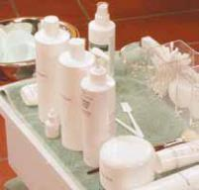

Figure 23–3

There is a wide variety of skin care products for every skin type.

texture. Hydrators for oilier skin are lighter weight. Proper hydration of the skin can result in smoother-looking and softer skin.

Most types of hyperpigmentation, or dark blotches of color, are caused by sun exposure or hormone imbalances. Clients who have spent a lot of time in the sun will often have hyperpigmentation. Hyperpigmentation is treated with mild exfoliation and home care products that discourage pigmentation. Daily use of sunscreen and avoidance of sun exposure are very important for this skin type.

Sensitive skin has a thin, red-pink look. Skin will turn red easily, and is easily inflamed by some skin care products. You should avoid strong products or cleansers, fragranced products, and strong exfoliants when treating sensitive skin. Rosacea is a chronic hereditary disorder that can be indicated by constant or frequent facial blushing.

A person with rosacea often has dilated capillaries, telangiectasis (tel-an-jee-EK-tuh-sus), which are distended or dilated surface blood vessels, and couperose (KOO-per-ohs), which are areas of skin with distended capillaries and diffuse redness.

Rosacea is considered a medical disorder and should be diagnosed by a dermatologist. You should treat a client who has rosacea with very gentle products and treatments, avoiding any treatment that releases heat or stimulates the skin.

Aging skin has loss of elasticity, and the skin tends to sag in areas around the eyes and jawline. Wrinkles may be apparent in areas of normal facial expression. Treatments that hydrate and exfoliate improve the appearance of aging skin.

Sun-damaged skin is skin that has been chronically and frequently exposed to sun over the client’s lifetime. Sun-damaged skin will have many areas of hyperpigmentation, lots of wrinkled areas including areas not in the normal facial expression, and sagging skin from damage to the elastic fibers. The skin looks older than it should for the age of the client. It is often confused with aging skin. LO3

Skin Care Products

There are many, many types of skin care products available for salon use and for the client’s home care. Most skin care products are designed for specific skin types or conditions. Major categories of skin care products are described below (Figure 23–3).

Cleansers are designed to clean the surface of the skin and to remove makeup. There are basically two types of cleansers: cleansing milks and foaming cleansers.

Cleansing milks are non-foaming lotion cleansers designed to cleanse dry and sensitive skin types and to remove makeup. They can be applied with the hands or an implement, but they must be removed with a

23

it.

dampened facial sponge, soft cloth, or cotton pad. Ingredients are sometimes added to cleansing milks to make them more specific to a given skin type.

Foaming cleansers are cleansers containing surfactants (detergents) which cause the product to foam and rinse off easily. These products are generally for combination or oilier skin types, although there are some rinse-off cleansers for dry and sensitive skin. Clients love using these products because they may be used quickly and easily in the shower. They have varying amounts of detergent ingredients to treat specific levels of oiliness. Foaming cleansers, like cleansing milks, may have special ingredients to make them more specific for certain skin types. Some have antibacterial ingredients for acne-prone skin.

Toners, also known as fresheners or astringents, are lotions that help rebalance the pH and remove remnants of cleanser from the skin. They may also contain ingredients that help to hydrate or soothe, and they may sometimes contain an exfoliating ingredient to help remove dead cells. Fresheners and astringents are usually stronger products, often with higher alcohol content, and are used to treat oilier skin types. Toning products are applied with cotton pads after cleansing. Some alcohol-free toners can be sprayed onto the face.

Exfoliants (ex-FO-lee-yahnts) are products that help bring about exfoliation (eks-foh-lee-AY-shun), the removal of excess dead cells from the skin surface. Removing dead cells from the surface of the skin allows the skin to look smoother and clearer.

Exfoliants help clear the skin of clogged pores and can improve the appearance of wrinkles, aging, and hyperpigmentation. Cosmetology professionals may use products that remove dead surface cells from the stratum corneum. Deeper, surgical-level peels must only be administered by dermatologists and plastic surgeons.

Exfoliation may be accomplished by using mechanical exfoliants or chemical exfoliants. Mechanical exfoliants are products used to physically remove dead cell buildup. Gommages (go-mah-jez), also known as roll-off masks, are peeling creams that are rubbed off of the skin, and microdermabrasion scrubs, scrubs that contain aluminum oxide crystals, along with other granular scrubs, are examples of mechanical exfoliants.

Microdermabrasion can also be used as a machine treatment, which is briefly discussed later in this chapter (Figure 23–4). Skin-brushing machines are another example of mechanical exfoliation (Figures 23–5 and 23–6).

Chemical exfoliants are products that contain chemicals that either loosen or dissolve dead cell buildup. They are either used for a short time (although some may be worn as a day or night treatment) or combined in a moisturizer. Popular exfoliating chemicals are alpha hydroxy acids (AHAs) (AL-fah hy-DRAHKS-ee AS-uds); these are gentle, naturally

caution

It is important to note that the cosmetology professional’s domain is the hair and superficial epidermis. Cosmetology professionals must not perform treatments that remove cells beyond the stratum corneum of the epidermis.
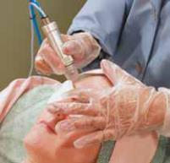

Figure 23–4 Microdermabrasion

treatment.
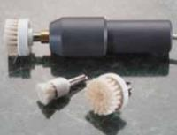

Figure 23–5 Skin-brushing machine.
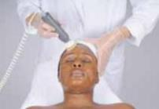

Figure 23–6

Using a skin-brushing machine during a facial treatment.

by Larry Hamill. © Milady, a part of Cengage Learning. Photography © Milady, a part of Cengage Learning. Photography by Larry Hamill.

Photography by Yanik Chauvin. © Milady, a part of Cengage Learning.

23

t.

©.

caution |  |  |  | occurring acids that remove dead skin cells by dissolving the bonds
 |  |  |  | and intercellular cement between cells. As dead cells are removed from
 |  |  |  | the surface over time, wrinkles appear less deep, skin discolorations
 |  |  |  | may fade, clogged pores are loosened and reduced, new clogged pores
Certain skin conditions can be easily
 |  |  |  | are prevented, and skin is smoother and more hydrated. These acids
inflamed by mechanical exfoliation.
 |  |  |  | encourage cell renewal, resulting in firmer and healthier-looking skin.
Also, certain medications may thin the
skin, making it more susceptible to |  |  |  | Salon AHA exfoliants, also known as peels, contain larger
inflammation, bruising, or blistering. |  |  |  | concentrations of AHA, usually around 20 to 30 percent. They
Do not use brushing machines, scrubs, |  |  |  | should never be used unless the client has been using 10 percent
or any harsh mechanical peeling |  |  |  | AHA products at home for at least two weeks prior to the higher
techniques on the following skin types |  |  |  | concentration salon treatment and using a daily facial sunscreen
and conditions: |  |  |  | product.
• Skin with many visible capillaries |  |  |  | Enzyme peels (EN-zym PEELS), also known as keratolytic (kair-
• Thin skin that reddens easily
 |  |  |  | uh-tuh-LIT-ik) enzymes or protein-dissolving agents, are a type
• Older skin that is thin and bruises
 |  |  |  | of chemical exfoliant that works by dissolving keratin protein in
easily or the skin of persons using
 |  |  |  | the surface cells of the skin. Usually, enzyme products are made
blood thinning medications
 |  |  |  | using plant-extracted enzymes from papaya (resulting in an enzyme
• Skin being medically treated with
 |  |  |  | known as papain, pronounced pa-PAIN) or pineapple (resulting
tretinoin (retinoic acid or Retin-A®),
 |  |  |  | in an enzyme known as bromelain, pronounced bro-ma-LAIN),
isotretinoin, azelaic acid, adapalene
 |  |  |  | or they are made from an enzyme derived from beef by-products
(Differin®), AHA, or salicylic acid (found
 |  |  |  | (resulting in an enzyme known as pancreatin, pronounced pan-cree-
in many common skin products)
 |  |  |  | at-tin). Enzymes sometimes are blended into scrubs or wearable
• Acne-prone skin with inflamed
 |  |  |  | products, but they are most often designed for use in the salon.
papules and pustules
 |  |  |  | There are two basic types of keratolytic enzyme peels. The first are
 |  |  |  | cream-type enzyme peels (gommage) that usually contain papain.
 |  | They are applied to the skin and allowed to dry for a few minutes. They
 |  | form a crust, which is then rolled off the skin (Figure 23–7).
 |  | The second and most popular type of enzyme peel is a powder that is
 |  | mixed with water in the treatment room and applied to the face. This
 |  | type of enzyme treatment does not dry the skin and can even be used
 |  | during a steam treatment.
 |  | Proper exfoliation may improve the appearance of the skin in the
 |  | following ways:
Figure 23–7 |  | • Reduces clogged pores and skin oiliness
 |  | • |  | Promotes skin smoothness
Rolling a gommage mask off the face.
 |  | • Increases moisture content and hydration
caution |  | • |  | Reduces hyperpigmentation
 |  | • Decreases uneven skin color
 |  | • |  | Eliminates or softens wrinkles and fine lines
You should always receive
hands-on training from your |  | • |  | Increases elasticity
instructor before attempting
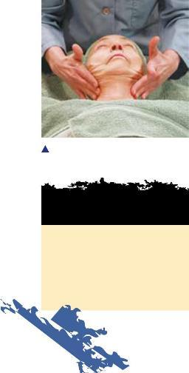
chemical exfoliation | In addition, proper exfoliation speeds up cell turnover and allows for
 | better penetration of treatment creams and serums. Makeup applies
treatments!
 | more evenly on exfoliated skin.

23

© Marek H., 2010; used under license from Shutterstock.com.

Moisturizers

Moisturizers are products that help increase the moisture content of the skin surface. Moisturizers help diminish the appearance of fine lines and wrinkles. They are basically mixtures of humectants (hyoo-MEKK-tents), also known as hydrators or water-binding agents, which are ingredients that attract water and emollients (ee-MAHL-yunts), which are oily or fatty ingredients that prevent moisture from leaving the skin.

Moisturizers for oily skin are most often in lotion form and generally contain smaller amounts of emollient. Oilier skin does not need

as much emollient because oily skin produces more than adequate amounts of protective sebum.

Moisturizers for dry skin are often in the form of a heavier cream, and they contain more emollients, which are needed by alipidic skin.

All moisturizers may have other ingredients that perform additional functions. These ingredients may include soothing agents for sensitive skin, AHAs or peptides for aging skin, or sunscreens.

Sunscreens and Day Protection Products

Shielding the skin from sun exposure is probably the most important habit to benefit the skin. Cumulative sun exposure causes the majority of skin cancers and prematurely ages the skin.

Most sun exposure over a lifetime is from casual sun exposure. Therefore, every client should be instructed to use a daily sunscreen. Look for daily moisturizers that contain broad-spectrum sunscreens, which protect against both UVA and UVB light. A sun protection factor (SPF) rating of 15 or higher is considered to be adequate strength for daily use. SPF measures how long someone can be exposed to the sun without burning. For example, if someone normally burns in an hour, an SPF-2 sunscreen allows the person to stay in the sun two times as long without burning. Sunscreens with higher SPF’s are appropriate for extended outdoor exposure and for sun-sensitive individuals.

Sunscreens are available in lotion, fluid, and cream forms. Lotions are suitable for combination skin, fluids for oily skin, and creams for dry skin.

Night treatments are usually more intensive products designed for use at night to treat specific skin problems. These products are generally heavier than day-use products, and they theoretically contain higher levels of conditioning ingredients.

Serums (SEH-rums) are concentrated products that generally contain higher concentrations of ingredients designed to penetrate the skin and treat various skin conditions (Figure 23–8). They are typically used at home, and they are applied under a moisturizer or sunscreen. Ampoules (am-pyools) are individual doses of serum, sealed in small vials.

Massage creams are lubricants used to make the skin slippery during massage. They often contain oils or petrolatum. If a massage cream is

caution

Over-exfoliation of the skin can result in ultrasensitive and inflamed skin. Never use an exfoliant more often than recommended by the manufacturer. Combining more than one type of exfoliation may lead to irritation. Always carefully advise your client on the proper use of a home care exfoliant, including the need for the use of a daily sunscreen with an SPF of at least 15.
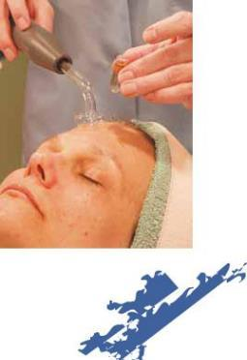

Figure 23–8

Skin treatment in an ampoule.

721 23

(s).

Euire it.

did you know?

A valuable ingredient in moisturizers, particularly in day creams, is sunscreen. Not only does sunscreen guard against premature aging of the skin, but also, when used consistently, it is one of the best ways to help prevent skin cancer.
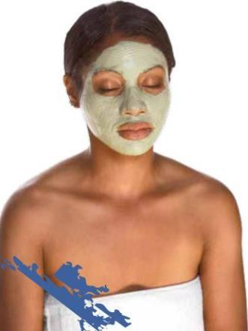

used during a facial treatment, it must be thoroughly removed before any other product can penetrate the skin.

There is a trend toward using treatment products that penetrate the skin during massage. For example, treatment products may be used to increase skin hydration or to soothe redness-prone skin. One of the biggest benefits of massage is that it increases product absorption which, in turn, increases the conditioning effect of treatment products.

Masks

Masks, also known as masques, are concentrated treatment products often composed of mineral clays, moisturizing agents, skin softeners,

aromatherapy oils, botanical extracts and other beneficial ingredients to cleanse, exfoliate, tighten, tone, hydrate, and nourish the skin.

Clay-based masks are oil-absorbing cleansing masks that have an exfoliating effect and an astringent effect on oily and combination skin, making large pores temporarily appear

smaller. They may have additional beneficial ingredients for soothing, or they may include antibacterial ingredients like

sulfur, which is helpful for acne-prone skin.

Cream masks are masks often containing oils and emollients as well as humectants, and they have a strong moisturizing effect. They do not dry on the skin like clay masks do, and they are often used to moisturize dry skin.

Gel masks can be used for sensitive or dehydrated skin, and they do not dry hard. They often contain hydrators and soothing ingredients, thus helping to plump surface cells with moisture, making the skin look more supple and more hydrated.

Alginate (al-gin-ate) masks are often seaweed based. They come in a powder form and are mixed with water or, sometime, serums. After mixing, they are quickly applied to the face. They dry to form a rubberized texture. A treatment cream, which is a specialty product designed to facilitate change in the skin’s appearance, or a serum is generally applied under alginate masks. The alginate mask forms a seal that encourages the skin’s absorption of the serum or treatment cream underneath. Alginate masks are generally used only in the salon.

Paraffin wax masks are specially prepared facial masks containing paraffin and other beneficial ingredients. They are melted at a little

more than body temperature before application. The paraffin quickly cools to a lukewarm temperature and hardens to a candle-like consistency. Paraffin masks are applied over a

treatment cream to allow the cream’s ingredients to penetrate more deeply into the surface layers of the skin. Eye pads and gauze are used in a paraffin mask application because facial hair could stick to the wax if it is not covered, making the mask difficult and painful to remove.

© maryo, 2010; used under license from Shutterstock.com.

© Lev Olkha, 2010; used under license from Shutterstock.com.

23 722

(s).

Euire it.

Modelage (mod-a-LAHJ) masks contain special crystals of gypsum,

- plaster-like ingredient (Figure 23–9). As with paraffin masks, modelage masks are used with a treatment cream. Modelage masks are mixed with cold water immediately before application and applied about ¼-inch thick. After application, the modelage mask hardens. The chemical reaction that occurs when the plaster and the crystals mix with water produces a gradual increase in temperature that reaches approximately 105 degrees Fahrenheit. As the mask is left on the skin, the temperature gradually cools, until it has cooled down completely. The setting time for modelage masks is approximately twenty minutes. Modelage masks sometimes vary in mixing technique or timing. Always follow the manufacturer’s instructions for the product you are using.

Figure 23–9
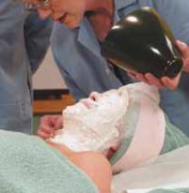
Modelage mask.

The heat generated by a modelage mask increases blood circulation and is very beneficial for dry, mature skin or for skin that looks dull and lifeless. This type of mask is not recommended for use on sensitive skin, skin with capillary problems, oily skin, or skin with blemishes. Modelage masks can become quite heavy on the face and should not be applied to the lower neck. These masks should never be used on clients who suffer from claustrophobia, which is a fear of being closed in or confined.

The Use of Gauze for Mask Application

Gauze is a thin, open-meshed fabric of loosely woven cotton

(Figure 23–10). Masks that have a tendency to run can be applied over a layer of gauze. The gauze holds the mask on the face, while allowing the ingredients to seep through to benefit the skin (Figure 23–11). Cheesecloth is sometimes used as well. In some cases, it is necessary to apply a second layer of gauze over the mask to keep the ingredients from sliding off. Gauze is also used to keep paraffin and gypsum/plaster masks from sticking to the skin and the tiny hairs on the skin.

To prepare gauze, cut a piece large enough to cover the entire face and neck. Cut out spaces for the eyes, nose, and mouth. Although the client could breathe through the gauze, the cut-out spaces will make breathing more comfortable for the client. LO4

Client Consultation

The salon should designate a quiet area for facial treatments. Not only does the relaxing nature of a facial call for a quiet spot, but also the area needs to be quiet enough that you can conduct a thorough consultation with your client. All facial treatments should begin with a consultation.

Record-Keeping

During the consultation, keep the health screening form and the client intake form at hand so that you can write down all necessary

Figure 23–10
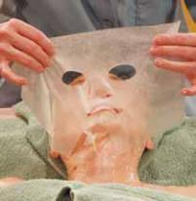
Placing gauze on the client’s face.
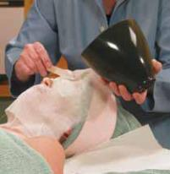

Figure 23–11

Applying a mask over the gauze.

723 23

(s).

Euire it.

Figure 23–12

Client intake form (front).

 | Name
 | Address
 | City
 | Tel. (Home)
 | Contraindications
 | Medical History
 | Current Medication
 | Previous treatments
 | Home Care Products used
Learning. | SKIN TYPE
 | SKIN CONDITION
a part of Cengage | Skin Abnormalities
 | Remarks
© Milady,

information (Figure 23–12). The client intake form should contain the following information:

- Client’s name, home address, and home telephone number

- Client’s occupation

- Client’s date of birth (useful so that you can determine if any signs of aging are premature)

- Client’s medical history and current medications, including whether the client is under the care of a physician or dermatologist

- Contraindications—such as a pacemaker, metal implants, pregnancy, diabetes, epilepsy, allergies, high blood pressure—that call for alternative methods of treatment

- Information as to whether the client has had facials before and, if so, what kind of treatments were performed

- Information on any skin care products the client is currently using

- Notation of how the client was referred to the salon

- Observations on the client’s skin type, skin condition, and any abnormalities of the skin

Fill out the client intake form to record the date and type of service and/or treatment being performed, the products that are being used, and products purchased by the client for home care. Be sure to

INTAKE FORM

 |  |  |  |  |  | Date of Consultation
 |  |  |  |  |  | D.O.B.
State |  |  | Zip
 |  |  |  |  |  | Occupation
(Business) |  |  |  |  |  | Ref. by

Oily Normal Dry (alipidic) Combination

Clogged pores Sensitive Dehydrated Mature

23 724

(s).

Euire it.

FACIAL RECORD

Date | Type of treatment |  | By | Products purchased
2/14 | Cleansing, Peel- Relaxing Massage |  | Mary | Moisturizer with sunscreen
3/16 | Cleansing, Peel | Modelage Mask | Mary | Cleanser, Toner
4/5 | Cleansing, Peel | High Frequency indirect | Mary | Moisturizer, Foundation #7
4/26 | Cleansing, Peel | Massage Alginate Mask | John
5/13 | Cleansing, Peel | Iontophoresis Paraffin Mask | Mary | Night cream for dry skin
 | Skin is showing marked improvement. |  |  | Lipstick #43
6/1 | Cleansing, Peel | Relaxing Massage | Mary | Eye contour mask

note specific products the client purchases so that you can help her repurchase if she forgets product names (Figure 23–13).

As part of the consultation, do not hesitate to recommend services and products that will be beneficial to the client (Figure 23–14). Since the client has taken the initiative to come into the salon, they will feel disappointed if you neglect to recommend salon treatments and products, as well as proper home-care products for the skin. Also, if you do not recommend professional products, your client may go elsewhere for advice, such as a department store or drugstore. She might not get the kind of product you would have advised, and you and the salon will not get the retail income.

Make it clear to your client that if they wish to achieve the best results from a treatment, they must follow a proven routine of skin care at home with products that reinforce the salon treatments. Be careful, however, not to make the client feel that the sole purpose of the consultation is to sell products. Review appropriate and discreet retailing techniques with your instructor to make sure you achieve the right tone with your client.

Classification of Skin Types

Figure 23–13

Client intake form (back).
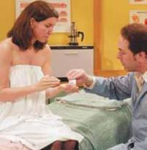

Figure 23–14

Recommend skin care products to the client.

During the first consultation and before every subsequent facial treatment, it is important to perform a thorough analysis of the client’s skin. This analysis should take place prior to cleansing. If the skin is oily, it will often look shiny or greasy. If the skin is dry, it may look flaky. Table 23–2 lists brief descriptions of basic skin types. LO5

Facial Massage

Massage is the manual or mechanical manipulation of the body by rubbing, gently pinching, kneading, tapping, and other movements to increase metabolism and circulation, to promote absorption, and to relieve pain. Cosmetologists massage their clients to help keep the facial skin healthy and the facial muscles firm.

725 23

(s).

Euire it.

Building Your Client Base

To master massage techniques, you must have a basic knowledge of anatomy and physiology, as well as considerable practice in performing the various movements. It is important that you use a firm, sure touch when giving a massage. To do this, you must develop flexible hands, a quiet temperament, and self-control.

Send your clients a birthday card. This form of advertisement is not expensive, and it is always greatly appreciated. Ask for your clients’ e-mail addresses for this purpose and for other kinds of communications. E-mail is now the preferred mode of communication for many people. In fact, many clients now prefer to book appointments using e-mail.
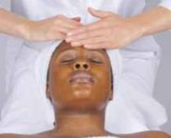

Keep your hands soft by using creams, oils, and lotions. File and shape your nails to avoid scratching your client’s skin. Your wrists and fingers should be flexible, and your palms should be firm and warm. Cream or oil should be applied to your hands to permit smoother and gentler hand movements and to prevent drag or damage to the client’s skin.

Basic Massage Manipulations

All massage treatments combine one or more basic movements or manipulations. Each manipulation is applied to the superficial muscles in a certain way to achieve a certain end. The impact of a massage treatment depends on the amount of pressure, the direction of movement, and the duration of each type of manipulation involved.

The direction of movement is always from the insertion of the muscle toward its origin. The insertion is the portion of the muscle at the more movable attachment (where it is attached to another muscle or to a movable bone or joint). The origin is the portion of the muscle at the fixed attachment (to an immovable section of the skeleton). Massaging a muscle in the wrong direction could result in a loss of resiliency and sagging of the skin and muscles.

Effleurage

© Milady, a part of Cengage

 |  |  |  | Effleurage (EF-loo-rahzh) is a light, continuous stroking
 |  |  |  | movement applied in a slow, rhythmic manner with the fingers
 |  |  |  | (digital effleurage) or the palms (palmar effleurage). No pressure
 |  |  |  | is used. The palms work the large surfaces, and the cushions of the
Figure 23–15 |  |  |  | fingertips work the small surfaces, such as those around the eyes
Digital effleurage on the forehead. |  |  |  | (Figure 23–15). Effleurage is frequently used on the forehead, face,
 |  |  |  | scalp, back, shoulder, neck, chest, arms, and hands for its soothing
 |  |  |  |  | and relaxing effects. Every massage should
 |  |  | As a cosmetologist, your services are limited to |  | begin and end with effleurage.
 |  |  |  |  | When performing effleurage, hold your whole
 |  |  | certain areas of the body: the scalp, face, neck,
 |  |  | and shoulders; the upper chest; the hands and |  | hand loosely, and keep your wrist and fingers
 |  |  | arms; and the feet and lower legs. Therapeutic |  | flexible. Curve your fingers slightly to conform
 |  |  | massage—including deep muscle massage, |  | to the shape of the area being massaged, with just
 |  |  | deep tissue massage, and lymph drainage— |  | the cushions of the fingertips touching the skin.
 |  |  | should only be performed by therapists |  | Do not use the ends of the fingertips. They are
 |  |  | specialized in working on various kinds of |  | pointier than the cushions, and will cause the
tissues. Therapeutic massage requires special training |  |  |  |  | effleurage to be less smooth. Also, the free edges
and, in many cases, licensure. |  |  |  |  | of your fingernails may scratch the client’s skin.

23 726

(s).

Euire it.

© Milady, a part of Cengage Learning. Photography by Yanik Chauvin.

Pétrissage

Pétrissage (PEH-treh-sahj) is a kneading movement performed by lifting, squeezing, and pressing the tissue with a light, firm pressure. Pétrissage offers deeper stimulation to the muscles, nerves, and skin glands, and improves circulation. These kneading movements are usually limited to the back, shoulders, and arms.

Although typically used on larger surface areas such as the arms and shoulders, digital kneading can also be used on the cheeks with light pinching movements (Figure 23–16). The pressure should be light but firm. When grasping and releasing the fleshy parts, the movements must be rhythmic and never jerky.

Fulling is a form of pétrissage in which the tissue is grasped, gently lifted, and spread out; this technique is used mainly for massaging the arms. With the fingers of both hands grasping the arm, apply a kneading movement across the flesh, with light pressure on the underside of the client’s forearm and between the shoulder and elbow.

Friction

Friction (FRIK-shun) is a deep rubbing movement in which you apply pressure on the skin with your fingers or palm while moving it over an underlying structure. Friction has been known to have a significant benefit on the circulation and glandular activity of the skin. Circular friction movements are typically used on the scalp, arms, and hands. Light circular friction is used on the face and neck (Figure 23–17).

Chucking, rolling, and wringing are variations of friction and are used mainly to massage the arms and legs, as follows:

- Chucking is grasping the flesh firmly in one hand and moving the hand up and down along the bone while the other hand keeps the arm or leg in a steady position.

- Rolling is pressing and twisting the tissues with a fast back-and-forth movement.

- Wringing is a vigorous movement in which the hands, placed a little distance apart on both sides of the client’s arm or leg and working downward, apply a twisting motion against the bones in the opposite direction.

Tapotement

Tapotement (tah-POH-te-ment), also known as percussion (pur-KUSH-un), consists of short quick tapping, slapping, and hacking movements. This form of massage is the most stimulating and should be applied with care and discretion. Tapotement movements tone the muscles and impart a healthy glow to the area being massaged.

Figure 23–16
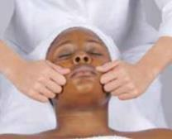
Pétrissage.
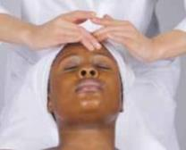

Figure 23–17

Friction.

727 23

(s).

Euire it.

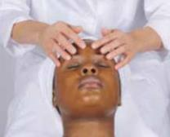

Figure 23–18

Tapotement.

In facial massage, use only light digital tapping. Bring the fingertips down against the skin in rapid succession. Your fingers must be flexible enough to create an even force over the area being massaged (Figure 23–18).

In slapping movements, keeping your wrists flexible allows your palms to come in contact with the skin in light, firm, and rapid slapping movements. One hand follows the other. With each slapping stroke, lift the flesh slightly.

Hacking is a chopping movement performed with the edges of

the hands. Both the wrists and hands move alternately in fast, light, firm, and flexible motions against the skin. Hacking and slapping movements are used only to massage the back, shoulders, and arms.

Vibration

Figure 23–19
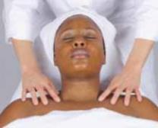
Vibration on the top of the shoulders.

Vibration (vy- BRAY- shun) is a rapid shaking of the body part while the balls of the fingertips are pressed firmly on the point of application. The movement is accomplished by rapid muscular contractions in your arms. It is a highly relaxing movement, and should be applied at the end of the massage (Figure 23–19). Deep vibration in combination with other classical massage movements can also be produced by the use of a mechanical vibrator to stimulate blood circulation and increase muscle tone.

Physiological Effects of Massage

To obtain proper results from a scalp or facial massage, you must have a thorough knowledge of the structures involved, including

Before performing a service that includes a facial massage, consult the client’s intake or health screening form. During the consultation acknowledge and discuss any medical condition that may contraindicate a facial massage. Ask the client if he or she has

discussed massage with a physician. If the client has not already sought a physician’s advice as to whether or not a facial massage is advisable, encourage him or her to do so before you perform the service.

Many clients who have high blood pressure (hypertension), diabetes, or circulatory conditions may still have facial massage without concern, especially if their condition is being treated and carefully looked after by a physician. Facial massage is, however,

contraindicated for clients with severe, uncontrolled hypertension. Also, clients with acne should not be massaged in any area that has breakouts.

If your client expresses a concern about having a facial massage and has a medical condition, advise him or her to speak with a physician before having the service.

If your client has sensitive or redness-prone skin, avoid using vigorous or strong massage techniques.

Do not talk to your client during the massage except to ask once whether your touch should be more or less firm. Talking eliminates the relaxation therapy of the massage.

When making decisions about whether to perform a facial massage on a person who has a medical condition, be conservative. When in doubt, don’t include massage as part of your service.

23 728

(s).

Euire it.

muscles, nerves, connective tissues, and blood vessels. Every muscle has a motor point, which is a point on the skin that covers the muscle where pressure or stimulation will cause contraction of that muscle. Some examples are illustrated in Figures 23–20 and 23–21. In order to obtain the maximum benefits from a facial massage, you must consider the motor points that affect the underlying muscles of the face and neck. The location of motor points varies among individuals due to differences in body structure. However,
a few manipulations on the proper motor points will relax the client early in the massage treatment.

Relaxation is achieved through light but firm, slow, rhythmic movements, or very slow, light hand vibrations over the motor points for a short time. Another technique is to pause briefly over the motor points, using light pressure.

Skillfully applied massage directly or indirectly influences the structures and functions of the body. The immediate effects of massage are first noticed on the skin. The area being massaged shows increased circulation, secretion, nutrition, and excretion. The following benefits may be obtained by proper facial and scalp massage:

- Skin and all structures are nourished

- Skin becomes softer and more pliable

- Circulation of blood is increased

- Activity of skin glands is stimulated

- Muscle fibers are stimulated and strengthened

- Nerves are soothed and rested

- Pain is sometimes relieved

The recommended frequency of facial or scalp massage depends on the condition of the skin or scalp, the age of the client, and the condition being treated. As a general rule, normal skin or scalp can be kept in excellent condition with the help of a weekly massage, accompanied by proper home care.

Facial nerve
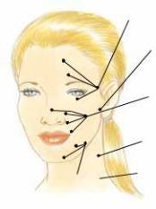
(temporal branch)

Facial nerve

(main trunk)

Facial nerve

(buccal branch)

Cervical nerve

Brachial Plexus
^{Facial nerve} (Erb’s point)
(mandibular branch)

Figure 23–20

Motor nerve points of the face.
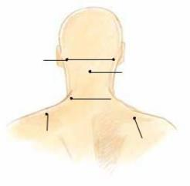

Posterior
auricular | Occipitalis
nerve
 | nerve
 | Cervical nerve
Trapezius | Plexus nerve
nerve

Figure 23–21

Motor nerve points of the neck.

Facial Manipulations

Because an overview of basic massage/manipulation techniques and guidelines is now complete, the best manipulations to use on the face can be discussed in more depth. When performing facial manipulations, keep in mind that an even tempo, or rhythm, is relaxing. Do not remove your hands from the client’s face once you have started the manipulations.

Should it become necessary to remove your hands, feather them off, and then gently replace them with feather-like movements. Remember that massage movements are generally directed from the muscle’s insertion toward its origin, in order to avoid damage to muscle tissues.

729 23

(s).

Euire it.

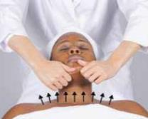

Figure 23–22

Chin movement.
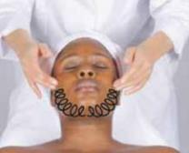

Figure 23–23

Circular movement of lower cheeks.
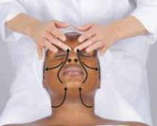

Figure 23–24

Mouth, nose, and cheek movements.
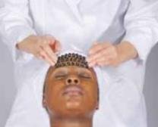

Figure 23–26
Circular movement over forehead.

The following photographs show the different movements that may be used on the various parts of the face, chest, and back. Each instructor may have developed her own routine, however. For example, some instructors and practitioners prefer to start massage manipulations at the chin, while others prefer to start at the forehead. Both are correct. Be guided by your instructor.

Chin movement. Lift the chin, using a slight pressure (Figure 23–22).

Lower cheeks. Using a circular movement, rotate from chin to ears (Figure 23–23).

Mouth, nose, and cheek movements. Follow the diagram (Figure 23–24).

Linear movement over the forehead. Slide fingers to the temples and then stroke up to hairline, gradually moving your hands across the forehead to the right eyebrow (Figures 23–25a and b).

Circular movement over the forehead. Starting at the eyebrow line, work across the middle of the forehead and then toward the hairline (Figure 23–26).

Crisscross movement. Start at one side of forehead and work back (Figure 23–27).
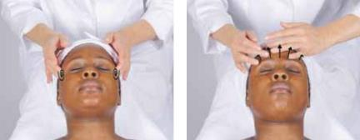

Figure 23–25a and b

Light circular movement over the temples continuing with linear movement over forehead.
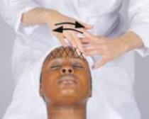

Figure 23–27

Crisscross movement.

23 730

(s).

Euire it.

Stroking (headache) movement. Slide your fingers toward the center of the forehead and then draw your fingers, with slight pressure, toward the temples and rotate (Figure 23–28).

Brow and eye movement. Place your middle fingers at the inner corners of the eyes and your index fingers over the brows. Slide them toward the outer corners of the eyes, under the eyes, and then back to the inner corners (Figure 23–29).

Nose and upper cheek movement. Slide your fingers down the nose. Apply a rotary movement across the cheeks to the temples and rotate gently. Slide your fingers under the eyes and then back to the bridge of the nose (Figure 23–30).

Mouth and nose movement. Apply a circular movement from the corners of the mouth up to the sides of the nose. Slide your fingers over the brows and then down to the corners of the mouth up to the sides of nose. Follow by sliding your fingers over the brows and down to the corners of the mouth again (Figure 23–31).

Lip and chin movement. From the center of the upper lip, draw your fingers around the mouth, going under the lower lip and chin (Figure 23–32).

Optional movement. Hold the head with your left hand, and draw the fingers of your right hand from under the lower lip and around mouth, moving to the center of the upper lip (Figure 23–33).
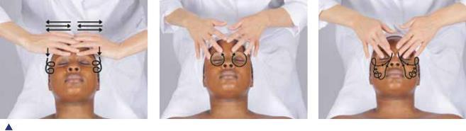

Figure 23–28 | Figure 23–29
Stroking (headache) movement. | Brow and eye movement.
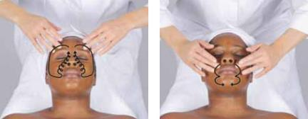

Figure 23–31 Figure 23–32

Mouth and nose movement. Lip and chin movement.

Figure 23–30

Nose and upper cheek movement.
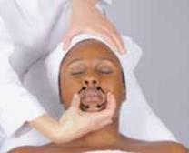

Figure 23–33

Optional movement.

23

(s).

Euire it.

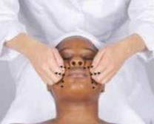

Figure 23–34

Lifting movement of cheeks.
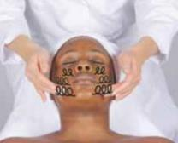

Figure 23–35

Rotary movement of cheeks.

Lifting movement of the cheeks. Proceed from the mouth to the ears, and then from the nose to the top part of the ears (Figure 23–34).

Rotary movement of the cheeks. Massage from the chin to the ear lobes, from the mouth to the middle of the ears, and from the nose to the top of the ears (Figure 23–35).

Light tapping movement. Work from the chin to the earlobe, from the mouth to the ear, from the nose to the top of the ear, and then across the forehead. Repeat on the other side (Figure 23–36).

Stroking movement of the neck. Apply light upward strokes over the front of the neck. Use heavier pressure on the sides of neck in downward strokes (Figure 23–37).

Circular movement over the neck and chest. Starting at the back of the ears, apply a circular movement down the side of the neck, over the shoulders, and across the chest (Figure 23–38).

Massaging male skin is not all that different from massaging female skin. However, it needs more attention in the areas of the face where there is hair growth. For your male clients, use downward movements in the beard area. Massaging against hair growth causes great discomfort. Pressure-point massage in the beard area is much appreciated by male clients.

Chest, Back, and Neck Manipulations (Optional)

State

R e g u l a t o r y

Check with your state regulatory agency before massaging the chest and back. Many state regulatory agencies limit a cosmetologists scope of practice to the face, neck, arms, legs, and shoulders.
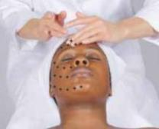

Some instructors prefer to treat these areas first before starting the regular facial. Apply cleanser, and remove it with a tissue or a warm, moist towel. Then apply massage cream and perform the following manipulations:

Chest and back movement. Use a rotary movement across the upper chest and shoulders. Then slide your fingers to the base of the neck and rotate three times.

Shoulders and back movement. Rotate the shoulders three times. Glide your fingers to the spine and then to the base of
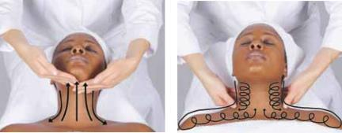

Figure 23–36 | Figure 23–37 | Figure 23–38
Light tapping movement. | Stroking movement of neck. | Circular movement over neck and chest.

23 732

© Milady, a part of Cengage Learning. Photography by Yanik Chauvin.

(s).

Euire it.

the neck. Apply circular movement up to the back of the ear, and then slide your fingers to the front of the earlobe. Rotate three times.

Back massage. To stimulate and relax the client, use your thumbs and bent index fingers to grasp the tissue at the back of the neck. Rotate six times. Repeat over the shoulders. Remove cream with tissues or a warm, moist towel. Dust the back lightly with talcum powder and smooth.
LO6

Facial Equipment

There are many types of facial equipment that can enhance your abilities to perform an outstanding facial treatment. These machines help to increase the efficacy of your products, increase product penetration, and provide for a more complete and relaxing treatment.

We have already mentioned magnifying lamps, which are necessary for both analysis of the skin and procedures such as extraction of comedones and tweezing of excess facial hair.

A facial steamer heats and produces a stream of warm steam that can be focused on the client’s face or other areas of skin. Steaming the skin helps to soften the tissues, making it more accepting of moisturizers and other treatment products. Steam also helps to relax and soften follicle accumulations such as comedones and clogged follicles, making them easier to extract (Figure 23–39).

Most steamers work by having a heating coil that boils water. The steam from the boiling water flows through a pipe that can be focused on the area to be treated, normally the face. Only distilled water should be used in most steamers to avoid mineral buildup in the machine. Steam is usually administered at the beginning of the facial treatment. Most clients enjoy steam, but precautions should be taken with clients who have asthma or other breathing disorders.

It is strongly recommended that a professional steamer be used, but if one is not available, a warm steamed towel may be gently wrapped around the face, leaving the nose exposed so the client can breathe comfortably. The towel should be comfortably warm, but not hot. Do not use steamed towels on clients who have sensitive skin, redness-prone skin, rosacea, or claustrophobia.

A brushing machine is a rotating electric appliance with interchangeable brushes that can be attached to the rotating head. Brushes of various sizes as well as textures are common. Larger and stiffer brushes are used for back treatment, and smaller and softer brushes are used for the face.

Brushing is a form of mechanical exfoliation, and it is usually administered after or during steam. A fairly thick layer of cleanser or moisturizer should be applied to the face before using the brushing machine.

caution

Information regarding facial equipment in this chapter is intended as an overview. You should receive hands-on experience from your instructor before using any facial equipment! Machine models differ; as a result, precautions vary as well. Consult with your instructor and the specific machine manual for safe operation. In some states, use of certain equipment may not be permissible for cosmetologists. Again, check with your instructor to find out what is allowed in your state.
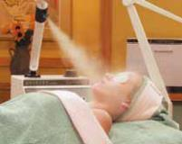

by Larry Hamill. © Milady, a part of Cengage Learning. Photography

Figure 23–39

Facial steamer being used

during a facial treatment.

733 23

(s).

Euire it.

This applied product provides a buffer for the brushes so that they do not scratch the face, which they might do if the face were completely dry.

Brushing helps remove dead cells from the skin surface, making the skin look smoother and more even in coloration. It also helps to stimulate blood circulation.

Brushing should never be used on clients using keratolytic drugs such as Retin-A®, Differin®, Tazorac®, or other drugs that thin or exfoliate the skin. Clients who have rosacea, sensitive skin, pustular acne, or other forms of skin inflammation or reddening should not have brushing administered. Never use a brushing machine at the same time as another exfoliation technique, such as an AHA treatment or microdermabrasion.

Brushes must be thoroughly cleaned and disinfected between clients.

The skin suction and cold spray machine is used to increase circulation, and to jet-spray lotions and toners onto the skin. Skin suction should only be used on nonsensitive and noninflamed skin.

Spray can be used on almost any skin type. Spray is often used to
hydrate the skin and to help clean off mask treatments. |  | LO7

 | Electrotherapy
 | and Light Therapy
 | Galvanic and high-frequency treatment are types of electrotherapy
 | (ee-LECK-tro-ther-ah-pee), which is the use of electrical currents to
 | treat the skin.
 | There are several contraindications for electrotherapy. Electrotherapy
 | should never be administered on heart patients, clients with pacemakers,
 | clients with metal implants, pregnant clients, clients with epilepsy or
 | seizure disorders, clients who are afraid of electric current, or clients
Figure 23–40 | with open or broken skin. Furthermore, if you ever have any doubts
Various electrodes. | about whether the client can have electrotherapy safely, request that
 | the client get approval from her physician before receiving this therapy.
 | An electrode is an applicator for directing the electric current from the
 | machine to the client’s skin (Figure 23–40). High-frequency machines
 | have only one electrode. Galvanic machines have two positive electrodes
 | called an anode (AN-ohd), which has a red plug and cord, and a
 | negative electrode called a cathode (KATH-ohd), which has a black
 | plug and cord (Figure 23–41).
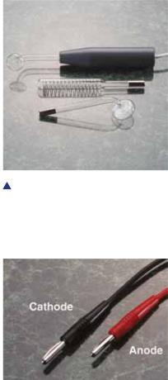

Galvanic current accomplishes two basic tasks. Desincrustation (des-in-cruh-STAY-shun) is the process of softening and emulsifying hardened sebum stuck in the hair follicles. Desincrustation is very helpful when treating oily areas with multiple comedones and most
Figure 23–41
_{Cathode and anode.} acne -prone skin. Desincrustation products are alkaline fluids or gels that act as solvents for the solidified sebum. These products make

23 734

(s).

Euire it.

Figure 23–42 Five-in-one machine, including galvanic electrodes.

extraction of the impactions and comedones much easier. When the negative pole is applied to the face over a desincrustation product, the current forces the product deeper into the follicle. The current also produces a chemical reaction that helps to loosen the impacted sebum (Figure 23–42).
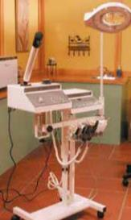

Both electrodes are wrapped in wet cotton. The active electrode is the one that should be applied to the skin. The active electrode—in the case of desincrustation, the negative electrode—is applied to the oily areas of the face for three to five minutes. The positive electrode (in this case, the inactive electrode) is held by
the client in her right hand or attached to a pad that is placed in contact with the client’s right shoulder (Figure 23–43). After the desincrustation process has taken place, sebum deposits can easily be extracted with gentle pressure.

Iontophoresis (eye- ahn-toh-foh-REE-sus) is the process of using galvanic current to enable water-soluble products that contain ions to penetrate the skin. Products suitable for iontophoresis will be labeled as such by manufacturers. When the negative current is applied to the face, products with negative ions are able to penetrate the skin, and when the positive current is applied to the face, products with positive ions are able to penetrate the skin. Many ampoules and serums are prepared for iontophoresis.

Again, you must receive thorough hands-on instruction from your teacher before attempting this procedure.

Microcurrent

Microcurrent (MY-kroh-KUR-ent) is a type of galvanic treatment using a very low level of electrical current; it has many applications in skin care and is best known for helping to tone the skin, producing a lifting effect for aging skin that lacks elasticity.

High-Frequency Current

High-frequency current, discovered by Nikolas Tesla, can be used to stimulate blood flow and help products penetrate. It works by warming tissues, which allows better absorption of moisturizers and other treatment products. High-frequency current can also be applied after extraction or during treatments for acne-prone skin because it has a germicidal effect.

© Milady, a part of Cengage Learning. Photography by Larry Hamill. | © Milady, a part of Cengage Learning. Photography by Yanik Chauvin.
 | Figure 23–43
 | Client holding passive electrode.
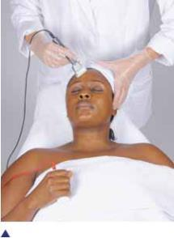

caution

Do not use the galvanic current on clients who have: • metal implants, a

pacemaker, or any heart condition.
• epilepsy.

• pregnancy.

• high blood pressure, fever, or any infection.
• insufficient nerve sensibility.

• open or broken skin

(wounds, new scars), including pustular acne.

• fear of electrical current.

735 23

(s).

Euire it.

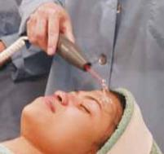

Figure 23–44

Direct application of high frequency.

caution

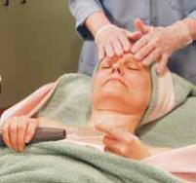

Figure 23–45

Indirect appplication of high frequency.

Electrodes for the high-frequency machine are made of glass and contain various types of gas, such as neon, which light up as a color when current is flowing through the electrode. Unlike the galvanic machine, high-frequency treatments require the use of only one electrode. There are several different types of electrodes used with high frequency. The most common is shaped like a mushroom, and it is referred

to as a mushroom electrode (Figure 23–44).

Place the passive electrode on the right side of the client’s body only (never on the left side) to avoid current flow through the heart.
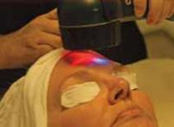

Courtesy of Revitalight.

Figure 23–46 Light therapy using a LED machine.

caution

The contraindications for galvanic current also apply to both indirect and direct high-frequency current. Furthermore, in order to prevent burns during the treatment, the client should avoid any contact with metal— such as chair arms, stools, jewelry, and metal bobby pins.

High frequency can be applied directly to the skin in a technique known as direct application. Another application method, known as indirect massage or Viennese massage, involves the client holding the electrode during treatment, creating an electrical stimulating massage (Figure 23–45).

High frequency is applied to the skin as part of the treatment phase of the facial treatment. Again, because machines vary, you should check with your instructor and the manufacturer’s manual for instructions for the specific machine you are using.

Light Therapy

Using light exposure to treat conditions of the skin is known as light therapy. There are several different types of light therapy utilizing various types of light. Traditionally, infrared lamps have been used to heat the skin and increase blood flow. Infrared lights have also been used for hair and scalp treatments.

One type of light therapy is called light-emitting diode (LED) treatment (Figure 23–46). This treatment uses concentrated light that flashes very rapidly. LEDs were originally developed to help with wound healing. In cosmetology, LED machines are used cosmetically to minimize redness, warm lower-level tissues, stimulate blood flow, and improve skin smoothness. They are applied to improve acne -prone skin. The type and color of the light varies according to treatment objective. Red lights are used to treat aging and redness, and blue light is used for acne-prone skin.

LEDs are a very safe treatment for most clients, but their use should be avoided on clients who have seizure disorders. Flashing lights have been known to trigger seizures in persons with seizure disorders. Any clients with questionable health conditions should receive written approval from a physician before having an LED treatment.

23 736

(s).
it.

Microdermabrasion

Microdermabrasion (MY-kroh-dur-muh-BRAY-zhun) is a type of mechanical exfoliation that involves shooting aluminum oxide or other crystals at the skin with a hand-held device that exfoliates dead cells. Microdermabrasion uses a closed vacuum to shoot crystals onto the skin, bumping off cell buildup that is then vacuumed up by suction. Microdermabrasion is a popular treatment because it produces fast, visible results. It is used primarily to treat surface wrinkles and aging skin. Performance of safe and effective microdermabrasion treatments requires extensive training. LO8

Facial Treatments

A professional facial is one of the most enjoyable and relaxing services available to the salon client. Clients who have experienced this very restful, yet stimulating experience do not hesitate to return for more. When clients receive them on a regular basis, the client’s skin tone, texture, and appearance are noticeably improved.

caution

The client’s eyes always should be protected during any light ray treatment. Use cotton pads saturated with alcohol-free freshener or distilled water. The eye pads protect the eyes from the glare of the reflecting rays.

Facial treatments fall into one of the following categories:

• Preservative. Maintains the health of the facial skin by cleansing correctly, increasing circulation, relaxing the nerves, and activating the skin glands and metabolism through massage.

• Corrective. Correct certain facial skin conditions, such as dryness, oiliness, comedones, aging lines,
and minor conditions of acne.

State

R e g u l a t o r y

Always check with your state regulatory agency to determine which electrical machines are approved for use in your state.

As with other forms of massage, facial treatments help to increase circulation, activate glandular activity, relax the nerves, maintain muscle tone, and strengthen weak muscle tissues.

Guidelines for Facial Treatments

Your facial treatments are bound to be successful and to inspire return visits if you follow the simple guidelines summarized below:

- Help the client to relax by speaking in a quiet and professional manner.

- Explain the benefits of the products and service, and answer any questions the client may have.

- Provide a quiet atmosphere, and work quietly and efficiently.

- Maintain neat, clean conditions in the facial work area, with an orderly arrangement of supplies.

- Follow systematic procedures.

- If your hands are cold, warm them before touching the client’s face.

23

- Keep your nails smooth and short to prevent scratching the client’s skin.

Another guideline you must always follow is to perform an analysis of your client’s skin. After the client is draped and lying on the facial table (also called a facial bed), you should inspect the skin to determine the following:

To safely and effectively perform advanced skin care treatments—such as microcurrent, microdermabrasion, and LED light— cosmetologists require advanced, specialized training.

- Is the skin dry, normal, or oily?

- Are there fine lines or creases?

- Are comedones or acne present?

- Are dilated capillaries visible?

- Is skin texture smooth or rough?

- Is skin color even?

The results of your analysis will determine the products to use for the treatment, what areas of the face need special attention, how much pressure to use when massaging, and what equipment should be used.

Basic Facial Application

The steps for performing a basic facial are listed in Procedure 23–1.

Some procedures may vary, however, so be guided by your instructor.

The procedure lists the basic implements and materials you will need to perform the basic facial, but you can add other items, such an alternative head covering, if you wish. There are several types of head coverings on the market. Some are a turban design; others are designed with elastic, like a shower cap. They are generally made

of either cloth or paper towels. For the paper towel procedure, be guided by your instructor.

Procedure Basic
23-1 Facial See page 741

Special Problems

There are a number of special problems that must

be considered when you are performing a

facial. These include dry skin, oily

skin and blackheads, and acne.

Dry skin is caused by an insufficient flow of sebum (oil) from the sebaceous glands. The facial for dry skin helps correct this condition. Although it can

23 738

(s).

Euire it.

be given with or without an electrical current, the use of electrical current provides better results.
Procedure _{Facial For}
23-2 Dry Skin See page 746

Oily skin is often characterized by comedones, which are caused by hardened masses of sebum formed in the ducts of the sebaceous glands.

Procedure | Facial for Oily Skin
23-3 | with Open Comedones See page 748
Special Notes for Acne-Prone Skin

Minor problem skin and oily skin should respond well to facial treatments. Unresponsive or severe cases of acne need medical treatment, and clients with such conditions should be referred to a dermatologist.

If a client is under medical care, the role of the cosmetologist is to work under the advisement of the client’s physician, following the physician’s instructions for the type and frequency of facial treatments. Cosmetologists can help these clients with extraction treatments, assist them in choosing proper home-care products and makeup, and help them to understand how to coordinate medications with a home skin care program.

There are numerous topical prescription medications that can make the skin more sensitive and more reactive to skin care products. Always check with the client’s dermatologist if you are performing treatments to clients who are under dermatological care.

Because skin with acne contains infectious matter, you must wear protective gloves and use disposable materials such as cotton cleansing pads when working with clients who have acne.

Procedure | Facial for Acne-Prone
23-4 | and Problem Skin | See page 751
Consultation and Home Care

Home care is probably the most important factor in a successful skin care program. The key word here is program. Clients’ participation is essential to achieve results. A program consists of a long-range plan involving home care, salon treatments, and client education.

Every new client should receive a thorough consultation regarding proper home care for his or her skin conditions.

F

Sharpening Your Personal Skills

If a client seems dissatisfied with a facial treatment, check to see if you have been guilty of any of the following:

• Offensive breath or body odor • Rough, cold hands or ragged nails that may have scratched

the client’s skin

• Allowing cream or other substances to get into the client’s eyes, mouth, nostrils, or hairline

• Towels that were too hot or too cold
• Talking too much

• Manipulating the skin roughly or in the wrong direction

• Being disorganized and interrupting the facial to get supplies

739 23

(s).

Euire it.

caution

Aromatherapy is sometimes used as a healing modality by natural healers who have received extensive training in the properties and uses of essential oils and their aromatherapy benefits. Cosmetologists should never attempt to perform healing treatments with aromatherapy.

After the first treatment, block out about thirty minutes to explain proper home care for the client.

After the treatment is finished, have the client sit up in the facial chair, or invite the client to move to a well-lighted consultation area. A mirror should be provided for the client, so that he or she can see conditions you will be discussing.

Explain, in simple terms, the client’s skin conditions, informing the client of how you propose to treat the conditions. Inform the client about how often treatments should be administered in the salon, and very specifically explain what the client should be doing at home.

You should organize the products you want the client to purchase and use. Explain the use of each one at a time, in the order of use. Make sure to have written instructions for the client to take home.

It is very important to provide clients with products that you believe in and that produce results. Retailing products for clients to use at home is very important for success in the treatment of skin conditions and success in your business.

Aromatherapy

The use of essential oils such as lemon verbena, lavender, and rose is a frequent practice in facial skin care. Many essential oils are also used for aromatherapy, the therapeutic use of plant aromas for beauty and health treatment. Aromatherapy is thought to benefit and enhance a person’s physical, emotional, mental, and spiritual well-being. Using various oils and oil blends for specific benefits is believed to create positive effects on the body, mind, and spirit (Figure 23–47).

Anna, 2010; used under license from Shutterstock.com.

Courtesy of Michael Dzaman.
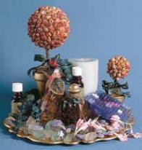

Figure 23–47

Some ingredients for aromatherapy.

Essential oils can be used in a variety of ways. Lighting a cinnamon candle in the winter can give the salon a cozy feeling and cheer up both clients and service providers. You can use a spray bottle to diffuse well-diluted essential oils in the treatment room or on the sheets. You can create your own aromatherapy massage oil by adding a few drops of essential oil to a massage oil, cream, or lotion. Always be careful to use essential oils lightly because they can sometimes be overpowering.

© Subbotina

23 740

(s).

Euire it.

© Milady, a part of Cengage Learning. Photography by Rob Werfel.

23Procedure-1 Implements Basic Facial and Materials
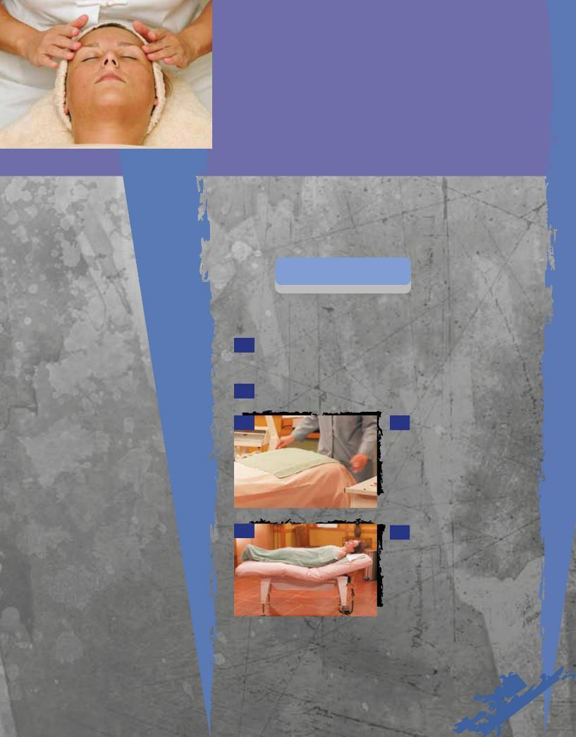

© Milady, a part of Cengage Learning. Photography by Larry Hamill. © Milady, a part of Cengage Learning. Photography by Larry Hamill.

You will need all of the following implements, materials, and supplies:

• Antiseptic lotion

• Clean sheet or other covering (blanket if necessary)
- Cleansers and makeup removers

- Cotton (roll)

- Cotton pads

- Cotton swabs and pledgets

- Facial steamer (optional)

• Facial table or chair

• Gauze

• Headband or head covering

- Magnifying lamp

- Masks

• Massage cream or

lubricating oil

• Moisturizers

- Bobby pins/safety pins

- Facial gown

- Spatulas

- Sponges

• Sun-protection products

- Tissues

- Toner

• Tonic lotions

• Towels

- Trash can

- Trolley for products and implements

Optional Items:

• Infrared lamp

- Other electrical equipment

- Specialty or intensive care products

Preparation
Procedure | Pre-Service
• Perform 22-1 | Procedure | See page 696

Procedure

- Ask the client to remove any jewelry such as a necklace or earrings. Store the client’s jewelry in a safe place. Clients may wish to keep their handbags nearby during the facial.

- Show the client to the dressing room and offer assistance if needed.

3 3 Place a clean towel

across the back of the facial table to prevent the client’s bare shoulders from coming into contact with the bed.

4 4 If necessary, help your

client get onto the facial bed. Place a towel across the client’s chest, and place a coverlet or sheet over the client’s body, folding the top edge of the towel over it. Remove the client’s shoes, and tuck the coverlet around her feet. Some salons provide disposable slippers that can be worn to and from the dressing room.

741 23

(s).

Euire it.

Procedure

23-1Basic Facial

continued
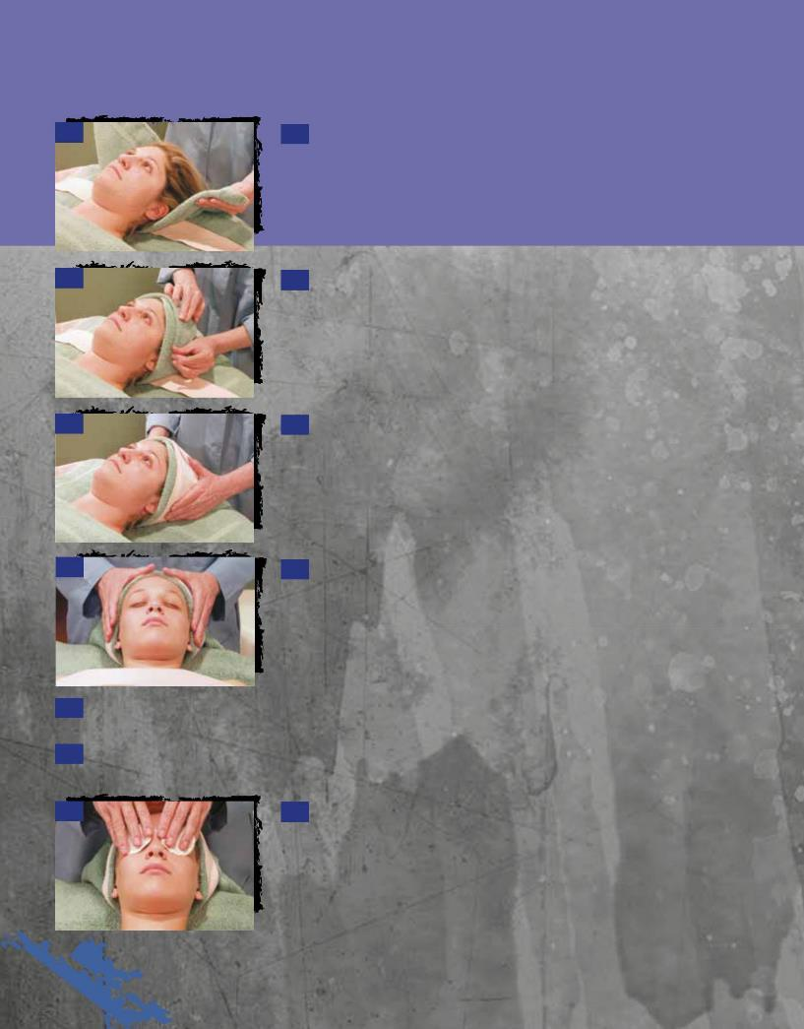

5 5 Fasten a headband lined with tissue, a towel, or other head covering around the client’s head to protect their hair. To drape the head with a towel, follow these steps:

5a

5b

5c

5a Fold the towel diagonally from one of the top corners to the opposite lower corner, and place it over the headrest with the fold facing down. Place the towel on the headrest before the client enters the facial area.

5b When the client is in a reclined position, the back of the head should rest on the towel so that the sides of the towel can be brought up to the center of the forehead to cover the hairline.

5c Use a headband with a Velcro closure or a pin to hold the towel in place. Make sure that all strands of hair are tucked under the towel, that the earlobes are not bent, and that the towel is not wrapped too tightly.

- Remove lingerie straps from a female client’s shoulders. Alternative method: If client is given a strapless gown to wear, tuck the straps into the top of the gown.

- If your client wears makeup, use the following steps to remove it. If your client has no makeup, proceed to step 8.

7a 7a Apply a pea-sized amount of eye makeup remover to each of two damp cotton pads and place them on the client’s closed eyes. Leave them in place for one minute.

23 742

© Milady, a part of Cengage Learning. Photography by Larry Hamill.

(s).

Euire it.

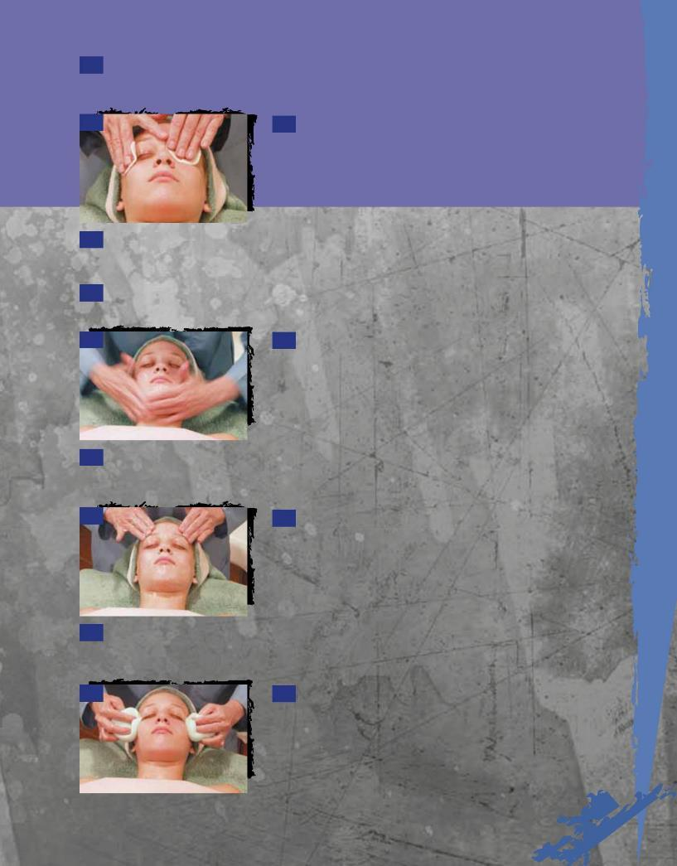
7b Meanwhile, apply another pea-sized amount of eye makeup remover to a damp cotton pad and gently remove the client’s lipstick with even strokes from the corners of the lips toward the center. Repeat the procedure until the lips are clean.

7c 7c Now, remove the eye makeup in the same way, gently stroking down and outward with the cotton pad. Do one eye first, and then the other. Repeat the procedure until the eyelids and lashes are clean.

© Milady, a part of Cengage Learning. Photography by Larry Hamill.

7d Ask the client to look up, and then remove any makeup underneath the eyes. Always be gentle around the eyes. Never rub or stretch this thin, delicate skin.

8 Remove about a teaspoon of cleanser from the container with a clean spatula. Blend it with your fingers to soften it.

8a 8a Starting at the neck with a sweeping movement, use both hands to spread the cleanser upward on the chin, jaws, cheeks, the base of the nose to the temples, and along the sides and the bridge of the nose. Make small circular movements with your fingertips around the nostrils and sides of the nose. Continue the upward sweeping movements between the brows and across the forehead to the temples.

8b Take additional cleanser from the container with a clean spatula and blend it with your fingers. Smooth down the neck, chest, and back with long, even strokes.

8c 8c Starting at the center of the forehead, move your fingertips lightly in a circle around the eyes to the temples and then back to the center of the forehead.

8d Slide your fingers down the nose to the upper lip, from the temples through the forehead, lightly down to the chin, and then firmly up the jaw line back toward the temples and forehead.

9 9 Remove the cleanser with facial sponges, tissues, moist cotton pads, or warm, moist towels. Start at the forehead and follow the contours of the face. Remove all the cleanser from one area of the face before proceeding to the next. Finish with the neck, chest, and back.

23

.

Procedure

23-1Basic Facial

continued

10 10 Analyze the client’s skin to determine the products and procedures to be used. Optional: if eyebrow arching is to be done, it should be done at this time.

11a 11b

- Use warm, moist towels or a facial steamer to moisturize and soften the facial skin, helping to loosen comedones for extraction. If you use a steamer, cover the client’s eyes with cotton pads moistened with either distilled water or a special eye compress solution. Steam helps to soften superficial lines and increases blood circulation to the surface of the skin.

- Assuming that the client’s skin is nonsensitive, exfoliate. Apply a granular scrub to the face and gently massage the scrub in small circular movements. Never use a granular product near the eye area because granules can accidentally get into the eye. This procedure should take about two minutes. If you like, this granular scrub can be used during exposure to the facial steamer. Remove the scrub carefully with damp sponges or cotton pads. A brushing machine can be used instead of the granular scrub, but remember to apply cleansing milk before using the machine. Check with your instructor to have her show you the correct way to use the brushing machine.

13 13 Choose a treatment cream, lotion, or massage cream appropriate for the skin type. Using the same procedure as for the cleanser, apply the cream to the face, neck, shoulders, chest, and back. If needed, apply lubrication oil or cream around the eyes and on the neck. Massage the face, using the facial manipulations described in the Facial Massage section of this chapter.

- Remove massage cream with warm, moist towels, moist cleansing pads, or sponges. Follow the same procedure as for removing cleanser.

23 744

ret.

© Milady, a part of Cengage Learning. Photography by Larry Hamill.

15
 |  |  | 15 | Sponge the face with cotton pledgets moistened with toner
 |  |  | or | freshener.
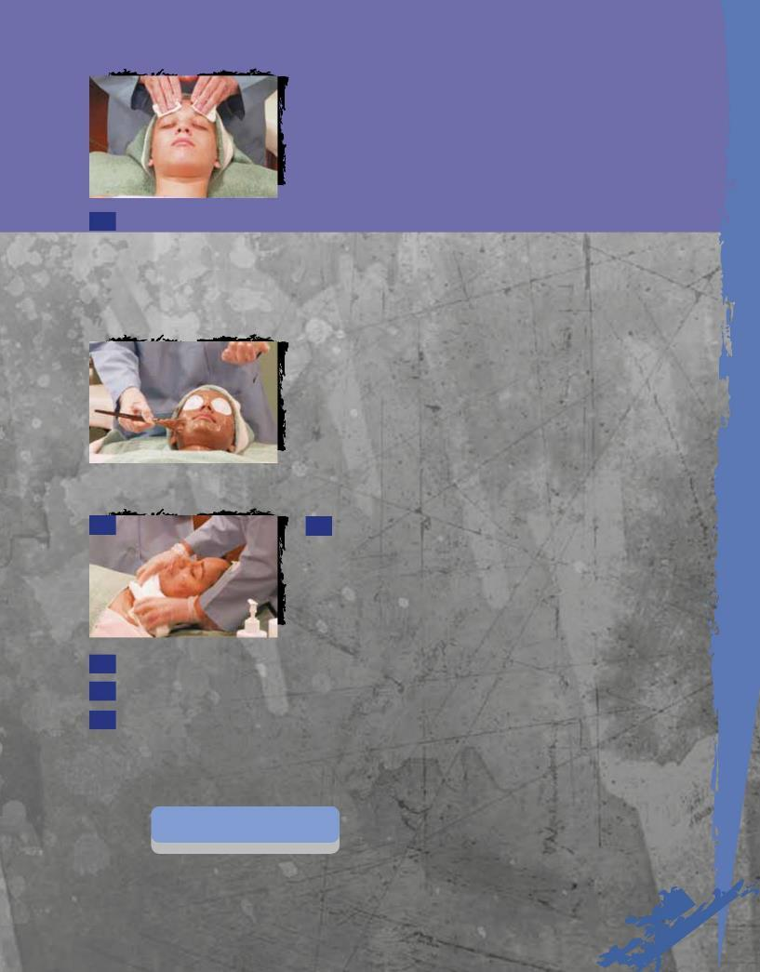

- Apply a treatment mask formulated for the client’s skin condition.

16a Remove some mask from its container with a clean spatula and place it in a little cup.

16b Apply the mask with a natural bristle brush, starting at the neck. Use long slow strokes from the center outward.

16c |  |  | 16c | Proceed to the jawline and apply the mask on the face from the
 |  |  | center | outward on half of the face and then on the other half.

16d Allow the mask to remain on the face for seven to ten minutes.

17 17 Remove the mask with wet cotton pledgets, sponges, or towels.

- Apply toner, astringent, or freshener.

19 Apply a moisturizer or sunscreen.

20 When the service is completed, remove the head covering and show the client to the dressing room, offering assistance if needed.

Post-Service
Procedure | Post-Service
• Complete 22-2 | Procedure | See page 699

23

).

.

23 Procedure -2

Post-Service
Procedure

Implements and Materials

In addition to the items needed for the Basic Facial, you will also need:

• Eye cream

• Galvanic or high-frequency machine, depending on treatment

- Specialized creams, serums, and toners
for dry skin

Preparation
Procedure | Pre-Service
• Perform 22-1 | Procedure | See page 696

Procedure

- Ask the client to remove any jewelry and store it in a safe place.

- Show the client to the dressing room and offer assistance if needed.

- Place a clean towel across the back of the facial table to prevent the client’s bare shoulders from coming into contact with the bed.

- If necessary, help your client get onto the facial bed. Place a towel across

the client’s chest, and place a coverlet or sheet over the client’s body, folding the top edge of the towel over it. Remove the client’s shoes, and tuck the coverlet around her feet.

- Fasten head covering.

6 Remove lingerie straps.

- Remove client’s makeup.

- Apply cleanser, gently massage to apply, and then remove with damp cotton pads, soft sponges, or a warm, moist, soft towel.

- Remove residue with toner on a damp cotton pad or a soft sponge.

- Focus steam on the face and allow steaming for five minutes.

11 During or after steaming, apply a mild granular exfoliating product designed for dry skin. Gently massage with light circular movements. Remove with damp cotton pads, soft sponges, or a warm, moist, soft towel.

12 Apply eye cream under the client’s eyes.

it.

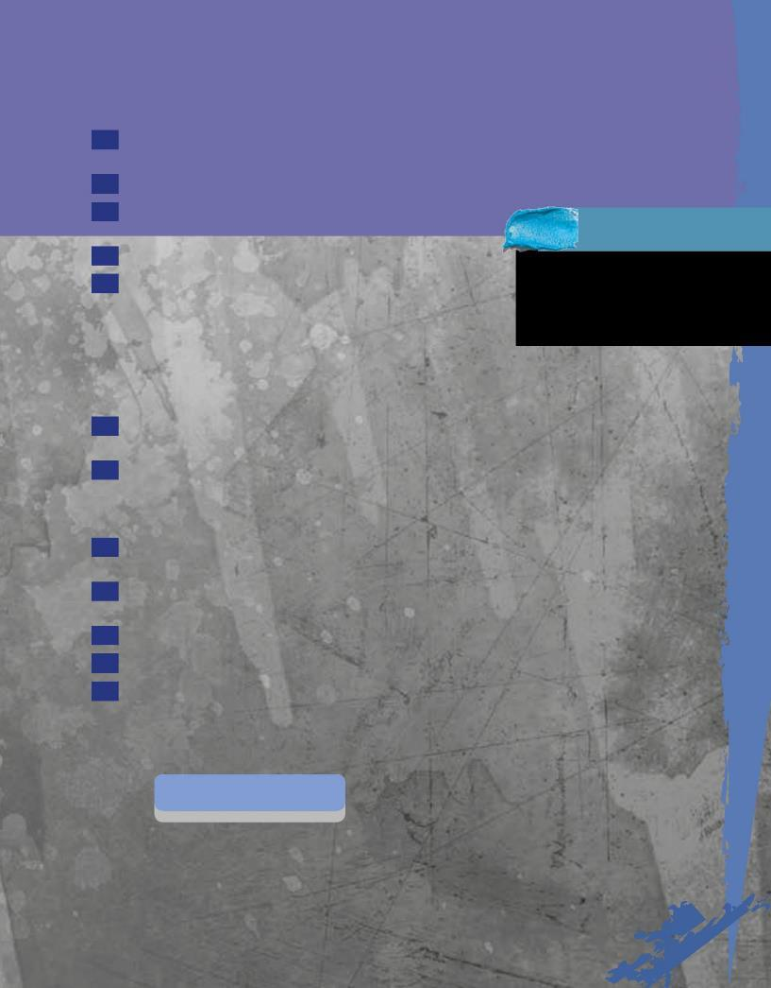

- Apply a moisturizing lotion, cream, or massage product designed for dry skin.

- Massage the skin with manipulations.

- If massage cream is used, remove with damp cotton pads,

soft sponges, or a warm, moist, soft towel.

- If you are not using electrotherapy, proceed to step 18.

- Electrotherapy Option 1, Galvanic Treatment: Apply ionized specialized serum, gel, or lotion. Apply galvanic current as directed by the manufacturer or your instructor. Electrotherapy Option 2, High-frequency Indirect Current Treatment: Use high-frequency machine as directed by the manufacturer or your instructor. Have the client hold the electrode in his or her hand. Perform manipulations, using the indirect method of high frequency, for seven to ten minutes. Do not lift your hands from the client’s face. Turn off high-frequency machine.

- Apply additional moisturizing or specialty product for dry skin with slow massage movements.

- Starting at the neck and using a soft mask brush, apply a soft-setting cream or hydrating gel mask. Make sure you remove the mask from its container with a clean spatula. Mask should be applied from the center outward.

- Apply cold cotton eye pads. Allow the mask to process for

seven to ten minutes. Make sure client is comfortable and warm.

- Remove the mask with warm, wet cotton pads, sponges, or warm, moist, soft towels.

- Apply toner for dry skin with cotton pads.

- Apply moisturizer or sunscreen designed for dry skin.

- When the service is completed, remove the head covering and show the client to the dressing room, offering assistance if needed.

Post-Service
Procedure | Post-Service
• Complete 22-2 | Procedure | See page 699

Service Tip

For dry skin, avoid using lotions with drying alcohols, such as isopropyl alcohol or SD alcohol.

require it.

23 Procedure -3

Facial for Oily Skin with Open Comedones (Blackheads)

Implements and Materials

In addition to the items needed for the Basic Facial, you will also need:

- Desincrustation gel or lotion

- Galvanic or high-frequency machine, depending on treatment

- Gloves

- Serum, mask, and toner for oily skin

Preparation
Procedure | Pre-Service
• Perform 22-1 | Procedure | See page 696

Procedure

- Ask the client to remove any jewelry and store it in a safe place.

2 Show the client to the dressing room and offer assistance if needed.

3 Place a clean towel across the back of the facial table to prevent the client’s bare shoulders from coming into contact with the bed.

- If necessary, help your client get onto the facial bed. Place a towel across the client’s chest, and place a coverlet or sheet over the client’s

body, folding the top edge of the towel over it. Remove the client’s shoes or slippers and tuck the coverlet around her feet. Some salons provide disposable slippers that can be worn to and from the dressing room.

- Fasten head covering.

- Remove lingerie straps.

7 Remove client’s makeup.

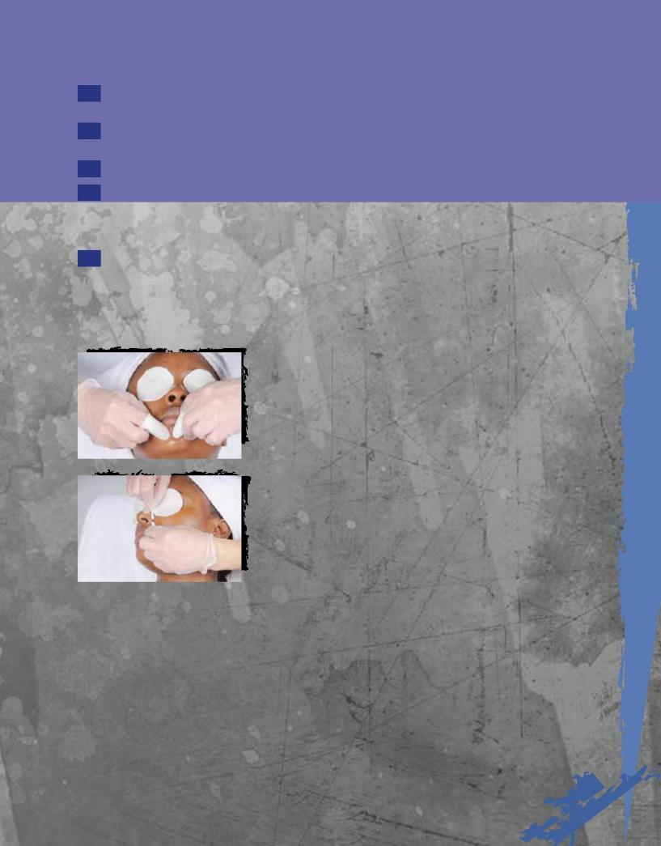
- Apply cleanser designed for oily skin, gently massage to apply, and then

remove with damp cotton pads, soft sponges, or a warm, moist, soft towel.

9 Remove residue with a damp cotton pad or a soft sponge. Do not tone at this time.

10 Focus steam on the face and allow steaming for five minutes.

- During or after steaming, apply a mild granular exfoliating product designed for oily or combination skin. Gently massage with light circular movements. Remove with damp cotton pads, soft sponges, or a warm, moist, soft towel.

- Apply a desincrustation lotion or gel to any area with clogged pores. Negative galvanic current may be applied over this lotion, depending on the

manufacturer’s instructions. The lotion should generally remain on the skin for five to eight minutes, again, depending on the manufacturer’s instructions. Remove the preparation with damp cotton pads, soft sponges, or a warm, moist, soft towel.

13a |  |  | 13a | Apply latex gloves prior to performing extractions. Apply damp
 |  |  | cotton | pads to the client’s eyes to avoid exposure to the glaring light from the
 |  |  | magnifying lamp. Cover your fingertips with cotton, and (using the magnifying
 |  |  | lamp) gently pressing out open comedones. Place your middle fingers on either
 |  |  | side of the comedone or clogged pore, stretching the skin. Push your fingers
 |  |  | down to reach underneath the follicle, and then gently squeeze. Apply the same
 |  |  | technique to all sides of the follicle. As an alternative, you may use the same
 |  |  | techniques using cotton swabs.
13b |  |  | 13b | Do not extract for more than five minutes for the entire face. Never
 |  |  | squeeze | with bare fingers or fingernails! If galvanic desincrustation was
 |  |  | performed prior to extraction, apply positive galvanic current to the face after
 |  |  | extractions are complete. This will help to re-establish the proper pH of the
 |  |  | skin surface.

Procedure

23-3Facial for Oily Skin with Open Comedones (Blackheads) continued

caution

You must receive hands-on instruction to properly perform extraction of clogged pores and comedones. Do not attempt this procedure without first obtaining instruction!

1caA rcfo i

Some people are allergic to latex or rubber. Check with your client to determine whether such an allergy exists and, if so, make a note on the client card. Then proceed, using vinyl gloves. Latex is also used in some facial sponges, so be sure to use cotton pads on clients with latex allergies.

1caA rcfo i

When treating acne-prone skin, disposable gloves should be worn throughout the treatment.

- After extraction is complete, apply an astringent lotion, a toner for oily skin, or a specialized serum designed to be used following extraction. Allow the skin to dry.

- Unfold gauze across the face and apply direct high frequency using the mushroom-shaped electrode, according to the machine manufacturer’s directions.

- Extremely oily or clogged skin should not be massaged. If the skin is very clogged, proceed to step 17. If skin is not extremely clogged, apply a hydration fluid or massage fluid designed for oily and combination skin, and perform massage manipulations.

- Using a mask brush, apply a clay-based mask to all oily areas. To dry areas, such as the eye and neck areas, you may choose to apply a gel mask for dehydrated skin. Allow the mask to process for about ten minutes. Do not allow the mask to overdry so that it cracks.

- Remove the mask with damp cotton pads, soft sponges, or a warm, moist, soft towel.

- Apply toner for oily skin with cotton pads.

- Apply moisturizer or sunscreen designed for oily or combination skin.

- When the service is completed, remove the head covering and show the client to the dressing room, offering assistance if needed.

Post-Service
Procedure | Post-Service
• Complete 22-2 | Procedure | See page 699

23

23 Procedure -4

Facial for Acne-Prone and Problem Skin

Implements and Materials

In addition to the items needed for the Basic Facial, you will also need:

- Antibacterial clay or sulfur mask

• Desincrustation gel or lotion

• Galvanic or high-frequency machine, depending on treatment

• Gloves

Preparation
Procedure | Pre-Service
• Perform 22-1 | Procedure | See page 696

Procedure

- Ask the client to remove any jewelry and store it in a safe place.

- Show the client to the dressing room and offer assistance if needed.

- Place a clean towel across the back of the facial table to prevent the client’s bare shoulders from coming into contact with the bed.

- If necessary, help your client get onto the facial bed. Place a towel across the client’s chest, and place a coverlet or sheet over the client’s body, folding the top edge of the towel over it. Remove the client’s shoes or slippers, and tuck the coverlet around her feet.

- Specialized fluids, serums, and toners for acne-prone skin

- Fasten head covering.

- Remove lingerie straps.

- Remove client’s makeup.

- Apply cleanser designed for oily/acne-prone skin, gently massage to apply, and then remove with damp cotton pads, soft sponges, or a warm, moist soft towel.

- Remove residue with damp cotton pad or soft sponge. Do not tone at this time.

- Focus steam on the face and allow steaming for five minutes.

Co
cs it.

Procedure

23-4Facial for Acne-Prone and Problem Skin continued
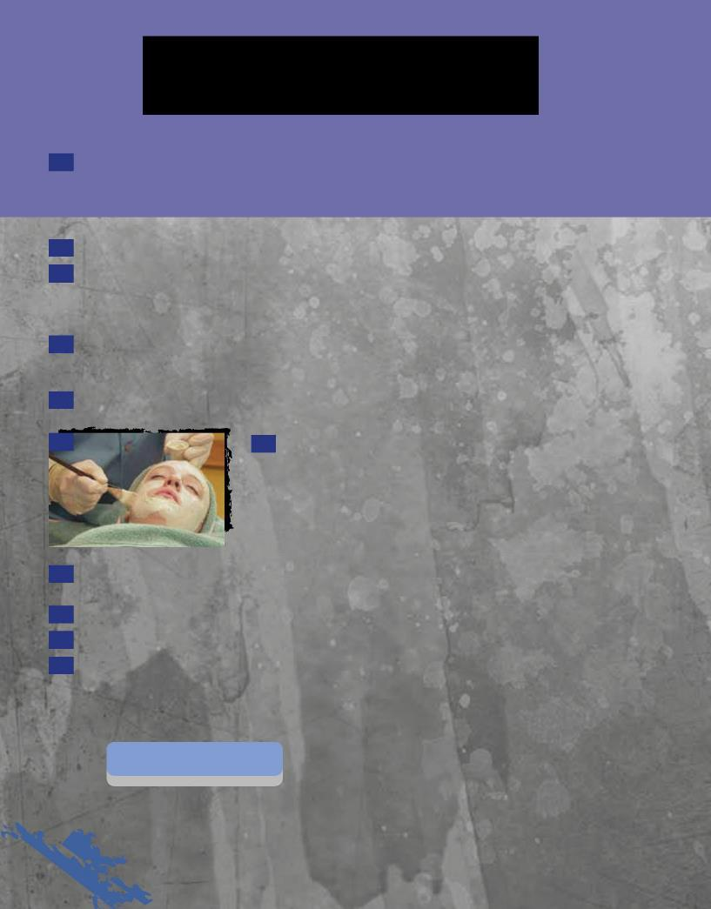

- Apply a desincrustation lotion or gel to any area with pimples or clogged pores. Negative galvanic current may be applied over this lotion, depending on the manufacturer’s instructions. The lotion should generally remain on the skin for five to eight minutes, again, depending on the manufacturer’s instructions. Remove the preparation with damp cotton pads, soft sponges, or a warm, moist, soft towel.

- Extract comedones.

- After extraction is complete, apply an astringent lotion, a toner for oily skin, or a specialized serum designed for use following extraction. Allow the skin to dry. Unfold gauze across the face and apply direct high-frequency using the mushroom-shaped electrode, as directed by the machine manufacturer and your instructor.

- If galvanic desincrustation was performed prior to extraction, apply positive galvanic current to the face after extractions are complete. This will help to re-establish the proper pH of the skin surface.

- Acne-prone skin should not be massaged.

16 16 Using a mask brush, apply an antibacterial or sulfur-based mask to all oily and acne-prone areas. To dry skin, such as the eye and neck areas, you may choose to apply a gel mask for dehydrated skin. Allow the mask to process for about ten minutes. Do not allow the mask to overdry so that it cracks.

- Remove the mask with damp cotton pads, soft sponges, or a warm, moist, soft

towel.

- Apply toner for oily skin with cotton pads.

- Apply specialized lotion or sunscreen designed for oily or acne-prone skin.

- When the service is completed, remove the head covering and show the client to the dressing room, offering assistance if needed.

Post-Service
Procedure | Post-Service
• Complete 22-2 | Procedure | See page 699

23

.

Questions

1. Explain skin analysis techniques. Why is skin analysis important?

2. What is a contraindication? List five examples.

3. Why is it important to have every client complete a health screening form?

4. Describe the differences between alipidic and oily skin.

5. What is the difference between skin type and skin condition?

6. Name and explain the different categories of skin care products.

7. What are the steps to completing a client consultation?

8. Why is massage used during a facial?

9. Name and briefly describe the five categories of massage manipulations.

- Name and describe two types of electrical machines used in facial treatments and why thesemachines

add value to a facial.

11. Who is not a good candidate for electrical current treatment? Why?

12. How can aromatherapy be used in the basic facial?

Glossary

alipidic Literally means “lack of lipids.” Describes skin that does not produce enough sebum,

indicated by absence of visible pores.

ampoules Individual doses of serum, sealed in small vials.

aromatherapy The therapeutic use of plant aromas for beauty and health treatment.

brushing machine A rotating electric appliance with interchangeable brushes that can be attached to the

rotating head.

chemical exfoliants Products that contain chemicals that either loosen or dissolve dead cell buildup.

chucking Massage movement accomplished by grasping the flesh firmly in one hand and moving

the hand up and down along the bone while the other hand keeps the arm or leg in a steady position.

clay-based masks Oil-absorbing cleansing masks that have an exfoliating effect and an astringent effect on

oily and combination skin, making large pores temporarily appear smaller.

cleansing milks Non-foaming lotion cleansers designed to cleanse dry and sensitive skin types and to

remove makeup.

contraindication Condition that requires avoiding certain treatments, procedures, or products to prevent

undesirable side effects.

couperose Distended capillaries caused by weakening of the capillary walls.

cream masks Masks often containing oils and emollients as well as humectants; have a strong

moisturizing effect.

effleurage Light, continuous stroking movement applied with the fingers (digital) or the palms (palmar) in

a slow, rhythmic manner.

electrotherapy The use of electrical currents to treat the skin.

emollients Oil or fatty ingredients that prevent moisture from leaving the skin.

enzyme peels Also known as keratolytic enzymes or protein-dissolving agents; a type of chemical exfoliant
that works by dissolving keratin protein in the surface cells of the skin.

exfoliants Products that help bring about exfoliation.

exfoliation The removal of excess dead cells from the skin surface.

foaming cleansers Cleansers containing surfactants (detergents) which cause the product to foam and rinse

off easily.

friction Deep rubbing movement requiring pressure on the skin with the fingers or palm while moving

them over an underlying structure.

fulling Form of pétrissage in which the tissue is grasped, gently lifted, and spread out; used mainly

for massaging the arms.

gommages Also known as roll-off masks; peeling creams that are rubbed off of the skin.

hacking Chopping movement performed with the edges of the hands in massage.

humectants Also known as hydrators or water-binding agents; ingredients that attract water.

masks Also known as masques; concentrated treatment products often composed of mineral clays,

moisturizing agents, skin softeners, aromatherapy oils, botanical extracts and other beneficial ingredients to cleanse, exfoliate, tighten, tone, hydrate, and nourish the skin.

massage Manual or mechanical manipulation of the body by rubbing, gently pinching, kneading,

tapping, and other movements to increase metabolism and circulation, promote absorption, and relieve pain.

massage creams Lubricants used to make the skin slippery during massage.

mechanical Methods used to physically remove dead cell buildup.

exfoliants

microdermabrasion Mechanical exfoliation that involves shooting aluminum oxide or other crystals at the skin

with a hand-held device that exfoliates dead cells.

microdermabrasion Scrubs that contains aluminum oxide crystals.

scrubs

modelage masks Facial masks containing special crystals of gypsum, a plaster-like ingredient.

moisturizers Products that help increase the moisture content of the skin surface.

Chapter Glossary

motor point Point on the skin over the muscle where pressure or stimulationwill cause contraction of

that muscle.

open comedones Also known as blackheads; follicles impacted with solidified sebumand dead cell buildup.

ostium Follicle opening.

paraffin wax masks Specially prepared facial masks containing paraffin and other beneficial ingredients; typically

used with treatment cream.

pétrissage Kneading movement performed by lifting, squeezing, and pressing thetissue with a light,

firm pressure.

rolling Massage movement in which the tissues are pressed and twisted using a fast

back-and-forth movement.

serums Concentrated products that generally contain higher concentrations of ingredients designed

to penetrate and treat various skin conditions.

steamer A facial machine that heats and produces a stream of warm steam that can be focused on

the client’s face or other areas of skin.

tapotement Also known as percussion; movements consisting of short quick tapping, slapping, and

hacking movements.

toners Also known as fresheners or astringents; lotions that help rebalance the pH and remove

remnants of cleanser from the skin.

treatment cream A specialty product designed to facilitate change in the skin’s appearance.

vibration In massage, the rapid shaking of the body part while the balls of the fingertips are pressed

firmly on the point of application.

wringing Vigorous movement in which the hands, placed a little distance apart on both sides of the

client’s arm or leg, working downward apply a twisting motion against the bones in the opposite direction.

