Chapter 3—Settling the Northern Colonies, 1619-1700

SHORT ANSWER

Identify and state the historical significance of the following:

1. John Calvin

ANS:
Student answers will vary.

2. Anne Hutchinson

ANS:
Student answers will vary.

3. Roger Williams

ANS:
Student answers will vary.

4. Henry Hudson

ANS:
Student answers will vary.

5. William Bradford

ANS:
Student answers will vary.

6. Peter Stuyvesant

ANS:
Student answers will vary.

7. Thomas Hooker

ANS:
Student answers will vary.

8. William Penn

ANS:
Student answers will vary.

9. John Winthrop

ANS:
Student answers will vary.

10. King Philip (Metacom)

ANS:
Student answers will vary.

11. John Cotton

ANS:
Student answers will vary.

12. Sir Edmund Andros

ANS:
Student answers will vary.

13. William and Mary

ANS:
Student answers will vary.

14. Massasoit

ANS:
Student answers will vary.

15. Fernando Gorges

ANS:
Student answers will vary.

16. Myles Standish

ANS:
Student answers will vary.

17. Martin Luther

ANS:
Student answers will vary.

18. Squanto

ANS:
Student answers will vary.

Define and state the historical significance of the following:

19. the "elect"

ANS:
Student answers will vary.

20. franchise

ANS:
Student answers will vary.

21. predestination

ANS:
Student answers will vary.

22. freemen

ANS:
Student answers will vary.

23. "visible saints"

ANS:
Student answers will vary.

24. conversion

ANS:
Student answers will vary.

25. doctrine of a calling

ANS:
Student answers will vary.

26. covenant

ANS:
Student answers will vary.

27. antinomianism

ANS:
Student answers will vary.

28. sumptuary laws

ANS:
Student answers will vary.

29. salutary neglect

ANS:
Student answers will vary.

30. passive resistance

ANS:
Student answers will vary.

31. "city upon a hill"

ANS:
Student answers will vary.

Describe and state the historical significance of the following:

32. Protestant Reformation

ANS:
Student answers will vary.

33. Pilgrims

ANS:
Student answers will vary.

34. New England Confederation

ANS:
Student answers will vary.

35. Calvinism

ANS:
Student answers will vary.

36. Massachusetts Bay Company

ANS:
Student answers will vary.

37. Dominion of New England

ANS:
Student answers will vary.

38. Institutes of the Christian Religion

ANS:
Student answers will vary.

39. Navigation Laws

ANS:
Student answers will vary.

40. Great Migration

ANS:
Student answers will vary.

41. Glorious Revolution

ANS:
Student answers will vary.

42. Puritans

ANS:
Student answers will vary.

43. General Court

ANS:
Student answers will vary.

44. Dutch West India Company

ANS:
Student answers will vary.

45. Separatists

ANS:
Student answers will vary.

46. Bible Commonwealth

ANS:
Student answers will vary.

47. Quakers (Religious Society of Friends)

ANS:
Student answers will vary.

48. Mayflower

ANS:
Student answers will vary.

49. Protestant ethic

ANS:
Student answers will vary.

50. Mayflower Compact

ANS:
Student answers will vary.

51. Fundamental Orders

ANS:
Student answers will vary.

52. French Huguenots

ANS:
Student answers will vary.

53. Scottish Presbyterians

ANS:
Student answers will vary.

54. Church of England

ANS:
Student answers will vary.

55. Dutchification

ANS:
Student answers will vary.

56. Plymouth Bay

ANS:
Student answers will vary.

57. Congregational Church

ANS:
Student answers will vary.

58. Pequot War

ANS:
Student answers will vary.

59. Dutch "golden age"

ANS:
Student answers will vary.

60. New Netherland

ANS:
Student answers will vary.

61. New Amsterdam

ANS:
Student answers will vary.

62. New Sweden

ANS:
Student answers will vary.

63. Penn's Woodland

ANS:
Student answers will vary.

COMPLETION

Locate the following places by reference number on the map:

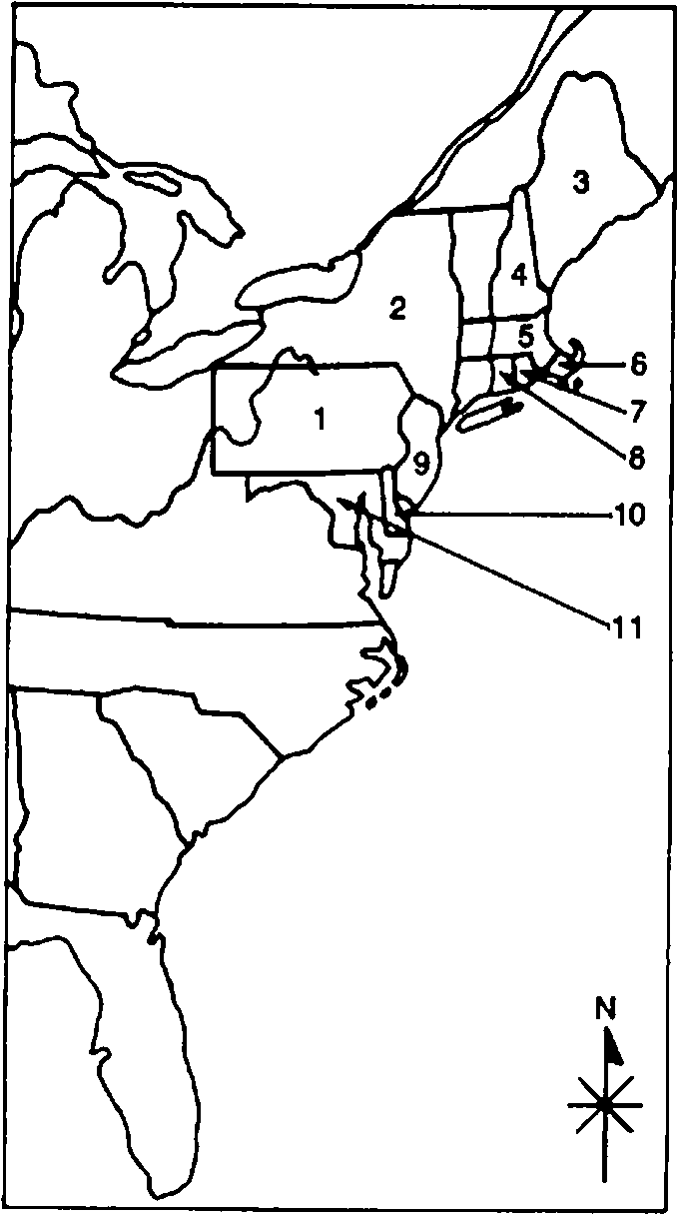

64. ____ Rhode Island

ANS: 7

65. ____ Massachusetts Bay

ANS: 5

66. ____ New Hampshire

ANS: 4

67. ____ Pennsylvania

ANS: 1

68. ____ New Jersey

ANS: 9

69. ____ Delaware

ANS: 10

70. ____ New York

ANS: 2

71. ____ Plymouth

ANS: 6

Locate the following places by reference number on the map:

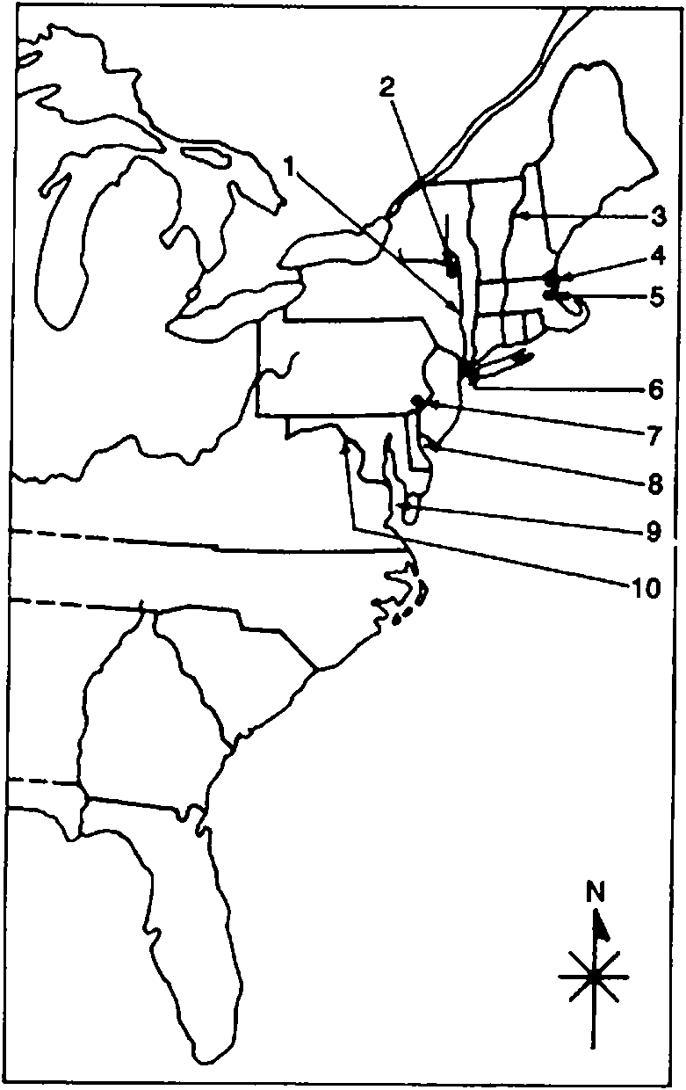

72. ____ Boston

ANS: 5

73. ____ Salem

ANS: 4

74. ____ Connecticut River

ANS: 3

75. ____ Delaware Bay

ANS: 8

76. ____ Hudson River

ANS: 1

77. ____ New York City

ANS: 6

78. ____ Albany

ANS: 2

79. ____ Philadelphia

ANS: 7

MULTIPLE CHOICE

80. Colonists in both the North and the South established differences in all of the following areas except
a. | patterns of settlement.
b. | economies.
c. | political systems.
d. | values.
e. | allegiance to England.

ANS: E REF: p. 41

81. Identify the statement that is false.
a. | The promise of riches, especially tobacco, drew the first settlers to the southern colonies.
b. | Religious devotion primarily shaped the earliest settlements in the New England colonies.
c. | Colonists in both the north and south shared a common language and English heritage.
d. | Colonists in both the north and south had strong common characteristics that would persist for generations.
e. | The colonies in the north and south had different patterns of settlement, different economies, different political systems, and even different sets of values.

ANS: D REF: p. 41

82. All of the following are true of Martin Luther except
a. | he was German.
b. | he protested against Catholic doctrines at Wittenberg in 1517.
c. | there was little notice of his reforms in Europe.
d. | he denounced the authority of priests and popes.
e. | he declared that the Bible was the only source of God's word.

ANS: C REF: p. 41

83. John Calvin profoundly affected the thought of all of the following except
a. | Spanish Armenians.
b. | New England Puritans.
c. | Scottish Presbyterians.
d. | French Huguenots.
e. | the Dutch Reformed Church.

ANS: A REF: p. 41

84. Match each item on the left with the correct definition.

A. | predestination | 1. | belief that from the moment of creation some souls were "saved" and others "damned"
B. | conversion | 2. | belief that faith, good works, and repentance could earn salvation
C. | antinomianism | 3. | the sign of receipt of God's free gift of saving grace
 |  | 4. | belief that those whom God had marked for salvation need not obey secular laws

a. | A-1, B-3, C-2
b. | A-3, B-2, C-1
c. | A-1, B-3, C-4
d. | A-4, B-l, C-3
e. | A-2, B-4, C-3

ANS: C REF: p. 41 | p. 45

85. In Calvinist thought, the "conversion" was
a. | something experienced as a group.
b. | earned by a person's good works.
c. | a Catholic heresy.
d. | an event that freed a person from having to live a holy life.
e. | a personal experience when God revealed an individual's heavenly destiny.

ANS: E REF: p. 41

86. In Puritan doctrine, the "elect" were also referred to as
a. | Separatists.
b. | "patroons."
c. | "visible saints."
d. | Pilgrims.
e. | Anglicans.

ANS: C REF: p. 41

87. Henry VIII aided the entrance of Protestant beliefs into England when he
a. | allowed Martin Luther to journey to England.
b. | broke England's ties with the Roman Catholic Church.
c. | removed himself as the head of the Church of England.
d. | ordered John Calvin to go to Switzerland.
e. | supported the Puritans.

ANS: B REF: p. 41

88. King James I opposed the Separatists who wanted to break away entirely from the Church of England because he
a. | realized that if his subjects could defy him as their spiritual leader, they could defy him as their political leader.
b. | strongly believed in the concept of "visible saints."
c. | never understood the political implications of their actions.
d. | believed that they were turning their backs on the true Calvinist faith.
e. | was a strong Catholic and the Separatists' doctrine went counter to the strict interpretation of the Bible.

ANS: A REF: p. 42

89. The Separatists migrated from Holland to the New World in order to
a. | avoid the coming war with France.
b. | gain wealth through all the economic incentives the New World offered.
c. | establish a new nation.
d. | avoid the Dutchification of their children.
e. | escape the jurisdiction of the Virginia Company.

ANS: D REF: p. 42

90. Match each colony on the left with its associated item.

A. | Plymouth | 1. | General Court
B. | Connecticut | 2. | Mayflower Compact
C. | Massachusetts Bay | 3. | Fundamental Orders
 |  | 4. | patroonships

a. | A-3, B-2, C-4
b. | A-2, B-3, C-1
c. | A-4, B-1, C-2
d. | A-1, B-4, C-3
e. | A-3, B-2, C-1

ANS: B REF: p. 42-46

91. All of the following were true of the Pilgrims except they
a. | were also known as Separatists.
b. | arrived in the New World on the ship the Mayflower.
c. | arrived at their original destination with no casualties.
d. | chose Plymouth Bay as their landing site in 1620.
e. | were without legal right to the land and specific authority to establish a government.

ANS: C REF: p. 42

92. The Mayflower Compact can be best described as a(n)
a. | agreement to follow the dictates of Parliament.
b. | document that allowed women limited participation in government.
c. | constitution that established a working government.
d. | complex agreement to form an oligarchy.
e. | promising step toward genuine self-government.

ANS: E REF: p. 43

93. The leader that helped the Pilgrims survive was
a. | John Smith.
b. | John Winthrop.
c. | Roger Williams.
d. | William Laud.
e. | William Bradford.

ANS: E REF: p. 43

94. The historical significance of the Pilgrims of Plymouth Bay lies in their
a. | numerical size.
b. | economic power.
c. | moral and spiritual qualities.
d. | dedication to family life.
e. | unwillingness to merge with the Puritans in Massachusetts Bay.

ANS: C REF: p. 43

95. Unlike Separatists, the Puritans
a. | advocated strict separation of church and state.
b. | practiced passive resistance to oppression.
c. | remained members of the Church of England.
d. | were Calvinists.
e. | rejected belief in witchcraft.

ANS: C REF: p. 43

96. Initially, the Massachusetts Bay Colony enjoyed all of the following advantages except that of
a. | being a well-equipped expedition.
b. | starting off on a larger scale than any other English colony.
c. | receiving many fairly prosperous and educated immigrants.
d. | receiving a majority of the Puritans coming to the New World.
e. | a shared purpose among the first settlers.

ANS: D REF: p. 43-44

97. Puritan doctrine included acceptance of
a. | antinomianism.
b. | the Pope's supremacy.
c. | the idea of a covenant with God.
d. | the doctrine of good works.
e. | the King as the final religious authority.

ANS: C REF: p. 44

98. With the franchise in Massachusetts extended to all adult males who belonged to Puritan congregations, the proportion of qualified voters (approximately 2/5) in this colony as compared to England was
a. | larger.
b. | somewhat smaller.
c. | about the same.
d. | not known.
e. | a great deal smaller.

ANS: A REF: p. 44

99. In the Massachusetts "Bible Commonwealth," clergymen
a. | could be elected to political office.
b. | could not be fired by their congregations.
c. | were not allowed to marry.
d. | were barred from holding formal political office.
e. | could not have children.

ANS: D REF: p. 45

100. Puritan religious beliefs allowed all of the following except
a. | drinking alcohol.
b. | eating plentifully.
c. | challenging religious authority.
d. | making love discreetly.
e. | singing songs.

ANS: C REF: p. 45

101. Among the Puritans, it was understood that
a. | they would establish democratic government in America.
b. | clergymen would hold the most powerful political office.
c. | the purpose of government was to enforce God's laws.
d. | all adult white male landowners could vote for political leaders.
e. | women could become religious leaders.

ANS: C REF: p. 45

102. People who flouted the authority of the Puritan clergy in Massachusetts Bay were subject to which of the following punishments?
a. | Fines
b. | Floggings
c. | Banishment
d. | Death
e. | All of these

ANS: E REF: p. 45

103. According to Anne Hutchinson, a dissenter in Massachusetts Bay
a. | predestination was not a valid idea.
b. | the truly saved need not bother to obey the laws of God or man.
c. | antinomianism was heresy.
d. | direct revelation from God was impossible.
e. | a person needs only to obey the law of God.

ANS: B REF: p. 45

104. Which of these is NOT a true statement about the fate of Anne Hutchinson?
a. | She was banished from the Massachusetts Bay Colony for her beliefs.
b. | She was pregnant when she headed with her family for Rhode Island.
c. | She and most of her family members were killed by Indians in New York.
d. | John Winthrop saw "God's hand" in her fate.
e. | She preached to fellow residents of Salem.

ANS: E REF: p. 45-46

105. All of the following were true of Roger Williams except
a. | he was a personable and popular Salem minister.
b. | he was not a Separatist and advocated reconciliation with the Church of England.
c. | aided by Indians, he fled the Puritan community and established Rhode Island in 1636.
d. | he challenged the legality of the Bay Colony's charter.
e. | he denied the authority of the civil government to regulate religious behavior.

ANS: B REF: p. 46

106. As the founder of Rhode Island, Roger Williams
a. | established religious freedom for all but Jews and Catholics.
b. | supported some types of special privileges.
c. | established complete religious freedom for all.
d. | demanded attendance at worship.
e. | became a very wealthy man.

ANS: C REF: p. 46

107. Roger Williams' beliefs included all of the following except
a. | breaking away from the Church of England.
b. | demanding oaths regarding religious beliefs.
c. | condemning the taking of Indian land without fair compensation.
d. | denying the authority of the civil government to regulate religious matters.
e. | challenging the legality of Massachusetts Bay's charter.

ANS: B REF: p. 46

108. As a colony, Rhode Island became known for
a. | its poor treatment of Indians.
b. | unified religious beliefs.
c. | support of special privilege.
d. | never having secured a charter from Parliament.
e. | individualistic and independent attitudes.

ANS: E REF: p. 46

109. Settlers of the Connecticut River colony developed a document known as the Fundamental Orders, which
a. | marked the beginning of the colony of Connecticut.
b. | established a regime democratically controlled by "substantial" citizens.
c. | set up a military alliance in New England.
d. | pleased King Charles I.
e. | supported a government controlled by all people.

ANS: B REF: p. 46

110. The Puritans who founded the city of New Haven had a goal of
a. | establishing it in tribute to Charles II.
b. | creating a haven for Quakers and other religious refugees.
c. | maintaining a democratic government controlled by its citizens.
d. | becoming self-supporting and prosperous in the fishing and fur trades.
e. | setting up an even closer church-state alliance than in Massachusetts.

ANS: E REF: p. 46

111. After the Pequot War, Puritan efforts to convert Indians to Christianity can best be described as
a. | vigorous but unsuccessful.
b. | more zealous than those made by Catholics, but still unsuccessful.
c. | filling "praying towns" with hundreds of Indians.
d. | feeble, not equaling that of the Spanish or the French.
e. | very successful.

ANS: D REF: p. 48

112. The New England Indians' only hope for resisting English encroachment lay in
a. | acquiring English muskets.
b. | enlisting the aid of the French.
c. | intertribal unity against the English.
d. | building fortifications.
e. | allying themselves with the Dutch.

ANS: C REF: p. 48

113. King Philip's War resulted in all of the following except
a. | the lasting defeat of New England's Indians.
b. | the immediate westward march of English settlement in New England.
c. | the death of hundreds of colonists and many more Indians.
d. | the destruction of 12 Puritan towns.
e. | the beheading of Wampanoag Chief Metacom and the sale of his wife and son into slavery

ANS: B REF: p. 48

114. During the early years of colonization in the New World, England
a. | closely controlled its colonies.
b. | maintained an excellent relationship with the Indians.
c. | paid little attention to its colonies.
d. | made sure all the colonies had royal charters.
e. | began the importation of African slaves in large numbers.

ANS: C REF: p. 48

115. The New England Confederation
a. | included all the New England colonies.
b. | was designed to bolster colonial defense.
c. | led the American colonies to seek independence from England.
d. | was created by the English government to streamline its administration of the colonies.
e. | was an economic and trade alliance.

ANS: B REF: p. 48

116. The Dominion of New England
a. | included all the New England colonies.
b. | was created by the English government to streamline the administration of its colonies.
c. | was designed to bolster colonial defense.
d. | eventually included New York and east and west New Jersey.
e. | All of these

ANS: E REF: p. 49

117. As the head of Dominion of New England, Sir Edmund Andros was all of the following except
a. | an able military man.
b. | conscientious.
c. | a Puritan.
d. | tactless.
e. | a leader who restricted the press.

ANS: C REF: p. 49

118. As a result of England's Glorious Revolution
a. | the Dominion of the New World collapsed.
b. | Sir Edmund Andros gained control over Massachusetts.
c. | Massachusetts regained its original charter.
d. | opposition to English rule in the colonies subsided.
e. | James II regained his legitimate right to the crown.

ANS: A REF: p. 50

119. As a result of Sir Edmund Andros's rule
a. | the power of town meetings was curbed.
b. | officials tried to enforce the Navigation Laws.
c. | taxes were levied without the consent of elected representatives.
d. | smuggling was suppressed.
e. | All of these

ANS: E REF: p. 50

120. New York was
a. | the best advertised of all the colonies.
b. | designed as a Quaker refuge.
c. | originally founded by the Dutch.
d. | a major contributor to political democracy and religious tolerance in the English colonies.
e. | the last of the middle colonies to be established.

ANS: C REF: p. 50

121. The Dutch colony of New Netherland (later New York)
a. | allowed only Dutch immigrants to settle there.
b. | was established for its quick profit of fur trading.
c. | tolerated Quakers from nearby Pennsylvania.
d. | supported free speech and other democratic practices.
e. | All of these

ANS: B REF: p. 50

122. New York and Pennsylvania were similar in that they both
a. | were established by joint-stock companies.
b. | experienced slow population growth.
c. | had ethnically mixed populations.
d. | were founded as religious refuges.
e. | had poor soil.

ANS: C REF: p. 51

123. All of the following were characteristics of New Netherland except
a. | New England immigrants made up half its population of 10,000 in 1664.
b. | its development was not a priority of the Dutch.
c. | it took on an aristocratic tint, including feudal estates known as patroonships.
d. | its main seaport city was the cosmopolitan New Amsterdam,
e. | it was established by the Dutch East India Company.

ANS: E REF: p. 50-52

124. When the English gained control over New Netherland
a. | the autocratic spirit survived.
b. | democracy replaced the old autocratic system.
c. | the colony grew quickly.
d. | new leaders distributed land grants in a more democratic fashion.
e. | they did so with great bloodshed.

ANS: A REF: p. 52

125. One of the traits that made Quakers unpopular in England was
a. | their refusal to do military service.
b. | the high pay given their clergy.
c. | their support of slavery.
d. | their violent treatment of their enemies.
e. | their refusal to hold public office.

ANS: A REF: p. 53

126. The physical growth of English New York was slowed because
a. | of the Indian threat.
b. | of an unhealthy climate.
c. | the Dutch engaged in guerrilla warfare.
d. | of the monopolistic land policies of the aristocrats.
e. | of the French threat.

ANS: D REF: p. 53

127. Pennsylvania was the
a. | best advertised.
b. | most lied about.
c. | slowest to attract settlers.
d. | only settlement with royal colony status.
e. | All of these

ANS: A REF: p. 54

128. Indian policy in early Pennsylvania can be best described as
a. | extremely harsh.
b. | bad at first but improving later.
c. | influenced mainly by the state-supported church.
d. | fair.
e. | None of these

ANS: D REF: p. 54

129. All of the following are true statements about Quakers except
a. | they were shrewd businessmen.
b. | they built simple meetinghouses and believed they were all children in the sight of God.
c. | they advocated passive resistance and turning the other cheek against their enemies.
d. | they swore solemn oaths of faith and devotion.
e. | they trusted Indians in Pennsylvania as babysitters.

ANS: D REF: p. 53-55

130. Economically, the colony of Pennsylvania
a. | got off to a very slow start.
b. | never prospered.
c. | received much help from New York.
d. | became profitable very quickly.
e. | had extensive plantations.

ANS: D REF: p. 55

131. All the middle colonies were
a. | founded by proprietors.
b. | established by joint-stock companies.
c. | notable for their fertile soil.
d. | intended as religious havens.
e. | dependent on slave labor.

ANS: C REF: p. 55

132. The middle colonies were notable for their
a. | lack of good river transportation.
b. | unusual degree of democratic control.
c. | lack of industry.
d. | status as the least "American" of the colonies.
e. | established churches.

ANS: B REF: p. 55 | p. 57

133. Recently, historians have increasingly viewed the colonial period as one
a. | in which the Puritans had been overlooked.
b. | of contact and adaptation between European and native populations.
c. | in which the settlement of the Caribbean has been stressed too much.
d. | in which economic ambition was the main reason all colonists came.
e. | All of these

ANS: B REF: p. 57

134. The section of the American colonies where there was the greatest internal conflict was
a. | New England.
b. | the Deep South.
c. | the western frontier.
d. | the middle colonies.
e. | the southwest.

ANS: D REF: p. 58

135. The picture of colonial America that is emerging from new scholarship is a society formed by
a. | encounters with native people.
b. | European heritage.
c. | many intertwining roots.
d. | American heritage.
e. | All of these

ANS: E REF: p. 57-58

136. Arrange the following events in chronological order: (A) restoration of Charles II to the English throne, (B) English Civil War, (C) Glorious Revolution, and (D) Protestant Reformation.
a. | D, B, A, C
b. | C, A, B, D
c. | D, C, B, A
d. | B, C, A, D
e. | A, B, C, D

ANS: A REF: p. 41 | p. 48 | p. 50

137. Arrange the following events in chronological order: (A) great Puritan migration, (B) founding of Plymouth Colony, (C) Protestant Reformation, and (D) founding of Rhode Island.
a. | A, B, D, C
b. | C, B, A, D
c. | C, A, B, D
d. | B, D, A, C
e. | D, A, C, B

ANS: B REF: p. 41-43 | p. 46

138. Arrange the following in chronological order: the founding of (A) New York, (B) Massachusetts Bay, (C) Pennsylvania, and (D) Plymouth.
a. | C, B, A, D
b. | B, D, C, A
c. | A, C, D, B
d. | D, B, A, C
e. | A, C, B, D

ANS: D REF: p. 43 | p. 50 | p. 53

MULTIPLE RESPONSE

139. John Calvin believed in
a. | predestination.
b. | conversion.
c. | the elect.
d. | antinomianism.
e. | divinity of Mary.

ANS: A, B, C REF: p. 41

140. Puritans
a. | were Calvinists.
b. | thought that the Church of England should be open to all comers.
c. | especially attracted England's economically depressed.
d. | thought that the Protestant Reformation was bringing too much change too quickly.
e. | supported the Separatists.

ANS: A, C REF: p. 42

141. Separatists
a. | were radical Puritans.
b. | were also known as Pilgrims.
c. | authored the Mayflower Compact.
d. | sought to reform the Church of England from within.
e. | were led by John Winthrop.

ANS: A, B, C REF: p. 47-48

142. The New England colonies included
a. | Massachusetts Bay.
b. | New York.
c. | Connecticut.
d. | Rhode Island.
e. | Pennsylvania.

ANS: A, C, D REF: p. 42-43

143. Roger Williams got into trouble with Massachusetts Bay authorities because he
a. | questioned the legality of the Massachusetts Bay charter.
b. | advocated Roman Catholicism.
c. | claimed that the colony's civil government should not regulate religious behavior.
d. | claimed to have had a direct revelation from God.
e. | wanted to leave the colony.

ANS: A, C REF: p. 46

144. Factors leading to the first major European migration include
a. | a population explosion.
b. | economic depression.
c. | better quality oceangoing vessels.
d. | religious repression.
e. | the use of African slaves.

ANS: A, B, D REF: p. 41-42

145. The Pequot War of 1637 resulted in
a. | the abolition of Indian "praying towns."
b. | the virtual annihilation of the Pequots.
c. | four decades of uneasy peace between the Puritans and the Indians.
d. | praise for the colonists from people in England for having dealt effectively with the Indians.
e. | better relations with the remaining Indians.

ANS: B, C REF: p. 47-48

146. Pennsylvania
a. | introduced an unusually liberal land policy that attracted a heavy flow of immigrants.
b. | had fertile soil that produced surplus grain for export.
c. | was first settled by small colonies of Swedes.
d. | was founded with the intention of making a profit.
e. | was named after William Penn.

ANS: A, B, D REF: p. 54-55

ESSAY

147. Compare and contrast the motives of their founders, religious and social orientation, economic pursuits, and political developments of two of the early colonial settlement areas.
South
New England
Middle

ANS:
Student answers will vary.

148. Analyze the extent to which the government of Massachusetts Bay was simultaneously theocratic, democratic, oligarchic, and authoritarian.

ANS:
Student answers will vary.

149. Compare and contrast the Confederation of New England and the Dominion of New England. Be sure to cite the date of the founding, state the reasons for their creation, describe how they functioned and what they accomplished, and explain why they were ultimately abandoned.

ANS:
Student answers will vary.

150. To what extent were the Puritans of Massachusetts Bay religious fanatics?

ANS:
Student answers will vary.

151. State and explain your position on whether or not political authority should be used to enforce a particular view of morality. Then explain why you would or would not have been in favor of banishing Roger Williams and/or Anne Hutchinson from Massachusetts Bay.

ANS:
Student answers will vary.

152. Construct a definition of Puritanism using the concepts of predestination, calling, covenant, Protestant ethic, and conversion.

ANS:
Student answers will vary.

153. Which of the New England or middle colonies would you have preferred to live in? Explain your answer by discussing your selection's social, economic, political, religious, and ethnic characteristics.

ANS:
Student answers will vary.

154. In your opinion, which three of the twelve colonies founded in the seventeenth century made the most significant contributions to the perennial American values of democratic self-government, educational opportunity, religious toleration, social plurality, and economic materialism? Explain your choice.

ANS:
Student answers will vary.

155. Make a list of the motives of English people who migrated to America in the seventeenth century. Rank the items in the list from most important to least important. Then justify your ranking.

ANS:
Student answers will vary.

156. Write your interpretation of John Winthrop's comment that Massachusetts Bay was to be "as a city upon a hill" and "a beacon to mankind." In your opinion, do Americans still hold this view of their nation's role in the world? Why or why not?

ANS:
Student answers will vary.

157. Some historians have argued that Puritanism was especially suited for life in the wilderness of seventeenth-century America. Do you agree? Why or why not?

ANS:
Student answers will vary.

158. To what extent should the colonization of America be understood as the extension of European civilization into the New World, or should it be understood as the gradual development of a uniquely American culture?

ANS:
Student answers will vary.

159. Assess the validity of the following statement, "Although colonists both north and south were bound together by a common language and a common allegiance to Mother England, they established different patterns of settlement, different economies, different political systems, and even different sets of values."

ANS:
Student answers will vary.

160. In what ways was the Mayflower Compact a genuine step toward self-government?

ANS:
Student answers will vary.

161. What did John Winthrop mean when he said, "we shall be as a city upon a hill"? Did the Massachusetts Bay Colony reach this objective? Why or why not?

ANS:
Student answers will vary.

162. To what extent had the Massachusetts Bay colonists endorsed the idea of the separation of church and state?

ANS:
Student answers will vary.

163. To what extent was the New England Confederation a first step toward colonial unity?

ANS:
Student answers will vary.

