Chapter 6—The Duel for North America, 1608-1763

SHORT ANSWER

Identify and state the historical significance of the following:

1. Samuel de Champlain

ANS:
Student answers will vary.

2. William Pitt

ANS:
Student answers will vary.

3. James Wolfe

ANS:
Student answers will vary.

4. Edward Braddock

ANS:
Student answers will vary.

5. Pontiac

ANS:
Student answers will vary.

6. Louis XIV

ANS:
Student answers will vary.

7. Benjamin Franklin

ANS:
Student answers will vary.

8. George Washington

ANS:
Student answers will vary.

Describe and state the historical significance of the following:

9. Huguenots

ANS:
Student answers will vary.

10. Seven Years' War (French and Indian War)

ANS:
Student answers will vary.

11. Acadians

ANS:
Student answers will vary.

12. War of Spanish Succession

ANS:
Student answers will vary.

13. Albany Congress

ANS:
Student answers will vary.

14. Iroquois

ANS:
Student answers will vary.

15. New France

ANS:
Student answers will vary.

16. Proclamation of 1763

ANS:
Student answers will vary.

17. Edict of Nantes

ANS:
Student answers will vary.

18. coureurs de bois

ANS:
Student answers will vary.

19. Jesuits

ANS:
Student answers will vary.

20. salutary neglect

ANS:
Student answers will vary.

21. War of Jenkin's Ear

ANS:
Student answers will vary.

22. Louisbourg

ANS:
Student answers will vary.

23. Fort Duquesne

ANS:
Student answers will vary.

24. Fort Necessity

ANS:
Student answers will vary.

COMPLETION

Locate the following places by reference number on the map:

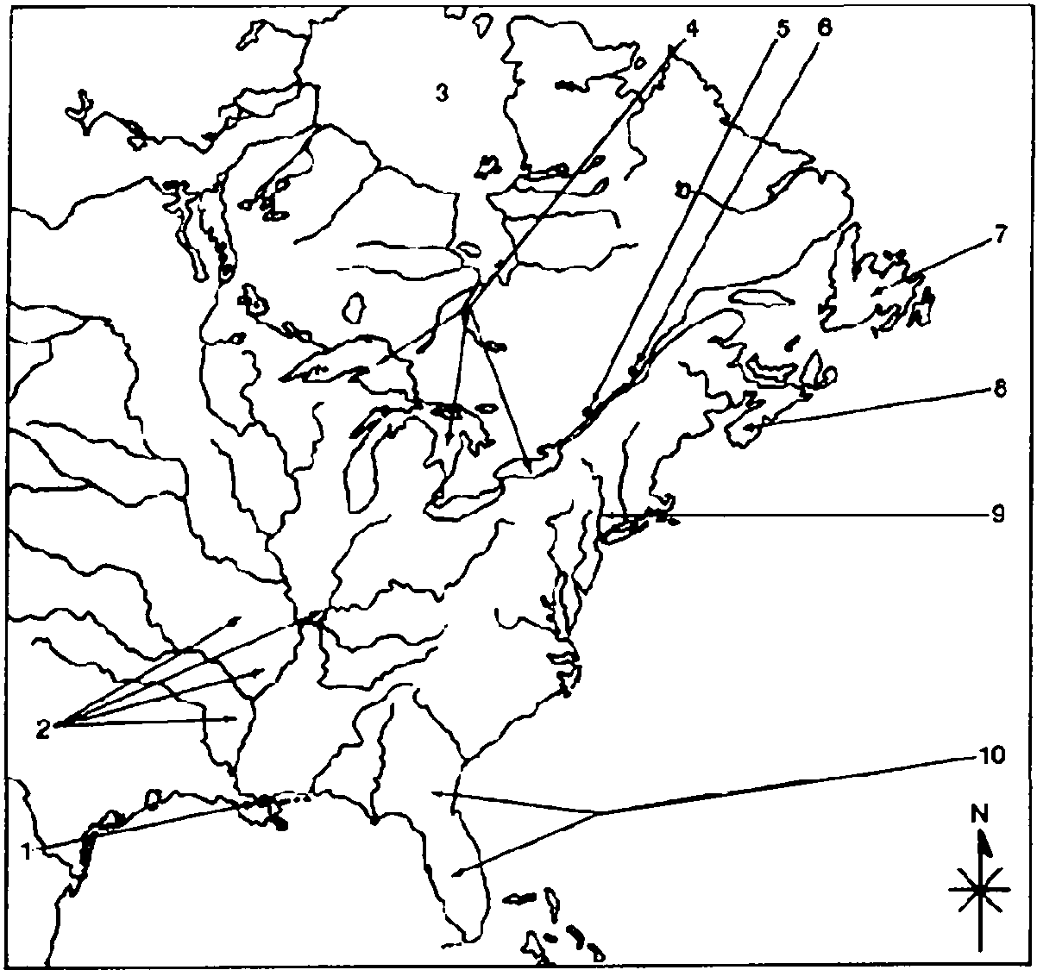

25. ____ Quebec

ANS: 6

26. ____ New Orleans

ANS: 1

27. ____ Great Lakes

ANS: 4

28. ____ Montreal

ANS: 5

29. ____ Hudson Bay

ANS: 3

30. ____ Newfoundland

ANS: 7

31. ____ Louisiana

ANS: 2

32. ____ Nova Scotia (Acadia)

ANS: 8

MULTIPLE CHOICE

33. From 1688 to 1763, America
a. | stayed out of European wars if possible.
b. | relied totally on the British for defense.
c. | started wars in Europe.
d. | was involved in every world war.
e. | fought wars on both land and sea.

ANS: D REF: p. 98

34. The soldier and explorer whose leadership in establishing French colonies earned him the title "Father of New France" was
a. | Samuel de Champlain.
b. | Robert de La Salle.
c. | Antoine Cadillac.
d. | Des Moines.
e. | Edward Vincennes.

ANS: A REF: p. 98

35. France was finally able to join in the scramble for colonies in the New World as a result of the
a. | Protestant takeover of the French government.
b. | end of the religious wars.
c. | revocation of the Edict of Nantes.
d. | St. Bartholomew's Day Massacre.
e. | Seven Years' War.

ANS: B REF: p. 98

36. During the early settlement of Quebec, French-Indian relations
a. | proved to be friendly and peaceful.
b. | led to France's lasting alliance with the Iroquois.
c. | were marked by tension and violence with the Hurons.
d. | meant an alliance with the Hurons that inspired the lasting hatred of the Iroquois.
e. | angered the British.

ANS: D REF: p. 98

37. Government in New France (Canada) was
a. | almost completely autocratic.
b. | democratic.
c. | similar to that of the English colonies.
d. | noted for its trial by jury.
e. | free from the king's control.

ANS: A REF: p. 98-99

38. Unlike the English colonies in America, in New France
a. | there were no popularly elected assemblies.
b. | the crown refused to promote the welfare of French colonization.
c. | the population grew very rapidly.
d. | no valuable resources for exploitation existed.
e. | the colonists practiced religious toleration.

ANS: A REF: p. 99

39. The population in Catholic New France grew very slowly because
a. | French peasants had no economic motive to move to the colonies.
b. | the Protestant Huguenots refused to move there.
c. | the French government was more concerned with its South American colonies.
d. | disease took a heavy toll on New France's inhabitants.
e. | of constant attacks by the Huron Indians.

ANS: A REF: p. 99

40. The coureurs de bois were
a. | French soldiers.
b. | French boatmen.
c. | Catholic priests.
d. | French farmers.
e. | French fur trappers.

ANS: E REF: p. 99

41. The primary economic pursuit of early settlers in New France was
a. | farming.
b. | fishing.
c. | mining.
d. | fur trapping.
e. | rum manufacturing.

ANS: D REF: p. 99

42. The Indians suffered from their association with the French in New France in all of the following ways except
a. | exclusion from the fur business.
b. | decimation of their numbers by the white man's diseases.
c. | violation of their religious beliefs about slaughtering animals.
d. | debauchery by the white man's alcohol.
e. | weakening of their traditional way of life.

ANS: A REF: p. 99

43. The Jesuit priests, despite their initial failure in gaining converts, played a vital role because
a. | of the many converts to Catholicism.
b. | of the health care they provided.
c. | they made peace with the Indians.
d. | they encouraged the Indians to participate in the fur trade.
e. | of their exploration and work as geographers.

ANS: E REF: p. 100

44. The French wanted to control Louisiana because they
a. | liked its climate.
b. | wanted to keep the area unfortified.
c. | would then control the mouth of the Mississippi River.
d. | feared Dutch expansion into the territory.
e. | saw it as a dumping ground for undesirables.

ANS: C REF: p. 100

45. French motives in the New World included the desire to
a. | establish agricultural communities to produce profitable staple crops.
b. | convert Indians to Protestantism.
c. | compete with Spain for an empire in America.
d. | provide a place for French religious dissenters to settle.
e. | compete with Portugal for an empire in America.

ANS: C REF: p. 100

46. The early wars between France and Britain in North America were notable for the
a. | large number of troops committed by both sides.
b. | lack of Indian participation.
c. | carryover of European tactics to America.
d. | use of primitive guerrilla warfare.
e. | advanced technology used during the warfare.

ANS: D REF: p. 101

47. During a generation of peace following the 1713 Treaty of Utrecht, Britain provided its American colonies with
a. | a large military presence for protection.
b. | decades of salutary neglect.
c. | higher taxes passed by Parliament.
d. | stronger parliamentary direction.
e. | representative seats in the British Parliament.

ANS: B REF: p. 101

48. The War of Jenkins's Ear was
a. | fought in European waters.
b. | a great victory for Spain.
c. | confined to the Caribbean Sea and Georgia.
d. | the event that established the policy of salutary neglect.
e. | a defeat for France.

ANS: C REF: p. 102

49. All of the following are true about the War of Jenkins's Ear except
a. | it resulted in France allying itself with Britain.
b. | it began as a small scuffle between Britain and Spain in America.
c. | it came to be called King George's War after merging with the War of Austrian Succession in Europe.
d. | New England recruits invaded New France.
e. | it resulted in Spain allying itself with Russia against France and Britain.

ANS: A REF: p. 102

50. New England colonists were outraged when British diplomats returned ____ to France in 1748.
a. | Hudson Bay
b. | Acadia
c. | Louisbourg
d. | Newfoundland
e. | Nova Scotia

ANS: C REF: p. 102

51. The clash between Britain and France for control of the North American continent sprang from their rivalry for control of
a. | Cape Breton Island.
b. | the Ohio River Valley.
c. | the Mississippi River.
d. | the Great Lakes.
e. | the St. Lawrence River.

ANS: B REF: p. 102

52. The reason Britain needed to control the Ohio Valley was to
a. | continue its expansion west and block French land-grabbing and influence.
b. | ensure defeat of the French in the War of Jenkins Ear.
c. | halt the growth of Spanish imposition in North America.
d. | secure the Mississippi River and continue pushing further south to control all of Mexico.
e. | link their Canadian holdings with those of the lower Mississippi Valley.

ANS: A REF: p. 102-103

53. The reason France needed to control the Ohio Valley was to
a. | stop Spain from extending its empire.
b. | help win the War of Jenkins's Ear.
c. | stop the Indian attacks on its outposts.
d. | link its Canadian holdings with those of the lower Mississippi Valley.
e. | be able to put more of its settlers there in order to increase farm production.

ANS: D REF: p. 102-103

54. In his first military command in the French and Indian War, George Washington
a. | won a decisive and hard-fought battle at Fort Duquesne.
b. | was defeated at Fort Necessity but was allowed to retreat.
c. | received strong support from the British.
d. | helped to force the French out of Nova Scotia.
e. | turned his twenty years of military experience to great success.

ANS: B REF: p. 103

55. The Seven Years' War was also known in America as
a. | the War of Jenkins's Ear.
b. | the French and Indian War.
c. | the War of the Austrian Succession.
d. | King William's War.
e. | Queen Anne's War.

ANS: B REF: p. 104

56. All of the following were allies on one side of the French and Indian War except
a. | France.
b. | Prussia.
c. | Spain.
d. | Austria.
e. | Russia.

ANS: B REF: p. 104

57. In the colonial wars before 1754, Americans
a. | functioned as a unified fighting force.
b. | received more support from France than Britain.
c. | demonstrated an astonishing lack of unity.
d. | were not involved in combat.
e. | rarely involved Indians in the fighting.

ANS: C REF: p. 104

58. The immediate purpose of the Albany Congress of 1754 was to
a. | request the help of the British military.
b. | keep the Iroquois tribes loyal to the British.
c. | prevent the French from attacking American outposts.
d. | support George Washington's desire to head the colonial militia.
e. | block British efforts to take control of New York City.

ANS: B REF: p. 105

59. Unlike the first three Anglo-French wars, the Seven Years' War
a. | won the British territorial concessions.
b. | united British colonists in strong support of the mother country.
c. | was fought initially on the North American continent.
d. | did not affect American colonists' attitudes toward England.
e. | resulted in a stronger French presence in North America.

ANS: C REF: p. 104

60. Arrange the following events in chronological order: (A) George Washington surrenders Fort Necessity; (B) General Edward Braddock is defeated near Fort Duquesne; (C) British troops capture Louisbourg in their first significant victory of the French and Indian War; and (D) General James Wolfe's army defeats Montcalm's on the Plains of Abraham.
a. | B, A, D, C
b. | A, B, C, D
c. | C, B, A, D
d. | A, C, B, D
e. | A, B, D, C

ANS: B REF: p. 103-108

61. The long-range purpose of the Albany Congress in 1754 was to
a. | achieve colonial unity and common defense against the French threat.
b. | propose independence of the colonies from Britain.
c. | declare war on the Iroquois tribe.
d. | prohibit New England and New York from trading with the French West Indies.
e. | gain peace with France.

ANS: A REF: p. 106

62. Benjamin Franklin published in his Pennsylvania Gazette his most famous cartoon of the colonial era, a disjointed snake, which
a. | promoted the idea that America, if they accepted the Albany Plan, would be cut apart and die.
b. | promoted the idea that if the colonies did not stand united against France, they would fall apart and die.
c. | argued that the British would cut apart the French (like the snake) once the Albany Plan was accepted.
d. | implied that the French was like the snake, waiting to be cut apart by the Albany Plan.
e. | promoted the idea that the French, if they accepted the Albany Plan, would join forces with the British and be united, unlike the disjointed snake.

ANS: B REF: p. 106

63. Benjamin Franklin's plan for colonial home rule was rejected by the individual colonies because
a. | it did not provide for the common defense.
b. | the British approved it.
c. | it did not seem to give enough independence to the colonies.
d. | they did not feel that they had been well represented at the Albany Congress.
e. | it placed too much power in the hands of local governments.

ANS: C REF: p. 106

64. As a result of General Braddock's defeat a few miles from Fort Duquesne
a. | the British controlled the frontier.
b. | George Washington was left without a military command.
c. | the frontier from Pennsylvania to North Carolina was open to Indian attack.
d. | General Braddock was forced to leave the military.
e. | the British called off their planned invasion of Canada.

ANS: C REF: p. 106

65. The British invasion of Canada in 1756 during the Seven Years' War
a. | resulted in victory for Britain.
b. | concentrated on Quebec and Montreal.
c. | followed sound strategic planning.
d. | ended in defeat.
e. | resulted in British control of the St. Lawrence River.

ANS: D REF: p. 106

66. When William Pitt became prime minister during the Seven Years' War, he
a. | ended Parliament's practice of reimbursing the colonies for their war-related expenditures.
b. | ordered a full-scale assault on the French West Indies.
c. | relied heavily on the older, more cautious generals in the British Army.
d. | focused his military strategy on the Quebec-Montreal area.
e. | remained popular with the wealthy but not the poor.

ANS: D REF: p. 106

67. The 1759 Battle of Quebec
a. | had little impact on the Seven Years' War.
b. | was a key turning point in Queen Anne's War.
c. | was a dramatic victory for the French.
d. | ended the war of French succession.
e. | ranks as one of the most significant victories in British and American history.

ANS: E REF: p. 107

68. In the peace arrangements that ended the Seven Years' War
a. | France surrendered to Great Britain all of its territorial claims to North America.
b. | England turned Florida over to Spain.
c. | Spain ceded all of Louisiana, including New Orleans, to Britain.
d. | France lost all its valuable sugar islands in the West Indies.
e. | the British got all of Canada except Nova Scotia.

ANS: A REF: p. 107

69. As a result of the Seven Years' War, Great Britain
a. | gained control of Louisiana.
b. | became the dominant power in North America.
c. | annexed the island of Cuba.
d. | gained exclusive control of the slave trade.
e. | All of these

ANS: B REF: p. 107

70. For the American colonies, the Seven Years' War
a. | ended the myth of British invincibility.
b. | left them in need of experienced officers.
c. | offered the opportunity to grow closer to the British.
d. | gave them the opportunity to finally gain control of Mississippi.
e. | helped improve relations between Britain and the colonies.

ANS: A REF: p. 107

71. Colonists emerged from the French and Indian War
a. | more loyal to Britain than ever.
b. | more confident in their military strength.
c. | with the respect of the British government.
d. | with increased authority to govern themselves.
e. | solidly allied with Native Americans.

ANS: B REF: p. 107

72. During the Seven Years' War
a. | colonial militiamen were impressed with the seeming invincibility of the British regulars.
b. | British officers roundly praised the skillful fighting ability of colonial troops.
c. | British officials were disturbed by the lukewarm support of many colonials.
d. | the colonists lost confidence in their own military capability.
e. | all American trade with Spain and France ended.

ANS: C REF: p. 108

73. Which of these statements does NOT describe relations between British and colonial troops during the Seven Years' War?
a. | The British looked down on the colonists as amateurish and contemptible.
b. | The colonists considered themselves to be on the cutting edge of British civilization.
c. | The British were dismayed by American shippers trafficking goods to enemy ports of the Spanish and French.
d. | All colonists freely donated money and men to the cause.
e. | the British refused to recognize any American militia commission above the rank of captain.

ANS: D REF: p. 108-109

74. With the end of the Seven Years' War, the disunity, jealousy, and suspicion that had long existed in the American colonies
a. | continued without change.
b. | began to melt somewhat.
c. | finally came to a complete end.
d. | resulted in renewed acts of violence.
e. | None of these

ANS: B REF: p. 109

75. The disunity that existed in the colonies before the Seven Years' War can be attributed to all of the following except
a. | the enormous distances between the colonies.
b. | geographical barriers like rivers.
c. | conflicting religions.
d. | varied nationalities.
e. | contempt for the British government.

ANS: E REF: p. 109

76. France had to give up its vision of a North American New France when
a. | its fishing industry faltered.
b. | farming proved to be unprofitable.
c. | King Louis XIV died.
d. | it was defeated by the British in 1713 and 1763.
e. | it could not entice enough settlers to America.

ANS: D REF: p. 109

77. With the British and American victory in the Seven Years' War
a. | the American colonies grew closer to Britain.
b. | Americans now feared the Spanish.
c. | a new spirit of independence arose, as the French threat disappeared.
d. | the Indians were stopped from ever again launching a deadly attack against whites.
e. | the British no longer retaliated against the Indians.

ANS: C REF: p. 109

78. In a sense, the history of the United States began with the
a. | Revolutionary War.
b. | July 4, 1776, signing of the Declaration of Independence.
c. | Boston Tea Party.
d. | founding of the first colony in 1607.
e. | fall of Quebec and Montreal.

ANS: E REF: p. 109

79. For Indians, the Treaty of Paris that ended the Seven Years' War
a. | safeguarded their lands from further encroachment by colonists.
b. | eliminated their ability to play off rival European powers against each other.
c. | forced the Indians to negotiate exclusively with the Spanish.
d. | pushed them onto reservations.
e. | None of these

ANS: B REF: p. 109

80. With the defeat of Chief Pontiac and his alliance, the British decided to
a. | stabilize Indian-white relations.
b. | let the colonists assume financial responsibility for defending themselves.
c. | remove troops stationed in the colonies.
d. | enlist the aid of France to halt the Indian menace.
e. | open land west of the Appalachian mountains to settlement.

ANS: A REF: p. 111

81. Chief Pontiac decided to try to drive the British out of the Ohio Valley because
a. | the British were weak as a result of the Seven Years' War.
b. | the British had deliberately infected Indians with smallpox.
c. | of the Proclamation of 1763.
d. | the Indians were in a precarious position.
e. | the French government had promised to help.

ANS: D REF: p. 110-111

82. The Proclamation of 1763 was designed mainly to
a. | oppress the colonists.
b. | punish the Indians.
c. | show the power of Parliament.
d. | allow western settlement by the colonists.
e. | work out a fair settlement of the Indian problem.

ANS: E REF: p. 111

83. In the wake of the Proclamation of 1763
a. | American colonists obeyed the law they hated.
b. | relations with France improved.
c. | relations between the American colonies and the British government improved.
d. | the American colonies believed their destiny had been destroyed.
e. | American colonists moved west, defying the Proclamation.

ANS: E REF: p. 111

84. The Proclamation of 1763
a. | was warmly received by American land speculators.
b. | removed the Spanish and Indian menace from the colonial frontier.
c. | declared war on Chief Pontiac and his fierce warriors.
d. | prohibited colonial settlement west of the Appalachian Mountains.
e. | opened Canada to American settlement.

ANS: D REF: p. 111

ESSAY

85. Compare and contrast the French colonies in North America with their British and Spanish counterparts. Consider, for example, location, timing, economy, political organization, and religious influences.

ANS:
Student answers will vary.

86. Why did the Ohio Valley become the arena of conflict between the French and British in America?

ANS:
Student answers will vary.

87. Write your definition of world war. Then use this definition to argue that the Seven Years' War was or was not a world war.

ANS:
Student answers will vary.

88. Write your definition of nationalism. Then use this definition to argue that the Seven Years' War was or was not a nationalizing experience for colonial Americans.

ANS:
Student answers will vary.

89. Identify which of the following contributed most to the British victory in the Seven Years' War: the leadership of William Pitt, the aid of American colonists, or the skill of the British regulars? Justify your choice.

ANS:
Student answers will vary.

90. The Seven Years' War has been called the "Great War for Empire." Assess the validity of the claim.

ANS:
Student answers will vary.

91. To what extent did the Seven Years' War help cause the American Revolutionary War?

ANS:
Student answers will vary.

92. Suppose that the French had won the Seven Years' War. What do you think would have been the consequences for the British colonies in America in both the short and long run?

ANS:
Student answers will vary.

93. What did Benjamin Franklin mean when he said, "all people agreed on the need for union, but their 'weak noodles' were 'perfectly distracted' when they attempted to agree on details"?

ANS:
Student answers will vary.

94. Compare and contrast the reasons for unity and the reasons for disunity in the American colonies before and after the Seven Years' War.

ANS:
Student answers will vary.

95. What was the Proclamation of 1763-how was it viewed by America and how was it viewed by England? What caused this difference in perception?

ANS:
Student answers will vary.

