Chapter 12—The Second War for Independence and the Upsurge of Nationalism, 1812-1824

SHORT ANSWER

Identify and state the historical significance of the following:

1. Oliver Hazard Perry

ANS:
Student answers will vary.

2. Thomas Macdonough

ANS:
Student answers will vary.

3. William Henry Harrison

ANS:
Student answers will vary.

4. Francis Scott Key

ANS:
Student answers will vary.

5. Andrew Jackson

ANS:
Student answers will vary.

6. Washington Irving

ANS:
Student answers will vary.

7. James Monroe

ANS:
Student answers will vary.

8. James Fenimore Cooper

ANS:
Student answers will vary.

9. John Marshall

ANS:
Student answers will vary.

10. John C. Calhoun

ANS:
Student answers will vary.

11. John Quincy Adams

ANS:
Student answers will vary.

12. Daniel Webster

ANS:
Student answers will vary.

13. Henry Clay

ANS:
Student answers will vary.

Define and state the historical significance of the following:

14. nationalism

ANS:
Student answers will vary.

15. peculiar institution

ANS:
Student answers will vary.

16. protective tariff

ANS:
Student answers will vary.

17. sectionalism

ANS:
Student answers will vary.

18. noncolonization

ANS:
Student answers will vary.

19. internal improvements

ANS:
Student answers will vary.

20. nonintervention

ANS:
Student answers will vary.

21. sectionalism

ANS:
Student answers will vary.

22. isolationism

ANS:
Student answers will vary.

23. Ohio fever

ANS:
Student answers will vary.

Describe and state the historical significance of the following:

24. second Bank of the United States

ANS:
Student answers will vary.

25. McCulloch v. Maryland

ANS:
Student answers will vary.

26. Tariff of 1816

ANS:
Student answers will vary.

27. Cohens v. Virginia

ANS:
Student answers will vary.

28. American System

ANS:
Student answers will vary.

29. Gibbons v. Ogden

ANS:
Student answers will vary.

30. Bonus Bill of 1817

ANS:
Student answers will vary.

31. Battle of Horseshoe Bend

ANS:
Student answers will vary.

32. Fletcher v. Peck

ANS:
Student answers will vary.

33. Virginia dynasty

ANS:
Student answers will vary.

34. Dartmouth College v. Woodward

ANS:
Student answers will vary.

35. Era of Good Feelings

ANS:
Student answers will vary.

36. Treaty of 1818

ANS:
Student answers will vary.

37. Panic of 1819

ANS:
Student answers will vary.

38. Florida Purchase Treaty of 1819

ANS:
Student answers will vary.

39. Tippecanoe

ANS:
Student answers will vary.

40. Constitution

ANS:
Student answers will vary.

41. Battle of the Thames

ANS:
Student answers will vary.

42. Land Act of 1820

ANS:
Student answers will vary.

43. Monroe Doctrine

ANS:
Student answers will vary.

44. Tallmadge Amendment

ANS:
Student answers will vary.

45. Russo-American Treaty of 1824

ANS:
Student answers will vary.

46. Missouri Compromise

ANS:
Student answers will vary.

47. Treaty of Ghent

ANS:
Student answers will vary.

48. Battle of Plattsburgh

ANS:
Student answers will vary.

49. Hartford Convention

ANS:
Student answers will vary.

50. Battle of New Orleans

ANS:
Student answers will vary.

51. "Blue Light" Federalists

ANS:
Student answers will vary.

COMPLETION

Locate the following places by reference number on the map:

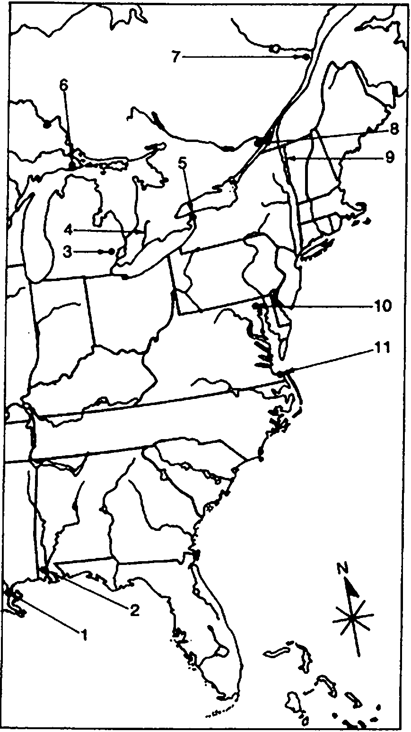

52. ____ Detroit

ANS: 3

53. ____ Fort Niagara

ANS: 5

54. ____ Lake Champlain

ANS: 9

55. ____ Michilimackinac

ANS: 6

56. ____ Thames River

ANS: 4

57. ____ Fort McHenry

ANS: 10

58. ____ New Orleans

ANS: 1

Locate the following places by reference number on the map:

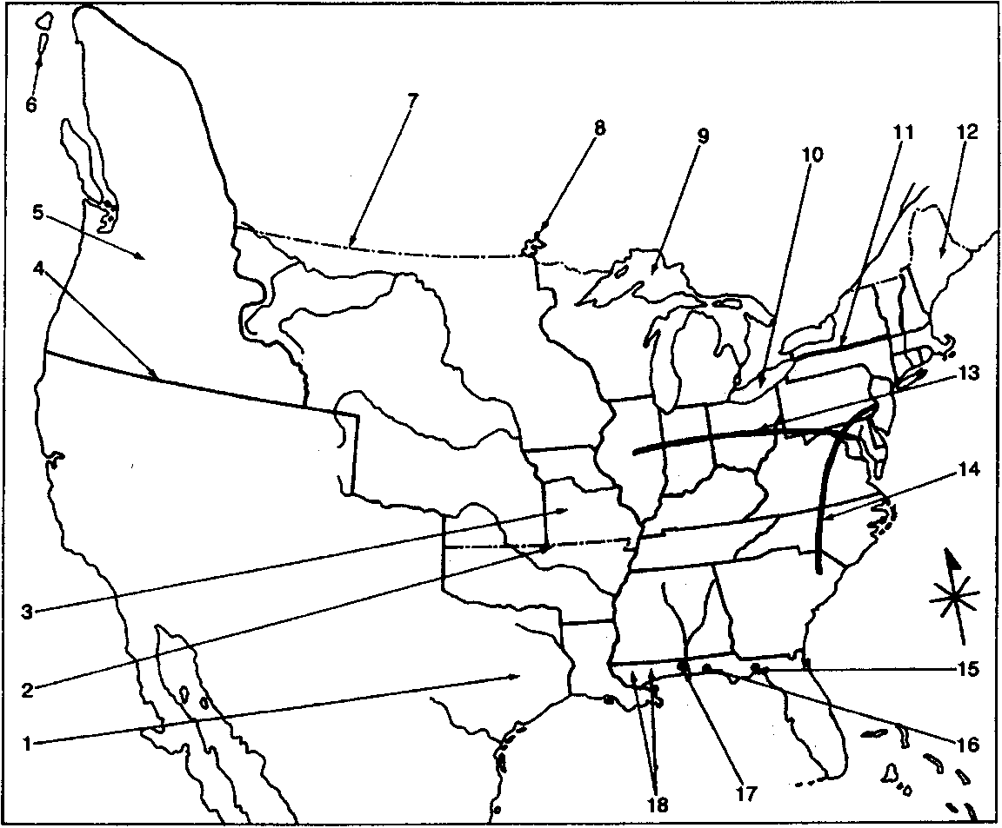

59. ____ Erie Canal

ANS: 11

60. ____ Cumberland Road

ANS: 13

61. ____ Missouri Territory

ANS: 3

62. ____ Maine

ANS: 12

63. ____ 36° 30'

ANS: 2

64. ____ forty-ninth parallel

ANS: 7

65. ____ Lake of the Woods

ANS: 8

66. ____ Oregon County

ANS: 5

67. ____ West Florida

ANS: 18

68. ____ Mobile

ANS: 17

69. ____ St. Marks

ANS: 15

70. ____ Pensacola

ANS: 16

MULTIPLE CHOICE

71. The War of 1812 was one of the worst fought wars in the United States history because
a. | the American military strategy was hopelessly flawed.
b. | no talented military commanders emerged.
c. | of inadequate financing of the war.
d. | the navy lacked skill and discipline.
e. | of the nation's apathy and national disunity.

ANS: E REF: p. 224

72. All of the following were true of the American regular army on the eve of the War of 1812 except
a. | they were ill-trained and ill-disciplined.
b. | they were widely scattered.
c. | their numbers were large enough that they did not have to rely on the militia.
d. | most of the generals were leftovers from the Revolutionary War and lacked vigor and vision.
e. | there was no burning national anger to unite them.

ANS: C REF: p. 224

73. When the United States entered the War of 1812, it was
a. | militarily unprepared.
b. | allied with France.
c. | united in support of the war.
d. | fortunate to have a strong and assertive commander in chief.
e. | clear what its political and military objectives were.

ANS: A REF: p. 224

74. The War of 1812 was one of the worst fought wars in American history for all of the following reasons except that
a. | the militia was never called up to supplement the regular army.
b. | disunity was widespread.
c. | only a zealous minority supported the war.
d. | at first, many of the generals were senile Revolutionary War veterans.
e. | the militia was poorly trained.

ANS: A REF: p. 224

75. Canada became an important battleground in the War of 1812 because
a. | it was the economic hub of the New England economy.
b. | Canadians would be willing to help the Americans overthrow the imperial yoke of British rule.
c. | British forces were weakest there.
d. | most of the American regular army was already located in Canada.
e. | Canada held important strategic military bases from which the Americans could attack the British.

ANS: C REF: p. 224

76. The performance of the United States' Navy in the War of 1812 could be best described as
a. | poor and unsuccessful in every category.
b. | less successful than that of the army.
c. | courageous but strategically ineffective.
d. | most effective on the Atlantic Ocean.
e. | surprisingly successful.

ANS: E REF: p. 225

77. America's campaign against Canada in the War of 1812 was
a. | unusual for its brilliant military leadership.
b. | poorly conceived because it split up the military and ultimately a failure.
c. | marked by good coordination of a complicated strategy.
d. | a failure because they focused all their attention on Montreal.
e. | a success on land but a failure on the water.

ANS: B REF: p. 225

78. Perhaps the key battle of the War of 1812, because it protected the United States from full-scale invasion and possible dissolution, was the Battle of
a. | Mackinac.
b. | Plattsburgh.
c. | the Thames.
d. | Horseshoe Bend.
e. | Fallen Timbers.

ANS: B REF: p. 225

79. By 1814, the British strategy included all of the following except
a. | invading New York.
b. | invading the Chesapeake Bay area.
c. | invading the Delaware and Hudson Valleys.
d. | blockading the Atlantic coast.
e. | invading New Orleans and the Mississippi Valley.

ANS: C REF: p. 225-227

80. British plans for their 1814 campaign did not include action in
a. | New York.
b. | the Chesapeake.
c. | Florida.
d. | New Orleans.
e. | Washington.

ANS: C REF: p. 225-226

81. The British attack on Fort McHenry
a. | resulted in another British victory.
b. | made possible the British invasion of Washington, D.C.
c. | inspired the writing of "The Star-Spangled Banner."
d. | produced the "Bladensburg Races."
e. | resulted in the destruction of many British shops.

ANS: C REF: p. 225

82. The most devastating defeat suffered by the British during the War of 1812 took place at the Battle of
a. | New Orleans.
b. | Horseshoe Bend.
c. | Tippecanoe.
d. | the Thames.
e. | Fallen Timbers.

ANS: A REF: p. 226

83. The Battle of New Orleans
a. | resulted in one more American defeat.
b. | helped the United States to win the War of 1812.
c. | saw British troops defeated by Andrew Jackson's soldiers.
d. | prevented America from taking Canada.
e. | resulted in Louisiana becoming part of the United States.

ANS: C REF: p. 226

84. The Battle of New Orleans
a. | saw the British win another victory.
b. | followed a British defeat at Washington, D.C.
c. | was fought by the United States only for material gain.
d. | resulted in the British seeking peace.
e. | unleashed a wave of nationalism and self-confidence.

ANS: E REF: p. 226-227

85. Andrew Jackson sought to recruit free blacks to defend New Orleans by appealing to the governor of Louisiana using all of the following arguments except
a. | free men of colour are inured to the Southern climate and would make excellent soldiers.
b. | many of the free men are idle and would benefit from a term of military service.
c. | trusting the free men to serve in the military will forge a strong bond between them and the interests of the country.
d. | free men of colour enjoy equal rights and privileges with white men.
e. | free blacks must choose up sides - either stand with the nation or stand against it.

ANS: B REF: p. 227

86. One result of the American naval victories on the Great Lakes during the War of 1812 was
a. | a British naval blockade of the American coast.
b. | the improvement of the American fishing industry.
c. | an increase in British naval operations in Canadian waters.
d. | the final elimination of British raiding parties landing on America's east coast.
e. | U.S. disruption of British overseas trade.

ANS: A REF: p. 227

87. At the peace conference at Ghent, the British began to withdraw many of its earlier demands for all of the following reasons except
a. | reverses in upper New York.
b. | a loss at Baltimore.
c. | increasing war weariness in Britain.
d. | concern about the still dangerous France.
e. | the American victory at New Orleans.

ANS: E REF: p. 227

88. Political cartoons lampooned the states that threatened to leave the Union at the Harford Convention by
a. | depicting Great Britain welcoming them back with promises of nobility, goods to smuggle and plenty of molasses and codfish.
b. | showing them as spoiled children, acting out against a firm parent.
c. | portraying them as militant anti-Federalists who put selfish interests above the nation's.
d. | highlighting their rigid refusal to consider gradually ending slavery.
e. | None of these

ANS: A REF: p. 228

89. The delegates of the Hartford Convention adopted resolutions that demanded all of the following except
a. | a single-term limit on the presidency.
b. | a guarantee of no future wars with Britain.
c. | financial compensation to New England for lost trade.
d. | abolition of the three-fifths clause.
e. | reduction in the amount of representation the South had in Congress.

ANS: B REF: p. 228-229

90. The delegates of the Hartford Convention adopted resolutions that included a call for
a. | a Constitutional amendment requiring a two-thirds vote in Congress before war was declared.
b. | New England's secession from the Union.
c. | a separate peace treaty between New England and the British.
d. | the dissolution of the Federalist party.
e. | war with England.

ANS: A REF: p. 228

91. The resolutions from the Hartford Convention
a. | helped to cause the death of the Federalist party.
b. | resulted in the resurgence of states' rights.
c. | called for southern secession from the union.
d. | supported use of state militias against the British.
e. | called for the West to join the War of 1812.

ANS: A REF: p. 229

92. From a global perspective, the War of 1812 was
a. | a highly significant conflict.
b. | more important to Europeans than to Americans.
c. | of little importance.
d. | responsible for the defeat of Napoleon.
e. | more important than the American Revolution.

ANS: C REF: p. 229

93. In diplomatic and economic terms, the War of 1812
a. | was a disaster for the United States.
b. | could be considered the Second War for Independence.
c. | had few significant consequences for Americans.
d. | created permanent hostility between the United States and Canada.
e. | made Americans more internationally minded.

ANS: B REF: p. 229

94. The outcome of the War of 1812 was a(n)
a. | decisive victory for the United States.
b. | stimulus to patriotic nationalism in the United States.
c. | embarrassment for American diplomacy.
d. | heavy blow to American manufacturing.
e. | decisive victory for the British.

ANS: B REF: p. 230

95. For Native Americans, the War of 1812 meant
a. | renewed ties to their British allies.
b. | treaties in which they reluctantly relinquished lands north of the Ohio River.
c. | the spread of diseases that decimated tribal populations.
d. | the destruction of the buffalo, on which they relied for food and trade.
e. | None of these

ANS: B REF: p. 230

96. The Rush-Bagot agreement
a. | required the Indians to relinquish vast areas of tribal lands north of the Ohio River.
b. | ended the traditional mutual suspicion and hatred between the United States and Great Britain.
c. | limited naval armaments on the Great Lakes.
d. | provided for Canadian independence from Great Britain.
e. | gave Florida to the United States.

ANS: C REF: p. 230

97. After Napoleon's defeat at Waterloo in 1815, Europe
a. | was engulfed by liberal and democratic revolutions.
b. | developed very close ties to the United States.
c. | formed a military alliance to contain any future French aggression.
d. | turned toward conservatism, illiberalism, and reaction.
e. | sought more trade with China.

ANS: D REF: p. 230

98. One of the most important by-products of the War of 1812 was
a. | a renewed commitment to states' rights.
b. | a heightened spirit of nationalism.
c. | a resurgence of the Federalist party.
d. | increased economic dependence on Europe.
e. | the subjugation of the Indians.

ANS: B REF: p. 230-231

99. The two most internationally recognized American writers in the 1820s were
a. | Washington Irving and James Fenimore Cooper.
b. | Edgar Allan Poe and Charles Baudelaire.
c. | Walt Whitman and Emily Dickinson.
d. | Herman Melville and Nathaniel Hawthorne.
e. | Ralph Waldo Emerson and Henry David Thoreau.

ANS: A REF: p. 231

100. Post-War of 1812, nationalism could be seen in all of the following except
a. | the way in which American painters depicted the beauty of American landscapes.
b. | a revival of American religion.
c. | the building of a more handsome national capital.
d. | an expanded army and navy.
e. | development of a national literature.

ANS: B REF: p. 231

101. At the end of the War of 1812, British manufacturers
a. | discontinued trade with America.
b. | conducted only limited trade with America.
c. | began dumping their goods in America at extremely low prices.
d. | demanded a high tariff against American goods.
e. | saw their profits fall dramatically.

ANS: C REF: p. 231

102. The Tariff of 1816 was the first in American history
a. | to be enacted without the consent of Congress.
b. | intended to raise revenue.
c. | that aimed to protect American industry.
d. | to impose taxes on American goods.
e. | designed to protect Southern agriculture.

ANS: C REF: p. 231

103. Henry Clay embraced a program in 1824 called the American System which would create all of the following except
a. | a strong banking system.
b. | easy and abundant credit.
c. | a protective tariff to enable manufacturing to grow.
d. | a network of roads and canals for transporting foodstuffs, raw materials and manufactured goods nationwide.
e. | a solid navy to protect America's merchant ships.

ANS: E REF: p. 231

104. New England opposed the notion of federally constructed roads because
a. | they cost too much.
b. | the Democratic-Republicans favored them.
c. | canals were a superior means of transportation.
d. | they would drain away population and create competing states in the West.
e. | they were poorly constructed.

ANS: D REF: p. 232

105. Democratic-Republicans opposed Henry Clay's American System because
a. | it favored only the South.
b. | it would provide stiff competition to the Erie Canal.
c. | they believed that it was unconstitutional.
d. | they thought it would center more control in Washington.
e. | they believed in low tariffs and low taxes.

ANS: C REF: p. 232

106. The Era of Good Feelings
a. | was characterized by the absence of any serious problems.
b. | was noted for cooperation between the Democratic-Republicans and the Federalists.
c. | marked a temporary end to sectionalism by uniting all parts of the country.
d. | was a misnomer, because the period was a troubled one.
e. | saw the start of the Whig political party.

ANS: D REF: p. 232

107. With the demise of the Federalist party
a. | the Democratic-Republicans established one-party rule.
b. | another party arose very quickly to take its place.
c. | little political trouble ensued.
d. | sectionalism disappeared.
e. | the Whig party rose to take its place.

ANS: A REF: p. 232

108. The Panic of 1819 brought with it all of the following except
a. | inflation.
b. | unemployment.
c. | bank failures.
d. | debtors' prisons.
e. | bankruptcies.

ANS: A REF: p. 233

109. One of the major causes of the Panic of 1819 was
a. | bankruptcies.
b. | overspeculation in frontier lands.
c. | deflation.
d. | the failure to recharter the Bank of the United States.
e. | a drought that resulted in poor agricultural production.

ANS: B REF: p. 233

110. The western land boom resulted from all of the following except
a. | it was a continuation of the old westward movement.
b. | land exhaustion in older tobacco states.
c. | speculators accepted small down payments.
d. | the frontier was pacified with the defeat of the Indians.
e. | the construction of railroad lines west of the Mississippi River.

ANS: E REF: p. 233-234

111. One of the West's persistent political demands was for
a. | a strong gold-back monetary system.
b. | a stronger Bank of the United States.
c. | cheap money issued by unregulated banks.
d. | federal aid to agriculture.
e. | a homestead act offering free land to settlers.

ANS: C REF: p. 234

112. When the House of Representatives passed the Tallmadge Amendment in response to Missouri's request for admission to the Union, the South thought that the amendment
a. | would threaten the sectional balance.
b. | might keep alive the institution of slavery.
c. | would slow the growth of the West.
d. | would silence the abolitionists.
e. | would keep Maine out of the union.

ANS: A REF: p. 234

113. The first state entirely west of the Mississippi River to be carved out of the Louisiana Territory was
a. | Kansas.
b. | Louisiana.
c. | Texas.
d. | Arkansas.
e. | Missouri.

ANS: E REF: p. 234

114. In the North, the admission of Missouri as a state
a. | inspired a small but growing group of antislavery advocates to speak out against the evils of slavery.
b. | was hailed by merchants as a potential new market.
c. | was seen as a chance to strengthen the "New England dynasty"
d. | inspired a movement to amend the Constitution.
e. | None of these

ANS: A REF: p. 234

115. As a result of the Missouri Compromise
a. | there were more slave than free states in the Union.
b. | slavery was outlawed in all states north of the forty-second parallel.
c. | slavery was banned north of 36° 30' in the Louisiana Purchase territory.
d. | Missouri was required to free its slaves when they reached full adulthood.
e. | there were more free states than slave states in the Union.

ANS: C REF: p. 235

116. All of the following were results of the Missouri Compromise except that
a. | extremists in both the North and South were not satisfied.
b. | Missouri entered the Union as a slave state.
c. | Maine entered the Union as a free state.
d. | sectionalism was reduced.
e. | the balance between the North and South was kept even.

ANS: D REF: p. 235

117. People moved into the Old Northwest for all of the following reasons except
a. | the canal and highway boom opened the area to settlement.
b. | the Indian threat had been substantially weakened.
c. | to acquire cheap and productive land.
d. | to escape the domination of wealthy plantation owners.
e. | to expand the territory where slavery was legal.

ANS: E REF: p. 236-237

118. Settlers from the South who moved into the Old Northwest territory were known as
a. | Yankees.
b. | carpet baggers.
c. | planters.
d. | slave holders.
e. | Butternuts.

ANS: E REF: p. 236

119. When moving to the Old Northwest, settlers from the North wanted to do all of the following except
a. | pay taxes for public improvements.
b. | build roads and canals.
c. | support an educated clergy.
d. | develop public education.
e. | live in harmony with the Indians.

ANS: C REF: p. 236-237

120. In interpreting the Constitution, John Marshall
a. | favored loose construction.
b. | supported strict construction.
c. | supported an unchanging document.
d. | advocated state control of interstate commerce.
e. | set few precedents.

ANS: A REF: p. 238

121. John Marshall uttered his famous legal dictum that "the power to tax involves the power to destroy" in
a. | Gibbons v. Ogden.
b. | Fletcher v. Peck.
c. | McCulloch v. Maryland.
d. | Dartmouth College v. Woodward.
e. | Marbury v. Madison.

ANS: C REF: p. 238

122. In the cases of Fletcher v. Peck and Dartmouth College v. Woodward, Chief Justice John Marshall's rulings
a. | erected barriers against democratic attacks on property rights.
b. | established the principle of judicial review.
c. | demonstrated his support for states' rights.
d. | upheld federal authority against individual rights at the federal level.
e. | held federal regulatory laws unconstitutional if they conflicted with the U.S. Constitution.

ANS: A REF: p. 238

123. In McCulloch v. Maryland, Cohens v. Virginia, and Gibbons v. Ogden, Chief Justice Marshall's rulings limited the extent of
a. | states' rights.
b. | judicial review.
c. | federalism.
d. | constitutionalism.
e. | federal authority.

ANS: A REF: p. 238

124. John Marshall's rulings almost single-handedly shaped Constitutional interpretation in the direction of
a. | strict adherence to the letter of the Constitution.
b. | upholding individual liberties.
c. | preserving the balance of power between Congress and the president.
d. | nationalistic centralism and conservatism.
e. | states' rights over the federal government.

ANS: D REF: p. 238

125. John Marshall's rulings upheld a defense of property rights against public pressure in
a. | McCulloch v. Maryland.
b. | Marbury v. Madison.
c. | Cohens v. Virginia.
d. | Fletcher v. Peck.
e. | Gibbons v. Ogden.

ANS: D REF: p. 238

126. The United States' most successful diplomat in the Era of Good Feelings was
a. | John C. Calhoun.
b. | Daniel Webster.
c. | John Quincy Adams.
d. | Andrew Jackson.
e. | James Monroe.

ANS: C REF: p. 239

127. The Treaty of 1818 with England
a. | used the watershed of the Missouri River to define the United States' border with Canada as far west as the Rocky Mountains.
b. | formally recognized America's earlier conquest of West Florida.
c. | called for a ten-year joint occupation of the Oregon country by both American citizens and British subjects.
d. | granted Canada exclusive use of Newfoundland fisheries.
e. | saw the United States forced to give up its tariffs on British goods.

ANS: C REF: p. 239

128. Andrew Jackson's military exploits were instrumental in the United States gaining
a. | a favorable border with Canada from the Great Lakes to the Rocky Mountains.
b. | possession of Florida from the Spanish.
c. | joint fishing rights in Labrador, Nova Scotia, and Newfoundland.
d. | naval limitations on the Great Lakes.
e. | gaining control of eastern Texas.

ANS: B REF: p. 240-241

129. Spain sold Florida to the United States because it
a. | wanted to help America to become a rival to Britain.
b. | could not defend the area and would lose it in any case.
c. | received America's promise to give up claims to Oregon.
d. | was pulling out of the Western Hemisphere.
e. | decided to concentrate its efforts in Mexico.

ANS: B REF: p. 240-241

130. Britain opposed Spain's reestablishing its authority in Latin American countries that had successfully revolted because
a. | Britain had now allied itself with France.
b. | Britain had great sympathy toward democratic revolutions.
c. | the United States had asked for such a policy.
d. | the ports of these nations were now open to lucrative trade.
e. | it wanted to take control of these nations.

ANS: D REF: p. 241

131. The doctrine of noncolonization in the Monroe Doctrine was
a. | applicable only to Central and South America.
b. | a response to the apparent designs of the Russians in Alaska and Oregon.
c. | included in the doctrine only over the opposition of Secretary of State John Quincy Adams.
d. | mostly a symbolic gesture of goodwill to the Latin American republics.
e. | aimed at British efforts to gain control over Cuba.

ANS: B REF: p. 242

132. At the time it was issued, the Monroe Doctrine was
a. | incapable of being enforced by the United States.
b. | greeted with enthusiasm and gratitude in South America.
c. | universally acclaimed in Britain as a great act of statesmanship.
d. | welcomed with relief by European powers who feared British power in the Western Hemisphere.
e. | opposed by both the Whigs and the Democratic-Republicans.

ANS: A REF: p. 243

133. Latin America's reaction to the Monroe Doctrine can best be described as
a. | enthusiastic.
b. | fearful of the United States.
c. | unconcerned or unimpressed.
d. | relying on Britain to void it.
e. | None of these

ANS: C REF: p. 243

134. The Russo-American Treaty of 1824 fixed the southernmost limits of Russian occupation of North America at
a. | 54° 40'.
b. | 36° 30'.
c. | the forty-second parallel.
d. | the forty-ninth parallel.
e. | the fifty-first parallel.

ANS: A REF: p. 243

135. The Monroe Doctrine was
a. | a striking new departure in American foreign policy.
b. | quickly codified into international law.
c. | a binding pledge on each subsequent presidential administration.
d. | an expression of the illusion of deepening American isolationism from world affairs.
e. | a commitment by the United States to internationalism.

ANS: D REF: p. 244

MULTIPLE RESPONSE

136. America's postwar nationalism manifested itself in the
a. | rechartering of a national bank.
b. | literary themes of James Fenimore Cooper and Washington Irving.
c. | financial Panic of 1819.
d. | Missouri Compromise debates.
e. | explorations of Lewis and Clark.

ANS: A, B REF: p. 230-232

137. Henry Clay's American System called for
a. | federally funded internal improvements.
b. | the abolition of slavery in the territories.
c. | international free trade.
d. | protective tariffs.
e. | continuation of the National Bank.

ANS: A, D REF: p. 231-232

138. The Panic of 1819
a. | created a setback for postwar nationalism.
b. | was particularly damaging to the West.
c. | led to the Land Act of 1820.
d. | resulted in legislation against imprisonment for debt in many states.
e. | saw the election of a Whig president in 1820.

ANS: A, B, C, D REF: p. 233

139. The rapid growth and development of the West after 1815 were stimulated by
a. | the lure of cheap lands to easterners and European immigrants.
b. | construction of new roads through the mountains into the West.
c. | the subduing of the Indian tribes during the War of 1812.
d. | the abolition of slavery from western territories.
e. | the Spanish leaving California.

ANS: A, B, C REF: p. 233-234

140. Sectionalism was stimulated by the
a. | American System.
b. | death of the Federalist party.
c. | Panic of 1819.
d. | Tallmadge Amendment.
e. | Monroe Doctrine.

ANS: C, D REF: p. 234

141. John Marshall's decisions as chief justice revealed his belief in
a. | manhood-suffrage democracy.
b. | strong central government.
c. | the sanctity of private property.
d. | Hamiltonian principles.
e. | states' rights.

ANS: B, C, D REF: p. 238-239

142. In the Florida Purchase Treaty,
a. | Spain ceded ownership of East Florida to the United States.
b. | the United States surrendered its claims to Spanish Texas.
c. | a boundary was established that separated American holdings in Louisiana and the Oregon Country from the Spanish Southwest.
d. | Spain promised to control Indian outlaws in East Florida.
e. | Spain promised to leave Cuba.

ANS: A, B, C REF: p. 241

143. The Monroe Doctrine was essentially intended to prevent
a. | new European colonies from being established in the Western Hemisphere.
b. | European nations from intervening in the affairs of Latin American countries.
c. | the United States from intervening in the affairs of Latin American countries.
d. | dictatorships in Latin American governments.
e. | Russian control of Alaska.

ANS: A, B REF: p. 242-243

ESSAY

144. Why were internal improvements a controversial issue in the decade following the War of 1812?

ANS:
Student answers will vary.

145. Why was the West the region most seized with the spirit of nationalism following the War of 1812?

ANS:
Student answers will vary.

146. To what extent had John Quincy Adam's behavior during the Florida Purchase Treaty and the Monroe Doctrine earned him the title of the "lone-wolf nationalist"?

ANS:
Student answers will vary.

147. Why did the United States reject the British foreign minister's proposal for a joint declaration of opposition to any further colonization in the Western Hemisphere?

ANS:
Student answers will vary.

148. To what extent was the Monroe Doctrine an isolationist document? Support your answer.

ANS:
Student answers will vary.

149. Rank the following in the order of what you see as their importance in shaping America's legal system: McCulloch v. Maryland, Gibbons v. Ogden, Fletcher v. Peck, Dartmouth College v. Woodward, and Cohens v. Virginia. Justify your ranking.

ANS:
Student answers will vary.

150. Select two of the following and explain what important contributions to American nationalism after the War of 1812 they made: John Marshall, Daniel Webster, Henry Clay, and John Quincy Adams? Justify your selection.

ANS:
Student answers will vary.

151. To what extent is the Era of Good Feelings "something of a misnomer" for the decade following the War of 1812?

ANS:
Student answers will vary.

152. Historians have sometimes referred to the program of the Jeffersonian Republicans after 1815 as "neo-Federalist." Is this an accurate label? Why or why not?

ANS:
Student answers will vary.

153. Compare and contrast the competing views behind both sides of the Missouri Compromise. To what extent can the compromise be seen as a victory and a loss for both sides. Which side do you think got the better deal? Justify your answer.

ANS:
Student answers will vary.

154. The text's authors crown John Marshall as "the foremost of the Molding Fathers," whereas a contemporary newspaper editorial condemned him as "a man whose political doctrines led him always ... to strengthen government at the expense of the people." Which point of view do you think has the most substance? Why?

ANS:
Student answers will vary.

155. Which do you think was the most significant event of the decade following the Treaty of Ghent: Panic of 1819, McCulloch v. Maryland, Florida Purchase Treaty, Missouri Compromise, or Monroe Doctrine? Justify your selection.

ANS:
Student answers will vary.

156. Why were the landlocked South and West so ardently in favor of a war for freedom of the seas that seacoast states in the East opposed?

ANS:
Student answers will vary.

157. Since both France and Britain were guilty of placing commercial restrictions on American trade, why did the United States declare war only on Britain?

ANS:
Student answers will vary.

158. To what extent can it be said that the United States won a victory over Great Britain in the War of 1812?

ANS:
Student answers will vary.

159. Write your definition of national independence. Then use this definition to argue that the War of 1812 should or should not be called the Second War for American Independence.

ANS:
Student answers will vary.

160. Which do you think was the major cause of the War of 1812: western war hawk territorial expansion, British violations of American neutrality rights on the high seas, or the urge to uphold national honor and pride? Justify your selection.

ANS:
Student answers will vary.

161. What do the text's authors mean by stating that the War of 1812 "was 'won' by the United States, so far as it was won at all, in Europe"?

ANS:
Student answers will vary.

162. Regarding opposition to the War of 1812, the authors remark that "profits dull patriotism." Is this a fair explanation of antiwar sentiment in 1812-1815? Why or why not?

ANS:
Student answers will vary.

163. What might the president and Congress have done in 1812 to avoid war with Britain and still maintain the nation's honor?

ANS:
Student answers will vary.

164. Assess the validity of the following statement, "America may not have fought the war as one nation, but it emerged as one nation."

ANS:
Student answers will vary.

165. Compare and contrast the strengths and weaknesses of Henry Clay's "American System." What was the basis of support and opposition for this proposal?

ANS:
Student answers will vary.

166. Describe the ways in which nationalism exhibited itself in the American republic following the War of 1812?

ANS:
Student answers will vary.

