Chapter 21—The Furnace of Civil War, 1861-1865

SHORT ANSWER

Identify and state the historical significance of the following:

1. Clement L. Vallandigham

ANS:
Student answers will vary.

2. Andrew Johnson

ANS:
Student answers will vary.

3. John Wilkes Booth

ANS:
Student answers will vary.

4. Robert E. Lee

ANS:
Student answers will vary.

5. Thomas J. Jackson

ANS:
Student answers will vary.

6. Ulysses S. Grant

ANS:
Student answers will vary.

7. George B. McClellan

ANS:
Student answers will vary.

8. William T. Sherman

ANS:
Student answers will vary.

9. George B. Meade

ANS:
Student answers will vary.

10. Salmon P. Chase

ANS:
Student answers will vary.

11. David G. Farragut

ANS:
Student answers will vary.

12. George Pickett

ANS:
Student answers will vary.

13. Edward Everett Hale

ANS:
Student answers will vary.

Describe and state the historical significance of the following:

14. Merrimack (the Virginia)

ANS:
Student answers will vary.

15. Monitor

ANS:
Student answers will vary.

16. Emancipation Proclamation

ANS:
Student answers will vary.

17. Thirteenth Amendment

ANS:
Student answers will vary.

18. Copperheads

ANS:
Student answers will vary.

19. Union party

ANS:
Student answers will vary.

20. First Battle of Bull Run

ANS:
Student answers will vary.

21. Second Battle of Bull Run

ANS:
Student answers will vary.

22. Battle of Antietam

ANS:
Student answers will vary.

23. Peninsula Campaign

ANS:
Student answers will vary.

24. Battle of Fredericksburg

ANS:
Student answers will vary.

25. Battle of Chancellorsville

ANS:
Student answers will vary.

26. Battle of Gettysburg

ANS:
Student answers will vary.

27. Battle of Vicksburg

ANS:
Student answers will vary.

28. Gettysburg Address

ANS:
Student answers will vary.

29. Congressional Committee on the Conduct of the War

ANS:
Student answers will vary.

30. Ford's Theater

ANS:
Student answers will vary.

31. The Man Without a Country

ANS:
Student answers will vary.

COMPLETION

Locate the following places by reference number on the map:

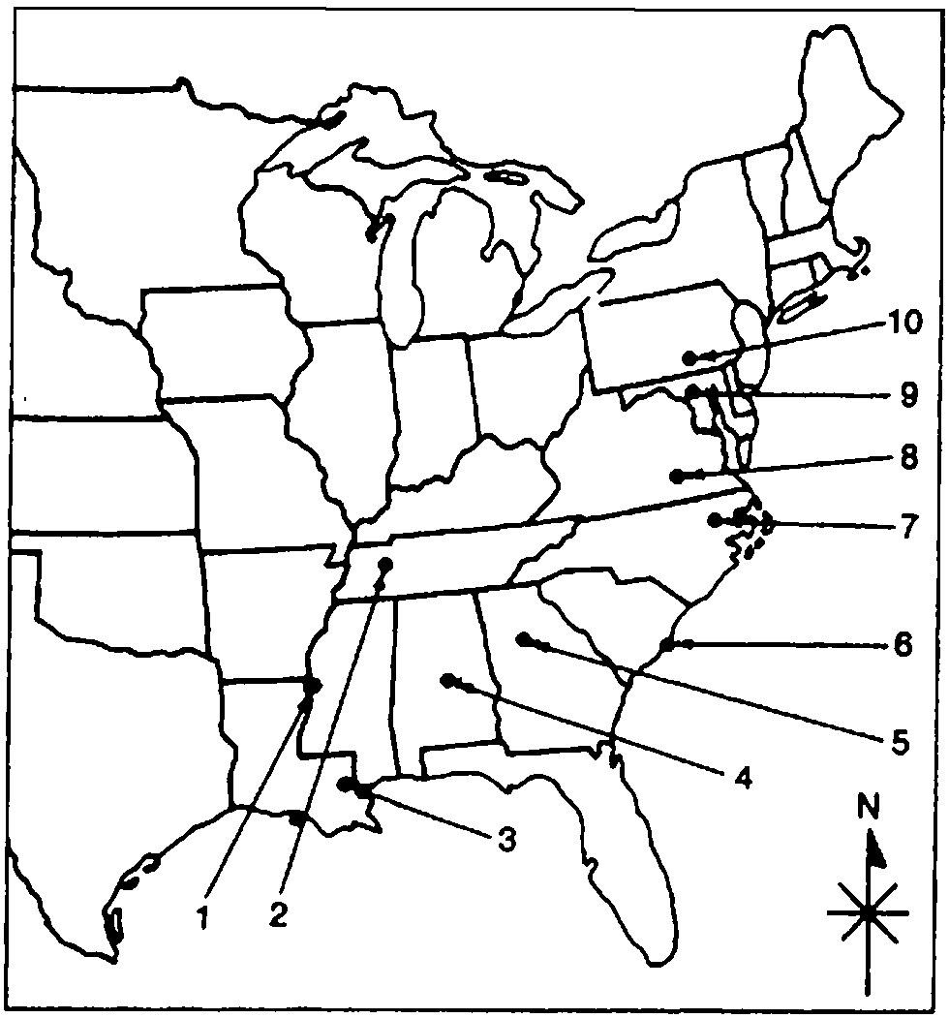

32. ____ Vicksburg

ANS: 1

33. ____ Gettysburg

ANS: 10

34. ____ Fort Sumter

ANS: 6

35. ____ Atlanta

ANS: 5

36. ____ Antietam

ANS: 9

37. ____ Montgomery

ANS: 4

38. ____ Richmond

ANS: 8

MULTIPLE CHOICE

39. At the beginning of the Civil War, President Abraham Lincoln favored
a. | postponing military action as long as possible.
b. | making the Civil War about ending slavery.
c. | long-term enlistments for Union soldiers.
d. | quick military action to show the folly of secession.
e. | seizing control of the Ohio and Mississippi Rivers.

ANS: D REF: p. 435

40. Lincoln hoped that a Union victory at Bull Run would
a. | lead to the capture of the Confederate capital at Richmond.
b. | bring an end to slavery.
c. | destroy the economy of the South.
d. | pull the Border states out of the Confederacy.
e. | All of these

ANS: A REF: p. 435

41. Arrange the following in chronological order: (A) the Battle of Bull Run, (B) the Battle of Gettysburg, (C) Lee's surrender at Appomattox, and (D) the Battle of Antietam.
a. | B, C, A, D
b. | D, B, C, A
c. | C, A, D, B
d. | A, B, D, C
e. | A, D, B, C

ANS: E REF: p. 435 | p. 440 | p. 445 | p. 455

42. The South's victory at Bull Run in 1861
a. | reduced enlistments in the South's army.
b. | reduced the number of Confederate deserters.
c. | demonstrated how difficult Confederate independence would be.
d. | convinced the South of the need to prepare for a protracted conflict.
e. | forced Lincoln to flee Washington.

ANS: A REF: p. 436

43. The Union's defeat in battle at Bull Run in 1861 was better than a victory because
a. | Ulysses S. Grant took command of the army immediately after the setback.
b. | the defeat caused Northerners to face up to the reality of a long, difficult war.
c. | "Stonewall" Jackson was killed.
d. | it caused Lincoln to declare a war against slavery.
e. | it allowed European powers the chance to intervene on behalf of the South.

ANS: B REF: p. 436

44. George B. McClellan, commander of the Army of the Potomac, is best described as
a. | disliked by his own men.
b. | aggressive.
c. | overly cautious.
d. | poorly prepared for military leadership.
e. | poorly organized.

ANS: C REF: p. 437

45. After assuming command of the Army of the Potomac, General George McClellan made the mistake of
a. | taking too many risks.
b. | relying on Lincoln's military judgment.
c. | being unconcerned about the morale of his troops.
d. | not drilling his troops enough to prepare them for battle.
e. | consistently believing that the enemy outnumbered him.

ANS: E REF: p. 437

46. As a result of the Union loss in the Peninsula Campaign
a. | Lincoln named George McClellan commander of the Union forces.
b. | the North decided to fight a war of containment.
c. | Lincoln began to draft the Emancipation Proclamation.
d. | Lincoln decided that the key to the war was controlling the Mississippi River.
e. | the Union commanders were left without an overall military strategy.

ANS: C REF: p. 438

47. After the Peninsula Campaign, Union strategy included all of the following except
a. | cutting the Confederacy in half by seizing the Mississippi River.
b. | marching through Georgia and then the Carolinas.
c. | blockading the Confederacy's coastline.
d. | liberating the slaves to undermine the southern economy.
e. | striking deep into the Confederacy via the Appalachian Mountain chain.

ANS: E REF: p. 438

48. As a result of the Confederate victory in the Peninsula Campaign
a. | Robert E. Lee was named to command the entire Southern army.
b. | Lincoln named Ulysses S. Grant as commander of the Union forces.
c. | Lincoln delayed his issuance of the Emancipation Proclamation.
d. | the Union turned to a strategy of total war.
e. | Lincoln abandoned the war in the West.

ANS: D REF: p. 438

49. Britain did not protest too loudly against the Union naval blockade of the Confederacy because
a. | Britain might want to use a similar blockade in a future war.
b. | the British government clearly supported the Union.
c. | it would have been useless to try to run the blockade.
d. | profits were not high enough to justify the risk.
e. | the blockade did not cut off cotton shipments.

ANS: A REF: p. 438

50. The most serious Confederate threat to the Union blockade came from
a. | British navy vessels on loan to the South.
b. | swift blockade-running steamers.
c. | the threat of mutiny from pro-southern sailors.
d. | the Confederate cruiser Alabama.
e. | the ironclad Merrimack (renamed the Virginia).

ANS: E REF: p. 439

51. The Confederate blockade runner, the Merrimack, was
a. | destroyed by Union troops to prevent its use as a slave ship.
b. | captured and used by Union troops to help restore the Federal blockade.
c. | destroyed by Confederate soldiers to keep it out of the hands of Union troops.
d. | able to escape to British ports.
e. | used to ferry both British and French troops across the ocean.

ANS: C REF: p. 440

52. After defeating McClellan at the Second Battle of Bull Run, Robert E. Lee decided to
a. | consolidate his forces to protect the Confederate capital.
b. | send Jeb Stuart's calvary to raid northern lines.
c. | invade the Union via Maryland.
d. | call for a ceasefire and peace negotiations.
e. | shift some of his troops to the Tennessee and Kentucky fronts.

ANS: C REF: p. 440

53. In invading Maryland, one of Lee's key objectives was to
a. | show northerners how polished and well-equipped the Confederate army was.
b. | capture or destroy Union arsenals and railroad lines.
c. | destroy McClellan's army.
d. | capture Lincoln and his Cabinet.
e. | inspire the Border States to rise up and join the Confederacy.

ANS: E REF: p. 440

54. A victory at Antietam probably would have won Confederate independence because
a. | the Union armies were already heavily demoralized.
b. | France and Britain were on the verge of recognizing the Confederate government.
c. | the Republicans would have lost the subsequent congressional elections.
d. | Lincoln would have been unable to issue the Emancipation Proclamation.
e. | the Border States would have joined the Confederacy.

ANS: B REF: p. 440

55. After halting Lee's troops at Antietam, General George McClellan
a. | retired from the military.
b. | moved to confront Lee again at Gettysburg.
c. | was appointed to command the main Western army.
d. | marched his army toward Atlanta.
e. | was removed from his field command.

ANS: E REF: p. 440

56. One of the key developments enabling the Union to stop the Confederate thrust into the North at Antietam was
a. | Europe's refusal to help the South before the battle.
b. | the Union's discovery of Robert E. Lee's battle plans.
c. | Lincoln's removal of General McClellan from his command.
d. | the use of the new repeating rifle for the first time.
e. | the death of Stonewall Jackson during the battle.

ANS: B REF: p. 440

57. The two major battles of the Civil War fought on Union soil were
a. | Shiloh and Chancellorsville.
b. | Bull Run and Vicksburg.
c. | Gettysburg and Antietam.
d. | Peninsula Campaign and Fredericksburg.
e. | Mobile and Missionary Ridge.

ANS: C REF: p. 440 | p. 445

58. The Battle of Antietam was particularly critical because it
a. | inflated an already dangerous overconfidence among Southerners.
b. | ended Lee's plan of invading the North.
c. | delayed Lincoln's plan to announce the Emancipation Proclamation.
d. | ensured the reelection of President Lincoln.
e. | probably prevented intervention by Britain and France on behalf of the Confederacy.

ANS: E REF: p. 440

59. The North's victory at Antietam allowed President Lincoln to
a. | issue the Emancipation Proclamation.
b. | seek military assistance from Great Britain.
c. | force the Border States to remain in the Union.
d. | keep General McClellan as commander of the Union forces.
e. | suppress Copperhead opposition in the North.

ANS: A REF: p. 440

60. Slavery was legally abolished in the United States by the
a. | Union victory over the Confederates at Gettysburg.
b. | surrender terms of Robert E. Lee to Ulysses S. Grant at Appomattox.
c. | Emancipation Proclamation.
d. | statutes of the individual states.
e. | Thirteenth Amendment to the Constitution.

ANS: E REF: p. 441

61. The Emancipation Proclamation had the effect of
a. | reducing desertions from the Union army.
b. | strengthening the moral cause and diplomatic position of the Union.
c. | increasing popular support for the Republicans in the 1864 election.
d. | quieting public opposition to Lincoln's war policies.
e. | weakening Confederate morale.

ANS: B REF: p. 440-441

62. When it was issued in 1863, the Emancipation Proclamation declared free only those slaves in
a. | the Border States.
b. | slave states that remained loyal to the Union.
c. | United States territories.
d. | Conferate states still in rebellion against the United States.
e. | areas controlled by the Union army.

ANS: D REF: p. 441

63. Southern slaves ran away to Union camps at the rate of
a. | one in three.
b. | one in four.
c. | one in five.
d. | one in six.
e. | one in seven.

ANS: E REF: p. 441

64. Northern soldiers became increasingly convinced of slavery's evils when
a. | Congress passed the Thirteenth Amendment to the Constitution.
b. | abolitionists praised Lincoln's Emancipation Proclamation.
c. | slaves ran away to Union camps and persevered against all odds.
d. | the South called Lincoln a "fiend."
e. | None of these

ANS: C REF: p. 441-442

65. All of the following occurred as a result of the Emancipation Proclamation except
a. | mounting opposition in the North to an "abolition war."
b. | sharp increases in Union desertions.
c. | heavy congressional defeats for Lincoln's administration.
d. | growing upper-class European support for the Union.
e. | complaints from abolitionists that it did not go far enough.

ANS: D REF: p. 441-442

66. During the Civil War
a. | blacks were enlisted by the Union army only after the Emancipation Proclamation was issued.
b. | Southern armies found no way of utilizing slave labor.
c. | thousands of slaves rose in armed rebellion behind Southern lines.
d. | about one out of every four Union troops was black.
e. | captured black soldiers were treated well by Confederates.

ANS: A REF: p. 443

67. African Americans who fought for the Union Army in the Civil War
a. | carried out reprisals against captured slaveowners.
b. | served mainly in military support units.
c. | served bravely and suffered extremely heavy casualties.
d. | accounted for less than 1 percent of total Union enlistments.
e. | refused to serve under white officers.

ANS: C REF: p. 444

68. Aside from ending slavery, blacks enlisted into the Union Army because they
a. | wanted to prove their manhood and increase their claim to full citizenship.
b. | desperately needed the jobs that military service provided.
c. | wanted revenge against abusive slave masters.
d. | hoped to obtain military pensions.
e. | None of these

ANS: A REF: p. 444

69. The Confederacy enlisted slaves into their army
a. | a month before the war ended.
b. | at the beginning of the war.
c. | as a response to the Emancipation Proclamation.
d. | to help in the attack on Gettysburg.
e. | in recognition that the idea of slavery was wrong.

ANS: A REF: p. 444

70. Slaves hindered the Confederacy's war efforts in all of the following ways except
a. | work slowdowns and strikes that diminished productivity.
b. | instilling a fear of insurrections.
c. | creating the need for white men to guard slaves when they could have been on the warfront.
d. | serving as spies, guides and scouts for the Union army.
e. | poisoning military food supplies.

ANS: E REF: p. 444

71. Robert E. Lee decided to invade the North through Pennsylvania in order to
a. | deliver a decisive blow that would strengthen the Northern peace movement.
b. | force the Union to ease its blockade of the South.
c. | cut Northern supply lines.
d. | stir northern draft resisters to rise in revolt.
e. | seize Philadelphia and Pittsburgh.

ANS: A REF: p. 445

72. The Battle of Gettysburg was significant because
a. | Lee's army was effectively shattered.
b. | it guaranteed Lincoln's re-election in 1864.
c. | Philadelphia and New York were safe from attack.
d. | Lee's military genius and right-hand man, Stonewall Jackson, was killed.
e. | Union victory meant that the Southern cause was doomed.

ANS: E REF: p. 446

73. The Union victory at Vicksburg was of major importance for all of the following reasons except
a. | it reopened the Mississippi River to Northern trade.
b. | coupled with the victory at Gettysburg, foreign help for the Confederacy was irretrievably lost.
c. | it helped to quell Northern peace agitation.
d. | it cut off the supply of cattle and other goods from Texas and Louisiana.
e. | it was the last major battle of the Civil War.

ANS: E REF: p. 448

74. As a theorist of warfare, General William T. Sherman was
a. | a master of the quick, surprising attack.
b. | careful to avoid "collateral damage" to civilian lives and property.
c. | a believer in siege warfare.
d. | insistent on maintaining strict military discipline among his troops.
e. | a pioneer of the strategy of total warfare aimed at destroying civilian morale.

ANS: E REF: p. 449

75. One consequence of General William T. Sherman's style of warfare was
a. | a longer war.
b. | the loss of more lives.
c. | fewer desertions on the Confederate side.
d. | southern resignation to defeat.
e. | a shorter war that saved lives.

ANS: E REF: p. 449

76. The group in the North most dangerous to the Union cause was the
a. | Northern Peace Democrats.
b. | Radical Republicans.
c. | Northern War Democrats.
d. | Union Party.
e. | African Americans.

ANS: A REF: p. 450

77. Clement L. Vallandigham, a Southern sympathizer and vocal opponent of the war, was derisively labeled a
a. | Carpetbagger.
b. | Contraband.
c. | Copperhead.
d. | Doughface.
e. | Prince of Jesters.

ANS: C REF: p. 450

78. In the election of 1864, the Republicans joined with the prowar Democrats and founded the ____ party.
a. | Federal
b. | Liberty
c. | Union
d. | National
e. | Progressive

ANS: C REF: p. 451

79. In the 1864 election, Abraham Lincoln's running mate was
a. | Salmon P. Chase.
b. | Wendell Phillips.
c. | William Tecumseh Sherman.
d. | Stephen A. Douglas.
e. | Andrew Johnson.

ANS: E REF: p. 452

80. In the l864 election, the Democratic party nominated ____ to oppose Lincoln's reelection.
a. | George McClellan
b. | Ulysses S. Grant
c. | Andrew Johnson
d. | Clement C. Vallandigham
e. | Horace Greeley

ANS: A REF: p. 452

81. The Union army's success in the capture of ____ was probably critical to Lincoln's reelection in 1864.
a. | Gettysburg and Harrisburg
b. | Richmond and Appomattox
c. | Vicksburg and Port Hudson
d. | Charleston and Columbia
e. | Atlanta and Mobile

ANS: E REF: p. 453

82. General Ulysses S. Grant's basic strategy in the Civil War involved
a. | using long-range artillery assaults.
b. | striking tactically from the flanks.
c. | assailing the enemy's armies simultaneously and directly.
d. | destroying the enemy's economy and undermining civilian morale.
e. | surrounding enemy armies for a long siege.

ANS: C REF: p. 453-454

83. During the Civil War, Grant lost one man for every ____, and Lee lost one man for every ____.
a. | 10, 5
b. | 5, 10
c. | 5, 20
d. | 2, 10
e. | 5, 2

ANS: A REF: p. 454

84. The assassination of Abraham Lincoln
a. | was a calamity for the South.
b. | benefited the South.
c. | had little effect on Reconstruction.
d. | saved him from possible impeachment.
e. | brought an abolitionist to the White House.

ANS: A REF: p. 457

85. The supreme test of American democracy in the nineteenth century was
a. | the Revolution.
b. | surviving the assassination of Abraham Lincoln.
c. | helping Britain to pass the Reform Bill of 1867.
d. | the War of 1812.
e. | the Civil War.

ANS: E REF: p. 461

86. The Civil War resulted in all of the following except
a. | expanded federal powers of taxation.
b. | the end of nullification and secession.
c. | the creation of the first federal social welfare agency.
d. | the end of slavery.
e. | the end of protective tariffs and isolationism.

ANS: E REF: p. 462

87. Scholars dispute whether the Civil War marked a watershed in American history for all of the following reasons except
a. | racial inequality persisted long after the war.
b. | industrial growth of the post-Civil War years had its real roots decades earlier in the Jacksonian era.
c. | regional differences between the North and South continued, even into the present.
d. | the lives of black and white Americans were not transformed by the war experience.
e. | None of these

ANS: D REF: p. 462

ESSAY

88. Explain the economic, military, and diplomatic results of the Union victory and Confederate defeat in the Civil War. What do you think was the main reason that the South lost? Explain your choice.

ANS:
Student answers will vary.

89. Which of the following do you think was the most significant battle of the Civil War: Antietam, Gettysburg, or Vicksburg? Why?

ANS:
Student answers will vary.

90. Historians usually rank the "Great Emancipator," Abraham Lincoln, as the greatest of American presidents. Do you agree? Why or why not?

ANS:
Student answers will vary.

91. To what extent did the role of blacks, free and slave, in both North and South, in any way affect the outcome of the Civil War?

ANS:
Student answers will vary.

92. The Civil War has also been called the "War Between the States" and the "War for Southern Independence." Which of the three titles do you find most apt? Why?

ANS:
Student answers will vary.

93. Explain why General Sherman conducted the devastating "march to the sea." Explain in what ways this was like conducting modern "total war."

ANS:
Student answers will vary.

94. Assess the validity of the following statement, "The Emancipation Proclamation was a proclamation without emancipation."

ANS:
Student answers will vary.

95. Assess the validity of the following statement, "The removal of Lincoln [as president in 1864] was the last real hope for a Confederate victory."

ANS:
Student answers will vary.

96. List the three most significant immediate consequences of the Civil War. Justify your selection and indicate which one consequence you think was the most important and why.

ANS:
Student answers will vary.

97. To what extent did the Civil War slow the United States Industrial Revolution, or did it help usher in modern America?

ANS:
Student answers will vary.

