Chapter 36—The Cold War Begins, 1945-1952

SHORT ANSWER

Identify and state the historical significance of the following:

1. Harry S. Truman

ANS:
Student answers will vary.

2. Benjamin Spock

ANS:
Student answers will vary.

3. George F. Kennan

ANS:
Student answers will vary.

4. Douglas MacArthur

ANS:
Student answers will vary.

5. Mao Zedong (Mao Tse-tung)

ANS:
Student answers will vary.

6. Jiang Jieshi (Chiang Kai-shek)

ANS:
Student answers will vary.

7. Dean Acheson

ANS:
Student answers will vary.

8. Joseph McCarthy

ANS:
Student answers will vary.

9. Julius and Ethel Rosenberg

ANS:
Student answers will vary.

10. Reinhold Niebuhr

ANS:
Student answers will vary.

11. J. Robert Oppenheimer

ANS:
Student answers will vary.

12. Henry Wallace

ANS:
Student answers will vary.

13. Thomas Dewey

ANS:
Student answers will vary.

14. Richard M. Nixon

ANS:
Student answers will vary.

Describe and state the historical significance of the following:

15. Yalta Conference

ANS:
Student answers will vary.

16. Taft-Hartley Act

ANS:
Student answers will vary.

17. Servicemen's Readjustment Act (GI Bill)

ANS:
Student answers will vary.

18. Cold War

ANS:
Student answers will vary.

19. Sunbelt

ANS:
Student answers will vary.

20. Frostbelt

ANS:
Student answers will vary.

21. baby boom

ANS:
Student answers will vary.

22. United Nations

ANS:
Student answers will vary.

23. U.N. Security Council

ANS:
Student answers will vary.

24. UNESCO

ANS:
Student answers will vary.

25. Nuremberg trials

ANS:
Student answers will vary.

26. iron curtain

ANS:
Student answers will vary.

27. Berlin airlift

ANS:
Student answers will vary.

28. "containment doctrine"

ANS:
Student answers will vary.

29. Truman Doctrine

ANS:
Student answers will vary.

30. Marshall Plan

ANS:
Student answers will vary.

31. National Security Act

ANS:
Student answers will vary.

32. North Atlantic Treaty Organization

ANS:
Student answers will vary.

33. H-Bomb

ANS:
Student answers will vary.

34. House Committee on Un-American Activities

ANS:
Student answers will vary.

35. McCarran Act

ANS:
Student answers will vary.

36. Dixiecrats

ANS:
Student answers will vary.

37. Progressive party

ANS:
Student answers will vary.

38. Point Four

ANS:
Student answers will vary.

39. Fair Deal

ANS:
Student answers will vary.

40. NSC-68

ANS:
Student answers will vary.

41. thirty-eighth parallel

ANS:
Student answers will vary.

COMPLETION

Locate the following places by reference number on the map:

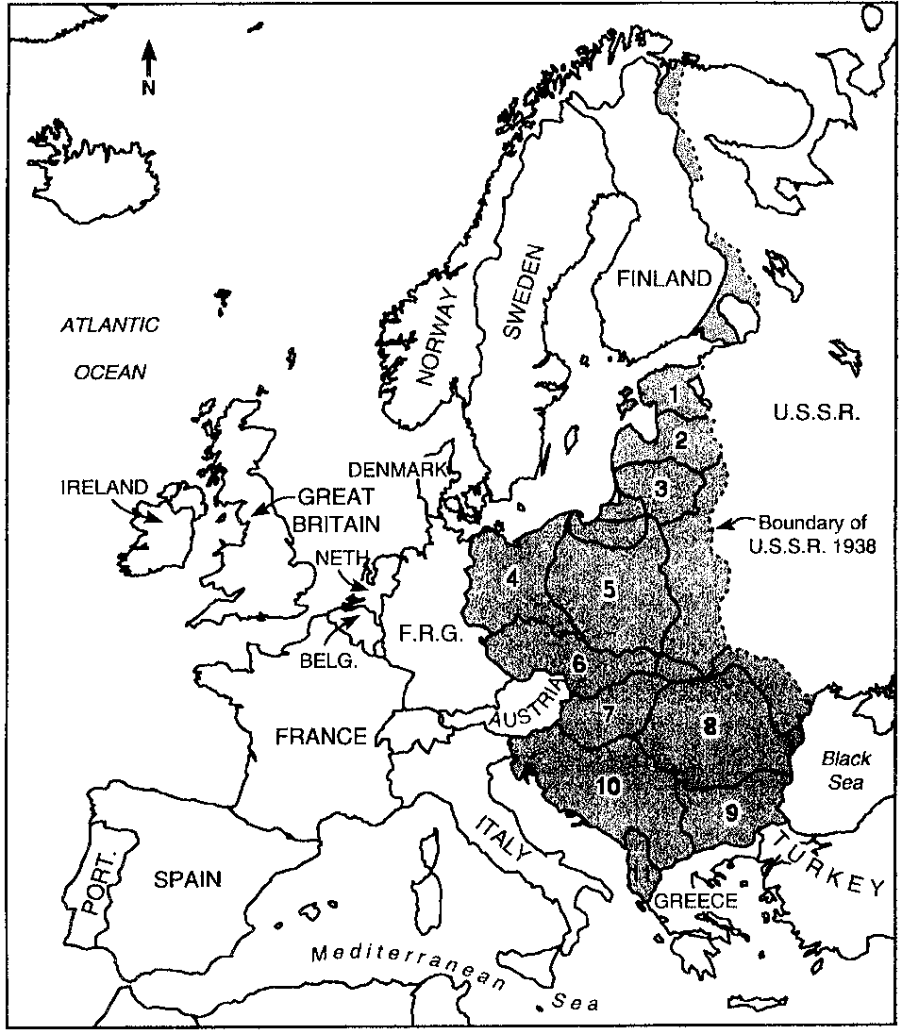

42. ____ Bulgaria

ANS: 9

43. ____ Albania

ANS: 11

44. ____ Estonia

ANS: 1

45. ____ Hungary

ANS: 7

46. ____ Poland

ANS: 5

47. ____ German Democratic Republic (East Germany)

ANS: 4

48. ____ Romania

ANS: 8

49. ____ Yugoslavia

ANS: 10

50. ____ Latvia

ANS: 2

51. ____ Lithuania

ANS: 3

52. ____ Czechoslovakia

ANS: 6

Locate the following places by reference number on the map:

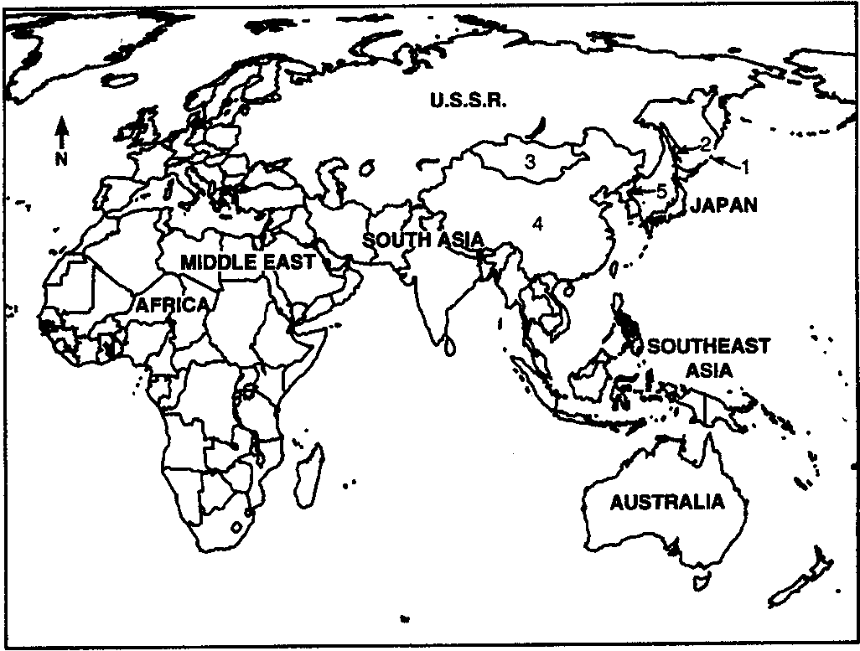

53. ____ China

ANS: 4

54. ____ Mongolia

ANS: 3

55. ____ South Sakhalin Island

ANS: 2

56. ____ North Korea

ANS: 5

57. ____ Kuril Islands

ANS: 1

MULTIPLE CHOICE

58. Many Americans feared that the end of World War II would bring
a. | heightened racial tensions.
b. | a return of the Great Depression.
c. | moral and religious decline.
d. | continued fascist resistance in Germany.
e. | a new war with the Soviet Union.

ANS: B REF: p. 830

59. The Taft-Hartley Act delivered a major blow to labor by
a. | outlawing strikes by public employees.
b. | creating a serious inflationary spiral.
c. | banning labor's political action committees.
d. | outlawing closed (all-union) shops.
e. | forbidding union organizers to enter workplaces.

ANS: D REF: p. 830

60. The passage of the Servicemen's Readjustment Act (GI Bill of Rights) was partly motivated by
a. | fear of postwar veterans' protests.
b. | memories of the mistreatment of the veterans' Bonus Army in the 1930s.
c. | fear that the labor markets could not absorb millions of discharged veterans.
d. | a desire to expand the social diversity of American colleges and universities.
e. | the need of American business for a more highly educated workforce.

ANS: C REF: p. 831

61. Which of these is NOT a true statement about the GI Bill?
a. | It included provisions to help veterans gain an education.
b. | Benefits included $16 million in loans for veterans to buy farms, homes or businesses.
c. | The GI Bill nurtured the nation's economic expansion in the postwar era.
d. | Benefits were only available in the first three months after leaving the military.
e. | Millions of veterans took advantage of the GI Bill programs.

ANS: D REF: p. 831

62. The growth of organized labor in the post-World War II era was slowed by all of the following except the
a. | Taft-Hartley Act.
b. | rapidly growing number of service-sector workers.
c. | failure of Operation Dixie.
d. | reduced number of women in the work force.
e. | growing number of part-time workers.

ANS: D REF: p. 830

63. In an effort to forestall an economic downturn, the Truman administration did all of the following except
a. | create the President's Council of Economic Advisers.
b. | sell war factories and other government installations to private businesses at very low prices.
c. | pass the Employment Act, which made it government policy to promote maximum employment.
d. | pass the Servicemen's Readjustment Act, known as the GI Bill of Rights.
e. | continue wartime wage and price controls.

ANS: E REF: p. 831

64. The post-World War II prosperity in the United States was most beneficial to
a. | African Americans.
b. | labor unions.
c. | women.
d. | Hispanics.
e. | farmers.

ANS: C REF: p. 832

65. One striking consequence of the postwar economic boom was
a. | the continued exclusion of most women from the workplace.
b. | the growing split between urban and rural America.
c. | the growing concentration of wealth at the top of society.
d. | a vast expansion of the homeowning middle class.
e. | the growth of blue-collar employment.

ANS: D REF: p. 832

66. The prosperity of the postwar decades paved the way for all of the following social transformations except
a. | the civil rights movement.
b. | new welfare programs like Medicare.
c. | America's international leadership.
d. | the migration of people to the North.
e. | increased opportunity to move up economically.

ANS: D REF: p. 832

67. The majority of the new jobs created in the postwar era went to
a. | men.
b. | women.
c. | African Americans.
d. | Hispanics.
e. | New immigrants.

ANS: B REF: p. 832

68. "Planned obsolescence" was a marketing tool invented in the postwar era that
a. | pushed families to buy a second car, rather than owning just one.
b. | encouraged manufacturers to make products that would break or wear out every two years.
c. | meant changing the design of goods frequently enough so that customers would replace older versions with newer ones.
d. | was the reason more and more mothers entered or re-entered the workforce.
e. | barraged consumers with repetitive advertising campaigns designed to make them purchase more.

ANS: C REF: p. 833

69. The long economic boom from World War II to about 1970 was especially fueled by
a. | low energy costs.
b. | reduced military expenditures.
c. | low inflation.
d. | low taxes.
e. | a more highly educated work force.

ANS: A REF: p. 834

70. Much of the prosperity of the 1950s and 1960s rested on the underpinnings of
a. | foreign aid.
b. | a rising stock market.
c. | foreign trade.
d. | a thriving automobile industry.
e. | colossal military budgets.

ANS: E REF: p. 832

71. One sign of the stress that the widespread post-World War II geographic mobility placed on American families was the
a. | redistribution of income.
b. | popularity of advice books on child-rearing.
c. | increasing reliance on television as a baby sitter.
d. | increased number of long-distance telephone calls.
e. | dramatic rise in divorces.

ANS: B REF: p. 835

72. The dramatically reduced number of American farms and farmers in the postwar era was accompanied by
a. | growing poverty in rural America.
b. | increasing shortages of American-grown food and fiber.
c. | radical protests by farmers and farm laborers.
d. | a romantic "back to the land" movement among city dwellers.
e. | spectacular gains in American agricultural productivity and food growing.

ANS: E REF: p. 834

73. Since 1945, population in the United States has grown most rapidly in the
a. | Northeast.
b. | Midwest.
c. | Sunbelt.
d. | Frostbelt.
e. | Pacific Northwest.

ANS: C REF: p. 834

74. Much of the Sunbelt's new prosperity was based on its
a. | tremendous influx of money from the federal government.
b. | policy of high state taxes.
c. | regulated economic growth.
d. | cooperative effort rather than unbridled individualism.
e. | attention to environmental issues.

ANS: A REF: p. 835

75. All of the following encouraged many post-1945 Americans to move to the suburbs except
a. | development of fuel-efficient automobiles.
b. | home-loan guarantees from the Federal Housing Authority and the Veterans' Administration.
c. | government-built highways.
d. | tax deductions for interest payments on home mortgages.
e. | white flight from racial change.

ANS: A REF: p. 835-836

76. Which of the following did not contribute to the rapid rise of suburbia in post-World War II America?
a. | The baby boom
b. | Government mortgage guarantees
c. | New federally funded highways
d. | White flight
e. | Urban environmental problems

ANS: E REF: p. 836-838

77. By 1960, the proportion of Americans who lived in areas classified as metropolitan suburbs was approximately
a. | three out of four (75 percent).
b. | one out of four (25 percent).
c. | half (50 percent).
d. | one out of ten (10 percent).
e. | four out of ten (40 percent).

ANS: B REF: p. 835 | p. 838

78. The continued growth of the suburbs led to
a. | increased school integration.
b. | better entertainment opportunities in the cities.
c. | an increase in urban poverty.
d. | a decrease in urban crime.
e. | more efficient transportation.

ANS: C REF: p. 836-837

79. Population distribution after World War II followed a pattern of
a. | movement into the Northeast and out of the South.
b. | mass migration of blacks from the West to the Midwest.
c. | movement from the Southwest to Appalachia.
d. | movement out of the cities and into small towns.
e. | an urban-suburban segregation of blacks and whites in major metropolitan areas.

ANS: E REF: p. 836-837

80. The refusal of the Federal Housing Authority to grant home loans to blacks contributed to
a. | the growth of savings and loan institutions exclusively for blacks.
b. | driving many blacks into public housing.
c. | the development of exclusively black suburbs.
d. | a decline in black migration to the cities.
e. | All of these

ANS: B REF: p. 838

81. The huge postwar baby boom reached its peak in the
a. | late 1940s.
b. | early 1950s.
c. | late 1950s.
d. | mid-1960s.
e. | early 1970s.

ANS: C REF: p. 838

82. Children of the baby boom
a. | comprised a lucrative market for prepared baby food and other infant products.
b. | grew into teenagers who spend $20 billion a year on clothes and music.
c. | became the foundation of the youth movements of the 1960s and 1970s.
d. | All of these
e. | None of these

ANS: D REF: p. 838

83. Before he was elected vice president of the United States in 1944, Harry S Truman had served as all of the following except
a. | a haberdashery store owner.
b. | secretary of the navy.
c. | a World War I artillery officer.
d. | a Missouri judge.
e. | a United States senator.

ANS: B REF: p. 838

84. Harry Truman possessed all of the following personal characteristics except
a. | willingness to admit mistakes.
b. | few pretensions.
c. | willingness to accept responsibility.
d. | honesty.
e. | courage.

ANS: A REF: p. 839

85. In early 1945, the United States was extremely eager to secure the Soviet Union's participation in the projected invasion of Japan because
a. | the Soviets would become so engaged in East Asia that they would not expand further into central Europe.
b. | without Soviet help, the Japanese could not be defeated.
c. | American casualties were expected to be high if only Americans were involved.
d. | Roosevelt believed that Stalin's involvement in Japan could help to control the communists in China.
e. | Roosevelt did not want Stalin to become aware of the atomic bomb secret.

ANS: C REF: p. 839-840

86. The crucial origins of the Cold War lay in a fundamental disagreement between the United States and the Soviet Union over postwar arrangements in
a. | North Africa.
b. | East Asia.
c. | the Middle East.
d. | the Third World.
e. | Eastern Europe.

ANS: E REF: p. 840

87. Which of the following were not among the key decisions made by Roosevelt, Stalin, and Churchill at the Yalta Conference?
a. | The Soviet Union would attack Japan within three months in exchange for territorial concessions.
b. | The Soviet Union would sponsor free elections in Poland, Bulgaria, and Romania.
c. | Occupation zones in Germany would be assigned to each of the victorious great powers.
d. | The Soviets and Americans would militarily withdraw from Europe after a peace treaty was signed.
e. | A new international peacekeeping organization, the United Nations, would be set up.

ANS: D REF: p. 839-840

88. Despite their political and strategic differences, the United States and the Soviet Union strongly resembled one another in 1945 in that they
a. | had long experience as great powers in Europe.
b. | accepted the idea of balance of power and spheres of influence.
c. | believed that control of the Middle East was essential to maintaining their national security.
d. | had been largely isolated from world affairs and practiced an ideological missionary foreign policy.
e. | both believed that Britain and France must be destroyed as major powers.

ANS: D REF: p. 840

89. Unlike the failed League of Nations, the new United Nations
a. | denied the power of veto to any party in an international dispute.
b. | established no forum for the smaller nations besides the great powers.
c. | assumed that there would eventually be conflict among the great powers.
d. | was unable to achieve approval by the United States Senate.
e. | was established in a spirit of cooperation before the war's actual end.

ANS: E REF: p. 844

90. One of the most significant structural differences between the old League of Nations and the new United Nations was that the U.N.
a. | did not attempt to include all the independent nations of the world in its membership.
b. | gave a veto in the powerful Security Council to the five Great Powers.
c. | did not try to address the question of colonialism.
d. | developed its own independent military force controlled by the Security Council.
e. | established a powerful independent executive branch in the Secretary General.

ANS: B REF: p. 844

91. Which of the following was not among the early successes of the United Nations?
a. | Stopping the spread of atomic weapons
b. | Preventing warfare over Kashmir and Iran
c. | Creating the new state of Israel
d. | Guiding former European colonies to independence
e. | Enhancing global health, food production, and cultural development

ANS: A REF: p. 844

92. The victorious World War II Allies quickly agreed that
a. | Germany should pay economically crippling war reparations.
b. | Nazism should be destroyed in Germany and high-ranking Nazis should be tried and punished for war crimes.
c. | occupied Germany should be reunited as soon as possible.
d. | Germany should receive massive economic aid.
e. | Germany should be divided into two nations, East and West Germany.

ANS: B REF: p. 844-845

93. When the Soviet Union denied the United States, Britain, and France access to Berlin in 1948, President Truman responded by
a. | asking the United Nations to intervene.
b. | denying the Soviets access to West Germany.
c. | declaring that an iron curtain had descended across Central Europe.
d. | organizing a gigantic airlift of supplies to Berlin.
e. | sending an armed convoy to Berlin.

ANS: D REF: p. 846

94. Soviet specialist George F. Kennan framed a coherent approach for America in the Cold War by advising a policy of
a. | détente.
b. | appeasement.
c. | containment.
d. | limited war.
e. | negotiation.

ANS: C REF: p. 846

95. The fundamental idea of the containment doctrine, embraced by President Truman, was
a. | the Soviet Union should be gradually forced to give up its sphere of influence in Eastern Europe.
b. | the Soviet Union should be prevented from trading with nations in Africa and Asia.
c. | the West and the Soviet Union should seek to contain the spread of nuclear weapons.
d. | Soviet expansion should be blocked by firm but not aggressive military and diplomatic strength.
e. | military competition between the West and the Soviets should be replaced by economic competition.

ANS: D REF: p. 846

96. The immediate crisis that prompted the announcement of the Truman Doctrine was related to the threat of a communist takeover in
a. | Iran.
b. | Greece and Turkey.
c. | Communist China.
d. | Czechoslovakia.
e. | Berlin.

ANS: B REF: p. 846-847

97. Under the Truman Doctrine, the United States pledged to
a. | refrain from polarizing the world into pro-Soviet and pro-American camps.
b. | maintain prosperity in America after World War II.
c. | give very limited assistance to nations fighting communism.
d. | support those who were resisting subjugation by communists.
e. | work to liberate the captive nations of Eastern Europe.

ANS: D REF: p. 847

98. Match each postwar American program below with its primary purpose.

A. | Point Four | 1. | assist communist-threatened Greece and Turkey
B. | NATO | 2. | promote economic recovery of Europe
C. | Truman Doctrine | 3. | aid underdeveloped nations of Latin America, Asia, and Africa
D. | Marshall Plan
 |  | 4. | resist Soviet military threat

a. | A-4, B-1, C-3, D-2
b. | A-2, B-3, C-1, D-4
c. | A-1, B-2, C-4, D-3
d. | A-3, B-4, C-1, D-2
e. | A-4, B-3, C-2, D-1

ANS: D REF: p. 846-847 | p. 849 | p. 854

99. A leading American theologian who urged a vigorous American foreign policy and a return to Christian foundations was
a. | Paul Tillich.
b. | Billy Graham.
c. | Benjamin Spock.
d. | Reinhold Nieburh.
e. | Norman Vincent Peale.

ANS: D REF: p. 847

100. President Truman's Marshall Plan called for
a. | military supplies for Britain and France.
b. | substantial financial assistance to rebuild Western Europe.
c. | economic aid for Japan.
d. | foreign aid for Third World countries to resist communism.
e. | an alliance to contain the Soviet Union.

ANS: B REF: p. 847

101. The Marshall Plan succeeded in reviving Europe's economy and thwarting the large internal Communist parties threatening to take over
a. | Italy and France.
b. | West Germany and East Germany.
c. | Britain and Ireland.
d. | Spain and Italy.
e. | Greece and Turkey.

ANS: A REF: p. 848

102. President Truman risked American access to Middle Eastern oil supplies when he
a. | sent U.S. military forces into Lebanon.
b. | refused to recognize the authoritarian Saudi Arabian monarchy.
c. | supported British control of the Suez Canal.
d. | tried to force the Soviet Union out of the Middle East.
e. | recognized the new Jewish state of Israel.

ANS: E REF: p. 848

103. American membership in the North Atlantic Treaty Organization did all of the following for the country except
a. | strengthen the containment of the Soviet Union.
b. | help reintegrate Germany into the European family.
c. | reduce our defense expenditures, since we would get help from other countries.
d. | reassure Europeans that the United States would not abandon them.
e. | strike a major blow to American isolationists.

ANS: C REF: p. 849

104. The United States' participation in NATO
a. | reaffirmed America's long-standing commitment to the defense of Western Europe.
b. | marked a dramatic departure from traditional American isolationism.
c. | reduced the need for increased military spending.
d. | helped to resolve the problem of Germany.
e. | All of these

ANS: B REF: p. 849

105. Postwar Japan
a. | was, like Germany, divided into Allied occupation zones.
b. | was destabilized by a civil war between nationalist and communist elements.
c. | resisted the imposition of American-style democracy.
d. | was governed from the island of Formosa (Taiwan) until 1949.
e. | had its military leaders tried for war crimes, as had occurred in Germany.

ANS: E REF: p. 850

106. Which of the following was not true of the new Japanese government installed by General Douglas MacArthur in 1946?
a. | It joined an American military alliance to prevent the spread of communism in East Asia.
b. | It pledged itself to providing for women's equality.
c. | It introduced a Western-style democratic constitution.
d. | It paved the way for a spectacular economic recovery.
e. | It renounced militarism.

ANS: A REF: p. 850

107. Jiang Jieshi and the Nationalist government lost the Chinese civil war to the communists and Mao Ze-dong mainly because
a. | Jiang lost the support and confidence of the Chinese people.
b. | the United States failed to give Jiang enough aid.
c. | Mao received much assistance from the Soviet Union.
d. | communists within the Truman administration undermined Jiang's efforts.
e. | the communists were closer to traditional Chinese culture.

ANS: A REF: p. 850

108. Republicans used the Communist victory in the Chinese civil war to claim that
a. | China now posed a greater threat to the United States than the Soviet Union.
b. | the United States should force a showdown with China over Korea.
c. | Japan should be given access to nuclear weapons as soon as possible.
d. | pro-Communist elements in the Truman administration had prevented Jiang Jieshi from winning.
e. | East Asia should be given a lesser priority in American policy than Europe.

ANS: D REF: p. 851

109. In an effort to detect communists within the federal government, President Harry Truman established the
a. | Committee on Un-American Activities.
b. | Central Intelligence Agency.
c. | Smith Act.
d. | McCarran Internal Security Act.
e. | Loyalty Review Board.

ANS: E REF: p. 852

110. Which of the following was not among the features of the increasing domestic anticommunist uproar in the late 1940s?
a. | The Federal Bureau of Investigation successfully prevented the Soviets from stealing American atomic secrets.
b. | Two American citizens, Julius and Ethel Rosenberg, were executed as Soviet spies.
c. | The House Un-American Activities Committee successfully exposed the State Department's Alger Hiss as a Communist agent.
d. | Conservative local politicians used communism to attack changes in sexual and cultural values.
e. | Teachers and other employees in many states were forced to sign loyalty oaths.

ANS: A REF: p. 852-853

111. In 1948, many southern Democrats split from their party to support Governor J. Strom Thurmond because
a. | China had fallen to the communists.
b. | they opposed American membership in the United Nations.
c. | President Truman took a strong stand in favor of civil rights.
d. | they found the Republican candidate, Thomas E. Dewey, more sympathetic to their conservative ideology.
e. | Truman appointed an ambassador to the Catholic Vatican City.

ANS: C REF: p. 853

112. Match each 1948 presidential candidate below with his political party.

A. | J. Strom Thurmond | 1. | Progressive
B. | Henry Wallace | 2. | Democratic
C. | Harry S Truman | 3. | States' Rights
D. | Thomas E. Dewey | 4. | Republican

a. | A-1, B-3, C-2, D-4
b. | A-4, B-2, C-1, D-3
c. | A-3, B-1, C-2, D-4
d. | A-1, B-4, C-3, D-2
e. | A-2, B-3, C-4, D-1

ANS: C REF: p. 853-854

113. Even by the end of the 1948 presidential campaign, almost everyone expected Governor Thomas Dewey to win because
a. | the Republicans had finally united their northeastern internationalist and midwestern isolationist wings.
b. | Truman had run a listless and defensive campaign.
c. | Dewey was such a charming and charismatic candidate.
d. | President Truman seemed unpopular and the Democrats had split three ways.
e. | the Republicans had developed a stronger and more progressive domestic platform.

ANS: D REF: p. 854

114. President Truman's domestic legislative plan was dubbed the
a. | Square Deal.
b. | New Deal.
c. | Fair Deal.
d. | Redeal.
e. | New Frontier.

ANS: C REF: p. 854

115. President Truman's action upon hearing of the invasion of South Korea illustrated his commitment to a foreign policy of
a. | appeasement.
b. | liberation.
c. | détente.
d. | multilateralism.
e. | containment.

ANS: E REF: p. 855

116. NSC-68 called for
a. | the invasion of North Korea by United Nations troops.
b. | a blockade of the China coast and bombing of Manchuria.
c. | a program of spying on the Soviet Union.
d. | the reorganization of the Defense Department.
e. | a massive increase in military spending.

ANS: E REF: p. 855

117. The NSC-68 document reflected the American belief
a. | in the limitless capabilities of the American economy and society.
b. | that we needed help to fight the spread of communism.
c. | that huge sacrifices would be needed by Americans to fight the Cold War.
d. | in the futility of containment.
e. | that military spending would help the economy.

ANS: A REF: p. 855

118. President Harry Truman relieved General Douglas MacArthur from command of United Nations troops in Korea when
a. | MacArthur continued to lose crucial battles.
b. | MacArthur crossed the 38th parallel and entered North Korea.
c. | the Chinese entered the Korean War after MacArthur said they would not.
d. | MacArthur began to openly criticize Truman's orders on military policy.
e. | MacArthur began to mock Truman for having been only a captain in the army.

ANS: D REF: p. 856

119. Arrange the following events in chronological order: (A) Berlin airlift, (B) Korean War, and (C) fall of China.
a. | A, C, B
b. | B, C, A
c. | A, B, C
d. | C, A, B
e. | C, B, A

ANS: A REF: p. 846 | p. 851 | p. 855

MULTIPLE RESPONSE

120. During Truman's presidency, Congress overrode his veto of the
a. | Smith-Connally Act.
b. | Taft-Hartley Act.
c. | G.I. Bill of Rights.
d. | McCarran Act.
e. | National Security Act.

ANS: B, D REF: p. 830 | p. 852-853

121. At the wartime Yalta conference, the Big Three allies
a. | agreed that the Soviet Union would not receive any territorial concessions in the Far East.
b. | drafted a comprehensive peace settlement for the postwar world.
c. | agreed to establish a postwar international peacekeeping organization.
d. | agreed that the Soviet Union would enter the war against Japan within three months of the surrender of Germany.
e. | agreed to the division of Germany.

ANS: C, D REF: p. 839-840

122. By 1945, the Soviet Union had reason to be suspicious of the United States because the
a. | United States had never extended formal diplomatic recognition to the Soviet government.
b. | British and Americans had delayed opening a second front in Europe during the war.
c. | British and Americans had not informed the Soviet Union of the A-bomb project until it was completed.
d. | United States had not given the Soviets any lend-lease aid during the war.
e. | United States had installed a pro-American government in France.

ANS: B, C REF: p. 840

123. In its early years, the United Nations was successful in
a. | preserving peace in several hot spots like Iran.
b. | guiding several former colonies to independent nationhood.
c. | establishing international control over atomic technology.
d. | helping to create the new Jewish state of Israel.
e. | establishing international health, science, and food agencies.

ANS: A, B, D, E REF: p. 844

124. The National Security Act of 1947 created the
a. | Joint Chiefs of Staff.
b. | Central Intelligence Agency.
c. | Federal Bureau of Investigation.
d. | Selective Service System.
e. | Department of Defense.

ANS: A, B, E REF: p. 849

ESSAY

125. Why were so many Americans anxious about the economic future of the nation at the conclusion of World War II? Why did these fears prove groundless?

ANS:
Student answers will vary.

126. What were the fundamental causes of the spectacular prosperity of the United States in the decades immediately after World War II? To what extent was the economic boom a result of factors internal to the United States, and to what extent was it a result of the devastation of much of Europe and Asia?

ANS:
Student answers will vary.

127. What motivated the large-scale postwar migration to the Sunbelt and the suburbs? To what extent were these movements a result of social changes like the baby boom, and to what extent were they a result of intentional federal government policies like federal housing loans, military spending, and the interstate highway system?

ANS:
Student answers will vary.

128. How did the rise of the suburbs affect American family life, community life, and race relations?

ANS:
Student answers will vary.

129. How do you assess Harry S Truman as a political leader? What were his greatest successes in foreign and domestic policy? What were his greatest failures?

ANS:
Student answers will vary.

130. Explain the rationale for the postwar policy of containment. Show how it was applied in the Truman Doctrine, the Marshall Plan, and NATO.

ANS:
Student answers will vary.

131. Trace the origins of the Cold War, considering the historical background of United States-Soviet Union relations, the wartime relationship, and early postwar developments.

ANS:
Student answers will vary.

132. To what degree do you think each of the following contributed to the Cold War: a. President Truman's style, b. the Soviet Union's security interests, and c. American expectations for the postwar world?

ANS:
Student answers will vary.

133. Was the Cold War inevitable? Why or why not? If so, at what point did it become inevitable?

ANS:
Student answers will vary.

134. Compare and contrast America's anticommunist containment policy in Europe and in East Asia. Why was the policy more successful in Europe than in Asia?

ANS:
Student answers will vary.

135. Should the victory of the Communists in the Chinese civil war in 1949 be judged as a failure of American foreign policy? Why or why not?

ANS:
Student answers will vary.

136. Normally, divisions or a split in a major political party spells certain defeat for its presidential candidate. Harry Truman was able to overcome a three-Democratic split in 1948, What explains his surprising underdog victory? Would Truman have won against any opponent besides Thomas Dewey?

ANS:
Student answers will vary.

137. What legitimate concerns might Americans and the American government have had about Soviet spying and American Communists' disloyalty in the late 1940s? Why did the hunt for spies and subversives expand into a wide-ranging witch hunt that smeared many innocent Americans?

ANS:
Student answers will vary.

138. Identify the factors that produced the anticommunist witch hunt after World War II. List some of its most important short- and long-term consequences.

ANS:
Student answers will vary.

139. Assess President Truman's response to the outbreak of hostilities in Korea in 1950. Do you think that he acted properly with regard to the United Nations, Congress, and his military commanders? Why or why not?

ANS:
Student answers will vary.

140. Why did President Truman relieve General MacArthur of his command in Korea? Do you think that it was a wise decision? Why or why not?

ANS:
Student answers will vary.

141. Though he was decidedly unpopular when he left the presidency, President Truman has since come to be viewed as one of America's ten greatest presidents. Explain why his popularity was so low in 1952 and why he is so well rated in retrospect.

ANS:
Student answers will vary.

142. Evaluate the trade-offs at the Yalta conference in 1945. Was it a sellout to the Soviet Union? Why or why not?

ANS:
Student answers will vary.

143. Do you think that the Nazi and Japanese leaders should have been tried for war crimes even though their crimes were not clearly defined as such before the war began? Why or why not?

ANS:
Student answers will vary.

144. Explain the United States' tremendous success story in postwar Japan versus its failure in China. Who was responsible for the fall of China?

ANS:
Student answers will vary.

145. Evaluate President Truman's strategy and conduct as commander in chief during the Korean War. Assess the realism of his goals and the propriety of his means.

ANS:
Student answers will vary.

