Essentials of Genetics
Mitosis and Meiosis

1) During interphase of the cell cycle, ________.
A) DNA recombines
B) sister chromatids move to opposite poles
C) the nuclear membrane disappears
D) RNA replicates
E) DNA content essentially doubles
Answer: E

2) If a typical somatic cell has 64 chromosomes, how many chromosomes are expected in each gamete of that organism?
A) 8
B) 16
C) 32
D) 64
E) 128
Answer: C

3) In an organism with 52 chromosomes, how many bivalents would be expected to form during meiosis?
A) 13
B) 26
C) 52
D) 104
E) 208
Answer: B

4) The ant Myrmecia pilosula is found in Australia and is named bulldog because of its aggressive behavior. It is particularly interesting because it carries all its genetic information in a single pair of chromosomes. In other words, 2n = 2. (Males are haploid and have just one chromosome.) Which of the following figures would most likely represent a correct configuration of chromosomes in a metaphase I cell of a female?
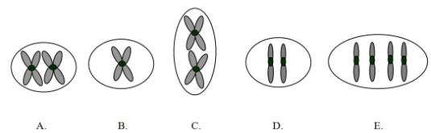
A) A
B) B
C) C
D) D
E) E
Answer: A

5) For the purposes of this question, assume that a G1 somatic cell nucleus in a female Myrmecia pilosula contains 2 picograms of DNA. How much DNA would be expected in a metaphase I cell of a female?
A) 16 picograms
B) 32 picograms
C) 8 picograms
D) 4 picograms
E) Not enough information is provided to answer the question.
Answer: D

6) An interesting group of ants consists of several virtually identical, closely related species, with females having chromosome numbers of 18, 20, 32, 48, 60, 62, and 64. If one crossed a female of species (A) with 32 chromosomes and a male species (B) with 9 chromosomes (males are haploid, and each gamete contains the n complement), how many chromosomes would one expect in the body (somatic) cells of the female offspring?
A) 4.5
B) 9
C) 25
D) 32
E) 41
Answer: C

7) What is the outcome of synapsis, a significant event in meiosis?
A) side-by-side alignment of nonhomologous chromosomes
B) dyad formation
C) monad movement to opposite poles
D) side-by-side alignment of homologous chromosomes
E) chiasma segregation
Answer: D

8) In a healthy male, how many sperm cells would be expected to form from (a) 400 primary spermatocytes? (b) 400 secondary spermatocytes?
A) (a) 800; (b) 800
B) (a) 1600; (b) 1600
C) (a) 1600; (b) 800
D) (a) 400; (b) 400
E) (a) 100; (b) 800
Answer: C

9) In a healthy female, how many secondary oocytes would be expected to form from 100 primary oocytes? How many first polar bodies would be expected from 100 primary oocytes?
A) 200; 50
B) 100; 50
C) 200; 300
D) 100; 100
E) 50; 50
Answer: D

10) Which type of cell structure is the nucleolus organizer (NOR) responsible for producing?
Answer: ribosome
Section: 2.1

11) Name two cellular organelles, each having genetic material, that are involved in either photosynthesis or respiration.
Answer: chloroplasts and mitochondria
Section: 2.1

12) List four terms used to describe the normal morphologies, with respect to arm ratio, of eukaryotic chromosomes.
Answer: metacentric, submetacentric, acrocentric, telocentric
Section: 2.2

13) Homologous chromosomes can be matched by their similar structure and function within a nucleus. Which chromosomes making up a genome do not follow the same characteristics of homology?
Answer: sex-determining chromosomes
Section: 2.2
14) How many haploid sets of chromosomes are present in a diploid individual cell with a chromosome number of 46? 32?
Answer: 2; 2

15) How many haploid sets of chromosomes are present in an individual cell that is tetraploid (4n)?
Answer: 4

16) In which stage of the cell cycle is G0 located?
Answer: G1

17) When cells withdraw from the continuous cell cycle and enter a "quiescent" phase, which stage are they said to be in?
Answer: G0

18) The house fly, Musca domestica, has a haploid chromosome number of 6. How many chromatids should be present in a diploid, somatic, metaphase cell?
Answer: 24

19) Regarding the mitotic cell cycle, what is meant by a checkpoint?
Answer: A checkpoint is the portion of a cell cycle that is sensitive to a variety of conditions that impact the eventual health of the cell or individual. Such checkpoints often restrict passage to the next event in the cell cycle.

20) After which meiotic stage (meiosis I or II) would one expect monads to be formed?
Answer: meiosis II

21) Assume that the somatic cells of a male contain one pair of homologous chromosomes (e.g., AaAb) and an additional chromosome without a homolog (e.g., W). Which chromosomal combinations would be expected in the meiotic products (spermatids) of a single primary spermatocyte? (There may be more than one answer.)
Answer: AaW, AaW, Ab, Ab or Aa, Aa, AbW, AbW

22) The accompanying sketch depicts a cell from an organism in which 2n = 2 and each chromosome is metacentric.

(a) Circle the correct stage for the cell in this sketch:

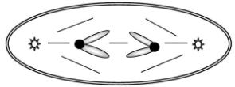

anaphase of mitosis
anaphase of meiosis I
anaphase of meiosis II
telophase of mitosis

(b) Given that each G1 nucleus from this organism contains 16 picograms of DNA, how many picograms of chromosomal DNA would you expect in the cell shown here?
Answer: (a) anaphase of meiosis II
(b) 16
Section: 2.2, 2.4

23) You may have heard through various media of an animal alleged to be the hybrid of a rabbit and a cat. Given that the cat (Felis domesticus) has a diploid chromosome number of 38 and a rabbit (Oryctolagus cuniculus) has a diploid chromosome number of 44, what would be the expected chromosome number in the somatic tissues of this alleged hybrid?
Answer: 41

24) The horse (Equus caballus) has 32 pairs of chromosomes, whereas the donkey (Equus asinus) has 31 pairs of chromosomes. How many chromosomes would be expected in the somatic tissue of a mule?
Answer: 63

25) Name two evolutionarily significant benefits of meiosis that are not present in mitosis.
Answer: reshuffling of homologous chromosomes and crossing over

26) What is meant by the term chiasma?
Answer: areas where chromatids intertwine during meiosis

27) List in order of occurrence the phases of mitosis.
Answer: prophase, prometaphase, metaphase, anaphase, telophase

28) The two terms reductional and equational generally refer to which stages of meiosis (I or II)?
Answer: meiosis I and meiosis II, respectively

29) Trisomy 21 or Down syndrome occurs when there is a normal diploid chromosomal complement of 46 chromosomes plus one (extra) chromosome 21. Such individuals therefore have 47 chromosomes. Assume that a mating occurs between a female with Down syndrome and a normal 46-chromosome male. What proportion of the offspring would be expected to have Down syndrome? Justify your answer.
Answer: One-half of the offspring would be expected to have Down syndrome because of 2 X 1 segregation of chromosome 21 at anaphase I.

30) Normal diploid somatic (body) cells of the mosquito Culex pipiens contain six chromosomes. Assign the symbols AmAp, BmBp, and CmCp to the three homologous chromosomal pairs. The "m" superscript indicates that the homolog is maternally derived; the "p" indicates a paternally derived homolog. Assume that in the genus Culex, the sex chromosomes are morphologically identical.

(a) For each of the cell types given below, draw and label (with reference to the symbols defined above) an expected chromosomal configuration.

mitotic metaphase
metaphase of meiosis I
metaphase of meiosis II

(b) The stage at which "sister chromatids go to opposite poles" immediately follows which of the stages listed in (a)?

(c) Assuming that all nuclear DNA is restricted to chromosomes and that the amount of nuclear DNA essentially doubles during the S phase of interphase, how much nuclear DNA would be present in each cell listed in part (a)? Note: Assume that the G1 nucleus of a mosquito cell contains 3.0 X 10-12 grams of DNA.

(d) Given that the sex of Culex is determined by alleles of one gene, males heterozygous, Mm, and females homozygous, mm, illustrate a labeled chromosomal configuration (involving the symbols AmAp, BmBp, and CmCp and the M locus) in a primary spermatocyte at metaphase. Assume that the M locus is on the AmAp chromosome and that crossing over has not occurred between the M locus and the centromere.
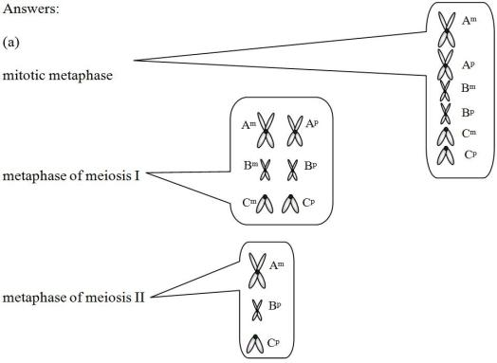

(b) metaphase of meiosis II and mitotic metaphase
(c) 6, 6, 3
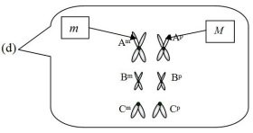

31) Drosophila melanogaster, the fruit fly, has a 2n chromosome number of 8. Assume that you are microscopically examining the mitotic and meiotic cells of this organism. You note that in the female, two chromosomal pairs are metacentric and two pairs are acrocentric.

(a) Draw the chromosomal configurations as you would expect to see them at the stages listed:

mitotic metaphase first polar body (metaphase)
primary oocyte (metaphase) ootid (G1)
secondary oocyte (metaphase)

(b) Given that the previously mentioned cells are from individuals heterozygous for two independently segregating, autosomal loci, plum eyes and curled wings, place appropriate symbols (of your designation) on chromosomes in the drawings you made for part (a). Assume no crossing over, and there may be more than one correct answer in some cases.

(c) Assuming that a somatic G2 nucleus from the individuals mentioned above contains about 8.0 picograms of DNA, how much nuclear DNA would you expect in each of the cells mentioned in part (a)?
Answer: (a,b)
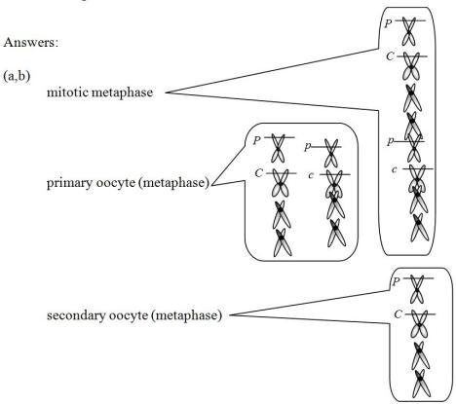
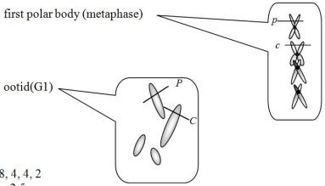
(c) 8, 8, 4, 4, 2

32) Down syndrome, or trisomy 21, in humans is caused by an extra copy of the relatively small, acrocentric 21. Including only chromosome 21, the X chromosome (medium in size and somewhat metacentric), and the Y chromosome (small and acrocentric), draw one possible array of chromosomes in the four sperm cells produced by the complete meiosis of one primary spermatocyte. For the purposes of this question, assume that males with Down syndrome produce normal ratios of sperm cells. (More than one answer is possible.)
Answer:
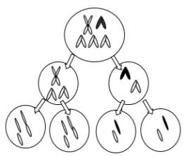

33) Assume that an organism has a diploid chromosome number of 6. Two chromosomal pairs are telocentric, and the other pair is metacentric. Assume that the sex chromosomes are morphologically identical. Draw chromosomes as you would expect them to appear at the following stages:

primary oocyte (metaphase)
secondary spermatocyte (metaphase)
first polar body (metaphase)
Answer:
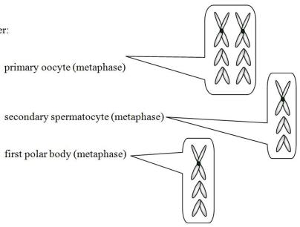

34) There is about as much nuclear DNA in a primary spermatocyte as in ________ (how many) spermatids?
Answer: 4

35) List, in order of appearance, all the cell types expected to be formed during (a) spermatogenesis and (b) oogenesis.
Answer: (a) spermatogonia, primary spermatocyte, secondary spermatocyte, spermatid, spermatozoa
(b) oogonium, primary oocyte, secondary oocyte and first polar body, ootid and second polar body

36) If a typical G1 nucleus is 2n and contains 2C (two complements) of DNA, a prophase I cell is 2n and contains 4C of DNA.
Answer: TRUE

37) S phase is the part of interphase when DNA duplication takes place.
Answer: TRUE

38) The centromere of a chromosome separates during anaphase.
Answer: TRUE

39) A chromosome may contain one or two chromatids in different phases of the mitotic or meiotic cell cycle.
Answer: TRUE
, 2.4

40) If a typical G1 nucleus contains 2C (two complements) of DNA, a gamete that is haploid (n) contains 1C of DNA.
Answer: TRUE

41) During meiosis, chromosome number reduction takes place in anaphase II.
Answer: FALSE

42) A bivalent at pachytene contains four chromatids.
Answer: TRUE

43) The meiotic cell cycle involves two cell divisions but only one DNA replication.
Answer: TRUE

44) An organism with a haploid number of 10 will produce 1024 combinations of chromosomes at the end of meiosis.
Answer: TRUE

45) An organism with a diploid chromosome number of 46 will produce 223 combinations of chromosomes at the end of meiosis.
Answer: TRUE

