Life: The Science of Biology

Studying Life

Multiple Choice

1. The basic structural and physiological unit of all living organisms is the
a. aggregate.
b. organelle.
c. organism.
d. membrane.
e. cell.
Answer: e

2. A cell
a. can be composed of many types of tissues.
b. is found only in plants and animals.
c. is the smallest entity studied by biologists.
d. may be a distinct entity or a building block of a more complex organism.
e. All of the above
Answer: d

3. The Curiosity rover is currently searching for signs of life on Mars. What kind of evidence would most likely indicate the presence of living organisms on Mars?
a. Fossilized prokaryotic cells
b. Different nucleic acids and amino acids than those found on Earth
c. Fatty acid molecules
d. Complex molecules containing genetic information
e. Simple organic molecules
Answer: d

4. Which of the following is not true of life?
a. Life has a common ancestry.
b. Life is made up of living organisms.
c. Living organisms are all descended from a common origin.
d. Life has multiple origins.
e. Life has striking similarities across gene sequences.
Answer: d

5. Earth is approximately _______ years old.
a. 5.5 million
b. 40–50 million
c. 4.5 billion
d. 5 trillion
e. 40 trillion
Answer: c

6. There has been life on Earth for approximately _______ years.
a. 10 thousand
b. 4 million
c. 100 million
d. 1 billion
e. 4 billion
Answer: e

7. The oldest rocks on Earth are approximately _______ years old.
a. 4,000‒5,000
b. 400,000‒500,000
c. 2–3 million
d. 4–5 billion
e. 8 billion
Answer: d

8. The seed of a desert plant may be dormant for many years without growing, but is still considered to be alive because it
a. is always converting molecules.
b. possesses heritable information.
c. is always regulating its internal environment.
d. is reproducing.
e. is extracting energy from its environment.
Answer: b

9. Which of the following statements about viruses is true?
a. They do not mutate and evolve.
b. They do not contain genetic information.
c. They carry out physiological functions on their own.
d. Their existence depends on cells.
e. Biologists do not consider viruses to be part of life.
Answer: d

10. The critical step for the evolution of life was the
a. formation of fatty acids.
b. formation of simple molecules.
c. appearance of proteins that could replicate themselves.
d. appearance of nucleic acids that could replicate themselves.
e. synthesis of proteins.
Answer: d

11. Cellular structure occurs due to
a. an aggregation of cells.
b. the synthesis of proteins with stable shapes.
c. the enclosure of biological molecules by a membrane.
d. complex proteins being dissolved in water.
e. the formation of reactants and products.
Answer: c

12. To fuel cellular metabolism, early prokaryotes
a. took in small molecules directly from the environment.
b. fed on other prokaryotes.
c. converted oxygen into biological energy.
d. transformed the energy of sunlight into biological energy.
e. Both a and d
Answer: a

13. The chemical formula for oxygen gas is
a. O.
b. O₂.
c. H₂O₂.
d. O₃.
e. CO₂.
Answer: b

14. The abundance of O₂ led to the evolution of
a. anaerobic eukaryotes.
b. aerobic eukaryotes.
c. anaerobic prokaryotes.
d. aerobic prokaryotes.
e. Both b and d
Answer: e

15. The chemical formula for ozone is
a. O.
b. O₂.
c. H₂O₂.
d. O₃.
e. None of the above
Answer: d

16. O₂ is important to life on Earth because it
a. allows for anaerobic metabolism.
b. blocks UV radiation.
c. produces ozone in the upper atmosphere.
d. provides energy to some basic forms of life.
e. provides food for early prokaryotes.
Answer: c

17. The accumulation of _______ allowed organisms to grow larger.
a. O₂ in the atmosphere
b. CO₂ in the atmosphere
c. CO₂ in the water
d. O₃ in the atmosphere
e. Both b and c
Answer: a

18. Which of the following statements about aerobic metabolism is false?
a. It is more efficient than anaerobic metabolism.
b. It can occur in O₂-rich environments.
c. It allows organisms to grow.
d. It is used by the majority of organisms on Earth today.
e. It provides protection from UV radiation.
Answer: e

19. The diversity of organisms that have descended from a single kind of unicellular ancestor is mainly due to
a. replication of the genome.
b. mating.
c. artificial selection.
d. mutations in the genome.
e. structural adaptations.
Answer: d

20. Natural selection functions
a. by causing mutations in the genome.
b. by producing structural and functional changes within organisms.
c. through differential probabilities of survival and reproductive success.
d. through sexual selection and genetic drift.
e. by allowing unlimited growth of populations.
Answer: c

21. Which of the following features is the same in muscle cells and gut cells?
a. Cell function
b. Local cell environment
c. Expressed genes
d. Genome
e. Proteins formed
Answer: d

22. The process of evolution acts on
a. populations.
b. species.
c. individual organisms.
d. communities.
e. ecosystems.
Answer: a

23. A species consists of
a. all the populations of different organisms that live together in a particular area.
b. all the populations found in a community.
c. a group of individuals of the same type of organism that can successfully interbreed.
d. all the populations found in an ecosystem.
e. a group of individual organisms in an area that do not interact.
Answer: c

24. Adaptations are _______ traits.
a. structural
b. physiological
c. behavioral
d. reproductive
e. All of the above
Answer: e

25. The toe pads of arboreal (tree) frogs and the webbed feet of aquatic frogs are examples of
a. genetic drift.
b. structural adaptations.
c. sexual selection.
d. artificial selection.
e. cooperation.
Answer: b

26. Refer to the figure below. Which of the following statements concerning the “tree of life” is true?

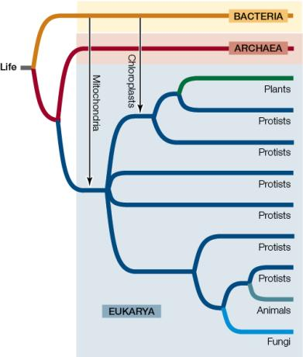

a. All protists are most closely related to other protists.
b. Only one domain includes single-celled prokaryotes.
c. Two of the domains had endosymbiotic events leading to the formation of mitochondria and chloroplasts.
d. All three domains split from one common ancestor.
e. Two of the domains have multicellular organisms.
Answer: d

27. All living organisms can be assigned to one of three separate
a. species.
b. genus groups.
c. domains.
d. ancestors.
e. genomes.
Answer: c

28. Species are given a distinctive scientific name formed from two Latin names called a
a. minimali.
b. biannual.
c. normal.
d. binomial.
e. polynomial.
Answer: d

29. Which of the scientific names below is written incorrectly?
a. Homo sapiens
b. Branta Canadensis
c. Acer saccharum
d. H. neanderthalensis
e. Canis lupis
Answer: b

30. A phylogenetic tree
a. classifies all plant species based on their habitats.
b. diagrams the evolutionary history of a particular group of organisms.
c. is based on binomial nomenclature.
d. only catalogues fossil plants.
e. only uses genome sequencing data.
Answer: b

31. The branching patterns of the evolutionary tree of life are based on a rich array of
a. fossil evidence.
b. molecular evidence.
c. information about metabolic processes.
d. All of the above
e. None of the above
Answer: d

32. Scientists group species on an evolutionary tree that is based on
a. the fossil record.
b. physical structures.
c. genomic sequencing.
d. All of the above
e. None of the above
Answer: d

33. Evolutionary relationships among living organisms can best be determined by comparing
a. the genomes of both extinct and living organisms.
b. the genomes of living organisms.
c. samples from the fossil record.
d. anatomical features of living organisms.
e. anatomical features of fossils.
Answer: b

34. You propose a set of experiments to test whether present-day chloroplasts originated from a single or multiple endosymbiotic events. Which experimental approach would provide the most detailed test of the hypothesis?
a. Testing whether plants and algae have similar pigments in their chloroplasts
b. Testing whether the chloroplasts of plants and algae have the same structure
c. Performing an instrumental test to determine if the wavelengths of light absorption by chloroplast pigments are the same in both plants and algae
d. Using structural chemistry to test if the light-absorbing pigments in plants and algae are the same
e. Comparing the genomes of plant and algal chloroplasts to determine how closely related the genome-encoded molecules are
Answer: e
; 1.2 How Do Biologists Investigate Life?

35. Plants, fungi, and animals have evolved from ancestral
a. protists.
b. endosymbiotic bacteria.
c. Archaea.
d. cyanobacteria.
e. inorganic molecules.
Answer: a

36. Plants are
a. eukaryotic unicellular aerobes.
b. eukaryotic multicellular aerobes.
c. eukaryotic multicellular anaerobes.
d. prokaryotic unicellular anaerobes.
e. prokaryotic multicellular aerobes.
Answer: b

37. Which of the following did not evolve from protists?
a. Plants
b. Archaea
c. Animal
d. Fungi
e. All of the above evolved from protists.
Answer: b

38. Which of the following had independent origins of multicellularity from protists?
a. Plants
b. Fungi
c. Animals
d. Plants and fungi
e. Plants, fungi, and animals
Answer: e

39. Which of the following represents the correct order of the levels of complexity at which life is studied, from most inclusive to least inclusive?
a. Cell, tissue, organ, organism, population, community
b. Community, population, organism, tissue, cell
c. Community, population, organism, organ, tissue, cell
d. Community, organism, population, organ, tissue, cell
e. Community, organism population, cell, organ, tissue
Answer: c

40. In the image below, what is the smallest (lowest) level of biological organization that is visible?

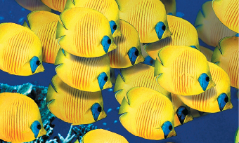

a. Community
b. Organism
c. Molecule
d. Cell
e. Population
Answer: b

41. Which of the following is not an example of the mechanical work of cells?
a. Transporting molecules around inside cells
b. Moving whole cells around
c. Moving whole tissues
d. Locomotion in an organism
e. Processing information in nervous systems
Answer: e

42. Which of the following is not one of the functions of homeostatic regulation?
a. The processing of sensory information
b. The regulation of salinity across the plasma membrane
c. The maintenance of a wide range for each physiological condition
d. The maintenance of physical conditions such as temperature
e. The sending of signals to components of physiological systems
Answer: c

43. Homeostasis is
a. the mechanism by which organisms acquire nutrients from the environment.
b. the maintenance of a narrow range of internal conditions.
c. the sensory system of an organism.
d. the mechanical movement of molecules from one cellular location to another.
e. the maintenance of extracellular fluids.
Answer: b

44. Which of the following always results from a scientific investigation?
a. Proof of the hypothesis
b. Refinement of the experimental design to produce qualitative data
c. Formulation of new questions that result in additional experimentation
d. Repetition of statistical tests to verify results
e. Development of additional technologies to meet the needs of scientists
Answer: c

45. Which of the following is not one of the major steps in the hypothesis‒prediction approach?
a. Stating an opinion
b. Forming a hypothesis
c. Making an observation
d. Asking a question
e. Testing a prediction
Answer: a

46. After observing that fish live in clean water but not in polluted water, researchers state that “polluted water kills fish.” This statement is an example of a(n)
a. fact.
b. observation.
c. prediction.
d. theory.
e. hypothesis.
Answer: e

47. A biologist listens to frogs singing at a local pond and hypothesizes that the sounds may be mating calls. What would be the next step in the hypothesis–prediction method?
a. Controlling an environment
b. Making an observation
c. Forming a hypothesis
d. Making a prediction
e. Testing a prediction
Answer: d

48. A biologist hypothesizes that the sounds made by lions at night in the Serengeti may be territoriality calls and predicts that two lions inhabiting the same territory will roar even louder. She selects an area inhabited by one lion, records its calls, and plays them back in the same area. She records her observations, and notes that the lion does indeed roar more often as a result of this experiment. What would be the next step in the hypothesis–prediction method?
a. Asking new questions
b. Making an observation
c. Forming a hypothesis
d. Making a prediction
e. Testing a prediction
Answer: a

49. The main purpose of any single experiment is to
a. obtain accurate quantitative measurements.
b. prove unambiguously that a particular hypothesis is correct.
c. avoid a merely comparative analysis.
d. answer as many key questions as possible.
e. test a prediction that is based on a hypothesis.
Answer: e

50. The advantage of controlled scientific experiments is that
a. all variables except one are held constant.
b. the hypothesis can be proven correct.
c. patterns can be predicted.
d. investigations can be carried out in the field.
e. a massive amount of data can be synthesized.
Answer: a

51. Which of the following is a characteristic of a comparative experiment?
a. It has only independent variables.
b. It has only one dependent variable.
c. It compares one independent variable with one dependent variable.
d. It starts with groups or samples that are as similar as possible.
e. It starts with the prediction that there will be a difference between groups or samples.
Answer: e

52. A rapid decline of amphibian populations has been observed worldwide. Which of the following could not be one of the proposed hypotheses related to this decline?
a. A fungal disease could be a cause.
b. Increased exposure to ultraviolet radiation could be a cause.
c. Exposure to agricultural chemicals could be a cause.
d. Exposure to atrazine could be a cause.
e. Frogs die naturally.
Answer: e

53. Which of the following statements about the experiments of Tyrone Hayes on abnormalities of male frog sex organs is true?
a. Based on a set of controlled experiments, Hayes had to reject his hypothesis that atrazine was causing abnormalities in male frogs.
b. Based on comparative experiments, Hayes formed a new hypothesis that UV radiation was causing abnormalities in frogs.
c. Hayes used controlled experiments to compare the effects of various atrazine concentrations on reproductive tissues.
d. Hayes reasoned, by means of inductive logic, that if atrazine caused abnormal testes development, then such deformities could be caused simply by exposing developing tadpoles to various concentrations of atrazine.
e. The experiments showed that the abnormality rate was proportional to the level of atrazine exposure.
Answer: c

54. Tyrone Hayes collected frog and water samples from eight widely separated sites across the U.S. and studied the incidence of abnormalities in frogs exposed to different levels of atrazine. This was a(n) _______ experiment.
a. comparative
b. controlled
c. inductive
d. logic
e. deductive
Answer: a

55. A statistical test starts with
a. a null hypothesis.
b. deductive logic.
c. inductive logic.
d. a hypothesis.
e. a model system.
Answer: a

56. Bacteria can be used as a model system to study chemical reactions in cells. These reactions can be related to similar processes in humans because bacteria and humans
a. share a genetic code.
b. are both prokaryotes.
c. have exactly the same genome.
d. have the same number of chromosomes.
e. Both a and d
Answer: a

57. Much of what we know about the biochemistry of photosynthesis was discovered in experiments with
a. fruit flies.
b. zebrafish.
c. roundworms.
d. Arabidopsis.
e. Chlorella.
Answer: e

58. Which of the following questions cannot be answered by means of the hypothesis‒prediction approach?
a. Are eastern meadowlark populations declining faster than western meadowlark populations?
b. Is the song of the western meadowlark prettier than that of the eastern meadowlark?
c. Do eastern and western meadowlarks interbreed?
d. Do meadowlarks benefit from prairie habitat restoration?
e. Have the migration paths of western meadowlarks been affected by climate change?
Answer: b

59. Which of the following is not part of the basis for the scientific conclusion that evolution is a fact?
a. Evolution can be observed and measured directly.
b. Predictions about future developments in the natural world can be made based on the principles of evolution.
c. The process of evolution can be observed in the fossil record.
d. Changes in the genetic composition of populations can be observed over relatively short periods of time.
e. The fossil record can be observed over an almost unimaginably long period of time.
Answer: b

60. Scientific explanations for a natural phenomenon
a. can be tested only in the laboratory.
b. are always based on an ethical point of view.
c. are based on reproducible and quantifiable observations.
d. are based on untested hypotheses.
e. cannot be rejected.
Answer: c

61. Which of the following statements represents a scientific point of view?
a. Earth was created by a supernatural force.
b. The positions of the sun, moon, and stars provide guidance for making decisions.
c. Inner strength comes from the beauty in nature.
d. Meditation helps to solve health problems.
e. Testing the effect of antibiotics on E. coli can help prevent deaths from food poisoning.
Answer: e

62. Many possible applications of scientific knowledge raise ethical issues for some people. Which of the following applications, however, would be rejected by all responsible scientists?
a. Selecting the sex of one’s children
b. Using stem cells as part of medical treatments
c. Modifying the human genome
d. Using scientific knowledge to dictate how the world ought to be
e. All of the above would be rejected by scientists.
Answer: d

63. In which of the following organisms have modern agricultural practices been used to develop new breeds or strains?
a. Animals
b. Plants
c. Fungi
d. Both a and b
e. All of the above
Answer: e

64. Which of the following scientific fields is providing us with knowledge that will help in the control of possible future tuberculosis epidemics?
a. Molecular biology
b. Physiology
c. Microbial ecology
d. Evolution
e. All of the above
Answer: e

65. New vaccines to protect against the influenza virus are developed every year because of the _______ the virus.
a. high rate of infection caused by
b. high rate of evolution of
c. long generation time of
d. low mutation rate of
e. Both a and c
Answer: b

66. Which of the following problems is directly related to global climate change?
a. Development of antibiotic-resistant bacteria
b. Overfishing of bluefin tuna
c. Engineering of drought-resistant crops
d. Consumption of fossil fuels
e. Genetic diseases
Answer: d

67. Overfishing in the Atlantic bluefin tuna breeding ground has resulted in a serious decline in the tuna’s population. In response, an international commission drew a line down the middle of the Atlantic Ocean with the intent of allowing western populations of bluefin tuna to recover by restricting fishing quotas in that hemisphere. Why did this policy fail to achieve the desired result?
a. Tracking data showed that the tuna’s breeding ground is not identical to its feeding ground.
b. Tracking data showed that western bluefin tuna feed all across the Atlantic Ocean.
c. Tracking data showed that eastern and western bluefin tuna populations are not, as was initially believed, geographically isolated in terms of their feeding grounds.
d. Many tuna caught on the eastern side of the line were from the western breeding population.
e. All of the above
Answer: e

68. Despite numerous studies showing the negative effects of atrazine on frog development, the Environmental Protection Agency continues to allow restricted use of atrazine as long as environmental levels do not exceed 30 to 40 ppb. What will be the likely result of this policy?
a. The occurrences of frog abnormalities will gradually decline.
b. Abnormalities will continue to appear in frogs.
c. No new abnormalities in frogs will appear.
d. Abnormal frogs that reproduce will have offspring that all develop normally.
e. Both c and d
Answer: b

69. Which of the following is not a direct concern for biologists?
a. The origin of the universe
b. The extraction and consumption of fossil fuels
c. The rate of change in the world’s ecosystems
d. The increase in anthropogenic carbon dioxide in the atmosphere
e. The rapid rate of climate warming
Answer: a

Fill in the Blank

1. _______ are the basic structural and physiological units of living organisms.
Answer: Cells

2. In the course of evolution, fatty acids were the critical ingredient in the enclosure of biological molecules in _______ films because these molecules are not _______ in water.
Answer: membranous (or membrane); soluble

3. The use of energy from sunlight to synthesize complex molecules is known as _______.
Answer: photosynthesis

4. The sum total of all the chemical transformations and other work done in a living organism is called its _______.
Answer: metabolism

5. In contrast to eukaryotic cells, prokaryotes lack intracellular compartments referred to as _______.
Answer: organelles

6. The total of all the information encoded by an organism’s genes constitutes its _______.
Answer: genome

7. The change in genetic makeup of biological populations through time is called _______.
Answer: evolution

8. Charles Darwin called the differential survival and reproduction among individuals in a population _______.
Answer: natural selection

9. _______ are structural, physiological, or behavioral traits that enhance an organism’s chance of survival and reproduction in its environment.
Answer: Adaptations

10. A group of individuals of the same species that interact is called a(n) _______; a number of such groups that live and interact in the same area are called a(n) _______; and the latter groupings, along with the nonliving environment, constitute the _______.
Answer: population; community; ecosystem

11. A Pacific tree frog has the scientific nomenclature of Hyla regilla. This particular tree frog belongs to the genus _______.
Answer: Hyla

12. Genome sequencing and other molecular techniques have allowed biologists to study the evolution and classification of life’s diverse organisms. By examining the fossil record and by identifying similarities and differences among living species, they have been able to construct _______ trees to diagram evolutionary relationships.
Answer: phylogenetic

13. The two membrane-enclosed compartments within cells that are thought to have arisen by endosymbiosis are _______ and _______.
Answer: mitochondria (or chloroplasts); chloroplasts (or mitochondria)

14. Single-celled organisms that lack discrete intracellular compartments belong to the domains _______ and _______.
Answer: Archaea (or Bacteria); Bacteria (or Archaea)

15. The three major groups of multicellular eukaryotes are the plants, animals, and _______. Each evolved independently from different groups of unicellular eukaryotes generally known as _______.
Answer: fungi; protists

16. After observing new data, scientists apply _______ logic in order to propose a possible explanation, which is called a(n) _______.
Answer: inductive; hypothesis

17. Platelets are cell fragments that are critical for blood clotting, a process that involves the release of proteins from platelet storage granules. Platelet granules contain approximately 300 different proteins. One hypothesis about the packaging of proteins into these granules is that each protein is delivered in precisely measured amounts to each granule. An alternative hypothesis is that each protein is targeted to the individual storage granules randomly. The second hypothesis is an example of a(n) _______ hypothesis.
Answer: null

18. Because of the similarities shared by many life forms, scientific knowledge gained about one type of organism can often be generalized to other organisms. Biologists studying photosynthesis, for example, have experimented with the Chlorella alga, knowing that they can extend their findings to other plants. In this case, photosynthesis in the alga was considered a _______ system.
Answer: model

19. The study of plant development in Arabidopsis thaliana has allowed scientists to understand the _______ that control development in other plants as well.
Answer: genes

20. Changes in the global climate, leading to the extinctions of large numbers of species and the spread of new and old diseases, are caused largely by the activities of _______.
Answer: humans (or man or people)

Diagram

1.‒2. Refer to the figure below showing life’s “timeline.”

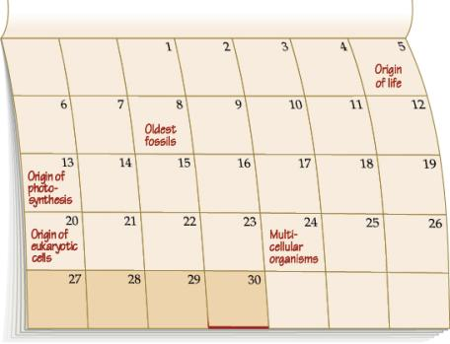

1. Based on the timeline, which of the following statements is true?
a. The oldest fossils include photosynthesizers.
b. The first photosynthesizers were prokaryotic.
c. Multicellularity arose before the evolution of eukaryotic cells.
d. The oldest fossils include multicellular organisms.
e. The first photosynthesizers were multicellular.
Answer: b

2. If we picture the history of Earth as a 30-day month, as in the timeline, modern humans arose
a. at the beginning of week 4.
b. on day 27.
c. in the last 5 minutes of day 30.
d. on day 29.
e. just before noon on day 30.
Answer: c

3.‒4. Refer to the figure below showing DNA as life’s “blueprint.”

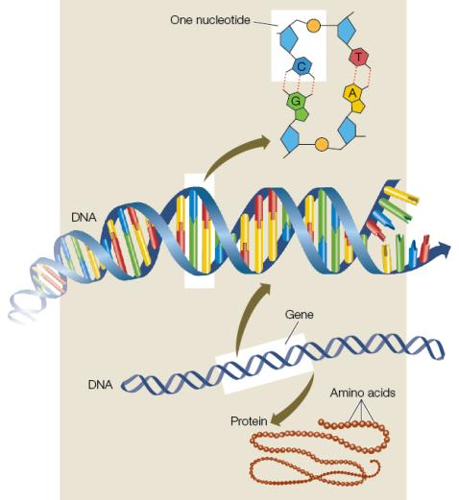

3. Which of the following statements is not supported by evidence presented in the figure?
a. Genes are composed of DNA.
b. Each cell contains the entire genome.
c. Nucleotides contain genetic information.
d. DNA is composed of nucleotides.
e. Proteins are composed of genes.
Answer: e

4. The exposure of DNA to excessive levels of ultraviolet radiation produces thymine (a nucleotide) dimers, which, if unrepaired, can lead to production of skin cancer. This mutation would
a. have no effect on genes.
b. have no effect on proteins.
c. effect both genes and proteins.
d. effect only proteins.
e. effect only genes.
Answer: c

5.‒6. Refer to the diagram below showing the evolutionary tree of life.

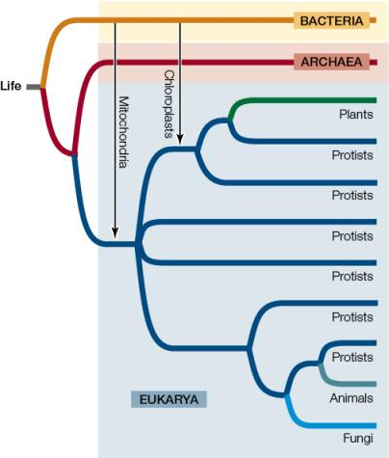

5. According to the relationships indicated by this phylogeny, which of the following statements is true?
a. Animals are equally related to plants and fungi.
b. Animals are more closely related to fungi than they are to plants or any protists.
c. Fungi evolved more recently than did plants.
d. Most eukaryotes are protists.
e. Some plants evolved more recently than did archaea.
Answer: d

6. Which of the following is demonstrated by this diagram?
a. Plants contain chloroplasts but not mitochondria.
b. No members of Eukarya contain both mitochondria and chloroplasts.
c. Chloroplasts are found in bacteria.
d. Mitochondria developed through endosymbiosis before chloroplasts.
e. Mitochondria are found in bacteria.
Answer: d

7. The image below shows a community. According to the hierarchy of biological systems, what level is created with the addition of nonliving components like sunlight and rain?

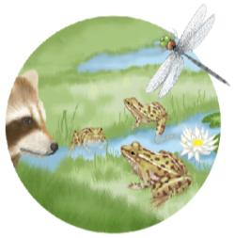

Answer: An ecosystem

8.‒9. Refer to the diagram below showing the steps in the scientific method.

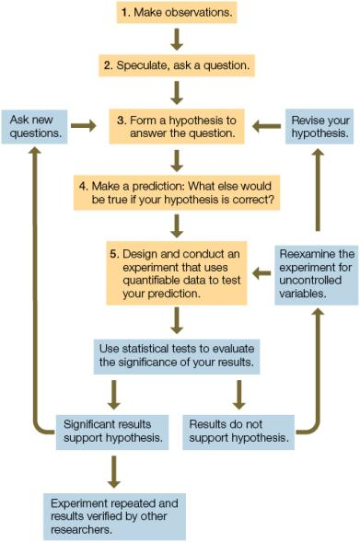

8. Which step in the diagram best illustrates the use of inductive logic?
a. 1
b. 2
c. 3
d. 4
e. 5
Answer: c

9. Step 4 illustrates the use of _______ logic.
Answer: deductive

10. The graph below shows the results of a study of atrazine exposure in male frogs. According to these data, higher atrazine concentrations do not result in a higher rate of gonadal abnormality. Which of the following conclusions could be deduced from these results?

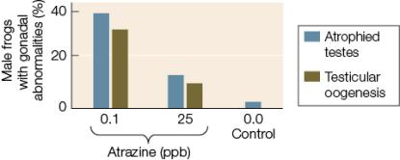

a. Low levels of atrazine are not as dangerous to amphibians as high levels of atrazine.
b. A dosage of 15 ppb would cause a rate of abnormality between the one caused by the 0.1 ppb dosage and the one caused by the 25 ppb dosage.
c. The effect of the atrazine exposure is not proportional to the level of exposure.
d. Atrazine is only hazardous in a natural ecosystem, where it is naturally diluted in the waterways.
e. Atrazine usage should be banned.
Answer: c

11. The figure below shows comparative experiments performed to study the incidence of abnormalities in frogs from environments with very different levels of atrazine. Which of the following is the best null hypothesis for this study?

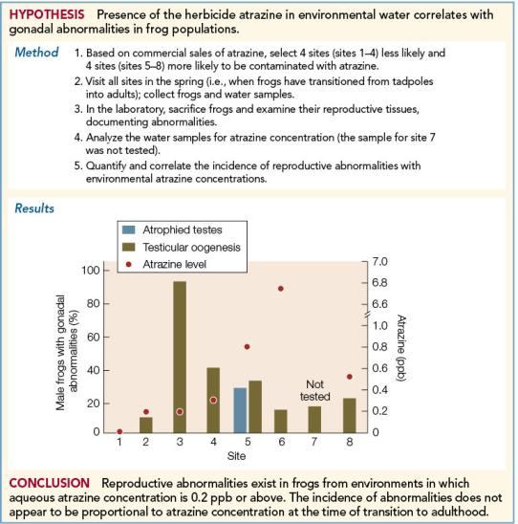

a. Atrazine might have a greater effect on gonad development at low concentrations than at high concentrations.
b. Testes are normal in the absence of atrazine, but male gonadal abnormalities occur in the presence of atrazine.
c. Atrophied testes and testicular oogenesis show no difference in their response to atrazine level.
d. Atrazine levels show no difference with respect to the percentage of gonadal abnormalities.
e. Differences in the percentage of gonadal abnormalities among sites with varied atrazine levels could be random sampling effects.
Answer: e

DIAGNOSTIC QUIZ QUESTIONS (from BioPortal)
(By Richard Shingles)

1. An organism
a. always contains more than one cell.
b. can evolve.
c. cannot do biological work.
d. can be generated from nonliving materials.
e. must reproduce to ensure survival of its kind.
Answer: e

2. A seed of a desert plant may survive for many years because it is
a. composed of a structure that protects it from the external environment.
b. unicellular.
c. always regulating its internal environment.
d. reproducing.
e. always extracting energy from its environment.
Answer: a

3. Viruses
a. can mutate.
b. can extract energy from their environment.
c. can synthesize DNA or RNA on their own.
d. can reproduce on their own.
e. are cellular.
Answer: a

4. Genomes are
a. genetic information shared among all living cells.
b. usually made of RNA.
c. made of proteins.
d. genetic information that can be passed on to offspring.
e. only found in animal and plant cells.
Answer: d

5. Energy transformations in early prokaryotes involved taking in small molecules from the environment and breaking them down to their component atoms. This process is called
a. mechanical work.
b. synthesis.
c. break down.
d. metabolism.
e. electrical work.
Answer: d

6. All cells in a complicated multicellular organism
a. produce all the same proteins.
b. have the same function.
c. express the same parts of the genome at the same time during development.
d. have controlled expression of the genome.
e. randomly express parts of the genome.
Answer: d

7. Which of the following statements about the tree of life (shown below) is false?

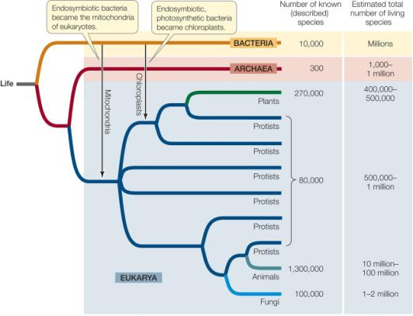

a. Most of the species that were ever present on Earth have already been discovered.
b. Earth’s organisms are divided into three domains.
c. Protists are microbial eukaryotes.
d. The organisms on any one branch share a common ancestor.
e. The common ancestor forms the root of the tree.
Answer: a

8. In terms of increasing complexity, the order of parts of a multicellular animal is
a. cell, macromolecule, tissue, organ, organ system.
b. molecule, cell, tissue, organ, organ system.
c. tissue, cell, molecule, organ system, organ.
d. molecule, tissue, cell, organ, organ system.
e. tissue, molecule, cell, organ, organ system.
Answer: b

9. A population differs from a community in that a community
a. consists of just one species.
b. includes the abiotic environment.
c. consists of many species.
d. is synonymous with an ecosystem.
e. is a group of the same species that interact with each other.
Answer: c

10. Oceans were a good environment for early organisms because they
a. contained ozone.
b. shielded organisms from visible light.
c. alleviated the need for a cell membrane.
d. shielded organisms from ultraviolet light.
e. were rich in oxygen.
Answer: d

11. The organisms that produced the oxygen gas in Earth’s early atmosphere in were
a. anaerobic eukaryotes.
b. aerobic eukaryotes.
c. photosynthetic prokaryotes.
d. aerobic prokaryotes.
e. completely unlike modern organisms.
Answer: c

12. Eukaryotes resemble prokaryotes in that both
a. contain nuclei.
b. have organelles.
c. have plasma membranes.
d. are multicellular.
e. contain specialized cells.
Answer: c

13. Which of the following statements about model systems is false?
a. The study of a model system can always be extended to humans.
b. Much of what we know about the genes that control plant development has come from work on Arabidopsis.
c. Basic understanding of many chemical reactions in cells came from research on bacteria.
d. The biochemistry of photosynthesis was largely worked out from experiments on Chlorella.
e. Knowledge of how animals develop has come from work on sea urchins.
Answer: a

14. In the scientific method, a hypothesis is
a. a final answer to a question.
b. formulated by deductive logic.
c. an alternative to an experiment.
d. the basis for making predictions.
e. formulated solely by speculation.
Answer: d

15. Scientific explanations for a natural phenomenon
a. cannot be tested by humans.
b. may be based on data that cannot be reproduced.
c. must be based on statistically significant data.
d. are tested exclusively by the original scientist.
e. are a reflection of how things should be.
Answer: c

16. The scientific method entails measuring the effects of specific factors that are altered by the experimenter. The factor that is changed is also called a(n)
a. hypothesis.
b. conclusion.
c. variable.
d. observation.
e. speculation.
Answer: c

17. In a scientific experiment, the control group is the one that
a. is not manipulated and used for comparison.
b. exerts control over the test subjects.
c. is usually discarded.
d. is exposed to a specific treatment to test the effects.
e. is statistically significant.
Answer: a

18. An international commission drew a line down the middle of the Atlantic Ocean with the intent of allowing western populations of bluefin tuna to recover from ocean fishing. Which of the following statements regarding this effort is false?
a. The policy had little effect on bluefin populations, as the eastern and western Atlantic populations freely mix.
b. Tracking data revealed that bluefin tuna feed across the Atlantic Ocean.
c. Bluefin tuna populations recovered in the western Atlantic Ocean
d. Bluefin fishing was restricted on the western Atlantic Ocean but not on the eastern Atlantic Ocean
e. It was initially assumed that bluefin tuna populations had geographically separated feeding grounds.
Answer: c

19. Which of the following is not an effect of the vastly increasing human population on the environment?
a. Changing global climate
b. Evolution of antibiotic resistant bacteria
c. The extinction of a great number of species
d. Spreading of disease
e. None of the above; all of the above are effects of a vastly increasing human population.
Answer: e

20. Which of the following is not of major interest to biologists?
a. That modern agriculture depends on biology
b. That biology is the basis of medical practice
c. That biology can inform us on the origin of the universe
d. That biology can inform public policy
e. That biology is crucial for understanding ecosystems
Answer: c

LEARNINGCURVE QUESTIONS (from BioPortal)
(By Richard Shingles)

1. Which of the following is not a characteristic of living organisms?
a. Self-regulation of an internal environment
b. Presence of one or more cells
c. The ability to produce biological molecules
d. The ability to extract energy from the environment
e. All of the above are characteristics of living organisms.
Answer: e

2. If samples were brought back from a distant planet, what would be the first evidence of life, assuming its evolution followed the same path as Earth’s?
a. Presence of nucleic acids
b. Multicellular life forms
c. Presence of oxygen
d. Cell membranes
e. Presence of fatty acids
Answer: a

3. Refer to the figure below.

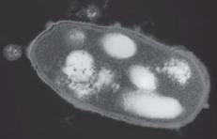

Imagine that NASA’s next probe to one of Jupiter’s moons takes a sample from one of its methane lakes. Pictures taken under a microscope reveal a cell-like structure remarkably similar to that of a simple prokaryotic organism. NASA calls it a “Xenop.” Based on the textbook’s discussion of the common aspects of living organisms on Earth, which of the following pieces of additional information about the Xenop is paired with its logical conclusion?
a. The Xenop looks like a prokaryote and is surrounded by a vesicle-like membrane and, therefore, is living.
b. The Xenop contains different nucleic acids and amino acids from life on Earth and, therefore, is not living.
c. The Xenop can go many years without extracting energy from its environment and, therefore, is not living.
d. The Xenop does not contain genetic information or reproduce and, therefore, is not living.
e. The Xenop contains complex molecules and, therefore, is living.
Answer: d

4. Scientists postulate that the enclosure of complex proteins and other biological molecules by membranes resulted in the first cells with the ability to
a. reproduce.
b. photosynthesize.
c. carry out aerobic respiration.
d. live in nonaqueous environments.
e. All of the above
Answer: a

5. Viruses
a. can mutate.
b. can extract energy from their environment.
c. can synthesize DNA or RNA on their own.
d. can reproduce on their own.
e. are cellular.
Answer: a

6. Life arose on Earth approximately _______ years ago.
a. 4000
b. 400,000
c. 4 million
d. 1.5 billion
e. 4 billion
Answer: e

7. Which of the following correctly lists the order of important first events in the history of life?
a. First archaea, chemical evolution, first chloroplasts, first nucleus, first cyanobacteria
b. Chemical evolution, first archaea, first cyanobacteria, first nucleus, first chloroplasts
c. Chemical evolution, first cyanobacteria, first archaea, first chloroplasts, first nucleus
d. First cyanobacteria, first nucleus, first archaea, first chloroplasts, chemical evolution
e. First cyanobacteria, chemical evolution, first archaea, first nucleus, first chloroplasts
Answer: b

8. Scientists estimate that for more than _______ years after cells originated, all organisms consisted of one cell.
a. 2500
b. 250,000
c. 2 million
d. 2 billion
e. 2 trillion
Answer: d

9. A cell
a. always contains a nucleus.
b. is found only in plants and animals.
c. is the fundamental unit of life.
d. is never an entire organism.
e. is always prokaryotic.
Answer: c

10. All chemical transformations and other work done in an organism contribute to its
a. mechanical work.
b. synthesis.
c. breakdown.
d. metabolism.
e. electrical work.
Answer: d

11. Metabolism is
a. the consumption of energy.
b. the release of energy.
c. all chemical transformations in a cell or organism.
d. the production of heat by chemical reactions.
e. the exchange of nutrients and waste products with the environment.
Answer: c

12. The early organisms that produced the first oxygen gas in Earth’s atmosphere were
a. aerobic eukaryotes.
b. anaerobic eukaryotes.
c. photosynthetic prokaryotes.
d. aerobic prokaryotes.
e. completely unlike modern organisms.
Answer: c

13. The initial accumulation of oxygen in the atmosphere was the result of photosynthesis from an organism most like modern
a. algae.
b. mosses.
c. kelp.
d. eukaryotes.
e. cyanobacteria.
Answer: e

14. Eukaryotic cells differ from prokaryotic cells in that eukaryotic cells have
a. genes.
b. proteins.
c. a membrane-bound nucleus.
d. membranes.
e. All of the above
Answer: c

15. Photosynthesis was a major evolutionary milestone because
a. photosynthetic organisms contributed oxygen to the environment, which led to the evolution of aerobic organisms.
b. photosynthesis led to conditions that allowed life to arise on land.
c. photosynthesis is the only metabolic process that can convert light energy to chemical energy.
d. photosynthesis provides food for organisms.
e. All of the above
Answer: e

16. Refer to the figure below.

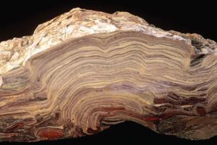

This fossil stromatolite is evidence for a major innovation in life’s history—what is the evolutionary innovation?
a. Organelles
b. Domain Eukarya
c. Photosynthesis
d. Multicellular organisms
e. Endosymbiosis
Answer: c

17. The organisms that produced oxygen gas in Earth’s atmosphere paved the way for the type of metabolism used by larger organisms, called _______ metabolism.
a. anaerobic
b. photosynthetic
c. aerobic
d. endosymbiotic
e. heterotrophic
Answer: c

18. Genomes are
a. the shared genetic information among all living cells.
b. usually made of RNA.
c. made of proteins.
d. the sum of genetic information in a cell.
e. only found in animal and plant cells.
Answer: d

19. The information needed to produce proteins is contained in
a. nutrients.
b. tissues.
c. evolution.
d. organs.
e. genes.
Answer: e

20. Ozone is important to life on Earth because it
a. is toxic to all forms of life.
b. can be used in place of oxygen.
c. blocks much ultraviolet radiation.
d. provides energy to some basic forms of life.
e. acts as a disinfectant.
Answer: c

21. A final prerequisite for the survival of life on land was the accumulation of a protective layer of
a. O₂ in the atmosphere.
b. CO₂ in the atmosphere.
c. water vapor in the atmosphere.
d. O₃ in the atmosphere.
e. bacteria in the soil.
Answer: d

22. What is required for natural selection to occur?
a. Organisms must display variation.
b. A trait must be passed on to future generations.
c. A trait must increase survival.
d. A trait must increase reproduction.
e. All of the above
Answer: e

23. Populations of organisms have been able to inhabit a wide variety of environments on Earth because they
a. have a genome.
b. contain organelles.
c. carry out photosynthesis.
d. adapt through evolution.
e. are similar to model organisms.
Answer: d

24. Darwin noted that all populations have _______ potential to grow, but in nature most populations _______ over time.
a. limited; are stable
b. unlimited; grow slowly
c. limited; fluctuate unpredictably
d. unlimited; are stable
e. limited; decrease slowly
Answer: d

25. Darwin referred to the differential reproductive success of individuals with particular variations as
a. evolution.
b. artificial selection.
c. the cell theory.
d. natural selection.
e. inheritance of acquired characteristics.
Answer: d

26. A key point in Darwin’s explanation of evolution is that
a. the biological structures most likely to be inherited are those that have become best suited to the environment through constant use.
b. all mutations that occur are those that will help future generations fit more successfully into their environments.
c. any trait that confers even a small increase in the probability that its possessor will survive and reproduce will be favored and will spread through the population.
d. genes change in order to help organisms cope with problems encountered within their environments.
e. extinction is nature’s way of weeding out undeserving organisms.
Answer: c

27. Which of the following statements is true?
a. The diversity of life has depended on similar environments and ecological communities around the globe.
b. Sexual selection and genetic drift contribute to the diversity of life.
c. Earth has existed and changed over a few thousand years, at most.
d. All ancestral forms of life were very similar to organisms that currently exist.
e. All organisms are closely related genetically.
Answer: b

28. Evolution is
a. only relevant to the study of biology.
b. the change in the genetic makeup of a population through time.
c. the change in protein expression of a population through time.
d. not influenced by natural selection.
e. None of the above
Answer: b

29. All cells in a complicated multicellular organism
a. contain a subset of the genome.
b. have the same function.
c. express the same parts of the genome at the same time during development.
d. control the expression of the genome.
e. randomly express parts of the genome.
Answer: d

30. Which of the following statements about mutations is incorrect?
a. All mutations are harmful.
b. Mutations occur spontaneously.
c. Mutations can be induced by outside environmental factors.
d. Mutations occur each time the genome is replicated.
e. A mutation can improve the functioning of an organism.
Answer: a

31. Which of the following statements is correct?
a. All cells from a single organism express the same genes.
b. Mutations are always caused by chemicals or radiation.
c. Mutations can occur spontaneously.
d. Most mutations are harmful, so evolution proceeds more rapidly when no mutations occur.
e. Mutations affect proteins but not the DNA.
Answer: c

32. Relationships between living organisms can best be gleaned by comparing
a. the fossil record.
b. the genomes of living organisms.
c. the genomes of both extinct and living organisms.
d. anatomical features of living organisms.
e. anatomical features of fossils.
Answer: c

33. A phylogenetic tree
a. shows evolutionary relationships.
b. relies on evidence from fossils, metabolic processes, and molecular analyses of genomes.
c. helps us understand the history and relationships of living organisms.
d. shows the order in which populations split and evolved into new species.
e. All of the above
Answer: e

34. Biologists have organized the diversity of life into three domains based largely on
a. physical similarities.
b. ecological niches.
c. chronological order.
d. molecular data.
e. All of the above
Answer: d

35. The domain Eukarya includes all of the following except
a. archaea.
b. plants.
c. fungi.
d. animals.
e. protists.
Answer: a

36. Plants are _______ organisms that are _______ of oxygen production.
a. eukaryotic unicellular; capable
b. eukaryotic multicellular; incapable
c. prokaryotic multicellular; capable
d. prokaryotic unicellular; incapable
e. eukaryotic multicellular; capable
Answer: e

37. Refer to the figure below.

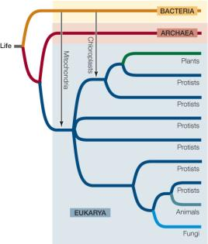

Which of the following is demonstrated in this diagram of the tree of life?
a. There are three groups of Eukarya.
b. Protists and bacteria have no common ancestor.
c. Plants and fungi have a more recent common ancestor than plants and animals do.
d. Plants, fungi, and animals are descendants of different microbial eukaryotic ancestors.
e. Archaea is the evolutionarily ancient group.
Answer: d

38. In terms of increasing complexity, the order of parts of a multicellular animal is
a. cell, macromolecule, tissue, organ, organ system.
b. molecule, cell, tissue, organ, organ system.
c. tissue, cell, molecule, organ system, organ.
d. molecule, tissue, cell, organ, organ system.
e. tissue, molecule, cell, organ, organ system.
Answer: b

39. Which of the following represents a correct ordering of the levels of complexity at which life is studied, from most simple to most complex?
a. Community, population, organism, organ, tissue, cell
b. Cell, organ, tissue, organism, population, community
c. Cell, tissue, organ, organism, population, community
d. Cell, tissue, organ, population, organism, community
e. Tissue, organ, cell, population, organism, community
Answer: c

40. Which of the following is not part of the basis for the scientific conclusion that evolution is a fact?
a. Evolution can be observed and measured directly.
b. The process of evolution can be observed in the fossil record.
c. Predictions about future developments in the natural world can be made based on the principles of evolution.
d. Changes in the genetic composition of populations can be observed over relatively short periods of time.
e. The fossil record can be observed over an almost unimaginably long period of time.
Answer: c

41. A group of differentiated cells that work together to carry out a similar function is known as a(n)
a. tissue.
b. organ system.
c. unicellular organism.
d. protein.
e. gene.
Answer: a

42. All living organisms acquire _______ from their environment.
a. sunlight
b. nutrients
c. carbon dioxide for photosynthesis
d. cues for forming different tissue types
e. All of the above
Answer: b

43. Nutrients acquired by animals
a. are synthesized by cells.
b. are broken down outside of cells.
c. require energy to be broken down.
d. are broken down inside cells.
e. do not play a role in the synthesis of complex molecules.
Answer: d

44. Homeostasis involves the regulation of a
a. variable internal environment.
b. constant external environment.
c. constant internal environment.
d. constant rate of natural selection.
e. variable rate of natural selection.
Answer: c

45. Which of the following processes is not dependent on interactions of plants with other organisms (including other plants)?
a. Obtaining nutrients
b. Regulating the internal environment
c. Dispersing seeds
d. Competing for water
e. Producing fertile seeds
Answer: b

46. Which of the following can scientists determine about a “tagged” fish that was just caught?
a. how deep it swam
b. the route it took before it was caught
c. how far it could swim
d. exactly how far it swam
e. whether it was a marine fish
Answer: c

47. In the scientific method, a hypothesis
a. is a final answer to a question.
b. is formulated by deductive logic.
c. does not have to be testable.
d. is the basis for making predictions.
e. is formulated solely by speculation.
Answer: d

48. Which of the following is not a major step in the hypothesis-prediction approach?
a. Controlling an environment
b. Making an observation
c. Forming a hypothesis
d. Making a prediction
e. Testing a prediction
Answer: a

49. Which of the following statements about the scientific method is true?
a. After forming a hypothesis, scientists apply deductive logic to make predictions from the hypothesis.
b. The most informative experiments are those that have the ability to show that a hypothesis is correct.
c. In a comparative experiment, a scientist compares groups that differ in a variable that has been manipulated in one of the groups and left unaltered in the other group.
d. Controlled experiments are valuable when we do not know or cannot control the critical variables.
e. A statistical test of a hypothesis starts with the premise that a significant difference exists between the groups in the study.
Answer: a

50. After observing that frogs live in clean water but not in polluted water, researchers state that “polluted water kills frogs.” This simple statement is an example of
a. scientific inquiry.
b. biological evolution.
c. a prediction.
d. a hypothesis.
e. a fact.
Answer: d

51. Which of the following questions cannot be answered by means of the hypothesis–prediction method?
a. Are bees more attracted to red roses than to yellow roses?
b. Are red roses more beautiful than yellow roses?
c. Why are red roses red?
d. Do red roses bloom earlier than yellow roses?
e. Are red roses more susceptible to mildew than yellow roses?
Answer: b

52. All of the following are features of scientific hypotheses except:
a. They are unable to be falsified.
b. They make predictions.
c. They are based on observations.
d. They can be tested by experimentation.
e. They can be tested by observational analysis.
Answer: a

53. Which of the following does not result from a scientific investigation?
a. Refinement of the experimental design
b. Formulation of new questions that result in additional experimentation
c. Use of statistical tests to evaluate the significance of the results
d. Experiments repeated and verified by others
e. None of the above
Answer: e

54. Comparative experiments are designed to answer questions that require
a. experimental groups and control groups.
b. little or no data collection.
c. a final, definitive answer.
d. the collection of qualitative data.
e. observation and comparison rather than controlled variables.
Answer: e

55. In a model experiment, researchers subjected frogs to various levels of atrazine while keeping all other variables constant. This is an example of a _______ experiment.
a. controlled
b. repeated
c. laboratory
d. comparative
e. None of the above
Answer: a

56. Refer to the information below.

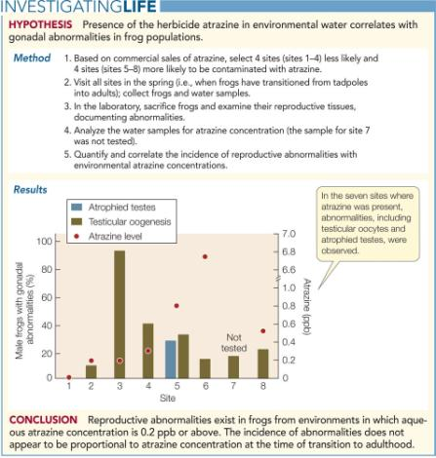

Which of the following is the best null hypothesis for this study?
a. Atrazine might have a greater effect on gonad development at low concentrations than at high concentrations.
b. Testes are normal in the absence of atrazine, but male gonadal abnormalities occur in the presence of atrazine.
c. Atrophied testes and testicular oogenesis show no differences in their response to atrazine level.
d. Atrazine levels show no differences with respect to the percentage of gonadal abnormalities.
e. Differences in percent gonadal abnormalities among sites with varied atrazine levels could be random sampling effects.
Answer: e

57. Which of the following statements about statistical analysis in science is false?
a. Statistical methods are applied to data to prove that the null hypothesis is incorrect.
b. Statistical tests analyze variation and calculate the probability that observed differences in an experiment could be due to random variation.
c. Statistical tests can be used to evaluate both comparative and controlled experiments.
d. Scientists generally conclude that the differences they measure are significant if the statistical tests show that the probability of error is 5 percent or lower.
e. The power of science derives from absolute dependence on evidence that comes from reproducible and quantifiable observations.
Answer: a

58. Which of the following statements about model systems is false?
a. The study of a model system can be extended to humans.
b. Much of what we know about the genes that control animal development has come from work on Arabidopsis.
c. Basic understanding of chemical reactions in cells came from research on bacteria.
d. The biochemistry of photosynthesis was worked out from experiments on Chlorella.
e. Knowledge of how animals develop has come from work on sea urchins.
Answer: b

59. Much of what we know about the genes that control plant development was discovered in experiments with
a. fruit flies.
b. zebrafish.
c. roundworms.
d. Arabidopsis.
e. Chlorella.
Answer: d

60. For a hypothesis to be scientifically valid, it must be _______, and it must be possible to _______ it.
a. testable; prove
b. testable; reject
c. controlled; prove
d. controlled; reject
e. testable; control
Answer: b

61. Which of the following statements is false?
a. The oxygen that we breathe is produced by photosynthesis.
b. The food that fuels our bodies comes from other living organisms.
c. The fuels that drive our cars are produced by living organisms.
d. Our bodies are covered in complex communities of living unicellular organisms.
e. All species that invade our bodies are harmful.
Answer: e

62. Which of the following has not been improved by genetic recombination?
a. New breeds of domestic animals
b. New strains of agricultural plants
c. Higher productivity in fungi
d. Evolution of pest resistance
e. Boosts in food production
Answer: d

63. Which of the following is not founded on modern-day medical practices combined with knowledge of biology?
a. Knowing that infections can be passed from one person to another
b. Understanding how living organisms work
c. Knowing that many diseases are genetic
d. Understanding the origin, basis, and effects of disease
e. Knowing that bacteria evolve
Answer: a

64. Many of the microbial organisms that are periodically epidemic in human populations have
a. short generation times and low mutation rates.
b. short generation times and high mutation rates.
c. long generation times and low mutation rates.
d. long generation times and high mutation rates.
e. long generation times and no mutations.
Answer: b

65. Scientists develop new vaccines for flu every year because of the
a. high rate of infection by the influenza virus.
b. long generation time of the influenza virus.
c. high rate of mutation of the influenza virus.
d. short generation time of the influenza virus.
e. Both c and d
Answer: e

66. Which of the following is not a concern for biologists?
a. Modern agriculture
b. Public policy
c. Understanding ecosystems
d. Medical practice
e. All of the above are concerns for biologists.
Answer: e

67. When applying biology to public policy,
a. the recommendations of scientists are always followed.
b. the economic issues of a policy are not considered.
c. several countries may be involved.
d. there are no ethical issues involved.
e. the correct course of action is always evident.
Answer: c

68. An international commission drew a line down the middle of the Atlantic Ocean with the intent of allowing western populations of Bluefin tuna to recover from ocean fishing. Which of the following statements is false?
a. The policy had little effect on Bluefin populations as the eastern and western Atlantic populations freely mix.
b. Tracking data revealed that Bluefin tuna feed across the Atlantic Ocean.
c. Bluefin tuna populations recovered in the western Atlantic Ocean.
d. Bluefin fishing was restricted on the western Atlantic Ocean but not on the eastern Atlantic Ocean.
e. It was initially assumed that Bluefin tuna populations had geographically separated feeding grounds.
Answer: c

69. When applying scientific studies to political policy,
a. the recommendations of scientists are always followed.
b. the economic issues of a policy are not considered.
c. scientific conclusions indicating negative effects on humans are not always considered.
d. there are no ethical issues involved.
e. scientific conclusions do not always prevail.
Answer: e

70. Which of the following is not something that a governmental institute should consider in crafting public policy?
a. Harmful effects demonstrated on wild species by an herbicide
b. Potential farming income losses due to a ban on an insecticide
c. Special handling procedures required to safely use a substance
d. Whether a government official holds stock in a company that produces a chemical
e. Widespread utility of a drug versus detrimental side effects
Answer: d

71. The concern over how human activities affect the world’s ecosystems is due to the
a. increase of change in ecosystems.
b. decrease of change in ecosystems.
c. rate of change in ecosystems.
d. absence of change in ecosystems.
e. None of the above
Answer: c

72. Which of the following is not an effect of a vastly increasing human population on the environment?
a. Changing global climate
b. Evolution of antibiotic resistant bacteria
c. Causing the extinctions of a great number of species
d. Spreading of disease
e. None of the above
Answer: e

73. When studying the natural history of a group of organisms, scientists look at all of the following except
a. how the organisms get their food.
b. how the organisms reproduce.
c. how the organisms behave.
d. how the organisms interact with other organisms.
e. what cash value the organisms have to entrepreneurs.
Answer: e

74. Which of the following human activities does not rely on biodiversity?
a. Birdwatching
b. Gardening
c. Farming
d. Hunting
e. Fishing
Answer: c

75. Which of the following statements is true?
a. Biologists have discovered almost all of the species that inhabit Earth.
b. Biologists have discovered about three-quarters of the species that inhabit Earth.
c. Biologists have discovered about half of the species that inhabit Earth.
d. Biologists have discovered only a small percentage of the species that inhabit Earth.
e. Biologists have discovered a small percentage of the species that inhabit Mars.
Answer: d

STUDY GUIDE QUESTIONS
(By Meredith Safford)

1. Life arose on Earth approximately _______ years ago.
a. 4 billion
b. 4 million
c. 4,600
d. 1.5 billion
e. 4 trillion
Answer: a

2. Which of the following is the feature or component of organisms that allows for life in such a wide variety of environments on Earth?
a. Prokaryotic cells
b. Eukaryotic cells
c. Homeostasis
d. Adaptation
e. Model systems
Answer: d

3. Which of the following is not a characteristic of most living organisms?
a. Regulation of internal environment
b. One or more cells
c. Ability to produce biological molecules
d. Ability to extract energy from the environment
e. All of the above are characteristics of most living organisms.
Answer: e

4. Photosynthesis was a major evolutionary milestone because
a. photosynthetic organisms contributed oxygen to the environment, which led to the evolution of aerobic organisms.
b. photosynthesis led to conditions that allowed life to arise on land.
c. photosynthesis is the only metabolic process that can convert light energy to chemical energy.
d. photosynthesis provides food for other organisms.
e. All of the above
Answer: e

5. Which of the following is not an attribute of homeostasis in a multicellular organism?
a. Maintaining a stable internal environment
b. Maintaining the extracellular fluid within a range of physical conditions
c. Maintaining a stable external environment
d. Physiological systems that can change in response to regulatory signals
e. None of the above
Answer: c

6. A group of cells that work together to carry out a similar function is known as a(n)
a. tissue.
b. organ system.
c. unicellular organism.
d. protein.
e. gene.
Answer: a

7. Which of the following does not contribute to adaptation in the wild?
a. Artificial selection
b. Genetic drift
c. Natural selection
d. Sexual selection
e. All of the above contribute to adaptation in the wild.
Answer: a

8. Which of the following is not considered part of the natural history of a group of organisms?
a. How the organisms behave
b. How the organisms interact with other organisms
c. How the organisms get their food
d. How the organisms reproduce
e. A natural history includes considerations of all of the above.
Answer: e

9. The information needed to produce proteins is contained in
a. nutrients.
b. tissues.
c. evolution.
d. organs.
e. genes.
Answer: e

10. Evolution is
a. not important to the study of biology.
b. the change in the genetic makeup of a population through time.
c. the change in protein expression of a population through time.
d. not influenced by natural selection.
e. None of the above
Answer: b

11. In a model experiment, researchers subjected frogs to various levels of atrazine while keeping all other variables constant. This is an example of a _______ experiment.
a. controlled
b. repeated
c. laboratory
d. comparative
e. None of the above
Answer: a

12. For a hypothesis to be scientifically valid, it must be _______ and it must be possible to _______ it.
a. testable; prove
b. testable; reject
c. controlled; prove
d. controlled; reject
e. testable; control
Answer: b

13. Eukaryotic cells differ from prokaryotic cells in that eukaryotic cells have
a. genes.
b. proteins.
c. organelles.
d. membranes.
e. All of the above
Answer: c

14. In the names of organisms, the _______ is placed first and the _______ is placed second.
a. species; genus
b. genus; domain
c. domain; genus
d. genus; species
e. domain; species
Answer: d

15. Metabolism refers to
a. natural selection.
b. the chemical transformations and work of a cell.
c. communities.
d. mutations in DNA.
e. cellular structure.
Answer: b

16. Which of the following factors are taken into consideration in the biological classification of organisms?
a. Physical characteristics
b. Fossil records
c. Molecular characteristics
d. All of the above
e. None of the above
Answer: d

17. Which of the following is not a step in the scientific method?
a. Observation
b. Quantifying data
c. Asking questions
d. Formulating a hypothesis
e. All of the above are steps in the scientific method.
Answer: e

18. The term “anthropogenic” refers to
a. human-caused fires.
b. the study of insects.
c. human-generated effects upon the environment.
d. the study of human biology.
e. the study of agriculture.
Answer: c

19. Which of the following is not a domain on the tree of life?
a. Archaea
b. Plantae
c. Eukarya
d. Bacteria
e. All of the above are domains on the tree of life.
Answer: b

CHAPTER REVIEW QUESTIONS (from Textbook)

1. Which of the following is not an attribute common to all living organisms?
a. They are made up of a common set of chemical components, including particular nucleic and amino acids.
b. They contain genetic information that uses a nearly universal code to specify the assembly of proteins.
c. They share sequence similarities among their genes.
d. They exist in populations that evolve over time.
e. They extract energy from the sun in a process called photosynthesis.
Answer: e

2. In describing the hierarchy of life, which of the following descriptions of relationships is not accurate?
a. An organ is a structure consisting of different types of cells and tissues.
b. A population consists of all of the different animals in a particular type of environment.
c. An ecosystem includes different communities.
d. A tissue consists of a particular type of cells.
e. A community consists of populations of different species.
Answer: b

3. Which of the following is a property of a good hypothesis?
a. It is a statement of facts.
b. It is general enough to explain a variety of possible experimental outcomes.
c. It is independent of any observations.
d. It explains things that are not addressable by experimentation.
e. It can be falsified by experiments.
Answer: c

4. Which of the following events was most directly responsible for increasing oxygen in Earth’s atmosphere?
a. The cooling of the planet
b. The origin of eukaryotes
c. The origin of multicellularity
d. The origin of photosynthesis
e. The origin of prokaryotes
Answer: d

5. Which of the following is a reason to use statistics to evaluate data?
a. It enables you to prove that your hypothesis is correct.
b. It enables you to exclude data that do not fit your hypothesis.
c. It makes it possible to exclude the null hypothesis.
d. It enables you to predict experimental results.
e. It accounts for variation in scientific measurements.
Answer: e

6. Why is it important in science to design and perform experiments that are capable of falsifying a hypothesis?
Answer: In science, we formulate hypotheses about how the world works, then try to reject those hypotheses with experiments. The experiments must be designed so that we would expect them to uncover problems with our hypothesis. If the experiments are incapable of rejecting a hypothesis, then the experiments are not a rigorous test of the hypothesis.

7. What is the significance of the fact that mitochondria and chloroplasts contain the DNA that instructs their form and function?
Answer: The independent DNA found in mitochondria and chloroplasts is evidence of the origin of these eukaryotic organelles from ancient bacteria that became incorporated in the eukaryotic cell. Since the ancestors of these organelles once existed as independent organisms, they have their own genomes.

8. The results in Dr. Hayes’s comparative experiments were more variable than the results from his controlled experiments. How would you explain this?
Answer: Controlled experiments, by definition, are able to control many variables in carefully maintained experiments, often in laboratory conditions. Comparative experiments, in contrast, often contain many additional variables that cannot be controlled by the investigator. Comparative experiments often incorporate realistic variation from uncontrolled factors, which accounts for their higher overall variability.

9. Biologists can now isolate genes from organisms and decode their DNA. When the nucleotide sequences from the same gene in different species are compared, differences are discovered. How could you use those data to deduce the evolutionary relationships among the organisms in your comparison?
Answer: If two species share particular changes in the gene we compare, and those changes are not shared by other species we examine, we would expect the two species with the common changes to be more closely related to one another. By comparing many such changes in many genes, we can group species based on their relative evolutionary divergence from one another. For example, we share more changes in our genes with chimpanzees than we do with gorillas. From this, we can deduce that humans and chimpanzees shared a more recent common ancestor than they shared with gorillas.

10. Mitochondria are cell organelles that have their own DNA and replicate independently of the cell itself. In most organisms, mitochondria are inherited only from the mother. Based on this observation, when might it be advantageous or disadvantageous to use mitochondrial DNA rather than nuclear DNA for studying evolutionary relationships among populations?
Answer: Mitochondrial DNA is often used to follow the history of maternal lineages in a population or species. Nuclear DNA is not used in such cases because it is typically inherited from both parents. This difference can be useful in many circumstances. For example, we might examine a hybrid individual between two species. Equal portions of nuclear DNA from both species could confirm that the individual is a direct hybrid between the two species. If we examine the mitochondrial DNA, however, we can learn which of the two parental species was the female in the cross—and therefore learn by default, which was the male.

