Biology

Reproduction

Chapter Scope

This is the final chapter of the textbook. Odd as it may seem to present this topic on human reproduction last, there are many practical reasons to support this format. First, sexual reproduction is a subject of enduring popularity to college students and is directly applicable to the their lives. Second, the student finishes with the miraculous development of a multicellular organism from a single cell and is left hopefully, with a sense of awe and inspiration for further study. Finally, reproduction is an exceedingly complex subject. Your successful comprehension of the structural and functional developments that occur from the moment of organism conception to death is dependent upon your understanding of the many complex hormonal and neural control systems that were introduced in many of the previous chapter discussions.
Chapter 1 introduced the concept of homeostasis, using an example of the secretion of sex steroid hormones and their control involving negative feedback mechanisms. Much of this hormonal regulation involves the hypothalamus and pituitary gland tissues that ultimately regulate the synthesis and release of hormones from the gonads. This regulation is influenced by the central nervous system (chapter 8). The nervous system also plays a role in reproductive performance, providing the delivery of sensory neuron (chapters 7 and 9) action potentials to the brain for interpretation and the relay of autonomic motor (chapter 10) signals back to the gonads and accessory organs. In chapter 3, during the description of the cell cycle and cell division (mitosis), the process of meiosis was introduced as a preview of male sperm and female ova formation. This chapter will challenge your memory of meiosis during the discussions of sperm production (spermatogenesis) and ovum development (oogenesis).
Perhaps a review of endocrine physiology (chapter 11) will help you the most in understanding this chapter. The clear descriptions of steroid hormone structure and their actions at specific target tissues around the body are especially noteworthy. Also recommended for review is the influence of higher brain centers, the hypothalamic control over the pituitary, and the roles these regions play in the overall endocrine administration of the gonads, placenta, and the lactating breast.
The remaining concepts in this chapter include the intricate hormonal changes that occur during the female menstrual cycle, and the related concepts of ovulation, fertilization, implantation (pregnancy), parturition (childbirth), and lactation (breastfeeding). All of these processes bring us to the end of this chapter, the end of the text, the end of this study guide, and the beginning of a new living person. Celebrate!

I. Sexual Reproduction
Early embryonic gonads can become either testes or ovaries. A particular gene on the Y chromosome induces the embryonic gonads to become testes. Females lack a Y chromosome, and the absence of this gene causes the development of ovaries. The embryonic testes secrete testosterone, which induces the development of male accessory sex organs and external genitalia. The absence of testes (rather than the presence of ovaries) in a female embryo causes the development of the female accessory sex organs.

A. Multiple Choice
- In sexual reproduction, the sperm and ova, known as __________ are formed within the testes and ovaries called ______________ by a process of reduction division known as __________.
a. gonads; germ cells; meiosis
b. gametes; gonads; meiosis
c. zygotes; gametes; mitosis
d. zygotes; germ cells; mitosis
- The total number of chromosomes found in a zygote is
a. twenty-one.
b. twenty-three.
c. thirty-eight.
d. forty-two.
e. forty-six.

- The total number of autosomes found in a zygote is
a. twenty-one.
b. twenty-six.
c. thirty-eight.
d. forty-four.
e. forty-eight.
- All ova must contain one __________ chromosome, whereas each sperm must contain one __________ chromosome.
a. Y; X
b. X; X
c. X; Y
d. Y; X or Y
e. X; X or Y
- The genotype in Klinefelter’s syndrome patients is __________, whereas the genotype in Turner’s syndrome patients is __________.
a. XXY; XXX
b. XXY; XO
c. XYY; XXY
d. XYY; XO
- The hormone, testosterone, is synthesized early in the embryo, by the ________ of the testes.
a. Leydig cells
b. seminiferous tubules
c. Sertoli cells
d. spermatogonia
e. germinal cells
- Which statement about the Müllerian Inhibition Factor (MIF) is false?
a. MIF is a polypeptide secreted from the seminiferous tubules of the testes.
b. MIF causes regression of the Müllerian ducts beginning about the eighth week.
c. MIF is necessary for normal development of the female embryo.
d. MIF allows the growth and development of the Wolffian ducts to proceed in the male.
e. MIF is made by the Sertoli cells of the male.
- The homologous structure of the male penis is the female ________ ; while the homologous structure of the male scrotum is the female _____________.
a. vagina; uterus
b. ovary; vagina
c. uterus; labia
d. clitoris; labia majora
e. ovary; fallopian tube
- The active form of testosterone in target organs is
a. testis-determining factor (TDF).
b. 5α-reductase.
c. Müllerian inhibition factor (MIF).
d. dihydrotestosterone (DHT).
e. progesterone.
- The abnormal condition in which an individual has normal functioning testes but lacks the target cell receptors for testosterone, is called
a. congenital adrenal hyperplasia.
b. hermaphroditism.
c. testicular feminization syndrome.
d. 5β-reductase deficiency.
e. None of these abnormal conditions is correct.

B. True or False/Edit
- Each zygote has twenty-three pairs of chromosomes from its mother and twenty-three pairs from its father; and when paired together are known as homologous chromosomes.
- The X and Y sex chromosomes form one homologous pair of chromosomes that look very much alike and contain similar genes.
- As each pair of homologous chromosomes from the mother and father separate during meiosis, the distribution of chromosomes to the haploid gamete is entirely random.
- The chromosomal sex of the zygote is determined entirely by the sperm.
- Only one X chromosome of the pair found in the female cells is active; the other chromosome forms a clump of inactive “heterochromatin,” called a polar body.
- The gene for sex determination is located on the short arm of the Y chromosome and is presumed to synthesize the testis-determining factor (TDF).
- In the formation of the embryo, the ovarian follicles of the female ovaries appear before the seminiferous tubules of the male testes.
- The descent of the testes from the abdomen into the scrotum cavity is required since the production of sperm (spermatogenesis) requires cooler temperatures.
- The female sex accessory organs develop due to the absence of testes rather than to the presence of ovaries.

II. Endocrine Regulation of Reproduction
The functions of the testes and ovaries are regulated by gonadotropic hormones secreted by the anterior pituitary. The gonadotropic hormones stimulate the gonads to secrete their sex steroid hormones, and these steroid hormones, in turn, have an inhibitory effect on the secretion of the gonadotropic hormones. This interaction between the anterior pituitary and the gonads forms a negative feedback loop.

A. Multiple Choice
- Which of the following is not a primary effect of the gonadotropic hormones (FSH and LH) in either males or females?
a. stimulate the formation of sperm (spermatogenesis) or ova (oogenesis)
b. stimulate steroid hormone secretion from the gonads
c. maintain the structure of the gonad tissue
d. stimulate the formation of the sexual accessory organs
e. All of these are primary gonadotropic hormone effects.
- Gonadotropin-releasing hormone (GnRH), also known as luteinizing hormone-releasing hormone (LHRH), is secreted by the
a. hypothalamus.
b. anterior pituitary.
c. posterior pituitary.
d. gonads.
- The polypeptide hormone, inhibin, is an important hormone secreted by the
a. hypothalamus.
b. anterior pituitary.
c. gonads.
d. cerebral cortex.
e. posterior pituitary.
- Which of the following is not a secondary sexual characteristic that occurs during puberty in boys?
a. growth of the testes
b. growth of the penis
c. darkening and distribution of pubic hair
d. growth of the larynx
e. descent of the testes into the scrotum

- The hormone that is derived from the amino acid tryptophan and that is secreted by the pineal gland primarily at night, is
a. melatonin.
b. gonadotropin releasing hormone (GnRH).
c. inhibin.
d. estradiol.
e. melanin.
- Arrange the four phases of the human sexual response in sequence:
1. plateau phase 2. orgasm phase 3. excitation phase 4. resolution phase
a. 1 2 3 4
b. 4 2 1 3
c. 2 3 4 1
d. 3 4 2 1
e. 3 1 2 4
- Which phase of the human sexual response is characterized by myotonia (increased muscular tone) and vasocongestion (blood engorgement of sexual tissues)?
- orgasm phase
- excitation (arousal) phase
- plateau phase
- refractory period
- resolution phase

B. True or False/Edit
___ 27. Unlike the embryonic testes that mature early and are active in development, the embryonic ovaries do not mature until the third trimester of pregnancy.
___ 28. Testosterone is most active in the third trimester of pregnancy, masculinizing the male embryo’s external genitalia and sex accessory organs.
___ 29. In castrated male or female animals, the blood levels of the gonadotropins, FSH and LH, are much lower than those measured in the intact animal.
___ 30. The sex steroid hormones (estrogen, progesterone, and testosterone) have a negative feedback effect both on the hypothalamus to inhibit its secretion of GnRH, and on the anterior pituitary to inhibit its responsiveness to GnRH.
___ 31. The polypeptide hormone inhibin appears to specifically inhibit the anterior pituitary’s secretion of LH without affecting the secretion of FSH.
___ 32. The onset of puberty in humans is triggered by changes in the hypothalamus leading to an increased secretion of GnRH that stimulates the pulsatile secretion of LH.
___ 33. The onset of puberty occurs sooner in children with very high levels of physical activity and lower levels of body fat.
___ 34. In the daytime, as light strikes the retina, the neurons responsible for activating pineal gland secretion are indirectly inhibited and the secretion of melatonin from the pineal gland is decreased.

III. Male Reproductive System
The Leydig cells in the interstitial tissue of the testes are stimulated by LH to secrete testosterone, a potent androgen that acts to maintain the structure and function of the male accessory sex organs and to promote the development of male secondary sex characteristics. The Sertoli cells in the seminiferous tubules of the testes are stimulated by FSH. The cooperative actions of FSH and testosterone are required to initiate spermatogenesis.

A. Multiple Choice
___ 35. The cellular receptor proteins for FSH are found exclusively on the
a. Sertoli cells of seminiferous tubules.
b. Leydig cells of interstitial tissue.
c. prostate gland.
d. spermatogonia cells.

___ 36. Which substance is not derived from testosterone within the target cells of the male brain?
a. estradiol-17β
b. inhibin
c. 3α-diol
d. 3β-diol
e. dihydrotestosterone (DHT)
___ 37. Which of the following hormones is not produced by the interstitial cells of Leydig?
a. adrenocorticotropic hormone (ACTH)
b. melanocyte stimulating hormone (MSH)
c. testosterone
d. β-endorphin
e. All of these hormones are produced by Leydig cells.
___ 38. Spermatogonia are
a. stem cells that have migrated from the yolk sac to the testes during early embryonic development.
b. located nearest the lumen of the seminiferous tubules in the adult testes.
c. haploid cells (with twenty-three chromosomes) within the seminiferous tubules of the testes.
d. also known as interstitial cells located between the tubules.
e. produced during the second meiotic division.
___ 39. Which statement about meiosis in the testes is false?
a. Primary spermatocytes are diploid.
b. Secondary spermatocytes are haploid.
c. During the first meiotic division duplicate chromatids separate as two daughter cells are formed.
d. The second meiotic division results in the formation of four haploid spermatids.
e. Meiosis occurs entirely within the walls of the seminiferous tubules.
___ 40. The Sertoli cells of the testes
a. are found in the interstitial spaces of the testes.
b. are the germinal “stem” cells from the embryo that will undergo meiosis.
c. form the blood-testis barrier to the movement of molecules to the germinal cells and prevents autoimmune destruction of sperm.
d. are formed during the process of spermiogenesis.
e. are responsible for the synthesis of testosterone.
___ 41. Which statement about semen is false?
a. Most of the semen volume (60%) comes from the two seminal vesicles.
b. Semen normally contains fructose and clotting proteins.
c. Semen is produced entirely in the lumen of the seminiferous tubules of the testes.
d. The prostate gland contributes citric acid, calcium, and coagulation proteins to the semen composition.
e. Semen is carried by two ejaculatory ducts to the single urethra.

B. True or False/Edit
___ 42. The secretion of testosterone by the interstitial cells of Leydig is stimulated by the arrival of the hormone FSH but not by LH.
___ 43. Inhibin is a protein (and therefore, water-soluble) hormone secreted by the Sertoli cells of the seminiferous tubules.
___ 44. Older males experience an abrupt drop in sex steroid secretions similar to that experienced by females during menopause.
___ 45. Examples of anabolic steroids include the androgens in males and the estrogens in females.
___ 46. In males, there is evidence that Sertoli cells of the seminiferous tubules, Leydig cells of interstitial tissue, and developing sperm cells can secrete estradiol; and express estrogen receptors that seem to play an important role in the development of male sperm (spermatogenesis) and for fertility.
___ 47. FSH stimulates the Sertoli cells to secrete inhibin that in turn, enhances the sensitivity of Leydig cells to LH, resulting in an overall increase in testosterone secretion.
___ 48. The process of spermatogenesis is continuous throughout the lifetime of a male because the spermatogonia are stem cells that first divide by mitosis to duplicate themselves; then only one offspring cell undergoes meiosis as the primary spermatocyte.
___ 49. The spermatids and mature spermatozoa are located toward the seminiferous tubule’s outer wall whereas spermatogonia and primary spermatocytes are located nearest the tubular lumen.
___ 50. The production of the FAS ligand by Sertoli cells and the subsequent binding of FAS to the T lymphocyte membrane surface FAS receptor triggers apoptosis; thereby helping protect developing sperm from immune attack.
___ 51. Spermiogenesis is the process whereby Sertoli cells eliminate the germ cell cytoplasm of spermatids, condense the nuclear chromatin, develop the flagellum and acrosome cap; and release spermatozoa into the lumen of the seminiferous tubules.
___ 52. LH-stimulated testosterone secretion promotes spermatogenesis, whereas FSH only enhances this effect but is not absolutely required.
___ 53. Spermatozoa development in the seminiferous tubules appears to be stimulated by Sertoli cells that secrete local paracrine regulators in response to the combined actions of circulating testosterone and FSH hormones.
___ 54. Spermatozoa that enter the lumen of the seminiferous tubule are nonmotile, relatively immature and are not capable of fertilizing an ovum.
___ 55. During erection of the penis, sympathetic axons release nitric oxide (NO) that stimulates cGMP production, which closes Ca²⁺ channels in smooth muscle causing muscle relaxation and dilation of penile blood vessels.
___ 56. Emission and ejaculation refer to the same process.
___ 57. Male sexual function requires the antagonistic action of the parasympathetic and sympathetic nervous systems.
___ 58. Approximately 70% of men with vasectomies develop antisperm antibodies to their own sperm, which may reduce the possibility of restoring fertility if desired.

IV. Female Reproductive System
The ovaries contain a large number of follicles, each of which encloses an ovum. Some of these follicles mature during the ovarian cycle, and the ova they contain progress to the secondary oocyte stage of meiosis. At ovulation, the largest follicle breaks open to extrude a secondary oocyte from the ovary. The empty follicle then becomes a corpus luteum, which ultimately degenerates at the end of a nonfertile cycle.

A. Multiple Choice
___ 59. The cervix is considered part of the
a. vagina.
b. uterus.
c. fallopian tube.
d. ovary.
e. clitoris.
___ 60. Like spermatogenesis in the testes of prenatal males, oogenesis in the ovary of prenatal females is arrested in ___________ of meiosis.
a. prophase I
b. metaphase I
c. anaphase I
d. prophase II
e. metaphase II
___ 61. The ring of granulosa cells surrounding the ovum is known as the
a. corona radiate.
b. cumulus oophorus.
c. antrum.
d. zona pellucida.
e. theca interna.

___ 62. The thin gel-like layer of proteins and polysaccharides just outside the oocyte that presents a barrier to the ability of sperm to fertilize an ovulated oocyte, is called the
a. corona radiate.
b. cumulus oophorus.
c. antrum.
d. zona pellucida.
e. theca interna.
___ 63. Within the graafian follicle of the ovary, the process of meiosis will be arrested in the secondary oocyte at
a. metaphase I.
b. anaphase I.
c. prophase II.
d. metaphase II.
e. anaphase II.
___ 64. The corpus luteum is an endocrine structure that is formed from the
a. enlarged primary oocyte.
b. graafian follicle after ovulation.
c. secondary oocyte after fertilization by sperm.
d. corpus albicans of the ovary.

B. True or False/Edit
___ 65. Fimbriae extensions of the uterine or fallopian tubes are not directly connected to the ovary; and therefore ova released during ovulation are “swept” along by the ciliated epithelial lining of the tubes.
___ 66. After birth, the number of oocytes and follicles increases steadily; reaching about 400,000 by the time the girl enters puberty.
___ 67. As the ovarian follicles grow, FSH stimulates the granulosa cells to convert precursor testosterone molecules into estrogen.
___ 68. Only after the secondary oocyte has been ovulated and fertilized by sperm does the oocyte complete its second meiotic division and form a second polar body.
___ 69. Unlike the corpus luteum that secretes only estrogen, the ovarian follicles secrete both estrogen and progesterone.
___ 70. Only one hypothalamic releasing hormone (GnRH) controls the release of both FSH and LH, consequently the blood levels of these two hormones raise and fall together.

V. Menstrual Cycle
Cyclic changes in the secretion of gonadotropic hormones from the anterior pituitary cause the ovarian changes during a monthly cycle. The ovarian cycle is accompanied by cyclic changes in the secretion of estradiol and progesterone, which interact with the hypothalamus and pituitary to regulate gonadotropin secretion. The cyclic changes in ovarian hormone secretion also cause changes in the endometrium of the uterus during a menstrual cycle.

A. Multiple Choice
___ 71. The average duration of the menstrual cycle is
a. fourteen days.
b. twenty-one days.
c. twenty-eight days.
d. thirty-six days.
e. seventy-two days.
___ 72. Which of the following is not a menstrual phase taking place either in the ovarian follicle or the endometrium of the uterus?
a. menstrual phase
b. follicular phase
c. proliferative phase
d. luteal phase
e. lunar phase

___ 73. “Day one” of the menstrual cycle conveniently refers to that particular day when
a. ovulation of the ovum from the graafian follicle occurs.
b. the loss of endometrial tissue as menstrual flow begins.
c. fertilization of the ovum by sperm occurs.
d. implantation of the fertilized ovum takes place.
e. the secondary oocyte undergoes its second meiotic division.
___ 74. The ___________ phase of the ovaries spans day one through fourteen, while the ___________ phase covers day fourteen through twenty-eight.
a. menstrual; proliferative
b. luteal; secretory
c. proliferative; secretory
d. follicular; luteal
e. secretory; proliferative
___ 75. In the uterus, days fourteen through twenty-eight are known as the ___________ phase.
a. menstrual
b. luteal
c. secretory
d. follicular
e. proliferative
___ 76. The anterior pituitary hormone that stimulates the secretion of estradiol (the principal estrogen) from the granulosa cells of the growing follicle before ovulation is
a. gonadotropin releasing hormone (GnRH).
b. follicle stimulating hormone (FSH).
c. luteinizing hormone (LH).
d. progesterone.
e. adrenocorticotropic hormone (ACTH).
___ 77. The positive feedback effect on the pituitary gland and the hypothalamus near the end of the follicular phase is primarily caused by the rapid rise in the blood levels of
a. FSH.
b. LH.
c. estradiol.
d. progesterone.
e. GnRH.
___ 78. The hormone whose blood concentration “surges” near day fourteen and is most responsible for triggering the rupture of the graafian follicle, or ovulation, is
a. FSH.
b. LH.
c. estrogen.
d. progesterone.
e. GnRH.
___ 79. The hormone that is present in negligible quantities in the first half (follicular phase) of the menstrual cycle but rises rapidly to peak levels during the second half (luteal phase), is
a. FSH.
b. LH.
c. estrogen.
d. progesterone.
e. GnRH.
___ 80. The thin, watery mucus secreted by the cervix close to the time of ovulation is caused by high blood levels of the hormone,
a. FSH.
b. LH.
c. estradiol.
d. progesterone.
e. GnRH.

___ 81. Careful measurement of oral basal body temperature can be used to predict
a. the day of ovulation.
b. the day of the peak LH “surge”.
c. the amount of estrogen secreted in the blood.
d. whether or not fertilization has occurred.
e. the day of implantation of the zygote.
___ 82. As a result of the birth control pill, hormone levels are altered so that the menstrual cycle resembles one long ______________ phase of the ovary.
a. proliferative
b. menstrual
c. luteal
d. follicular
e. secretory
___ 83. Menopause is caused primarily by a decrease in the normal activity of the
a. anterior pituitary.
b. hypothalamus.
c. ovary.
d. uterine endometrium.
e. vagina.

B. True or False/Edit
___ 84. Estrous in nonprimate female mammals and menstruation in most female primates refer to the same basic process.
___ 85. Toward the end of the follicular phase of the normal menstrual cycle in the ovary, one follicle in one ovary reaches maturity and becomes the graafian follicle.
___ 86. Although blood levels of FSH stay relatively constant during the early follicular phase, estrogen production by the follicles increases as the number of new FSH receptors in the granulosa cells increases.
___ 87. During ovulation the ovum sheds its zona pellucida and corona radiata, which remain behind with the follicle as the ovum is released.
___ 88. There is only one corpus luteum formed during each menstrual cycle.
___ 89. Estrogen and progesterone levels fall during the nonfertile late luteal phase (about day twenty-two) because the corpus luteum regresses and stops functioning.
___ 90. The proliferative phase of the endometrium occurs during the same menstrual cycle time period as the luteal phase of the ovaries.
___ 91. The appearance of blood during the menstrual phase seems to be due to blood loss as newly developed spiral arteries constrict causing necrosis (cell death) and sloughing of the stratum functionale of the endometrium.
___ 92. Birth control pills provide both synthetic estrogen and synthetic progesterone, which prevent the process of implantation by suppressing the release of the gonadotropins.
___ 93. Postmenopausal women with more adipose tissue are less prone to osteoporosis because they have more mesenchymal cells within adipose tissue that can convert weak androgens secreted from the adrenal cortex into the weak, yet protective, estrogen called estrone.
___ 94. During menopause, “hot flashes” may occur with atrophy of the urethra, vaginal wall, and vaginal glands – all caused by the age-related decline in estradiol secretion from the ovaries.

C. Label the Figure — Endocrine Control of the Ovarian Cycle
Figure 20.36 in the text is an excellent summary of the female menstrual cycle. This cyclical flow diagram roughly in the shape of a clock, outlines the hormonal control over the sequence of events that occur within the ovary follicle during one menstrual cycle. These follicular events are correlated with the phases of the uterus (endometrium) that are taking place simultaneously. In figure 20.1, identify and write the name of the appropriate hormone in the space provided. Choose the hormones from this list: estradiol, progesterone, GnRH, FSH, and LH. Notice that each hormone can be used more than once. Be sure to attempt to label the figure without using the text, and then check your work.
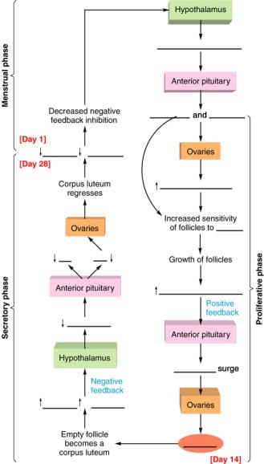

Figure 20.1 This sequence of events in the endocrine control of the ovarian cycle is shown together with the associated phases of the endometrium during the menstrual cycle.

VI. Fertilization, Pregnancy, and Parturition
Once fertilization has occurred, the secondary oocyte completes meiotic division. It then undergoes mitosis, first forming a ball of cells and then an early embryonic structure called a blastocyst. Cells of the blastocyst secrete human chorionic gonadotropin, a hormone that maintains the mother’s corpus luteum and its production of estradiol and progesterone. This prevents menstruation so that the embryo can implant in the endometrium, develop, and form a placenta. Birth is dependent upon strong contractions of the uterus, which are stimulated by oxytocin from the posterior pituitary.

A. Multiple Choice
___ 95. The term capacitation refers to the
a. formation of the sperm head, body, and tail.
b. process by which sperm become able to fertilize an ovum.
c. recognition of the ova by approaching sperm.
d. removal of the sperm body and tail after fertilization.
___ 96. During fertilization, the acrosomal reaction that occurs when the sperm meets the oocyte, causes
a. activation of hyaluronidase and protein-digesting enzymes.
b. sperm to tunnel its way through the corona radiata and zona pellucida layers of the oocyte.
c. a chemical change in the zona pellucida, allowing the entry of only one sperm.
d. the secondary oocyte to complete its second meiotic division.
e. All of these statements regarding the acrosomal reaction are correct.
___ 97. In the female reproductive tract, the secondary oocyte (ovum) lives about _______ day(s); whereas sperm live about _______ day(s).
a. one; two
b. one; three
c. two; one
d. two; three
e. three; one
___ 98. By about fifty to sixty hours after fertilization a third cleavage occurs, producing a ball of _______ cells called a(n) _______.
a. two; zygote
b. two; embryo
c. four; blastocyst
d. eight; morula
e. sixteen; trophoblast
___ 99. The term nidation refers to the process of
a. ovulation.
b. fertilization.
c. cleavage.
d. implantation.
e. parturition.
- Human chorionic gonadotropin (hCG) is an important hormone secreted by the
a. trophoblast cells of the chorion.
b. inner cell mass (fetus).
c. endometrium of the uterus.
d. corpus luteum of the ovary.
- The effects of hCG on the corpus luteum of the ovary resemble those of which other hormone?
a. follicle stimulating hormone (FSH)
b. luteinizing hormone (LH)
c. estradiol 17-☺
d. progesterone
e. oxytocin
- Which two structures—one from fetal tissue and one from maternal tissue—together form the functional unit known as the placenta?
a. endoderm and ectoderm
b. decidua basalis and mesoderm
c. endoderm and chorion frondosum
d. ectoderm and mesoderm
e. decidua basalis and chorion frondosum
- Which of the following techniques is not used to evaluate the status of the growing embryo during pregnancy?
a. chorionic villus biopsy
b. amniocentesis
c. ultrasound imaging
d. All of these techniques are used to evaluate the growing embryo.

- The high metabolic activity seen in the placenta including its rapid rate of protein synthesis most resembles that seen in the
a. kidney.
b. liver.
c. thyroid.
d. pancreas.
e. heart.
- The two placental hormones—human chorionic gonadotropin (hCG) and human chorionic somatomammotropin (hCS)—duplicate the actions of four hormones that are secreted by the
a. anterior pituitary gland.
b. posterior pituitary gland.
c. thyroid gland.
d. hypothalamus.
e. ovaries.
- The two agents most responsible for stimulating the powerful smooth muscle contractions of the uterus in labor during parturition (childbirth), are
a. LH and progesterone.
b. oxytocin and estrogen.
c. hCG and prostaglandins.
d. oxytocin and prostaglandins.
e. estrogen and progesterone.
- As the placenta continues to convert dehydroepiandrosterone sulfate (DHEAS) into estrogens, the rising blood levels of estrogens in the pregnant female, in turn, stimulate the uterus to
- produce more receptors for oxytocin.
- produce more receptors for prostaglandins.
- produce more gap junctions or electrical synapses between myometrial cells in the uterus.
- increase the sensitivity of the myometrium prior to labor and parturition.
- All of these events occur following a rise in blood estrogens.
- During pregnancy, high estrogen levels in the blood inhibit breast milk production by stimulating the secretion of prolactin-inhibiting hormone (PIH, thought to be dopamine) produced by the
a. anterior pituitary.
b. posterior pituitary.
c. ovary.
d. hypothalamus.
e. placenta.
- Successful lactation, including the milk-ejection reflex or milk let-down, results from the combined action of these two hormones.
a. PIH and oxytocin
b. estrogen and progesterone
c. prolactin and oxytocin
d. PIH and prostaglandins
e. progesterone and PIH

B. True or False/Edit
- Freshly ejaculated sperm are not capable of immediately fertilizing an ovum.
- Each ovulation releases a secondary oocyte arrested during prophase of its second meiotic division.
- The second polar body is formed after fertilization by a sperm as the second meiotic division is completed; and, like the first polar body, ultimately fragments and disintegrates.
- The ball of cells called a morula consists of two parts, an inner cell mass (that later forms the fetus) and a surrounding trophoblast layer or chorion (that later forms the placenta).
- Cells obtained from the inner cell mass of a blastocyst (embryonic stem cells) are multipotent in that they can give rise to all tissues except the trophoblast cells of the placenta; whereas adult stem cells are called pluripotent because they can give rise to a number of differentiated cells.
- An important effect of human chorionic gonadotropin (hCG) is to prevent menstruation and thus maintain pregnancy by prolonging the secretions of the corpus luteum.
- The last of three embryonic cell layers to form from the cytotrophoblast portion of the chorion is the mesoderm layer.
- The entire fetus with its umbilical cord are located within the amniotic sac and bathed by amniotic fluid.
- The umbilical artery carries oxygenated blood from the placenta to the fetus, as the umbilical vein carries deoxygenated blood from the fetus to the placenta.
- The maternal and fetal blood come close together within the placenta but never mix.
- During pregnancy the placenta becomes a major sex steroid-producing gland secreting increasing amounts of estrogen and progesterone until the end of gestation, when plasma levels of both hormones are significantly higher than normal.
- In the fetus, the cortex of the adrenal gland is composed of an outer part that secretes the hormone, cortisol (as in adults), and an inner part that secretes the androgen dehydroepiandrosterone sulfate (DHEAS) – which is later converted by the placenta into estrogens.
- Umbilical cord blood that is banked properly can reconstitute a person’s entire hematopoietic system because umbilical cord blood contains high concentration of hematopoietic stem cells.
- Although still incompletely understood, the initiation of the chain of events that leads to labor and parturition may begin with the maturation of the placenta and its secretion of corticotropin-releasing hormone (CRH).
- Unlike the softening of the symphysis pubis and relaxation of the cervix in animals produced by the hormone relaxin in animals during parturition, the action of relaxin in humans appears in the first trimester and is required for normal formation and functioning of the placenta.
- Since breast milk contains immunoglobulin A (IgA), gamma interferon, lysozyme, neutrophils and macrophages, infants who are breast-fed seem to develop fewer infections than those who are bottle-fed on formula.
- Mammary gland development during pregnancy and the subsequent lactation response require complex interactions among many hormones and their regulation by the neuroendocrine system.
- Before childbirth the low secretion of prolactin from the anterior pituitary gland is controlled by prolactin-inhibiting hormone (PIH), which is believed to be the neurotransmitter, dopamine.
- Breast-feeding, acting through reflex inhibition of GnRH secretion from the hypothalamus, can ultimately inhibit ovulation and thereby serve as a natural contraceptive mechanism in some mothers with limited caloric intake.

C. Label the Figure — The Hormonal Control of Mammary Gland Development and Lactation
Figure 20.53 in the text outlines the complex hormonal control of mammary gland development during gestation (pregnancy) and explains why milk is not produced until after parturition (childbirth). Study figure 20.2, identify the correct hormone for each blank answer line and then write the name of that hormone in the space provided. As always, once you have completed the figure, check your work with the text.
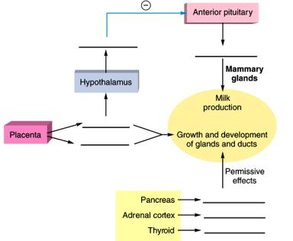
Figure 20.2 The hormonal control of mammary gland development during pregnancy and lactation. Notice that milk production is prevented during pregnancy by estrogen inhibition of prolactin secretion. This inhibition is accomplished by the stimulation of PIH (prolactin-inhibiting hormone) secretion from the hypothalamus.

VII. Chapter Review

A. Crossword Puzzle — Reproduction

Across
1. anterior pituitary hormone that stimulates spermatogenesis in the seminiferous tubules
3. pineal gland hormone influenced by the light-dark cycle
8. labor and delivery (childbirth)
9. tubules, site of meiosis and the formation of sperm
10. male gamete
14. the active form of testosterone in male target cells
15. event influenced by oxytocin and prostaglandins
17. embryo cell layer that forms part of the placenta
20. formation of the male gamete
22. the dominant sex steroid in females
23. sperm travels through the __________ deferens during emission
25. combination of the chorion frondosum and decidua basalis
26. days one through five constitute the __________ phase of the uterus
27. the event that occurs as a result of a surge in plasma LH levels
28. the hypothalamic hormone that is secreted in a “pulsatile” fashion
30. the hypothalamic hormone that blocks the formation of milk
31. fingerlike extensions of the fallopian tubes in females
32. the dominant androgen in males
Down
2. fructose and citric acid flow into semen from the __________ vesicles
4. the sexual response in males that is regulated by activity in the sympathetic nervous system
5. after ovulation, the graafian follicle becomes a corpus __________
6. sperm or ovum
7. Sertoli cell secretion that inhibits FSH release from the anterior pituitary
11. the eight-cell ball of embryonic cells following fertilization
12. the sex chromosome genotype for a Turner’s female
13. testis or ovary
15. the gonadotropin that stimulates testosterone secretion from Leydig cells
16. the hollow ball of cells that implants in the endometrium
18. the menstrual cycle event that may occur on about day twenty-one
19. formation of female gametes (ova) within the follicles of the ovary
21. nongerminal cells of the male seminiferous tubules
24. the inactive “heterochromatin” or X chromosome in female cells, known as a(n) __________ body
29. the chorionic hormone that mimics both growth hormone and prolactin

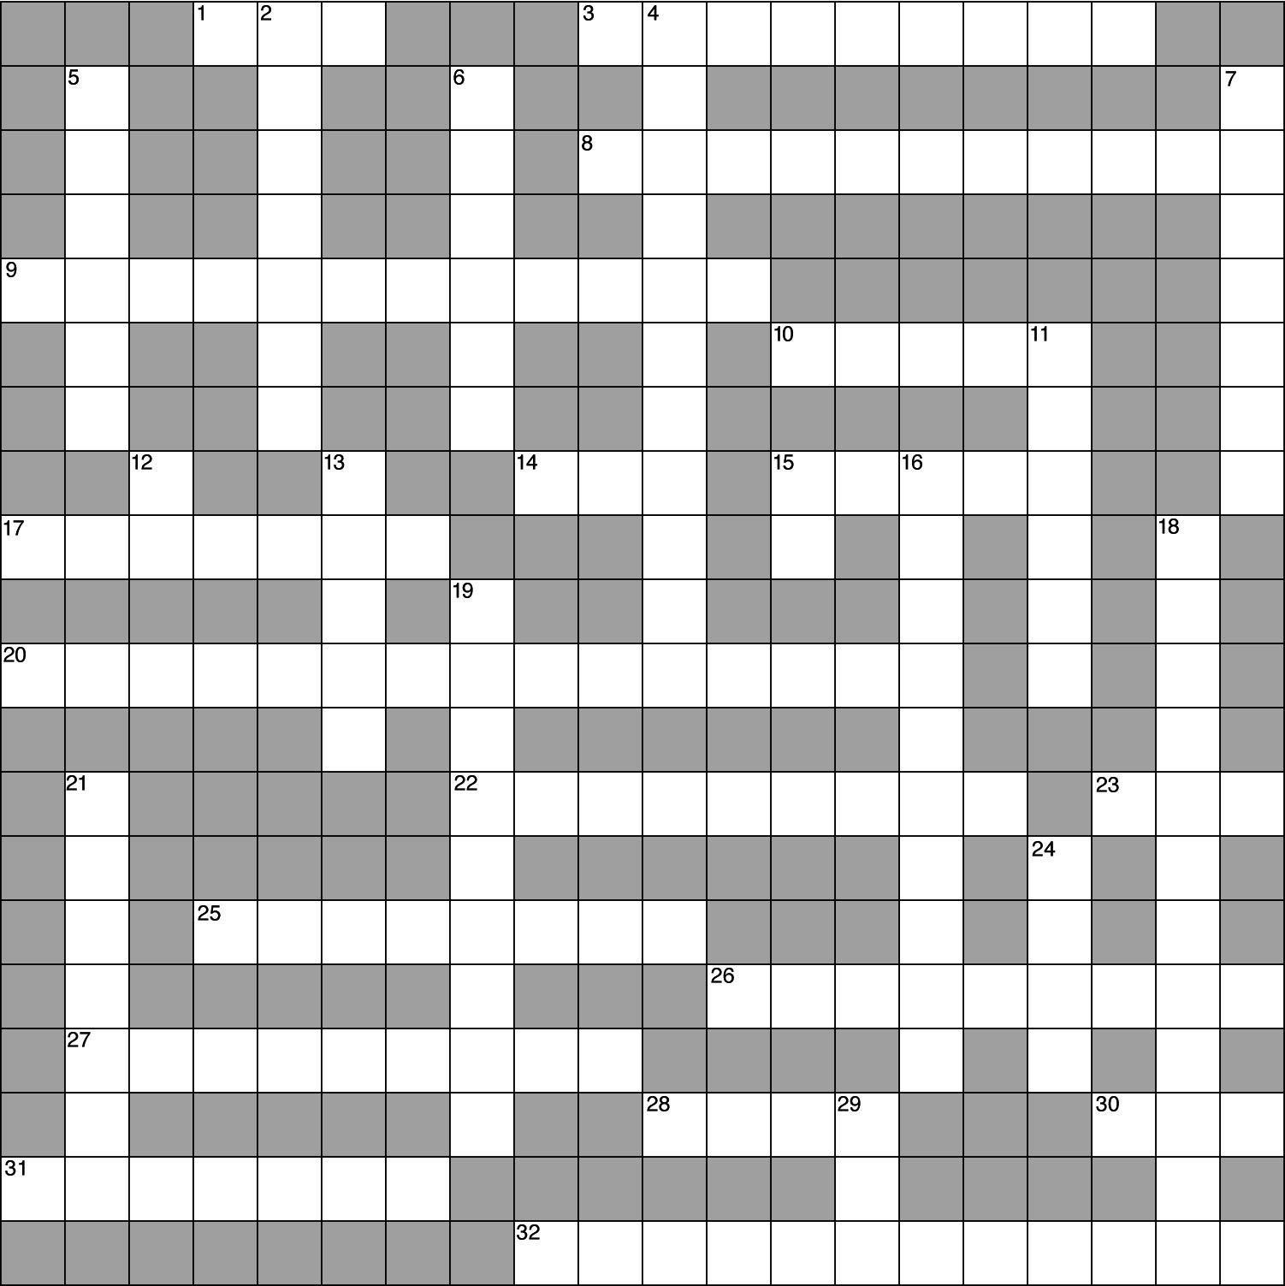

B. Essay

Essay Tutorial
This essay tutorial will answer the first essay question found in the “Review Activities” section of your Human Physiology textbook. Please read Essay Question 1 in “Test Your Understanding of Concepts and Principles” located at the end of chapter 20 and let me guide you through one possible answer. Watch for key terms in boldface type, helpful tips and general suggestions on writing the essay or short-answer questions. Enjoy!

129. Identify the conversion products of testosterone and describe their functions in the brain, prostate, and seminiferous tubules.
Answer. As a nonpolar steroid molecule, testosterone enters all cells by simple diffusion from higher to lower concentrations. However, testosterone receptors are only present in those cells genetically programmed as “target” cells. Once inside the selective target cells, testosterone is converted by means of an enzyme called 5α-reductase into the active hormone. Known as dihydrotestosterone (DHT), this activated hormone directly mediates the androgenic effect in these tissues. In the target neurons of the brain, DHT can, in turn, be changed by other enzymes into other 5α-reduced androgens — abbreviated 3α-diol and 3β-diol. Other brain cells make an enzyme called aromatase, which converts testosterone to estradiol-17β, the major estrogen sex steroid in females. This newly formed estradiol may mediate the negative feedback effect of testosterone on the secretion of GnRH from the hypothalamus and LH from the anterior pituitary gland, resulting in a decrease in blood levels of both hormones.
The stimulation of the prostate gland by testosterone, or its derivatives, is required for normal prostate growth and function. This is the “trophic,” or “nourishing supportive” effect of testosterone. Without testosterone the prostate as well as other sex accessory organs atrophy (“lack nourishment”). The target cells within the seminiferous tubules of adult males are also able to convert incoming testosterone into 5α-reduced androgens, yet their significance is not well understood. The Sertoli cell of the seminiferous tubules must also be stimulated by testosterone, or its derivatives, for normal sperm production. During puberty, testosterone arrives to help initiate spermatogenesis and to maintain sperm production in the adult male thereafter.
Congratulations — by working through these essay questions with me in this study guide I hope you have learned a few tips for answering essay or short answer format questions. To summarize essay-writing techniques,
First, take time to read the question slowly, underline each critical word which will indicate the direction your answer should take and help you confine your discussion to the question.
Second, avoid rambling sentences that may lead you down a path that strays from the points you are trying to make. Remember, if words seem unnecessary they probably are, so don’t use them.
Third, don’t be afraid to express yourself since there is no perfect essay and most professors will give partial credit for honest efforts in the right direction. Here are a few more questions on the reproductive system. Good luck!

130. Draw a cross-section diagram of the seminiferous tubule and label each cell stage that occurs in meiosis during spermatogenesis. Include the important role of the Sertoli cell in this process.

131. Suppose a man is training for the Mr. Universe body-building contest and is abusing anabolic steroids. Discuss the possible effects these exogenous (out of the body) steroids would have on the negative feedback control of hormones from the hypothalamus, pituitary, and the testes. Include their possible effects on the sex accessory glands as well.

132. Divide the twenty-eight-day menstrual cycle into an ovarian cycle and a uterine cycle. Start with day one of the ovarian cycle, and describe the two phases of the ovarian cycle and the hormones involved. In a similar way, describe the phases and hormones characteristic of the uterine cycle.

133. Assuming ovulation and fertilization have occurred on day fourteen of the menstrual cycle, follow the growth and development of the embryo through implantation and formation of the placenta.

134. Where are the hormones human chorionic gonadotropin (hCG) and human chorionic somatomammotropin (hCS) produced, what are their roles in pregnancy, and which four hormones do they mimic?

Answers – Chapter 20

- Sexual Reproduction
- 1. b, 2. e, 3. d, 4. e, 5. b, 6. a, 7. c, 8. d, 9. d, 10. c
- 11. T, 12. F—The Y chromosome is smaller and has different genes, 13. T, 14. T, 15. F—Replace “polar” with “Barr,” 16. T, 17. F—Replace “before” with “after,” 18. T, 19. T
- Endocrine Regulation of Reproduction
- 20. d, 21. a, 22. c, 23. e, 24. a, 25. e, 26. b
- 27. T, 28. F—Replace “third” with “first,” 29. F—Replace “lower” with “higher,” 30. T, 31. F—Switch “LH” and “FSH,” 32. T,
33. F—Replace “sooner” with “later,” 34. T
- Male Reproductive System
- 35. a, 36. b, 37. e, 38. a, 39. c, 40. c, 41. c
- 42. F—Switch “FSH” and “LH,” 43. T,
44. F—Male hormone secretion declines gradually with age, 45. F—Estrogen is not considered an anabolic steroid,
46. T, 47. T, 48. T, 49. F—Switch “outer wall” with “lumen,” 50. T, 51. T, 52. T,
53. T, 54. T, 55. F—Replace “sympathetic” with “parasympathetic,” 56. F—In emission semen moves into the urethra; in ejaculation semen is expelled from the penis,
57. F—Replace “antagonistic” with “synergistic,” 58. T
- Female Reproductive System
- 59. b, 60. a, 61. a, 62. d, 63. d, 64. b
- 65. T, 66. F—Replace “increases” with “decreases,” 67. T, 68. T,
69. F—Switch “corpus luteum” and “ovarian follicles,” 70. F—FSH and LH levels in the blood are influenced by other factors and do not rise and fall together
- Menstrual Cycle
- 71. c, 72. e, 73. b, 74. d, 75. c, 76. b, 77. c, 78. b, 79. d, 80. c, 81. a, 82. c, 83. c
- 84. F—Many differences exist between estrous and menstruation, 85. T, 86. T,
87. F—The zona pellucida and corona radiata remain with the ovum, 88. T,
89. T, 90. F—Replace “luteal” with “follicular,” 91. T, 92. F—Replace “implantation” with “ovulation,” 93. T, 94. T
- Label the figure — Endocrine Control of the Ovarian Cycle; See figure 20.36 in the text
- Fertilization, Pregnancy, and Parturition
- 95. b, 96. e, 97. b, 98. d, 99. d, 100. a, 101. b, 102. e, 103. d, 104. b, 105. a, 106. d, 107. e, 108. d, 109. c
- 110. T, 111. F—Replace “prophase” with “metaphase,” 112. T, 113. F—Replace “morula” with “blastocyst,” 114. F—Switch “multipotent” with “pluripotent,” 115. T, 116. T, 117. T, 118. F—Switch “artery” and “vein,” 119. T, 120. T, 121. T, 122. T,
123. T, 124. T, 125. T, 126. T, 127. T,
128. T
- Label the Figure — The Hormonal Control of Mammary Gland Development and Lactation. See figure 20.53 in the text
- Chapter Review

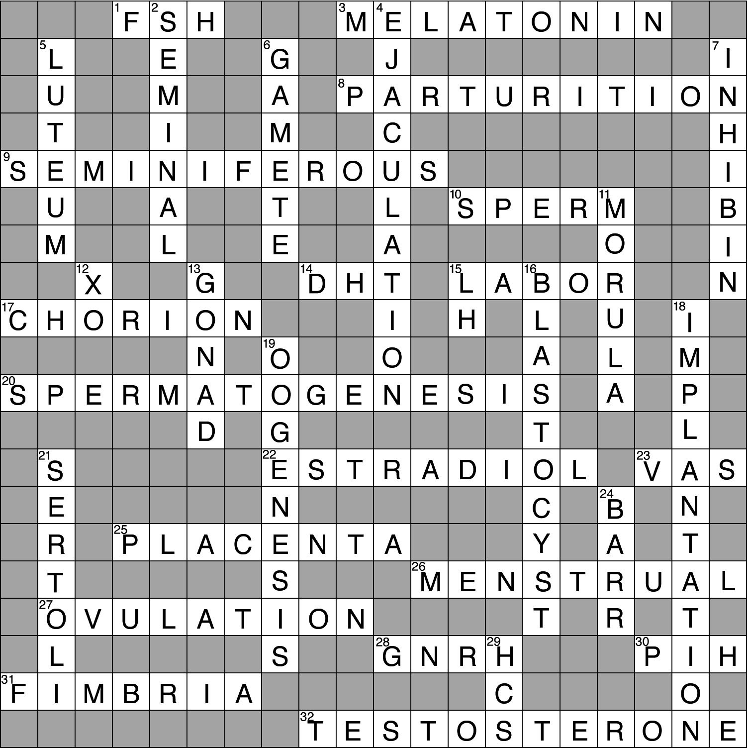
- Crossword Puzzle

