Teeth and Tooth Decay
- Mechanical digestion
  - Break food into smaller pieces to increase surface area for enzymes to work.

Types of teeth:

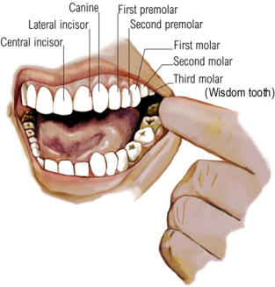

Incisor
Sharp edge to bite of pieces of food.

Canine
Sharply pointed to tear and bite off pieces of food.

Premolars and Molars
Flat and strong to crush and grind food into a pulp.

Structure of a tooth:

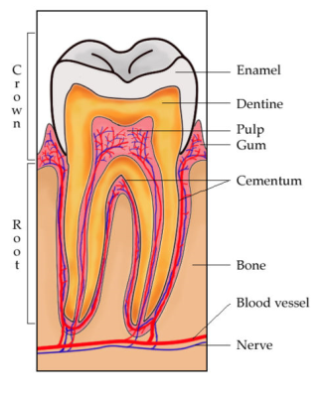

Enamel
Very hard outer covering of the crown. The hardest substance in the human body.

Dentine
Hard main part of the tooth.

Pulp Cavity
Contains blood, nerve and lymph supply and keeps the tooth healthy.

Cementum
Body material that holds the tooth firmly in the jaw

Tooth decay:

Definition of “plaque”:
Layer of bacteria and undigested food that builds up on the tooth.

Process of decay:

- Plaque bacteria feed on sugars which are broken down into acids.
- Acids dissolve the enamel and dentine of the tooth. This creates a cavity.
- When acid reaches the pulp cavity, toothache occurs.

How tooth decay can be prevented:

- Brushing and cleaning with dental floss after meals to remove plaque and food debris.
- Not eating too many sugary foods.
- Don’t drink fruit juices between meals (acidic).
- Use flouride-containg toothpaste.
- Visiting dentis regularly.
- Ensure that toothpaste is in good condition.

Toothpaste:

- Contains sodium bicarbonate (Baking soda), flouride and calcium.

Sodium bicarbonate:
- Reacts with and nuetralizes acids, preventing tooth decay.

Flouride and calcium:
- Needed for formation of strong and healthy dentine and enamel.

Addition of flouride to drinking water

- Reduces rate of tooth decay, but too much can cause dark colouration of the teeth.

Alimentary Canal
- Ingestion
  - Taking in food, crushing it into smaller pieces and mixing it with enzymes before being swallowed.
- Digestion
  - Breaking down of large, complex molecules by enzymes.
- Absorption
  - Passing of small molecules into the blood stream
- Assimilation
  - Transfer of molecules to different cells in the body
- Egestion
  - Removal of undigested waste products.
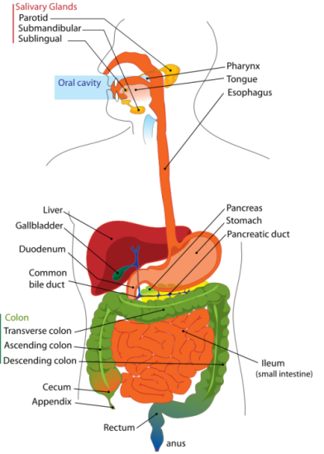

Ingestion

Mouth
- Teeth break down food into smaller pieces and increase the surface area for enzymes to work.

Saliva
- Saliva (slightly alkaline) is secrected by the salivary glands and contains the following:
  - Water and mucus
    - Moistens the food for easier swallowing.
  - Amylase
    - Digests starch into maltose by hydrolysing the glycosidic bonds of the polysaccharides.

Oesophagus
- Food is swallowed and moves down the oesophagus to the stomach by peristalsis.
  - A sphincter muscle prevents food from coming back up the oesophagus.

Digestion

Stomach
- Muscles around the stomach mix the food, acid and proteins very well.

Gastric Juice
- Gastric juice is secreted by the gastric glands and contains the following:
  - Hydrochloric acid
    - Creates the optimum acidic environment for the enzymes to work.
  - Pepsin
    - Digests proteins into amino acids by hydrolysing the peptide bonds of the polypeptides.

- A sphincter muscle gradually allows the mixture (called chyme) to move into the small intestine.
- There is some absorption of water and soluble molecules that need no digestion.

Duodenum

Bile
- Bile is a solution of bile salts and pigments produced by the liver and is stored in the gall bladder.
- Bile is secreted into the duodenum through the bile duct and does the following:
  - Emulsifies fats (break fats into smaller droplets)
  - This creates a greater surface area for the lipase enzyme to digest the fats.

Pancreatic Juice
- The following is secreted by glands in the intestinal wall and the pancreas through the pancreatic duct:
  - Sodium hydrogen carbonate
    - Nuetralizes the acid.
  - Amylase and maltase
    - Continues the break down of starch into glucose.
  - Lipase
    - Digests fats into glycerol and fatty acids by hydrolysing the ester bonds of the fats.
  - Trypsin
    - Continues the break down of proteins into amino acids.

Absorption

Ileum
- All nutrients (monosaccharides, amino acids, fatty acids and glycerol) are now soluble.
- They are absorbed into the blood system through the intestinal wall of the ileum by the villi and microvilli.

Important adaptations:
- Extensive surface area
Microvilli
  - From finger-like projections called villi that have tiny microvilli branching off of them.
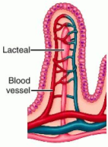
- Rich blood supply.
- Minimal distance separating nutrients from the blood supply.

Villus
- Lacteal absorbs glycerol and fatty acids and transports it through the lymphatic system.
  - They recombine to form fats.
- Blood cappilaries absorb amino acids and monosaccharides by active transport.
  - Transported to the liver.

Large intestine (Colon)
- Absorbs water, minerals and vitamins that are made by bacteria in the colon.
- Compacts indigestable food into faeces and move them to the rectum.

Diarrhoea
When the colon stops absorbing water, the person quickly becomes dehydrated and needs a lot of water to drink.

Constipation
When there is a lack of fibre in the diet, peristalsis slows down and faeces become stuck in the colon and dry out. When this happens the alimentary canal becomes blocked and the sufferer will feel pain.

Assimilation

Liver (Advanced explanation later)
- Food that has been absorbed by small intestine moves through the hepatic portal vein to the liver.
  - Fats first move from a lymph node into the bloodstream through a lymph duct and then to the liver.
- When it reaches the liver, one of the following processes will occur:
  - Materials will move to body cells unchanged or be stored in the liver unchanged.
  - Materials will be changed and then move to body cells or be stored in the liver.

Egestion

Anus
- Removal of indigestable waste (in the form of faeces) from the body.
- NOT TO BE CONFUSED WITH EXCRETION!

Structure of the alimentary canal
- Similar along its length, but with special adaptations for specialized functions.
- The wall has a:
  - Lining of mucous membrane on its inner surface
  - Layer of smooth muscle with its fibres arranged circularly.
  - Layer of smooth muscle with its fibres arranged longitudinally.
Circular muscles
Longitudinal muscles
Mucous membrane

Peristalsis

- Rhythmical contraction of circular and longitudinal muscles causing waves of contration, pushing a ball of food forward through the alimentary canal.
- Effects of peristalsis:
  - Push food along the alimentary canal and keep it moving in the right direction.
  - Help mix food with digestive juices.
  - Helps with mechanical digestion.
- Circular contraction squeezes the food forward.
Gut cavity
Longitudinal muscles
Circular muscles contract
Circular muscles
Wave of contraction
Circular muscles relax
Bolus

Metabolism in the liver

Glucose metabolism

- Blood glucose levels need to be kept in a narrow range of values.
  - When high level Insulin secreted Glucose converted into glycogen
  - When low level Glucagon secreted Glycogen converted into glucose
- There is a limit to how much glycogen can be stored in the liver, when the limit is reached, it is turned to fat and stored in adipose cells under the skin.

Amino acid metabolism

- Body cannot store excess amino acids.
- Excess amino acids are broken down in the liver into urea (containing ammonia) and carbohydrates or fats.
- The removal of the NH₂ (Amino) group for ammonia in urea is called deamination.
- CO₂ is added to the NH₂ to form CO(NH₂)₂ which is urea and is later excreted by the kidneys.
- The remaining carboxyl group, hydrogen, alpha carbon and side chain are converted into fats or carb’s.

