Gaseous Exchange

Movement of substances in and out of cells:

- Exchange of oxygen and carbon dioxide occurs by diffusion.
- Rate of diffusion depends on the concentration gradients.
- Gases can only diffuse across cell membranes in a solution, therefore membranes must be moiste.

Specialized respiratory and circulatory systems:

- Respiratory system is specially adapted for gaseous exchange in the following ways:
  - Large surface area
  - Moiste
  - Rich blood supply
  - Very thin
  - Has a ventilating system

Gaseous exchange in humans

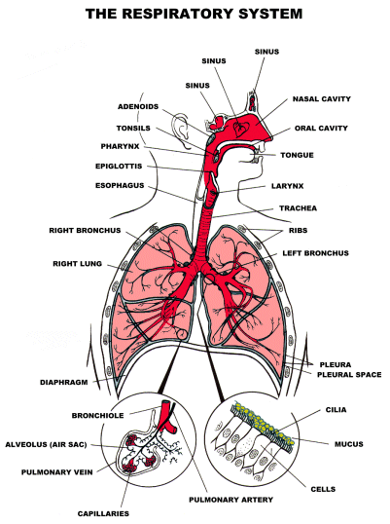
Path of air into the lungs:

Nasal Cavity
Air enters here and becomes warm and moist.

Larynx (Voice box)
Contains vocal chords: Folds of epithelium that vibrate as air moves over them and produce sounds.

Trachea
Takes the air down near to the lungs.

Bronchi
The air branches out from the trachea into two brochi.

Bronchioles
The bronchi branch out into smaller bronchioles.

Alveoli
Tiny sacs with one-cell thick walls where gaseous echange takes place.

Structures:

Trachea and Bronchi
- Strengthened with C-shaped rings of cartilage which prevent the tubes from collapsing.
- Lining secretes mucus to trap dust and bacteria.
- Some cells have tiny projections called cilia which are always moving and waft mucus up to the throat where it is swallowed.

Diaphragm
- A sheet of tissue made out of muscle and tendons.
- Seperates the chest cavity from the abdominal cavity.
- Contraction of the diaphragm results in breathing.

Ribs
- Protects the lungs.
- Inside the ribs are pleural membranes with secrete a liquid to lubricate the movement of the lungs.

Nasal cavity
- Has a mucous membrane that keeps the lungs clean by trapping dust and foreign matter in the mucus.
- The membrane also warms the air through the heat energy in its blood.

Alveoli and gaseous exchange

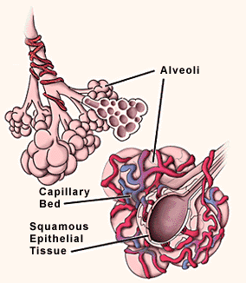

The following features make the alveoli an efficient exchange surface:

- Large surface area for gaseous exchange.
- A single layer of flattened epithelial cells forms the alveoli wall. Gases diffuse across this easily
- Surrounded by a network of blood cappilaries which provide an efficient transport system for the oxygen and carbon dioxide between tissues. This maintains a concentration gradient.
- Distance between the air in the lungs and the blood is tiny. The distance is the thickness of two cells (the alvolar epithelium and the cappilary epithelium).
- A thin moist film coats the wall which allows oxygen to diffuse into it.

Gaseous exchange and diffusion gradients

Diffusion gradient for oxygen:

- Atmospheric air in lungs contains 20% oxygen whereas blood in the lung capillaries contains 18% oxygen.
- Therefore the concentration of oxygen is higher in the lungs and will move into the blood.

Diffusion gradient for carbon dioxide:

- Blood in lung capillaries contains 3% carbon dioxide whereas air in the lungs contains 0.04% carbon dioxide.
- Therefore the concentration of carbon dioxide is higher in the blood and will move into the lungs.

Ventilation
- The movement of air in and out of the lungs is called ventilation.
- The volume of he thorax must change to move air in and out of the lungs
- The supply of fresh air maintains the concentration gradient which allows gaseous exchange to continue.

Volume-pressure changes during breathing

Air moves in and out of the lungs due to the pressure changes brought on by a change in volume of the chest cavity.

These changes in volume are caused by the contraction and relaxation of:

- The muscles of the diaphragm
- The intercostal muscles between the ribs

Volume

Diaphragm

Inspiration (Increase in volume):
Diaphragm muscles contract and the diaphragm flattens.

Expiration (Decrease in volume:
Diaphragm muscles relax and the diaphragm is curved (dome-shaped).
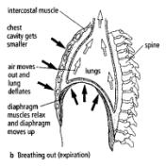
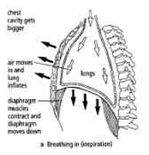

Ribs

Inspiration (Increase in volume):
Intercostal muscles contract and the ribs swing upwards and outwards.

Expiration (Decrease in volume):
Intercostal muscles relax and the ribs swing downwards and inwards.

Pressure

Inspiration:
- Volume increases
- Pressure decreases and is lower than the atmospheric pressure
- Air moves into the lungs and lungs inflate

Expiration
- Volume decreases
- Pressure increases and is higher than atmospheric pressure
- Air moves out of the lungs and the lungs deflate.

Effects of tabacco smoke and pollution

Tabacco smoke

Smoking tabacco is detrimental to one’s health. The following substances are in tobacco smoke:

- Nicotine
  - Is a stimulant and increases heart rate and blood pressure
    - This makes smokers more susceptible to heart disease.
  - Is poisonous and half of the intake remains in the blood

- Tar
  - Contains carcinogens and is absorbed by cells in the bronchi and bronchioles
    - This may cause lung cancer.
  - Irritates the linings of the respiratory passages
    - This causes inflammation and chronic bronchitis.
  - Damages cilia linings
    - This causes mucus to trickle down to the bottom of the lungs.
      - Bacteria breed in the mucus and cause infection.
      - The sufferer coughs to try and get rid of the mucus. This damages the alveoli and as a result, sufferers have a lack of oxygen. This is called EMPHYSEMA.

- Carbon monoxide
  - Combines rapidly and very strongly to haemoglobin to form carboxyhaemoglobin.
    - Oxygen cannot be absorbed by the red blood cells anymore.
      - Shortness of breath occurs.
    - Cells (especially brain cells) are less able to absorb oxygen and this causes damage.

Air pollution

Coal Fires

- Produce vast amounts of sulphur dioxide which cause irritation of the air passages.
- People who are allergic to sulphur dioxide may respond with hay fever or asthma.

Coal-powered power stations are the main contributor of sulphur dioxide.

Allergic reactions

- People who are sensitive to substances such as pollen in the air’s natural defence system overreacts when in contact with these substances and produce histamine which causes sneezing, a runny nose, itching and watery eyes.
- Air pollution makes the symptons of allergic reactions far worse. This is due to low-level ozone and pollutants that damage the linings of the nose and make a substance trigger an allergic reactions much faster than normal.

Asthma

- Caused by many factors such as tobacco smoke, pollen and poor air quality.
- During an asthma attack, a sticky mucus is produced and the muscles around the airways contract and make the airways very narrow. The sufferer becomes breathless and wheezy.

