Ebola
Summary
- Introduction
- 1) Viruses
- 2) Interspecies Transmission processes
- 3) Biodiversity Damage
- Conclusion / Opening
- Virus
a : What is a virus?
    - Considered like a non-living entity
    - Needs a host to survive
    - 2 types: DNA and RNA virus
    - Life cycle
Life cycle

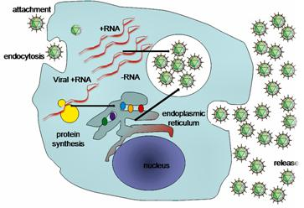

b : Description of Ebola Virus
    - Photography
    - Infection processes
    - Specificities

Ebola virus Photography
80 nm in diameter
Filovirus family
~ 19000 nucleotids
288 amino acids
codes for seven structural proteins and one non-structural protein

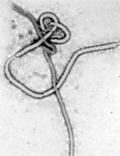

Infection processes
- Blood
- Organ secretion
- Body fluids

Specificities
- 4 types of Ebola virus :
    - Zaire
    - Sudan
    - Ivory Coast
    - Reston
- Incubation period : 2 to 21 days
- Pathologies : hemorrhagic fever, death by stroke

- Human contagion
    - Transmission between species
    - Geographical distribution
    - Mode of action and Symptoms

Transmission between species
Mecanism of action
- Every tissues are affected, excepted bones and muscles.
- The virus creates blood clots.
- Clots goes towards internal organs (lungs, eyeballs…).
- It prevents oxygen to rise tissues.
- The virus also destroys connective tissues (affinity with collagen).

Symptoms
- Initial symptoms :
  - High temperature (at least 38.8°C)
  - Muscle, joint, abdominal pain
  - Nausea
  - Blood stream slow down
- Late symptoms:
  - Diarrhea
  - Vomitting blood
  - Hemorrhage of sclerotic arterioles
  - Internal and external haemorrhages from orifices (nose, mouth, skin, eyes)

- Biodiversity damages
Lethality rate : between 50% and 90%
Death after 6-10 days
Outbreaks of Ebola Virus in Africa from 1976 to 2005
(OMS)

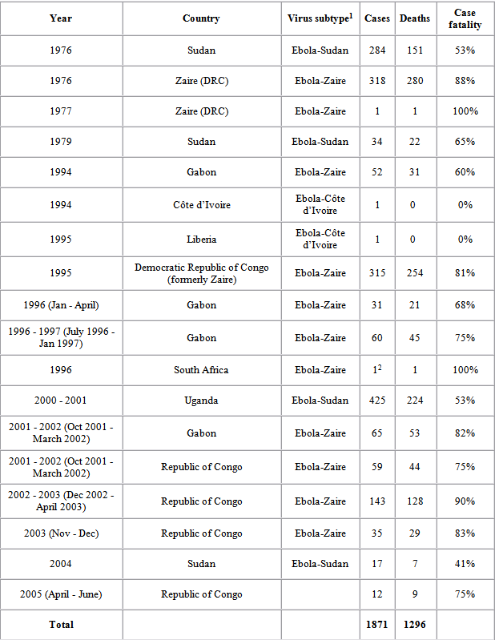

Gorilla, chimpanzee, and duiker population indices

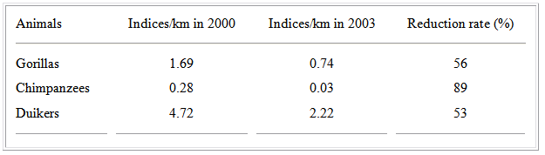
Multiple Ebola virus transmission events and rapid decline of Central African wildlife, SCIENCE, 2004.

Conclusion
- Ebola virus is extremely virulent
- The infected organism does not have time to react to the virus
- First symptoms appear during the critical period.

Opening
- Methods needed to detect the virus as soon as possible: PCR ≠ ELISA techniques
- How bats can be protected against the Ebola Virus?

