Physics for Scientists and Engineers

Describing Motion: Kinematics in One Dimension

2.1
Conceptual Questions

1)
Car A is traveling at twice the speed of car B. They both hit the brakes at the same time and undergo identical decelerations. How does the time required for car A to stop compare with that for car B?
Answer:
Car A takes twice as long to stop.

2)
Car A is traveling at twice the speed of car B. They both hit the brakes at the same time and undergo identical decelerations. How does the distance required for car A to stop compare with that for car B?
Answer:
It takes four times the distance to stop.

3)
It is possible to have a zero acceleration, and still be moving.
Answer:
TRUE

4)
When the velocity and acceleration of an object have the same sign, the speed of the object increases.
Answer:
TRUE

5)
When the velocity and acceleration of an object have opposite signs, the speed of the object increases.
Answer:
FALSE

6)
The average velocity of a car traveling with a constant acceleration during a certain time interval is equal to the mean of the velocities at the beginning and end of that time interval.
Answer:
TRUE

7)
Suppose that an object travels from one point in space to another. Make a comparison between the displacement and the distance traveled.
A)
The displacement is either greater than or equal to the distance traveled.
B)
The displacement is always equal to the distance traveled.
C)
The displacement is either less than or equal to the distance traveled.
D)
The displacement can be either greater than, smaller than, or equal to the distance traveled.
E)
If the displacement is equal to zero, then the distance traveled will also equal zero.
Answer:
C

8)
Which statement below about the distance between the starting and ending positions and the displacement between the starting and ending positions is correct?
A)
The distance between the starting and ending positions is twice the magnitude of the displacement between the starting and ending positions.
B)
The distance between the starting and ending positions is equal to the magnitude of the displacement between the starting and ending positions.
C)
The distance between the starting and ending positions is the negative of the magnitude of the displacement between the starting and ending positions.
D)
The distance between the starting and ending positions is greater than the magnitude of the displacement between the starting and ending positions.
E)
The distance between the starting and ending positions is less than the magnitude of the displacement between the starting and ending positions.
Answer:
B

9)
Which statement is correct about the relationship between the average speed and the magnitude of the average velocity for any motion?
A)
The average speed is always one-half the magnitude of the average velocity.
B)
The average speed is always greater than or equal to the magnitude of the average velocity.
C)
The average speed can be less than, greater than or equal to the magnitude of the average velocity.
D)
The average speed is always less than or equal to the magnitude of the average velocity.
E)
The average speed is always equal to the magnitude of the average velocity.
Answer:
B

10)
Which statement is correct about the relationship between the instantaneous speed and the magnitude of the instantaneous velocity?
A)
The average speed can be less than, greater than or equal to the magnitude of the average velocity.
B)
The instantaneous speed is always equal to the magnitude of the instantaneous velocity.
C)
The average speed is always less than or equal to the magnitude of the average velocity.
D)
The instantaneous speed is always greater than or equal to the magnitude of the instantaneous velocity.
E)
The average speed is always one-half the magnitude of the average velocity.
Answer:
B

Page Ref: Sec. 2-3

11)
The slope of a line connecting two points on a position versus time graph gives
A)
displacement.
B)
instantaneous velocity.
C)
average velocity.
D)
instantaneous acceleration.
E)
average acceleration.
Answer:
C

Page Ref: Sec. 2-3

12)
The slope of a tangent line at a given time value on a position versus time graph gives
A)
displacement.
B)
instantaneous velocity.
C)
average velocity.
D)
instantaneous acceleration.
E)
average acceleration
Answer:
B

Page Ref: Sec. 2-3
13)
If the position versus time graph of an object is a horizontal line, the object is
A)
moving with constant non-zero speed.
B)
moving with constant non-zero acceleration.
C)
at rest.
D)
moving with infinite speed.
E)
none of the above
Answer:
C

Page Ref: Sec. 2-3

14)
If the position versus time graph of an object is a vertical line, the object is
A)
moving with constant non-zero speed.
B)
moving with constant non-zero acceleration.
C)
at rest.
D)
moving with infinite speed.
E)
none of the above
Answer:
D

Page Ref: Sec. 2-3

15)
When is the average velocity of an object equal to the instantaneous velocity?
A)
always
B)
never
C)
only when the velocity is constant
D)
only when the velocity is increasing at a constant rate
E)
only when the velocity is decreasing at a constant rate
Answer:
C

Page Ref: Sec. 2-3

FIGURE 2-1
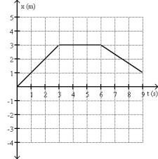
16)
Fig. 2-1 shows the position of an object as a function of time. During which time interval is the object at rest between 0.0 s and 9.0 s?
A)
The object is at rest between 6.0 s and 9.0 s.
B)
The object is always at rest except at the instants t = 3.0 s and t = 6.0 s.
C)
The object is at rest between 0.0 s and 3.0 s.
D)
The object is at rest between 3.0 s and 6.0 s.
E)
The object is never at rest.
Answer:
D

Page Ref: Sec. 2-3
17)
Suppose that an object is moving with a constant velocity. Make a statement concerning its acceleration.
A)
The acceleration must be constantly increasing.
B)
The acceleration must be constantly decreasing.
C)
The acceleration must be a constant non-zero value.
D)
The acceleration must be equal to zero.
E)
A statement cannot be made without additional information.
Answer:
D

18)
Suppose that an object is moving with constant acceleration. Which of the following is an accurate statement concerning its motion?
A)
In equal times its speed changes by equal amounts.
B)
In equal times its velocity changes by equal amounts.
C)
In equal times it moves equal distances.
D)
The object is not moving; it is at rest.
E)
A statement cannot be made without additional information.
Answer:
B

19)
At a given instant, the acceleration of a certain particle is zero. This means that
A)
the velocity is constant.
B)
the velocity is increasing.
C)
the velocity is decreasing.
D)
the velocity is not changing at that instant.
E)
the velocity is zero.
Answer:
D

20)
Suppose that a car traveling to the East (+x direction) begins to slow down as it approaches a traffic light. Make a statement concerning its acceleration.
A)
The car is decelerating, and its acceleration is positive.
B)
The car is decelerating, and its acceleration is negative.
C)
The acceleration is zero.
D)
The car is accelerating, and its acceleration is positive.
E)
The car is accelerating, and its acceleration is negative.
Answer:
B

21)
Suppose that a car traveling to the West (-x direction) begins to slow down as it approaches a traffic light. Make a statement concerning its acceleration.
A)
The car is decelerating, and its acceleration is positive.
B)
The car is decelerating, and its acceleration is negative.
C)
The acceleration is zero.
D)
The car is accelerating, and its acceleration is positive.
E)
The car is accelerating, and its acceleration is negative.
Answer:
A

22)
A car is traveling north at 20.0 m/s at time t = 0.00 s. The same car is traveling north at 24.0 m/s at time t = 8.00 s. What statement is necessarily true about the acceleration of the car?
A)
The car undergoes constant acceleration of 0.500 m/s2 during the time from t = 0.00 s to t = 8.0 s.
B)
The car undergoes constant acceleration of 4.00 m/s2 during the time from t = 0.00 s to t = 8.0 s
C)
The car has zero acceleration during the time from t = 0.00 s to t = 8.0 s
D)
The average acceleration of the car is 0.500 m/s2 during the time from t = 0.00 s to t = 8.0 s
E)
The average acceleration of the car is 4.00 m/s2 during the time from t = 0.00 s to t = 8.0 s
Answer:
D

23)
If the velocity of an object is zero, does it mean that the acceleration is zero? Support your answer with an example.
A)
no, and an example would be an object starting from rest
B)
no, and an example would be an object coming to a stop
C)
yes, and an example would be an object sitting at rest
D)
yes, because of the way in which velocity is defined
E)
yes, because of the way in which acceleration is defined
Answer:
A

24)
The slope of a line connecting two points on a velocity versus time graph gives
A)
displacement.
B)
instantaneous velocity.
C)
average velocity.
D)
instantaneous acceleration.
E)
average acceleration.
Answer:
E

25)
The slope of a tangent line at a given time value on a velocity versus time graph gives
A)
displacement.
B)
instantaneous velocity.
C)
average velocity.
D)
instantaneous acceleration.
E)
average acceleration.
Answer:
D

26)
If the velocity versus time graph of an object is a horizontal line, the object is
A)
moving with constant non-zero speed.
B)
moving with constant non-zero acceleration.
C)
at rest.
D)
moving with infinite speed.
E)
none of the above
Answer:
A

27)
If the velocity versus time graph of an object is a straight line making an angle of 30 degrees with the time axis, the object is
A)
moving with constant non-zero speed.
B)
moving with constant non-zero acceleration.
C)
at rest.
D)
moving with infinite speed.
E)
none of the above
Answer:
B

FIGURE 2-2

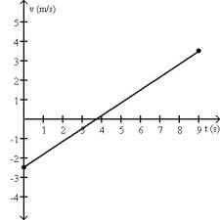

28)
The motion of a particle is described in the velocity vs. time graph shown in Fig. 2-2. We can say that its speed
A)
increases.
B)
decreases.
C)
increases and then decreases.
D)
decreases and then increases.
E)
remains constant.
Answer:
D

FIGURE 2-3
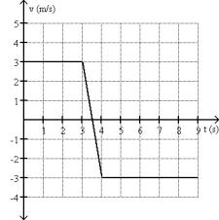
29)
Fig. 2-3 shows the velocity of an object as a function of time. Which graph best represents the acceleration as a function of time?
A)

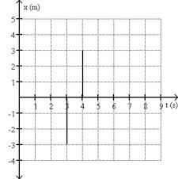
B)

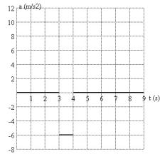
C)

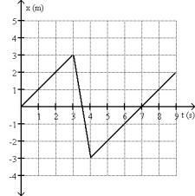
D)

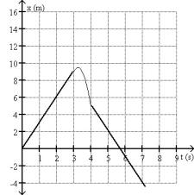
E)
none of the above
Answer:
B

30)
Can an object's velocity change direction when its acceleration is constant? Support your answer with an example.
A)
No, this is not possible because it is always speeding up.
B)
No, this is not possible because it is always slowing up.
C)
No, this is not possible because it is always speeding up or always slowing down, but it can never turn around.
D)
Yes, this is possible, and a rock thrown straight up is an example.
E)
Yes, this is possible, and a car that starts from rest, speeds up, slows to a stop, and then backs up is an example.
Answer:
D

31)
Can an object have increasing speed while its acceleration is decreasing? Support your answer with an example.
A)
No, this is impossible because of the way in which acceleration is defined.
B)
No, because if acceleration is decreasing the object will be slowing down.
C)
Yes, and an example would be an object falling in the absence of air friction.
D)
Yes, and an example would be an object rising in the absence of air friction.
E)
Yes, and an example would be an object released from rest in the presence of air friction.
Answer:
E

32)
Under what condition is average velocity equal to the average of the object's initial and final velocity?
A)
The acceleration must be constantly increasing.
B)
The acceleration must be constantly decreasing.
C)
The acceleration must be constant.
D)
This can only occur if there is no acceleration.
E)
This is impossible.
Answer:
C

33)
When is the average acceleration of an object equal to the instantaneous acceleration?
A)
always
B)
never
C)
only when the acceleration is constant
D)
only when the acceleration is increasing at a constant rate
E)
only when the acceleration is decreasing at a constant rate
Answer:
C

34)
During the time that the acceleration of a particle is constant, its velocity-vs.-time curve is
A)
a straight line.
B)
a parabola opening downward.
C)
a parabola opening upward.
D)
a parabola opening toward the left.
E)
a parabola opening toward the right.
Answer:
A

35)
An object is moving with constant non-zero velocity on the +x axis. The position versus time graph of this object is
A)
a horizontal straight line.
B)
a vertical straight line.
C)
a straight line making an angle with the time axis.
D)
a parabolic curve.
E)
a hyperbolic curve.
Answer:
C

36)
An object is moving with constant non-zero velocity on the +x axis. The velocity versus time graph of this object is
A)
a horizontal straight line.
B)
a vertical straight line.
C)
a straight line making an angle with the time axis.
D)
a parabolic curve.
E)
a hyperbolic curve.
Answer:
A

37)
An object is moving with constant non-zero acceleration on the +x axis. The position versus time graph of this object is
A)
a horizontal straight line.
B)
a vertical straight line.
C)
a straight line making an angle with the time axis.
D)
a parabolic curve.
E)
a hyperbolic curve.
Answer:
D

38)
An object is moving with constant non-zero acceleration on the +x axis. The velocity versus time graph of this object is
A)
a horizontal straight line.
B)
a vertical straight line.
C)
a straight line making an angle with the time axis.
D)
a parabolic curve.
E)
a hyperbolic curve.
Answer:
C

FIGURE 2-4
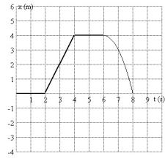
39)
A graph of position as a function of time is shown in Fig. 2-4. During which time interval could the object be possibly moving with non-zero constant acceleration?
A)
0.1 s to 1.9 s
B)
4.1 s to 5.9 s
C)
2.1 s to 3.9 s
D)
6.1 s to 7.9 s
E)
There is no interval that is consistent with constant non-zero acceleration.
Answer:
D

FIGURE 2-5
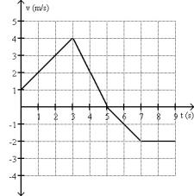
40)
A plot of position as a function of time is shown in Fig. 2-5. Which graph represents the acceleration as a function of time?
A)

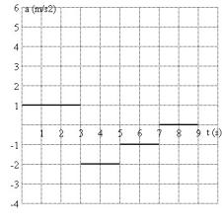
B)

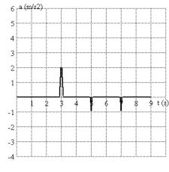
C)

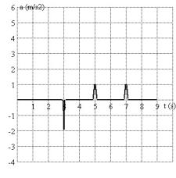
D)

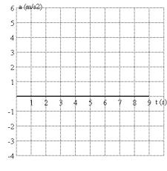
E)

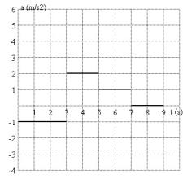
Answer:
C

Page Ref: Sec. 2-6

41)
Which graph below could represent the motion of the object described in the following sentences? The object that starts its motion with a constant velocity of 2.0 m/s east. After 3.0 s, the object stops for 1.0 s. The object then moves toward the west a distance of 2.0 m in 3.0 s. The object continues traveling in the same direction, but increases its speed by 1.0 m/s for the next 2.0 s.
A)

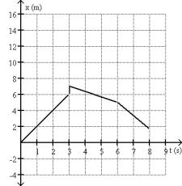
B)

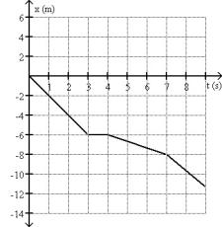
C)

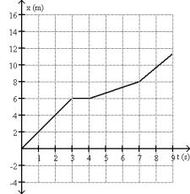
D)

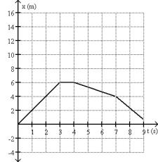
E)
None of the above graphs could represent the motion described.
Answer:
D

Page Ref: Sec. 2-6
42)
A stone is thrown straight up. When it reaches its highest point,
A)
both its velocity and its acceleration are zero.
B)
its velocity is zero and its acceleration is not zero.
C)
its velocity is not zero and its acceleration is zero.
D)
neither its velocity nor its acceleration is zero.
E)
neither velocity nor acceleration can be determined without additional information.
Answer:
B

Page Ref: Sec. 2-7

43)
Suppose a ball is thrown straight up, reaches a maximum height, then falls to its initial height. Make a statement about the direction of the velocity and acceleration as the ball is going up.
A)
Both its velocity and its acceleration point upward.
B)
Its velocity points upward and its acceleration points downward.
C)
Its velocity points downward and its acceleration points upward.
D)
Both its velocity and its acceleration points downward.
E)
Neither velocity nor acceleration can be determined without additional information.
Answer:
B

Page Ref: Sec. 2-7

44)
A ball is thrown straight up, reaches a maximum height, then falls to its initial height. Make a statement about the direction of the velocity and acceleration as the ball is coming down.
A)
Both its velocity and its acceleration point upward.
B)
Its velocity points upward and its acceleration points downward.
C)
Its velocity points downward and its acceleration points upward.
D)
Both its velocity and its acceleration point downward.
E)
Neither velocity nor acceleration can be determined without additional information.
Answer:
D

Page Ref: Sec. 2-7

45)
Two objects are dropped from a bridge, an interval of 1.0 s apart. During the time that both objects continue to fall, their separation
A)
increases.
B)
decreases.
C)
stays constant.
D)
increases at first, but then stays constant.
E)
decreases at first, but then stays constant.
Answer:
A

Page Ref: Sec. 2-7

46)
Which of the following graphs could possibly represent the motion as a function of time of an object in free fall?
A)

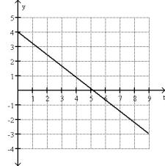
B)

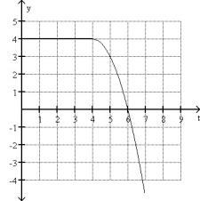
C)

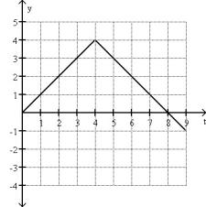
D)

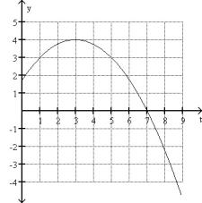
E)

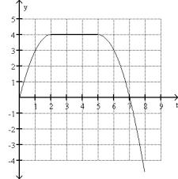
Answer:
D

Page Ref: Sec. 2-7

47)
Two objects are thrown from the top of a tall building. One is thrown up, and the other is thrown down, both with the same initial speed. What are their speeds when they hit the street?
A)
The one thrown up is traveling faster.
B)
The one thrown down is traveling faster.
C)
They are traveling at the same speed.
D)
It is impossible to tell because the height of the building is not given.
E)
It is impossible to tell because a numerical value for the initial speed is not given.
Answer:
C

Page Ref: Sec. 2.7

48)
Two objects are dropped from a bridge, an interval of 1.0 s apart. As time progresses, the difference in their speeds
A)
increases.
B)
remains constant.
C)
decreases.
D)
increases at first, but then stays constant.
E)
decreases at first, but then stays constant.
Answer:
B

Page Ref: Sec. 2-7

49)
The area under a curve in a velocity versus time graph gives
A)
distance traveled.
B)
displacement.
C)
speed.
D)
velocity.
E)
acceleration.
Answer:
B

2.2
Quantitative Problems

1)
Arthur and Betty start walking toward each other when they are 100 m apart. Arthur has a speed of 3.0 m/s and Betty has a speed of 2.0 m/s. How long does it take for them to meet?
Answer:
20 seconds

2)
Arthur and Betty start walking toward each other when they are 100 m apart. Arthur has a speed of 3.0 m/s and Betty has a speed of 2.0 m/s. Their dog, Spot, starts from Arthur's side at the same time and runs back and forth between them. By the time Arthur and Betty meet, what is Spot's displacement?
Answer:
60 m in the direction of Betty

3)
Arthur and Betty start walking toward each other when they are 100 m apart. Arthur has a speed of 3.0 m/s and Betty has a speed of 2.0 m/s. Their dog, Spot, starts by Arthur's side at the same time and runs back and forth between them at 5.0 m/s. By the time Arthur and Betty meet, what distance has Spot run?
Answer:
100 m

4)
The position of a particle as a function of time is given by x(t) = (3.5 m/s)t - (5.0 m/s2)t2. What is the average velocity of the particle between t = 0.30 s and t = 0.40 s?
Answer:
0 m/s

FIGURE 2-6
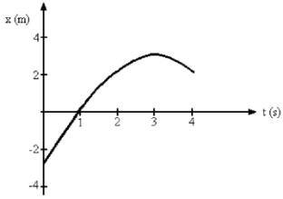
5)
Fig. 2-6 represents the position of a particle as it travels along the x-axis. What is the average speed of the particle between t = 0 s and t = 3 s?
Answer:
2 m/s

Page Ref: Sec. 2-3

6)
Fig. 2-6 represents the position of a particle as it travels along the x-axis. What is the average speed of the particle between t = 2 s and t = 4 s?
Answer:
1 m/s

Page Ref: Sec. 2-3

7)
Fig. 2-6 represents the position of a particle as it travels along the x-axis. What is the average velocity of the particle between t = 0 s and t = 3 s?
Answer:
2 m/s

Page Ref: Sec. 2-3

8)
Fig. 2-6 represents the position of a particle as it travels along the x-axis. What is the average velocity of the particle between t = 2 s and t = 4 s?
Answer:
0 m/s

Page Ref: Sec. 2-3
9)
Fig. 2-6 represents the position of a particle as it travels along the x-axis. What is the magnitude of the instantaneous velocity of the particle when t = 1 s?
Answer:
3 m/s

Page Ref: Sec. 2-3

10)
A certain car can accelerate from 0 to 100 km/hr in 6.0 seconds. What is the average acceleration of that car in m/s2?
Answer:
4.6 m/s2

11)
If a car accelerates at 4.0 m/s2, how long will it take to reach a speed of 80 km/hr, starting from rest?
Answer:
5.6 seconds

FIGURE 2-7
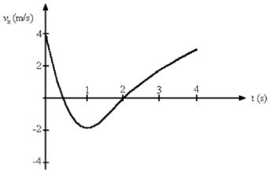
12)
Fig. 2-7 represents the velocity of a particle as it travels along the x-axis. In what direction is the acceleration at t = 0.5 s?
Answer:
in the negative x direction

13)
Fig. 2-7 represents the velocity of a particle as it travels along the x-axis. In what direction is the acceleration at t = 3.0 s?
Answer:
in the positive x direction

14)
Fig. 2-7 represents the velocity of a particle as it travels along the x-axis. What is the average acceleration of the particle between t = 2 s and t = 4 s?
Answer:
1.5 m/s2

15)
Fig. 2-7 represents the velocity of a particle as it travels along the x-axis. At what value of t is the instantaneous acceleration equal to zero?
Answer:
At t = 1 s

16)
A car with good tires on a dry road can decelerate at about 5.0 m/s2 when braking. Suppose a car is initially traveling at 55 mi/h.
(a.) How much time does it take the car to stop?
(b.) What is the stopping distance?
Answer:
(a.) 4.9 s
(b.) 60 m

& 2-6

17)
At the instant a traffic light turns green, a car that has been waiting at the intersection starts ahead with a constant acceleration of 2.00 m/s2. At that moment a truck traveling with a constant velocity of 15.0 m/s overtakes and passes the car.
(a.) Calculate the time necessary for the car to reach the truck.
(b.) Calculate the distance beyond the traffic light that the car will pass the truck.
(c.) Determine the speed of the car when it passes the truck.
Answer:
(a.) 15.0 s
(b.) 225 m
(c.) 30.0 m/s

& 2-6

18)
A ball is thrown straight up with a speed of 30 m/s.
(a.) How long does it take the ball to reach the maximum height?
(b.) What is the maximum height reached by the ball?
(c.) What is its speed after 4.2 s?
Answer:
(a.) 3.1 s
(b.) 46 m
(c.) 11 m/s

Page Ref: Sec. 2-7

19)
A foul ball is hit straight up into the air with a speed of 30.0 m/s.
(a.) Calculate the time required for the ball to rise to its maximum height.
(b.) Calculate the maximum height reached by the ball.
(c.) Determine the time at which the ball pass a point 25.0 m above the point of contact between the bat and ball.
(d.) Explain why there are two answers to part c.
Answer:
(a.) 3.06 s
(b.) 45.9 m
(c.) 0.995 s and 5.13 s
(d.) One value for the ball traveling upward; one value for the ball traveling downward.

Page Ref: Sec. 2-7
FIGURE 2-8
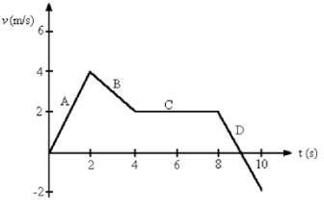
20)
Fig. 2-8 shows the velocity-versus-time graph for a basketball player traveling up and down the court in a straight-line path. Find the displacement of the player for each of the segments A, B, C and D.
Answer:
A, 4 m; B, 6 m; C, 8 m; D, 0 m

21)
A person walks in a distance x northward, turns around and walks a distance 7.00x southward. If the total displacement of the person from his starting position is 400 m south. What was the total distance walked?
A)
421 m
B)
457 m
C)
515 m
D)
533 m
E)
400 m
Answer:
D

22)
The position of an object is given as a function of time as x(t) = (3.00 m/s)t + (2.00 m/s2)t2. What is the displacement of the object between t = 4.00 s and t = 5.00 s?
A)
8.00 m
B)
5.00 m
C)
21.0 m
D)
65.0 m
E)
44.0 m
Answer:
C

FIGURE 2-9

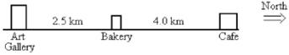

23)
Refer to Fig. 2-9. If you start from the Bakery, travel to the Cafe, and then to the Art Gallery, what is the distance you have traveled?
A)
6.5 km
B)
2.5 km
C)
10.5 km
D)
0 km
E)
1.5 km
Answer:
C

24)
Refer to Fig. 2-9. If you start from the Bakery, travel to the Cafe, and then to the Art Gallery, what is the magnitude of your displacement?
A)
6.5 km
B)
2.5 km
C)
10.5 km
D)
9.0 km
E)
1.5 km
Answer:
B

FIGURE 2-10
25)
Fig. 2-10 shows the position of an object as a function of time. What is the length of the path the object followed during the time interval from time t = 0.0 s and time t = 9.0 s?
A)
-1.0 m
B)
3.0 m
C)
1.0 m
D)
19.5 m
E)
5.0 m
Answer:
E

26)
Fig. 2-10 shows the position of an object as a function of time. What is the displacement of the object between time and time t = 9.0 s?
A)
3.0 m
B)
19.5 m
C)
5.0 m
D)
1.0 m
E)
-1.0 m
Answer:
D

27)
A man walks south at a speed of 2.00 m/s for 15.0 minutes. He then turns around and walks north a distance 2000 m in 15.0 minutes. What is the average speed of the man during his entire motion?
A)
1.89 m/s
B)
3.35 m/s
C)
3.21 m/s
D)
2.82 m/s
E)
2.11 m/s
Answer:
E

28)
A man walks south at a speed of 2.00 m/s for 60.0 minutes. He then turns around and walks north a distance 3000 m in 25.0 minutes. What is the average velocity of the man during his entire motion?
A)
0.824 m/s south
B)
1.93 m/s south
C)
2.00 m/s south
D)
1.79 m/s south
E)
800 m/s south
Answer:
A

29)
A man walks south at a speed of 2.00 m/s for 30.0 minutes. He then turns around and walks north a distance 6000 m in 15.0 minutes. What is the displacement of the man from his starting position?
A)
1800 m north
B)
3600 m south
C)
5940 m south
D)
4200 m south
E)
2400 m north
Answer:
E

FIGURE 2-9

30)
Refer to Fig. 2-9. If you start from the Bakery, travel to the Art Gallery, and then to the Cafe, in 1.0 hour, what is your average speed?
A)
6.5 km/hr
B)
2.5 km/hr
C)
9.0 km/hr
D)
10.5 km/hr
E)
1.5 km/hr
Answer:
C

FIGURE 2-10
31)
Fig. 2-10 shows the position of an object as a function of time. What is the average speed of the object between time and time t = 9.0 s?
A)
0.11 m/s
B)
-0.33 m/s
C)
0.33 m/s
D)
0.56 m/s
E)
-0.11 m/s
Answer:
D

32)
Fig. 2-10 shows the position of an object as a function of time. What is the average velocity of the object between time t = 0.0 s and time t = 9.0 s?
A)
-0.11 m/s
B)
0.55 m/s
C)
-0.33 m/s
D)
0.33 m/s
E)
0.11 m/s
Answer:
E

33)
The position of an object is given as a function of time as x(t) = (3.00 m/s)t + (2.00 m/s2)t2. What is the average velocity of the object between t = 0.00 s and t = 2.00 s?
A)
3.00 m/s
B)
11.0 m/s
C)
27.0 m/s
D)
13.0 m/s
E)
7.00 m/s
Answer:
E

34)
In a 400-m relay race the anchorman (the person who runs the last 100 m) for team A can run 100 m in 9.8 s. His rival, the anchorman for team B, can cover 100 m in 10.1 s. What is the largest lead the team B runner can have when the team A runner starts the final leg of the race, in order that the team A runner not lose the race?
A)
1.0 m
B)
2.0 m
C)
3.0 m
D)
4.0 m
E)
5.0 m
Answer:
C

35)
The position of an object is given as a function of time as x(t) = (-3.00 m/s)t + (1.00 m/s2)t2. What is the average speed of the object between t = 0.00 s and t = 2.50 s?
A)
0.500 m/s
B)
2.00 m/s
C)
-0.500 m/s
D)
1.30 m/s
E)
2.60 m/s
Answer:
D

FIGURE 2-11
36)
Fig. 2-11 represents the position of a particle as it travels along the x-axis. What is the magnitude of the average velocity of the particle between t = 1 s and t = 4 s?
A)
0.25 m/s
B)
0.50 m/s
C)
0.67 m/s
D)
1.0 m/s
E)
1.3 m/s
Answer:
C

Page Ref: Sec. 2-3

37)
Fig. 2-11 represents the position of a particle as it travels along the x-axis. What is the average speed of the particle between t = 1 s and t = 4 s?
A)
1.0 m/s
B)
1.3 m/s
C)
0.67 m/s
D)
0.50 m/s
E)
0.25 m/s
Answer:
B

Page Ref: Sec. 2-3

FIGURE 2-12
38)
Fig. 2-12 represents the position of a particle as it travels along the x-axis. At what value of t is the speed of the particle equal to zero?
A)
0 s
B)
1 s
C)
2 s
D)
3 s
E)
4 s
Answer:
D

Page Ref: Sec. 2-3
39)
A runner leaves the starting blocks and accelerates at 2.60 m/s2 for 4.00 s. What speed does the runner reach?
A)
32.0 m/s
B)
10.4 m/s
C)
23.3 m/s
D)
1.45 m/s
E)
4.65 m/s
Answer:
B

40)
The velocity of an object as a function of time is given by v(t) = -3.0 m/s - (2.0 m/s2) t + (1.0 m/s3) t2. Determine the instantaneous acceleration at time t = 2.00 s.
A)
-5.0 m/s2
B)
2.0 m/s2
C)
-18 m/s2
D)
-3.0 m/s2
E)
18 m/s2
Answer:
B

41)
The velocity of an object as a function of time is given by v(t) = 2.00 m/s + (3.00 m/s) t - (1.0 m/s2) t2. Determine the instantaneous acceleration at time t = 4.00 s.
A)
-2.00 m/s2
B)
-5.00 m/s2
C)
1.00 m/s2
D)
0.00 m/s2
E)
-1.00 m/s2
Answer:
B

FIGURE 2-13
42)
Fig. 2-13 represents the velocity of a particle as it travels along the x-axis. What is the average acceleration of the particle between t = 1 second and t = 4 seconds?
A)
0.33 m/s2
B)
1.7 m/ s2
C)
2.0 m/ s2
D)
2.5 m/ s2
E)
3.0 m/ s2
Answer:
B

43)
The velocity of a particle as a function of time is given by v(t) = (2.3 m/s) + (4.1 m/ s2)t - (6.2 m/ s3)t2. What is the average acceleration of the particle between t = 1.0 s and t = 2.0 s?
A)
-13 m/ s2
B)
-15 m/ s2
C)
13 m/ s2
D)
15 m/ s2
E)
0 m/ s2
Answer:
B

44)
At time t = 0.00 s, a car is traveling along a straight line at a speed of 20 m/s with constant acceleration. The car travels 56.0 m during the time interval between t = 2.00 s and t = 4.00 s. What is the acceleration of the car?
A)
14.0 m/ s2
B)
0.00 m/ s2
C)
7.00 m/ s2
D)
5.33 m/ s2
E)
2.67 m/ s2
Answer:
E

& 2-6
45)
A airplane that is flying level needs to accelerate from a speed of 200 m/s to a speed of 240 m/s while it flies a distance of 1200 m. What must the acceleration of the plane be?
A)
4.44 m/s2
B)
2.45 m/s2
C)
7.33 m/s2
D)
5.78 m/s2
E)
1.34 m/s2
Answer:
C

& 2-6

46)
A runner maintains constant acceleration after starting from rest as she runs a distance of 60.0 m. The runner's speed at the end of the 60.0 m is 9.0 m/s. How much time did it take the runner to complete the 60.0 m distance?
A)
6.67 s
B)
15.0 s
C)
9.80 s
D)
10.2 s
E)
13.3 s
Answer:
E

& 2-6

47)
An object starts from rest at time t = 0.00 s and moves with constant acceleration. The object travels 3.00 m from time t = 1.00 s to time t = 2.00 s. What is the acceleration of the object?
A)
-3.00 m/s2
B)
6.00 m/s2
C)
-1.00 m/s2
D)
1.00 m/s2
E)
2.00 m/s2
Answer:
E

& 2-6

48)
A car starts from rest and accelerates with a constant acceleration of 1.00 m/s2 for 3.00 s. The car continues for 5.00 s at constant velocity. How far has the car traveled from its starting point?
A)
24.0 m
B)
9.00 m
C)
19.5 m
D)
4.50 m
E)
15.0 m
Answer:
C

& 2-6

49)
A jet fighter plane is launched from a catapult on an aircraft carrier. It reaches a speed of 42 m/s at the end of the catapult, and this requires 2.0 s. Assuming the acceleration is constant, what is the length of the catapult?
A)
16 m
B)
24 m
C)
42 m
D)
63 m
E)
84 m
Answer:
C

& 2-6

50)
A ball rolls across a floor with an acceleration of 0.10 m/s2 in a direction opposite to its velocity. The ball has a velocity of 4.00 m/s after rolling a distance 6.00 m across the floor. What was the initial speed of the ball?
A)
4.15 m/s
B)
5.85 m/s
C)
4.60 m/s
D)
5.21 m/s
E)
3.85 m/s
Answer:
A

& 2-6

51)
A car is 200 m from a stop sign and traveling toward the sign at 40.0 m/s. If the driver realizes they must stop the car at this time. It takes 0.20 s for the driver to apply the brakes. What must the constant acceleration of the car be after the brakes are applied so that the car would come to rest at the stop sign?
A)
2.89 m/s2
B)
3.89 m/s2
C)
4.17 m/s2
D)
3.42 m/s2
E)
2.08 m/s2
Answer:
C

& 2-6

52)
A car is traveling with a constant speed when the driver suddenly applies the brakes, giving the car a deceleration of 3.50 m/s2. If the car comes to a stop in a distance of 30.0 m, what was the car's original speed?
A)
10.2 m/s
B)
14.5 m/s
C)
105 m/s
D)
210 m/s
E)
315 m/s
Answer:
B

& 2-6
53)
A speeding car is traveling at a constant 30.0 m/s when it passes a stationary police car. If the police car delays its motion for 1.00 s before starting, what must the constant acceleration of the police car be to catch the speeding car after the police car travels a distance of 300 m?
A)
6.00 m/s2
B)
3.00 m/s2
C)
7.41 m/s2
D)
1.45 m/s2
E)
3.70 m/s2
Answer:
C

& 2-6

54)
In a relay race, runner A is carrying the baton and has a speed of 3.00 m/s. When he is 25.0 m behind the starting line, runner B starts from rest and accelerates at 0.100 m/s2. How long afterwards will A catch up with B to pass the baton to B?
A)
5.17 s
B)
10.0 s
C)
11.9 s
D)
20.4 s
E)
A never catches up.
Answer:
B

& 2-6

55)
In a relay race, runner A is carrying the baton and has a speed of 3.4 m/s. When he is 25 m behind the starting line, runner B starts from rest and accelerates at 0.140 m/s2. How fast is B traveling when A overtakes her?
A)
0.10 m/s
B)
0.33 m/s
C)
1.3 m/s
D)
2.0 m/s
E)
A never catches up.
Answer:
C

& 2-6

56)
A rock is dropped from a vertical cliff. The rock takes 7.00 s to reach the ground below the cliff. What is the height of the cliff?
A)
80.1 m
B)
240 m
C)
100 m
D)
26.2 m
E)
481 m
Answer:
B

Page Ref: Sec. 2-7

57)
If an object was freely falling, from what height would it need to be dropped to reach a speed of 70.0 m/s before reaching the ground?
A)
250 m
B)
322 m
C)
189 m
D)
500 m
E)
712 m
Answer:
A

Page Ref: Sec. 2-7

58)
Two objects are dropped from a bridge, an interval of 1.00 s apart. What is their separation 1.00 s after the second object is released?
A)
4.90 m
B)
7.35 m
C)
9.80 m
D)
14.7 m
E)
19.8 m
Answer:
D

Page Ref: Sec. 2-7

59)
An object is dropped from a bridge. A second object is thrown downwards 1.00 s later. They both reach the water 20.0 m below at the same instant. What was the initial speed of the second object?
A)
4.91 m/s
B)
14.6 m/s
C)
9.90 m/s
D)
19.6 m/s
E)
21.3 m/s
Answer:
B

Page Ref: Sec. 2-7
60)
A ball is dropped from somewhere above a window that is 2.00 m in height. As it falls, it is visible to a person looking through the window for 200 ms as it passes by the 2.00 m height of the window. From what height above the top of the window was the ball dropped?
A)
8.32 m
B)
1.87 m
C)
4.15 m
D)
4.76 m
E)
6.78 m
Answer:
C

Page Ref: Sec. 2-7

61)
A rock is dropped from a vertical cliff. The rock takes 3.00 s to reach the ground below the cliff. A second rock is thrown vertically from the cliff. It takes 2.00 s to reach the ground below the cliff from the time it is released. With what velocity was the second rock released?
A)
4.76 m/s upward
B)
5.51 m/s downward
C)
12.3 m/s upward
D)
4.76 m/s downward
E)
12.3 m/s downward
Answer:
E

Page Ref: Sec. 2-7

62)
An object is thrown upwards with a speed of 14 m/s. How long does it take to reach a height of 5.0 m above the projection point while descending?
A)
0.42 s
B)
1.2 s
C)
2.4 s
D)
3.1 s
E)
4.2 s
Answer:
C

Page Ref: Sec. 2-7

63)
To determine the height of a flagpole, Abby throws a ball straight up and times it. She sees that the ball goes by the top of the pole after 0.5 s and then reaches the top of the pole again after a total elapsed time of 4.1 s. How high is the pole above the point where the ball was launched?
A)
10 m
B)
13 m
C)
16 m
D)
18 m
E)
26 m
Answer:
A

Page Ref: Sec. 2-7

64)
Abby throws a ball straight up and times it. She sees that the ball goes by the top of a flagpole after 0.50 s and reaches the level of the top of the pole after a total elapsed time of 4.10 s. What was the speed of the ball at as it passed the top of the flagpole?
A)
6.40 m/s
B)
16.2 m/s
C)
17.6 m/s
D)
29.0 m/s
E)
33 m/s
Answer:
C

Page Ref: Sec. 2-7

65)
The velocity of an object is given by the expression v(t) = 3.00 m/s + ( 2.00 m/s3)t2. Determine the position of the object as a function of time if it is located at x = 1.00 m at time t = 0.00 s.
A)
( 2.00 m/s)t + 1.00 m
B)
(3.00 m/s)t + ( 0.667 m/s3)t3
C)
( 2.00 m/s)t
D)
0.667 m
E)
1.00 m + (3.00 m/s)t + ( 0.667 m/s3)t3
Answer:
E

Page Ref: Sec. 2-8

66)
The acceleration of an object as a function of time is given by a(t) = (3.00 m/s3)t. If the object is at rest at time t = 0.00 s, what is the velocity of the object at time t = 5.00 s?
A)
15.0 m/s
B)
37.5 m/s
C)
0.00 m/s
D)
12.0 m/s
E)
75.0 m/s
Answer:
B

Page Ref: Sec. 2-8
67)
The acceleration of an object as a function of time is given by a(t) = (3.00 m/s3)t. If the object has a velocity 1.00 m/s at time t = 1.00 s, what is the displacement of the object between time t = 2.00 s and time t = 4.00 s?
A)
33.0 m
B)
30.0 m
C)
36.0 m
D)
27.0 m
E)
Not enough information is given to determine the displacement of the object between these two times.
Answer:
D

Page Ref: Sec. 2-8

68)
The acceleration of an object as a function of time is given by a(t) = (1.00 m/s2)t2. If displacement of the object between time t = 1.00 s and time t = 2.00 s is 15.0 m, what is the velocity of the object at time t = 0.00 s?
A)
1.25 m/s
B)
3.75 m/s
C)
6.25 m/s
D)
13.5 m/s
E)
Not enough information is given to determine the velocity of the object at time t = 0.00 s.
Answer:
D

Page Ref: Sec. 2-8

FIGURE 2-8
69)
Fig. 2-8 shows the velocity-versus-time graph for a basketball player traveling up and down the court in a straight-line path. Find the net displacement of the player for the 10 s shown on the graph.
A)
20 m
B)
18 m
C)
16 m
D)
14 m
E)
12 m
Answer:
B

70)
Fig. 2-8 shows the velocity-versus-time graph for a basketball player traveling up and down the court in a straight-line path. Find the total distance run by the player in the 10 s shown in the graph.
A)
20 m
B)
18 m
C)
16 m
D)
14 m
E)
12 m
Answer:
A

