Lesson 3
Communication and its need for Development

The notion of communication as considered in this report must not be confused with the technical means of communication such as telecommunications, informatics, postal services and similar devices, though they are indispensable vehicles to the dissemination of information and knowledge. Furthermore, the conceptual category of communication as specified in the title refers to development. In other words, this study deals with the central role of the discipline of communication for a successful implementation of development programmes and for an improvement of the interaction between actors in development, namely the United Nations system, governments, NGOs and the beneficiaries.
Because of this approach and in order to avoid overlapping, the JJU, under the guidance of the same Inspector, is preparing a separate study entitled "A review of Telecommunications and Related Information Technologies in the United Nations System". Although a sound telecommunication infrastructure is an essential support to development, the prevailing choice is in favour of a separate exploration of the subject. This is not only because of the specific suggestion which came from FAO, but also in consideration of the fact that the JIU has in the past undertaken two studies on the same topic entitled "Communication in the United Nations System" (JIU/REP/72/7 and JIU/REP/82/6). The rapid progress in technology and its bearing on the field of communications demand an updating on the subject which will be better tackled in a separate report.
As stated in Article 1.2 of its Constitution, UNESCO is the principal United Nations Organization mandated to be responsible for communication. In addition, it also has the lead mandate in the field of social communication. UNESCO has, therefore, recognized, inter-alia, the need for a mechanism to coordinate communication activities through appropriate media and suggested to the JIU that it undertake a study on "Communication for
Development Programmes in the United Nations System". The terms of reference for the study are to:
- analyze and evaluate existing informal arrangements for the coordination of communicationat an inter-agency level;
- develop proposals for an improved and more institutionalized mechanism to facilitate coordination; and
- describe the particular dimension of communication and its specificity vis-a-vis other aspects of information technology, in particular informatics and telecommunications as support areas.
It is with this in mind and cognizant of the important evolution in the field of communication for development that the report will:
- try to define the notion of communication for development and its dimension as an instrument for rallying communities to participate in development projects from assessed needs to implementation, monitoring and evaluation;
- look into the communication programmes of UNESCO;
- examine the status of communication programmes of other agencies;
- review previous attempts and existing informal arrangements for the co-ordination of communication programmes for development in the United Nations system;
- examine the opportunity, evaluate the convenience and propose the setting-up of a more appropriate mechanism for enhancing cooperation among agencies;
- consider how this mechanism could strengthen communication in humanitarian assistance activities and in peace-keeping operations; and
- explore the possibility of cost saving aspects by using already-existing fora and facilities.
The methodology used for the preparation of the study was, mainly, visits by the Inspector to headquarters and field offices and analysis of replies to questionnaires provided by the specialized agencies: UNESCO, UNDP, UNICEF, UNFPA, United Nations/DPI, WFP, UNIDO, UNHCR, ILO, WHO, ITU, IMO, WMO, IAEA, ICAO, and FAO. It should be specified at the outset that some organizations have responded stating that they do not have communication for development programmes at the headquarters level; for others, only at the field level. Still others mentioned the fact that programmes for communication are implemented by the national authorities in co-operation with United Nations agencies. One organization stated that it does not have any information to contribute to the study, while another responded by stating that they have no communication programme in the sense that it is understood by UNESCO. Views were also exchanged with the communication departments of a university and non-governmental organization in the field.
The investigation showed that UNESCO's request has been particularly timely and has raised problem areas for which there is an increasing awareness and greater demand for solutions. This is also in the light of the fresh approach of the Secretary-General to the problems of development and of his appeal to the international community for more attention to be paid to such an important issue the implications of which are so effectively put into light in the "agenda for development".
The Inspector is grateful to all who have spared their time and energy to contribute to the preparation of the study. Their participation has greatly facilitated work on the report and stimulated research, providing a new dimension and commitment.
I. The importance and scope of the field of communication
The importance and scope of "Communication for Development" differs widely from one organization to another. Organizations such as UNICEF and UNFPA tend to decentralize their activities to the regional and country offices. They accord a great deal of importance to "communication/mobilization programmes". UNICEF alone spends over $100 million a year on such programmes. UNFPA allocated 17 percent of its resources for communication and education programmes in 1992. This was the second largest allocation after family planning, which also has a communication support component. WHO has allocated about $4 million for communication and public information at Headquarters level for the biennium 1994-95, representing approximately 0.5 percent of its total regular programme budget. United Nations/DPI allocates 0.6 percent of its overall regular budget for strengthening communication capabilities of developing countries. Other agencies do not have specific allocations for communication for development but they include communication as part of the approved work programme of some sections, whilst some have simply no financial allocation for communication. According to an FAO publication on Communication for Development, the overall budget for communication is about 10 percent of the total development programme budget. For large-scale programmes, however, it may be as low as one percent, and for small programmes somewhat higher than 10 percent.1
Two different approaches and orientations exist concerning communication. The first is field-oriented and relies on communication for human development emphasizing more popular participation through extension and development agents including development-oriented NGOs.
The second approach maintains a global view of the problems of development rather than specific country policies and is mainly concerned with development of communication per se, involving the media in general with respect to the formulation of general programmes requiring global actions such as the campaign against AIDS, illiteracy, the promotion of the Programme of Health for all by the year 2000. Distinct actions and useful complementarity characterize these two approaches.
UNDP makes some funding available to both groups. Since the 1970s, it has evolved a policy whereby communication components are integrated in projects at the country level through the Development Support Communication Office (later called the Development Communication Training Programme) which also had regional bureaux. These funds were administered mainly by this Office, and not by the specialized agencies. As a matter of fact, most funds for communication were allocated for telecommunication and transportation projects proposed by governments.
Humanitarian assistance within the framework of peace-making and peacekeeping processes is a new area requiring communication structures. The Department of Peace-Keeping Operations (DPKO) is assigned an important communication and co-ordination role at Headquarters level by "co-ordinating instructions sent to the field missions on operational matters as well as co-ordinating relationships between Headquarters, New York and each mission in the field by providing backstopping". The JIU through its report on "Staffing of the United Nations Peace-Keeping and Related Missions" (Civilian Component) (JIU/REP/93/6) has maintained that "...Communication from the field continues to be irregularly channelled to different departments at Headquarters creating further problems in the flow of information, co-ordination and hence, coherence and timely instructions".
A. Principal ways of conveying public information
Public information concerning development programmes is presently conveyed in four principal ways:
- Provision of news and information to the people through the press, radio, television and audiovisual educational programmes.
- Informatics: access to data base and electronically-stored information in libraries, archives and cultural centres.
- Telecommunications: telephone services, facsimile, telex, telegrams, data transmission, electronic mail.
- Postal Services: mail and parcel services, telegrams.
Information technology has become an indispensable tool for developing an effective communication structure. New technologies are offering many opportunities, with the possibility of reaching untapped audiences. In many developing countries this could include interactive media. The United Nations system needs to be at the cutting edge of such possibilities. In more traditional areas, the use of radio has to be stressed and the conduct of journalists' training courses in developing countries should be seen as a form of capacity building.
Keeping up with modern technology is a priority concern to developing countries which have limited access to the information media. They seek more assistance in this area to ensure that their requirements for information technology are accurately reflected in every project set up to help them build up their information infrastructure. The World Bank states that "Information technology, if used correctly, can help increase workers' productivity, make governments and companies more flexible, and improve decision-making. In the long run, it can make governments more accountable and coordinated and could allow them to respond better to social needs".3 The ITU in its Missing Link report concluded more dramatically that "...henceforth no development programme of any country should be regarded as balanced, properly integrated or likely to be effective unless it includes a full and appropriate role for telecommunications and accords corresponding priority for the improvement and expansion of telecommunications".
B. Types of communications
The focus of this report, however, is not public information per se, but communication as part of the social process of development. With this
limitation in mind, two types of communications are of special interest to the present report:
- Communication for development purposes included in the design of projects.
- Communication for humanitarian assistance activities and peacemaking and peace-keeping processes.
1. Communication for Development
Communication for development is a specialized field which requires ad hoc training. As understood and used by agencies of the United Nations system, communication for development can be clustered in the following areas:
- advocacy at the national and global levels;
- public information at the national and global levels;
- programme communication and social mobilization at the project, community and individual levels; and use of tools and systems that enhance the above, namely the print media, interpersonal communication, telecommunication and networking.
The goal of communication for development is to integrate, within project designs, motivation and teaching skills to strengthen the processes that enable communities and people therein to acquire new knowledge, ideas and analyze decisions and actions. This objective corresponds closely to the mandates of most of the development agencies and in particular to that of the International Programme for Development Communication (IPDC) of UNESCO. The mandates of these agencies give a central role to communication. Some of the agencies such as UNICEF, FAO, WHO and UNEP have recognized the need for social mobilization of their activities which is beyond the traditional
"provision of information", and is the essence of "communication" as distinct from information. Participatory approach to development can release a chain reaction leading to results by which development assistance can be measured.
An FAO publication on "Communication a key to human development" explains the role of communication as follows: "A decisive role can be played by communication in promoting human development in today's new climate of social change. As the world moves towards greater democracy, decentralization and the market economy, conditions are becoming more favourable for people to start steering their own course of change. But it is vital to stimulate their awareness, participation and capabilities.
Communication skills and technology are central to this task, but at present are often under-utilized. Policies are needed that encourage effective planning and implementation of communication programmes."
The JIU report on "Evaluation of Rural Development Activities of the United Nations System in three African Least Developed Countries" (JIU/REP/89/2, A/45/76, E/1990/12) attempted to determine the extent to which beneficiaries were involved in the identification, planning and implementation of project activities. The report emphasized that communication should always be included in the preparation of projects to ensure that the project is needed and understood by the beneficiaries. A policy of communicating with the beneficiaries at the planning level of a programme, and taking into account their views and needs, is one way of assuring the success and sustainability of the programme. Years of technical co-operation experience has proved that "popular participation" is indispensable for any United Nations project to succeed, and that ample use of communication can catalyze and multiply this popular participation. In fact, the IPDC accords first priority to the financing of projects from the least developed countries and annually prepares a budget for preparatory assistance for these countries' projects.
A second, equally important, function of communication is the maintenance of liaison between the United Nations and the government decision/policy-makers throughout the duration of a project. The United Nations deals directly with sovereign states; it needs to enhance its communication with them. One way of achieving an effective channel of communication with appropriate government officials at the decision-making level would be by including formal training for local nationals in communication skills as an integrated component of development projects. This could include on-the-job training provided by project experts as well as formal educational institutions for training general communication experts.

Lesson 4
The Story of the Larger Grain Borer
Presented by Christelle SwartandMarianna Theyse
Purpose
 To explore the communication media used in the LGB awareness programme of the Department of Agriculture, South Africa
 To investigate and offer an assessment of the communication approach followed
Data Collection
 A theoretical overview ofdevelopment communication theory
 A telephonic interview with a member of the LGB National Coordinating Committee
 A review of existing documents at the national Department ofAgriculture
Clarifying Terminology
Community
The term ‘community’ for thepurposes of this paper and the case study refers to the rural farming community of Malekutu in Mpumalanga Province, South Africa. The community cans therefore beregarded a geographic community bound together by common aims, affinity, fellowship, common culture, cooperation and strong bonds
Development Communication
It may be defined as all forms of communication that are used for the improvement of an individual, community or country’s material, cultural, spiritual, social and other conditions
Development Communication Media and Methods
Development Communication Methods and Media, for the purposes of this paper, can be regarded as the physical means of carrying communication messages in development programmes and refer to the capacity to carry information.
Development Communication Media - First World Countries
 Print Media: bulletins, annual reports, newsletters, magazines, newspaper inserts, etc.
 Audio-visual media: radio, film, television, trade and public exhibitions, radio dramas, etc.  High-tech media: Internet, new cable television, satellite, cellular phones, etc.
Development Communication Media - Developing Countries
 Interactive and/or participatory media
 Community-based print media
 Community online media
 Development communication media
Development Communication Media - Developing Countries  Interactive and/or Participatory Media:
Traditional folk media: folk theatre, puppet shows, poetry, ballads, mime, etc.
Oramedia: humour, music, singing, dancing, market places, weddings, funerals, traditional festivals, etc.
 Interactive and/or Participatory Media:
Commuter channels: taxis, train stations, bus depots, etc.Film and video
Photo Novella Community radio
 Community-based Print Media Community newspapers
 Development Communication Media
Existing structures: libraries, churches, schools, etc.
Interpersonal communication: discussions, community meetings, workshops, etc.
Political engagements of key leaders in the country Field tours and farm walks Events such as demonstrations
Findings
 Exclusion of community in needs analysis, decision-making, and overall planning
 Extension personnel
 No participation by the community in planning and execution of communication activities
 Communication methods and media restricted to print and audio-visual media
 No recognition of the value of traditional and development media in delivering customized communication
Communication Approach  mainly top- down
 The participatory potential of the awareness programme is limited due to limited or no consultation with the community
 Failure to engage in information-sharing
 lacking evaluation (original, assessment, implementation, completion)
 No focus on building of working relationships
 the role of extension personnel can be described as ‘agricultural extension’  Limited feedback
Communication Support for Rural Development Campaigns
Essential Elements
- Formulation of specific objectives aimed at solving a significant problem
- Focus on a few critically important messages
- Expression of messages in an attention holding way so that audience will remember them
- Use of a variety of communication channels to reach audience
- Repetition of messages over a sustained period of time
- Messages not only inform but also motivate people to take action
- The entire process is carefully planned
- Each element is tested to make sure that it will produce the desired results before full scale implementation
- Systematic monitoring and evaluation
The effort is conducted by a team and administered by a single manager
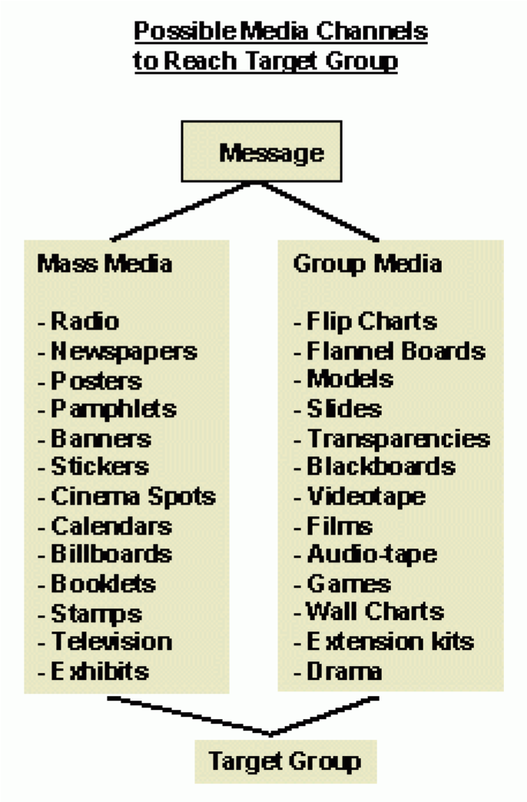
Diffusion of innovations
According to Rogers” Diffusion is the process by which an innovation is communicated through certain channels over time among the members of a social system." In other words, the study of the diffusion of innovation is the study of how, why, and at what rate new ideas and technology spread through cultures.
The S-Curve and technology adoption
The adoption curve becomes an s-curve when cumulative adoption is used. Everett M. Rogers in his 1962 book, Diffusion of Innovations, theorized that innovations would spread through society in an S curve, as the early adopters select the technology first, and followed by the majority, until a technology or innovation is common.
According to Rogers, diffusion research centers on the conditions which increase or decrease the likelihood that a new idea, product, or practice will be adopted by members of a given culture. According to Rogers people’s attitude toward a new technology is a key element in its diffusion. Roger’s Innovation Decision Process theory states that innovation diffusion is a process that occurs over time through five stages: Knowledge, Persuasion, Decision, Implementation and Confirmation. Accordingly, the innovation-decision process is the process through which an individual or other decision-making unit passes. From first knowledge of an innovation, to forming an attitude toward the innovation, to a decision to adopt or reject, to implementation of the new idea, and to confirmation of this decision.
Various computer models have been developed in order to simulate the diffusion of innovations. Veneris developed a systems dynamics computer model which takes into account various diffusion patterns modeled via differential equations.

