Chapter 29 Estates in Real Property

1. Estates in real property are divided into two groups: freehold estates and leasehold estates.
2. Four freehold estates are fee simple, fee tail, determinable fee, and life estate.
3. An estate in fee simple descends to the owner's heirs on his or her death. It can be sold or granted out by the owner at will during the owner's lifetime.
4. The fee tail estate was created in England in 1285 as a way to keep real property in the family forever.
5. If a person conveys real property to a particular church "so long as the premises shall be used for church purposes," the church has a fee simple determinable.
6. A life estate may be created by deed, will, or operation of law.
7. A remainder interest is an interest that takes effect after another estate is ended. A reversionary interest is a right to the future enjoyment of property that one originally owned.
8. C will own the property when B dies.
9. The rights of dower and curtesy, and the right of a surviving spouse to waive the will of a deceased spouse sometimes create life estates.
10. A freehold estate is an estate in which the holder owns the land for life or forever. A leasehold estate is an estate that is less than a freehold estate.
11. Four types of leasehold estates are: (a) estate for years, (b) estate from year to year, (c) estate at will, and (d) estate at sufferance.

Understanding Legal Concepts
1. T 6. F, is capable of coming to an end
2. F, for life or forever 7. T
3. F, can 8. F, be
4. T 9. F, reversionary
5. T 10. T

Checking Terminology
1. f 5. e 9. x 13. d, l 17. r 21. g
2. k, m, j 6. c 10. o 14. w 18. p
3. n 7. q 11. a 15. b 19. s
4. h 8. v 12. i 16. u 20. t

Using Legal Language
Harvey owned a(n) life estate in real property, which was limited to the duration of his life. It was not a(n) estate pur autre vie—that is, a life estate on the life of another. He was known as a(n) life tenant and was responsible to others for the commission of waste, which is the destruction or deterioration of the premises. On Harvey's death, the estate—that is, the ownership interest—went to Harriet, a new owner who had a(n) remainder interest, which took effect after Harvey's estate ended. It was not a(n) reversionary interest because title did not revert—that is, go back—to an earlier owner. Similarly, it was not a(n) fee tail estate designed to restrict ownership of real property to a particular family blood line, with its variations of estate tail male and estate tail special. The deed conveying title to Harriet contained the apt words—that is, the suitable words—to give her the largest estate that one can own in land. This estate has various names, including fee simple, fee simple absolute, and just plain fee. The estate was not a(n) determinable fee—that is, an estate in real property that is capable of coming to an end, nor was it defeasible, meaning one that can be lost or defeated. It was not a fee simple subject to a(n) condition subsequent because no conditions were in the deed. In addition, it was not a(n) leasehold estate because it was not less than a(n) freehold estate, which is an estate in which the holder owns the land for life or forever.

Puzzling Over What You Learned
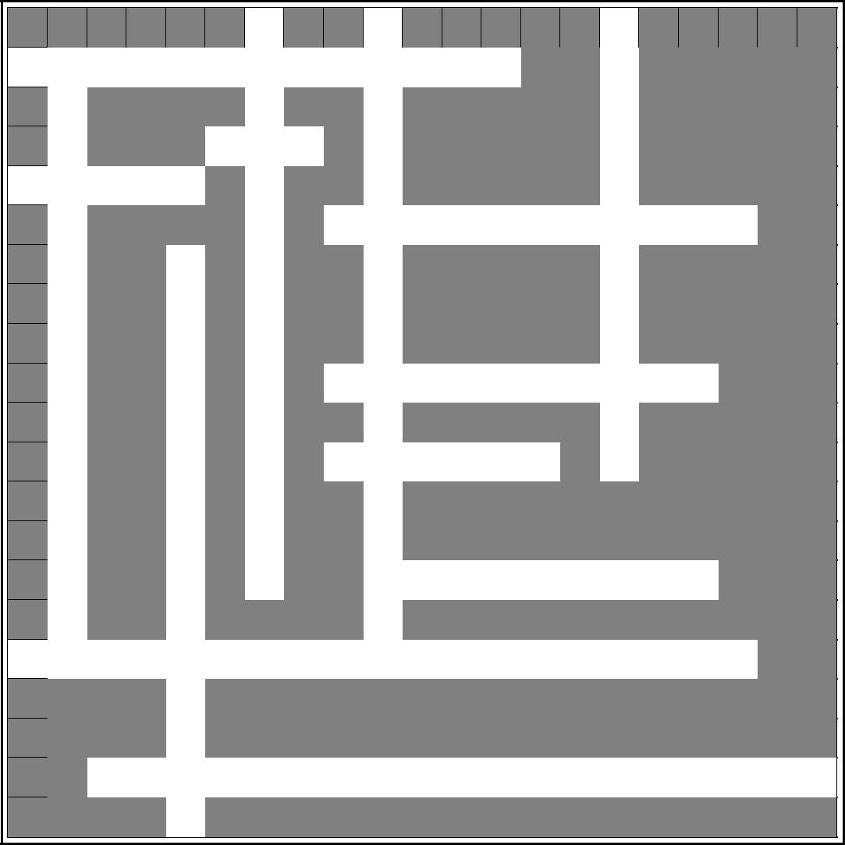
 |  |  |  |  |  | 1 |  |  | 2 |  |  |  |  |  | 3
4 | 5 |  |  |  |  | F |  |  | F |  |  |  |  |  | L
 |  |  |  |  |  |  |  |  |  |  |  |  |  |  | I
R E |  | A | L |  | P R |  | O | P | E | RT |  | Y
 |  |  |  |  |  | E |  |  | E |  |  |  |  |  | F
 | S
 | T |  |  |  | 6 | E | E |  |  |  |  |  |  |  | E
 |  |  |  |  | F
7 | A | S | T | E |  | H |  |  | S
W
 | T |  |  |  |  | O |  | 8
 |  |  |  |  |  |  |  | L I |  | F | E |  | E | S | T | A | T | E
 |  |  |  | 9 |  | L |  |  | M |  |  |  |  |  | E
 | E |  |  | F
 |  |  |  | E |  | D |  |  | P |  |  |  |  |  | N
 | T |  |  | E |  |  |  |  | L |  |  |  |  |  | A
 | A |  |  |  |  | E |  | 10
 |  |  |  |  |  |  |  | D E |  | T | E | RM |  | I | N | ES
 | I |  |  | T |  | S |  |  |  |  |  |  |  |  | T
 |  |  |  | A |  | T |  | 11 |  |  |  |  |  |  | S
 | L |  |  |  |  |  |  | R | E | V | E | R | T
 |  |  |  | I |  | A |  |  | S
 | M |  |  | L |  | T |  |  | T
 | A |  |  |  |  | E |  |  | 12
 |  |  |  |  |  |  |  |  | A | P | T |  | W | O | R | D | S
 | L |  |  | E |  |  |  |  | T
13
F E |  | E |  | S | I | M | P | L | E |  | A | B | S | O | L | UT |  | E
 |  |  |  | T
 |  |  |  | A
 |  | 14
 |  | E S |  | T | A | T | E |  | T | A | I | L |  | S | P | E | C | I | A | L
 |  |  |  | E

Caveat: Allow squares for spaces between words and punctuation (apostrophes, hyphens, etc.) when filling in crossword.

Across

- The ground and anything permanently attached to it.

- The largest estate that one can own in land.

- Destruction, alteration, or deterioration of a premises.

- Estate limited in duration to the life of the owner or another person.

- Comes to an end.

- Go back.

- Suitable words.

- The largest estate that one can own in land.

- A freehold estate restricting ownership to a husband, wife, and bodily heirs.

Down

- An estate in which the holder owns land for life or forever.

- The largest estate that one can own in land.

- Owners of a life estate.

- A freehold estate restricting ownership to men in the family line.

- A freehold estate that restricts ownership of real property to a family bloodline.

