Chapter 30 Co-Ownership and Multi-Ownership of Real Property

1. The most common co-tenant relationships are tenants in common, joint tenants, tenants by the entirety, and tenants in partnership.
2. Each tenant in common is entitled to possession of the entire premises.
3. Upon death, the interest in real property of a tenant in common passes to his or her heirs or devisees.
4. Yes. Yes. No.
5. Tenants in common may separate their interests in the property by petitioning the court for a partition of the premises.
6. The four unities in a joint tenancy are: (a) unity of interest, (b) unity of possession, (c) unity of time, and (d) unity of title.
7. On the death of one joint tenant, the entire ownership remains in the other joint tenants.
8. A tenancy by entirety may be held only by a husband and wife.
9. Under the community property system, property acquired by the efforts of either spouse during marriage belongs to both spouses equally—that is, each spouse owns one-half.
10. The states that follow the community property system are: Arizona, California, Idaho, Louisiana, Nevada, New Mexico, Texas, Washington, Wisconsin, and Puerto Rico.
11. Under the common law rule, the husband has the entire control over the estate including the exclusive right to possession and the right to all rents and profits. The husband may transfer his interest in the tenancy to someone else without his wife's consent. In addition, his interest may be attached and taken on execution by his creditors. His interest, however, is limited to merely the right to possession of the property and profits from it, plus exclusive title only if he survives his wife.
12. Tenancy by the entirety is popular because it offers protection against attaching creditors and neither spouse can defeat the other spouse's interest in the estate without the other's consent.
13. Some states have modified the common law version of tenants by the entirety to give equal rights to the spouses, while at the same time retaining the feature of protection against attachment by creditors.
14. Under a tenancy in partnership, partners' interest in the property are not subject to attachment or execution except on a claim against the partnership.
15. On the death of a partner, the decedent's right in specific partnership property become vested in the surviving partners who may possess such property only for partnership purposes.

Understanding Legal Concepts
1. F, one person 6. T
2. F, the entire premises 7. F, cannot
3. T 8. T
4. T 9. F, tenancy in common
5. F, tenant in common 10. T

Checking Terminology
1. b 7. q 12. c, g 17. e 22. d
2. h 8. a 13. bb 18. aa 23. cc
3. y 9. m 14. k, l 19. v 24. n
4. z 10. u 15. i 20. j, w 25. p
5. f 11. r 16. t 21. x 26. o
6. s

Using Legal Language
James and Kathleen, who were business partners, took title to a parcel of real property as tenants in partnership to protect their interests from being attached except on a claim against the partnership. When the partnership was dissolved, Kathleen bought out James's interest and owned the property severally—that is, separately. She sold the property to Larry, Mary, and Nancy who took title as joint tenants, which means that on the death of one of them, the entire ownership would remain in the surviving owners. They were called co-tenants because of the concurrent ownership, and they had the following unities: time, title, interest, and possession. Mary decided to sell her interest in the property but couldn't find a buyer. To avoid having the court partition the property—that is, divide it into separate parcels—Larry and Nancy bought Mary's share. They decided to take title as tenants in common so that if one of them died, his or her share would go to his or her heirs. Later, however, when Larry and Nancy became married to each other, they had their attorney change the way in which they owned the property to tenants by the entirety so that they would have protection against attaching creditors (people who are owed money) who could levy on execution to collect money owed them by putting into effect a court judgment. They did not live in a community property jurisdiction in which all property (other than a gift or inheritance) acquired by either of them during marriage would belong to both equally. Eventually, Larry and Nancy sold the property and bought a condominium, which is a parcel of real property, portions of which, called units, are owned separately in fee simple by individual owners, and the remainder of which, called the common area, is owned as tenants in common by all the owners.

Puzzling Over What You Learned
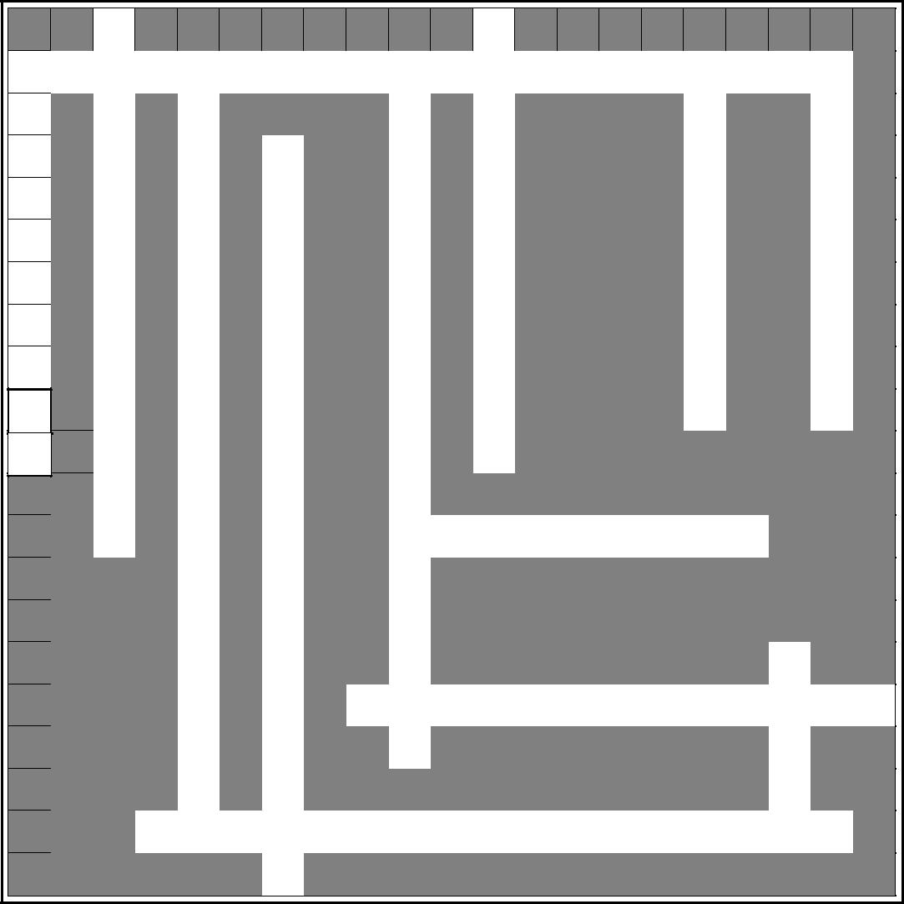
 | 1 |  |  |  |  |  |  |  | 2
 | U |  |  |  |  |  |  |  | C
3 |  |  | 4 |  |  |  | 5 |  |  |  |  |  |  | 6 |  |  |  | 7
C ON |  | C | UR |  | R E | N | T |  | O | WNE |  |  |  | R | SH |  | I | P
O | I |  |  |  |  |  |  |  | N |  |  |  |  |  |  |  |  | A
 |  |  | N |  |  |  | E |  |  |  |  |  |  |  | E
 |  |  |  |  | 8
 | T |  | I |  |  |  | N |  | D |  |  |  |  |  | V
- |  |  |  |  | C |  |  |  |  |  |  |  |  |  |  |  |  | R
T | Y |  | T |  | O |  | A |  | O |  |  |  |  |  | E |  |  | T
E |  |  | Y |  | M |  | N |  | M |  |  |  |  |  | R |  |  | I
N | O |  |  |  | M |  | T |  | I |  |  |  |  |  | A |  |  | T
A | F |  | O |  | U |  | S |  | N |  |  |  |  |  | L |  |  | I
N |  |  | F |  | N |  |  |  | I |  |  |  |  |  |  |  |  | O
 |  |  |  |  |  |  |  |  |  |  |  |  |  |  | L
 | T
T |  |  |  |  | I |  | I |  | U |  |  |  |  |  | Y |  |  | N
S | I |  | P |  | T |  | N |  | M
 | M |  | O |  | Y
 | E |  |  |  |  |  | 9 | R | E | D | I |  | T | O | R | S
 |  |  | S |  |  |  | C
 |  |  | S |  | P |  | O
 |  |  | E |  | R |  | M
 |  |  | S |  | O |  | M |  |  |  |  |  |  |  |  |  | 10
 |  |  |  |  |  |  |  |  |  |  |  |  |  |  |  |  | U
 |  |  |  |  |  | 11
 |  |  |  |  | P
 |  |  | S |  |  | J | O | I | N | T |  |  | T | E | N | A | N | C Y
 |  |  | I |  | E |  | N |  |  |  |  |  |  |  |  |  | I
 |  |  | O |  | R |  |  |  |  |  |  |  |  |  |  |  | T
 |  | 12 | U N | I | T | Y | O | F |  | I |  | N | T | E | R | E | S | T
 |  |  |  |  | Y

Caveat: Allow squares for spaces between words and punctuation (apostrophes, hyphens, etc.) when filling in crossword.

Across

3. Ownership of property by more than one person.

9. People who are owed money.

- Estate owned by joint tenants.

- Equal interest in property by all owners.

Down

- All owners of property taking title at the same time.

- Real property, portions of which are owned separately and the remainder of which is owned by all owners.

- Two or more owners of real property.

- Equal rights to possession of the entire property by all owners.

- Two or more persons owning property that passes to heirs upon death.

- Separately.

- Division of land held by co-tenants into distinct parcels.

- Property acquired by a spouse during marriage that belongs to both equally.
10. The individual portions of a condominium.

