Business Statistics for Business
Organizing and Visualizing Data

1) Jared was working on a project to look at global warming and accessed an Internet site where he captured average global surface temperatures from 1866. Which of the four methods of data collection was he using?
A) published sources
B) experimentation
C) surveying
D) observation
Answer: A

2) The British Airways Internet site provides a questionnaire instrument that can be answered electronically. Which of the four methods of data collection is involved when people complete the questionnaire?
A) published sources
B) experimentation
C) surveying
D) observation
Answer: C

3) A marketing research firm, in conducting a comparative taste test, provided three types of peanut butter to a sample of households randomly selected within the state. Which of the four methods of data collection is involved when people are asked to compare the three types of peanut butter?
A) published sources
B) experimentation
C) surveying
D) observation
Answer: B

4) Tim was planning for a meeting with his boss to discuss a raise in his annual salary. In preparation, he wanted to use the Consumer Price Index to determine the percentage increase in his real (inflation-adjusted) salary over the last three years. Which of the four methods of data collection was involved when he used the Consumer Price Index?
A) published sources
B) experimentation
C) surveying
D) observation
Answer: A

5) Which of the four methods of data collection is involved when a person counts the number of cars passing designated locations on the Los Angeles freeway system?
A) published sources
B) experimentation
C) surveying
D) observation
Answer: D

6) A statistics student found a reference in the campus library that contained the median family incomes for all 50 states. She would report her data collection method as
A) a designed experiment.
B) observational data.
C) a random sample.
D) a published source.
Answer: D

7) The personnel director at a large company studied the eating habits of the company's employees. The director noted whether employees brought their own lunches to work, ate at the company cafeteria, or went out to lunch. The goal of the study was to improve the food service at the company cafeteria. This type of data collection would best be considered as
A) an observational study.
B) a designed experiment.
C) a random sample.
D) a quota sample.
Answer: A

8) A study attempted to estimate the proportion of Florida residents who were willing to spend more tax dollars on protecting the beaches from environmental disasters. Twenty-five hundred Florida residents were surveyed. What type of data collection procedure was most likely used to collect the data for this study?
A) a designed experiment
B) a published source
C) a random sample
D) observational data
Answer: C

TABLE 2-1
An insurance company evaluates many numerical variables about a person before deciding on an appropriate rate for automobile insurance. A representative from a local insurance agency selected a random sample of insured drivers and recorded, X, the number of claims each made in the last three years, with the following results.

X f
1 14
2 18
3 12
4 5
5 1

9) Referring to Table 2-1, how many drivers are represented in the sample?
A) 5
B) 15
C) 18
D) 50
Answer: D

Keywords: frequency distribution

10) Referring to Table 2-1, how many total claims are represented in the sample?
A) 15
B) 50
C) 111
D) 250
Answer: C

Keywords: interpretation, frequency distribution
11) A type of vertical bar chart in which the categories are plotted in the descending rank order of the magnitude of their frequencies is called a
A) contingency table.
B) Pareto chart.
C) stem-and-leaf display.
D) pie chart.
Answer: B

Keywords: Pareto chart

TABLE 2-2
At a meeting of information systems officers for regional offices of a national company, a survey was taken to determine the number of employees the officers supervise in the operation of their departments, where X is the number of employees overseen by each information systems officer.

X f
1 7
2 3
3 11
4 8
5 9

12) Referring to Table 2-2, how many regional offices are represented in the survey results?
A) 5
B) 11
C) 15
D) 40
Answer: D

Keywords: interpretation, frequency distribution

13) Referring to Table 2-2, across all of the regional offices, how many total employees were supervised by those surveyed?
A) 15
B) 40
C) 127
D) 200
Answer: C

Keywords: interpretation, frequency distribution
14) The width of each bar in a histogram corresponds to the
A) differences between the boundaries of the class.
B) number of observations in each class.
C) midpoint of each class.
D) percentage of observations in each class.
Answer: A

Keywords: frequency distribution

TABLE 2-3
Every spring semester, the School of Business coordinates a luncheon with local business leaders for graduating seniors, their families, and friends. Corporate sponsorship pays for the lunches of each of the seniors, but students have to purchase tickets to cover the cost of lunches served to guests they bring with them. The following histogram represents the attendance at the senior luncheon, where X is the number of guests each graduating senior invited to the luncheon and f is the number of graduating seniors in each category.

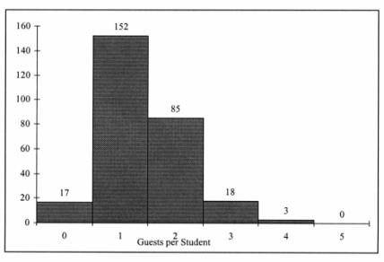
15) Referring to the histogram from Table 2-3, how many graduating seniors attended the luncheon?
A) 4
B) 152
C) 275
D) 388
Answer: C
Explanation: C) The number of graduating seniors is the sum of all the frequencies, f.
Difficulty: Difficult
Keywords: interpretation, histogram
16) Referring to the histogram from Table 2-3, if all the tickets purchased were used, how many guests attended the luncheon?
A) 4
B) 152
C) 275
D) 388
Answer: D
Difficulty: Difficult
Keywords: interpretation, histogram

17) A professor of economics at a small Texas university wanted to determine what year in school students were taking his tough economics course. Shown below is a pie chart of the results. What percentage of the class took the course prior to reaching their senior year?

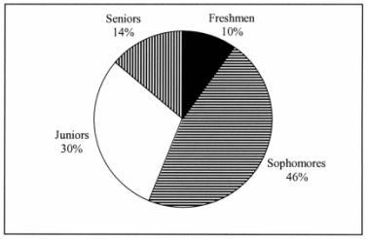

A) 14%
B) 44%
C) 54%
D) 86%
Answer: D

Keywords: interpretation, pie chart

18) When polygons or histograms are constructed, which axis must show the true zero or "origin"?
A) the horizontal axis
B) the vertical axis
C) both the horizontal and vertical axes
D) neither the horizontal nor the vertical axis
Answer: B

Keywords: polygon, histogram
19) When constructing charts, the following is plotted at the class midpoints:
A) frequency histograms.
B) percentage polygons.
C) cumulative percentage polygon (ogives).
D) all of the above
Answer: B

Keywords: percentage polygon

TABLE 2-4
A survey was conducted to determine how people rated the quality of programming available on television. Respondents were asked to rate the overall quality from 0 (no quality at all) to 100 (extremely good quality). The stem-and-leaf display of the data is shown below.

Stem Leaves
3 2 3
4 0 3 4 7 8 9 9 9
5 0 1 1 2 3 4 5
6 1 2 5 6 6
7 0 1
8
9 2

20) Referring to Table 2-4, what percentage of the respondents rated overall television quality with a rating of 80 or above?
A) 0
B) 4
C) 96
D) 100
Answer: B

, interpretation

21) Referring to Table 2-4, what percentage of the respondents rated overall television quality with a rating of 50 or below?
A) 11
B) 40
C) 44
D) 56
Answer: C

, interpretation
22) Referring to Table 2-4, what percentage of the respondents rated overall television quality with a rating from 50 through 75?
A) 11
B) 40
C) 44
D) 56
Answer: D

, interpretation

TABLE 2-5
The following are the duration in minutes of a sample of long-distance phone calls made within the continental United States reported by one long-distance carrier.

Relative
Time (in Minutes) Frequency
0 but less than 5 0.37
5 but less than 10 0.22
10 but less than 15 0.15
15 but less than 20 0.10
20 but less than 25 0.07
25 but less than 30 0.07
30 or more 0.02

23) Referring to Table 2-5, what is the width of each class?
A) 1 minute
B) 5 minutes
C) 2%
D) 100%
Answer: B

Keywords: class interval, relative frequency distribution

24) Referring to Table 2-5, if 1,000 calls were randomly sampled, how many calls lasted under 10 minutes?
A) 220
B) 370
C) 410
D) 590
Answer: D

Keywords: relative frequency distribution, interpretation
25) Referring to Table 2-5, if 100 calls were randomly sampled, how many calls lasted 15 minutes or longer?
A) 10
B) 14
C) 26
D) 74
Answer: C

Keywords: relative frequency distribution, interpretation

26) Referring to Table 2-5, if 10 calls lasted 30 minutes or more, how many calls lasted less than 5 minutes?
A) 10
B) 185
C) 295
D) 500
Answer: B

Keywords: relative frequency distribution, interpretation

27) Referring to Table 2-5, what is the cumulative relative frequency for the percentage of calls that lasted under 20 minutes?
A) 0.10
B) 0.59
C) 0.76
D) 0.84
Answer: D

Keywords: cumulative relative frequency

28) Referring to Table 2-5, what is the cumulative relative frequency for the percentage of calls that lasted 10 minutes or more?
A) 0.16
B) 0.24
C) 0.41
D) 0.90
Answer: C

Keywords: cumulative relative frequency
29) Referring to Table 2-5, if 100 calls were randomly sampled, ________ of them would have lasted at least 15 minutes but less than 20 minutes
A) 6
B) 8
C) 10
D) 16
Answer: C

Keywords: relative frequency distribution, interpretation

30) Referring to Table 2-5, if 100 calls were sampled, ________ of them would have lasted less than 15 minutes.
A) 26
B) 74
C) 10
D) none of the above
Answer: B

Keywords: relative frequency distribution, interpretation

31) Referring to Table 2-5, if 100 calls were sampled, ________ of them would have lasted 20 minutes or more.
A) 26
B) 16
C) 74
D) none of the above
Answer: B

Keywords: relative frequency distribution, interpretation

32) Referring to Table 2-5, if 100 calls were sampled, ________ of them would have lasted less than 5 minutes or at least 30 minutes or more.
A) 35
B) 37
C) 39
D) none of the above
Answer: C
Difficulty: Difficult
Keywords: relative frequency distribution, interpretation
33) Which of the following is appropriate for displaying data collected on the different brands of cars that students at a major university drive?
A) a Pareto chart
B) a two-way classification table
C) a histogram
D) a scatter plot
Answer: A

Keywords: Pareto diagram

34) One of the developing countries is experiencing a baby boom, with the number of births rising for the fifth year in a row, according to a BBC News report. Which of the following is best for displaying this data?
A) a Pareto chart
B) a two-way classification table
C) a histogram
D) a time-series plot
Answer: D

Keywords: time-series plot

35) When studying the simultaneous responses to two categorical questions, you should set up a
A) contingency table.
B) frequency distribution table.
C) cumulative percentage distribution table.
D) histogram.
Answer: A

Keywords: contingency table

36) Data on 1,500 students' height were collected at a larger university in the East Coast. Which of the following is the best chart for presenting the information?
A) a pie chart
B) a Pareto chart
C) a side-by-side bar chart
D) a histogram
Answer: D

Keywords: choice of chart, histogram
37) Data on the number of part-time hours students at a public university worked in a week were collected. Which of the following is the best chart for presenting the information?
A) a pie chart
B) a Pareto chart
C) a percentage table
D) a percentage polygon
Answer: D

Keywords: choice of chart, percentage polygon

38) Data on the number of credit hours of 20,000 students at a public university enrolled in a spring semester were collected. Which of the following is the best for presenting the information?
A) a pie chart
B) a Pareto chart
C) a stem-and-leaf display
D) a contingency table
Answer: C

Keywords: choice of chart, stem-and-leaf

39) In a survey, 150 executives were asked what they think is the most common mistake candidates make during job interviews. Six different mistakes were given. Which of the following is the best for presenting the information?
A) a bar chart
B) a histogram
C) a stem-and-leaf display
D) a contingency table
Answer: A

Keywords: choice of chart, bar chart

40) You have collected information on the market share of five different search engines used by U.S. Internet users in January 2011. Which of the following is the best for presenting the information?
A) a pie chart
B) a histogram
C) a stem-and-leaf display
D) a contingency table
Answer: A

Keywords: choice of chart, pie chart
41) You have collected information on the consumption by the 15 largest coffee-consuming nations. Which of the following is the best for presenting the shares of the consumption?
A) a pie chart
B) a Pareto chart
C) a side-by-side bar chart
D) a contingency table
Answer: B
Explanation: B) Even though a pie chart can also be used, the Pareto chart is preferable for separating the "vital few" from the "trivial many".

Keywords: choice of chart, Pareto chart

42) You have collected data on the approximate retail price (in $) and the energy cost per year (in $) of 15 refrigerators. Which of the following is the best for presenting the data?
A) a pie chart
B) a scatter plot
C) a side-by-side bar chart
D) a contingency table
Answer: B

Keywords: choice of chart, scatter plot

43) You have collected data on the number of U.S. households actively using online banking and/or online bill payment from 1995 to 2010. Which of the following is the best for presenting the data?
A) a pie chart
B) a stem-and-leaf display
C) a side-by-side bar chart
D) a time-series plot
Answer: D

Keywords: choice of chart, time-series plot

44) You have collected data on the monthly seasonally adjusted civilian unemployment rate for the United States from 1998 to 2010. Which of the following is the best for presenting the data?
A) a contingency table
B) a stem-and-leaf display
C) a time-series plot
D) a side-by-side bar chart
Answer: D

Keywords: choice of chart, time-series plot
45) You have collected data on the number of complaints for six different brands of automobiles sold in the United States in 2006 and in 2010. Which of the following is the best for presenting the data?
A) a contingency table
B) a stem-and-leaf display
C) a time-series plot
D) a side-by-side bar chart
Answer: D

Keywords: choice of chart, side-by-side bar chart

46) You have collected data on the responses to two questions asked in a survey of 40 college students majoring in business  What is your gender (Male = M; Female = F) and What is your major (Accountancy = A; Computer Information Systems = C; Marketing = M). Which of the following is the best for presenting the data?
A) a contingency table
B) a stem-and-leaf display
C) a time-series plot
D) a Pareto chart
Answer: A

Keywords: choice of chart, contingency table

TABLE 2-6
A sample of 200 students at a Big Ten university was taken after the midterm to ask them whether they went bar hopping the weekend before the midterm or spent the weekend studying, and whether they did well or poorly on the midterm. The following table contains the result.

 | Did Well in Midterm | Did Poorly in Midterm
Studying for Exam | 80 | 20
Went Bar Hopping | 30 | 70

47) Referring to Table 2-6, of the students in the sample who went bar hopping the weekend before the midterm, ________ percent did well on the midterm.
A) 15
B) 27.27
C) 30
D) 55
Answer: C

Keywords: contingency table, interpretation
48) Referring to Table 2-6, of the students in the sample who did well on the midterm, ________ percent went bar hopping the weekend before the midterm.
A) 15
B) 27.27
C) 30
D) 50
Answer: B

Keywords: contingency table, interpretation

49) Referring to Table 2-6, ________ percent of the students in the sample went bar hopping the weekend before the midterm and did well on the midterm.
A) 15
B) 27.27
C) 30
D) 50
Answer: A

Keywords: contingency table, interpretation

50) Referring to Table 2-6, ________ percent of the students in the sample spent the weekend studying and did well on the midterm.
A) 40
B) 50
C) 72.72
D) 80
Answer: A

Keywords: contingency table, interpretation

51) Referring to Table 2-6, if the sample is a good representation of the population, we can expect ________ percent of the students in the population to spend the weekend studying and do poorly on the midterm.
A) 10
B) 20
C) 45
D) 50
Answer: A

Keywords: contingency table, interpretation
52) Referring to Table 2-6, if the sample is a good representation of the population, we can expect ________ percent of those who spent the weekend studying to do poorly on the midterm.
A) 10
B) 20
C) 45
D) 50
Answer: B

Keywords: contingency table, interpretation

53) Referring to Table 2-6, if the sample is a good representation of the population, we can expect ________ percent of those who did poorly on the midterm to have spent the weekend studying.
A) 10
B) 22.22
C) 45
D) 50
Answer: B

Keywords: contingency table, interpretation

54) In a contingency table, the number of rows and columns
A) must always be the same.
B) must always be 2.
C) must add to 100%.
D) none of the above
Answer: D

Keywords: contingency table
55) Retailers are always interested in determining why a customer selected their store to make a purchase. A sporting goods retailer conducted a customer survey to determine why its customers shopped at the store. The results are shown in the bar chart below. What proportion of the customers responded that they shopped at the store because of the merchandise or the convenience?

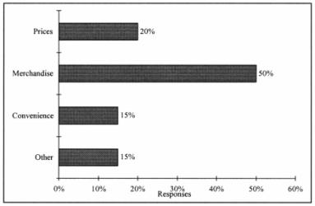

A) 35%
B) 50%
C) 65%
D) 85%
Answer: C

Keywords: bar chart, interpretation

TABLE 2-7
The stem-and-leaf display below contains data on the number of months between the date a civil suit is filed and when the case is actually adjudicated for 50 cases heard in superior court.

Stem Leaves
1 2 3 4 4 4 7 8 9 9
2 2 2 2 2 3 4 5 5 6 7 8 8 8 9
3 0 0 1 1 1 3 5 7 7 8
4 0 2 3 4 5 5 7 9
5 1 1 2 4 6 6
6 1 5 8

56) Referring to Table 2-7, locate the first leaf, i.e., the lowest valued leaf with the lowest valued stem. This represents a wait of ________ months.
Answer: 12

, interpretation
57) Referring to Table 2-7, the civil suit with the longest wait between when the suit was filed and when it was adjudicated had a wait of ________ months.
Answer: 68

, interpretation

58) Referring to Table 2-7, the civil suit with the fourth shortest waiting time between when the suit was filed and when it was adjudicated had a wait of ________ months.
Answer: 14

, interpretation

59) Referring to Table 2-7, ________ percent of the cases were adjudicated within the first two years.
Answer: 30

, interpretation

60) Referring to Table 2-7, ________ percent of the cases were not adjudicated within the first four years.
Answer: 20

, interpretation

61) Referring to Table 2-7, if a frequency distribution with equal sized classes was made from this data, and the first class was "10 but less than 20," the frequency of that class would be ________.
Answer: 9

, interpretation

62) Referring to Table 2-7, if a frequency distribution with equal sized classes was made from this data, and the first class was "10 but less than 20," the relative frequency of the third class would be ________.
Answer: 0.20 or 20% or 10/50

, relative frequency distribution

63) Referring to Table 2-7, if a frequency distribution with equal sized classes was made from this data, and the first class was "10 but less than 20," the cumulative percentage of the second class would be ________.
Answer: 46% or 0.46 or 23/50

, cumulative percentage distribution
TABLE 2-8
The stem-and-leaf display represents the number of times in a year that a random sample of 100 "lifetime" members of a health club actually visited the facility.

Stem Leaves
0 012222233333344566666667789999
1 1111222234444455669999
2 00011223455556889
3 0000446799
4 011345567
5 0077
6 8
7 67
8 3
9 0247

64) Referring to Table 2-8, the person who has the largest leaf associated with the smallest stem visited the facility ________ times.
Answer: 9

, interpretation

65) Referring to Table 2-8, the person who visited the health club less than anyone else in the sample visited the facility ________ times.
Answer: 0 or no

, interpretation

66) Referring to Table 2-8, the person who visited the health club more than anyone else in the sample visited the facility ________ times.
Answer: 97

, interpretation

67) Referring to Table 2-8, ________ of the 100 members visited the health club at least 52 times in a year.
Answer: 10

, interpretation

68) Referring to Table 2-8, ________ of the 100 members visited the health club no more than 12 times in a year.
Answer: 38

, interpretation
69) Referring to Table 2-8, if a frequency distribution with equal sized classes was made from this data, and the first class was "0 but less than 10," the frequency of the fifth class would be ________.
Answer: 9

, frequency distribution

70) Referring to Table 2-8, if a frequency distribution with equal sized classes was made from this data, and the first class was "0 but less than 10," the relative frequency of the last class would be ________.
Answer: 4% or 0.04 or 4/100

, relative frequency distribution

71) Referring to Table 2-8, if a frequency distribution with equal sized classes was made from this data, and the first class was "0 but less than 10," the cumulative percentage of the next-to-last class would be ________.
Answer: 96% or 0.96 or 96/100

, cumulative percentage distribution

72) Referring to Table 2-8, if a frequency distribution with equal sized classes was made from this data, and the first class was "0 but less than 10," the class midpoint of the third class would be ________.
Answer: 25 or (20+30)/2

, class midpoint

TABLE 2-9
The frequency distribution below represents the rents of 250 randomly selected federally subsidized apartments in a small town.

Rent in $ Frequency
300 but less than 400 113
400 but less than 500 85
500 but less than 600 32
600 but less than 700 16
700 but less than 800 4

73) Referring to Table 2-9, ________ apartments rented for at least $400 but less than $600.
Answer: 117

Keywords: frequency distribution
74) Referring to Table 2-9, ________ percent of the apartments rented for $600 or more.
Answer: 8 or 20/250

Keywords: frequency distribution, cumulative percentage distribution

75) Referring to Table 2-9, ________ percent of the apartments rented for at least $500.
Answer: 20.8 or 52/250

Keywords: frequency distribution, cumulative percentage distribution

76) Referring to Table 2-9, the class midpoint of the second class is ________.
Answer: 450

Keywords: frequency distribution, class midpoint

77) Referring to Table 2-9, the relative frequency of the second class is ________.
Answer: 85/250 or 17/50 or 34% or 0.34

Keywords: frequency distribution, relative frequency distribution

78) Referring to Table 2-9, the percentage of apartments renting for less than $600 is ________.
Answer: 230/250 or 23/25 or 92% or 0.92

Keywords: frequency distribution, cumulative percentage distribution
TABLE 2-10
The histogram below represents scores achieved by 200 job applicants on a personality profile.

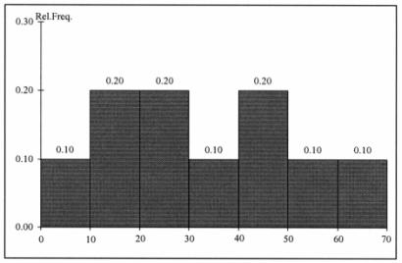

79) Referring to the histogram from Table 2-10, ________ percent of the job applicants scored between 10 and 20.
Answer: 20

Keywords: histogram, percentage distribution

80) Referring to the histogram from Table 2-10, ________ percent of the job applicants scored below 50.
Answer: 80

Keywords: histogram, percentage distribution

81) Referring to the histogram from Table 2-10, the number of job applicants who scored between 30 and below 60 is ________.
Answer: 80

Keywords: histogram

82) Referring to the histogram from Table 2-10, the number of job applicants who scored 50 or above is ________.
Answer: 40

Keywords: histogram
83) Referring to the histogram from Table 2-10, 90% of the job applicants scored above or equal to ________.
Answer: 10

Keywords: histogram, cumulative percentage distribution

84) Referring to the histogram from Table 2-10, half of the job applicants scored below ________.
Answer: 30

Keywords: histogram, cumulative percentage distribution

85) Referring to the histogram from Table 2-10, ________ percent of the applicants scored below 20 or at least 50.
Answer: 50

Keywords: histogram, cumulative percentage distribution

86) Referring to the histogram from Table 2-10, ________ percent of the applicants scored between 20 and below 50.
Answer: 50

Keywords: histogram, cumulative percentage distribution

TABLE 2-11
The ordered array below resulted from selecting a sample of 25 batches of 500 computer chips and determining how many in each batch were defective.

Defects
1 2 4 4 5 5 6 7 9 9 12 12 15
17 20 21 23 23 25 26 27 27 28 29 29

87) Referring to Table 2-11, if a frequency distribution for the defects data is constructed, using "0 but less than 5" as the first class, the frequency of the "20 but less than 25" class would be ________.
Answer: 4

Keywords: frequency distribution

88) Referring to Table 2-11, if a frequency distribution for the defects data is constructed, using "0 but less than 5" as the first class, the relative frequency of the "15 but less than 20" class would be ________.
Answer: 0.08 or 8% or 2/25

Keywords: relative frequency distribution
89) Referring to Table 2-11, construct a frequency distribution for the defects data, using "0 but less than 5" as the first class.
Answer: Defects Frequency
0 but less than 5 4
5 but less than 10 6
10 but less than 15 2
15 but less than 20 2
20 but less than 25 4
25 but less than 30 7

Keywords: frequency distribution

90) Referring to Table 2-11, construct a relative frequency or percentage distribution for the defects data, using "0 but less than 5" as the first class.
Answer: Defects Percentage
0 but less than 5 16
5 but less than 10 24
10 but less than 15 8
15 but less than 20 8
20 but less than 25 16
25 but less than 30 28

Keywords: relative frequency distribution, percentage distribution

91) Referring to Table 2-11, construct a cumulative percentage distribution for the defects data if the corresponding frequency distribution uses "0 but less than 5" as the first class.
Answer: Defects CumPct
0 0
5 16
10 40
15 48
20 56
25 72
30 100

92) Referring to Table 2-11, construct a histogram for the defects data, using "0 but less than 5" as the first class.
Answer:
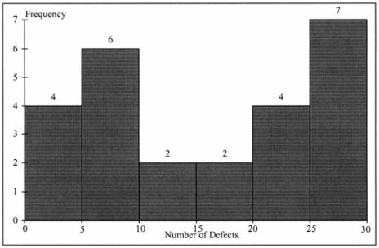

Keywords: histogram, frequency distribution

93) Referring to Table 2-11, construct a cumulative percentage polygon for the defects data if the corresponding frequency distribution uses "0 but less than 5" as the first class.
Answer:
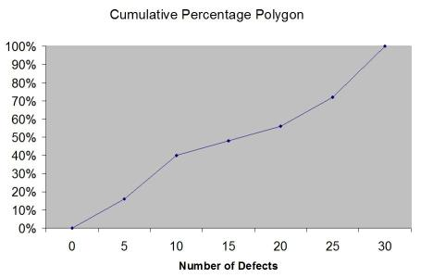

Keywords: cumulative percentage polygon
94) The point halfway between the boundaries of each class interval in a grouped frequency distribution is called the ________.
Answer: class midpoint

Keywords: cumulative percentage polygon, frequency distribution

95) A ________ is a vertical bar chart in which the rectangular bars are constructed at the boundaries of each class interval.
Answer: histogram

Keywords: histogram

96) It is essential that each class grouping or interval in a frequency distribution be ________ and ________.
Answer: non-overlapping and of equal width

Keywords: frequency distribution, class interval

97) In order to compare one large set of numerical data to another, a ________ distribution must be developed from the frequency distribution.
Answer: relative frequency or percentage

Keywords: relative frequency distribution, percentage distribution

98) When comparing two or more large sets of numerical data, the distributions being developed should use the same ________.
Answer: class boundaries.

Keywords: class boundaries

99) The width of each class grouping or interval in a frequency distribution should be ________.
Answer: the same or equal

Keywords: class interval, frequency distribution

100) In constructing a polygon, each class grouping is represented by its ________ and then these are consecutively connected to one another.
Answer: midpoint

Keywords: polygon, class interval, midpoint
101) A ________ is a summary table in which numerical data are tallied into class intervals or categories.
Answer: frequency distribution

Keywords: frequency distribution, class interval

102) True or False: In general, grouped frequency distributions should have between 5 and 15 class intervals.
Answer: TRUE

Keywords: frequency distribution, number of classes

103) True or False: The sum of relative frequencies in a distribution always equals 1.
Answer: TRUE

Keywords: relative frequency

104) True or False: The sum of cumulative frequencies in a distribution always equals 1.
Answer: FALSE

Keywords: cumulative distribution

105) True or False: In graphing two categorical data, the side-by-side bar chart is best suited when comparing joint responses.
Answer: TRUE

Keywords: side-by-side chart

106) True or False: When constructing a frequency distribution, classes should be selected so that they are of equal width.
Answer: TRUE

Keywords: frequency distribution

107) True or False: A research analyst was directed to arrange raw data collected on the yield of wheat, ranging from 40 to 93 bushels per acre, in a frequency distribution. He should choose 30 as the class interval width.
Answer: FALSE

Keywords: frequency distribution, class interval

108) True or False: If the values of the seventh and eighth class in a cumulative percentage distribution are the same, we know that there are no observations in the eighth class.
Answer: TRUE

109) True or False: One of the advantages of a pie chart is that it clearly shows that the total of all the categories of the pie adds to 100%.
Answer: TRUE

Keywords: pie chart

110) True or False: The larger the number of observations in a numerical data set, the larger the number of class intervals needed for a grouped frequency distribution.
Answer: TRUE

Keywords: class interval, frequency distribution

111) True or False: Determining the class boundaries of a frequency distribution is highly subjective.
Answer: TRUE

Keywords: class boundaries, frequency distribution

112) True or False: The original data values cannot be determined once they are grouped into a frequency distribution table.
Answer: TRUE

Keywords: frequency distribution

113) True or False: The percentage distribution cannot be constructed from the frequency distribution directly.
Answer: FALSE

Keywords: percentage distribution, frequency distribution

114) True or False: The stem-and-leaf display is often superior to the frequency distribution in that it maintains the original values for further analysis.
Answer: TRUE

, frequency distribution

115) True or False: The relative frequency is the frequency in each class divided by the total number of observations.
Answer: TRUE

Keywords: relative frequency distribution

116) True or False: Ogives are plotted at the midpoints of the class groupings.
Answer: FALSE

Keywords: ogives, midpoint
117) True or False: Percentage polygons are plotted at the boundaries of the class groupings.
Answer: FALSE

Keywords: percentage polygons

118) True or False: The main principle behind the Pareto chart is the ability to separate the "vital few" from the "trivial many."
Answer: TRUE

Keywords: Pareto chart

119) True or False: A histogram can have gaps between the bars, whereas bar charts cannot have gaps.
Answer: FALSE

Keywords: histogram, bar chart

120) True or False: Histograms are used for numerical data while bar charts are suitable for categorical data.
Answer: TRUE

Keywords: histogram, bar chart

121) True or False: A Walmart store in a small town monitors customer complaints and organizes these complaints into six distinct categories. Over the past year, the company has received 534 complaints. One possible graphical method for representing these data would be a Pareto chart.
Answer: TRUE

Keywords: Pareto chart

122) True or False: Apple Computer, Inc. collected information on the age of its customers. The youngest customer was 12 and the oldest was 72. To study the distribution of the age among its customers, it can use a Pareto chart.
Answer: FALSE

Keywords: Pareto chart

123) True or False: Apple Computer, Inc. collected information on the age of its customers. The youngest customer was 12 and the oldest was 72. To study the distribution of the age among its customers, it is best to use a pie chart.
Answer: FALSE

Keywords: pie chart
124) True or False: Apple Computer, Inc. collected information on the age of its customers. The youngest customer was 12 and the oldest was 72. To study the distribution of the age among its customers, it can use a percentage polygon.
Answer: TRUE

Keywords: percentage polygon

125) True or False: Apple Computer, Inc. collected information on the age of its customers. The youngest customer was 12 and the oldest was 72. To study the percentage of their customers who are below a certain age, it can use an ogive.
Answer: TRUE

Keywords: ogive

126) True or False: If you wish to construct a graph of a relative frequency distribution, you would most likely construct an ogive first.
Answer: FALSE

Keywords: Ogive

127) True or False: An ogive is a cumulative percentage polygon.
Answer: TRUE

Keywords: Ogive, cumulative percentage polygon

128) True or False: A side-by-side chart is two histograms plotted side-by-side.
Answer: FALSE

Keywords: side-by-side chart

129) True or False: A good choice for the number of class groups to use in constructing frequency distribution is to have at least 5 but no more than 15 class groups.
Answer: TRUE

Keywords: number of classes

130) True or False: In general, a frequency distribution should have at least 8 class groups but no more than 20.
Answer: FALSE

Keywords: number of classes
131) True or False: True of False: To determine the width of class interval, divide the number of class groups by the range of the data.
Answer: FALSE

Keywords: class interval

132) True or False: The percentage polygon is formed by having the lower boundary of each class represent the data in that class and then connecting the sequence of lower boundaries at their respective class percentages.
Answer: FALSE

Keywords: percentage polygon

133) True or False: A polygon can be constructed from a bar chart.
Answer: FALSE

Keywords: polygon

134) True or False: To evaluate two categorical variables at the same time, a ________ could be developed.
Answer: contingency or cross-classification table or side-by-side bar chart

Keywords: contingency table, cross-classification table

135) True or False: Relationships in a contingency table can be examined more fully if the frequencies are converted into ________.
Answer: percentages or proportions

Keywords: contingency table
TABLE 2-12
The table below contains the opinions of a sample of 200 people broken down by gender about the latest congressional plan to eliminate anti-trust exemptions for professional baseball.

For Neutral Against Totals
Female 38 54 12 104
Male 12 36 48 96
Totals 50 90 60 200

136) Referring to Table 2-12, construct a table of row percentages.
Answer: For Neutral Against Totals
Female 36.54 51.92 11.54 100.00
Male 2.50 37.50 50.00 100.00
Totals 25.00 45.00 30.00 100.00

Keywords: row percentages

137) Referring to Table 2-12, construct a table of column percentages.
Answer: For Neutral Against Totals
Female 76.00 60.00 20.00 52.00
Male 24.00 40.00 80.00 48.00
Totals 100.00 100.00 100.00 100.00

Keywords: column percentages

138) Referring to Table 2-12, construct a table of total percentages.
Answer: For Neutral Against Totals
Female 19.00 27.00 6.00 52.00
Male 6.00 18.00 24.00 48.00
Totals 25.00 45.00 30.00 100.00

Keywords: total percentages

139) Referring to Table 2-12, of those for the plan in the sample, ________ percent were females.
Answer: 76

Keywords: contingency table, column percentages

140) Referring to Table 2-12, of those neutral in the sample, ________ percent were males.
Answer: 40

Keywords: contingency table, column percentages
141) Referring to Table 2-12, of the males in the sample, ________ percent were for the plan.
Answer: 12.50

Keywords: contingency table

142) Referring to Table 2-12, of the females in the sample, ________ percent were against the plan.
Answer: 11.54

Keywords: contingency table

143) Referring to Table 2-12, of the females in the sample, ________ percent were either neutral or against the plan.
Answer: 63.46 or (51.92+11.54)

Keywords: contingency table

144) Referring to Table 2-12, ________ percent of the 200 were females who were against the plan.
Answer: 6

Keywords: contingency table

145) Referring to Table 2-12, ________ percent of the 200 were males who were neutral.
Answer: 18

Keywords: contingency table

146) Referring to Table 2-12, ________ percent of the 200 were females who were either neutral or against the plan.
Answer: 33
Difficulty: Difficult
Keywords: contingency table

147) Referring to Table 2-12, ________ percent of the 200 were males who were not against the plan.
Answer: 24
Difficulty: Difficult
Keywords: contingency table

148) Referring to Table 2-12, ________ percent of the 200 were not neutral.
Answer: 55
Difficulty: Difficult
Keywords: contingency table, row percentages
149) Referring to Table 2-12, ________ percent of the 200 were against the plan.
Answer: 30

Keywords: contingency table, row percentages

150) Referring to Table 2-12, ________ percent of the 200 were males.
Answer: 48

Keywords: contingency table, column percentages

151) Referring to Table 2-12, if the sample is a good representation of the population, we can expect ________ percent of the population will be for the plan.
Answer: 25

Keywords: contingency table, row percentages

152) Referring to Table 2-12, if the sample is a good representation of the population, we can expect ________ percent of the population will be males.
Answer: 48

Keywords: contingency table, column percentages

153) Referring to Table 2-12, if the sample is a good representation of the population, we can expect ________ percent of those for the plan in the population will be males.
Answer: 24

Keywords: contingency table

154) Referring to Table 2-12, if the sample is a good representation of the population, we can expect ________ percent of the males in the population will be against the plan.
Answer: 50

Keywords: contingency table

155) Referring to Table 2-12, if the sample is a good representation of the population, we can expect ________ percent of the females in the population will not be against the plan.
Answer: 88.46 or (36.54+51.92)

Keywords: contingency table
TABLE 2-13
Given below is the stem-and-leaf display representing the amount of detergent used in gallons (with leaves in tenths of gallons) in a day by 25 drive-through car wash operations in Phoenix.

9 | 147
10 | 02238
11 | 135566777
12 | 223489
13 | 02

156) Referring to Table 2-13, if a frequency distribution for the amount of detergent used is constructed, using "9.0 but less than 10.0 gallons" as the first class, the frequency of the "11.0 but less than 12.0 gallons" class would be ________.
Answer: 9

Keywords: frequency distribution

157) Referring to Table 2-13, if a percentage histogram for the detergent data is constructed, using "9.0 but less than 10.0 gallons" as the first class, the percentage of drive-through car wash operations that use "12.0 but less than 13.0 gallons" of detergent would be ________.
Answer: 24%

Keywords: relative frequency distribution, percentage distribution

158) Referring to Table 2-13, if a percentage histogram for the detergent data is constructed, using "9.0 but less than 10.0 gallons" as the first class, what percentage of drive-through car wash operations use less than 12 gallons of detergent in a day?
Answer: 68%

Keywords: percentage distribution, cumulative relative frequency

159) Referring to Table 2-13, if a relative frequency or percentage distribution for the detergent data is constructed, using "9.0 but less than 10.0 gallons" as the first class, what percentage of drive-through car wash operations use at least 10 gallons of detergent in a day?
Answer: 88%

Keywords: relative frequency distribution, percentage distribution

160) Referring to Table 2-13, if a relative frequency or percentage distribution for the detergent data is constructed, using "9.0 but less than 10.0 gallons" as the first class, what percentage of drive-through car wash operations use at least 10 gallons but less than 13 gallons of detergent in a day?
Answer: 80%

Keywords: relative frequency distribution, percentage distribution
161) Referring to Table 2-13, construct a frequency distribution for the detergent data, using "9.0 but less than 10.0 gallons" as the first class.
Answer:
Purchases (gals) Frequency
9.0 but less than 10.0 3
10.0 but less than 11.0 5
11.0 but less than 12.0 9
12.0 but less than 13.0 6
13.0 but less than 14.0 2

Keywords: frequency distribution

162) Referring to Table 2-13, construct a relative frequency or percentage distribution for the detergent data, using "9.0 but less than 10.0" as the first class.
Answer:
Gasoline
Purchases (gals) Percentage
9.0 but less than 10.0 12%
10.0 but less than 11.0 20
11.0 but less than 12.0 36
12.0 but less than 13.0 24
13.0 but less than 14.0 8

Keywords: relative frequency distribution, percentage distribution

163) Referring to Table 2-13, construct a cumulative percentage distribution for the detergent data if the corresponding frequency distribution uses "9.0 but less than 10.0" as the first class.
Answer:
Gasoline Frequency Percentage
Purchases (gals) Less Than Less Than
9.0 but less than 10.0 3 12
10.0 but less than 11.0 8 32
11.0 but less than 12.0 17 68
12.0 but less than 13.0 23 92
13.0 but less than 14.0 25 100

164) Referring to Table 2-13, construct a percentage histogram for the detergent data, using "9.0 but less than 10.0" as the first class.
Answer:
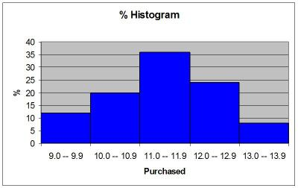

Keywords: histogram, frequency distribution

165) Referring to Table 2-13, construct a cumulative percentage polygon for the detergent data if the corresponding frequency distribution uses "9.0 but less than 10.0" as the first class.
Answer:
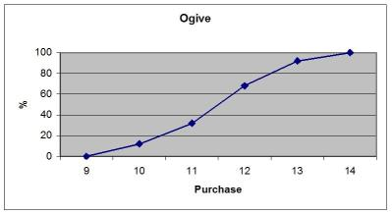

Keywords: cumulative percentage polygon
166) Referring to Table 2-13, construct a percentage polygon for the detergent data if the corresponding frequency distribution uses "9.0 but less than 10.0" as the first class.
Answer:
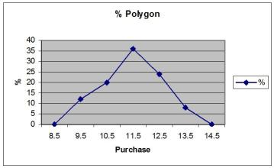

Keywords: percentage distribution, percentage polygon

TABLE 2-14
The table below contains the number of people who own a portable DVD player in a sample of 600 broken down by gender.

Own a Portable
DVD Player Male Female
Yes 96 40
No 224 240

167) Referring to Table 2-14, construct a table of row percentages.
Answer:
Own | Male | Female | Total
Yes | 70.59% | 29.41% | 100.00%
No | 48.28% | 51.72% | 100.00%
Total | 53.33% | 46.67% | 100.00%

Keywords: row percentages

168) Referring to Table 2-14, construct a table of column percentages.
Answer:
Own | Male | Female | Total
Yes | 30.00% | 14.29% | 22.67%
No | 70.00% | 85.71% | 77.33%
Total | 100.00% | 100.00% | 100.00%

Keywords: column percentages
169) Referring to Table 2-14, construct a table of total percentages.
Answer:
Own | Male | Female | Total
Yes | 16.00% | 6.67% | 22.67%
No | 37.33% | 40.00% | 77.33%
Total | 53.33% | 46.67% | 100.00%

Keywords: total percentages

170) Referring to Table 2-14, of those who owned a portable DVD in the sample, ________ percent were females.
Answer: 29.41

Keywords: contingency table, row percentages

171) Referring to Table 2-14, of those who did not own a portable DVD in the sample, ________ percent were males.
Answer: 48.28

Keywords: contingency table, row percentages

172) Referring to Table 2-14, of the males in the sample, ________ percent owned a portable DVD.
Answer: 30

Keywords: contingency table, column percentages

173) Referring to Table 2-14, of the females in the sample, ________ percent did not own a portable DVD.
Answer: 85.71

Keywords: contingency table, column percentages

174) Referring to Table 2-14 of the females in the sample, ________ percent owned a portable DVD.
Answer: 14.29

Keywords: contingency table, column percentages

175) Referring to Table 2-14, ________ percent of the 600 were females who owned a portable DVD.
Answer: 6.67

Keywords: contingency table, total percentage
176) Referring to Table 2-14, ________ percent of the 600 were males who owned a portable DVD.
Answer: 16

Keywords: contingency table, total percentage

177) Referring to Table 2-14, ________ percent of the 600 were females who either owned or did not own a portable DVD.
Answer: 46.67

Keywords: contingency table, total percentage

178) Referring to Table 2-14, ________ percent of the 600 were males who did not own a portable DVD.
Answer: 37.33

Keywords: contingency table, total percentage

179) Referring to Table 2-14, ________ percent of the 600 owned a portable DVD.
Answer: 22.67

Keywords: contingency table, column percentages

180) Referring to Table 2-14, ________ percent of the 600 did not own a portable DVD.
Answer: 77.33

Keywords: contingency table, column percentages

181) Referring to Table 2-14, ________ percent of the 600 were females.
Answer: 46.67

Keywords: contingency table, row percentages

182) Referring to Table 2-14, if the sample is a good representation of the population, we can expect ________ percent of the population will own a portable DVD.
Answer: 22.67

Keywords: contingency table, column percentages

183) Referring to Table 2-14, if the sample is a good representation of the population, we can expect ________ percent of the population will be males.
Answer: 53.33

Keywords: contingency table, column percentages
184) Referring to Table 2-14, if the sample is a good representation of the population, we can expect ________ percent of those who own a portable DVD in the population will be males.
Answer: 70.59

Keywords: contingency table, row percentages

185) Referring to Table 2-14, if the sample is a good representation of the population, we can expect ________ percent of the males in the population will own a portable DVD.
Answer: 30

Keywords: contingency table, column percentages

186) Referring to Table 2-14, if the sample is a good representation of the population, we can expect ________ percent of the females in the population will not own a portable DVD.
Answer: 85.71

Keywords: contingency table, column percentages

TABLE 2-15
The figure below is the ogive for the amount of fat (in grams) for a sample of 36 pizza products where the upper boundaries of the intervals are: 5, 10, 15, 20, 25, and 30.

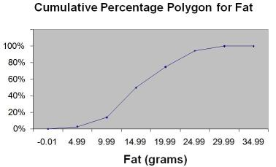

187) Referring to Table 2-15, roughly what percentage of pizza products contain less than 10 grams of fat?
A) 3%
B) 14%
C) 50%
D) 75%
Answer: B

188) Referring to Table 2-15, what percentage of pizza products contain at least 20 grams of fat?
A) 5%
B) 25%
C) 75%
D) 96%
Answer: B

189) Referring to Table 2-15, what percentage of pizza products contain between 10 and 25 grams of fat?
A) 14%
B) 44%
C) 62%
D) 81%
Answer: D

TABLE 2-16
The figure below is the percentage polygon for the amount of calories for a sample of 36 pizzas products where the upper limits of the intervals are: 310, 340, 370, 400 and 430.

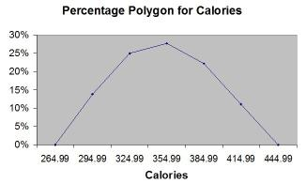

190) Referring to Table 2-16, roughly what percentage of pizza products contain between 400 and 430 calories?
A) 0%
B) 11%
C) 89%
D) 100%
Answer: B

Keywords: percentage polygon, interpretation
191) Referring to Table 2-16, roughly what percentage of pizza products contain between 340 and 400 calories?
A) 22%
B) 25%
C) 28%
D) 50%
Answer: D

Keywords: percentage polygon, interpretation

192) Referring to Table 2-16, roughly what percentage of pizza products contain at least 340 calories?
A) 25%
B) 28%
C) 39%
D) 61%
Answer: D

Keywords: percentage polygon, interpretation
TABLE 2-17
The following table presents total retail sales in millions of dollars for the leading apparel companies during April 2009 and April 2010.

Apparel Company | April 2009 | April 2010
Gap | 1,159.00 | 962
TJX | 781.7 | 899
Limited | 596.5 | 620.4
Kohl's | 544.9 | 678.9
Nordstrom | 402.6 | 418.3
Talbots | 139.9 | 130.1
AnnTaylor | 114.2 | 124.8

193) Referring to Table 2-17, construct a table of column percentages.
Answer:
Apparel Company | April 2009 | April 2010
Gap | 31.00% | 25.09%
TJX | 20.91% | 23.45%
Limited | 15.95% | 16.18%
Kohl's | 14.57% | 17.71%
Nordstrom | 10.77% | 10.91%
Talbots | 3.74% | 3.39%
AnnTaylor | 3.05% | 3.26%
Total | 100.00% | 100.00%

Keywords: column percentages
194) Referring to Table 2-17, construct a side-by-side bar chart.
Answer:
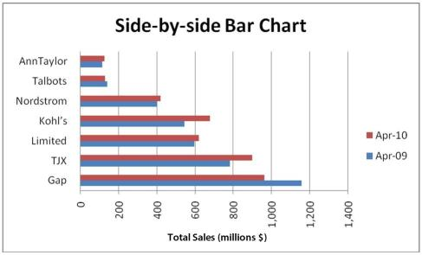

Keywords: column percentages, side-by-side chart

195) True or False: Referring to Table 2-17, in general, retail sales for the apparel industry have seen a modest growth between April 2008 and April 2009.
Answer: TRUE

Keywords: column percentages, side-by-side chart, interpretation

196) Referring to Table 2-17, among the 8 stores, ________ saw a sales decline.
Answer: Gap and Talbots

Keywords: column percentages, side-by-side chart, interpretation
TABLE 2-18
The stem-and-leaf display below shows the result of a survey on 50 students on their satisfaction with their school with the higher scores represent higher level of satisfaction.

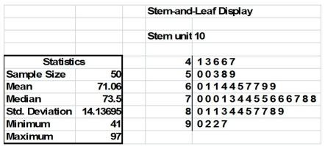

197) Referring to Table 2-18, what was the highest level of satisfaction?
Answer: 97

198) Referring to Table 2-18, what was the lowest level of satisfaction?
Answer: 41

199) Referring to Table 2-18, how many students have a satisfaction level in the 50s?
Answer: 5

200) Referring to Table 2-18, how many students have a satisfaction level below 60?
Answer: 10

201) Referring to Table 2-18, how many students have a satisfaction level of at least 80?
Answer: 15

202) True or False: Referring to Table 2-18, the level of satisfaction is concentrated around 75.
Answer: TRUE

203) True or False: Referring to Table 2-18, if a student is randomly selected, his/her most likely level of satisfaction among the 40s, 50s, 60s, 70s, 80s and 90s will be in the 70s.
Answer: TRUE

204) True or False: Referring to Table 2-18, if a student is randomly selected, his/her most likely level of satisfaction among the 40s, 50s, 60s, 70s, 80s and 90s will be in the 60s.
Answer: FALSE

205) True or False: Given below is the scatter plot of the price/earnings ratio versus earnings per share of 20 U.S. companies. There appears to be a negative relationship between price/earnings ratio and earnings per share.

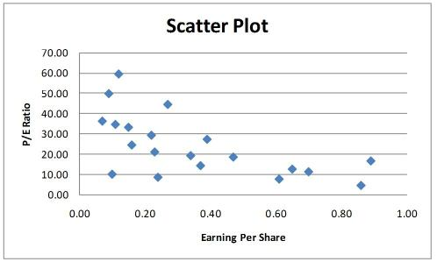

Answer: TRUE

206) True or False: Given below is the scatter plot of the price/earnings ratio versus earnings per share of 20 U.S. companies. There appear to be a positive relationship between price/earnings ratio and earnings per share.

Answer: FALSE

207) True or False: Given below is the scatter plot of the market value (thousands$) and profit (thousands$) of 50 U.S. companies. Higher market values appear to be associated with higher profits.

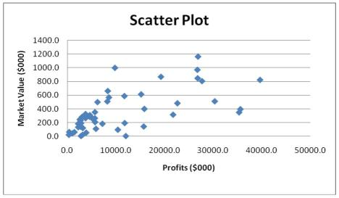

Answer: TRUE

208) True or False: Given below is the scatter plot of the market value (thousands$) and profit (thousands$) of 50 U.S. companies. There appears to be a negative relationship between market value and profit.

Answer: FALSE

209) True or False: Given below is the scatter plot of the number of employees and the total revenue ($millions) of 20 U.S. companies. There appears to be a positive relationship between total revenue and the number of employees.

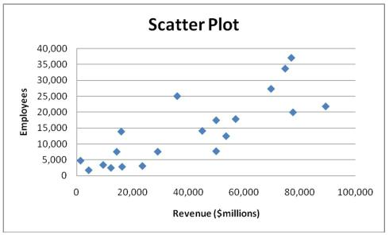

Answer: TRUE

210) True or False: Given below is the scatter plot of the number of employees and the total revenue ($millions) of 20 U.S. companies. Companies that have higher numbers of employees appear to also have higher total revenue.

Answer: TRUE

