Markets and the Market Process

MULTIPLE CHOICE

1. ____ is an example of an allocation mechanism.
a. | Market
b. | First-come, first-served
c. | Government dictate
d. | Random
e. | All of these are examples of allocation mechanisms.

ANS: E

2. Which of the following exemplifies the first come, first-served allocation mechanism?
a. | Air travel on the Wednesday before Thanksgiving is always expensive.
b. | People who purchase air tickets a week before travel pay more than people who purchase tickets two months before travel.
c. | People will pay scalpers many times the face value of a ticket to the Super Bowl.
d. | Customers in a crowded restaurant may slip the headwaiter some money in order to be seated more quickly.
e. | People line up outside stores on Thanksgiving night for the 5:00 a.m. Black Friday (day after Thanksgiving) sale.

ANS: E

3. Which of the following exemplifies the market allocation mechanism?
a. | Prices of swim suits are marked down in September.
b. | A store limits the quantity of an item that a customer can purchase.
c. | Medicare (health care for the elderly).
d. | Christmas decorations and merchandise in stores by Halloween.
e. | All of these are examples of the market allocation mechanism.

ANS: A
TOP: Preview

4. Which of the following mechanisms is unfair?
a. | Market.
b. | First-come, first-served.
c. | Government
d. | Random
e. | All of these are unfair in a sense; it depends on the incentives each creates.

ANS: E
TOP: Preview

5. Which of the following examples deals with price, with the allocation of goods and services, and also with demand and supply?
a. | Lodging in Phoenix may cost twice as much in the winter as in the summer.
b. | Lodging in Colorado may cost much more in the winter than in the summer.
c. | People will pay scalpers many times the face value of a ticket to a popular show.
d. | Customers in a crowded restaurant may slip the headwaiter some money in order to be seated more quickly.
e. | All of these

ANS: E
TOP: Preview

6. Which of the following is not an allocation mechanism?
a. | Fairness
b. | Markets
c. | First come, first served
d. | Random
e. | Government

ANS: A

7. What incentives are created under a first come, first served allocation mechanism?
a. | Fairness
b. | Equality for all
c. | To be first
d. | To produce the most
e. | To acquire purchasing ability (to obtain income and wealth)

ANS: C

8. What incentives are created under a government allocation scheme?
a. | Fairness
b. | Equality for all
c. | To be first
d. | To be in favor with or match up with government's rules
e. | To acquire purchasing ability (to obtain income and wealth)

ANS: D

9. What incentives are created under a random allocation scheme?
a. | Fairness
b. | Equal results for all
c. | To be first
d. | To be in favor with or match up with government's rules
e. | No incentives are created

ANS: E

10. What incentives are created under a market allocation scheme?
a. | Fairness
b. | Equality for all
c. | To be first
d. | To be in favor with or match up with government's rules
e. | To acquire purchasing ability (to obtain income and wealth)

ANS: E

11. In the long run, under which allocation mechanism will a society grow most quickly?
a. | Market
b. | Government
c. | First-come, first served
d. | Random
e. | All of these mechanisms will lead to long-run, sustained economic growth

ANS: A

12. The market system results in
a. | economic growth
b. | an increased standard of living
c. | efficiency
d. | motivation for sellers to improve the quality of their products
e. | All of these result from the market system.

ANS: E

13. The efficiency of an economic system is a measure of
a. | how well off people are.
b. | how well a system satisfies people's wants and needs.
c. | the standard of living.
d. | inflation.
e. | unemployment.

ANS: B

14. The market system is said to be efficient because it
a. | takes fewer resources to work than any other system.
b. | requires more labor than any other system.
c. | determines the price.
d. | allocates resources to who wants them.
e. | creates fewer goods and services than other systems.

ANS: C

15. For a free market to exist, economists say that
a. | the government must act in the best interest of the political leadership.
b. | all's well that ends well.
c. | supply must determine demand.
d. | there must be voluntary exchanges and secure private property rights.
e. | everything must have a price that is lower than competitive offerings from other countries.

ANS: D

16. When economists say that people are self-interested, they mean that people are
a. | using their scarce resources to maximize their well-being.
b. | selfish.
c. | greedy for other peoples' possessions.
d. | efficiently substituting market demands for complementary goods.
e. | reacting to shortages by creating surpluses of socially acceptable wants and needs.

ANS: A

17. Even in the United States, not all allocation is carried out in a market because, in some cases, people
a. | want more of the product.
b. | want less of the product.
c. | do not like the market outcome.
d. | support the market outcome.
e. | disagree with a random allocation.

ANS: C

18. Even in the United States, not all allocation is carried out in a market because, in some cases,
a. | people want more of the product.
b. | people want less of the product.
c. | the market outcome is not always efficient.
d. | people support the market outcome.
e. | people disagree with a random allocation.

ANS: C

19. The market system may not be efficient because people want more of the product. In this situation, the market
a. | is not able to account for all costs and benefits.
b. | is always able to account for all costs and benefits.
c. | accounts for all costs and benefits except in the case of fast food.
d. | cannot account for the cost of Styrofoam cups.
e. | is unable to measure the cost of cigarettes.

ANS: A

20. One reason governments pay so much for military weapons is
a. | they are greedy.
b. | they do not want a free market system for military weapons.
c. | consumers want more than the government is willing to buy.
d. | they want to pay more, assuming they will get better-quality weapons.
e. | all of these.

ANS: B

21. Why is the market system not universally relied on to allocate goods and services?
a. | Government wants to impose its preferences.
b. | People do not like the outcome.
c. | The market simply cannot function.
d. | The market system is not always the most efficient allocation mechanism.
e. | All of these.

ANS: E

22. An example of the market allocation mechanism is
a. | The 50% off sale on Christmas items on December 26.
b. | A one-pound box of See's candy selling for US $40 in Hong Kong.
c. | Discounted matinee movie tickets
d. | Buyers paying more than the suggested retail price for a Mazda Miata when they were introduced in the U.S. in 1990.
e. | All of these are examples of the market mechanism.

ANS: E

23. The following is an example of the market allocation mechanism
a. | Long lines of people waiting to purchase the new Apple iPad
b. | The raffle drawing for a trip to Hawaii
c. | The American interstate freeway system
d. | The $5 pizza special at the nearby-campus pizzeria
e. | None of these is an example of the market allocation mechanism.

ANS: D

24. The following is an example of the first-come, first-served allocation mechanism
a. | Long lines of people waiting to purchase the new Apple iPad
b. | The raffle drawing for a trip to Hawaii
c. | The American interstate freeway system
d. | The $5 pizza special at the nearby-campus pizzeria
e. | None of these is an example of the market allocation mechanism.

ANS: A

25. The following is an example of the random allocation mechanism
a. | Long lines of people waiting to purchase the new Apple iPad
b. | The raffle drawing for a trip to Hawaii
c. | The American interstate freeway system
d. | The $5 pizza special at the nearby-campus pizzeria
e. | None of these is an example of the market allocation mechanism.

ANS: B

26. A market
a. | makes possible the exchange of goods and services between buyers and sellers.
b. | refers only to a specialized place or service where goods and services are exchanged.
c. | refers only to a formally organized place where a well-defined commodity is always traded.
d. | refers only to a localized place or service that facilitates the exchange of goods and services.
e. | refers to both large and small places where poorly defined commodities are traded.

ANS: A

27. Which of the following statements concerning markets is false?
a. | Buyers and sellers communicate with each other directly or indirectly about the quality and quantity of the product.
b. | Buyers and sellers discuss, either face to face or through an agent or broker, what they are willing to pay and receive for a good or service.
c. | Black markets deal with exchanges that violate the law.
d. | Markets are always formally organized, like the stock market.
e. | Underground market is the term given to unrecorded transactions, whether legal or illegal.

ANS: D

28. Which of the following is an example of a market?
a. | The exchange of votes and benefits by voters and politicians
b. | The exchange of shares of stock
c. | Sales and purchases of illegal drugs
d. | The exchange of a particular good at many different locations
e. | All of these

ANS: E

29. Which of the following goods are bought and sold in a market?
a. | Food
b. | Stocks
c. | Foreign goods
d. | Drugs
e. | All of these

ANS: E

30. Markets
a. | must be specialized.
b. | must be general.
c. | must consist of one buyer and one seller.
d. | must consist of many buyers and many sellers.
e. | can be organized either loosely or formally.

ANS: E

31. In general, the purpose of markets is to
a. | facilitate the exchange of goods and services between buyers and sellers.
b. | provide a means for illegal transactions.
c. | provide a forum for the exchange of political benefits.
d. | provide a means for unrecorded payments.
e. | facilitate the exchange of illegal commodities.

ANS: A

32. The market process tends to ensure that
a. | consumers get the products firms want to sell them.
b. | consumers get the products they want.
c. | producers get the products they want.
d. | consumers are not left out.
e. | inefficiency exists.

ANS: B

33. What does the market process refer to?
a. | The trading, buying, and selling of goods, services, and resources
b. | Barter exchange only
c. | Money exchange only
d. | The process of allocating goods fairly
e. | The process of ensuring that supermarkets exist

ANS: A

34. Which of the following is not a likely result in a market system?
a. | Consumers increase their marginal profit.
b. | Prices tend to be low.
c. | Resources tend to be used where they are most valued.
d. | Inefficient firms do not last.
e. | Inefficiency does not last.

ANS: A

35. According to the law of demand, if the price of compact disks decreased, everything else held constant, the
a. | demand for compact disks would increase.
b. | quantity demanded of compact disks would decrease.
c. | quantity demanded of compact disks would increase.
d. | demand for compact disks would decrease.
e. | quantity demanded of compact disks would not change.

ANS: C

36. The law of demand illustrates that
a. | as price decreases, demand increases.
b. | price changes are always in the same direction as demand changes.
c. | as price increases, quantity demanded increases.
d. | as price decreases, quantity supplied increases.
e. | as price decreases, quantity demanded increases.

ANS: E

37. According to the law of demand,
a. | the lower the price of a commodity, the lower the quantity demanded of that commodity.
b. | as the price of a commodity increases, the quantity demanded of that commodity also increases.
c. | the lower the price of a commodity, the greater the quantity demanded of that commodity.
d. | the lower the price of a commodity, the greater the quantity supplied of that commodity.
e. | as the price of a commodity increases, the quantity supplied of that commodity decreases.

ANS: C

38. Which of the following is not held constant when constructing a demand curve for good X?
a. | Consumer income
b. | Consumer tastes
c. | Price of good X
d. | Prices of other goods
e. | Consumer expectations

ANS: C

39. An individual demand schedule or curve shows the various quantities of a good that a person
a. | wants and is able to purchase at alternative prices, everything else held the same.
b. | has purchased at alternative prices, everything else held the same.
c. | is able to purchase at alternative prices, everything else held the same.
d. | is able to purchase at alternative income levels, everything else held the same.
e. | has purchased at alternative income levels, everything else held the same.

ANS: A

40. A table or list of the prices and the corresponding quantities demanded of a particular good is called a
a. | demand curve.
b. | demand schedule.
c. | supply curve.
d. | supply schedule.
e. | production possibilities schedule.

ANS: B

41. Which of the following is not constant along an individual consumer's demand curve for Coke?
a. | The price of Coke
b. | The price of Pepsi
c. | The consumer's income
d. | The consumer's tastes
e. | All of these

ANS: A

Table 2.1

Table 2.1
 | Quantities of Compact Disks (CDs) Demanded
Price of CD | Maria ¹ | Abdul ¹ | Jorgen ¹
$14  $12  $10  $ 8  $ 6 | 20  30  40  50  60 | 20  50  70  90  110 | 15  17  24  36  58
¹ Maria, Abdul, and Jorgen are the only consumers.

42. According to the data in Table 2.1, the market quantity of compact disks demanded at a price of $8 is
a. | 176.
b. | 36.
c. | 92.
d. | 50.
e. | 90.

ANS: A

43. Refer to Table 2.1. The market demand schedule is given by what quantities corresponding to $14, $12, $10, $8, and $6?
a. | 228, 176, 134, 97, 65
b. | 15, 17, 24, 36, 58
c. | 55, 97, 134, 176, 228
d. | 20, 30, 40, 50, 60
e. | 50, 80, 110, 140, 170

ANS: C

44. Refer to Table 2.1. If Maria and Jorgen are the only consumers in the market, the market demand schedule would be given by what quantities corresponding to $14, $12, $10, $8, and $6?
a. | 40, 80, 110, 140, 170
b. | 35, 67, 94, 126, 168
c. | 170, 140, 110, 80, 50
d. | 35, 47, 64, 86, 118
e. | 30, 50, 70, 90, 110

ANS: D

45. The market demand curve, with price on the vertical axis and quantity on the horizontal axis, is determined by
a. | adding individual demand curves in a horizontal direction.
b. | adding individual demand curves in a vertical direction.
c. | subtracting the demand for the product from the supply of the product.
d. | adding the demand for the product and the supply of the product.
e. | subtracting supply from demand at each price.

ANS: A

46. A boycott of lettuce would, if effective, cause a(n)
a. | increase in the equilibrium quantity of lettuce bought and sold.
b. | increase in the price of lettuce.
c. | decrease in the demand for lettuce.
d. | decrease in the supply of lettuce.
e. | decrease in the demand for and the supply of lettuce.

ANS: C

47. If the population doubles in size, what can be expected to happen to the market for automobiles?
a. | Automobile manufacturers will decrease supply.
b. | The price of automobiles will decrease.
c. | More automobiles will be sold at any given price.
d. | People will use fewer automobiles.
e. | None of these

ANS: C

48. If everyone expects the price of almonds to rise in the near future, what will happen to the market for almonds?
a. | People will buy the same amount now.
b. | People will buy less now, causing a decrease in demand.
c. | The amount bought and sold today will increase.
d. | The supply will increase today.
e. | The amount bought and sold today will decrease.

ANS: C

49. Which of the following would not shift the demand curve for golf balls?
a. | An increase in the price of golf clubs
b. | A decrease in the popularity of golf
c. | An increase in the number of golfers
d. | All of these would shift the demand curve for golf balls
e. | A decrease in the price of golf balls

ANS: E

50. A decrease in the price of a product causes
a. | demand to increase.
b. | the demand curve to shift to the left.
c. | movement down along the demand curve.
d. | movement up along the demand curve.
e. | none of these.

ANS: C

51. Assume the demand for watermelons is downward sloping. An increase in price from $1 per pound to $2 per pound
a. | could have been caused by an increase in supply.
b. | will cause a larger quantity of watermelons to be demanded.
c. | will cause demand to decrease.
d. | could have been caused by an extra-large crop yield.
e. | will cause a smaller quantity of watermelons to be demanded.

ANS: E

52. Which of the following will not cause the demand for ice cream to change?
a. | A change in population size
b. | A change in the price of ice cream
c. | All of these would cause a change in the demand for ice cream.
d. | A change in consumer preferences
e. | A change in consumer incomes

ANS: B

53. When economists say that the demand for a product has increased, they mean that
a. | consumers are willing and able to purchase more at any given price.
b. | the demand curve has shifted to the left.
c. | the product has become more scarce and consumers therefore want it more.
d. | consumers would be willing and able to pay less to receive the same quantity.
e. | the price has decreased and consumers will therefore purchase more of the product.

ANS: A

54. Which of the following will not cause a change in demand?
a. | Changes in income
b. | Changes in tastes and preferences
c. | Changes in the price of the product
d. | Changes in the number of buyers
e. | Changes in the prices of related goods and services

ANS: C

55. Which of the following may cause a change in demand for a product?
a. | A change in the profitability of producing another product
b. | A decrease in the cost of producing the product
c. | A change in consumer incomes
d. | A change in the price of the product
e. | A change in the plans of producers

ANS: C

56. Which of the following statements is true?
a. | An increase in demand always means the same as an increase in quantity demanded.
b. | Price and quantity demanded are positively related.
c. | An increase in quantity demanded means a movement along a given demand curve.
d. | An increase in demand means a movement along a given demand curve.
e. | An increase in demand means that consumers will purchase less of a product at each possible price.

ANS: C

57. Which of the following would most likely cause an increase in the demand for personal computers?
a. | A reduction in the price of personal computers, other things being equal
b. | An increase in the supply of personal computers, other things being equal
c. | A requirement by universities that all students buy personal computers
d. | An increase in the number of computer manufacturers, other things being equal
e. | An increase in the cost of computer paper

ANS: C

58. Assume that there is an inverse relationship between the price and quantity demanded of personal computers. If the price of computers increases, the
a. | quantity supplied decreases.
b. | quantity demanded decreases.
c. | quantity demanded increases.
d. | demand curve shifts to the left.
e. | demand curve shifts to the right.

ANS: B

59. If consumers are willing and able to pay a higher price to obtain any particular quantity, then
a. | demand has increased.
b. | supply has increased.
c. | demand has decreased.
d. | supply has decreased.
e. | both demand and supply have decreased.

ANS: A

60. Tennis rackets and tennis balls are
a. | independent goods.
b. | complementary goods.
c. | substitute goods.
d. | economic bads.
e. | free goods.

ANS: B

61. If the price of tennis rackets increases and causes the demand for tennis balls to shift to the left, then
a. | tennis rackets and tennis balls are complements.
b. | tennis rackets and tennis balls are substitutes.
c. | tennis rackets and tennis balls are bads.
d. | only tennis balls are bads.
e. | tennis rackets and tennis balls are too expensive.

ANS: A

62. If a decrease in the demand for product X causes the demand curve for product Y to shift to the right, then X and Y are most likely to be which of the following?
a. | Shoes and laces
b. | Tennis balls and tennis rackets
c. | Butter and margarine
d. | Knives and forks
e. | Cars and gasoline

ANS: C

63. If an increase in the price of good X causes the demand for good Y to decrease, it can be concluded that
a. | X and Y are substitutes.
b. | X and Y are complements.
c. | X and Y are inferior goods.
d. | X and Y are superior goods.
e. | there is collusion in the marketplace.

ANS: B

64. If the demand curve for product J shifts to the left as the price of product K increases, then
a. | the number of consumers of product K has increased.
b. | the income of consumers of product K has increased.
c. | products J and K are substitute goods.
d. | products J and K are complementary goods.
e. | products J and K are not related.

ANS: D

65. If beer and pretzels are complementary goods, then an increase in the price of beer, other things being equal, will result in a(n)
a. | decrease in the demand for pretzels.
b. | decrease in the demand for beer.
c. | increase in the demand for pretzels.
d. | increase in the quantity demanded of beer.
e. | increase in the demand for beer.

ANS: A

66. Every Friday night Elizabeth either goes bowling or goes to the movies. Because the price of bowling went up, Elizabeth now sees more movies. Elizabeth's behavior would be best described as a change in which determinant of demand?
a. | The price of complementary goods
b. | Expectations
c. | Income
d. | The number of buyers
e. | The price of substitute goods

ANS: E

67. A rightward shift in the demand curve for popcorn could be the result of a(n)
a. | decrease in the number of buyers of popcorn.
b. | decrease in the price of potato chips (a substitute good).
c. | increase in the price of butter (a complementary good).
d. | increase in income.
e. | increase in the price of popcorn.

ANS: D

68. Economists use the term supply to refer to
a. | the downward-sloping line that relates consumer expenditures to different output levels.
b. | the upward-sloping line that relates consumer expenditures to different output levels.
c. | a set of price and quantity-supplied combinations, everything else held constant.
d. | a particular quantity supplied at a specific price.
e. | the amount producers are willing but not able to produce at each price.

ANS: C

69. The quantity supplied is
a. | the amount sellers are willing and able to offer at a given price during a particular time period, everything else held constant.
b. | the amount sellers are willing and able to offer for sale at all possible prices.
c. | a set of price and quantity-supplied combinations, everything else held constant.
d. | a list of prices and the corresponding quantities supplied.
e. | a downward-sloping line that relates expenditures to different levels of output.

ANS: A

70. The law of supply illustrates that
a. | as price increases, quantity supplied decreases.
b. | demand must increase to cause an increase in quantity supplied.
c. | a change in price causes a change in supply.
d. | price and quantity supplied move in the same direction.
e. | price changes are always in the same direction as supply changes.

ANS: D

71. According to the law of supply, if the price of electric ranges increased, everything else held constant, the
a. | supply of electric ranges would decrease.
b. | demand for gas ranges would increase.
c. | demand for electric ranges would decrease.
d. | supply of electric ranges would increase.
e. | quantity supplied of electric ranges would increase.

ANS: E

72. A graph of a list of the prices and corresponding quantities supplied of a good or service is called
a. | a supply curve.
b. | a supply schedule.
c. | a demand curve.
d. | a demand schedule.
e. | none of these.

ANS: A

Table 2.2

Table 2.2
 | Quantities Supplied
Price per Loaf | Orobran ¹ | Holsum ¹ | Deliteful ¹
$5  $4  $3  $2  $1 | 60  50  40  30  20 | 30  25  20  15  10 | 12  9  6  3  0
¹ Orobran, Holsum, and Deliteful are the only producers of bread.

73. According to the data in Table 2.2, the market supply of bread is given by what quantities corresponding to $5, $4, $3, $2, $1?
a. | 102, 84, 66, 48, 30
b. | 60, 50, 40, 30, 20
c. | 42, 34, 26, 18, 10
d. | 90, 75, 60, 45, 30
e. | 30, 25, 20, 15, 10

ANS: A

74. Refer to Table 2.2. If Orobran decreased its bakers' wages, it would
a. | increase its quantity supplied.
b. | increase its supply but the market supply would fall.
c. | decrease its supply but the market supply would rise.
d. | increase its supply and the market supply would rise.
e. | increase its quantity supplied, causing the market quantity supplied to fall.

ANS: D

75. Which of the following would least affect the supply of automobiles?
a. | An increase in the price of steel
b. | An improvement in the technology of automobile manufacturing
c. | An increase in the price of motor oil
d. | A decrease in the number of automobile producers
e. | An increase in the productivity of workers

ANS: C

76. Suppose laborers have received a substantial pay increase. What would happen in those markets in which those workers are employed?
a. | Demand would decrease.
b. | Output would rise.
c. | Price would fall.
d. | Supply would increase.
e. | Supply would decrease.

ANS: E

77. An increase in the price of crude oil will most likely cause
a. | an increase in demand for gasoline.
b. | a decrease in demand for computer software.
c. | governments to institute price controls.
d. | an increase in global warming.
e. | a decrease in the supply of products made using oil and oil derivatives.

ANS: E

78. The Federal Reserve and economists concerned about inflation monitor changes in technology, knowing improvements in technology tend to
a. | decrease demand for technology.
b. | increase the quantity supplied as prices decrease.
c. | increase supply and lower prices.
d. | reduce offshoring and increase gainsharing.
e. | do all of these.

ANS: C

79. If producers must obtain a higher price to produce any given quantity, we can conclude that
a. | supply decreased.
b. | demand decreased.
c. | demand increased.
d. | supply increased.
e. | both demand and supply increased.

ANS: A

80. An improvement in entrepreneurial skills applied to the production of a particular product would cause
a. | the supply curve for that product to shift to the right.
b. | a movement to the right along the supply curve for that product.
c. | a movement to the left along the supply curve for that product.
d. | an increase in the quantity supplied of that product.
e. | a decrease in the quantity supplied of that product.

ANS: A

81. If farmers believe that it is more profitable to produce wheat than corn, we can expect the
a. | price of wheat to rise.
b. | supply of corn to increase.
c. | quantity demanded of wheat to decrease.
d. | demand for wheat to increase.
e. | supply of corn to decrease.

ANS: E

82. In terms of the supply side of the market, the initial consequences of a violation of the "other things being equal" condition is likely to be a
a. | movement along the supply curve.
b. | movement along the supply schedule.
c. | shift of the supply curve.
d. | change in quantity supplied.
e. | change in quantity sold.

ANS: C

83. Assume an increase in the profitability of firms in a product market. Over time, we can expect
a. | market supply to decrease.
b. | the demand for resources to increase.
c. | the equilibrium price of the product to rise.
d. | firms to leave this market.
e. | the equilibrium price of the product to fall.

ANS: B

84. Suppose that sales of a product depend directly on economic growth. If producers of that product expect an economic recession in the near future, there is likely to be
a. | a rightward shift of the supply curve.
b. | a movement to the left along the supply curve.
c. | a leftward shift of the supply curve.
d. | a movement to the right along the supply curve.
e. | none of these.

ANS: C

85. When economists say that the supply of a product has decreased, they mean that
a. | a smaller quantity will be produced at any price.
b. | the price is too high for equilibrium.
c. | a greater quantity will be produced at any price.
d. | the price is too low for equilibrium.
e. | demand is too high for producers to make a profit.

ANS: A

86. Assume that the supply curve of sirloin steak is upward sloping. If the price increases from $5.25 to $8.60 per pound,
a. | the supply of sirloin steak will rise.
b. | a greater quantity of sirloin steak will be supplied.
c. | a smaller quantity of sirloin steak will be supplied.
d. | the demand for sirloin steak will decrease.
e. | the supply of sirloin steak will decrease.

ANS: B

87. Which of the following is not a determinant of supply?
a. | The prices of resources
b. | The price of the good or service
c. | The number of producers in the market
d. | The technology available
e. | The expectations of producers

ANS: B

88. In which of the following statements are the terms demand, supply, quantity demanded, and/or quantity supplied used correctly?
a. | Changes in demand and supply cause changes in the equilibrium price.
b. | If the demand rises, supply rises.
c. | Oranges are cheaper in Florida and therefore the demand is greater in Florida.
d. | When the quantity demanded exceeds supply, the equilibrium price will rise.
e. | All of these

ANS: A

89. If a smaller quantity is supplied at each price, then
a. | supply has decreased.
b. | supply has increased.
c. | demand has decreased.
d. | demand has increased.
e. | none of these is true.

ANS: A

90. If a U.S. firm is purchasing supplies from another country and that country's currency rose relative to the dollar, the
a. | cost to the U.S. firm for the same quantity of the supplies has fallen.
b. | cost to the U.S. firm for the same quantity of the supplies has risen.
c. | firm will produce more at every output price.
d. | firm will produce the same at every output price.
e. | firm will not produce.

ANS: B

91. A market is in equilibrium when
a. | equilibrium price equals equilibrium quantity.
b. | the price is high.
c. | the price is low.
d. | the government imposes price controls.
e. | the demand and supply curves intersect.

ANS: E

92. A market is in equilibrium when
a. | changes in demand are equal to changes in supply.
b. | the amount consumers wish to purchase is equal to the amount producers wish to produce.
c. | the determinants of supply are equal to the determinants of demand.
d. | quantity demanded is equal to quantity supplied.
e. | consumer preferences are equal to production costs.

ANS: D

93. Which of the following cannot occur when a market is not in equilibrium?
a. | There is a shortage.
b. | The quantity demanded and the quantity supplied are not equal.
c. | The quantity demanded and the quantity supplied are equal.
d. | There is a surplus.
e. | The quantity demanded is greater than the quantity supplied.

ANS: C

94. A price at which quantity demanded equals quantity supplied
a. | could not possibly exist in the short run.
b. | will cause a shift in demand.
c. | is below the equilibrium price.
d. | is an equilibrium price.
e. | is above the equilibrium price.

ANS: D

95. At the equilibrium price,
a. | there is a tendency for the price to rise.
b. | there is no pressure on price to rise or fall.
c. | quantity demanded exceeds quantity supplied.
d. | quantity supplied exceeds quantity demanded.
e. | there is a tendency for the price to fall.

ANS: B

Table 2.3

Table 2.3
Price per Loaf | Quantity Demanded | Quantity Supplied
$5  $4  $3  $2  $1 | 30  48  66  84  102 | 102  84  66  48  30

96. According to the data in Table 2.3, equilibrium in the bread market occurs at which price and quantity supplied?
a. | $5; 72
b. | $4; 36
c. | $3; 66
d. | $2; 36
e. | $1; 72

ANS: C

97. Beginning with equilibrium in Table 2.3, an increase in price of $1 would
a. | cause a shortage of 36.
b. | cause a surplus of 36.
c. | cause a shortage of 72.
d. | cause a surplus of 72.
e. | lead to an increase in demand.

ANS: B

98. Refer to Table 2.3. Assuming linearity, an increase in demand of 18 units would lead to a new equilibrium at
a. | $4; 88 units.
b. | $3.50; 75 units.
c. | $2.50; 93 units.
d. | $2; 102 units.
e. | $3; 84 units.

ANS: B

99. Disequilibrium does not exist when
a. | there is a shortage.
b. | there is a surplus.
c. | the existing price is above the equilibrium price.
d. | the existing price is below the equilibrium price.
e. | quantity demanded and quantity supplied are equal.

ANS: E

100. Which of the following statements is true of any market?
a. | The interaction of demand and supply determines the price and quantity in that market.
b. | There must be a supply of the item but not necessarily a demand for the item.
c. | Demand and supply are always equal for an item.
d. | There must be a demand for the item but not necessarily a supply of the item.
e. | The market will always be in equilibrium.

ANS: A

101. From a point of equilibrium, which of the following would most likely result in a surplus?
a. | If demand shifted to the right
b. | If the government kept the price greater than the equilibrium price
c. | If supply shifted to the left
d. | If the government kept the price below the equilibrium price
e. | If the quantity demanded was greater than the quantity supplied

ANS: B

102. When a shortage exists in a market,
a. | the actual price is lower than the equilibrium price.
b. | there is an excess quantity supplied.
c. | consumers increase the quantities they are willing and able to purchase.
d. | suppliers will quit producing until the shortage disappears.
e. | the actual price is greater than the equilibrium price.

ANS: A

103. The difference between scarcity and shortages is
a. | scarcity is reflected in lower prices.
b. | shortages are always caused by government.
c. | shortages can be eliminated by higher prices.
d. | scarcity reflects surpluses.
e. | all of these.

ANS: C

104. If price is below equilibrium,
a. | demand is too low for equilibrium.
b. | the income and substitution effects will cause the price to rise.
c. | quantity demanded exceeds quantity supplied, and a shortage exists.
d. | demand will increase.
e. | quantity supplied exceeds quantity demanded, and a shortage exists.

ANS: C

Figure 2.1

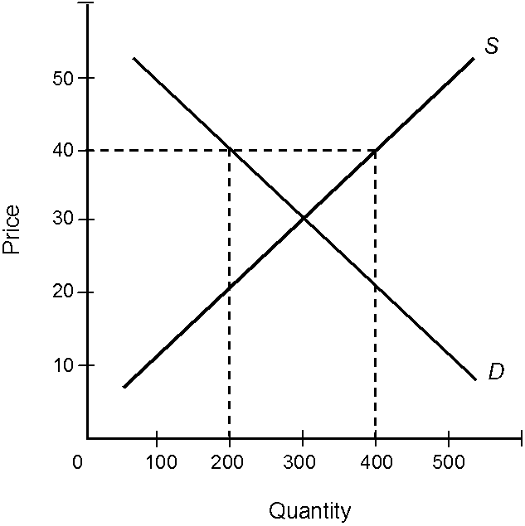

105. Consider the market described by the demand and supply curves in Figure 2.1. Which of the following is true if the current market price is $40 per unit?
a. | The quantity demanded is 400 units.
b. | There is a shortage of 200 units.
c. | The quantity sold is 200 units.
d. | The quantity supplied is 200 units.
e. | There is an excess demand of 200 units.

ANS: C

106. Assume that the market described by the demand and supply curves in Figure 2.1 is originally in equilibrium. What is the most likely consequence of a government-imposed price ceiling (maximum price that producers are allowed to charge) of $10 per unit?
a. | Supply will increase.
b. | Demand will increase.
c. | Quantity supplied will decrease.
d. | There will be a surplus of the good.
e. | There will be no consequence at all.

ANS: C

Table 2.4

Table 2.4
Price | Quantity Demanded | Quantity Supplied
$1  $2  $3  $4  $5 | 1,500  1,000  900  600  400 | 500  700  900  1,100  1,300

107. Consider the market represented by the schedule in Table 2.4. At a price of $2 per unit,
a. | the quantity purchased is 1,000 units.
b. | the quantity sold is 700 units.
c. | there is a surplus of 300 units.
d. | there will be a tendency for the price to decrease.
e. | there is a surplus of 700 units.

ANS: B

108. Consider the market represented by the schedule in Table 2.4. At equilibrium,
a. | the market price is $5 per unit.
b. | there is a surplus of 900 units.
c. | there is a shortage of 900 units.
d. | 900 units are traded at a price of $3 per unit.
e. | the market price is $1 per unit and the quantity traded is 500 units.

ANS: D

109. Consider the market described by the schedule in Table 2.4. Which of the following is true?
a. | The law of demand is violated.
b. | The law of supply is violated.
c. | There is no equilibrium.
d. | At $5 per unit, people will purchase 400 units.
e. | At $2 per unit, people will purchase 1000 units.

ANS: D

110. Consider the market described by the schedule in Table 2.4. At a price of $5 per unit,
a. | the quantity purchased is 1,000 units.
b. | the quantity traded is 1,000 units.
c. | there is a surplus of 900 units.
d. | the quantity sold is 1,800 units.
e. | there is excess demand.

ANS: C

Figure 2.2

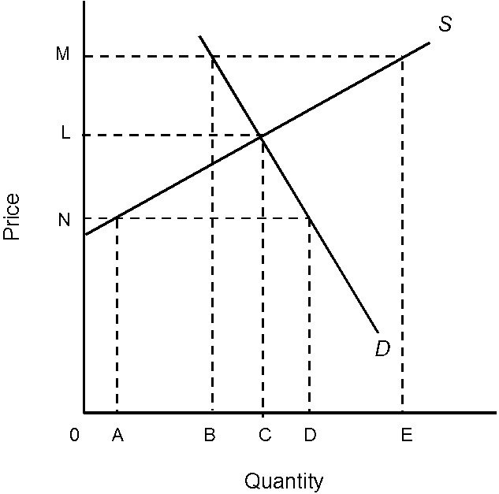

111. In Figure 2.2, a price of
a. | M would cause a surplus of BE quantity.
b. | M would cause a shortage of BE quantity.
c. | N would cause a shortage of BE quantity.
d. | 0 would bring about an equilibrium solution.
e. | L would cause a shortage of BC quantity.

ANS: A

112. In Figure 2.2,
a. | at a price of M, quantity B will be sold.
b. | at a price of M, quantity E will be sold.
c. | at a price of N, quantity C will be sold.
d. | the change in demand exceeds the change in supply.
e. | the change in supply exceeds the change in demand.

ANS: A

113. An equilibrium in a market results when the market
a. | produces a surplus.
b. | produces an output at which the price consumers are willing to pay exactly equals the price producers are willing to accept.
c. | produces an output at which the demand curve lies above the supply curve.
d. | results in a product that can be purchased at many different prices.
e. | produces an output at which the supply curve lies above the demand curve.

ANS: B

114. The output level that occurs in any market that is in equilibrium
a. | is the quantity where the supply curve intersects the Y axis.
b. | is the quantity where the demand curve intersects the X axis.
c. | is the quantity at an output level in which buyers will pay more than suppliers require.
d. | is an output level where buyers will not pay as much as suppliers require.
e. | means consumers or producers cannot be made better off by an expansion or contraction of output.

ANS: E

Figure 2.3

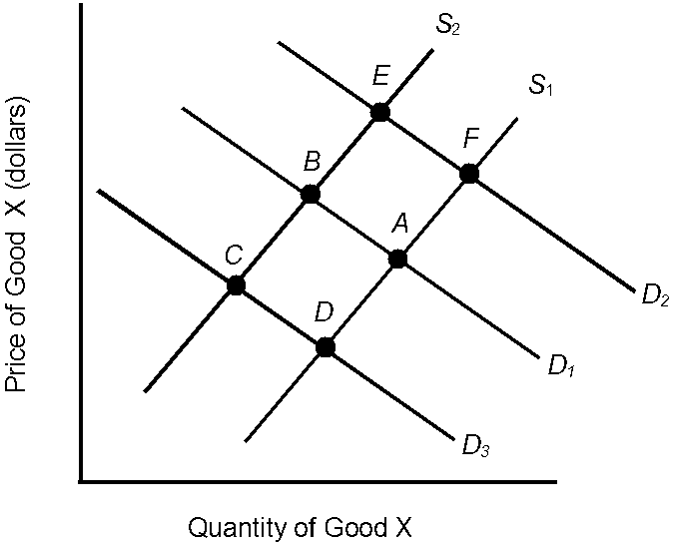

115. In Figure 2.3, the initial demand curve is D₁ and the supply curve is S₁. Which of the following would most likely change equilibrium from point A to point D?
a. | An increase in income
b. | A decrease in the price of good X
c. | An increase in the price of a complementary good
d. | Lower productivity
e. | An increase in the price of a substitute good

ANS: C

116. In Figure 2.3, the initial demand curve is D₁ and the supply curve is S₁. The most likely result of pessimistic producer expectations is a move from equilibrium
a. | A to equilibrium D.
b. | A to equilibrium E.
c. | A to equilibrium F.
d. | B to equilibrium A.
e. | A to equilibrium B.

ANS: E

117. In Figure 2.3, the initial demand curve is D₁ and the supply curve is S₁. If the price of a substitute good increases, what is the most likely result?
a. | Demand will shift to D₂.
b. | Equilibrium will move from A to E.
c. | Equilibrium will move from A to C.
d. | Equilibrium will move from A to D.
e. | Demand will shift to D₃.

ANS: A

118. In Figure 2.3, the initial demand curve is D₁ and the supply curve is S₁. If consumers become optimistic about their future economic well-being, the most likely consequence is a shift from
a. | S₁ to S₂.
b. | D₁ to D₂.
c. | D₁ to D₃.
d. | D₃ to D₁.
e. | D₂ to D₁.

ANS: B

Figure 2.4

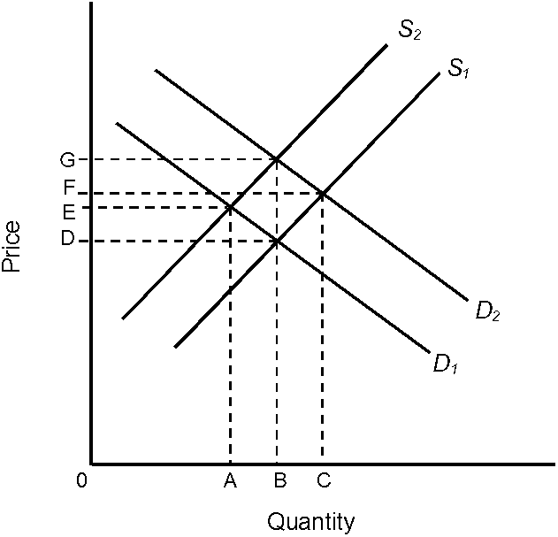

119. In Figure 2.4, if D₁ and S₁ are the original demand and supply curves, the original equilibrium price and equilibrium quantity would be
a. | E and A.
b. | G and B.
c. | F and C.
d. | D and A.
e. | D and B.

ANS: E

120. In Figure 2.4, given D₁, if supply moves from S₁ to S₂,
a. | the quantity supplied has increased.
b. | the demand will decrease from B to A.
c. | a surplus will exist equal to AB.
d. | the supply has decreased, and equilibrium price and equilibrium quantity will move to G and B, respectively.
e. | the supply has decreased, and equilibrium price and equilibrium quantity will move to E and A, respectively.

ANS: E

121. In Figure 2.4, given S₁, if demand shifts from D₁ to D₂, which of the following is not correct?
a. | Demand has increased.
b. | Equilibrium quantity will rise.
c. | Equilibrium price will rise to F.
d. | Quantity supplied will increase to C.
e. | Quantity supplied will rise to F.

ANS: E

122. In Figure 2.4, if demand shifts from D₁ to D₂ and supply shifts from S₁ to S₂,
a. | equilibrium price will rise to F but equilibrium quantity will remain at B.
b. | equilibrium price will move to C and equilibrium quantity will move to G.
c. | demand has decreased and supply has increased.
d. | equilibrium price will rise to G and equilibrium quantity will remain at B.
e. | both equilibrium price and equilibrium quantity will decrease.

ANS: D

123. Assume that at the current market price of $4 per unit of a good, you are willing and able to buy 20 units. Last year, at a price of $4 per unit, you would have purchased 30 units. What has most likely happened over the last year?
a. | Demand has increased.
b. | Demand has decreased.
c. | Supply has increased.
d. | Supply has decreased.
e. | Quantity supplied has decreased.

ANS: B

124. More television sets are being sold today than one year ago, and the selling price has increased. This could have been caused by a(n)
a. | decrease in supply.
b. | increase in demand.
c. | decrease in demand.
d. | increase in supply.
e. | exception to the law of demand.

ANS: B

125. The development of a low-cost synthetic fuel is expected to affect the market for crude oil in which of the following ways?
a. | Decrease the demand for oil
b. | Decrease the price of oil
c. | Decrease the quantity demanded and quantity supplied of oil
d. | Decrease the equilibrium quantity of oil
e. | All of these

ANS: E

126. This month Fritter Firm finds that it has been able to sell 200 fritters at a price of $1 per fritter. Last month, the firm was able to sell only 150 fritters at $1 per fritter. What most likely happened over the month?
a. | Demand increased.
b. | Supply increased.
c. | Supply decreased.
d. | Quantity supplied decreased.
e. | Quantity demanded increased.

ANS: A

127. The entry of Sony's Walkman MP3 player into the portable video and music playback market is expected to cause
a. | Demand to increase, causing price and quantity to increase.
b. | Demand to decrease, causing price and quantity to decrease.
c. | Supply to increase, causing price and quantity to increase.
d. | Supply to increase, causing price to decrease and quantity to increase.
e. | No change in the market.

ANS: D

128. A freeze that destroys all of the Florida orange crop would result in
a. | a lower price for orange juice as people will switch to Texas grapefruit juice
b. | a higher price for orange juice as people demand more orange juice
c. | no change in the price for orange juice
d. | a higher price for orange juice due to the decrease in supply of oranges
e. | a higher price for orange juice due to the increase in demand for oranges

ANS: D

Figure 2.5

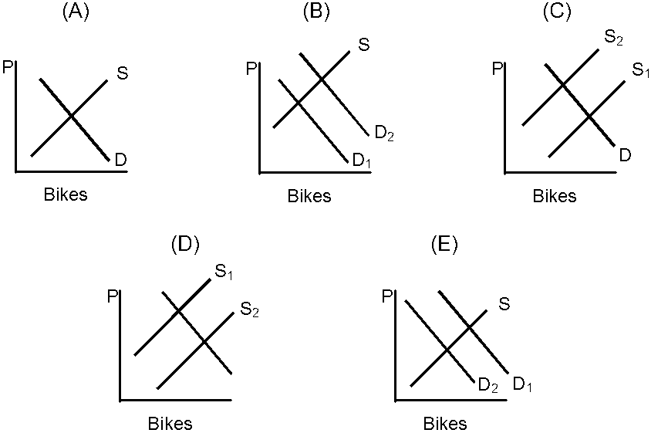

129. In Figure 2.5, which graph represents what might happen if research proved that riding a bike one mile every day will add two years to your life?
a. | A
b. | B
c. | C
d. | D
e. | E

ANS: B

130. In Figure 2.5, which graph represents what might happen to the market for bikes if there were a decrease in the cost of public transportation (i.e., buses, subways, etc.)?
a. | A
b. | B
c. | C
d. | D
e. | E

ANS: E

131. In Figure 2.5, which graph represents what might happen if there were an increase in the price of metal used in the production of bicycles?
a. | A
b. | B
c. | C
d. | D
e. | E

ANS: C

Figure 2.6

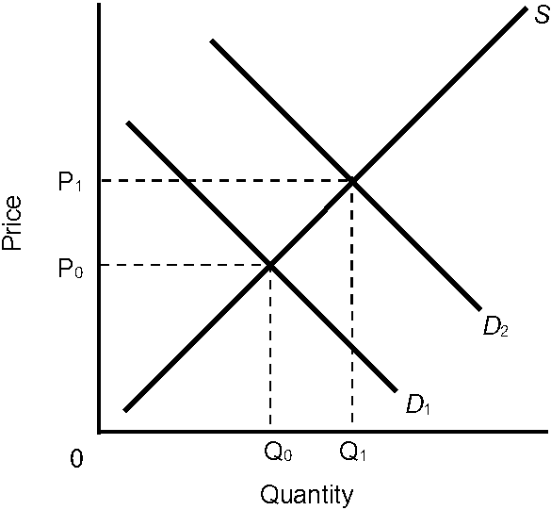

132. In Figure 2.6, if D₁ is the original demand curve and D₂ is the new demand curve, which of the following is true?
a. | Supply has increased.
b. | Quantity demanded has increased.
c. | Equilibrium price has decreased.
d. | Equilibrium quantity has decreased.
e. | Immediately after the change in demand, a shortage will exist at the original price P₀.

ANS: E

133. If the price of hot dogs were to decrease, we would expect the equilibrium price of hot dog buns in the hot dog bun market to
a. | decrease and the quantity of hot dog buns sold to increase.
b. | increase and the quantity of hot dog buns sold to decrease.
c. | increase and the quantity of hot dog buns sold to increase.
d. | decrease and the quantity of hot dog buns sold to decrease.
e. | stay the same and the quantity of hot dog buns sold to increase.

ANS: C

134. If demand decreases but supply increases, we can say that
a. | equilibrium price will rise, but equilibrium quantity is indeterminate.
b. | equilibrium quantity will decrease, but equilibrium quantity is indeterminate.
c. | we require more information to determine the movement in price and quantity.
d. | equilibrium price will decrease, but equilibrium quantity is indeterminate.
e. | equilibrium quantity will rise, but equilibrium price is indeterminate.

ANS: D

135. If demand moves to the right as supply moves to the right, then
a. | equilibrium price must increase, but equilibrium quantity may either rise, fall, or remain unchanged.
b. | equilibrium price and quantity must both go down.
c. | equilibrium quantity must rise, but equilibrium price may either rise, fall, or remain unchanged.
d. | equilibrium price and quantity must both go up.
e. | none of these occurs.

ANS: C

136. Last year a firm made 1,000 units of its good available at a price of $5 per unit. This year, the firm will still make 1,000 units available, but only if the price is $7 per unit. What has most likely happened?
a. | Supply has increased.
b. | Supply has decreased.
c. | Demand has decreased.
d. | Demand has increased.
e. | Quantity supplied has decreased.

ANS: B

Figure 2.7

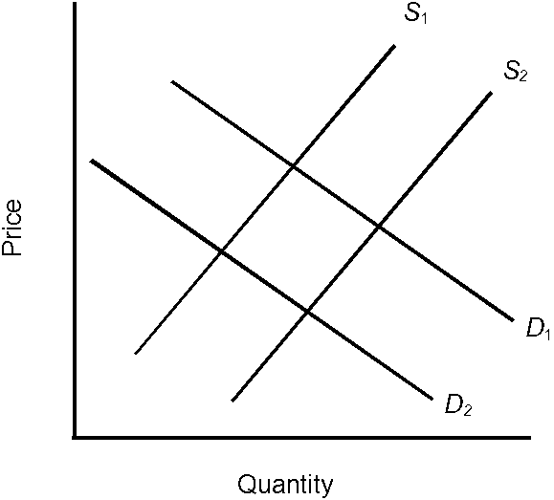

137. Refer to Figure 2.7. Assume that D₁ and S₁ are the initial curves. The shift in supply to S₂ could have been the result of each of the following except
a. | a technological improvement.
b. | optimistic producer expectations.
c. | an increase in the number of producers.
d. | higher resource costs.
e. | greater productivity.

ANS: D

138. Refer to Figure 2.7. Assume that D₁ and S₁ are the initial curves. The shift in demand to D₂ is most likely the result of
a. | an increase in the number of consumers.
b. | an increase in expected income.
c. | an increase in the price of a substitute good.
d. | pessimistic producer expectations.
e. | a shift in consumer tastes away from the product.

ANS: E

139. If a technological improvement took place in the computer industry, we would expect the equilibrium price of computers to
a. | increase and the quantity of computers sold to increase.
b. | decrease and the quantity of computers sold to increase.
c. | increase and the quantity of computers sold to decrease.
d. | decrease and the quantity of computers sold to decrease.
e. | increase and the quantity of computers sold to stay the same.

ANS: B

140. If supply and demand for a good both decrease, which of the following is true?
a. | Equilibrium price will rise, but we cannot say for sure what will happen to equilibrium quantity.
b. | Equilibrium price will fall, but we cannot say for sure what will happen to equilibrium quantity.
c. | Equilibrium quantity will rise, but we cannot say for sure what will happen to equilibrium price.
d. | Equilibrium quantity will fall, but we cannot say for sure what will happen to equilibrium price.
e. | Equilibrium price and equilibrium quantity will both fall.

ANS: D

141. If both supply and demand for a good increase, which of the following will definitely happen?
a. | Price will remain the same.
b. | Price will increase.
c. | Price will decrease.
d. | Quantity will increase.
e. | Quantity will decrease.

ANS: D

Figure 2.8

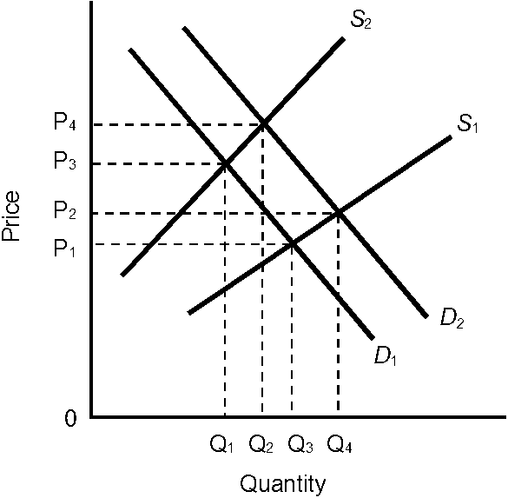

142. In Figure 2.8, which of the following is true?
a. | The change in demand could have resulted from a decrease in income if this is a normal good.
b. | The change in supply could have resulted from a decrease in resource costs.
c. | The new equilibrium occurs at a higher price than the original equilibrium.
d. | The change in demand could have resulted from a decrease in price.
e. | All of these

ANS: C

143. Many state governments are looking for new revenue sources, and a tax on internet purchases has been proposed by many. To an economist, this could be modeled by
a. | a decrease in demand, resulting in a lower price and quantity
b. | a decrease in supply, resulting in a higher price and lower quantity
c. | a decrease in demand, resulting in a higher price and lower quantity
d. | an increase in demand, resulting in a higher price and higher quantity
e. | a decrease in supply, resulting in a higher price and higher quantity.

ANS: B

144. The increase in gas prices can be explained by
a. | increased instability in the Middle East
b. | a decrease in personal income
c. | an increase in the number of hybrid vehicles sold
d. | higher mileage standards for new cars
e. | all of these

ANS: A

145. When a new pest destroys the coffee trees in Latin America, which of the following is correct?
a. | The demand for coffee decreases, the price of coffee increases, less coffee will be sold.
b. | The supply of coffee decreases, the price of coffee increases, the price of tea will increase.
c. | The demand for coffee increases, the price of coffee increases, more coffee will be sold.
d. | The supply of coffee increases, the price of coffee decreases, more coffee will be sold.
e. | The supply of coffee decreases, the price of coffee decreases, more tea will be sold.

ANS: B

TRUE/FALSE

146. Economists assume people are selfish.

ANS: F

147. For a free market to function, economists assume that voluntary exchanges and secure private property rights exist.

ANS: T

148. Ryan is on a limited budget. He constantly takes money from the office coffee jar to pay for his meals. Ryan is utilizing a free market as it is intended to be used.

ANS: F

149. The exchange of goods and services without the use of money is called over-the-counter exchange.

ANS: F

150. In general, the purpose of markets is to facilitate the exchange of goods and services between buyers and sellers.

ANS: T

151. A market is always a specific location or store.

ANS: F

152. The market process tends to ensure that the goods and services are provided at the lowest possible price.

ANS: T

153. Inefficient firms tend to flourish in a market system.

ANS: F

154. According to the law of demand, if the price of compact disks decreased, everything else held constant, the demand for compact disks would increase.

ANS: F

155. The demand curve for ice cream will shift if there is a change in the price of ice cream.

ANS: F

156. According to the law of demand, when the price of a BMW or a Gucci purse increases, the quantity demanded of these goods will also increase because the goods have become more prestigious.

ANS: F

157. An individual demand schedule or curve shows the various quantities of a good that a person is willing and able to purchase at alternative income levels, everything else held the same.

ANS: F

158. The demand schedule is a table or list of the prices and corresponding quantities demanded of a particular good or service.

ANS: T

159. The market demand curve is determined by adding the individual demand curves in a vertical direction.

ANS: F

160. If more consumers enter a market, the market demand will increase.

ANS: T

161. A successful consumer boycott of lettuce is expected to cause a decrease in the demand for lettuce.

ANS: T

162. If the price of a product decreases, then the demand curve shifts to the right.

ANS: F

163. When economists say that the demand for a product has increased, they mean that consumers are willing and able to purchase more at any given price.

ANS: T

164. When economists say that the demand for a product has increased, they mean that suppliers will be willing and able to offer more for sale at any given price.

ANS: F

165. If the price of product X falls and thus causes the demand for product Y to shift to the right, then we can conclude that X and Y are substitutes.

ANS: F

166. One reason entertainment and sports stars are paid huge sums to endorse products is that they influence consumers' tastes and preferences.

ANS: T

167. If the demand curve for product J shifts to the left as the price of product K increases, then J and K are complementary goods.

ANS: T

168. If three gasoline stations are located at the same intersection, their prices are often identical because they are complementary goods.

ANS: F

169. Economists use the term supply to refer to the quantity of a good that is supplied at various price levels, that is, a set of price and quantity-supplied combinations, everything else held constant.

ANS: T

170. According to the law of supply, if the price of calculators decreased, the supply of calculators would decrease, everything else held constant.

ANS: F

171. A supply schedule is a table or list of the prices and the corresponding quantities supplied of a good or service.

ANS: T

172. This month, Fritter Firm finds that it has been able to sell 200 fritters at a price of $1 per fritter. Last month, the firm was able to sell only 150 fritters at $1 per fritter. This change is most likely due to an increase in supply.

ANS: F

173. More television sets are being sold today than one year ago, and the selling price has increased. This could have been caused by an increase in demand.

ANS: T

174. The development of a low-cost synthetic fuel is expected to affect the market for crude oil and cause a decrease in the price of oil.

ANS: T

175. A shortage occurs when prices are lower than the equilibrium price.

ANS: T

