Applying Graphs to Economics

MULTIPLE CHOICE

1. A direct relationship exists when:
a. | there is no association between two variables.
b. | one variable increases and there is no change in the other variable.
c. | one variable increases and the other variable increases.
d. | one variable increases and the other variable decreases.

ANS: C TOP: Direct relationship

2. An upward-sloping line or curve is used to illustrate:
a. | a direct relationship.
b. | an inverse relationship.
c. | two unrelated variables.
d. | the ceteris paribus assumption.

ANS: A TOP: Direct relationship

3. Suppose two variables are directly related. If one variable rises, then the other variable:
a. | also rises.
b. | falls.
c. | remains unchanged.
d. | reacts unpredictably.

ANS: A TOP: Direct relationship

4. Which of the following pairs is the most likely to exhibit a direct relationship?
a. | The price of gasoline and the amount of gasoline that people purchase.
b. | Cholesterol levels and the likelihood of developing heart disease.
c. | Outdoor temperature and heating oil sales.
d. | Annual income and weekly pawn shop visits.

ANS: B TOP: Direct relationship

5. A direct relationship is expressed graphically as a:
a. | positively sloped line or curve.
b. | negatively sloped line or curve.
c. | horizontal line.
d. | vertical line.

ANS: A TOP: Direct relationship

6. An inverse relationship exists when:
a. | there is no association between two variables.
b. | one variable increases and there is no change in the other variable.
c. | one variable increases and the other variable increases.
d. | one variable increases and the other variable decreases.

ANS: D TOP: Inverse relationship

7. Which of the following pairs is the most likely to exhibit an inverse relationship?
a. | The amount of time you study and your grade point average.
b. | People's annual income and their expenditure on personal computers.
c. | Baseball players' salaries and their batting averages.
d. | The price of a concert and the number of tickets people purchase.

ANS: D TOP: Inverse relationship

8. When an inverse relationship is graphed, the resulting line or curve is:
a. | horizontal.
b. | vertical.
c. | upward-sloping.
d. | downward-sloping.

ANS: D TOP: Inverse relationship

9. What is used to illustrate an independent relationship between two variables?
a. | An upward-sloping curve.
b. | A downward-sloping curve.
c. | A hill-shaped curve.
d. | A horizontal or vertical line.

ANS: D

10. Which of the following is used to illustrate an independent relationship between two variables?
a. | An upward-sloping curve
b. | A downward-sloping curve
c. | A hill-shaped curve
d. | A horizontal or vertical line

ANS: D

11. Measured between two points on a curve, the ratio of the change in the variable on the vertical axis to the change in the variable on the horizontal axis is the:
a. | axis.
b. | slope.
c. | dependent curve.
d. | independent curve.

ANS: B TOP: Slope of a line

12. Which of the following statements is correct?
a. | Slope is the ratio of the vertical change (the rise or fall) to the horizontal change (the run).
b. | A direct relationship is one in which two variables change in the same direction.
c. | An inverse relationship is one in which two variables change in opposite directions.
d. | An independent relationship is one in which two variables are unrelated.
e. | All of the above.

ANS: E TOP: Slope of a line

13. A line that has a different slope at each point is a:
a. | curve.
b. | straight line.
c. | vertical line.
d. | horizontal line.

ANS: A TOP: Slope of a curve

Exhibit 1A-1 Straight line

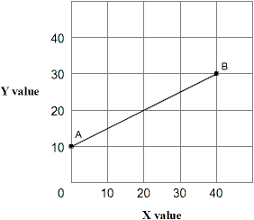

14. In Exhibit 1A-1, as X increases along the horizontal axis, corresponding to points A-B on the line, the Y values increase. The relationship between the X and Y variables is:
a. | direct.
b. | inverse.
c. | independent.
d. | variable.

ANS: A TOP: Direct relationship

15. Straight line AB in Exhibit 1A-1 shows that:
a. | increasing values for X will decrease the values of Y.
b. | decreasing values for X will increase the values of Y.
c. | there is a direct relationship between X and Y.
d. | all of the above.

ANS: C TOP: Direct relationship

16. In Exhibit 1A-1, the slope of straight line AB is:
a. | positive.
b. | zero.
c. | negative.
d. | variable.

ANS: A TOP: Slope of a line

17. In Exhibit 1A-1, the slope of straight line AB is:
a. | 1.
b. | 5.
c. | 1/2.
d. | −1.

ANS: C TOP: Slope of a line

18. As shown in Exhibit 1A-1, the slope of straight line AB:
a. | decreases with increases in X.
b. | increases with increases in X.
c. | increases with decreases in X.
d. | remains constant with changes in X.

ANS: D TOP: Slope of a line

Exhibit 1A-2 Straight line

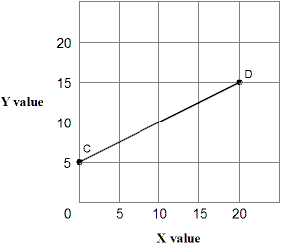

19. Straight line CD in Exhibit 1A-2 shows that:
a. | increasing values for X will increase the value of Y.
b. | decreasing values for X will decrease the value of Y.
c. | there is a direct relationship between X and Y.
d. | all of the above.

ANS: D TOP: Direct relationship

20. In Exhibit 1A-2, as X increases along the horizontal axis, corresponding to points C-D on the line, the Y values increase. The relationship between the X and Y variables is:
a. | direct.
b. | inverse.
c. | independent.
d. | variable.

ANS: A TOP: Direct relationship

21. In Exhibit 1A-2, the slope of straight line CD is:
a. | 3.
b. | 1.
c. | −1.
d. | 1/2.

ANS: D TOP: Slope of a line

22. In Exhibit 1A-2, the slope of straight line CD is:
a. | positive.
b. | zero.
c. | negative.
d. | variable.

ANS: A TOP: Slope of a line

23. As shown in Exhibit 1A-2, the slope of straight line CD:
a. | decreases with increases in X.
b. | increases with increases in X.
c. | increases with decreases in X.
d. | remains constant with changes in X.

ANS: D TOP: Slope of a line

Exhibit 1A-3 Straight line

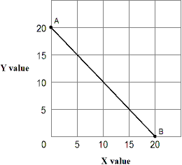

24. Straight line AB in Exhibit 1A-3 shows that:
a. | increasing values for X reduces the value of Y.
b. | decreasing values for X increases the value of Y.
c. | there is an inverse relationship between X and Y.
d. | all of the above.

ANS: D TOP: Inverse relationship

25. In Exhibit 1A-3, as X increases along the horizontal axis, corresponding to points A-B on the line, the Y values decrease. The relationship between the X and Y variables is:
a. | direct.
b. | inverse.
c. | independent.
d. | variable.

ANS: B TOP: Slope of a line

26. As shown in Exhibit 1A-3, the slope of straight line AB:
a. | decreases with increases in X.
b. | increases with increases in X.
c. | increases with decreases in X.
d. | remains constant with changes in X.

ANS: D TOP: Slope of a line

27. In Exhibit 1A-3, the slope for straight line AB is:
a. | 3.
b. | 1.
c. | −1.
d. | −5.

ANS: C TOP: Slope of a line

28. In Exhibit 1A-3, the slope of straight line AB is:
a. | positive.
b. | zero.
c. | negative.
d. | variable.

ANS: C TOP: Slope of a line

Exhibit 1A-4 Straight line

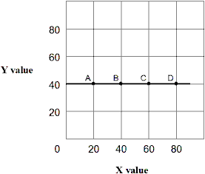

29. Straight line A-D in Exhibit 1A-4 shows that:
a. | increasing value for X will increase the value of Y.
b. | increasing value for X will decrease the value of Y.
c. | increasing values for X do not affect the value of Y.
d. | all of the above.

ANS: C

30. In Exhibit 1A-4, the slope of straight line A-D is:
a. | positive.
b. | zero.
c. | negative.
d. | variable.

ANS: B

31. In Exhibit 1A-4, as X increases along the horizontal axis, corresponding to points A-D on the line, the Y value remains unchanged at 40 units. The relationship between the X and Y variables is:
a. | direct.
b. | inverse.
c. | independent.
d. | undefined.

ANS: C

32. In Exhibit 1A-4, the slope of the straight line A-D is:
a. | 0.
b. | 1.
c. | 1/2.
d. | −1.

ANS: A TOP: Slope of a line

Exhibit 1A-5 Straight line

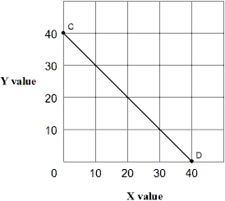

33. Straight line CD in Exhibit 1A-5 shows that:
a. | increasing values for X increases the value of Y.
b. | decreasing values for X decreases the value of Y.
c. | there is an inverse relationship between X and Y.
d. | all of the above.

ANS: C TOP: Inverse relationship

34. In Exhibit 1A-5, as X increases along the horizontal axis, corresponding to points C-D on the line, the Y values decrease. The relationship between the X and Y variables is:
a. | direct.
b. | inverse.
c. | independent.
d. | variable.

ANS: B TOP: Inverse relationship

35. In Exhibit 1A-5, the slope of straight line CD is:
a. | positive.
b. | zero.
c. | negative.
d. | variable.

ANS: C TOP: Slope of a line

36. In Exhibit 1A-5, the slope for straight line CD is:
a. | 5.
b. | 1.
c. | −1.
d. | −5.

ANS: C TOP: Slope of a line

37. As shown in Exhibit 1A-5, the slope of straight line CD:
a. | decreases with increases in X.
b. | increases with increases in X.
c. | increases with decreases in X.
d. | remains constant with changes in X.

ANS: D TOP: Slope of a line

Exhibit 1A-6 Straight line

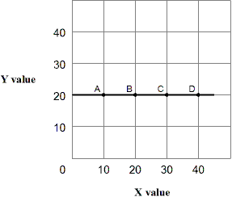

38. Straight line A-D in Exhibit 1A-6 shows that:
a. | increasing value for X will increase the value of Y.
b. | increasing value for X will decrease the value of Y.
c. | increasing values for X does not affect the value of Y.
d. | all of the above.

ANS: C

39. In Exhibit 1A-6, as X increases along the horizontal axis, corresponding to points A-D on the line, the Y values remain unchanged at 20 units. The relationship between the X and Y variables is:
a. | direct.
b. | inverse.
c. | independent.
d. | undefined.

ANS: C

40. In Exhibit 1A-6, the slope of straight line A-D is:
a. | greater than 1.
b. | equal to 1.
c. | less than 1.
d. | zero.

ANS: D

41. In Exhibit 1A-6, the slope of the straight line A-D is:
a. | 0.
b. | 1.
c. | 1/2.
d. | −1.

ANS: A TOP: Slope of a line

42. In Exhibit 1A-6, the slope of straight line A-D is:
a. | positive.
b. | zero.
c. | negative.
d. | variable.

ANS: B TOP: Slope of a line

43. In a graphic relationship, shifts in a curve are caused by a change in:
a. | the slope of the curve.
b. | a factor not measured on the axes of the graph.
c. | one of the factors measured on either axes of the graph.
d. | any factor, whether measured on the axes of the graph of not.

ANS: B

44. A shift in a curve represents a change in:
a. | the variable on the horizontal axis.
b. | the variable on the vertical axis.
c. | a third variable that is not on either axis.
d. | any variable that is relevant to the relationship being graphed.

ANS: C

45. A change in a third variable not on either axis of a graph is illustrated with a:
a. | horizontal or vertical line.
b. | movement along a curve.
c. | shift of a curve.
d. | point of intersection.

ANS: C

Exhibit 1A-7 Straight line relationship

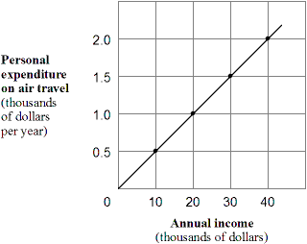

46. According to Exhibit 1A-7, the relationship between annual income and air-travel expenditures is:
a. | direct.
b. | inverse.
c. | complex.
d. | independent.

ANS: A TOP: Direct relationship

47. What is the slope of the line shown in Exhibit 1A-7?
a. | 1/20.
b. | 1/10.
c. | 1/5.
d. | 1/2.

ANS: A TOP: Slope of a line

48. Which of the following would cause a shift in the relationship shown in Exhibit 1A-7?
a. | A rise in people's annual income.
b. | A rise in people's expenditure on air travel.
c. | A rise in the price of air travel.
d. | All of the above would shift the line in the graph.

ANS: C

Exhibit 1A-8 Straight line relationship

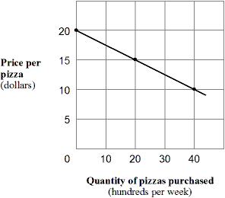

49. According to the Exhibit 1A-8, the relationship between the price and quantity purchased of pizza is:
a. | direct.
b. | inverse.
c. | complex.
d. | independent.

ANS: B TOP: Inverse relationship

50. What is the slope of the line shown in Exhibit 1A-8?
a. | −1.
b. | −1/2.
c. | −1/4.
d. | 0.

ANS: C TOP: Slope of a curve

51. Which of the following would cause a shift in the relationship shown in Exhibit 1A-8?
a. | A fall in household incomes.
b. | A fall in the price of pizza.
c. | A fall in the quantity of pizza that people wish to purchase.
d. | All of the above would shift the line in the graph.

ANS: A

Exhibit 1A-9 Multi-curve graph

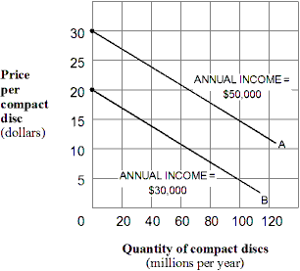

52. Exhibit 1A-9 represents a three-variable relationship. As the annual income of consumers falls from $50,000 (line A) to $30,000 (line B), the result is a(n):
a. | rightward movement along each curve.
b. | leftward movement along each curve.
c. | leftward shift in curve A to curve B.
d. | rightward shift in curve A to curve B.

ANS: C

Exhibit 1A-10 Multi-curve graph

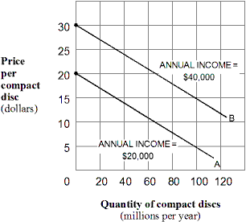

53. Exhibit 1A-10 represents a three-variable relationship. As the annual income of consumers rises from $20,000 (line A) to $40,000 (line B), the result is a(n):
a. | rightward movement along each curve.
b. | leftward movement along each curve.
c. | leftward shift in curve B to curve A.
d. | leftward shift in curve A to curve B.

ANS: D

TRUE/FALSE

1. A graph is one method of expressing a model.

ANS: T TOP: Graph

2. A two-dimensional graph can only represent the relationship between two variables.

ANS: F TOP: Direct relationship

3. Direct relationships are illustrated using upward-sloping lines and curves.

ANS: T TOP: Direct relationship

4. The graph of a direct relationship will have a positive slope.

ANS: T TOP: Direct relationship

5. An upward-sloping straight line exhibits a direct relationship between two variables.

ANS: T TOP: Direct relationship

6. A downward-sloping straight line exhibits a direct relationship between two variables.

ANS: F TOP: Direct relationship

7. If two variables are inversely related, then they change in the same direction.

ANS: F TOP: Inverse relationship

8. Two variables that are inversely related tend to move in opposite directions.

ANS: T TOP: Inverse relationship

9. A horizontal line represents an independent relationship.

ANS: T

10. The slope of a line is calculated as the ratio of the "rise" over the "run".

ANS: T TOP: Slope of a line

11. A horizontal line has an infinite slope.

ANS: F TOP: Slope of a line

12. A downward-sloping line has a negative slope.

ANS: T TOP: Slope of a line

13. A straight line or curve can shift when a factor not included on the vertical axis or horizontal axis changes.

ANS: T

14. A graph can be used to illustrate the relationship between the price of compact discs and the quantity of compact discs demanded. If there is evidence that buyers' income also influences the demand for compact discs, then a movement along the curve can be caused by a change in the price of compact discs.

ANS: T

ESSAY

1. Distinguish a direct and an inverse or negative relationship. Provide an example of each type of relationship.

ANS:
A direct relationship between two variables means an increase in the value of the independent variable will cause an increase in the value of the dependent variable; and vice versa. An example would be the relationship between the selling price of a good and the amount of the good put up for sale by producers. An inverse relationship between two variables means an increase in the value of the independent variable will cause a decrease in the value of the dependent variable; and vice versa. An example would be the relationship between the price of a good and the amount purchased.

2. Graphically express a direct and an inverse or negative relationship. What could cause a shift in a line or curve expressing a relationship between two variables?

ANS:
A direct relationship will slope upward; it will have a positive slope. An inverse relationship will slope downward; it will have a negative slope. A change in some relevant variable other than those listed on the vertical or horizontal axis must change in order to shift a line or curve expressing a relationship between two variables.

