Ch03 Demand and Supply

Multiple Choice Questions

1. The downward slope of the demand curve again illustrates the pattern that as _____________ rises, _________________ decreases.

A. quantity demanded, price
B. quantity supplied, quantity demanded
C. price, quantity demanded
D. price, quantity supplied

Answer: C Reference:

Explanation:

2. The nature of demand indicates that as the price of a good increases:

A. suppliers wish to sell less of it.
B. more of it is produced.
C. more of it is desired.
D. buyers desire to purchase less of it.

Answer: D Reference:

Explanation:

3. Any given demand or supply curve is based on the ceteris paribus assumption that ___________________.

A. everything is variable.
B. all else is held equal
C. no one knows which variables will change and which will remain constant.
D. what is true for the individual is not necessarily true for the whole.

Answer: B Reference:

Explanation:

4. The term "ceteris paribus" means that:

A. everything is variable.
B. all variables except those specified are constant.
C. no one knows which variables will change and which will remain constant.
D. what is true for the individual is not necessarily true for the whole.

Answer: B Reference:

Explanation:

Category: Remember

5. A supply curve is a graphical illustration of the relationship between price, shown on the vertical axis, and ____________, shown on the horizontal axis.

A. demand
B. quantity
C. quantity supplied
D. quantity demanded

Answer: B Reference:

Explanation:

6. Economists refer to the relationship that a higher price leads to a lower quantity demanded as the _____________.

A. income gap
B. market equilibrium
C. law of demand
D. price model

Answer: C Reference:

Explanation:

7. A demand curve shows the relationship between price and _________________ on a graph.

A. quantity demanded
B. quantity produced
C. economies of scale
D. costs

Answer: A Reference:

Explanation:

8. _________________ refers to the total number of units that are purchased at that price.

A. quantity
B. quantity demanded
C. supply
D. market quantity

Answer: B Reference:

Explanation:

9. In economics, the demand for a good refers to the amount of the good that people:

A. would like to have if the good were free.
B. will buy at various prices.
C. need to achieve a minimum standard of living.
D. will buy at alternative income levels.

Answer: B Reference:

Explanation:

10. The demand curve for a typical good has a(n):

A. negative slope because some consumers switch to other goods as the price rises.
B. negative slope because consumer incomes fall as the price of the good rises.
C. negative slope because the good has less "snob appeal" as its price falls.
D. inverse slope because as the price goes up, the good has more profitability.

Answer: A Reference:

Explanation:

11. When economists talk about supply, they are referring to a relationship between price received for each unit sold and the _________________.

A. demand schedule
B. market price
C. quantity supplied
D. demand curve

Answer: C Reference:

Explanation:

Difficulty:

12. But nearly all supply curves share a basic similarity: they slope _______________.

A. down from left to right
B. up from left to right
C. up from right to left
D. down from right to left

Answer: B Reference:

Explanation:

13. The demand schedule for a good:

A. indicates the quantity that people will buy at the prevailing price.
B. indicates the quantities that suppliers will sell at various market prices.
C. is determined primarily by the cost of producing the good.
D. indicates the quantities that will be purchased at alternative market prices.

Answer: D Reference:

Explanation:

14. When quantity demanded decreases in response to a change in price:

A. the demand curve shifts to the right.
B. the demand curve shifts to the left.
C. there is a movement down along the demand curve.
D. there is a movement up along the demand curve.

Answer: D Reference:

Explanation:

15. The ___________ is the only price where quantity demanded is equal to quantity supplied.

A. equilibrium price
B. horizontal axis intercept
C. vertical axis intercept
D. market price

Answer: A Reference:

Explanation:

16. After widespread press reports about the dangers of contracting "mad cow disease" by consuming beef from Canada, the likely economic effect on the U.S. demand curve for beef from Canada is:

A. no change; only the supply curve for beef is likely to be affected.
B. a shift of the demand curve for beef to the left.
C. a movement down along the demand curve for beef to the right.
D. a shift of the demand curve for beef to the right.

Answer: B Reference:

Explanation:

Category: Analyze

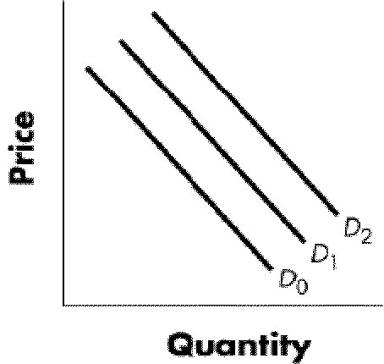

Figure 4-1

17. Refer to Figure 4-1. Using the graph above and beginning on D1, a shift to D2 would indicate a(n):

A. increase in quantity demanded.
B. decrease in quantity demanded.
C. increase in demand.
D. decrease in demand.

Answer: C Reference:

Explanation:

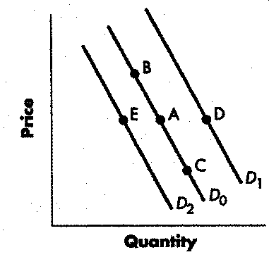

Figure 4-2

18. Refer to Figure 4-2. A change from Point A to Point B represents a(n):

A. increase in demand.
B. decrease in demand.
C. decrease in quantity demanded.
D. increase in quantity demanded.

Answer: C Reference:

Explanation:

19. If new manufacturers enter the computer industry, then (ceteris paribus):

A. the supply curve shifts to the left.
B. the supply curve shifts to the right.
C. the demand curve shifts to the left.
D. some established manufacturers must exit the industry.

Answer: B Reference:

Explanation:

20. If a firm faces ________________________, while the prices for the output the firm produces remain unchanged, a firm’s profits will increase.

A. higher demand
B. lower costs of production
C. equilibrium
D. a shift in demand

Answer: B Reference:

Explanation:

21. When __________________, a firm will supply a higher quantity at any given price for its output, and the supply curve will shift to the right.

A. prices rise
B. equilibrium is achieved
C. costs of production fall
D. there is a population increase

Answer: C Reference:

Explanation:

22. A severe freeze has once again damaged the Florida orange crop. The impact on the market for orange juice will be a leftward shift of:

A. the supply curve.
B. the demand curve, as consumers try to economize because of the shortage.
C. both the supply and demand curves.
D. the supply curve and a rightward shift of the demand curve, resulting in a higher equilibrium price.

Answer: A Reference:

Explanation:

Category: Analyze

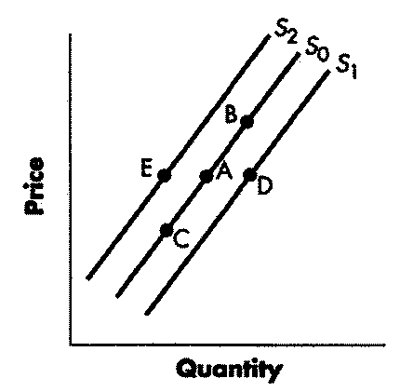

Figure 4-3

23. Refer to Figure 4-3. A change from Point A to Point E represents a(n):

A. increase in supply.
B. decrease in supply.
C. increase in quantity supplied.
D. decrease in quantity supplied.

Answer: B Reference:

Explanation:

24. Refer to Figure 4-3. A change from Point A to Point D represents a(n):

A. decrease in quantity supplied.
B. increase in quantity supplied.
C. decrease in supply.
D. increase in supply.

Answer: D Reference:

Explanation:

25. Refer to Figure 4-3. A change from Point A to Point B represents a(n):

A. increase in supply.
B. decrease in supply.
C. increase in quantity supplied.
D. decrease in quantity supplied.

Answer: C Reference:

Explanation:

26. A drought decreases the supply of agricultural products, which means that at any given price a lower quantity will be supplied; conversely, especially good weather would shift the __________________ .

A. demand curve to the right
B. supply curve to the left
C. supply curve to the right
D. demand curve to the left

Answer: C Reference:

Explanation:

27. A change in price of a good or service typically causes ___________________________ for that specific good or service.

A. a new equilibrium price
B. a change along the supply curve
C. the supply curve to shift
D. a decreased demand

Answer: B Reference:

Explanation:

28. According to the law of supply:

A. there is a direct relationship between price and the quantity supplied.
B. there is an inverse relationship between price and the quantity supplied.
C. there is a direct relationship between price and quantity demanded.
D. there is an inverse relationship between price and quantity demanded.

Answer: A Reference:

Explanation:

29. Which of the following would reduce the supply of microcomputers?

A. a technological improvement that lowers the cost of producing the computers
B. higher wage rates for the workers that assemble the computers
C. a reduction in the price of computer chips used to produce the computers
D. a reduction in the price of computers.

Answer: B Reference:

Explanation:

Category: Analyze

30. Interpret the following statement: "An increase in the price of wheat will encourage farmers to increase the quantity of wheat supplied to the market."

A. The statement is correct.
B. The statement would be correct if "quantity of wheat demanded" were substituted for "quantity of wheat supplied."
C. The statement is incorrect because it confuses a change in quantity supplied with a change in supply.
D. The statement would be correct if it read that a "decrease in the price of wheat will encourage farmers to increase the quantity of wheat supplied to the market."

Answer: A Reference:

Explanation:

31. ______________ are enacted when discontented sellers, feeling that prices are too low, appeal to legislators to keep prices from falling.

A. Rent controls
B. Price ceilings
C. Price floors
D. Subsidies

Answer: C Reference:

Explanation:

32. Andy views beer and pizza as complements to one another. If the price of pizza decreases, economists would expect:

A. Andy's demand for pizza to increase.
B. Andy's demand for pizza to decrease.
C. Andy's quantity of pizza demanded to decrease.
D. Andy's demand for beer to increase.

Answer: D Reference:

Explanation:

Category: Analyze

33. If an increase in the price of Good X causes a decrease in the demand for Good Y, we can conclude that:

A. the price of Good Y will increase.
B. Goods X and Y are normal goods.
C. Goods X and Y are substitute goods.
D. Goods X and Y are complement goods.

Answer: D Reference:

Explanation:

34. If the price is below the equilibrium level, then the quantity demanded will exceed the quantity supplied. This is known as ___________________

A. excess supply
B. excess demand
C. ceteris paribus
D. a price ceiling

Answer: B Reference:

Explanation:

35. The ____________ is the quantity where quantity demanded and quantity supplied are equal at a certain price.

A. quantity demanded
B. equilibrium quantity
C. demand schedule
D. supply schedule

Answer: B Reference:

Explanation:

Essay Questions

1. Various factors cause a demand curve to shift. List four different factors.

Reference:

Explanation: Various factors may cause a demand curve to shift: changes in income, changes in population, changes in taste, changes in expectations of future prices.

2. What are five things that will shift a supply curve to the right?

Reference:

Explanation: (any five of)
• A decrease in the price of a substitute in production.
• An decrease in input prices which make production less expensive.
• A change in technology.
• An expected decrease in future price.
• An increase in the number of producers.
• Deregulation.
• A reduction in taxes or an increase in subsidies.
• Weather.

3. Define consumer surplus and producer surplus.

Reference:

Explanation: Consumer surplus is the gap between the price that consumers are willing to pay, based on their preferences, and the market equilibrium price. Producer surplus is the gap between the price for which producers are willing to sell a product, based on their costs, and the market equilibrium price.

4. Define social surplus and deadweight loss.

Reference:

Explanation: Social surplus is the sum of consumer surplus and producer surplus. Total surplus is larger at the equilibrium quantity and price than it will be at any other quantity and price. Deadweight loss is loss in total surplus that occurs when the economy produces at an inefficient quantity.

5. Price floors and price ceilings often lead to unintended consequences, because buyers and sellers have many margins for action. List at least four margins.

Reference:

Explanation: These margins include black markets, side payments, quality adjustments, and shifts in who is involved in the transaction.

6. Around the world, many countries have passed laws to keep farm prices higher than they otherwise would be. Why does this widespread practice continue?

Reference:

Explanation: Price floors are enacted when discontented sellers, feeling that prices are too low, appeal to legislators to keep prices from falling.

7. With alternative policies like income subsidies and directed construction subsidies readily available, why do governments enact price floors and price ceilings?

Reference:

Explanation: One reason is that in public policy debates over price controls, people often don’t take into account the unintended but predictable tradeoffs. Another reason is that government sometimes views laws about price floors and ceilings as having zero cost, while giving subsidies to demanders or suppliers requires a government to collect taxes and spend money.

8. Define consumer surplus, producer surplus, and social surplus.

Reference:

Explanation: The amount that individuals would have been willing to pay minus the amount that they actually paid is called consumer surplus. Producer surplus is the amount that a seller is paid for a good minus the seller’s actual cost. Social surplus is the sum of consumer surplus and producer surplus.

9. What is the difference between a change in demand and a change in quantity demanded?

Reference:

Explanation: A change in quantity demanded is caused by a change in the price of the product and is represented as a movement along a stationary demand curve. A change in demand is caused by a change in tastes, income, price of a related good, number of consumers or expectations and is illustrated as a horizontal shift of the entire demand curve.

10. Wheat and oats are both used to make cereal and both are grown on the prairies. What would happen to the supply and demand of oats if the price of wheat were to rise?

Reference:

Explanation: An increase in the price of wheat would reduce the quantity demanded of wheat, and decrease the quantity supplied of wheat. Since wheat and oats are substitutes on the demand side, the increase in the price of wheat increases the demand for oats. Wheat and oats are also substitutes on the supply side, so the increase in the price of wheat reduces the supply of oats.

