**TOPOGRAPHIC PROFILES**

**Using Google Earth to Examine Earth’s Relief**

In this exercise, you will learn to construct topographic profiles. Topographic profiles are cross-sections showing how elevation varies along a traverse on Earth’s surface. Topographic profiles are useful in developing a sense of the relief (total elevation change) and steepness of different landscapes.

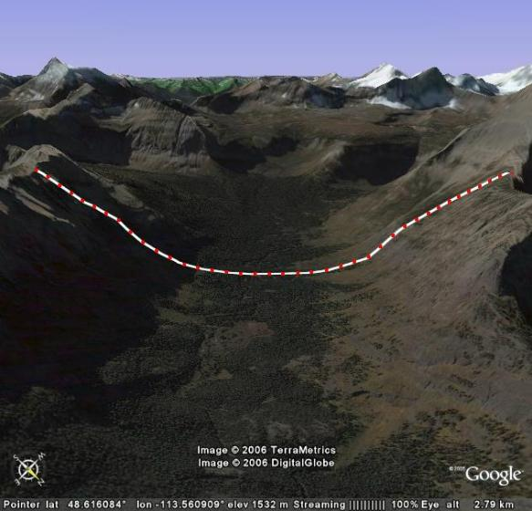

Fig. 1. Topographic profile across glacial valley in Glacier National Park, Montana, USA.

All of the imagery used in Google Earth is overlaid on an elevation model of the Earth. Thus, when you tilt an image, you will begin to see the three-dimensional nature of the area you are examining. This feature of Google Earth is especially impressive in areas of high relief (such as mountainous regions). In this exercise, you will use the tilt feature of Google Earth to help you visualize the topographic profiles you generate. You will then extract topographic data from your profile and plot the data on graph paper or graph them using the charting functions in Microsoft Excel.

NOTE: This is an open-ended assignment, so students will produce a broad variety of topographic profiles depending on the location they choose to use in Google Earth. A good way to review this concept is to present examples from the class showing topographic profiles from different landscapes—even better, let the students present their work! This may also lead to discussion of vertical exaggeration and its impact on profile visualization.

1. To construct a topographic profile, begin by enabling the metric measures in Google Earth. This is accomplished by clicking on ‘Tools’ on the menu bar at the top of the page, the clicking on ‘Options’. When the ‘Options’ dialogue opens, you will see in the lower left of the dialogue an ‘Elevation’ option. Choose Meters, Kilometers, then ‘Apply Settings’.
2. Next, you should start up the Microsoft Excel program as you will be entering data generated from Google Earth into this spreadsheet. When the spreadsheet opens, label one column ‘Distance (m)’ and one column ‘Elevation (m)’.
3. Next, return to the Google Earth window and enable the ‘Measure’ tool by clicking on the word ‘Measure’ (or simultaneously using ‘ctrl + 6’ keys on your keyboard). When the ‘Measure’ dialogue box appears, use the drop down window to choose meters as the units of distance. Also select the tab labeled ‘Path’.
4. Note that the ‘Measure’ icon on your image appears as a box with tick marks along the mid-points. This box can be used to add points along your profile with approximately equal spacing; simply click the first point, then move the box until one of its tick marks is aligned with this point; now click again. The next point is located approximately the distance from the center of the box to a tick mark. This distance varies depending on the level to which you are zoomed into the image. In addition, from point to point, the distance is not precisely the same, but it is close enough for the exercises we are attempting to conduct. If you add a point and want to delete it, simply right click on your mouse and it will disappear.
5. You can determine the approximate spacing to each point by noting the cumulative distance along your profile and entering this distance at each point into the spreadsheet.
6. To begin your topographic profile, find a mountainous region of the world. Note your location and write it down so others will know where you are. Zoom in until you can see details of surface features. Then click any point on your image using the ‘measure’ cursor. Move the ‘Measure’ cursor until the point is centered (a pointing finger icon will appear), and you will be able to read the elevation (“elev”) of the point along the bottom of the image window.
7. Increment to your next point along your traverse by moving the ‘Measure’ cursor approximately by the half-width of the cursor box, then click again. This is your second profile point. When you click this point, note the distance along your profile (read from the ‘Measure’ dialogue box; note the distance of the first point will always be 0) and the elevation of the point (read along the bottom of the image next to the latitude and longitude). Enter the distance and the elevation into their respective columns in your spreadsheet. Repeat this process until you have completed a substantial traverse of at least 40 points.
8. Once you have completed your topographic profile, slowly tilt your image until you can see the profile and its relief as it traverses topography. When you have a view that you like, save the image to your disk drive by clicking on the ‘File’ menu, then choosing ‘Save Image’. Name the image after the location and include it in your final report for this assignment. Also, plot your data on graph paper or generate a plot of your data in Excel and turn this in with your image.
9. Create two additional topographic profiles somewhere on Earth and include these in your final report. Be sure to always include some geographic information (coordinates and the location name, country, state, etc.) so others will be able to view this area in Google Earth, too.



Fig. 2. Topographic profile from figure 1 (above) plotted using Microsoft Excel.

**LINKS TO RELATED SITES:**

Wikipedia entry on Topographic Profiles: <http://en.wikipedia.org/wiki/Topographic_profile>

Creating Topographic Profiles: <http://geology.isu.edu/geostac/Field_Exercise/topomaps/topo_profiles.htm>

Animated Topographic Profile Instructions: <http://www.uwsp.edu/geo/faculty/ritter/geog101/textbook/manuals/instructor_manual/how_to/topographic_profile.html>