GEOLOGIC STRUCTURES
Faults and Faulting

Tectonism is ubiquitous on Earth, the fundamental process responsible for the terrains we find familiar. In this exercise, you will visit a series of locations where distinctive geologic structures are exposed by geologic processes. Your task will be to identify these structures as best you can.
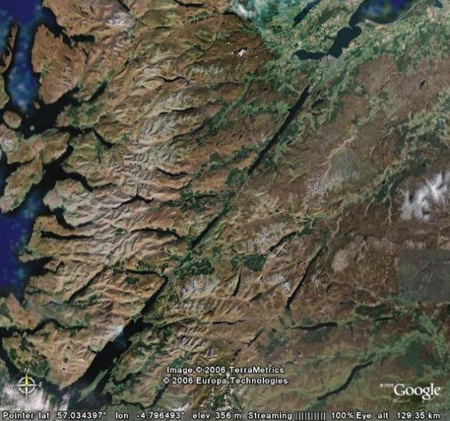
Fig. 1. Google Earth image of Great Glen Fault, Scotland. Can you determine the sense of offset?
In Google Earth, use the coordinates below to locate a variety of faults. Inspect each fault and try to determine the sense of offset. Note: In some instances, it may be helpful to increase the vertical exaggeration of the images. This can be changed in Google Earth by accessing ‘Tools’ from the main menu bar. Under the ‘Options’ function you will see ‘Elevation Exaggeration:’ in the lower left of the dialogue box. You can change the vertical exaggeration of the terrain model in Google Earth by typing 1, 2, or 3 (3 is the greatest vertical exaggeration, 1 is the least).
- The list of coordinates below will take you to various parts of the world to see examples of different types of geologic structures (faults). Examine each image and identify the type(s) of structure illustrated.
LATITUDE | LONGITUDE | ALTITUDE (km) | FAULT OFFSET (e.g., upthrown on N side, left-lateral, etc.
44.969228 | -108.414814 | 10 | Downthrown on east.
35.528348 | -117.336538 | 2 | Left-lateral.
38.734632 | -109.507026 | 3.5 | Downthrown on west.
35.442394 | -117.686327 | 4 | Left-lateral.
36.601581 | -114.551509 | 1 | Upthrown on north
36.453616 | -114.483167 | 4 | Upthrown on east.
39.426819 | -113.366425 | 20 | Downthrown on west.
36.500986 | -111.714474 | 6 | Downthrown on northeast.
57.034394 | -4.796493 | 190 | Left lateral.
41.955153 | 0.845450 | 4 | Upthrown on west.
40.774071 | 32.047001 | 54 | Right lateral.
19.563824 | 41.577638 | 9 | Upthrown on north.
LINKS TO RELATED SITES:
Wikipedia entry on Structural Geology: http://en.wikipedia.org/wiki/Structural_geology
Wikipedia entry on Faults: http://en.wikipedia.org/wiki/Geological_fault
Web Resources in Structural Geology: http://www.science.smith.edu/departments/Geology/Structure_Resources/

