LATITUDE AND LONGITUDE
Introduction to Coordinate Systems on Earth

This exercise is an introduction to a standardized coordinate system used throughout the world for centuries, Latitude and Longitude. While there are many coordinate systems that have been developed for a variety of mapping and geographic purposes, the great majority of maps produced for public use still rely on the traditional Latitude and Longitude system.
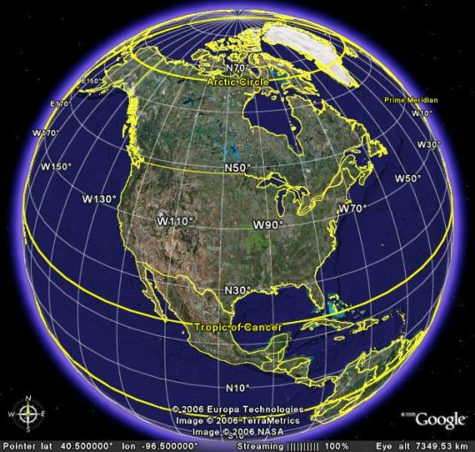
Fig. 1. Google Earth display of Earth with overlaid latitude/longitude grid.
In Google Earth, you can toggle the latitude/longitude grid on/off from the menu bar at the top of the page. Move your cursor to the ‘View’ option on the menu bar and click it. Locate the Lat/Lon Grid option and click it. You will see the latitude/longitude grid appear on the Earth image in Google Earth. Clicking on the Lat/Lon Grid option again will turn off the grid. Alternatively, you can toggle the latitude/longitude grid by simultaneously using the ‘ctrl + L’ keys on your keyboard.
In the latitude/longitude system, the nearly spherical Earth is divided into a grid composed of parallels of latitude (North-South grid lines) and meridians of longitude (East-West grid lines). The equator serves as the reference line for latitude and was arbitrarily assigned a value of 0 degrees centuries ago. Latitude is then measured in degrees north or south from the equator.
- What is the angular distance from the South Pole to the North Pole? 180 degrees
- What is the angular distance from the Equator to the South Pole? 90 degrees
- What is the angular distance from the Equator to the North Pole? 90 degrees
Longitude is measured in degrees east or west from the Prime Meridian (rotate the Google Earth globe to locate the Prime Meridian). Note that the Prime Meridian is the meridian of longitude passing through the Greenwich Observatory in Greenwich, England. In 1884, this meridian was arbitrarily chosen as the ‘zero meridian’ for the world. Not only is the Prime Meridian the east-west origin of the global longitude grid, it is also the point of origin for the global system of time keeping – each new day begins on the Prime Meridian. This time is known as 0000 hours Greenwich Mean Time, corresponding to midnight at the Greenwich Observatory, and Greenwich Mean Time is often abbreviated as GMT.
Note on the Google Earth latitude/longitude grid that several grid lines are indicated in yellow. These are 1) the Prime Meridian, 2) the Equator, 3) the Tropic of Cancer, 4) the Tropic of Capricorn, 5) the Arctic Circle, and 6) the Antarctic Circle.
- At what latitude is the Tropic of Cancer and what is its significance?
23.5°N; the sun is directly overhead at noon on the June solstice.
- At what latitude is the Tropic of Capricorn and what is its significance?
23.5°S; the sun is directly overhead at noon on the December solstice.
- At what latitude is the Arctic Circle and what is its significance?
66.5°N; it is 23.5° south of the North Pole; on the March equinox, the Sun rises and does not set until the September equinox.
- At what latitude is the Antarctic Circle and what is its significance?
66.5°S; it is 23.5° north of the South Pole; on the March equinox, the Sun sets and does not rise until the September equinox.
Compile a table showing the approximate latitude and longitude of the following locations. Enter the location name into the query bar of Google Earth, then record the latitude/longitude displayed in the Google Earth window for each site.
LOCATION | LATITUDE | LONGITUDE
Your college/university | Customized for location | Customized for location
Your home town (list in space below) | Customized for location | Customized for location
The Forbidden City | 39.917004 | 116.391006
The Taj Mahal | 27.175183 | 78.041399
The Eiffel Tower | 48.858208 | 2.294359
The Sydney Opera House | -33.856979 | 151.215027
The Pyramids of Giza | 29.977440 | 31.132317
The Parthenon | 37.971596 | 2.3726625
CN Tower | 43.641834 | -79.387291
Big Ben | 51.500698 | -0.124261
LINKS TO RELATED SITES:
Wikipedia entry on Coordinates Systems: http://en.wikipedia.org/wiki/Latitude_and_longitude
Wikipedia entry on Latitude: http://en.wikipedia.org/wiki/Latitude
Wikipedia entry on Longitude: http://en.wikipedia.org/wiki/Longitude
Wikipedia entry on the Prime Meridian: http://en.wikipedia.org/wiki/Prime_meridian
Wikipedia entry on the Int’l Date Line: http://en.wikipedia.org/wiki/International_Date_Line
Wikipedia entry on the Tropic of Cancer: http://en.wikipedia.org/wiki/Tropic_of_cancer
Wikipedia entry on the Tropic of Capricorn: http://en.wikipedia.org/wiki/Tropic_of_capricorn
Wikipedia entry on the Arctic Circle: http://en.wikipedia.org/wiki/Arctic_circle
Wikipedia entry on the Antarctic Circle: http://en.wikipedia.org/wiki/Antarctic_circle
History of the Royal Observatory: http://www.nmm.ac.uk/server/show/conWebDoc.13496
U.S. Naval Observatory: http://www.usno.navy.mil/

