Chapter 19 Deserts and Winds
Earth: An Introduction to Physical Geology

19.1
Multiple-Choice Questions

1)
Which one of the following statements is true?
A)
Desert landscapes are monotonous, relatively flat areas covered to various depths with sand.
B)
Deserts and dry lands are concentrated in areas of ascending air masses and relatively low atmospheric pressures.
C)
Despite infrequent rainfalls, erosional and depositional features of running water are important in desert landscapes.
D)
Rainshadow deserts occur where air masses descend after first having risen to cross a mountain range.
Answer:
C

2)
________ have rainfall amounts and soil moisture contents between those of true deserts and humid lands.
A)
Tundras
B)
Steppes
C)
Sundras
D)
Sabkhas
Answer:
B

3)
Most dry lands lie between ________ degrees north and south of the equator.
A)
40 and 50
B)
20 and 30
C)
5 and 10
D)
0 and 5
Answer:
B

4)
Which one of the following statements concerning rock weathering is true?
A)
Warm temperatures and high soil moisture contents accelerate chemical weathering.
B)
Low temperatures and high soil moisture contents accelerate chemical weathering but inhibit mechanical weathering.
C)
Warm temperatures and low soil moisture contents both promote rapid rates of mechanical weathering.
D)
Temperature has no effect on rock weathering.
Answer:
A

5)
A ________ is an intermittent stream channel in the dry land areas of the western United States.
A)
rivulet
B)
playa
C)
rill
D)
wash
Answer:
D

6)
________ refers to the "bouncing" mode of sand transport in a windstorm or stream.
A)
Saltation
B)
Ventifaction
C)
Siltation
D)
Deflation
Answer:
A

7)
Which one of the following will effectively limit further deflation in a given area?
A)
sea level
B)
desert pavement
C)
a hanging valley
D)
the repose level
Answer:
B

8)
Which one of the following statements is correct?
A)
Alluvial fans typically rim desert valleys; playas form in the lowest, interior parts of the valleys.
B)
Inselbergs are low, circular depressions on gently sloping pediments and bajadas.
C)
Playas are typically covered with gravel-sized desert pavement and loess deposits.
D)
Saline sediments and evaporites are common in inselbergs and pediments of desert landscapes.
Answer:
A

9)
In which area would surface water most effectively infiltrate into the local groundwater system?
A)
a stream in a steep-sided, bedrock canyon in the mountains
B)
streams flowing in the numerous channels of an alluvial fan
C)
a playa lake with a thick mud bottom
D)
All of the above would promote infiltration.
Answer:
B

10)
Which of the following characteristics would suggest geologically recent, fault uplift of a desert mountain range?
A)
flat, upland surfaces, steep slopes and small alluvial fans
B)
extensive pediments and bajadas and small, deep playas
C)
inselbergs, extensive pediments and flat valley floors
D)
steep playas with extensive, bedrock alluvial fans and numerous sand dunes
Answer:
A

11)
How is desert pavement formed?
A)
Deflation removes the coarse fragments leaving behind a layer of loess.
B)
Alluvial fans are eroded to form inselbergs with rocky surfaces.
C)
Groundwater in an alluvial fan evaporates, leaving behind a surface layer of hard-baked mud.
D)
Runoff and deflation carry off the silt and clay, leaving coarser particles behind.
Answer:
D

12)
Which one of the following is determined by the angle of repose for dry sand?
A)
longitudinal dune gradient angle
B)
slope of an alluvial fan
C)
a vertical cut bank in loess
D)
inclination angle of a dune slip face
Answer:
D

13)
Which one of the following statements about sand dunes is correct?
A)
A dune migrates in the direction of inclination of the slip face.
B)
The more gently sloping surface is the leeward slope of the dune.
C)
Sand is blown up the slip face and rolls down the more gently sloping flank of the dune.
D)
In a sand dune, the more gently inclined strata lie parallel to the slip face.
Answer:
A

14)
Deposition of glacial rock flour from blowing winds is responsible for ________.
A)
deflation ventifacts
B)
blowout pavement
C)
star steppes
D)
loess deposits
Answer:
D

15)
Which one of the following is the one best measure of the wetness or dryness of a region?
A)
total annual precipitation
B)
mean annual temperature
C)
difference between annual precipitation and evaporation potential
D)
percentage of precipitation that falls during the summer months
Answer:
C

16)
Which one of the following concerning desert lands is false?
A)
Less than 30 percent is covered with dunes and drifting sand.
B)
Wind erosion and deposition are important processes.
C)
Running water has little effect on shaping the landscape.
D)
Most desert areas are characterized by descending wind patterns.
Answer:
C

17)
Desertification has been particularly well documented over the past 50 years in ________.
A)
the Empty Quarter of the Arabian Peninsula
B)
the Sahel along the southern margin of the Sahara Desert
C)
the Dust Bowl states of the Great Plains
D)
the steppe lands of southern Russia, Ukraine, and Kazakhstan
Answer:
B

18)
Which of the following statements concerning dry lands is not true?
A)
Precipitation totals are low; dew points are lower in the summer than winter.
B)
Evaporation potential exceeds actual precipitation.
C)
Storms are infrequent and rainfall amounts are highly variable.
D)
Wind is the dominant agent of erosion and sediment transport.
Answer:
D

19)
How are sand grains transported by the wind?
A)
high in the moving air column as suspended load
B)
by saltation in the first few meters above the land surface
C)
by deflation of abraded desert pavement
D)
by being picked up in swirling dust clouds and carried to distant blowouts
Answer:
B

20)
Which of the following best describes the climatic factors that cause low latitude deserts like the Sahara in Africa?
A)
Cool, dry air aloft is descending; surface winds are blowing toward the equator.
B)
Warm, humid air aloft is descending; surface winds blow away from the equator.
C)
Warm, humid air is rising; surface winds are calm.
D)
Cool, dry air at the surface is rising causing winds to blow away from the equator.
Answer:
A

21)
How is desert pavement formed?
A)
Deflation and sheet wash remove fine-sized materials leaving coarse, weathered, rock fragments concentrated at the surface.
B)
Blowing wind removes fine-size soil particles; coarser particles abrades to sand size.
C)
Running water deposits gravel and sand over the finer-sized soil particles.
D)
Intense chemical weathering removes the sand- and silt-sized particles, leaving coarse rock debris covering the land surface.
Answer:
A

22)
Loess deposits in the central United States ________.
A)
blew in from the dry areas in the Great Plains and southwestern desert areas
B)
originated as rock flour in Pleistocene glacial streams and rivers
C)
accumulated from flooding of the Mississippi River
D)
were originally deposited as barchanoid dunes and later redeposited by glaciers
Answer:
B

23)
Assume that the central slip face of a barchan dune slopes downhill toward the east. What is the direction of the prevailing wind?
A)
east to west
B)
north to south
C)
south to north
D)
west to east
Answer:
D

24)
Desert and steppe lands cover about what percentage of Earth's land area?
A)
10%
B)
66%
C)
30%
D)
3%
Answer:
C

25)
Inselbergs are ________.
A)
insulated icebergs floating in a hot spring
B)
blowouts cut from bedrock in mountainous areas
C)
lithified rock formed by cementation of wind-deposited, dune sands
D)
bedrock hills in a highly eroded desert landscape
Answer:
D

26)
A ________ is formed by abrasion of rocks by windblown sand.
A)
playa
B)
ventifact
C)
pediment
D)
desert pavement
Answer:
B

27)
Which one of the following would probably not affect the size and depth of a blowout?
A)
a rise in sea level
B)
the near surface water table
C)
type and density of vegetation
D)
areas of desert pavement
Answer:
A

28)
What mature, desert landscape feature consists of coalesced alluvial fans?
A)
balda
B)
bajada
C)
bahia
D)
baja
Answer:
B

29)
A ________ is a crescent-shaped dune whose tips point downwind.
A)
parabarcal
B)
transverse
C)
barchan
D)
star
Answer:
C

30)
During a typical sandstorm, saltating sand grains reach a maximum height of ________ above the land surface.
A)
1 inch
B)
2 meters
C)
10 centimeters
D)
40 feet
Answer:
B

31)
Rainshadow deserts are common in ________.
A)
vast, dry, steppe lands like the Great Plains
B)
north central Africa
C)
the dry valleys of eastern California and Nevada
D)
Europe north of the Alps
Answer:
C

32)
________ are both dry land, erosional features cut from bedrock.
A)
Inselbergs and barcanoids
B)
Pediments and playas
C)
Bajadas and blowouts
D)
Pediments and inselbergs
Answer:
D

33)
________ dunes result from persistent, onshore winds in certain coastal areas.
A)
Diabolic
B)
Barchanoid
C)
Parabolic
D)
Staroid
Answer:
C

34)
________ dunes are long, high, sand dunes parallel with the prevailing wind direction.
A)
Transducinal
B)
Longitudinal
C)
Latitudinal
D)
Transversal
Answer:
B

35)
Which one of the following is a low-latitude desert characterized by high atmospheric pressures and descending air masses (not rain shadow deserts).
A)
Sahara Desert; northern Africa
B)
Atacama Desert in Chile, South America
C)
Gobi Desert, China and Mongolia
D)
desert valleys of the Great Basin, U.S.
Answer:
A

For the following question(s), match the sand dune with the appropriate description.

A. star B. barchan C. parabolic D. barchanoid E. transverse F. longitudinal

36)
________ complexly shaped dunes formed in response to different, seasonal, wind directions
Answer:
A

37)
________ linear sand ridges at right angles to the prevailing wind direction
Answer:
E

38)
________ linear sand ridges parallel to the prevailing wind direction
Answer:
F

39)
________ multiple, connected, crescent-shaped coastal dunes with the tips pointing toward the beach
Answer:
D

40)
________ sand ridges at right angles to prevailing winds with crescent-shaped slip faces pointing downwind
Answer:
D

41)
________ single, crescent-shaped dune with the tips pointing downwind
Answer:
B

19.2
Word Analysis Questions

Examine the words and/or phrases for each question below and determine the relationship among the majority of words/phrases. Choose the option which does not fit the pattern.
1)
A) pothole B) glacial striation C) ventifact D) steppe stone
Answer:
steppe stone

2)
A) arroyo B) wadi C) inselberg D) nullah
Answer:
inselberg

3)
A) ventifact B) alluvial fan C) playa D) inselberg
Answer:
ventifact

4)
A) sand dune B) deflation C) blowout D) desert pavement
Answer:
sand dune

5)
A) barchan dune B) star dune C) transverse dune D) parabolic dune
Answer:
star dune

19.3
True/False Questions

1)
Running water is an important erosional agent in many arid lands despite infrequent rainfalls.
Answer:
TRUE

2)
Sand dunes cover more than 50 percent of most desert lands.
Answer:
FALSE

3)
Deserts between 30 and 45 degrees of latitude are more extensive in the southern hemisphere than in the northern hemisphere.
Answer:
FALSE

4)
The loess in western China was derived from windblown, glacial rock flour.
Answer:
FALSE

5)
Bajadas develop from coalescence of alluvial fans along fronts of mountain ranges in arid lands.
Answer:
TRUE

6)
About one-third of the Earth's land areas have arid to semiarid climates.
Answer:
TRUE

7)
The Basin and Range Province of the southeastern United States is well known for its numerous and diverse arid region landforms.
Answer:
TRUE

8)
A playa is an intermittent lake on the floor of a desert valley.
Answer:
TRUE

9)
Steppes are the driest of the true desert lands.
Answer:
FALSE

10)
Intermittent streams in dry areas of the western United States are called washes.
Answer:
TRUE

11)
Windblown loess, like sand, typically accumulates as mound-like dunes.
Answer:
FALSE

12)
In North America, loess deposits are found mainly in the dry to semiarid lands of southwestern United States and northern Mexico.
Answer:
FALSE

13)
Sand is transported by saltation in running water and blowing winds.
Answer:
TRUE

14)
Blowouts are broad, shallow depressions excavated by deflation.
Answer:
TRUE

15)
Ventifacts are wind-abraded blowouts exceeding one kilometer in diameter.
Answer:
FALSE

16)
The steeper, lee slope of a sand dune is called the slip face.
Answer:
TRUE

17)
Loess consists mainly of silt-sized particles.
Answer:
TRUE

18)
Saltation refers to evaporation of shallow, muddy waters from a playa lake.
Answer:
FALSE

19)
Desert pavement accelerates deflation of bedrock pediments in alluvial fans.
Answer:
TRUE

20)
Inselbergs and small, steep, alluvial fans are characteristic of recently faulted, basin and range terrain in dry lands.
Answer:
TRUE

21)
Wind turbines 10 meters above the ground surface are subjected to relatively little abrasion by blowing sand.
Answer:
TRUE

19.4
Short Answer Questions

1)
________ dunes are long, sand ridges that develop at right angles to the prevailing wind direction.
Answer:
Transverse

2)
A ________ is an intermittent lake on the floor of a desert basin.
Answer:
playa

3)
________ is the skipping and bouncing transport of sand in blowing wind and running water.
Answer:
Saltation

4)
In dry lands, ________ is the covering of coarse particles left on the surface after the finer particles are carried away by wind and running water.
Answer:
desert pavement

5)
________ are rocks with one or more flat surfaces abraded by windblown sand.
Answer:
Ventifacts

6)
The leeward slope of a sand dune is also known as the ________.
Answer:
slip face

7)
________ are solitary, crescent-shaped dunes whose tips face downwind.
Answer:
Barchan

8)
________ describes the complex, internal stratification or bedding in a sand dune.
Answer:
Cross bedding

9)
Deposits of windblown silt are called ________.
Answer:
loess

10)
________ dunes form in areas where the prevailing wind directions change with the seasons.
Answer:
Star

11)
The low, bedrock ridges and peaks of a highly eroded, basin and range, desert landscape are called ________.
Answer:
inselbergs

19.5
Critical Thinking Questions

Use complete sentences, correct spelling, and the information presented in Chapter 19 to answer the questions below
1)
Wind is included along with gravity, water, and ice as an agent of erosion. In many national parks and other areas of natural beauty, statements are often made that credit wind as having sculpted the landscape. Briefly discuss the importance of wind as an agent of erosion and explain why such statements are probably geologically inaccurate.

2)
What features or characteristics would distinguish a Paleozoic sandstone formation as being eolian (wind-blown) in origin rather than having formed from an ancient stream or coastal environment?

19.6
Visualization Questions

1)
Label the alluvial fans and playa lakes on the diagram below.

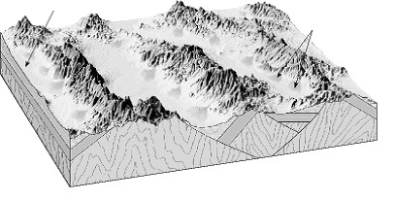

Answer:
See figure 19.7 A in chapter 19 of Earth, 9e

2)
Label the bajadas and playa on the diagram below.

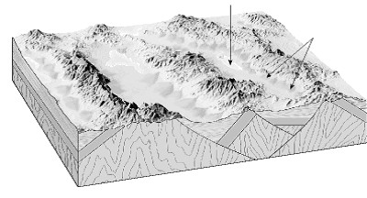

Answer:
See figure 19.7 B in chapter 19 of Earth, 9e

3)
On the blank spaces provided beside each illustration, write the name of the type of dunes shown in the illustration.

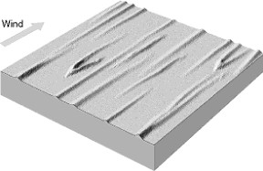 a) ________

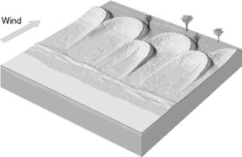 b) ________

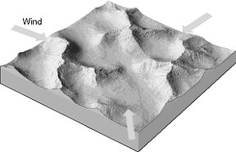 c) ________

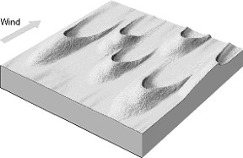 d) ________

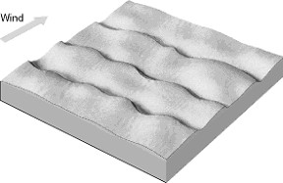 e) ________

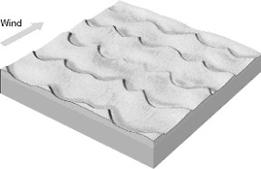 f) ________

