Alliances and Partnerships

Module 2

Learning Summary
This module has considered alliances and partnerships in the context of the value chain, and specifically in relation to how alliances and partnerships fit within the value chain. It has also considered the concept of equity joint ventures and non-equity alliances, these being the two primary types of large-scale alliance and partnership. The module has also considered the interdependency networks that tend to exist between alliances in given industries or sectors, and the way in which alliances often congregate together within the alliance network to form hubs. The final sections of the module considered national and international regulation and how these can impact on the formation and execution of alliances and partnerships.
The candidate should now understand:
- the concept of the value chain;
- how alliances and partnerships can be located within the value chain;
- some of the main types of alliance;
- the concept of equity-based alliances;
- the concept of non-equity-based alliances;
- the concept of alliance hubs;
- the concept of alliance networks;
- the concept of national and international regulation;
- the potential impact of regulation on strategic alliances.
The following section briefly summarises the primary learning outcomes from each section included in this module.

Some Common Questions about Alliances and Partnerships
- Companies conduct alliances and partnerships as a way of increasing their competitive advantage.
- Alliances and partnerships give a company the opportunity to increase its competitive advantage by working together with another company or group of companies so that collectively the competitive advantage of each member company is greater than it was when the company was acting in isolation.
- The concept of alliances and partnerships is similar to that of the old adage that ‘two heads are better than one’ when it comes to trying to address a problem.
- The primary difference between alliances and partnerships and mergers and acquisitions is the degree of commitment and irreversibility offered by the arrangement.
- In an acquisition, one company takes over the control and identity of another company.
- In an alliance a company works with another company without taking it over. The two companies work together for the common good.
- There may be a contractual agreement between two alliance partners, in which case there may be financial or other penalties associated with one company withdrawing from the alliance or not performing within the terms of the original alliance agreement.
- In other cases there may be no contractual basis for the alliance.
- In most cases, even if a formal contract is present, an alliance or a partnership offers considerably more freedom of action and flexibility than a merger or an acquisition.
- There are examples of alliances that have lasted for decades.
- In terms of individual companies, alliances and partnerships may be initiated purely as a means of improving efficiency and adding value.
- They may also be initiated as a survival necessity.
- The formation of an alliance or partnership can significantly alter the risk profile facing each of the partner companies.
- Confidentiality breach and the accidental disclosure of important company information are examples of new risks created by the formation of an alliance.
- The value chain is one term given to the sequence of processes and organisations involved in creating value. It is most often represented as a simple schematic diagram that includes the main processes involved and also shows the supply and customer bases.
- Companies rely on making effective use of all aspects of the value chain. Alliances and partnerships can be used to strengthen parts of the chain and/or to strengthen the linkages between elements of the chain.
- There are numerous types of alliance and partnership.
- In some cases, an alliance might be formed between two very similar companies with the objective of exploiting a simple scale economy.
- In other cases, the alliance might involve very different companies where the objective is to reduce risk or stabilise supply and/or sales output.
- Some alliances and partnerships may be directly affected by national and international regulation.
- Regulators usually act where the proposed alliance or partnership would significantly affect the level of competition within an industry or sector.

Some Common Misconceptions about Alliances and Partnerships
- Alliances and partnerships are often built around a central core contract, but such a contract is by no means a prerequisite for the formation of the alliance.
- It is commonplace to find alliances and partnerships where there are no formal contractual agreements of any kind.
- Many companies involved in the formation of strategic alliances have no previous practical experience of forming such associations.
- It is difficult to prove that an alliance or partnership actually adds value, as value itself is a function of so many variables.
- Companies sometimes withdraw from long-established alliances, even though the alliance may have served all the reasons that it was established for.
- The power balance within an alliance may be unevenly distributed among the partner companies.
- Alliances and partnerships tend to form under highly competitive conditions, particularly in industries or sectors subject to sustained innovation and change.
- There is no direct evidence to suggest that alliances and partnerships are any less effective than mergers and acquisitions.

The Value Chain
- The value chain is a representation of the sequence of processes through which the company creates value. The entire process is sometimes referred to as the value chain.
- Value chain processes usually:
  - have to be executed in a certain sequence;
  - are interrelated;
  - vary in terms of their relative importance to the chain as a whole;
  - are necessary in order for the chain to function.
- Some processes may make a larger individual contribution than others, but all are necessary.
- In some cases, modification of the value chain could be limited by other variables such as the availability of new technology or external restrictions such as regulation or statutory imposition.
- The value chain can sometimes be modified to a greater extent and improved by a factor greater than would otherwise be possible by the formation of suitable alliances and partnerships, as these can make additional resources available and may reduce the overall risk profile and exposure by sharing and spreading risk.
- The concept of the value chain is closely related to that of the supply chain.
- The supply chain concerns the efficient movement of raw materials through the production process from upstream suppliers, through the company and into products, which are then sold downstream to customers.
- The real significance of value chain management becomes clear when companies integrate activities across organisational boundaries with each other in terms of:
  - supply chain management;
  - customer relationship management;
  - supplier relationship management.
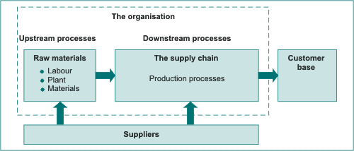
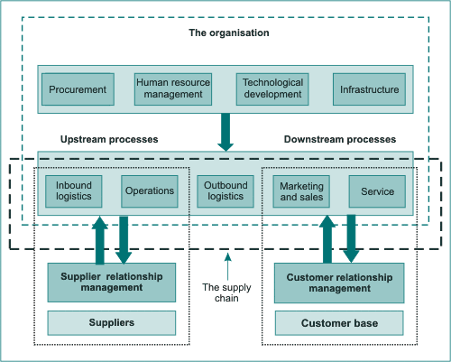
- Supply chain management, customer relationship management and supplier relationship management are the three key integrative elements of the value chain. They really represent visibility.
- This visibility is essential where companies generate products in different locations, using a range of outsourced suppliers in order to service powerful customer bases.
- Porter’s value chain primary activities are:
  - inbound logistics;
  - operations;
  - outbound logistics;
  - marketing and sales;
  - service.
- Porter’s value chain secondary activities are:
  - procurement;
  - human resource management;
  - technological development;
  - infrastructure.
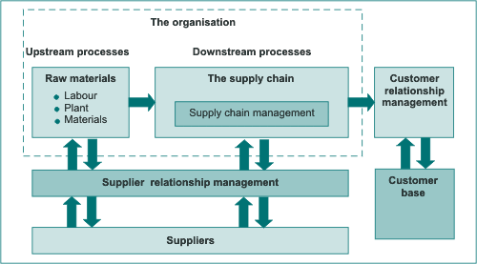

- The literature does not suggest any clear indication of the likely success or otherwise of an alliance or partnership, or the range or extent of the value chain that it addresses.
- Logically, it would seem reasonable to assume that alliances and partnerships that address as wide a range of value chain elements as possible are more likely to be successful than alliances and partnerships that address only a restricted range of the value chain. This does not appear to be the case, however.
- There is some evidence to suggest that the most effective alliances and partnerships are those where the resulting value chain, as perceived by each partner, is improved from the point of view of each partner’s value chain priority.
- Process mapping in its simplest form comprises a simple matching matrix in which the strengths and weaknesses of each company are plotted according to some form of process classification system.
- Process mapping itself uses a mapping key or mapping profile that represents the profile of strengths and weaknesses exhibited by each party to the alliance or partnership.
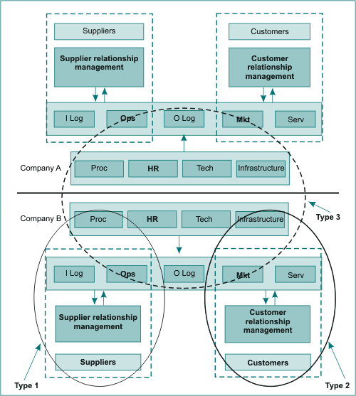
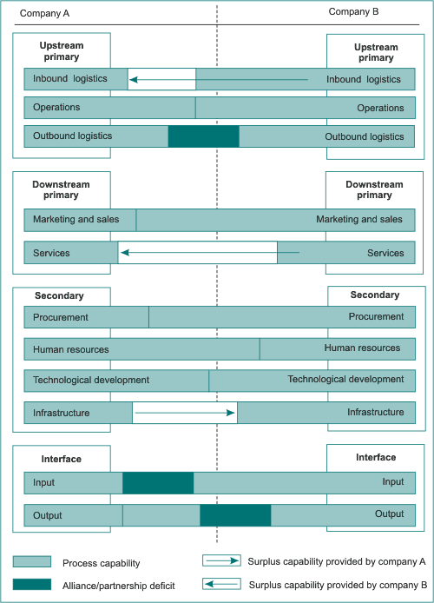
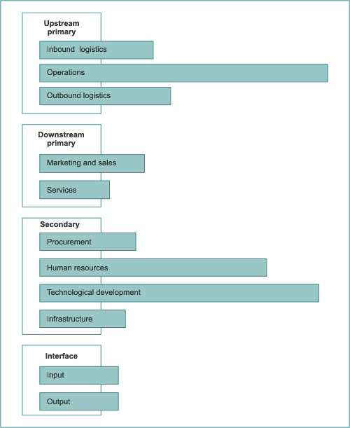

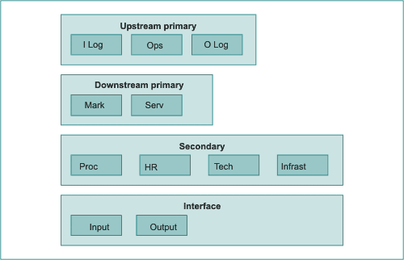

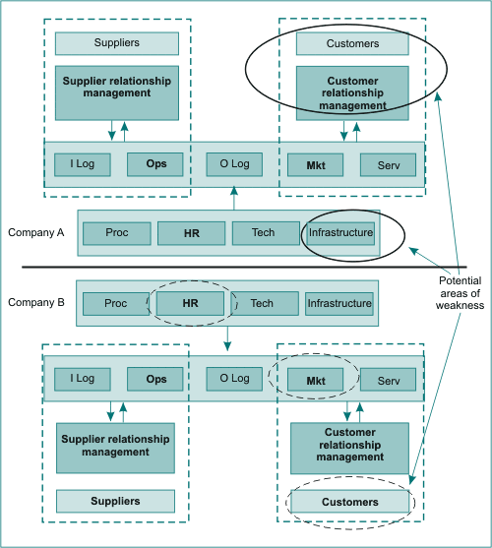

Types of Alliance and Partnership
- Alliances and partnerships can also be categorised in terms of whether or not equity is involved. Two companies may form an alliance where they simply agree to work together for the common benefit, or they may form a more formalised alliance in the form of a joint venture company (JVC).
- The two main types of alliance are:
  - equity joint ventures (EJVs);
  - non-equity alliances (NEAs).
- EJVs are formed where two or more companies come together to form a new company in which each founder company has an equity share holding. In other words, the founding partners both own and control the new company. Each founder company can therefore expect:
  - representation on the board;
  - an equity dividend;
  - voting rights/a role in decision making.
- EJVs can be listed companies. In some cases they can be very large and can carry high value.
- In general terms, EJVs are usually limited liability companies and are separate and distinct entities from their investors. The liabilities of all contributing parties are usually limited to the capital investment made by each party. EJVs are usually regarded in law as being individual entities that can be subject to company law. In addition, EJVs can sue or be sued.
- EJVs usually have some form of registered capital. This capital can be in the form of cash or cash-in-kind (a cash equivalent).
- EJVs generally have a board of directors. The directors themselves are usually appointed by the investors and usually in proportion to the investment made.
- NEAs are agreements involving cooperation, but they do not involve the creation of new companies although, in some cases, equity may be shared or transferred between the partners.
- Alliances that do not involve the creation of equity are sometimes referred to as cooperative agreements (CAs) or cooperative joint ventures (CJVs).
- NEAs may take the form of limited liability companies or (more often) simple contractual arrangements whereby each partner agrees to provide goods or services, or equivalent, for an agreed period of time.
- NEAs that do not involve the formation of limited liability companies are sometimes referred to as unincorporated non-equity alliances (UNEAs). In this case, there is no separate trading company representing the alliance and each party to the alliance retains its own corporate individuality.
- In most legal systems a UNEA does not exist as a separate contractual entity. It cannot form contracts with a third party because it does not exist as a separate trading entity. UNEAs cannot sue or be sued.
- UNEAs do not normally possess registered capital. The partners may contribute capital in the form of cash or cash-in-kind (as in EJVs), but they may also contribute capital in non-monetary terms.

Alliance Networks and Hubs
- Alliances and partnerships within a sector or industry can be considered in the form of a network.
- Individual leading companies tend to form a series of alliances, each of which is linked to other alliances within the sector or industry.
- These leading companies form alliance hubs by the formation of multiple alliances.
- Microsoft is a perfect example of a computer software sector hub.
- Alliance networks and hubs occur in virtually all industries and sectors.
- Networks and hubs may be inhibited by the actions of regulators.
- In relation to the size of the industry or sector, the number of hubs tends to be relatively small.

National and International Regulation
- Regulators exist at a range of different levels. They include:
  - international regulators;
  - national regulators;
  - industry regulators;
  - sector regulators.
- At the highest level there are the international regulators. These are bodies that are responsible for ensuring effective competition between countries and/or between trading blocs.
- Different countries tend to have their own national regulators, which operate within the umbrella of the international regulators but also have direct responsibility for the level of competition within the individual country concerned.
- In the UK, companies that wish to enter into an alliance or partnership where the outcome could affect free competition within a particular sector of industry are required to apply to the director of the Office of Fair Trading for a decision.
- The ways in which the various competition commissions operate vary from country to country and from continent to continent. In all cases, however, the commissions can either block proposed alliances themselves or can recommend to the appropriate government or governments that alliances should be blocked.
- In other cases, the commissions may recommend that alliances are blocked until certain provisions are met.

