Alliances and Partnerships

Module 6

Learning Summary
This module has considered some of the primary issues related to alliance formation.
The module began by considering some important questions and misconceptions in relation to alliance formation. These questions and misconceptions established a basic framework for the text that followed.
The module went on to consider some common barriers to alliance formation. It stressed that an alliance or partnership, just like a merger or acquisition, is a type of project that is subject to some form of performance controls. As with any project, there are a range of obstacles to achieving the stated success criteria. The module made it clear that one of the primary obstacles is the emergence of alternatives. Companies often switch from pursuing an alliance or partnership to pursuing a merger or acquisition or buy-in or internal development of the same capability.
The module went on to consider the most common stages in the process of alliance formation. There is no single way of forming an alliance, and the module addressed only one possible sequence of processes. The module stressed that some alliance and partnership formation processes are considerably more complex than others.
The module then considered in more detail the organisational design considerations involved in alliance or partnership formation. It stressed that organisational design is often a sticking point in negotiations, and it is important that each partner is equally or proportionately represented while common interests are protected.
The final section of the module considered alliance contracts. It presented some of the common headings that are often found in alliance contracts that form the basis of the formation of a joint venture company.
The candidate should now understand:
- some of the primary obstructions to alliance formation;
- the importance of prospective partner size;
- the importance of emergent outcome alternatives;
- the importance of both national and sector regulation as an obstruction;
- the primary processes involved in alliance formation;
- the basic sequence of processes involved in alliance formation;
- the importance of maintaining strategic focus;
- the importance of maintaining strategic alignment;
- the importance of mutually acceptable joint venture company organisational design;
- the alternative basic organisational designs available;
- the importance of alliance contracts;
- the basic alliance contract section headings.
The following section briefly summarises the primary learning outcomes from each section included in this module.

Some Common Questions about Alliance Formation
- Most alliances are originally conceived as a natural product of strategic planning.
- Most large companies develop detailed strategic plans that establish where the company needs to go over the next few years in order to achieve its long-term objectives. When considered in detail it may become apparent that one or more strategic objectives cannot be effectively achieved by the company alone.
- In many cases, the choice of potential partners is restricted and may be obvious.
- The main risks involved in alliances and partnerships occur in the operational phase. There are, however, often risks involved in the formation process. One of the principal formation risks is that of abortive input.
- The formation of a major alliance may have a considerable input demand, and the prospective partners may have to invest a considerable amount of time and money in the formation process. The risk of abortive cost write-off may be significant.
- An alliance can still be a net success even if it does not achieve the overall strategic objectives for which it was created. An alliance could even be a failure in respect of all its strategic objectives yet it might still contribute to the overall competitive advantage of one or more partners.
- All the evidence suggests that alliances and partnerships are more frequent now than they have ever been in the past. Along with mergers and acquisitions they provide an attractive course of action under a range of different circumstances.
- Numerous elements can impact on alliance formation. Perhaps the primary barrier is that of achieving partner consensus.
- There are no international standards or codes of practice on the procedure to be adopted in alliance formation. Like mergers and acquisitions, alliances are often entered into by companies that have little or no prior experience of alliance formation.
- Strategic considerations are sometimes the most risky because they aim at targets that are relatively remote in time, and as such, are at risk from time-related risk impacts. The longer the timescale concerned, the more difficult it becomes to foresee all possible risks and make adequate provision for them.
- Holding companies are companies that control other companies. An alliance or partnership may lead to the establishment of a holding company that is jointly controlled by the alliance partners.

Some Common Misconceptions about Alliance Formation
- There are numerous different approaches to forming an alliance or partnership. The degree of integration between two partners can vary from a significant degree of overlap to virtually none.
- As with mergers and acquisitions, the time required to form an alliance can vary considerably.
- There are examples of alliances that have taken years of negotiation and renegotiation before they were completed.
- It may cost a considerable amount of money to form an alliance. Major alliances can involve a considerable amount of complex negotiation, often at the highest levels within the partner companies.
- Alliances and partnerships are increasingly being used by smaller companies as a method of achieving the operational status looked for by larger companies and government bodies in awarding supply or other forms of contract.
- Alliance formation can be a lengthy and complex process, and a significant number of proposed alliances do not take place because the prospective partners have been unable to agree on aspects of the formation.
- The eventual formation of the alliance usually depends on the successful outcomes of partner negotiations.
- Companies often make use of initial subjective rather than objective apprai- sals of prospective partners.
- Prospective partners can usually withdraw right up to conclusion, although it is important to appreciate the consequences of failure withdrawal.
- Companies may have to write off very significant direct and opportunity costs where considerable amounts of time and money have been spent on negotiations and direct partner analysis such as due diligence.

Obstacles to Alliance Formation
- Some of the more common barriers to the formation of alliances and partnerships are:
  - small company size;
  - poor reputation;
  - inadequate commitment;
  - insufficient potential value added;
  - shareholder repudiation.
- Small to medium-sized enterprises (SMEs) often use alliances and partnerships as a means of obtaining credibility when aiming at contracts from larger companies or government departments.
- Partner lack of commitment is often a factor in alliance formation failure.
- The value of the prospective partner should be considered. Some prospective partners may be potentially more valuable than others.
- Sector and/or national regulator block is a common barrier to the formation of large-scale alliances and partnerships.
- Shareholder opinion can act as a powerful barrier to alliance formation.
- In most cases, there are other options available. Alliances and partnerships are only one way in which a company can achieve its strategic objectives. For example, a company that wishes to develop a more advanced research and development capability may consider that it has four primary options:
  - an alliance or partnership;
  - a merger or acquisition;
  - internal development;
  - buy-in.
- The company may decide that an alliance or partnership is the best way forward and may initiate the formation process. As the formation is in process, other factors may emerge that act to generate alternatives that become equally or more attractive.
- There are numerous factors that could do this. Some of the more common ones are:
  - resource availability;
  - time availability;
  - risk;
  - profile;
  - environmental change.
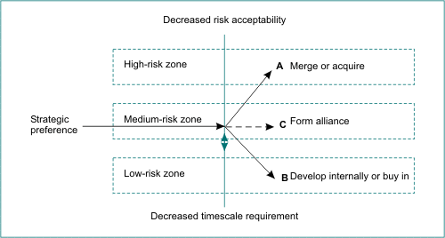

The Process of Alliance Formation
- The main stages in the formation process are usually as listed below.
  - Inception.
  - Establishment of alliance strategic objectives.
  - Establishment of required partner profiles.
  - Prospective partner search.
  - Prospective partner matching.
  - Initial shortlist.
  - Preliminary approaches.
  - Preliminary negotiations.
  - Final partner selection.
  - Final negotiations.
  - Detailed proposals.
  - Conclusion.
  - Formation of joint venture contract.
  - Formation of joint venture limited company.
  - Establishment of organisational structure, corporate governance, risk management system, and other strategic and operational processes.
- At inception, the company makes a firm decision that an alliance or partnership is required. The primary alternatives, such as internal development, buy-in or merger and acquisition, have been ruled out on cost, risk, timescale and/or other grounds.
- The first stage after inception is the formation of the strategic objectives for the alliance. The proposed alliance is a major project, designed to bring about planned strategic change. The overall strategic objectives of the alliance must be determined before any approach to prospective partners is made.
- Having established the strategic objectives of the alliance, the required profile of prospective partners can be developed. The profile describes the primary characteristics of the potential partner.
- Partner searches can make use of a number of different tools, from subjective awareness of the sector to specialist consultant search tools.
- Specialist consultants and more experienced companies often maintain prospective partner characteristics databases. These databases record a range of characteristics data on a wide range of prospective partner types.
- The initial shortlist usually contains a relatively small number of potential partners. The matching process can be refined so that all but, for example, the six best matches are relegated to a reserve list.
- The final shortlist is usually refined down to two or three-best match prospective partners. Preliminary negotiations may then be initiated with the top-ranked prospective partner. In some cases, preliminary negotiations may be conducted with more than one prospective partner.
- Preliminary negotiations tend to cover the most fundamental items to be agreed, such as individual partner investment commitment, timescales for completion and initiation, proposed management and organisational structure, and shareholder issues.
- Where the preliminary negotiations are successful, and both prospective partners appear to be in agreement about the basic and fundamental alliance issues, a final commitment may be made subject to detailed due diligence and final approvals, for example, from shareholders and/or from regulators where appropriate.
- The final negotiations can be protracted and highly complex. In large-scale alliances and partnerships the final negotiations may involve large teams of specialist consultants such as accountants (due diligence) and lawyers (contract negotiations).
- There may also be a requirement for detailed negotiation and consultation with shareholder groups and regulators.
- Detailed proposals are often required where the alliance is looking for investment from outside, or where shareholders are involved.
- The agreement can be concluded when all negotiations and approvals are complete. Conclusion is usually regarded to have taken place when the partners sign all required contracts and the agreement legally comes into force.
- There may be no formal contract between the partners, whereas in larger-scale alliances the level of contractual agreement may be considerable.
- In the case of a joint venture company limited by guarantee, each partner may be required to enter into a contract stipulating such factors as the levels of investment due by each partner, minimum commitment timescales, proposed organisational structure and board membership, and joint and several liability for warranties and guarantees.
- Once the contracts are signed and approved, the joint venture limited company can be formed using standard company formation procedures.
- The final stage is the detailed design of the new joint venture limited company. The various project and functional units within the company are established, and the various organisational, authority and contractual links are established and activated. Other obvious elements include the design and initialisation of an appropriate risk management system.
- The most successful alliances are those that enhance the degree of strategic focus of the partners. The same general pattern appears to hold in large-scale mergers and acquisitions.
- It is important that the original strategic focus objectives are monitored throughout the negotiation stages to ensure that outcome strategic focus is not compromised.
- In most cases, alliances are designed to be aligned to the strategic objectives of the partners. In other words, the alliance should contribute to the achievement of the overall strategic objectives of each company.
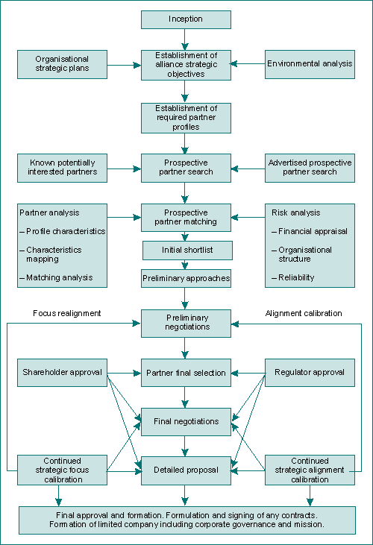

Organisational Structure Issues
- One of the most challenging types of alliance organisational structure is that involved in the formation of a joint venture company or equity joint venture (EJV). In this case the alliance partners form a new company financed usually by a combination of investment capital and share issue. The EJV has to declare its directors, and it is liable for its own actions and operation, as is any other company.
- EJVs, just like all companies, require good senior management leadership.
- Potential investors will be looking for a certain level of credibility in the organisational design of the EJV. The company may depend on external investment and the raising of capital through share issues.
- Prospective investors may look carefully at the organisational design before committing. Investors and analysts may look particularly at the identities of the EJV board members. Individual names and/or combinations of names can be important considerations.
- It is important that all alliance partners feel an equal sense of ownership, or at least a level of ownership that is appropriate to their respective levels of investment and risk.
- It is important to ensure that the organisational design generates this sense of joint ownership at all levels of each partner organisation.
- In designing the organisational structure, it is essential that the arrangement allows sufficient flexibility for subsequent change.
- Some typical alliance organisational structures include:
  - joint representation;
  - the impartial CEO;
  - holding companies and subsidiaries;
  - licensing agreements.
- In a joint representation arrangement each partner has a representation on the joint venture company board.
- In the impartial CEO arrangement the board is staffed by representatives from each partner company, with the impartial CEO acting as board chairperson.
- Holding companies are sometimes formed by alliances to control other subsidiary companies.
- Subsidiary companies are wholly owned and controlled by other companies. These other companies may be holding companies.
- Licensing agreements are sometimes used where one company allows another company to manufacture and sell a branded product under strict quality controls.
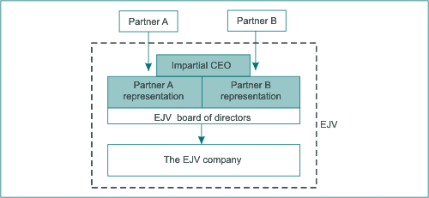

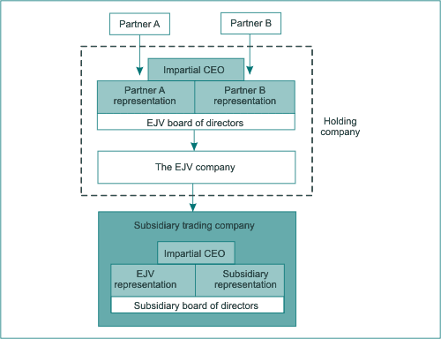

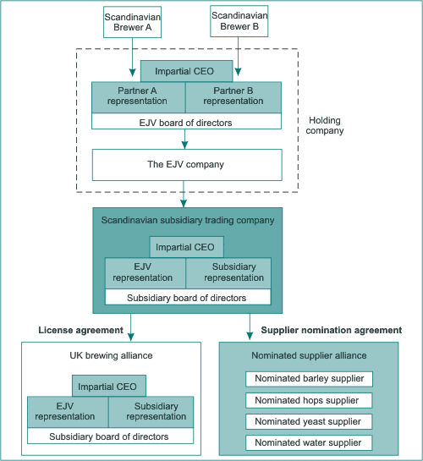

Contractual Issues
- Not all alliances have formal contractual agreements.
- Some alliances include numerous complex contractual agreements.
- Most alliance contracts start with some kind of terms of reference and preambles. These contain contract information that sets the overall agreement in context. Typical entries include:
  - date of the agreement;
  - parties to the contract;
  - legal system applicable to the agreement;
  - geographical location;
  - sector/industry-specific information;
  - conditions necessary for performance of the contract;
  - early withdrawal penalties;
  - time and cost limitations;
  - relevant standards and codes of practice.
- The alliance or partnership is formed by a number of specified companies who have evaluated each other and have decided that the alliance offers sufficient potential gains to outweigh potential risks.
- The decision to form the alliance is based on each organisation’s perceptions of the alliance partners. The contract normally names the partner as signatories so that it is clear who the contract is between. This is important in the event of any dispute and also in relation to the validity of the alliance.
- The contract should always contain specific reference to the aims and objectives of the organisations involved. The aim or aims in this context can be taken as meaning the outcome or outcomes that are desired.
- Alliance contracts usually contain detailed and specific terms and conditions on the rights and obligations of each partner. This section overlaps to some extent with contractual provisions considered elsewhere in this section, such as rights and obligations in relation to:
  - joint venture shares;
  - joint venture profits;
  - share distribution on withdrawal;
  - information to be disclosed;
  - intellectual property rights;
  - trade secrets;
  - early withdrawal penalties;
  - breach penalties.
- Alliances and partnerships may be formed for a specific duration and/or until a certain range of specified aims and objectives are achieved.
- The contract should stipulate any limitations on the actions of all parties to the contract.
- Most contracts contain some provision for the resolution of disputes.
- Litigation is a time-consuming and expensive process as it involves the use of public resources.
- In some cases, arbitration provides a workable alternative. Arbitration is a process conducted by one or more qualified arbitrators. Most EU countries have professional associations of arbitrators who can provide this service.

Table 6.1 Option availability
Option | Resource availability | Time availability | Risk | Prospective partner profile | Degree of environmental change | Long-term stability
Alliances and partnerships | Low | Low | Moderate | Different | Slow | Low
Mergers and acquisitions | Moderate | Moderate | High | Dissimilar | Moderate | Medium
Internal development | High | High | Low | Similar | Fast | High
Buy-in | Low | Low | Low | Irrelevant | Fast | High

