KEY ISSUES IN CB --- CONSUMER’S PERSPECTIVE

When we talk about Consumer Banking, it means that we talk about facilitating the common and ordinary people of the society by providing them an opportunity to acquire the necessities and accessories of life that are needed by them to maintain/sustain an affordable, pleasurable, easy, and comfortable life.

Consumer Banking: Definition
Services provided by commercial banks to individuals (as opposed to business customers) that include Current Accounts, Deposit and Savings Accounts, as well as Credit Cards, Auto Loans, House Loans (Mortgages), Personal Loans and Investments. It is also called “Retail Banking” and may be used interchangeably.

Consumer Banking is the provision of products and services to meet the financial needs of individuals in order to generate products that will boost the bank’s deposit base as well as quality risk asset portfolio.

The Consumer Banking environment today is changing fast. The changing customer demographics demands to create a differentiated application based on: scalable technology, improved service and banking convenience. Higher penetration of technology and increase in global literacy levels has set up the expectations of the customer higher than never before. Increasing use of modern technology has further enhanced reach and accessibility.

The market today gives us a challenge to provide multiple and innovative contemporary services to the customer through a consolidated window as so to ensure that the bank’s customer gets “Uniformity and Consistency” of service delivery across time and at every touch point across all channels. The pace of innovation is accelerating and security threat has become prime for all electronic transactions. High cost structure rendering mass-market servicing is prohibitively expensive.

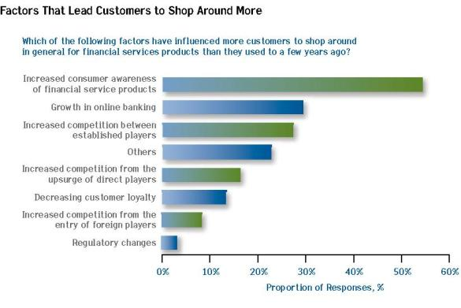

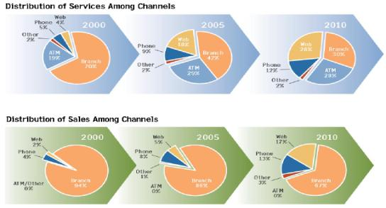

Changing Trends

Present day bankers are now more looking at reduction in their operating costs by adopting scalable and secure technology thereby reducing the response time to their customers so as to improve their client base and economies of scale.

The solution lies to market demands and challenges lies in innovation of new offering with minimum dependence on branches, a multi-channel bank and to eliminate the disadvantage of an inadequate branch network. Generation of leads to cross sell and creating additional revenues with utmost customer satisfaction has become focal point worldwide for the success of a Bank.

Consumer Financing
Consumer financing is a type of service that is designed to provide the individuals with necessary finance for personal purchases ranging from buying a car, shopping purchases, to buying a house. The concept of consumer financing is based on the need for an institutional arrangement that provides consumers with financing support to enhance their consumption and, as a result, improve their standards of living.

Advantages of Consumer Banking
Consumer banking has inherent advantages outweighing certain disadvantages. Advantages are analyzed from the resource angle and asset angle.

The Resource/Liability Side:
- Retail deposits are stable and constitute core deposits
- They are generally insensitive to profit/return with less bargaining for higher rate
- They constitute low cost funds for the banks
- Effective customer relationship management with the retail customers build a strong customer base
- Retail banking increases the subsidiary business of the banks

The Assets Side:
- Retail banking results in better yield and improved bottom line for a bank
Retail segment is a good avenue for funds deployment
- Consumer loans are presumed to be of lower risk and NPA perception

- Helps economic revival of the nation through increased production activity
- Improves lifestyle and fulfils aspirations of the people through affordable credit
- Innovative product development
- Retail banking involves minimum marketing efforts in a demand driven economy
- Diversified portfolio due to huge customer base enables bank to reduce their dependence on few or single borrower

- Banks can earn good profits by providing non-fund based or fee based services without deploying their funds

Disadvantages of Consumer Banking
- Designing own and new financial products is very costly and time consuming for the bank
- Customers now-a-days prefer net banking to branch banking. The banks that are slow in introducing technology-based products, are finding it difficult to retain the customers who wish to opt for net banking
- Customers are attracted towards other financial products like mutual funds and NSS
- Though banks are investing heavily in technology, they are not able to exploit the same to the full extent

- A major disadvantage is monitoring and follow up of huge volume of loan accounts inducing banks to spend heavily in human resource department

- Long term loans like housing loan due to its long repayment term in the absence of proper follow-up, can become NPAs
- The volume of amount borrowed by a single customer is very low as compared to wholesale banking. This does not allow banks to exploit the advantage of earning huge profits from single customer as in case of wholesale banking

Challenges to Retail Banking in Pakistan
- The issue of money laundering is very important in retail banking. This compels all the banks to scrutinize diligently all the documents which they accept while entering into a relationship
- Outsourcing has become significant in recent past because various core activities such as hardware and software maintenance, entire ATM set up and operation (including cash, refilling) etc., are being handled by outside vendors
- Banks are expected to take utmost care to retain the ongoing trust of the public
- Customer service should be at the end all in retail banking. Someone has rightly said, “It takes

months to find a good customer but only seconds to lose one.” Thus, strategy of Knowing Your Customer (KYC) is important

- The dependency on technology has brought IT departments’ additional responsibilities and challenges in managing, maintaining and optimizing the performance of retail banking networks

- It is equally important that banks should maintain security to the advance level to keep the faith of the customer

- The efficiency of operations would provide the competitive edge for the success in retail banking in coming years

- The customer retention is of paramount important for the profitability of retail banking business & increase in the market share

- One of the crucial impediments for the growth of this sector is the shortage of manpower talent of this specific nature, a modern banking professional, for a modern banking sector

Operational Excellence in Banking
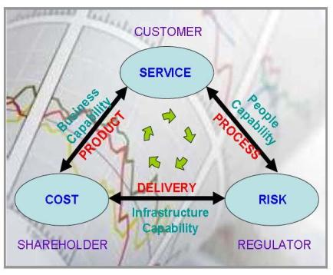

Customer Service
Customer service is perhaps the most important dimension of retail banking. While most banks offer the same range of service with similar technology/expertise, the level of customer service matters the most in bringing in more business. Perhaps more than the efficiency of service, the approach and attitude towards customers will make the difference.

Front line staffs have to be educated in this regard. A scheme of entrusting a group of important customers to the care of each employee/officer with a person to person knowledge and intimacy can be implemented all sundry advices/notices such as Dr. /Cr. advices. TDR maturity advices, etc. whether signed by employees or officers should be identifiable by the name of those signing, and inviting customers to contact them for further assistance in the matter.

A customer centered organization has to be built up, whose ultimate goal is to "own" a customer. Focused merchandizing through effective market segmentation is the need of the hour. A first step can be the organization of the various retail branches to enter for different market segments like up-market individuals, traders, common customers, etc. For the SIB (Small Industry and Business) sector banks, the focus should be on identifying efficient units and allocations of loans to these units. These banks should try Merchant Banking services on a small scale. With agricultural output growing at a fast rate and mechanization setting in, banks should try to cater to the credit needs of the people involved in this profession. A wide network is absolutely imperative for this sector.

Separate branches/divisions should be opened for traders and similar government businesses. Special facilities for cash tendered in bulk and immediate issue of drafts, by extending facilities like "guarantee bond" system, will go a long way in mitigating problems faced by traders who are the major customers for drafts issue. Provision for cash counting machines in these branches will reduce the monotony of cashiers and unnecessary delays, thus resulting in better productivity and ultimately in improved customer service.
The personal segment is however the most important one. With the urban segment moving away because of disintermediation and competition from foreign banks, retail banks should focus on the rural/semi-urban areas that hold the maximum potential. In the urban areas, private banking to affluent customers can be introduced, through which advisory and execution services could be provided for a fee. Foreign currency denominated accounts can also be introduced for them.

Technology
In the current scenario, the importance of technology cannot be understated for retail banks which entail large volumes, large queues and paperwork. But most of the banks are burdened with a large staff strength which cannot be done away with. Besides, in the rural and semi-urban areas, customers will not be at home in an automated, impersonal environment.

The objective would be to ensure faster and easier customer service and more usable information, instantly, economically and easily to all those who need it -customers as well as employees. Proper management information systems can also be implemented to aid in superior decision making.

Communication technology is especially needed for money transfer between the same city and also between cities. There are inordinate delays in our country because of geographical and other factors. Modern technology can make it possible to clear any check anywhere in Pakistan within three days. Installation of FAX facilities at all the big branches will facilitate speedy transfer of payment advices. Computerization will be of great help in improving back-office operations. At present, 60% of rural branches have PCs. These can be used for quick retrieval and report generation. This will also drastically reduce the time, bank staffs spend in filling and filing returns. Housekeeping operations can also be speeded up.

Price Bundling
Price bundling is a selling arrangement where several different products are explicitly marketed together to a price that is dependent on the offer. As banks are multi-product firms this strategy is more applicable to retail banking. Price bundling offers several economic and strategic benefits to a bank. It offers economies of, utilization of the existing capacities and reaching wider population of customers. Bank can get the benefits of information and transacting. In the process of extending variety of services, banks are acquiring enormous amount of customer information. If this information is systematically stored, banks can efficiently utilize this information in order to explore new segments and to cross-sell new services to these segments. Cross-selling opportunities and larger customer base can also be the motive for merger against usually stated advantage of cost savings. Price bundling can be used in order to lengthen the relationship with a customer. It will reduce the need of resources to be put on acquiring new customers and saves time of the bank. Among the strategic benefits, price bundling may cause less aggressive competition; it differentiates its products compared to rivals in the same market where the products are sold individually or in other kinds of bundles.

Retail banking offers many services and it gives an opportunity to the bank to combine different services in different kinds of bundles. In many cases demand for one service affects the demand for another service, for example current or savings account and payment services are highly related, and here price bundling is a better alternative than individual selling. Banks have to analyze the customer segment and bundle products before applying the pricing strategies.

The first step in price bundling decision is to select the customer segment. The bundle is targeted to choose a strategic objective. If there are two products (A and B) that are considered to be bundled together, the comprehensive strategic objectives for the different customer segments are:
- Cross-selling to customers that only buy one of the products

- Retaining customers that already buy both of the products
- Acquiring new customers when they buy neither product for the time being

Innovation
The scope for innovation in financial services is unlimited. Although banks have introduced a variety of deposit and loan products, the basic features of all these products are almost one and the same. Among the delivery channels, ATMs have emerged as ubiquitous money centers. Almost all banks have established their ATMs. For most of the banks the overhead costs on these ATMs are far higher than the revenue generated by them. ATM operation costs are largely fixed in nature - the cost of the machine, its maintenance, replenishment of currency, and the satellite (network) connection. There should be a minimum number of transactions to cover these costs. Banks have to innovate wide range of services in addition to cash withdrawals. ATMs should allow customers to buy postal and revenue stamps, payment of bills, event tickets, sports tickets, etc. Banks can offer ATM screens for slide show advertising also. However, the advantage of the ATM has always been speed and convenience, probably on introduction of these new services customer has to spend more time at a point. ATMs can guide the customer also. For example, if a customer's account balance has reached to bare minimum the ATM can give a helpful suggestion that "we notice your balance is low, can we help with a loan?" ATMs can be either within the premises of a branch or at a remote place. On premises ATMs are highly immune to competition, but branches can reduce the staff, on installation of ATM. The scope for wider services through off-premises ATMs is very high; it provides great opportunity for fee revenue. The cost of maintenance of off-premises ATMs is higher in terms of replenishment, cash couriers, armed security etc. In the US, approximately 23 percent of ATMs are offering sale of postage stamps. It is the right time for banks to question themselves whether ATM is a service channel, sales channel, or branding opportunity.

The future of retail banking lies more in mobile banking. Mobile telephone market is penetrating, and mobile phones are ideal to utilize Internet banking services without customer accesses to PC.

Smart card revolution will further change the face of retail banking. Smart cards can store information; carry out local processing on the data stored and can perform complex calculations.

