Module 2: Theories of Retail Change

Introduction
- A number of explanations have been made about how retail organizations grow, develop, expand and succeed. Theories of retail change make sense of what has happened to retail organisations in the past and, more importantly, help retailers to foresee future scenarios for their business, and those of their competitors
- Major theories: 1- cyclical theories. 2-environmental theories. 3- conflict theory. 4- combined theory;
1- Cyclical theories
- Cyclical theories are those which trace common patterns in retail development over time and include the earliest theories of retail change. ( 3 theories)
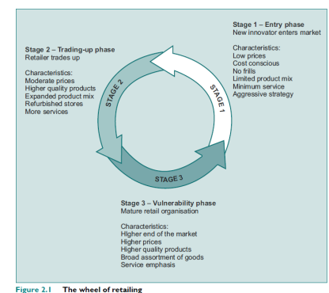
- The Wheel of Retailing:
- In stage 1, opportunistic management style can lead to success, whether the organization is completely new to the market, or a new format brought on-stream by an existing organization.
- As the organization/format grows, management strength is needed in terms of leadership and organization of the growing number of staff and units. IKEA, for example, have found it difficult to resist widening their merchandise range or adding services such as delivery.
- Moving to stages 2 & 3 require to utilize the economies of scale throughout expansion strategy which is somehow confronted by governmental policies and restrictions. Merger and acquisition is one of the option strategies for retailers that help them achieve an expansion strategy.
- Adding more quality and services throughout the time is very important for retailers’ success. For example, Wal-Mart at the time it was competing with Target has designed its stores to be have wider aisles, less crowed items, an more stylish format of market
- Without doubt, many retail organizations have developed in line with the wheel theory,
- for example department stores and variety stores such as BhS and Marks & Spencer, which have been challenged by former grocery retailers’ expansion into fashion
- Criticism of the theory:
- Is that it cannot be universally applied and is therefore not valid. Not all retail organizations enter the market at stage 1
- The theory does not appear to apply to internationalization of retail formats
- Time is linear rather than cyclical and therefore past patterns cannot be applied to future development

- Retail Life Cycle
- This second cyclical theory of retailing, in common with demographic and product life cycle theories, assumes that all retail organisations have a finite lifespan, during which they go through four phases of development: innovation; growth; maturity; decline
- The time dwelt within each phase will vary widely, as will the total lifespan of the organisation or format
PHASE I: INNOVATION
- A new retail format will spend a short time.
- Non-successful innovators will not enter the next phase, while successful innovators can take advantage of a lack of direct competitors to grow sales rapidly and develop retail unit numbers, entering the growth phase
- Profits during this phase are low or non-existent due to investment in creation, infrastructure, expansion and promotion of the format.
PHASE II: GROWTH
- The number of units is expanded rapidly, often with strong centralized planning and control.
- Both sales and profitability growth should follow.
- Investment levels will remain high
PHASE III: MATURITY
- Will last indefinitely as long as the retailer is customer and competition orientated
- Sales growth slows together with the level of profitability
PHASE V: DECLINE
- Sales growth becomes negative and profitability is very low
- The declining format will have fewer direct competitors and more indirect competitors in the growth and maturity phases of the life cycle
- Organisations with declining formats require investment in format innovation or acquisition/merger; e.g., Marks and Spencer moved into decline in the 1990s they entered a partnership with UK retail entrepreneur George Davies to develop the Per Una branded ‘store within a store’.
- Criticism of the theory: The difficulty in specifying time in each phase

- Retail Accordion
- The third cyclical theory is the retail accordion, which relates retail development over time to merchandise range. This theory noted that there was a tendency for retail organizations to move towards specialization and diversification over time.
- It is debatable whether this theory can be applied to future development of the retail industry.
- The earliest stores were general stores delivering a wide merchandise range, with narrow depth
- The next expansion brought the development of department stores offering a wide merchandise range and depth of category
- The latest stage brought more concentration of merchandise range in niche retailers such as Toys ‘R’ Us
- In order to minimize the cost of faulty developments, retailers should be careful regarding:
- The extent to which new, unrelated merchandise lines are added;
- The relationship between new merchandise lines and the core offering in terms of
- The benefits they offer customers, and the synergy offered in terms of service requirements;
- Supporting merchandise diversification and specialization strategies with market research focusing on the requirements of their core customers and potential customers
- The effects which diversification or specialization strategies will have on corporate image
- Criticism of the theory: This theory is more applicable to trends in merchandise assortments than to development of store formats
2- Environmental Theories
- Environmental theories are concerned with the interplay between the external environment and organizational environment.
- The various influences of the external environment –political, legal, socio-cultural and demographic, economic and technological – on retailers change over time.
- Conditions can change slowly or rapidly, and only those organisations which can adapt to change and take advantage of the opportunities offered by the environment will grow, develop and thrive.
- There are two dominant environmental theories of retail change: 1. Evolution theory. 2. Institutional theory
- Evolution Theory
- Organisations which successfully adapt to changes in the external environment are those most likely to thrive.
- External factors are PESTEL factors which are political, economic, soci-culture, techonological, environment and legal.
- Therefore, structure of retailing at any point in time is the result of all previous retail management decisions, together with the external environment factors (PESTEL).
- Criticism on the evolution theory base on the fact that it doesn't take into the consideration of retailing decision on the external environment factors. Examples for this include the following:
- Planning gain: in order to secure a site a retailer may develop roads or leisure facilities which will bring with them housing development, which will have effects on the economy.
- Lobbying: most of the largest retail groups have close political connections, which can have effects on locational policy.
- 24-hour opening: part-time flexible working, and has had a role in raising the proportion of women in the UK workforce to over 50 per cent
- Online retailing: contributed to the uptake of computers in the home, improving the technological skills of the workforce plus enhancing the business for thosed companies like DHL, FedEx, etc.
- There is a distinction between the development of firms and formats, the former evolving relatively slowly with the environment, the latter adapting more dynamically to meet the needs of local environments.
- Therefore, a retail organisation can run a variety of successful formats which may or may not carry the memes of the parent organisation.
- When change is slow and predictable, firms and formats have a better chance of survival; conversely, when change is rapid and unpredictable, greater opportunism exists and the number and variety of formats and firms will change
- Within any design space there are two types of strategies:
- R-strategies:
- Occur when the environment is rapidly changing & discontinuous
- Throwing up opportunities that are developed by opportunist organizations (prospector)
- Resulting new formats
- K-strategies:
- Occur when the environment is stable
- Larger, dominant organisations converge on the successful formats, applying them with the efficiencies of scale.
A range of strategies have been used by successful firms to ensure survival:
- Experimentation. This is widely used by successful retailers, who will test out unrelated merchandise or new systems in one or a few stores before rolling out successful innovations. (Pilottign )
- Joint retailing. Two normally separate organisations combine to create a synergistic offer to their customers. Examples include McDonalds restaurants in Wal-Mart and ASDA stores offering cheap food to people shopping for cheap merchandise.
- Physical premises mutation. The retailer changes its usual location or combines innovative activities under one roof store.
- Copycatting: Exploiting innovative systems or formats that have been developed by other organisations.
- Vertical integration. Retailers take over other distribution channel functions such as manufacturing or wholesaling in order to gain organisational power over supply of goods. This also operates in the opposite direction, with manufacturers entering the retail market to gain higher margins.
- Horizontal integration. Retailers acquire control of other retail organisations in order to boost market share, gain market innovation or management/operational expertise.
- Micro-merchandising. Retailers involved in micro-merchandising make use of market segmentation techniques to focus on meeting the needs of a demographic or lifestyle group through creation of a suitable retail format.
- Institutional Theory
- Institutional theory recognises that the organisation is an organic part of its environment and that there is a degree of interdependency between them.
- According to this theory, the decisions and actions of a retail organisation reflect the economic and cultural norms of the environment in which it exists. These norms exist at task and institutional levels.
  - At task level, the organisation responds to its environment through actions aimed at retail performance – from a customer perspective, these are linked to retail performance related decisions on, for example, merchandise assortment, pricing strategy, inventory and location.
  - At institutional level, the retailer’s actions are constrained or framed according to cultural and moral norms which will influence both the internal culture of the organisation and its perceived role in the society in which it exists. For example, customers may expect it to employ and promote local talent, be active in the community, and sell local products along with those which are sourced nationally or internationally.
- When a retailer’s actions reflect the norms of its environment (termed isomorphism), this legitimises the organisation (and its institutional and performance actions) in the minds of the various institutional stakeholders
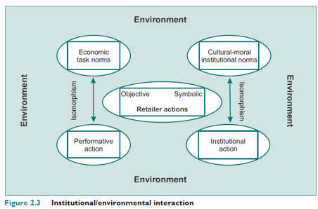
3- Conflict Theory
- Conflict theory addresses what happens when a new innovation or format challenges the status quo in a retail sector. As retail organisations adapt to each other in the competitive marketplace, new and different forms of retailing develop. This continual shift in operating forms is derived from a dialectic process which consists of action–reaction– synthesis.
- As an innovator successfully enters the market through some competitive advantage (action), existing organisations will take actions designed to minimise that competitive advantage (reaction), which eventually lead to a modification of their operating methods. Meanwhile, the innovating organisation will also adapt as it becomes established in the market (trading up according to wheel theory). The continual adaptation will bring the two differing types of trading closer and closer together until they are virtually indistinguishable (synthesis)
- According to conflict theory there are four stages of response to a retail innovation:
1. shock; 2. defensive retreat; 3. acknowledgement; 4. adaptation.

4- Combined Theory

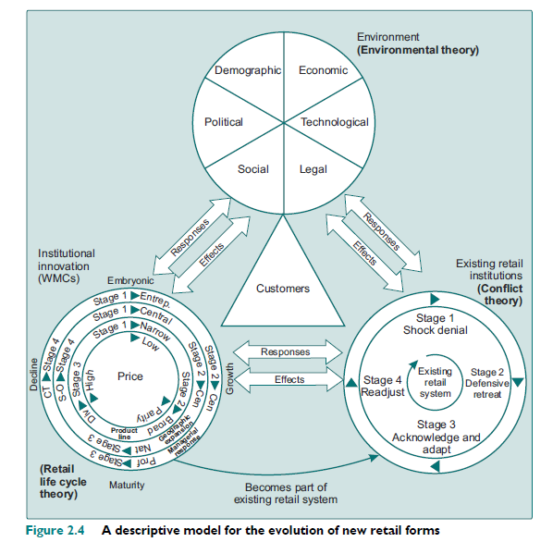

- Environment theory – environmental conditions enable the creation and development of the innovation. Political and economic conditions created negative growth in income for the majority of Americans during the 1980s, which, together with a car-based social environment, created conditions favourable for the growth of value retail formats such as factory outlet centres and WMCs. Internet use soared in the late 1990s, creating a technological and social environment which was successfully exploited by some retailers as a viable format and by many retailers to streamline their logistical efforts in a bid to drive down costs and increase competitiveness.
- Cyclical theory – there are four main indicators retailers can use in establishing the life cycle stage of their organisation (or format). These are:
- Price: In the figure, these are portrayed as rings because each has its own separate stages, which may ‘revolve’ at varying rates according to external environmental forces.
- product range: The second innermost ring is that of product range – as retail formats mature the trend is from narrow to broad and then to diversified product ranges.
- geographical expansion; Retailers tend to expand outwards from their base location as they grow and mature, firstly
- management style: entrepreneurial in the innovation phase, centralised during growth, professional during maturity, and caretaker during decline.
- A maturing retailer will become part of the established retail system as existing retail institutions acknowledge and adapt to accommodate them (conflict theory).

