Module 5: Retail Buying in the Twenty-first Century

1- The Role of the Retail Buyer
- Their categorization recognized three primary functions
- Change agent, where the buyer influences and alters consumer purchase behavior by offering new products and services.
- Gatekeeper, where the buyer assumes responsibility for the flow of product from suppliers to the end consumer. Those buyers who purchase manufacturer brands and product and who take no role in the process of developing and branding
- Opinion-leader, where the buyer influences consumer opinion but does not necessarily prompt a purchase from their company. As such, consumers may only use the retailer as a source for ideas and information
2- The Principal Buying Activities
- Analysis of market opportunity:
  - Buyers should identify profitable market opportunity for the business
  - evaluation of competitor performance
  - Identify continuing and new market opportunities for the retailer and from this develop a merchandise plan.
- Creation of the merchandise plan:
  - The merchandise plan details the nature and characteristics of the product range in terms of its breadth (the range of different product categories) and depth (the choice of products within a specific category).
  - The merchandise plan must also include a forecast of future sales and profit margin within each product category.
  - Determining retail price levels within the company.
  - A sales and profit budget by week, month, quarter and year will also be included.
- Selecting the supply base:
  - Do the suppliers’ selection criteria that will typically extend beyond merely price or supply considerations, to include issues pertinent to the supplier’s record on employees’ rights and the use of child labor.
  - Agreeing terms of trade with the supplier is negotiated on the retailer’s behalf by the buying and merchandising team.
- Product development and supplier performance management:
This shift in power in favor of the retailer has meant that suppliers must adhere to strict performance criteria, particularly in relation to product quality standards, and availability levels
- Presentation of merchandise at point of sale:
The involvement of the buying team in this area may include their directing the nature and form of product packaging, and determining the mechanisms by which products will be displayed to consumers, as well as proposing the amount of space that is allocated to product categories in order that target sales volumes can be achieved.
- The buying function, particularly within larger retail organizations, includes the following:
- Buyers are specifically responsible for:
- Qualitative side of buying (requirements of the market)
- Determining which products would best satisfy customer needs
- Identifying and selecting appropriate sources of supply.
- Merchandisers are typically responsible for:
- Quantitative side of product management
- Financial responsibility for the buying function
  - Determine the buying budget
  - Monitor margin performance
  - Along with the buyer, the merchandiser will set the retail price of a product
  - Forecasting responsibilities
- Responsible for the movement of stock in the business
  - organise when goods will be delivered into the company
  - planning deliveries into stores.
- Quality controllers are vested with the responsibility of
- Monitoring product quality (visiting suppliers and checking that the product specifications)
- Monitor customer product complaints and will provide technical advice to customer service departments, who, in turn, will respond to customer comments.
- Visual merchandisers assume the responsibility for :
- Physical presentation of in-store product ranges.
- Their presentation plans are often based upon guidelines set by the buyers.
- These guidelines express the buyer’s thinking in terms of the themes and concepts that underpinned the design and creation of the product ranges.
- Space planners are responsible for:
- Allocation of space in stores to specific product ranges directed both by the buyer’s sales plans and by the sales histories
- Allocation of space to particular ranges may be based upon agreements made by the buyers with manufacturers who agree to pay the retailer a retainer for access to key locations within the store.
3- Measuring the Performance of the Buying Function
- Financial and resource performance measures. The finance and resource utilization dimensions used to measure buying function performance include:
  - Gross Margin performance as measured by levels achieved against budget and the previous year’s margin levels.
  - Optimization of sales level as measured by levels achieved against budget and previous year’s sales levels.
  - Level of market share achieved as measured by levels achieved against target level and previous year’s market share level.
  - Minimal level of mark-downs as measured by levels achieved against targets and last year’s mark-down levels
- Customer satisfaction measures.
  - Minimal level of out-of-stock ranges as measured by levels achieved against target. (availability)
  - Minimal level of customer complaints and returns as measured by levels achieved against target.
  - Consistent quality of goods as measured by levels of customer returns and complaints, as well as rejections and the results of company quality control checks
- Innovation and market development measures.
  - Development of distinct competitive advantage in terms of product ranges, price levels and quality as measured against the competition.
  - Level of success achieved in relation to new product development introductions as measured by previous year’s performance, the terms of the development strategy and the competition
  - Speed of reaction to changes in demand at the macro and micro level as measured by minimal levels of sell-outs and the profitable optimization of sales.
  - Level of development with respect to the creation of new market segments as measured against previous year’s performance levels and planned development levels.
4-The Defining Issues in Retail Buying (3 Issues)
    - Dimensions that they perceived to be important and challenging to the buyers’ roles, both now and in the medium-term future are as the following
- Trend Management Strategies
    - Trend management is important for the following reasons:
  - Innovation within many product categories
  - Customers’ positive dealing with new products
  - Desire to offer the most up-to the-minute product by retailers is often motivated by the desire to achieve market differentiation
Customer Trends
- Macro-market consumer Trends (demographic, economic, technological and social dimensions)
  - Analysis of market-level consumer trends
  - Life Style Profile: lifestyle portrait presents a summation of relevant qualitative and quantitative data with the intention of identifying how these trends may explain the attitudes and behavior of their target customer segments. Starting
It helps buyers predict which products currently, and in the future, will best match the customer’s lifestyle requirements.
- Micro-level consumer trends (consumption patterns of their target customers with respect to specific product categories + supported by the merchandize function’s data analysis of historical sales data for specific product rage and brands)
Buyers will examine a number of other factors in order to generate an intimate profile of their customers’ purchasing habits, and these will include consideration of:
    - average transaction value;
    - average selling price for specific products;
    - best-selling products;
    - worst-selling products;
    - linked sales (i.e. those products that are purchased at the same time);
    - time and place of purchase.
Competitor Trends: A competitor review report will contain:
- Product Ranges analysis is the review of the breadth and depth of the competition’s product offer including the private label range of the retail company itself
- Pricing Strategy entry level prices – price lining – extent to which the competitors'’ prices have changed during a certain period of time …. Monitoring the pricing strategy of the competitors and coping with it
The products that are usually monitored are those that are in high demand.
- Promotional Strategy: an analysis will review the ranges of products included in the promotion, as well as the conditions of the promotion itself.
- Visual Merchandising Methods: consideration is given to the way in which competitors present merchandise in terms of store layout, and the way in which they group products and arrange product adjacency to get new ideas.
By identifying which products are presented in the areas of highest visibility within a store, the buyer may also deduce that these are likely to be in high demand and may yield the highest levels of profitability.
- Store Windows: which products are more important for the compititor
- Customer Profile Review: who is shopping at the competitor at any givin time
Product Trends
- Forecasted/Pipeline Developments
- Recent Product Launches
- Upgrading/Extension of Current Product Ranges: An analysis of the various product range extensions undertaken by suppliers and retailers is important for the retail buyer for two particular reasons.
- It may provide direction for the buyer to extend their product ranges similarly.
- It may instead encourage them not to extend their ranges in a similar way so that they can maintain a distinctive positioning either by retaining a precise product focus or by developing their ranges in another direction.
- New Supplier Selection Strategies
    - Looking specifically to the strategies that buyers adopt for new supplier selection, it is possible to identify four stages to the process. Each of these is listed below and will be considered in turn.
- Identification of supplier selection criteria :five key areas for consideration
- Product
- Range of products available in the supplier’s portfolio
- Quality of goods and services.
- Value for money of the range
- Product development potential of the supplier.
- Exclusivity potential
- Terms of trade
- Cost price levels.
- Payment cycle requirements – 30, 60 or 180 days.
- Range and conditions of discounts.
- Guarantees and other bonds
- Level of investment required by the retailer in terms of their providing either financial or technical support to the supplier.
- Reputation of the supplier
- Customer portfolio
- Reputation for ethical and safety standards
- Reputation of the senior management and personnel
- Financial standing of the supplier
- Technical capability and reputation for quality management.
- Systems support
- Communication systems for buyer–supplier relationship management.
- Stock management systems.
- Customer service systems
- Administrative support for stock and financial processing.
- Marketing support
- Reputation of the supplier’s brand
- In-store merchandising support available from the supplier.
- Promotional activities proposed by the supplier in order to support product in the market.
- Advertising support proposed by the supplier
- Supplier identification procedures.
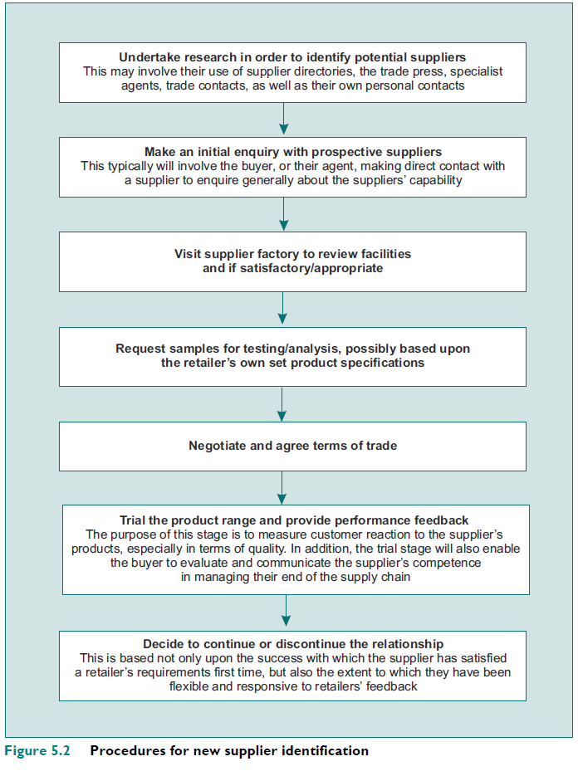
- Supplier evaluation processes.
- Factory audits
- It is common for buyers, merchandisers and quality control specialists to visit the factories that supply these goods. These visits may, in some circumstances, be undertaken without prior warning.
- Buying team will develop a standard document that records their findings
- Delivery performance
- with respect to the timeliness, quality and accuracy of their delivery of goods.
- It is the merchandising team who are normally responsible for monitoring and assessing supplier delivery performance.
- Complaint monitoring
- Tracking the level of complaints that may arise, such as in relation to product quality, is an important mechanism for measuring customer satisfaction and dissatisfaction with respect to a given supplier’s products
    - Having identified the mechanisms for evaluating suppliers for their performance, it is also important to consider the options that are available to a buyer should the performance of the supplier fail to meet expectations.
- Precisely define the area of under-performance.
- Measure the frequency of the under-performance and the impact that this has upon customer satisfaction.
    - Before considering the various responses take into account
      - the importance of the supplier to the company
      - whether the supplier is a major or the only source in the market
      - Whether substitute products or alternative suppliers are readily available in the market.
    - The course of action that a buyer will be able to take with respect to a supplier’s poor performance
      - a buyer must first inform the supplier of a problem and expect an explanation
      - Formal or informal warning to the supplier may be issued
      - The goods may be returned to the supplier.
      - Buying team may raise cash penalties or cancel the order
- Negotiation of trading arrangements:
    - The ability to control supplier negotiations in order to protect and enhance the position of the buyer’s company, irrespective of their position in the market and the stature of the supply base, is a critical buyer attribute.
    - Recent practice underlines an increased commitment to collaborative forms of buyer–supplier relationships ( long-term relationships)
    - From a buyer’s perspective, the starting point for successful negotiation necessitates that they have a competent understanding of the market, the product(s) and the issues associated with their delivery. The buyer must
    - With this information, the buyer must then identify their requirements with regards to: the unit cost price of a product; their order quantity requirements; product lead times; delivery schedule requirements; exclusivity agreements; and marketing support requirements.
    - Therefore, it is necessary for the buyer to identify, prior to a negotiation, what they might ideally obtain, what they would like to obtain and must obtain from a negotiation. The LIM acronym (Like, Ideal and Must)
- Procedures for Managing the Development of Own-Brand Products (5 Phases)
Phase 1: Situation Review and Opportunity Identification
    - Their initial analysis of the external environment will consider the various consumer, competitor and product trends
    - Review the product situation in the company (competitive position, stage on the product life cycle, and the rate of growth and decline)
    - Review the capability of the existing supply base.
    - Finally, reflect, where possible, upon previous successful product developments.
Phase 2: Concept Development and Refinement
    - The inspiration for a new product concept may come from a variety of sources:
  - Buyer may use, visits to trade shows, exhibitions and fairs often provide the primary inspiration for a new product idea.
  - Replication of the competition’s products with just sufficient modification in order not to fall foul of copyright infringement
  - For fashion buyers, new product inspiration may come from visits to foreign retailers.
  - Idea source for new products comes from customers themselves
Phase 3: Product Implementation
    - The process of implementing the production, marketing, testing and distribution of a new product is complex and resource intensive.
    - The buyer may choose to brief more than one supplier in order that they may then compare supplier performance in terms of quality, innovation and cost.
    - A confidentiality agreement will have to be signed by the suppliers. This will seek to prevent suppliers from providing information to the competition, often for a fixed period, normally of up to five years.
    - Alongside the development of the actual product, it is also necessary for the buying team to manage the packaging requirements of each new product.
    - Once the final specification of the product has been agreed, the buying team will then seek an agreement on the cost price with their suppliers.
    - In terms of agreeing the price, this will be dependent upon the raw material costs, development costs handling and supply chain costs, and the supplier’s mark-up policy...etc
    - Prior to the full launch of a new product, buyers may insist on a small pre-production trial
      - To ensure that any problems with respect to the supply process or the product itself can be identified and rectified.
      - Assist in the identification of future demand.
      - Evaluate the rate and nature of customer interest in a product range.
Phase 4: Evaluation of the New Development
    - The most commonly used methods include measuring changes in sales and profit, and monitoring the rate of product sell-thorough, as well as identifying changes in average customer transactions value, the number of transactions and the demand for substitute product
    - If positive evaluation: an increase in production plans, delivery phasing and the required volume of packaging can be made.
    - If negative, initial actions may include re-merchandising the product range
    - If the product continues to underperform against budget expectations.
      - Decision must be made to cease production so as to minimizes losses.
      - The buying team must then assess the value of stock in the pipelines and develop a contingency for the liquidation of that stock.
Phase 5: Commercialization
    - The final phase in the process is the commercialization of the new product in the market.
    - merchandising team ensures the maximum availability of the product within stores and controlling the supply chain
    - Ensure that visual merchandising standards are maintained.
    - The buying team will closely monitor the sales of their new product.
    - Furthermore, their attention will also extend to a consideration of the impact of the new introduction upon sales of existing lines
5- Centralized Buying and Offshore Sourcing Strategies
Buying Structures
- Three main types of buying structure:
  - Centralized structure: this is favored by large multiple groups;
  - Decentralized structure: this is favored mainly by independents, franchise chains and voluntary groups;
  - combined structure

The Trend towards Centralized Buying
    - The trend towards centralized buying has occurred because:
      - as large retailers have grown both nationally and internationally, there are economies of scale to be generated through centralization;
      - trends can be identified and responded to more rapidly at a macro level;
      - there is less duplication of buying effort;
      - administration costs are reduced;
      - the supply base can be controlled more effectively
    - Drawbacks to centralization of the buying function
- High cost of setting up a centralized buying system,
- Loss of flexibility at store level to respond to local and regional market conditions and consumption patterns
- De-skilling and demonization among store managers, who lose control over the layout and appearance of their stores and the availability of brands and merchandise that are stocked.
The Role of Offshore Sourcing
    - Dimensions to sourcing strategy:
- Supply markets: the geography of sourcing (domestic, offshore(international, Global))
- Supply channels: whether or not to outsource the task of supplying products
- Organizational: 1- strategic 2- opportunistic sourcing (for example sourcing from a large supplier using integrated technology enabling sustained retailer–supplier relations to enhance reliability of supply or facilitate category management as opposed to opportunistic sourcing of ‘good deals’ in the market).
- Tactical: 1- single, 2- double 3- hybrid/network sourcing (sourcing from a single supplier; sourcing mainly from a single supplier with backup supply from a second supplier; or sourcing from multiple suppliers – the last option can be used where there are multiple suppliers of products that are low in price and where market conditions enable the buyer to switch suppliers easily and cheaply).
Managing Offshore Sourcing Activities
    - There are three main ways retailers manage offshore sourcing activities.
- They use direct sourcing from a centralized headquarters established in the home country.
- They can source via third-party specialists (outsourcing the sourcing to import or export intermediaries such as trading agents, export management companies, foreign trade companies, export merchants and sourcing organizations).
- They can establish international hubs that are used for direct sourcing. Sourcing hubs allow direct sourcing from suppliers, thereby retaining control without incurring costs

