Database Systems
Database Requirements and ER Modeling

2.1 Multiple Choice Questions

1) A regular entity must have at least one of the following attributes:
A) Unique attribute
B) Composite attribute
C) Multivalued attribute
D) Derived attribute
Answer: A

2) The following attribute represents a collection of attributes:
A) Unique attribute
B) Composite attribute
C) Multivalued attribute
D) Derived attribute
Answer: B

3) The following attribute can contain more than one value for each entity instance.
A) Unique attribute
B) Composite attribute
C) Multivalued attribute
D) Derived attribute
Answer: C

4) The values of the following attribute are NOT permanently stored in a database.
A) Unique attribute
B) Composite attribute
C) Multivalued attribute
D) Derived attribute
Answer: D

5) Maximum cardinality can be:
A) One or many
B) Zero or many
C) Optional or mandatory
D) Optional or many
Answer: A

6) Minimum cardinality can be:
A) One or many
B) Zero or many
C) Optional or mandatory
D) Optional or many
Answer: C

7) Which of the following is NOT a possible cardinality constraint?
A) Optional one
B) Optional zero
C) Optional many
D) Mandatory one
Answer: B

8) Which of the following is a possible type of relationship (maximum cardinality-wise)?
A) One-to-one
B) Zero-to-zero
C) Zero-to-one
D) Zero-to-many
Answer: A
Page Ref: 17

9) Relationship attributes may be necessary in a relationship of what type?
A) One-to-one
B) One-to-many
C) Zero-to-many
D) Many-to-many
Answer: D

10) Which of the following is a legitimate exact minimum and maximum cardinality?
A) (20, 10)
B) (5, 0)
C) (5, 10)
D) (5, 4)
Answer: C

11) How many entities are involved in a binary relationship?
A) 1
B) 2
C) More than 2
D) Between 1 and 2
Answer: B

12) How many entities are involved in a unary relationship?
A) 1
B) 2
C) More than 2
D) Between 1 and 2
Answer: A

13) A multivalued composite attribute can be used to depict which of the following weak entity concepts?
A) Partially unique attribute
B) Identifying relationship
C) A regular (non-identifying) one-to-many relationship between a weak entity and a regular entity
D) A regular (non-identifying) many-to-many relationship between a weak entity and a regular entity
Answer: B

14) How many entities are depicted by the following requirements?
School XYZ keeps track of its 100 students, 10 teachers, and 5 classrooms.
A) 3
B) 4
C) 115
D) 116
Answer: A
Page Ref: 36

15) An M:N relationship that can have multiple occurrences between the same instances of involved entities can be depicted as a:
A) Weak entity with one owner
B) Multivalued composite attribute
C) Unary M:N relationship
D) Weak entity with two owners
Answer: D

16) What type of ternary relationship CANNOT be depicted as two binary relationships?
A) One-to-one-to-one
B) Many-to-many-to-many
C) One-to-one-to-many
D) One-to-many-to-many
Answer: B

17) An associative entity is used as an alternative way of depicting:
A) 1:M relationships
B) 1:1 relationships
C) M:N relationships
D) Multivalued attributes
Answer: C

18) Attribute B of EntityX is a:
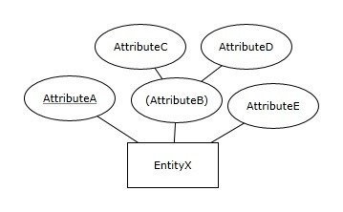
A) Composite attribute
B) Multivalued attribute
C) Derived attribute
D) Unique composite attribute
Answer: A
Page Ref: 22
SUNSHINE AIRLINE COMPANY
The ER Diagram for the SUNSHINE AIRLINE COMPANY is based on the following:
- For each airplane type, we keep track of a unique airplane type ID (AirplaneTypeID), number of engines (NoOfEngines), and number of seats (NoOfSeats).
- For each airport, we keep track of a unique airport ID (AirportID), and the length of the main runway (LengthOfRunway).
- Each airplane type is able to land at one airport at least, but may be able to land at many airports. Each airport accommodates landing of at least one airplane type, but may accommodate landing of more airplane types.

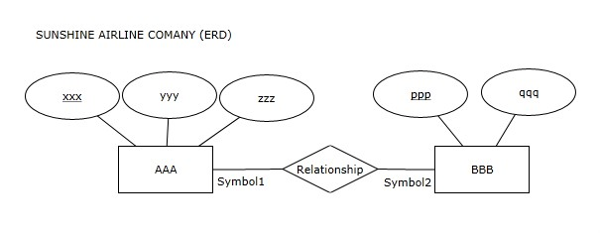
This ER diagram will be used for the following questions citing SUNSHINE AIRLINE ER Diagram.

19) In the ER Diagram for the SUNSHINE AIRLINE COMPANY, which word should replace AAA?
A) AirplaneTypeID
B) AIRPLANETYPE
C) AirportID
D) AIRPORT
Answer: B
Page Ref: 14-17

20) In the ER Diagram for the SUNSHINE AIRLINE COMPANY, which word should replace BBB?
A) AirplaneTypeID
B) AIRPLANETYPE
C) AirportID
D) AIRPORT
Answer: D
Page Ref: 14-17

21) In the ER Diagram for the SUNSHINE AIRLINE COMPANY, which word should replace xxx?
A) AirplaneTypeID
B) NoOfEngines
C) AirportID
D) LengthOfRunway
Answer: A
Page Ref: 14-17
22) In the ER Diagram for the SUNSHINE AIRLINE COMPANY, which word should replace ppp?
A) AirplaneTypeID
B) NoOfEngines
C) AirportID
D) LengthOfRunway
Answer: C
Page Ref: 14-17

23) In the ER Diagram for the SUNSHINE AIRLINE COMPANY, which word should replace qqq?
A) AirplaneTypeID
B) NoOfEngines
C) AirportID
D) LengthOfRunway
Answer: D
Page Ref: 14-17

24) In the ER Diagram for the SUNSHINE AIRLINE COMPANY, which two words should replace yyy and zzz?
A) AirplaneTypeID and NoOfSeats
B) NoOfEngines and NoOfSeats
C) AirportID and AirplaneTypeID
D) LengthOfRunway and NoOfSeats
Answer: B
Page Ref: 14-17

25) In the ER Diagram for the SUNSHINE AIRLINE COMPANY, Symbol1 should be:
A) ||
B) >|
C) >○
D) |○
Answer: B
Page Ref: 14-17

26) In the ER Diagram for the SUNSHINE AIRLINE COMPANY, Symbol2 should be:
A) ||
B) |<
C) ○<
D) ○|
Answer: B
Page Ref: 14-17

ABC RETAILER
Observe the ER diagram for the ABC Retailer: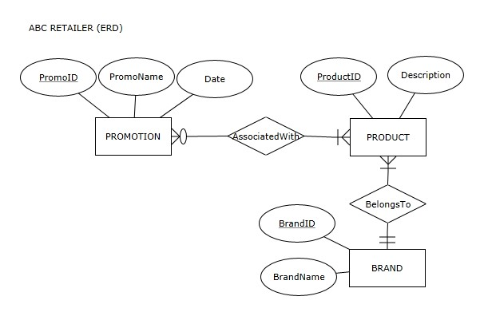
This ER diagram will be used for the following questions citing ABC Retailer ER Diagram.

27) Which of the following is true according to the ABC Retailer ER diagram?
A) A promotion can be associated with many products and it has to be associated with at least one product
B) A promotion can be associated with many products but it does not have to be associated with any products
C) Each promotion is associated with exactly one product
D) A promotion is not associated with any products
Answer: A
Page Ref: 14-22

28) Which of the following is true according to the ABC Retailer ER diagram?
A) A product can be associated with many promotions and it has to be associated with at least one promotion
B) A product can be associated with many promotions but it does not have to be associated with any promotions
C) Each product is associated with exactly one promotion
D) A product is not associated with any promotions
Answer: B
Page Ref: 14-22
29) Which of the following is true according to the ABC Retailer ER diagram?
A) Each promotion has a unique promotion name
B) Each brand has a unique brand name
C) Each product has a unique product ID
D) All of the above
Answer: C
Page Ref: 14-22

30) Which of the following is true according to the ABC Retailer ER diagram?
A) We cannot keep track of promotions that are not associated with multiple products
B) We must keep track of promotions that are not associated with any products
C) We can keep track of promotions that are not associated with any products
D) We cannot keep track of promotions that are not associated with any products
Answer: D
Page Ref: 14-22

31) Which of the following is true according to the ABC Retailer ER diagram?
A) We cannot keep track of products that are not associated with multiple promotions
B) We must keep track of products that are not associated with any promotions
C) We can keep track of products that are not associated with any promotions
D) We cannot keep track of products that are not associated with any promotions
Answer: C
Page Ref: 14-22

32) Which of the following is true according to the ABC Retailer ER diagram?
A) A product can belong to multiple brands but it must belong to at least one brand
B) Each product belongs to multiple brands
C) Each product belongs to exactly one brand
D) Each product belongs to either one brand or no brand at all
Answer: C
Page Ref: 14-22

33) Which of the following is true according to the ABC Retailer ER diagram?
A) A brand can have many products but it does not have to have any products
B) A brand can have many products and it has to have at least one product
C) Each brand is associated with exactly one product
D) A brand is not associated with any products
Answer: B
Page Ref: 14-22

34) Which of the following is true according to the ABC Retailer ER diagram?
A) We cannot keep track of brands that do not have multiple products
B) We must keep track of brands that do not have any products
C) We can keep track of brands that do not have any products
D) We cannot keep track of brands that do not have any products
Answer: D
Page Ref: 14-22
35) Which of the following is true according to the ABC Retailer ER diagram?
A) We cannot keep track of products that belong to any brand
B) We must keep track of products that do not belong to any brand
C) We can keep track of products that do not belong to any brand
D) We cannot keep track of products that do not belong to any brand
Answer: D
Page Ref: 14-22

ZYX COMPANY
Observe the ER diagram for the ZYX COMPANY:
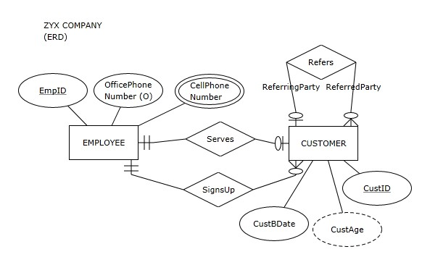
This ER diagram will be used for the following questions citing ZYX Company ER Diagram.

36) Observe the ER diagram for the ZYX Company:
Which of the following is true according to the ZYX Company ER diagram?
A) An employee can serve many customers and he or she has to serve at least one customer
B) An employee can serve one customer or he or she does not have to serve any customers
C) Each employee serves exactly one customer
D) Employees do not serve customers
Answer: B
Page Ref: 14-22

37) Which of the following is NOT true according to the ZYX Company ER diagram?
A) Each customer has a unique CustID
B) Each employee has a unique EmpID
C) Each customer has a unique employee serving him or her
D) Each employee is serving a unique customer
Answer: C
Page Ref: 14-22
38) Which of the following is true according to the ZYX Company ER diagram?
A) A customer can be served by many employees and he or she has to be served by at least one employee
B) A customer can be served by one employee or he or she does not have to be served by any employees
C) Each customer is served by exactly one employee
D) Customers are not served by employees
Answer: C
Page Ref: 14-22

39) Which of the following is true according to the ZYX Company ER diagram?
A) An employee can sign up many customers and he or she has to sign up at least one customer
B) An employee can sign up many customers but he or she does not have to sign up any customers
C) Each employee signs up exactly one customer
D) Each employee signs up many customers
Answer: B
Page Ref: 14-22

40) Which of the following is true according to the ZYX Company ER diagram?
A) A customer can be signed up by many employees and he or she has to be signed up by at least one employee
B) A customer can be signed up by one employee or he or she does not have to be signed up by any employees
C) Each customer is signed up by exactly one employee
D) Customers are not signed up by employees
Answer: C
Page Ref: 14-22

41) Which of the following is true according to the ZYX Company ER diagram?
A) A customer cannot be referred by another customer
B) A customer can be referred by at most one customer
C) A customer can be referred by many customers
D) A customer must be referred by another customer
Answer: B
Page Ref: 14-30

42) Which of the following is true according to the ZYX Company ER diagram?
A) A customer cannot refer another customer
B) A customer can refer either only one customer or no customers at all
C) A customer can refer many customers
D) A customer must refer many customers
Answer: C
Page Ref: 14-30
43) Which of the following is true according to the ZYX Company ER diagram?
A) We will store CustomerBDate value for each customer
B) We will store OfficePhoneNumber value for each employee
C) We will store CustomerAge value for each customer
D) All of the above
Answer: A
Page Ref: 14-30

44) Which of the following is NOT true according to the ZYX Company ER diagram?
A) We can keep track of employees that have multiple cell phone numbers
B) We can keep track of employees that have multiple office phone numbers
C) We can keep track of employees that have one cell phone number
D) We can keep track of employees that have one office phone number
Answer: B
Page Ref: 14-30

45) Which of the following is true according to the ZYX Company ER diagram?
A) We cannot keep track of employees that do not sign up any customers
B) We cannot keep track of employees that do not serve any customers
C) We cannot keep track of employees that serve multiple customers
D) We cannot keep track of employees that sign up multiple customers
Answer: C
Page Ref: 14-22

46) Which of the following is true according to the ZYX Company ER diagram?
A) We can keep track of customers that are not served by any employees
B) We can keep track of customers that are not signed up by any employees
C) We can keep track of customers that are served by multiple employees
D) We can keep track of customers that are not referred by any customers
Answer: D
Page Ref: 14-22
CENTRAL SCHOOL LIBRARY
Observe the ER diagram for the CENTRAL SCHOOL LIBRARY
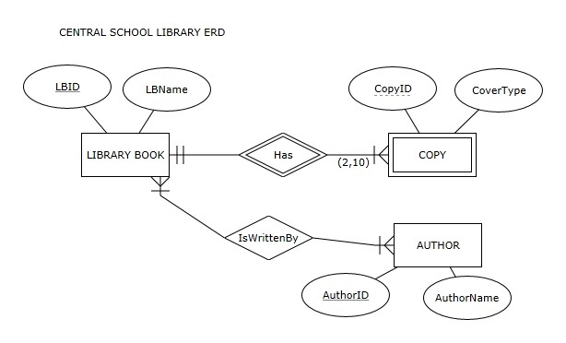
This ER diagram will be used for the following questions citing Central School Library ER Diagram.

47) Which of the following is true according to the Central School Library ER diagram?
A) Each library book must have at least one copy
B) Each library book must have multiple copies
C) Each library book must have at least 10 copies
D) Each library book must have more than 2 copies
Answer: B
Page Ref: 14-33

48) Which of the following is NOT true according to the Central School Library ER diagram?
A) Each copy of the same book must have a different CopyID value
B) Two copies can have the same CopyID value
C) Each author has a different AuthorName value
D) Each library book has a name
Answer: C
Page Ref: 14-33

49) Which of the following is NOT true according to the Central School Library ER diagram?
A) A book can have no authors
B) A book can have one author
C) A book can have two authors
D) A book can have more than two authors
Answer: A
Page Ref: 14-22
50) Which of the following is true according to the Central School Library ER diagram?
A) We cannot keep track of authors that did not write any of the library books
B) We cannot keep track of authors that wrote only one of the library books
C) We cannot keep track of authors that wrote multiple library books
D) We cannot keep track of authors that wrote more than 10 library books
Answer: A
Page Ref: 14-22

2.2 True/False Questions

1) ER modeling is a widely used logical database modeling method.
Answer: FALSE
Page Ref: 13

2) Entity instances are depicted in ER diagrams.
Answer: FALSE
Page Ref: 14

3) Within one entity, each attribute name must be different.
Answer: TRUE
Page Ref: 14

4) A unique attribute is an attribute whose value is different for each entity instance.
Answer: TRUE
Page Ref: 14

5) Within an ER diagram, each entity must be related to at least one other entity via a relationship.
Answer: TRUE
Page Ref: 15

6) Minimum cardinality can be many.
Answer: FALSE
Page Ref: 15

7) Maximum cardinality can be optional.
Answer: FALSE
Page Ref: 15

8) Relationship instances occur when an instance of one entity is related to an instance of another entity via a relationship.
Answer: TRUE
Page Ref: 18

9) A relationship attribute of a M:N relationship cannot be assigned to either of the entities involved in that relationship.
Answer: TRUE
Page Ref: 19-20
10) A relationship attribute of a 1:N relationship cannot be assigned to either of the entities involved in that relationship.
Answer: FALSE
Page Ref: 19-20

11) An attribute can be a part of several composite attributes.
Answer: TRUE
Page Ref: 22-23

12) Components of a unique composite attribute are not unique.
Answer: TRUE
Page Ref: 23-24

13) An optional attribute occurs only in an entity that is involved in a relationship with optional participation.
Answer: FALSE
Page Ref: 26

14) Exact maximum cardinality is calculated by adding the exact minimum cardinalities.
Answer: FALSE
Page Ref: 27

15) A unary relationship cannot have mandatory participation on both sides.
Answer: FALSE
Page Ref: 29

16) A unary relationship can have one or many maximum cardinalities on either side.
Answer: TRUE
Page Ref: 28-29

17) Two entities can be related via multiple different binary relationships.
Answer: TRUE
Page Ref: 30

18) Each instance of a weak entity must participate in one instance of the identifying relationship.
Answer: TRUE
Page Ref: 32

19) A weak entity that has a 1:1 identifying relationship with its owner, must have a partial key.
Answer: FALSE
Page Ref: 30-33

20) A weak entity that has a 1:M identifying relationship with its owner must have a partial key.
Answer: TRUE
Page Ref: 30-33

21) Adding a unique attribute to a weak entity converts the weak entity to a regular entity.
Answer: TRUE
Page Ref: 42-43
22) In an ER diagram, each entity is always connected to all of the other entities, either via a direct relationship or indirectly via other entities and relationships.
Answer: TRUE
Page Ref: 33-35

23) Every ER notation uses the same rule for placement of cardinality constraints in the relationships of the ER diagram.
Answer: FALSE
Page Ref: 39

24) A relationship of degree 3 (also known as a ternary relationship) depicts 3 or more entities involved in one relationship.
Answer: FALSE
Page Ref: 45

25) A ternary relationship can always be depicted as three binary relationships.
Answer: FALSE
Page Ref: 45-46
EAGLERUN TRUCKING DISPATCHER
Observe the ER diagram for the Eaglerun Trucking Dispatcher: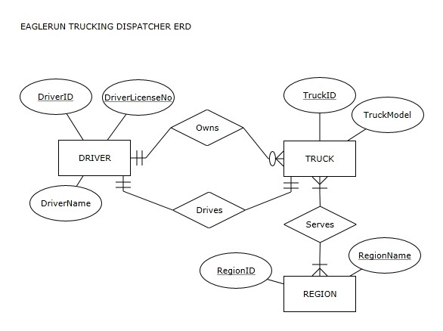
This ER diagram will be used for the following questions citing Eaglerun Trucking Dispatcher ER Diagram.

26) According to the Eaglerun Trucking Dispatcher ER diagram, each driver has a unique DriverID value.
Answer: TRUE
Page Ref: 14

27) According to the Eaglerun Trucking Dispatcher ER diagram, each driver has a unique DriverLicenseNo value.
Answer: TRUE
Page Ref: 14

28) According to the Eaglerun Trucking Dispatcher ER diagram, each driver has a unique DriverName value.
Answer: FALSE
Page Ref: 14

29) According to the Eaglerun Trucking Dispatcher ER diagram, each truck has a unique TruckID value.
Answer: TRUE
Page Ref: 14
30) According to the Eaglerun Trucking Dispatcher ER diagram, each truck has a unique TruckModel value.
Answer: FALSE
Page Ref: 14

31) According to the Eaglerun Trucking Dispatcher ER diagram, each region has a unique RegionID value.
Answer: TRUE
Page Ref: 14

32) According to the Eaglerun Trucking Dispatcher ER diagram, each region has a unique RegionName value.
Answer: TRUE
Page Ref: 14

33) According to the Eaglerun Trucking Dispatcher ER diagram, each truck is owned by a driver.
Answer: TRUE
Page Ref: 14-17

34) According to the Eaglerun Trucking Dispatcher ER diagram, each driver owns a truck.
Answer: FALSE
Page Ref: 14-17

35) According to the Eaglerun Trucking Dispatcher ER diagram, a truck can be owned by multiple drivers.
Answer: FALSE
Page Ref: 14-17

36) According to the Eaglerun Trucking Dispatcher ER diagram, a driver can own two trucks.
Answer: TRUE
Page Ref: 14-17

37) According to the Eaglerun Trucking Dispatcher ER diagram, a driver can drive two trucks.
Answer: FALSE
Page Ref: 14-17

38) According to the Eaglerun Trucking Dispatcher ER diagram, we will keep track of the same number of trucks and drivers.
Answer: TRUE
Page Ref: 14-17

39) According to the Eaglerun Trucking Dispatcher ER diagram, a truck can serve multiple regions.
Answer: TRUE
Page Ref: 14-17

40) According to the Eaglerun Trucking Dispatcher ER diagram, every region must be served by multiple trucks
Answer: FALSE
Page Ref: 14-17
2.3 Essay Questions

1) What is the purpose of ER modeling?
Answer: Entity-relationship (ER) modeling, a widely used conceptual database modeling method, is a technique that enables the structuring and organizing of the requirements collection process and provides a way to graphically represent the requirements.
Page Ref: 13

2) What is depicted by the cardinality constraints?
Answer: Cardinality constraints depict how many instances of one entity are associated with instances of another entity.
Page Ref: 15

3) What is a candidate key?
Answer: Candidate keys occur when an entity has more than one unique attribute. In such cases, each unique attribute is also called a candidate key. The term candidate key comes from the fact that a candidate key is a candidate to be chosen as the primary identifier (also known as a primary key) when implementing the resulting database.

4) What is a degree of a relationship?
Answer: Degree of a relationship is the number that reflects how many entities are involved in the relationship.

5) What is a relationship role?
Answer: Relationship role refers to an additional syntax that can be used in ER diagrams at the discretion of a data modeler to clarify the role of each entity in a relationship.

6) Create an example ER diagram that illustrates two entities with two separate relationships between them
Answer: Figure 2.31 (or similar example).

7) What is an identifying relationship?
Answer: An identifying relationship in an ER diagram is a relationship between a weak entity and its owner entity.
8) What is a partial key?
Answer: A partial key is an attribute of a weak entity that, combined with the unique attribute of the owner entity, uniquely identifies the weak entity's instances.

9) Create an ER diagram based on the following requirements:
The database will keep track of students and campus organizations.
- For each student, we will keep track of his or her unique student ID, and his or her name and gender.
- For each organization, we will keep track of its unique organization ID and the location.
- Each student in the database belongs to at least one organization and can belong to multiple organizations.
- Each organization in the database has at least one student belonging to it and can have multiple
students.
- For every instance of a student belonging to an organization, we will record the student's function in the organization (e.g., president, vice president, treasurer, member, etc.).
Answer: Figure 2.11

10) Create an ER diagram based on the following requirements:
The database will keep track of students and colleges.
- For each student, we will keep track of his or her name and unique student ID.
- For each college, we will keep track of its unique name and its location.
- Each student in the database attends exactly one college.
- Each college in the database has multiple students.
- For each student, we keep track of the date he or she started attending his or her college.
Answer: Diagram in the bottom part of Figure 2.12

