Planning, Deploying, and Managing Microsoft Systems Management Server 2003

QUESTION 1:

You are the SMS administrator for Certkiller .com. Certkiller uses Active Directory System Discovery when configuring SMS to discover computers. The Organizational Unit (OU) structure is shown in the following exhibit
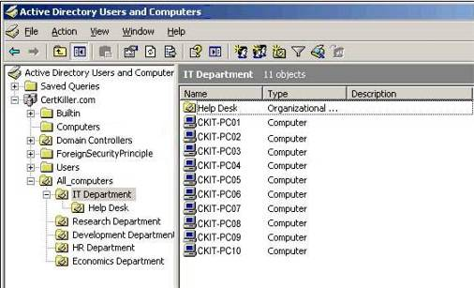

You need to configure Active Directory System Discovery to discover the computers in the IT Department OU, but not the Help Desk OU.

Which two actions should you perform? (Each correct answer presents part of the solution. Choose two.)

- Ensure that the Recursive search option is selected.

- Query the local domain location.
- Query the local forest location.
- Ensure that the Recursive search option is not selected.
- Create a custom LDAP or GC query that points to the IT Department OU.

Answer: D, E

Explanation:

All AD based discovery methods give you a great deal of control over
what they evaluate, and you can use this to your advantage. Utilizing the custom LDAP or GC query option, you can restrict a site to discovery only on objects relative to it.
A custom LDAP query in this case would look like this: LDAP://OU=ALL_COMPUTERS,OU=IT DEPARTMENT,DC= Certkiller ,DC=COM. After you specify which Active Directory containers to scan, you specify whether to scan recursively. Recursive scanning finds objects that are stored in the Active Directory containers that you specify, and it finds any subcontainers. By default, all containers are

scanned recursively. You can toggle the recursive scanning of containers by selecting the container and then clicking the Recursive button.

QUESTION 2:

You are the SMS administrator for Certkiller .com. The Hardware Inventory Client Agent is enabled with the default configuration settings.

You need to ensure that the Hardware Inventory Client Agent is run every Tuesday at 19:00.
What should you do?

- Configure the Hardware Inventory Client Agent to use a Full schedule.

- Add an IDMIF file to each client that sets the new schedule.
- Configure the Hardware Inventory Client Agent to use a Simple schedule.
- Change the SMS_def.mof to comply with the new schedule.

Answer: A

Explanation:

You can't use a simple schedule because a simple schedule will only allow you to set it to run every xdays, whilea full schedule will allow you to set a schedule indicating what day and time. IDMIF files are used to create entire new architectures in the SMS site database, or to update existing architectures. They can also be used to add stand-alone computers to the SMS site database. IDMIF files are also frequently used to inventory non-system items. Systems Management Server (SMS) uses the Sms_def.mof file to specify which hardware classes and attributes are collected and reported for hardware inventory.

QUESTION 3:

You are the SMS administrator for Certkiller .com. Your network consists of a single Active Directory domain. The network contains a Microsoft SQL Server 7.0 SP3 computer. The SMS site server runs Microsoft Windows 2000 Server SP3. The SMS site server is configured as a management point, client access point, server locator point, and reporting point.

You want to use a server that runs Microsoft Windows NT Server 4.0 SP4 as a distribution point.
The SMS site currently uses the standard security mode.
You need to migrate from the standard security mode to the advanced security mode. You want to achieve this goal by using the least amount of administrative effort.
Which two actions should you perform? (Each correct answer presents part of the solution. Choose two.)

A. Upgrade the computer you want to configure as a distribution point to Windows NT Server 4.0 SP6.

- Upgrade the computer you want to configure as a distribution point to Windows 2000 Server SP3.
- Upgrade the SQL Server computer to SQL Server 2000 SP3a.
- Upgrade the SMS site server to Windows Server 2003.
- Extend the Active Directory schema.

Answer: B, C

Explanation:

For an SMS 2003 site to use advanced security, the SMS site server and all SMS site systems must be running Windows 2000 SP1 or later, or an operating system in the Windows Server 2003 family, in an Active Directory domain. It is not possible to use an advanced security site in a Windows NT 4.0 domain. The SMS site database servers must be running SQL Server 2000 or later. The SQL Servers must be in Windows authentication mode only.

QUESTION 4:

You are the SMS administrator for Certkiller .com. All servers run Microsoft Windows Server 2003. All desktop computers run Windows XP Professional. The company has a single SMS 2.0 SP3 site. You plan to upgrade the SMS 2.0 site to SMS 2003 SP1.

You need to test specific upgrade tasks before implementing SMS 2003 SP1 in the production environment.
Which task should you avoid performing in a production environment?

- installingInternet Information Services

- upgrading to SMS 2.0 SP4
- running the Deployment Readiness Wizard
- runningSetup.exe /testdbupgrade SMS_

Answer: D

Explanation:

Running Setup with the /testdbupgrade switch is a destructive test.
Ensure that you use this option on a copy of your SMS site database only, not on your production SMS site database. The /testdbupgrade switch is valid only when run against a copy of the SMS site database where the SMS provider does not exist.

QUESTION 5:

You are the SMS administrator for Certkiller .com. The SMS 2003 site hierarchy consists of a single primary site. The SMS site server is configured as a management point, client access point, server locator point, and distribution point.

The hardware on the management point must be replaced. You need to transfer the management point role to a different server. The only computer available for this

purpose runs Microsoft Windows NT Server 4.0 SP4.

You need to prepare this computer to be a management point. What should you do?

- Install Windows 2000 Server SP3 and IIS.

- Install Windows Server 2003 with the default settings.
- Install SP6 for Windows NT Server 4.0 and IIS
- Install Windows 2000 Server SP2.

Answer: A

Explanation:

System Management Server 2003 system requirements: Microsoft
Windows Server 2003 (Standard, Enterprise or Datacenter Edition) or Windows 2000 Server SP2 (Standard, Advanced or Datacenter Edition). Distribution points, Management points and Reporting points also require that Internet Information Services (IIS) is installed as part of the Windows Server installation.

QUESTION 6:

You are the SMS administrator for Certkiller .com. All servers run Microsoft Windows Server 2003. All desktop computers run Microsoft Windows XP Professional. The company has a single SMS site. The SMS Advanced Client is installed on all computers on the network.

You need to inventory the network to discover only the following.
- The version of Microsoft Word that is being used by each computer

- A list of applications that is installed on each computer
- The version of the definition file named Av.dat that is used by the antivirus software
You need to modify the default settings for the SMS Software Inventory Client Agent to collect this information. You need to achieve this goal by using the least amount of administrative effort.
Which entry or entries should you add? (Choose all that apply.)

- *.exe

- Av.dat
- Winword.exe
- *.*

Answer: B

Explanation:

By default, *.exe is collected, which would by default collect version
for Winword.exe.A list of installed applications is created by the Hardware Inventory Client Agent and presented in the Resource Explorer under Add/Remove

Programs. Any files with *.dat extension would need to be manually added to the list of collected files for the Software Inventory Client Agent.

QUESTION 7:

You are the SMS administrator for Certkiller .com. All servers run Microsoft Windows Server 2003. All desktop computers run Windows XP Professional.

You install SMS 2003 SP1. You configure the SMS site with advanced security. You install the SMS Advanced Client on all computers.
You need to discover all SMS clients by using Network Discovery. Which Network Discovery method will be unavailable?

- DHCP

- Domains
- SNMP
- SNMP Devices
- Subnets

Answer: A

Explanation:

DHCP network discovery is disabled by default when the SMS site is
running advanced security. This is by design. Advanced security relies on using the LocalSystem Account context to access server resources such as DHCP data. However, DHCP data cannot be accessed by using the LocalSystem Account security context. Therefore, DHCP network discovery is disabled in advanced security mode.

QUESTION 8:

You are the SMS administrator for Certkiller .com. All domain controllers run Microsoft Windows Server 2003. All desktop computers run Windows XP Professional. You plan to install SMS 2003 SP1.

You need to instruct the Active Directory administrator how to prepare Active Directory for SMS integration.
What instruction or instructions should you convey to the Active Directory administrator? (Choose all that apply.)

- Create the System Management container.

- Create the SMS 2003 container.
- Give appropriate rights to the System Management container.
- Give appropriate rights to the SMS 2003 container.
- Log on by using a user account that is a member of the Schema Admins group.
- Run ExtADSchem.exe

Answer: A, C, E

Explanation:

System Management is the correct name for the AD container containing SMS information, there is no need for a SMS 2003 container
ExtADSchem.exe does not exist, therefore extadsch.exe would be the correct executable. However, it is not a choice, so the container needs to be created manually (A) and to do this you have to be logged on with the correct credentials and also assign the appropriate rights to the container after it has been created.

QUESTION 9:

You are the SMS administrator for Certkiller .com. All servers run Microsoft Windows Server 2003. All desktop computers run Windows XP Professional.

You want to install the SMS Advanced Client on all computers on the network. You use the Client Push Installation Wizard to install the SMS client software on the computers.
You discover that some of the computers failed to install the SMS client. You need to identify the cause of the problem.
Which three log files could you examine on both the SMS client and the SMS site server? (Each correct answer presents a complete solution. Choose three.)

- Ccm.log

- Ccmsetup.log
- Cidm.log
- Client.msi.log
- Ddm.log

- Smsexec.log

Answer: A, B, D

Explanation:

Ccm.log (Server side): Search for computer name and make sure no errors are in this log associated with the computer the client is being installed on. Seeing 'Unable to retrieve' or 'could not retrieve' here is normal. This is when the server verified that the client is not already installed.
Ccmsetup.log (client side): Logs when Management Point is identified, client.msi is downloaded, when the installation starts and completes.
Client.msi.log (client side): Logs any errors during install. Search for "return value 3" to find the actual error.

QUESTION 10:

You are the SMS administrator for Certkiller .com. All servers run Microsoft Windows Server 2003. All desktop computers run Windows 98.

You plan to deploy the SMS client software to all desktop computers on the network. You want to install the SMS client software based on the logon credentials.

You need to create a logon script that will automatically install the SMS client on all desktop computers.

What are two possible ways to achieve this goal? (Each correct answer presents a complete solution. Choose two.)

- Configure the logon script to run Capinst.exe.

- Configure the logon script to run CCMSetup.exe.
- Configure the logon script to run Client.msi.
- Configure the logon script to run Smsman.exe.

Answer: A, D

Explanation:

Capinst.exe is the recommended program to use in manual and logon script installations. Capinst.exe supports both Legacy and Advanced client
installations. By default the Legacy client is deployed, use /advcli to install the Advanced client.
Smsman.exe is used to install Legacy Clients by connecting to the CAP using a UNC path. If you want users to run it from other locations, such as domain controllers, you must copy it to those locations and specify the CAP using the SMSman.exe command-line switch SMSman.exe /M <\\<server>\CAP_<site code>>

QUESTION 11:

DRAG DROP

You are the SMS administrator for Certkiller .com. You want to upgrade client computers that run Microsoft Windows 2000 Professional to Windows XP Professional CP2.

You need to use the Operating System Deployment (OSD) to upgrade the computers.
What should you do?
To answer move the appropriate phases from the list of phases to the answer area and arrange them in the correct order.

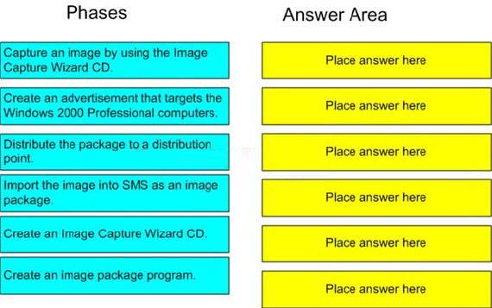

Drag and drop question. Drag the items to the proper locations.

Answer:
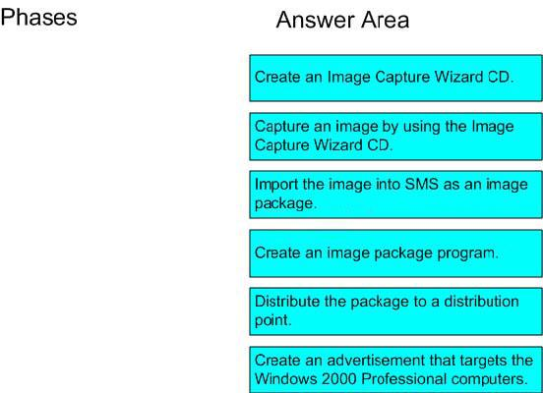

Reference: Microsoft System Management Server 2003 Operating System Deployment Feature Pack Users Guide, page 21-32

QUESTION 12:

You are the SMS administrator for Certkiller .com. The company has a single SMS site. Employees use Windows mobile devices. You use the Device Client to manage these devices with the SMS Device Management Feature Pack.

You want to ensure that the mobile devices meet the following security guidelines:
- Passwords comply with complexity requirements.
- Desktop computers use digital certificates while connecting over the virtual private network (VPN).
You need to configure the mobile devices to comply with these guidelines. Which two tasks should you perform? (Each correct answer presents part of the solution. Choose two.)

- Use an advertisement to run a Microsoft Visual Basic Scripting Edition (VBScript) script to configure VPN settings.
- Use an advertisement to run a Microsoft Visual Basic .NET assembly to configure VPN settings.
- Use Device Settings Manager to configure the VPN settings.
- Use Device Settings Manager to configure the password policy.

Answer: C, D

Explanation:

The Device Management Feature Pack provides Hardware inventory,
Software inventory, File collection, Software distribution, Settings management and Password policy management for Windows Mobile devices.

QUESTION 13:

You are the SMS administrator for Certkiller .com. Your SMS hierarchy consists of a single primary site. Your SMS site consists of a single site server configured as a management point, a client access point, a server locator point, and a distribution point.

Employees use Pocket PC devices. They only access the company network over a wireless connection. You want to use SMS to manage the Pocket PC devices. You install and configure the Device Management Feature Pack on the SMS site server. You now need to deploy the client software to the mobile devices.
What should you do?

- Create an advertisement to install the Device Client on the computers running Microsoft ActiveSync.
- Create an advertisement to install the Device Client on the mobile devices.
- Use Client Push Installation to install the Device Client.
- Use a Web site to make the Device Client installation available.

Answer: D

Explanation:

The Windows Mobile Device Management Client can be manually
installed or automatically deployed and configured using the SMS 2003 desktop client. As the SMS 2003 desktop client is not an alternative the only correct answer has to be a manual installation, in this case they are using a Web site for the distribution of the installation files.

QUESTION 14:

You are the SMS administrator for Certkiller .com. The company has a single SMS site. All site roles are enabled. The Hardware Inventory Client Agent and the Software Inventory Client Agent are disabled. The SMS Advanced Client is installed on all computers in the network.

You want to create a list of the computers on the network. The list must include the computer name, IP address, last logged on user, and MAC address for each computer. You want all users on your team to have access to this list. You are the only user on your team who has access to the SMS Administrator console.
You need to configure SMS to automatically create the list.
Which two actions should you perform? (Each correct answer presents part of the solution. Choose two.)

- Create a report to display the required data.

- Create a query to display the required data.
- Configure permissions on the created report to allow users to view it.

- Configure permissions on the created query to allow users to view it.

Answer: A, C

Explanation:

Queries are mainly used to create collections not to present information.

QUESTION 15:

DRAG DROP

You are the SMS administrator for Certkiller .com .Your SMS hierarchy consists of a single primary site. Your network contains several Windows Server 2003 computers that function as database servers, messaging servers, and file servers.
A new service pack for Microsoft Windows Server 2003 is available. You want to deploy the service pack to all Windows Server 2003 computers to comply with Certkiller 's security guidelines.You designate five Windows Server 2003 computers as test computers.
You need to avoid disrupting the services that are provided by the servers while deploying this service pack.

What should you do?

To answer move the appropriate actions from the list of actions to the answer area and arrange them in the correct order.
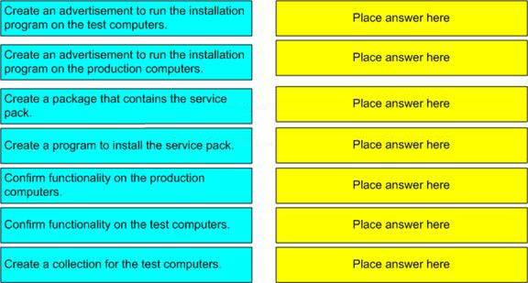

Drag and drop question. Drag the items to the proper locations.

Answer:

Explanation:
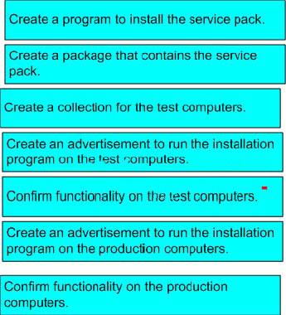

Reference: Microsoft System Management Server 2003 Operations Guide Chapter 5.

QUESTION 16:

DRAG DROP

You are the SMS administrator for Certkiller .com.You use 2003 SP1 and the Security Update Inventory Tool for patch management.
A new critical update for IIS is released. You want to quickly identify which Web servers require the update and then apply the update.
You need to create an advertisement to install the new update. What should you do?
To answer, move the appropriate actions from the list of actions to the answer area and arrange them in the correct order.
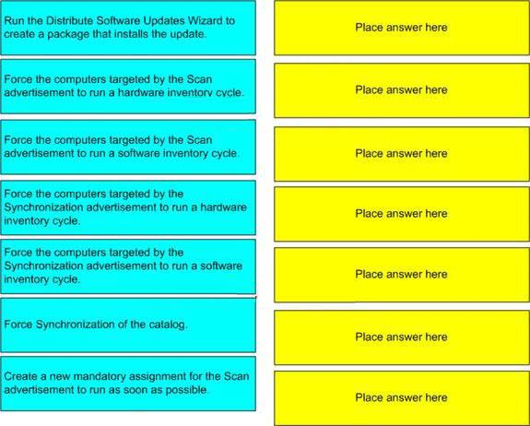

Answer:

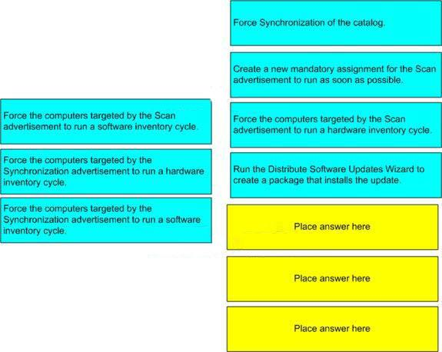

Explanation:

You have to start by forcing synchronization of the catalog so that
your SMS installation becomes aware of the new critical updates. After the synchronization you have to target which computers are lacking the update so you run a mandatory Scan as soon as possible. Next you retrieve the latest list over applications and updates installed on the computers targeted by the Scan advertisement and last but not least you actually create the package containing the critical update and advertise it to your computers.

QUESTION 17:

You are the SMS administrator for Certkiller .com. The SMS 2003 site hierarchy consists of a single primary site. Servers run Microsoft Windows Server 2003. Desktop computers run Windows XP Professional.

Users who are members of a group named HelpDesk_staff want to access computers remotely.
The Remote Tools Client Agent is configured as shown in the exhibit.

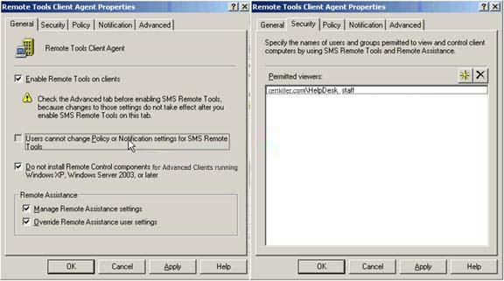

Users in the Help Desk group have full access rights on the Remote Assistance tool and SMS Remote Tools. All SMS client computers use the default settings for the Remote Desktop service.

You need to instruct the users in the Help Desk group how to access computers remotely.
What should you instruct them to do?

- In the SMS Administrator console, start Windows Diagnostics.

- In the SMS Administrator console, start Remote Tools.
- In the SMS Administrator console, start Remote Assistance.
- In the SMS Administrator console, start Remote Desktop Client.

Answer: C

Explanation:

The Remote Assistance and Terminal Services features, which are
available in the applicable Windows operating systems of clients, are integrated into the SMS 2003 Administrator console. This provides you with more options for remotely assisting clients from within the SMS Administrator console.

QUESTION 18:

You are the SMS administrator for Certkiller .com. You use SMS 2003 SP1 and the Security Update Inventory Tool for patch management. The Security Update Inventory Tool is installed and configured with the default settings.

A new set of updates is available.
You need to identify which computers are not compliant with a specific update. You want to achieve this goal by using the least amount of administrative effort.

What should you do?

- View the Software Updates container of the SMS Administrator console to find the computers that need the updates.
- View Resource Explorer for each computer to identify applicable updates.
- Create a query that selects computers that need the updates.
- Run the Computers where a specific software update is applicable report to find the computers that need the updates.

Answer: D

Explanation:

The easiest way to identify the computers that need a specific update is
by opening the predefined report Computers where a specific software update is applicable and specifying the title of the update, collection where to look and what type of scan (Extended MBSA and Microsoft Updates).
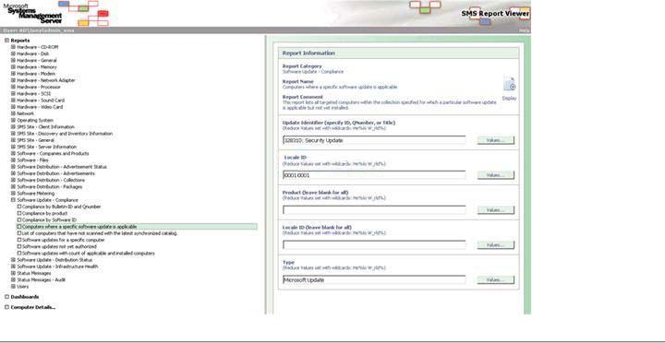

QUESTION 19:

You are the SMS administrator for Certkiller .com. You use SMS 2003 SP1 and the Security Update Inventory Tool for patch management. The Security Update Inventory Tool is installed and configured with the default settings. The package created by the tool is named Security.

You force the Security Sync advertisement to run and download new information on updates. You force the Security advertisement to run on a test server named

Certkiller 1 to collect software update data. Three hours later you discover that there is no new data.

You need to ensure that the current software update data is sent from Certkiller 1 to the SMS server as soon as possible.
What should you do?

- Change the Security advertisement to run the Security program.

- Change the Security program to run Scanwrapper.exe /cache /kick.
- Force Certkiller 1 to run a hardware inventory cycle.
- Force Certkiller 1 to run a software inventory cycle.

Answer: C

Explanation:

To ensure that Software Update data is sent to the server confirm that
the specific client meets all these requirements: It is member of the collection to which the Security Update Inventory Tool has been advertised, an inventory scan cycle has executed successfully on this client computer and hardware inventory has been collected and rolled up to the site server.

QUESTION 20:

You are the SMS administrator for Certkiller .com. The SMS hierarchy consists of a single primary site.

You use SMS to deploy a program that examines the latest version of the antivirus software that is used by the computers on the network. Two advertisements use this program. One advertisement runs daily on servers and portable computers.

Another advertisement runs weekly on desktop computers. You discover a security flaw in the program that collects the antivirus software information.
You need to prevent computers from running the program until you fix the security flaw. You need to ensure that all other advertisements function normally. You want to achieve this goal by using the least amount of administrative effort.
What should you do?

- Disable the program.

- Delete the program.
- Disable the Advertised Programs Client Agent.
- Delete each advertisement.

Answer: A

Explanation:

The easiest way to prevent a program from running is by right
clicking on the program associated to the package, choosing Properties and on the Advanced tab of the Program Properties window you mark the Disable this

program on computers where it is advertised, this will prevent the program from being displayed or run on the client computer.

QUESTION 21:

You are the SMS administrator for Certkiller .com. Your SMS hierarchy consists of a single primary site. Your SMS site consists of three site systems named Certkiller 1, Certkiller 2, and Certkiller 3.

The site systems are configured as shown in the following table.

Server | Certkiller1 | Certkiller2 | Certkiller3
Management | X | - | -
point
Client access | X | - | -
point
Server locator | X | - | -
point
Distribution |  | X
point | - |  | -
Reporting point | - | X | X
You want to view the status messages for all components that are installed on each server in a single screen. You want to view this information without using the SMS Administrator console.
You need to configure SMS to generate the list of status messages.
Which two actions should you perform? (Each correct answer presents part of the solution. Choose two.)

- Create a status message query that displays status messages for the specified components. Configure the status message query to use the server name as a parameter.
- Create a report for each server. Configure each report to show status messages for the specified components that are installed on the server.
- Create a status message query for each server. Configure each query to show status messages for the specified components that are installed on the server.
- Create a dashboard and add all reports created to the dashboard.
- Create a dashboard and add all queries created to the dashboard.

Answer: B, D

Explanation:

To view all the status messages in a single screen without using the
SMS Administrator console you'll have to use a custom dashboard that you access through Report Viewer. You create a dashboard by determining the number of reports that it can contain by specifying the number of rows and columns. Because you cannot configure a dashboard to pass prompt values to a report that it contains, you can only include reports that do not require prompts.

QUESTION 22:

You are the SMS administrator for Certkiller .com. The SMS hierarchy consists of two primary sites. The SMS Advanced Client is installed on all computers.

You create a new advertisement to download and install Microsoft Office Professional Edition 2003. The advertisement that uses this package is available from all distribution points in both sites. A network administrator at one site reports that a large amount of traffic is crossing the link that connects the two sites. The traffic occurs as a result of the packages being downloaded by roaming clients from a remote distribution point.
You need to prevent the SMS clients from downloading this package from a remote distribution point, without affecting other packages.
What should you do?

- Protect the distribution points.

- Disable roaming.
- Configure the advertisement not to run the program remotely.
- Create an individual advertisement for each site.

Answer: C

Explanation:

You can configure an remote roaming Advanced client to skip
advertisement, download from remote distribution point and execute or run from remote distribution point (see figure). In this case the right answer is to prohibit roaming clients from using the remote distribution point.

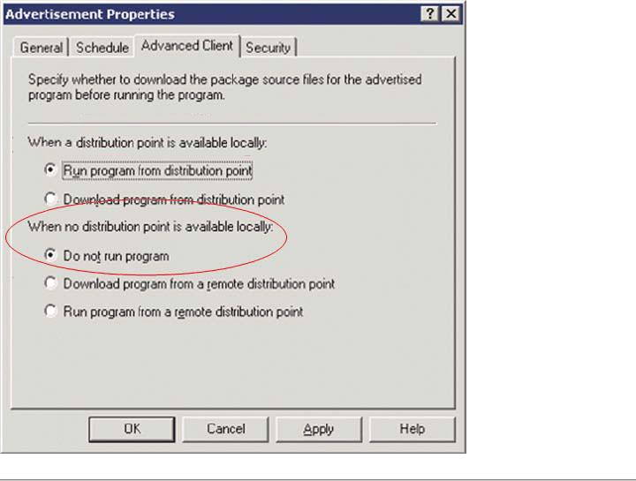

QUESTION 23:

You are the SMS administrator for Certkiller .com. All servers run Microsoft Windows Server 2003. Desktop computers run Windows XP Professional or Windows NT Server 4.0. Your SMS 2003 site hierarchy consists of a single primary site. Your site server is configured as a management point, client access point, server locator point, and distribution point.

You want to install an application on all computers. Installing this application requires administrative rights. You create an advertisement with a mandatory assignment to install this application. You discover that all of the computers that run Windows NT Server 4.0 fail to run the advertisement.
You need to ensure that computers running Windows NT Server 4.0 can run the advertisement. You want to achieve this goal by using the least amount of administrative effort.
What should you do?

- Configure the SMS Service Account with administrative privileges on all Windows NT Server 4.0 computers.
- Instruct users to log on to their computers using the local Administrator account.
- Configure an Advanced Client Network Access account.
- Configure a Legacy Client Software Installation account.

Answer: D

Explanation:

When a user at a Legacy Client runs an advertised program locally,
that program has the potential to run under two user contexts. Unless otherwise specified, the program runs under the logged-on user's context. If this user account does not have sufficient privileges to install software on the client, configure the program to run with administrative credentials by using the Legacy Client Software Installation account. You can specify the Legacy Client Software Installation Account by navigating in the SMS Administrator console tree to Site Settings, pointing to Component Configuration, and then clicking Software Distribution. Then, for programs that require this account, configure the program by selecting its Properties dialog box, clicking the Environment tab, and then clicking Use Software Installation Account.

QUESTION 24:

You are the SMS administrator for Certkiller .com. The SMS 2003 site hierarchy consists of a single primary site named Site1.

You configure the Hardware Inventory Client Agent to run daily. A few days later, you discover that no inventory data was available for a computer named Certkiller 1. You need to find out whether Certkiller successfully gathered inventory data and sent the data to the management point.

Which two files on Certkiller could you review? (Each correct answer presents a complete solution. Choose two.)

- DataTransferService.log

- ExecMgr.log
- InventoryAgent.log
- CcmExec.log

Answer: C, D

Explanation:

CcmExec.log: Log file for the SMS Agent Host. After the advanced client has generated discovery, inventory, status data, etc. data, this log file shows any communications errors with the Management Point. (Example: WINHTTP ERROR may appear when a client can't talk to the Management Point)
InventoryAgent.log: This log is for discovery, hardware and software inventory processing of the Advanced Client. There is a single agent on the advanced client that is

used for all three of these processes. This log file shows properties being discovered in HINV as well as paths in SINV being discovered. Look for the mp_xxxxEndpoint to see what data is being sent to the management point.

Wrong Answers:
DataTransferService.log: Shows the actual download of policies that are retrieved from the Management Point (including the URL used by the client to retrieve the data). The Data Transfer Service is what actually completes the download of those policies. Check this log file for advanced client problems transferring or obtaining polices from the Management Point.
ExecMgr.log: Running advertised programs, similar to the SMSapm32.log file from the SMS 2.0. Command lines executed, successful or not, and exit codes will appear in this log file. Check this log for issues with advertisements.

QUESTION 25:

You are the SMS administrator for Certkiller .com. The company network consists of a single Active Directory domain. The SMS Advanced Client is installed on all computers. The company's SMS hierarchy is shown in the exhibit.
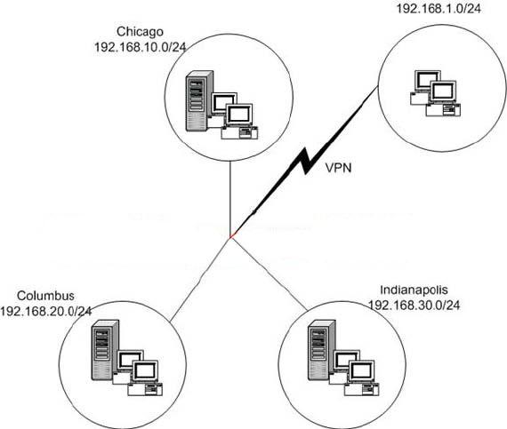

Every site contains at least one distribution point. Client computers connect to the sites either locally or remotely through a virtual private network (VPN) connection. You need to ensure that critical updates are downloaded to client computers when they connect through the VPN connection. You need to ensure that other packages are downloaded only when the client computer is locally connected to a site. Which two actions should you perform? (Each correct answer presents part of the solution. Choose two.)

- Configure the advertisement of critical update distribution packages to allow download for remote clients.
- Configure the advertisement of non-critical distribution packages to not allow download or installation for remote clients.
- Configure the roaming boundaries for Chicago to include the 192.168.1.0/24 subnet as a local roaming boundary.
- Configure the roaming boundaries for Indianapolis to include the 192.168.1.0/24 subnet as a local roaming boundary.
- Configure the roaming boundaries for Columbus to include the 192.168.1.0/24 subnet as a local roaming boundary.

Answer: A, B

Explanation:

An SMS site can include boundaries that define clients the site should
manage but that may be across a slow WAN link and considered remote from the installed SMS site server and distribution points. Such boundaries are designated as "remote roaming" boundaries, which means that clients residing within or travelling to the designated boundary have no local distribution point and should be assumed remote for the purposes of software distribution. 192.168.1.0/24 is to be considered as a "remote roaming" boundary for all sites and therefore alternative C, D and E are wrong.

QUESTION 26:

You are the SMS administrator for Certkiller .com. The SMS hierarchy consists of a central site named London and two primary child sites named Paris and Dublin. Both primary child sites are directly below London in the SMS hierarchy. The boundaries of all SMS sites are correctly configured. The SMS Advanced Client is installed on all computers.

When you test the roaming feature, you observe that SMS Advanced Clients from London are able to access packages in the Dublin site and in the Paris site. However, the SMS Advanced Clients from Dublin and Paris cannot access packages in other SMS sites in the hierarchy.
You need to ensure that SMS Advanced Clients from Dublin and Paris can roam to any SMS site.
What should you do?

- Add entries that point to the management points for Dublin and Paris to the WINS servers in all sites.
- Allow SMS to publish data to Active Directory.
- Configure the roaming boundary in Dublin and Paris to set London as a remote roaming boundary.
- Add proxy management points for Dublin and Paris in every SMS site.

Answer: B

Explanation:

You need to extend the Active Directory schema if:
- You want to use global roaming for Advanced Clients.
- You want to use the most secure method available for authenticating management points to Advanced Clients.
- You want to use automatic key exchange for secure site-to-site communications.
- You want clients to automatically detect the server locator points and management points without requiring Windows Internet Name Services (WINS). If you do not extend the schema, WINS is required for automatic site assignment, roaming and selection of a local management point.

QUESTION 27:

You are the SMS administrator for Certkiller .com. All SMS site system roles are enabled. The SMS Advanced Client is installed on all computers.

You create a new advertisement to install an update on a group of computers. Two days later the security team in Certkiller reports that the update causes a security breach and needs to be uninstalled.

You need to identify the computers that successfully executed the advertisement. You want to achieve this goal by using the least amount of administrative effort. What should you do?

- Filter the status messages for the advertisement in the Advertisement Status container of the SMS Administrator console.
- Run the Advanced Client Policy Spy tool.
- Run the SMS Trace tool and open ExecMgr.log.
- Run the Status of a specific advertisement report.

Answer: D

Explanation:

Log on the SMS Report Viewer, Select "Software Distribution - Advertisement Status" > "Status of a specific advertisement" and specify the Advertisement. This report shows the status summary of all resources that have been targeted by an advertisement. The summary is broken into two parts.

Acceptance status will summarize how many resources have received, rejected, or

not yet received the advertisement. Delivery status will summarize the resources that have run or attempted to run the program being advertised.

QUESTION 28:

You are the new SMS administrator for Certkiller .com. The SMS 2003 site hierarchy consists of a central primary site and two primary child sites.

You do not have documentation on which site system roles are enabled on which server.
You need to document the roles that are enabled on each server, the components that are running on each server, and the status of each component. You want to accomplish this goal by using the least amount of administrative effort.
What should you do?

- List all messages for each component from the Component Status container.

- List all messages for each site system from the Site System Status container.
- Run the Network Trace tool.
- Run Network Monitor.

Answer: C

Explanation:

The Network Trace Tool verifies that site systems can communicate
with the site server, and identifies and views network connectivity problems within a site. The Network Trace Tool maps routes between an SMS site server and site systems, based on the information contained in the SMS site database.

QUESTION 29:

You are the SMS administrator for Certkiller .com. The SMS hierarchy consists of a primary central site and two primary child sites below the central site. There are two secondary child sites below each primary child site. The SMS Backup Task is enabled to run once a week for the central primary site only.

Two days after the last backup, the SMS Executive service in one of the primary child sites stops running. You cannot recover the site by performing a site reset. You need to recover the SMS site server for the primary child site. You want to achieve this goal by using the least amount of administrative effort.
What should you do?

- Restore the backup files to the primary central site.

- Reinstall SMS on the failed primary child site server and reconfigure the site as a child of the primary central site.
- Run the Repair Site Wizard to recover the primary child site from backup files.
- Run the Repair Site Wizard to recover the primary child site without using the backup files.

Answer: D

Explanation:

Use the SMS Site Repair Wizard to recover data from parent and
child primary reference sites without the need of any backup files. For more information about the SMS Site Repair Wizard, see "Appendix F: Recovery and Repair Tools" in Scenarios and Procedures for Microsoft Systems Management Server 2003:Backup, Recovery and Maintenance on the Microsoft Download site.

QUESTION 30:

You are the SMS administrator for Certkiller .com. The SMS 2003 site hierarchy consists of a single primary site named Site1.

You are responsible for monitoring client status. You discover that 20 clients are not reporting SMS data in a timely fashion.
You need to generate a list that identifies these 20 clients. What should you do?

- Run the SMS Advanced Client Troubleshooting Tool.

- Run the Client Health Pivot Table Report.
- Run the All Non-Client Systems query.
- Run the Computers assigned but not installed for a particular site report.

Answer: B

Explanation:

The SMS 2003 Client Health Monitoring Tool contains a Microsoft
Excel pivot table with details retrieved from the Client Health database that can be used to help troubleshoot client health issues. This Excel pivot table report provides additional filtering of client health data, and detailed information about specific clients that belong to each health category.

QUESTION 31:

You are the SMS administrator for Certkiller .com. You are responsible for implementing the backup and recovery strategy for your site. The SMS backup maintenance task is configured to run daily.

You store the set of scripts created to help manage your site in a folder named SMS_SCRIPTS in the D drive.
You need to ensure that this folder is copied as part of the SMS backup task. What should you do?

- Add an entry to the SMSBKUP.CTL file

- Add an entry to the SMS Sitectrl.ct0 file.
- Create a batch file that copies the folder to the backup destination folder.
- Create a backup job to copy the folder.

Answer: A

Explanation:

The backup control file, SMSbkup.ctl, is an ASCII text file located on
the site server at SMS\Inboxes\Smsbkup.box\. The file contains site-specific information that the Backup SMS Site Server task requires. This file contains the names of the files, registry keys, and databases that need to be backed up. It also contains commands that run during the backup operation to gather configuration information. The SMSbkup.ctl file contains tokens that it uses during run time, such as the SITE_BACKUP_DESTINATION token.
When the backup task runs, it reads this file and performs the commands in the order that they appear in the file. The SMSbkup.ctl file drives the Backup SMS Site Server task and determines what data is backed up from the site and where it is stored at the backup snapshot destination.

QUESTION 32:

You are the SMS administrator for Certkiller .com. The SMS 2003 site hierarchy consists of a single primary site. The site contains both Advanced Clients and Legacy Clients. Hardware and software inventory run on a daily basis.

When you open Resource Explorer for a desktop computer, you discover that the last hardware and software scans happened three days ago. You verify that other desktop computers also show the same date.
You need to verify that the SMS server is receiving inventory data from desktop computers on a daily basis.

Which inbox folder or folders should you examine? (Choose all that apply.)

- Schedule.box

- Sinv.box
- Inventory.box
- Dataldr.box
- Colleval.box
- Sitecomp.box

Answer: C, D, E

Explanation:

\Inventry.box - This folder temporarily stores hardware inventory files from CAPs after clients transfer their hardware inventory to the CAP. The Inventory Processor converts the .nhm file to a binary .mif file and then moves the file to the \Dataldr.box folder.
Examine status messages for the SMS Inventory Processor for possible problems. You can also examine the Invproc.log file for errors or additional information. \Dataldr.box - This folder stores .mif files that represent hardware inventory data for SMS client computers. This folder also stores IDMIF files for custom architectures. A backlog of files may indicate problems accessing the SMS database. Examine status

messages for the SMS Inventory Data Loader for possible problems. You can also examine the Dataldr.log file for errors or additional information.

\Colleval.box - Recieves files from SMS_SQL_MONITOR (to indicate addition, updating, or deletion of a collection is required), and PSDs from parent site.

QUESTION 33:

You are the SMS administrator for Certkiller .com. Your network consists of a single Active Directory domain.

Certkiller is planning to implement SMS 2003 SP1. You are analyzing business requirements to decide on the number of SMS sites and the hierarchy.
You need to compile a list of criteria on which you will base your decision. Which three criteria should you include in this list? (Each correct answer presents part of the solution. Choose three.)

- the number of employees who use computers

- the number of locations that the company has offices in
- the number of switches
- the need for central administration versus local administration of the SMS sites
- the number of departments

Answer: A, B, D

Explanation:

The number of switches and departments has no impact on the
number of SMS sites in you SMS hierarchy. Collections will include user accounts and computer accounts and in a widely spread organization link utilization and local vs. remote administration may have some impact on your decisions regarding the number of SMS sites and their location.

QUESTION 34:

You are the SMS administrator for Certkiller .com. The SMS hierarchy consists of three primary sites named Site1, Site2, and Site3. All sites are configured with the default boundary configuration. The hierarchy of the SMS sites is shown in the exhibit.

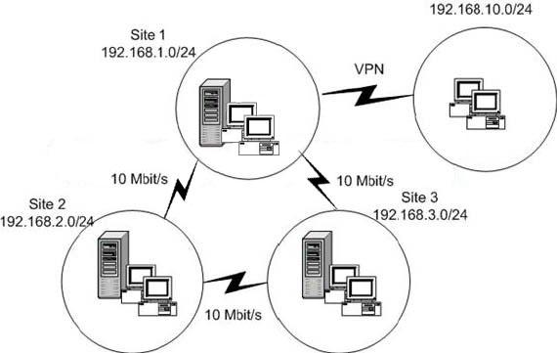

You are responsible for administering Site1. All virtual private network (VPN) clients are assigned to Site1. You want to manage all clients by using SMS.

You need to ensure that clients that connect to Site1 by using a VPN connection can only access specific advertisements.
What should you do?

- Add 192.168.1.0 as a remote roaming boundary.

- Add 192.168.2.0 as a remote roaming boundary.
- Add 192.168.3.0 as a remote roaming boundary.
- Add 192.168.10.0 as a local roaming boundary.
- Add 192.168.10.0 as a remote roaming boundary.

Answer: E

Explanation:

An SMS site can include boundaries that define clients the site should
manage but that may be across a slow WAN link and considered remote from the installed SMS site server and distribution points. Such boundaries are designated as "remote roaming" boundaries, which means that clients residing within or travelling to the designated boundary have no local distribution point and should be assumed remote for the purposes of software distribution.

QUESTION 35:

HOTSPOT

You are the SMS administrator for Certkiller .com. The network contains computers

running the following operating systems:

- Microsoft Windows NT Workstation 4.0
- Microsoft Windows 2000 Professional
- Microsoft Windows XP Professional
- Microsoft Windows Server 2003 Standard Edition
All operating systems are running the latest service packs.
You need to deploy the SMS client software on all the computers on company's network. You want to use the SMS Client Push Installation method.
You need to configure the SMS Client Push Installation Properties. What should you do?
To answer, use the dialog box controls to configure the options correctly in the answer area.
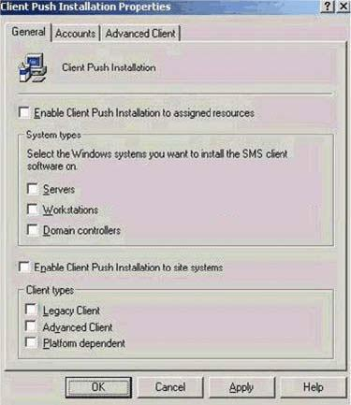

Answer:

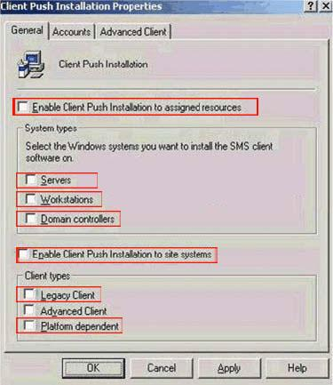

Explanation:

Check Enable Client Push, need to be selected.
System Types: All must be selected, as the question says install on "all computers in company". Per MS, if no boxes are selected, the client will not be installed on any computers.
Check - Enable client push to site sys, need to be selected. Client Types: Two boxes must be selected:
Legacy - There are NT4 computers, which must run Legacy Client
Platform Dependent - Means push Advanced Client to any and all systems which support Advanced Client.

QUESTION 36:

You are the SMS administrator for Certkiller .com. Your SMS hierarchy consists of a single SMS 2003 SP1 site.

Certkiller acquires a company that has a single office with an Active Directory domain and a single SMS 2.0 SP4 site. You create a two-way trust relationship between your domain and this new domain.
You need to manage SMS for the new environment from Certkiller 's current office. You want to achieve this goal by using the least amount of administrative effort. What should you do?

- Upgrade the SMS 2.0 SP4 site to an SMS 2003 site and configure the new site as a child site.
- Uninstall the SMS 2.0 SP4 site and configure the existing SMS 2003 site to contain the boundaries for the new network.
- Configure the SMS 2.0 SP4 site as a child of the existing SMS 2003 site.
- Install SMS 2003 SP1 on another computer and create a new site. Configure the existing two SMS sites as children of the new site.

Answer: C

Explanation:

SMS 2003 can work with an SMS 2.0 child site (including secondary
sites), primarily to continue the support for NetWare and Windows 95 where it is required. This solution would achieve the goal with the least amount of administrative effort but it is not the recommended solution for a production environment.

QUESTION 37:

You are the SMS administrator for Certkiller .com. Your SMS 2003 hierarchy consists of a central site and a primary child site.

You move a computer from the child site to the central site. You assign this computer to the central site. You discover that the computer is unable to access a management point on the central site.
You need to allow the computer to access the management point on the central site. You want to achieve this goal by using the least amount of administrative effort. What should you do?

- Reinstall the SMS client by using the Client Push Installation Wizard.

- Reinstall the management point.
- Reinstall the SMS client by using Smsman.exe.
- Reinstall the SMS client by using Client.msi.

Answer: A

Explanation:

Reinstalling the management point would do no good in this case as it is only this one computer that is unable to access the management point.
Reinstalling by using the Client Push Installation Wizard would solve the problem with least administrative effort as the other reinstallation options would require manual installation.

QUESTION 38:

You are the SMS administrator for Certkiller .com. Your network consists of a single Active Directory domain. Advanced security is enabled.

Currently, Active Directory is not being used by SMS. You want to enable SMS to publish data in Active Directory.

You need to configure Active Directory to be used by SMS.
Which two actions should you perform? (Each answer presents part of the solution. Choose two.)

- Grant Full Control permission for the System container to the SMS Admins group.

- Grant Full Control permission for the System container to the SMS Service Account.
- Create a container in Active Directory named System Management under the System container.
- Create a container in Active Directory named SMS under the System container.
- Grant Full Control permission for the System Management container to the site server computer account.

Answer: C, E

Explanation:

The Active Directory container used by SMS 2003 is named System Management so answer E is incorrect. The SMS site server will publish into the System Management container and therefore the site server computer accounts needs Full Control permission on this container. The SMS Service Account or

members of a SMS Admins group should never change anything within the System Management container.

QUESTION 39:

You are the SMS administrator for Certkiller .com. The company has a main office and a branch office. The SMS Advanced Client is installed on all computers on the network. A secondary SMS site server is installed at the branch office. The main office is connected to the branch office by a 128-Kbps WAN connection.

You need to limit traffic over the WAN connection while software is deployed and during client communication.
Which two roles should you assign to the SMS server at the branch office? (Each correct answer presents part of the solution. Choose two.)

- Client access point

- Distribution point
- Proxy management point
- Server locator point

Answer: B, C

Explanation:

A local distribution point at the branch office is to prevent program
packages from being downloaded from the main office more than once. The proxy management point will collect the inventory data from all the clients at that site and

convert them from XML to native SMS file format and forward them to the secondary site. The secondary site will then compress these files and forward them, via the sender (and using the sender scheduling and bandwidth controls) to its parent primary site server. The secondary site will also send these files in batches (saving even more space) on a per file type basis, if there are multiple inventory files of the same type.

QUESTION 40:

You are the SMS administrator for Certkiller .com. Certkiller has resources that include computers in Active Directory, computers in workgroups, network print devices, and routers. Only the default SMS discovery methods are enabled.

You need to discover network resources that have an IP address and Active Directory computers that have IP addresses on a weekly basis.
You need to use SMS to perform these tasks.
Which SMS discovery method or methods should you configure and enable? (Choose all that apply.)

- Network Discovery

- Heartbeat Discovery
- Windows User Group Discovery
- Windows User Account Discovery
- Active Directory System Discovery
- Active Directory System Group Discovery

Answer: A, E

Explanation:

Plan to use Network Discovery if you want to find any device on your
network that has an IP address. Use Network Discovery to search specific subnets, domains, SNMP devices, and Windows NT or Windows 2000 Dynamic Host Configuration Protocol (DHCP) servers for resources. The Active Directory System Discovery method polls the nearest Active Directory domain controller to discover Active Directory computers.

QUESTION 41:

You are the SMS administrator for Certkiller .com. You use SMS 2003 SP1 and the Security Update Inventory Tool for patch management.

You install a new server on the network. The server is discovered by SMS. The SMS Advanced Client software is installed on the server. The Security Scan advertisement runs successfully on the new server.
You need to verify that the new server has all the necessary software updates applied.
What should you do?

- Force a hardware inventory cycle and verify the information in the Software Updates folder in Resource Explorer.
- Force a software inventory cycle and verify the information in the Software Updates folder in Resource Explorer.
- Force a hardware inventory cycle and verify the information in the Software Updates container in the SMS Administrator console.
- Force a software inventory cycle and verify the information in the Software Updates container in the SMS Administrator console.

Answer: A

Explanation:

You use the Hardware Inventory Client Agent to import data into the Add/Remove programs part of the Resource Explorer. The Software Updates container in the SMS Administrator Console will not display which computers that need specific updates.

QUESTION 42:

You are the SMS administrator for Certkiller .com. The SMS hierarchy consists of a single primary site. The SMS site contains two distribution points. The SMS Advanced Client is installed on all computers.

You create an advertisement to install Microsoft Office Professional Edition 2003 on all computers. Users report that they are not able to access files over the network. You discover that the package download for the advertisement is consuming 100 percent of the available network resources.

You need to enable users to resume their regular work while the package is being downloaded.
What should you do?

- Create a Network Load Balancing cluster with the existing distribution points.

- Enable Background Intelligent Transfer Service (BITS) on the distribution points.
- Add more distribution points.
- Protect the distribution points.

Answer: B

Explanation:

BITS is a component that that will transfer files in the foreground or background, provide download resume capabilities and provide bandwidth throttling for downloads.

QUESTION 43:

You are the SMS administrator for Certkiller .com. All servers run Microsoft Windows Server 2003. All desktop computers run Windows XP Professional.

Certkiller has a single SMS site, and the SMS Advanced Client is installed on all computers on the network.

Certkiller is creating an inventory of all computer hardware. You need to gather hardware-specific information from each computer in Certkiller .
You need to create and collect asset tag data for each computer so that you can customize the information that the Hardware Inventory Client Agent compiles. Which two actions should you perform? (Each correct answer presents part of the solution. Choose two.)

- Create an IDMIF file.

- Create a NOIDMIF file.
- Select the Collect IDMIF files check box.
- Select the Collect NOIDMIF files check box.
- Stop and restart the Windows Management Instrumentation (WMI) service.

Answer: B, D

Explanation:

The most common way to use a NOIDMIF file is to create a new class
that cannot be collected with inventory, and then store it in the SMS site database. For example, before SMS was installed on their network, Certkiller catalogued each computer in the organization by using a company-assigned asset number. These numbers were assigned and collected by hand. With SMS, administrators from Certkiller can use a NOIDMIF file to add the asset number for each client computer to its other information within the SMS site database, so that it is available for queries and asset management. Because the asset number is then associated with collected inventory properties, much more information is always available to administrators. The following sample NOIDMIF file illustrates this process:

Start Component
Name="System Information" Start Group
Name=" Certkiller Asset Numbers" ID=1
Class=" Certkiller AssetNumbers" Key=1 Start Attribute
Name="Computer Asset Number" ID=1 Type=String(10)
Value="414207" End Attribute End Group
End Component
IDMIF and NOIDMIF files are not validated, so they could be used to alter tables that you do not want altered. Valid data could be overwritten by invalid data. Large amounts of data could be loaded, causing delays in all SMS functions. To mitigate this risk, you can disable the IDMIF and NOIDMIF collection. Newly installed SMS2003 sites have MIF collection disabled by default.

QUESTION 44:

You are the SMS administrator for Certkiller .com. Certkiller has a single SMS site, and the SMS Advanced Client is installed on all computers. The only optional SMS site system role that is enabled on the site is the management point. The Hardware Inventory Client Agent and the Software Inventory Client Agent are disabled.

You plan to upgrade the memory on all computers that have less than 512 MB of RAM. You want to maintain a list of these computers so that you can view the list at any time, directly from the SMS Administrator console.
You need to configure SMS to create the list.
Which two actions should you perform? (Each correct answer presents part of the solution. Choose two.)

- Enable the Hardware Inventory Client Agent.

- Enable the Software Inventory Client Agent.
- Create a report to display the required data.
- Create a query to display the required data.
- Create a dashboard to display the required data.

Answer: A, D

Explanation:

To start with you have to enable the Hardware Inventory Client Agent
to know how much memory any computer has. The fastest way to get SMS to present the data, if you don't need the good looking report would be to use a query (see the figure) with the criteria "Memory.Total Physical Memory (Kbytes) is less than 524288"

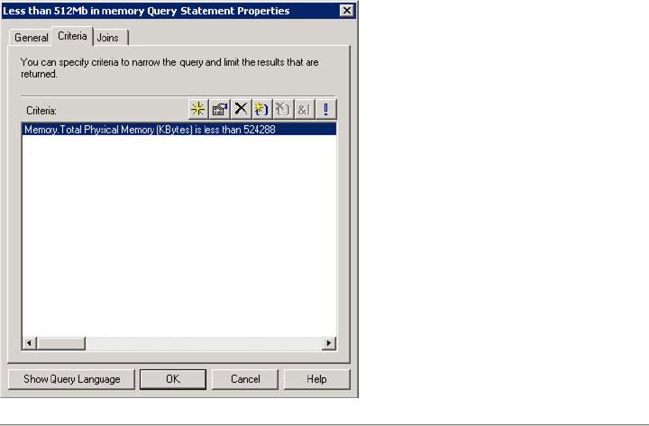

QUESTION 45:

You are the SMS administrator for Certkiller .com. You use SMS 2003 SP1 and the Security Update Inventory Tool for patch management.

You add several new computers to the network. The new computers run Microsoft Windows 2000 Server and Microsoft SQL Server 2000. The new computers are discovered by SMS. The SMS Advanced Client software is installed on the computers. You configure an advertisement to run the Security Scan tool and force an inventory cycle on the new computers.
You need to verify that all necessary updates for the operating system and SQL Server are applied to these computers. You want to achieve this goal by using the least amount of administrative effort.
What should you do?

- Run a software compliance report and filter by Knowledge Base article.

- Run a software compliance report and filter by product.
- Run a software distribution report.
- Run a software update distribution report and filter by Knowledge Base article.

Answer: B

Explanation:

To filter by Knowledge Base article would not give you a verification
of all necessary updates for SQL or Windows 2000. A software distribution report would give you the status of all advertised programs. A Software Updates by Product report would give you the option to show all updates for SQL or Windows 2000 and which computers that have installed the updates.

QUESTION 46:

You are the SMS administrator for Certkiller .com. You use SMS 2003 SP1 and the Security Update Inventory Tool for patch management. The Security Update Inventory Tool is installed and configured with the default settings. The package created by the tool is named Security.

You test the patch management process. You are running the Security advertisement on a single test computer named Certkiller 1. You discover that there is a long delay before SMS displays the software update information.
You need to ensure that the software update data is sent to the SMS server as soon as the Security advertisement finishes running. You want to achieve this goal by using the least amount of administrative effort.
What should you do?

- Create a new package with a script that forces a software inventory cycle to run on Certkiller 1.
- Force a software inventory cycle from Certkiller 1 after running the Security advertisement.

- Force a hardware inventory cycle from Certkiller 1 after running the Security advertisement.
- Change the Security advertisement to run the Security (expedited) program.

Answer: D

Explanation:

Using the expedited program will cause a full hardware inventory
cycle and may cause serious network and performance issues. This method is recommended for a small collection of reference machines only. Speeding up the software inventory cycle would not help as the updates are inventoried through the hardware inventory.

QUESTION 47:

You are the SMS administrator for Certkiller .com. The SMS hierarchy consists of a single primary site.

The company is deploying Microsoft Office Professional Edition 2003. You want to ensure that Office 2003 is installed only on computers that have at least 256 MB of RAM. You want to ensure that after a memory upgrade occurs, the computer will

automatically run an advertisement to install Office 2003. You create a collection to use as the target for this advertisement.

You need to populate the new collection. What should you do?

- Run a report to display all computers that have at least 256 MB of RAM. Add each computer to the collection.
- Run a query to display all computers that have at least 256 MB of RAM. Add each computer to the collection.
- Create a Direct Membership to include all computers that have at least 256 MB of RAM.
- Create a Query Membership to include all computers that have at least 256 MB of RAM.

Answer: D

Explanation:

Answers A, B and C all fails to make the collection dynamic so that
whenever a memory upgrade occurs on a computer, that computer will NOT join the collection with the Office 2003 installation.

QUESTION 48:

You are the SMS administrator for Certkiller .com. The SMS 2003 site hierarchy consists of a single primary site. Servers run Microsoft Windows Server 2003. Desktop computers run Windows XP Professional.

You enable the Remote Tools Client Agent to manage the Remote Assistance settings. Users who are members of a group named Help Desk need to be able to take control of the SMS clients by using Remote Assistance.
You need to ensure that the Help Desk group has the required permissions. You want to achieve this goal by using the least amount of administrative effort. What should you do?

- Advertise a script that adds the Help Desk group to the list of Remote Users to run on all computers.
- Create a Group Policy object to add the Help Desk group to the list of Remote Users for all computers.
- Add the Help Desk group to the list of Remote Users on every computer to which the members of the group should have access.
- Add the Help Desk group to the list of Permitted Viewers and set the access level to Full control.

Answer: D

Explanation:

The easiest way for an SMS administrator to grant a group of users

permission to remotely administer a computer is by adding the group to the list of Permitted viewers under the security tab in the Remote Tools Client Agent Properties window and the setting the Level of remote access allowed to Full under the Policy tab.

QUESTION 49:

You are the SMS administrator for Certkiller .com. The SMS hierarchy consists of a single primary site.

You create a package that will be used to install new accounting software. You want to ensure that only members of a group named Accounting Department can install the package.
You need to prevent other user groups from accessing the distribution point share manually and installing the package, without affecting other packages.
What should you do

- Change the Access Accounts settings for the package to include only the Accounting Department group.
- Change the permissions for the distribution point share to include only the Accounting Department group.
- Change the package to use a hidden share.
- Change the package to use a UNC path instead of a share.

Answer: A

Explanation:

In the SMS Administrator Console under System Management Server
> Site Database > Packages > [Package Name] > Access Accounts remove the Read permissions from the Users group and ad the Accounting Department group with Read permissions. Changing the permissions for the share is not an option as this would deny everyone except the Accounting Department group access to all applications on the server. The package is put in a folder inside a share containing folders for all packages so hiding the share for the package folder is not an option. Changing to a UNC path would in no way prevent other users from accessing the package.

QUESTION 50:

You are the SMS administrator for Certkiller .com. All desktop computers run Microsoft Windows XP Professional. The SMS 2003 Advanced Client is installed on all the computers on the network.

You create a package and distribute it to all distribution points. You configure a mandatory advertisement to target all Advanced Clients within the site.
You need to verify if a specific SMS client computer executed the advertisement. Which three resources should you use? (Each correct answer presents part of the solution. Choose three.)

- Advanced Client Spy tool (CliSpy.exe)

- Policy Spy tool (PolicySpy.exe)
- ExecMgr.log
- Client.msi.log
- Status Messages
- Software Updates node

Answer: A, C, E

Explanation:

Advanced Client Spy tool (CliSpy.exe) - Troubleshoots Advanced Client problems and is used for troubleshooting Advanced Client software distribution problems. It also reports inventory and software metering data.
Policy Spy tool (policySpy.exe) - An Advanced Client policy viewer that is required to troubleshoot an Advanced Client's policy.
ExecMgr.log - Running advertised programs, command lines executed, successful or not, and exit codes will appear in this log file. Check this log for issues with advertisements. Client.msi.log - Logs any errors during install of the SMS Client.
Status Messages - The natural place to look for status on advertisements, distribution points and every other function provided by SMS.
Software Updates node - Is used to distribute Software updates through the SMS Administrator console. Will not show status on any advertisements.

QUESTION 51:

DRAG DROP

You are the SMS administrator for Certkiller .com.The SMS 2003 site hierarchy consists of a single primary site.The site server is configured as a management point, client access point, server locator point, and distribution point. All client computers run the SMS Advanced Client.
You need to track the accounts that are used by SMS to access a distribution point from a SMS client. All advertisements are assigned to computers.
You need to prepare a list of these accounts and arrange them in the order in which they are used.
To answer, move the appropriate accounts from the list of accounts to the answer area and arrange them in the correct order.
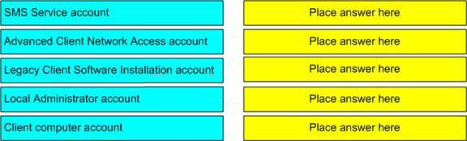

Drag and drop question. Drag the items to the proper locations.

Answer:
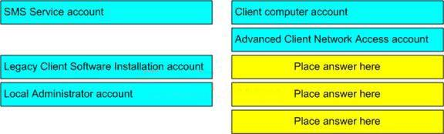

Explanation:

Client computer account - The computername$ is the normal way for an Advanced Client to access the distribution point.
Advanced Client Network Access account - is used for software distribution, when either the currently logged on user account or the client computername$ account does not have sufficient permissions to access the distribution point. Used only for accessing content on the network, but never for running content on the computer.

QUESTION 52:

You are the SMS administrator for Certkiller .com. Hardware and software inventory run on a daily basis.

You monitor the inbox folders in your SMS site server daily. While performing this maintenance task, you discover that the Sinv.box and Dataldr.box folders contain a backlog of more than 10,000 files each.
You need to identify the cause of this backlog. What is the most likely cause of this problem?

- The SMS_SOFTWARE_INVENTORY_PROCESSOR component is not working.

- The SMS_INVENTORY_DATA_LOADER component is not working.
- The management point is not processing data from client computers.
- The SMS site server cannot access the site database.

Answer: D

Explanation:

This folder stores client software inventory files (.sic and .sid files) that are copied from the CAP. A backlog of files may indicate that the Software
Inventory Processor cannot connect to the SMS database or that too many files were received. Examine status messages for the Software Inventory Processor for possible problems. You can also examine the Sinvproc.log file for errors or additional information.

QUESTION 53:

You are the SMS administrator for Certkiller .com. The SMS 2003 site hierarchy consists of a single primary site named Site1. The SMS 2003 Advanced Client is installed on all computers.

You need to monitor the SMS clients. You install the SMS 2003 Client Health Monitoring Tool on a computer in Site1. The SMS 2003 Client Health Monitoring tool is configured as shown in the Health Configuration exhibit.
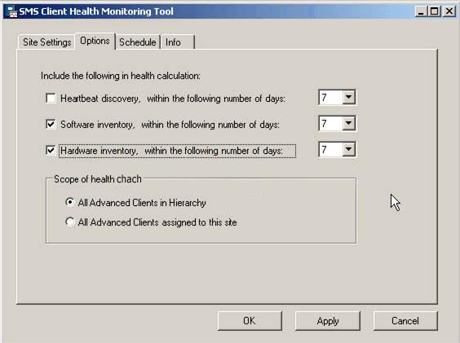

The Hardware Inventory Client Agent and the Software Inventory Client Agent are scheduled to run at identical intervals, as shown in the Hardware Inventory Client Agent exhibit.

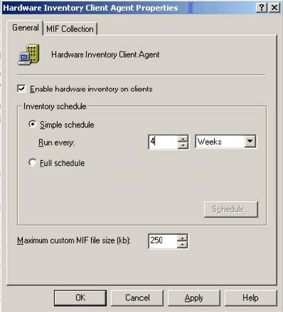

You add 90 new client computers to the network. All of the new client computers are assigned to the SMS site. The SMS Advanced Client is installed on all of the new computers.

Two weeks later you run the Client Health Summary report. The report indicates the majority of the clients on your network are unhealthy. You confirm that the 90 new client computers are healthy.
You need to ensure that all healthy clients on the network are reported accurately by the SMS 2003 Client Health Monitoring Tool. You want to achieve this goal by using the least amount of administrative effort.
What should you do?

- Configure the hardware and software inventory options for the SMS 2003 Client Health Monitoring Tool to use periods longer than the periods specified in the SMS inventory agents.

- Configure the hardware and software inventory options for the SMS 2003 Client Health Monitoring Tool to run every 14 days.
- Configure the hardware and software inventory schedules to run once a week.
- Configure all client computers to run a hardware and software inventory cycle.

Answer: A

Explanation:

A recommended practice is to set the health period to be at least twice

the corresponding SMS client agent interval. For example, if you collect hardware inventory once a week, set the hardware inventory health period to 14 days.

QUESTION 54:

You are the SMS administrator for Certkiller .com. You are responsible for implementing a backup and recovery strategy. The SMS backup maintenance task is configured as shown in the exhibit.
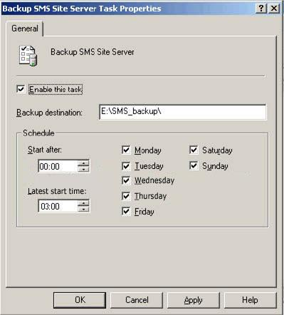

You need to copy the backup data to a network location so that it is available in the event of a server failure. You create a batch file that copies the SMS backup data to the appropriate network location immediately after the backup is complete.

What should you do next?

- Save the batch file as Afterbackup.bat in the C. \BACKUP folder.

- Save the batch file as Afterbackup.bat in the Smsbkup.box folder.
- Create a Scheduled Task to run the batch file on a daily schedule.
- Create a SQL Task in SMS to run the batch file on a daily schedule.

Answer: B

Explanation:

You can use the AfterBackup.bat file to run a third-party tool that
automatically archives the backup snapshot every time you back up your site. After successfully backing up the site, the SMS backup task runs the AfterBackup.bat batch file. The AfterBackup.bat file integrates the archive and the backup operations, thus ensuring that every new backup snapshot is archived. Every time the backup task runs successfully, it will run the SMS\inboxes\smsbkup.box\AfterBackup.bat file.

QUESTION 55:

You are the SMS administrator for Certkiller .com. The SMS 2003 site hierarchy consists of a primary central site and a secondary child site. The two sites are linked by a 64-Kbps connection.

The status of the SMS_HIERARCHY_ MANAGER component and the SMS_LAN_SENDER component both display as Critical. You discover that the available bandwidth is insufficient. It will take two weeks to acquire a new connection.
You need to ensure that the status for the SMS_HIERACHY_MANAGER and the SMS_LAN_SENDER components are not set to Critical or Warning.
What are two possible ways to achieve the goal? (Each correct answer presents a complete solution. Choose two.)

- Configure the address rate limit to use 25 percent of the available bandwidth.

- Change the Warning threshold and Critical threshold for warning messages and error messages for the two components to the maximum possible value in the Component Status Summarizer for the SMS site.
- Create Status Filter Rules to track messages for each component, and select the Do not forward to status summarizer check box.
- Create Status Filter Rules to track messages for each component, and clear the Replicate to parent site check box.

Answer: B, C

Explanation:

You view the thresholds for a component by right-clicking a component in the details pane and clicking Properties. The Status Threshold Properties dialog box specifies Warning and Critical thresholds for Error, Warning, and Informational status messages and the Threshold period. The threshold period specifies the period of time for which the thresholds are evaluated. For example, if the threshold period is Since 8:00:00 AM and the Informational messages threshold is set to 100 for Warning and 200 for Critical, then the component's status indicator is set to Warning whenever the component has reported between 100 and 199 Informational status messages since 8:00:00 A.M. on any given day. The component's status

indicator is set to Critical whenever the component reports 200 or more Informational status messages.

The "Do not forward to status summarizer" specifies that each time a status message matches this rule, the Status Manager should not forward a copy of this status message to any status summarizer components. You use this option to throw away messages that are flooding the system. For example, if a server component reports a particular Error status message every 10 seconds that is not relevant for your site, that error is not tallied by the Component Status Summarizer. A long series of these errors in a short time causes the Critical Threshold to be exceeded, and the component is flagged as Critical in the Component Status summary display. You can set up a filter rule to prevent a particular Error status message from being forwarded to the Component Status Summarizer, which prevents the threshold from being exceeded and the component being marked as Critical.

QUESTION 56:

You are the SMS administrator for Certkiller .com. The network consists of a single Active Directory domain. The SMS hierarchy consists of a central primary site and two primary child sites. The primary child sites are directly below the central site in the SMS hierarchy.

You configure the site boundaries for each SMS site. When computers from a child site roam to another site, they cannot access the management points and the local distribution points. Computers from the central site do not encounter this problem when roaming.
You need to ensure that client computers can roam to any site.
Which two actions should you perform? (Each correct answer presents part of the solution. Choose two.)

- Extend the Active Directory schema for SMS.

- Add a WINS entry for each management point in your SMS hierarchy.
- Add all Active Directory sites to the roaming boundaries of each SMS site as local roaming boundaries.
- Enable SMS to publish data to Active Directory.
- Enable the Remote Tools Client Agent.

Answer: A, D

Explanation:

You need to extend the Active Directory schema if:
- You want to use global roaming for Advanced Clients.
- You want to use the most secure method available for authenticating management points to Advanced Clients.
- You want to use automatic key exchange for secure site-to-site communications.
- You want clients to automatically detect the server locator points and management points without requiring Windows Internet Name Services (WINS). If you do not extend the schema, WINS is required for automatic site assignment, roaming and selection of a local management point.

Additionally you have to allow SMS to publish data to Active Directory; otherwise extending the schema will have no effect.

QUESTION 57:

You are the SMS administrator for Certkiller .com. Your SMS 2003 site hierarchy consists of a single primary site that was recently installed. Servers run Microsoft Windows Server 2003, Windows 2000 Server, or Windows NT Server 4.0. Client computers run Windows XP, Windows 2000 Professional, Windows 98, or Windows 95. All operating systems run the latest service packs.

You are responsible for deploying the SMS client software on all computers in your SMS site.
You need to identify which SMS client software will be deployed to the computers. Which SMS client or clients should you deploy to the computers? (Choose all that apply.)

- Advanced Client

- Legacy Client
- SMS 2.0 Client
- Device Client

Answer: A, B

Explanation:

Advanced Client should be installed on all computers except the
Windows NT Server 4.0 and the Windows 98 computers, which should use the Legacy client. The Advanced client and the Legacy client are the only clients used by SMS 2003.

QUESTION 58:

You are the SMS administrator for Certkiller .com. The network consists of a single Active Directory domain. The SMS 2003 site hierarchy consists of a single primary site. All roles are enabled on the SMS site server. The SMS Advanced Client is installed on all computers.

You move a Web server from the internal network to the perimeter network. You remove this Web server from the Active Directory domain and add it to the perimeter network workgroup. You discover that the Web server is no longer able to communicate with the SMS site. You verify that the perimeter network IP subnet is included in the SMS site boundaries.
You need to ensure that the Web server located on the perimeter network is managed by the SMS site.
What should you do?

A. Configure the Web server to use the production WINS server to resolve the management point.

- Configure the Web server to use the production WINS server to resolve the server locator point.
- Install a management point on the perimeter network IP subnet.
- Install a server locator point on the perimeter network IP subnet.

Answer: A

Explanation:

When the Web server no longer is a member of the Active Directory
domain it will not be able to resolve the management point through the System Management container in the Active Directory and therefore needs to look up the Management point through WINS. The Server Locator Point is used to automatically assign a Advanced Client to a Management point during installation and installing a Management Point on the perimeter network would not help as this also would publish information to the Active Directory.

QUESTION 59:

You are the SMS administrator for Certkiller .com. The company has two offices. One office is installed as a primary site. The other office is installed as a secondary site.

The secondary site contains Advanced Clients. You discover that some of these clients run advertised programs from the distribution point in the primary site rather than from the local distribution point.
You need to ensure that these computers run advertised programs from the local distribution point.

What are two possible ways to achieve the goal? (Each correct answer presents a complete solution. Choose two.)

- Remove the secondary site's site boundary from the primary site's roaming boundaries.
- Remove the secondary site's site boundary from the primary site's site boundary.
- Add the primary site's site boundary to the secondary site's roaming boundaries.
- Add the primary site's site boundary to the secondary site's site boundary.

Answer: A, B

Explanation:

Removing the secondary site's boundary from the primary site's
roaming boundaries would prevent all clients from the secondary site to use the primary site's distribution point as a remote distribution point. It is not a good practice to have multiple sites sharing common boundaries. It is perfectly fine to have multiple sites in the same domain, but you should not have multiple sites sharing a common boundary. That makes it hard to isolate your clients to a specific SMS site.

QUESTION 60:

You are the SMS administrator for Certkiller .com. The SMS hierarchy consists of a single SMS 2.0 SP3 site. The site uses a Microsoft SQL Server 7.0 database.

You need to upgrade the site to SMS 2003 SP1 in advanced security mode. You want to use software metering. You decide to perform an in-place upgrade.
Which two actions must you perform before you upgrade the site to SMS 2003 SP1? (Each answer presents part of the solution. Choose two.)

- Upgrade the SMS software to SMS 2.0 SP4, or later.

- Upgrade SMS clients to Advanced Clients
- Upgrade SMS clients to Legacy Clients.
- Upgrade SQL Server 7.0 to SQL Server 7.0 SP3.
- Upgrade SQL Server 7.0 to SQL Server 2000 SP3, or later.

Answer: A, E

Explanation:

SMS 2003 supports an upgrade path from SMS 2.0 SP4 or later. SQL
2000 SP3 or later is required for the SMS to run in advanced security mode.

QUESTION 61:

You are the SMS administrator for Certkiller .com. Your network consists of a single Active Directory domain. Your network is configured as shown in the exhibit.
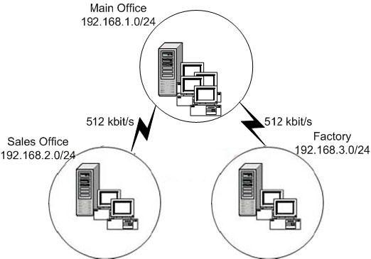

The SMS Advanced Client is installed on all computers on the network. The help desk department is located at the main office. Network administrators are located at the main office and the factory site. These administrators are responsible for maintaining the SMS hierarchy.

You want to control the settings for the factory site independently of the other sites. You want to access SMS data for any site from the main office. You also want to control the bandwidth that is used by SMS when data is exchanged between the locations.
You need to decide on the number of SMS sites, their location, and type. You want to implement the SMS hierarchy by incurring the least cost.
What should you do?

- Create a single primary SMS site.

- Create a primary SMS site for the main office, a primary SMS site for the factory, and only a protected distribution point in the sales office.
- Create a primary SMS site for the main office, a secondary SMS site for the factory, and another secondary SMS site for the sales office.
- Create a primary SMS site for the main office, a primary SMS site for the factory, and a secondary SMS site for the sales office.

Answer: D

Explanation:

With only one primary SMS site you won't be able to control the
settings for the factory site independently. A protected distribution point at the sales office would not help you to manage the bandwidth used by the Advanced Clients when they connect to the Primary site, for this you would need a secondary site acting as a proxy management point. A secondary site at the factory site would not help as the Advanced Clients are always assigned to a primary site.

QUESTION 62:

You are the SMS administrator for Certkiller .com. Your SMS 2003 hierarchy consists of a single primary site. The SMS site server is configured as a management point, client access point, and server locator point. The SMS Advanced Client is installed on 25,000 desktop computers.

As a result of the large number of desktop computers, the management point is often unavailable for receiving data. You want to increase the capacity of your current SMS site.
You need to configure your SMS infrastructure so that desktop computers can access multiple management points.
What should you do?

- Add IISLockdown to the existing management point.

- Add a primary site with a new management point.

- Add a management point and configure Network Load Balancing.

- Add a management point as the default management point for the site.

Answer: C

Explanation:

You can use Network Load Balancing for management points and
server locator points to meet the capacity needs of your organization. However, a primary site can have only one logical management point (the default management point). That default management point can be either a single computer or multiple computers running in a Network Load Balancing cluster. You can also implement Network Load Balancing for server locator points, although you are not restricted to a single server locator point in a site or even a site hierarchy.

QUESTION 63:

You are the SMS administrator for Certkiller .com. Your SMS 2003 site hierarchy consists of a single primary site that was recently installed with advanced security. All roles are enabled on the SMS site server. All client computers run Microsoft Windows XP Professional.

You are responsible for deploying the SMS client software on all computers in the SMS site today.
You need to configure the SMS site server to automatically install the SMS client software for all existing computers. In addition, you want the SMS site server to proceed with the installation process as soon as it discovers new computers. Which action or actions should you perform? (Choose all that apply.)

- Enable Client Push Installation to push the Advanced Client to all computers.

- Run Active Directory System Discovery to poll data as soon as possible.
- Run Active Directory System Group Discovery to poll data as soon as possible.
- Enable Active Directory System Discovery.
- Enable Active Directory System Group Discovery.
- Create an installation script to run Smsman.exe as the logon script for all users.
- Create an account that has rights to install software on all computers.

Answer: A, B, D, G

Explanation:

First you need to find all computers and all new computers in the
future, for this you have to enable and run the Active Directory System Discovery. If you want the SMS server to automatically install the SMS client on all computers you have to enable the Client Push Installation and for it to work you have to create an account with the appropriate rights that the Client Push Installation can use to connect to the computers.

QUESTION 64:

You are the SMS administrator for Certkiller .com. The network contains 10 SMS sites with three SMS site versions.

The site versions are as shown in the following tablE.
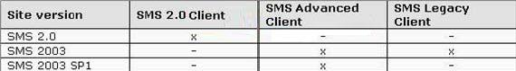

All SMS client computers run Microsoft Windows 2000 Professional.

You want to upgrade the existing Windows 2000 Professional computers to Windows XP Professional by using the Operating System Deployment (OSD) Feature Pack.
Which SMS client or clients support the OSD Feature Pack? (Choose all that apply.)

- SMS 2.0 C 2.0 Client

- SMS 2003 C Advanced Client
- SMS 2003 C Legacy Client
- SMS 2003 SP1 C Advanced Client
- SMS 2003 SP1 C Legacy Client

Answer: D, E

Explanation:

You must run SMS 2003 with Service Pack 1 (SP1) and install the
SMS SP1 client throughout your enterprise to take advantage of the OSD Feature Pack.

QUESTION 65:

You are the SMS administrator for Certkiller .com. Certkiller wants to use the SMS Device Management Feature Pack to manage Microsoft Windows CE enabled devices and Microsoft Windows Mobile 2003 enabled devices.

On which two SMS site systems can you install and configure the Device Management Feature Pack? (Each correct answer presents a complete solution. Choose two.)

- Client access point

- Management point
- SMS site server
- Microsoft SQL Server computer

Answer: B, C

Explanation:

The Microsoft Systems Management Server 2003 Device Management Feature Pack helps SMS 2003 manage devices running Windows CE 4.2 or Windows Mobile 2003 software for Pocket PC. The Feature Pack installs components on existing SMS 2003 Administrator Console, Site Server, and Management Point roles.

The feature pack includes the following features - Hardware inventory, Software inventory and file collection and Software distribution.

QUESTION 66:

You are the SMS administrator for Certkiller .com. All servers run either Microsoft Windows Server 2003 or Windows 2000 Server. Desktop computers run the following operating systems:

- Windows XP Professional
- Windows 2000 Professional
- Windows 98
- Windows 95
The company is planning to upgrade the current SMS site from SMS 2.0 to SMS 2003 SP1.
You need to ensure that all client computers are managed by SMS 2003 SP1. Which client operating system or systems must be upgraded? (Choose all that apply.)

- Windows 95

- Windows 98
- Windows 2000 Professional

- Windows XP Professional

Answer: A

Explanation:

SMS 2003 supports all listed Operating Systems except for Windows 95 with either the Advanced Client or the Legacy Client.

QUESTION 67:

You are the SMS administrator for Certkiller .com. The network consists of a single Active Directory domain. All servers run Microsoft Windows Server 2003. All desktop computers run Windows XP Professional.

You install a single SMS site server.
You need to discover all the computers on the network, including computers that are not turned on.
Which discovery method should you use?

- Active Directory User Discovery

- Active Directory System Discovery

- Active Directory System Group Discovery

- Heartbeat Discovery
- Network Discovery

Answer: B

Explanation:

The Active Directory System Discovery will detect all computers that have been made members of your Active Directory Domain. The SMS server will not try to connect to the client computers at the discovery phase and therefore it doesn't matter whether they are turned on or not.

QUESTION 68:

You are the SMS administrator for Certkiller .com. The network consists of a single Active Directory domain.

You create a report that displays hardware and software configurations for each SMS client computer. You need to ensure that help desk technicians can access this report.
You need to set up access to this report only for the group named Help Desk in the domain.
Which two actions should you perform? (Each correct answer presents part of the solution. Choose two.)

- Add Read access to the Help Desk group in the Class security rights section of the Security Properties for the report.

- Add Read access to the Help Desk group in the Instance security rights section of the Security Properties for the report.
- Add the Help Desk group to the SMS Reporting Users local group on the site server.
- Add the Help Desk group to the SMS Admins local group on the site server.
- Add the Help Desk group to the Users local group on the site server.

Answer: B, C

Explanation:

The Help Desk group has to bee a member of the SMS Reporting User
local group to be able to access the reports and in addition to this the group also has to added to the Instance security rights section of the Security Properties of the report to be able to see the contents of the report. If you add the Help Desk group in the Class security rights section of the Security Properties of the report the Help Desk group will have access to all reports.

QUESTION 69:

You are the SMS administrator for Certkiller .com. The network consists of a single Active Directory forest. The network is configured as shown in the following exhibit.

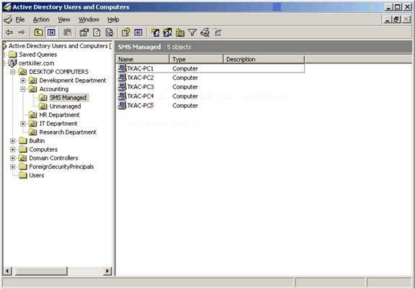

You are using Active Directory System Discovery.

You need to define the correct Active Directory LDAP path to ensure that only computers in the SMS Managed Organizational Unit (OU) will be discovered. Which LDAP path should you define for SMS Active Directory System Discovery?

- LDAP://OU=SMS MANAGED,OU=ACCOUNTING,OU=DESKTOP COMPUTERS,DC= Certkiller ,DC=COM,DC=REDMOND
- LDAP://OU=SMS MANAGED,OU=ACCOUNTING,OU=DESKTOP COMPUTERS,DC= Certkiller ,DC=COM
- LDAP://OU=SMS MANAGED,OU=ACCOUNTING,OU=DESKTOP COMPUTERS,DC= Certkiller
- LDAP://OU=SMS MANAGED,OU=ACCOUNTING,OU=DESKTOP COMPUTERS

- LDAP://OU=SMS MANAGED,OU=ACCOUNTING
- LDAP://OU=SMS MANAGED

Answer: B

Explanation:

LDAP usage: LDAP://<server>/OU=<Organizational Unit>,DC=<domain>,DC=<third tier DNS name>,DC=<second tier DNS name>,DC=<first tier DNS name>.

QUESTION 70:

You are the SMS administrator for Certkiller .com. You create a query to be used by the Help Desk group and the Database Administrators group on your network. The security properties for the query are configured as shown in the exhibit.
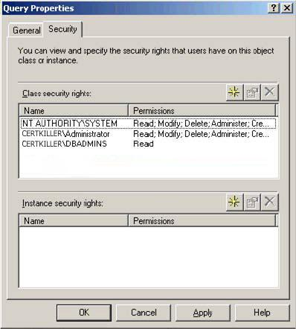

You need to configure the security for queries in the following manner:

- Members of the Database Administrators group should have read access to the query that you created.
- Members of the Help Desk group should have read access to all queries. What should you do?

- Remove the Database Administrators group from the Class security rights panel. Add the Help Desk group to the Instance security rights panel with read access.
- Add the Help Desk group to the Instance security rights panel with read access.
- Add the Help Desk group to the Class security rights panel with read access.
- Remove the Database Administrators group from the Class security rights panel and add it to the Instance security rights panel with read access. Add the Help Desk group to the Class security rights panel with read access.

Answer: D

Explanation:

Class level security rights grants users permissions for all object types
in a specific class - for example, all packages or all collections. Instance level security rights grants permissions for a specific instance of an object type, such as the "All Windows 98 Systems" collection or a " Certkiller Client Computers" collection.

QUESTION 71:

You are the SMS administrator for Certkiller .com. All servers run Microsoft Windows Server 2003. All desktop computers run Windows XP Professional. You need to create a Remote Installation Services (RIS) image that will include the SMS Advanced Client.

You want to ensure that the SMS Advanced Client is installed properly on the image. You need to install the SMS client software on a reference computer. Which two actions should you perform? (Each correct answer presents part of the solution. Choose two.)

- Run Ccmclean.exe on the reference computer.

- Run Ccmsetup.exe on the reference computer.
- Run Ccmdelcert.exe on the reference computer.
- Run Smsman.exe on the reference computer.

Answer: B, C

Explanation:

Ccmsetup.exe is used to invoke the Advanced Client Installer. The Advanced Client Installer works in the background in all Advanced Client installations, regardless of the SMS deployment method that you use. Ccmsetup.exe uses command-line options to modify its behavior, and then calls the Client.msi program, in which specified installation properties are used to complete the client installation. You can run the Ccmsetup.exe without any command-line options. If you do, you must ensure that there is a copy of Client.msi in the same folder with Ccmsetup.exe. The last step to perform with your master image before you are ready to save it for deployment, is to remove the security certificate. You do this by executing the CCMdelcert.exe tool from the CCMtools.msi file found on the SMS 2003 CD in the SMSSetup\Tools folder. Delete the certificate on the original computer before the master image is created. If a client refresh cycle runs, such as when the computer reboots, then before the image is created, the certificate must be deleted again.

QUESTION 72:

You are the SMS administrator for Certkiller .com. All desktop computers run Microsoft Windows NT workstation 4.0 sp6a.

You want to upgrade the existing desktop computers to Windows XP Professional SP2, You want to use the Operating System Deployment (OSD) Feature Pack to upgrade the computers, You create the image package by using the OSD Feature Pack,

You need to use the image package to upgrade the desktop computers,
Which two methods can you use to deploy the image package that you created? (Each correct answer presents a complete solution, Choose two,)

- Integrate the OSD Feature Pack image package with Remote Installation Services (RIS)
- Start a target system by using the Image Installation CD,
- Use SMS software distribution to advertise the package,
- Integrate the OSD Feature Pack image package with Automated Deployment Services
- Start a target system with the Image Capture Wizard CD,

Answer: A, C

Explanation:

The next step in the image deployment process is to distribute the OS Deployment package and program to the destination computers. You can distribute the OS Deployment package using SMS to advertise the OS Deployment package and program that you created, or you can deploy the package using a CD or Windows RIS server. Source: Microsoft Systems Management Server 2003 Operating System Deployment Feature Pack Users Guide, page 43.

QUESTION 73:

DRAG DROP

Exhibit:
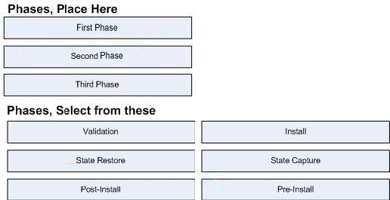

You are the SMS administrator for Certkiller .com. Certkiller .com has a single SMS site. The SMS advanced Client is installed on all discovered computers.

You need to upgrade the operating system on the SMS client computers from

Microsoft Windows 2000 Professional to Windows XP Professional. You have installed the Operating System Deployment (OSD) Feature Pack on the SMS site server.

You need to plan the sequence in which the OSD Feature Pack phases will be executed.
What should you do?

Answer:

Explanation:
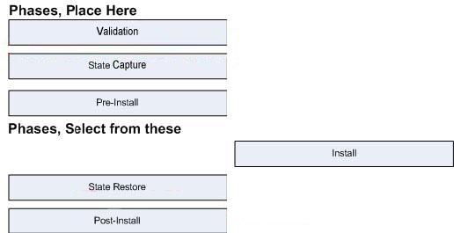

Reference: Microsoft Systems Management Server 2003 Operating System Deployment Feature Pack User Guide, page 34-38

QUESTION 74:

You are the SMS administrator for Certkiller .com. The SMS 2003 site hierarchy consists of a single primary site named London. The server for this side is named LONSMS. LONSMS has advanced security enabled, LONSMS is configured as a management point, client access point, server locator point, and distribution point. The SMS 2003 Advanced Client is installed on all computers.

Certkiller .com opens a new office in Dublin. The new server is named DUBSMS. This server will be a proxy management point, client access point, and distribution point for the new Dublin site.
You need to configure the Dublin site to be a secondary child site under London. You first configure an address for the new SMS site in LONSMS that points to DUBSMS.
Which two actions should you perform next to complete the task? (Each correct answer presents part of the solution. Choose two.)

- Add the DUBSMS$ account to the SMS_SiteToSiteConnection group in LONSMS.

- Add the DUBSMS$ account to the SMS_SiteSystemToSQLConnection group in LONSMS.

- Add the DUBSMS$ account to the SMS_SiteSystemToSiteServerConnection group in LONSMS.
- Add the DUBSMS$ account to the SMS Admins group in LONSMS.
- Add the DUBSMS$ account to the SMS Reporting group in LONSMS.

Answer: A, C

Explanation:

SMS_SiteToSiteConnection group - This group has the necessary permissions for a sender to connect from one site to another. All child site servers should be added to the Site to Site Connection group on the parent site. SMS_SiteSystemToSiteServerConnection group - This group allows site systems to connect to the site server. Management points, client access points, reporting points, and server locator points should be members of this group. Distribution points should not be members of this group.

QUESTION 75:

You are the SMS administrator for Certkiller .com. The SMS 2003 Advanced Client is installed on all computers.

You create an optional advertisement targeting all computers in a specific department. After three days you discover that only 20 percent of the targeted clients have executed the advertisement successfully.
You need to ensure that the advertisement is executed on all targeted computers. You want to accomplish this goal by using the least amount of administrative effort. What should you do?

- Instruct all users to run the advertisement from Run Advertised Programs In Control Panel.
- Instruct all users to run the advertisement from Add or Remove Programs In Control Panel.
- Create a mandatory advertisement to install the application on computers that did not run the previous advertisement.
- Create a network shared folder and instruct users to install the application from the shared folder.

Answer: C

Explanation:

If it is not an optional application you are advertising you should use
the mandatory advertisement and not rely on users that may be out of office, or just don't have time or care to run the advertisement.

QUESTION 76:

You are the SMS administrator for Certkiller .com. The SMS 2003 site hierarchy

consist of a single primary site.

You install a new security update by creating an advertisement with a mandatory assignment that targets all SMS clients. The next day, you discover that the advertisement was not executed by any of the SMS clients In your site.
You log on locally to an SMS client to check for new policies. You discover that no new policies were found. You perform the same test on multiple SMS clients and obtain the same result.
What should you do?

- view the SMS_Hierarchy_Manager components status.

- view the SMS_Despooler components status
- view the SMS_Scheduler components status
- view the SMS_MP_Control_Manager components status

Answer: D

Explanation:

The SMS _MP _Control_Manager will show you if there is any problems with the Management Point on the server.

QUESTION 77:

You are the SMS administrator for Certkiller .com. The network consists of a single Active directory domain and two SMS sites. The central SMS site is named London, and the primary child site is named Paris. The SMS Advanced Client is installed on all computers. Employees frequently roam between the London site and Paris site Network administrators report that WAN traffic has increased. You discover that SMS clients are accessing packages across the WAN connection.

You need to prevent SMS clients from connecting to a remote distribution point to download packages.
What should you do?

- Change the roaming boundaries for the Paris site to include the London Active Directory site as a remote boundary.
- Configure the distribution points as Background Intelligent Transfer Service (BITS) enabled distribution points.
- Configure all advertisements to prevent remote Advanced Clients from downloading or installing packages.
- Configure all packages to use the distribution points in London and Paris.

Answer: A

Explanation:

An SMS site can include boundaries that define clients the site should
manage but that may be across a slow WAN link and considered remote from the installed SMS site server and distribution points. Such boundaries are designated as

"remote roaming" boundaries, which means that clients residing within or traveling to the designated boundary have no local distribution point and should be assumed remote for the purposes of software distribution. These clients will then try to locate a distribution point at the site where they are at the moment instead of pulling the installation packages over the WAN link.

QUESTION 78:

You are the SMS administrator for Certkiller .com. The SMS 2003 site hierarchy consist of a central primary site named Site1 and one primary child site name dSite2. The SMS Advanced Client is installed on all computers.

You install the SMS 2003 Client Health Monitoring Tool on a computer assigned to Sitel. You configure the tool to use the SMS database in Sitel. Three days later, you run the SMS 2003 Client Health Monitoring Tool. You discover that only SMS clients that are assigned to Sitel are being monitored.
You need to monitor client computers assigned to all SMS sites. You want to achieve this goal by using the least amount of administrative effort.
What should you do?

- Install the SMS 2003 Client Health Monitoring Tool in Site2.

- Reinstall the SMS 2003 Client Health Monitoring Tool in Sitel and configure it to connect to the SMS site database for Site2.
- Configure the SMS 2003 Client Health Monitoring Tool in Sitel to monitor the SMS hierarchy.
- Configure Site2 as a secondary site that uses the database in Sitel.

Answer: C

Explanation:

The SMS 2003 Client Health Monitoring Tool documentation with the tool. Pg 29.

