Chapter 5:

Basic Productivity Applications

Multiple Choice:

- Entering and editing text can be done most efficiently using a:
  - spreadsheet.
  - desktop publishing program.
  - typewriter.
  - word processing program.
Answer: D Reference: Word Processing Tools and Techniques Difficulty: Easy
- The common term pronounced “wizzy-wig” stands for:
  - what you see is what you get.
  - what you see works in great ways.
  - WYSWWIG.
  - WZZYWIG.
Answer: A Reference: Word Processing Tools and Techniques Difficulty: Easy
- To have a page number and chapter title appear at the bottom of every page, create a:
  - header.
  - footer.
  - footnote.
  - heading at the bottom of the page.
Answer: B Reference: Word Processing Tools and Techniques Difficulty: Easy
- What is the term for how words will appear on a page?
  - Typeface
  - Point size
  - Character formatting
  - Text formatting
Answer: D Reference: Word Processing Tools and Techniques Difficulty: Moderate
- The alignment of text on a line is referred to as:
  - spacing.
  - alignment.
  - justification.
  - margin alignment.
Answer: C Reference: Word Processing Tools and Techniques Difficulty: Moderate
- When both margins are straight and smooth, the document contains:
  - left justification.
  - full alignment.
  - full justification.
  - right justification.
Answer: C Reference: Word Processing Tools and Techniques Difficulty: Easy
- Documents converted to ___________ can be published to the Web.
  - a .doc file
  - HTML
  - http
  - machine language
Answer: B Reference: Word Processing Tools and Techniques Difficulty: Moderate
- Characters displayed on a monitor or printed on paper are simply:
  - a row of straight lines.
  - dots of light.
  - a collection of dots.
  - made by a laser.
Answer: C Reference: How It Works: 5.1 Font Technology Difficulty: Moderate
- The two primary companies developing OpenType font formats are Microsoft and:
  - Intel.
  - IBM.
  - Hewlett-Packard.
  - Adobe.
Answer: D Reference: How It Works: 5.1 Font Technology Difficulty: Challenging
- Where are downloadable fonts stored?
  - In the printer
  - In the computer system
  - On CD
  - On a HP CD
Answer: B Reference: How It Works: 5.1 Font Technology Difficulty: Moderate
- What type of font looks fine on a monitor but is not smooth when printed?
  - Bitmapped font
  - Downloadable
  - Scalable
  - Unscalable
Answer: A Reference: How It Works: 5.1 Font Technology Difficulty: Challenging
- Printer fonts are stored in the:
  - RAM of the computer system.
  - ROM of the computer system.
  - RAM of the printer.
  - ROM of the printer.
Answer: D Reference: How It Works 5.1: Font Technology Difficulty: Moderate
- What may happen if a font resides in a printer and you take your document to another computer system?
  - The same printer font may not be available.
  - The font will be saved with the document.
  - The font cannot reside only in the printer.
  - Fonts are all the same on every printer.
Answer: A Reference: How It Works 5.1: Font Technology Difficulty: Challenging
- Advanced word processing features include all EXCEPT creation of:
  - alternate headers and footers.
  - columns.
  - detailed architectural drawings.
  - stylesheets.
Answer: C Reference: Word Processing Tools and Techniques Difficulty: Easy
- If you type “recieve” instead of “receive,” ____________ will automatically change it.
  - autocorrect
  - autoedit
  - autooptions
  - a macro
Answer: A Reference: Word Processing Tools and Techniques Difficulty: Moderate
- To find a word to replace “happiness,” use the:
  - spelling checker.
  - dictionary.
  - autocorrect feature.
  - thesaurus.
Answer: D Reference: Digital References Difficulty: Moderate
- Digital References include all EXCEPT:
  - dictionaries.
  - atlases.
  - databases.
  - almanacs.
Answer: C Reference: Digital References Difficulty: Easy
- The errors in the sentence “Their is a read house on this block” would be caught by the:
  - spelling checker.
  - thesaurus.
  - autocorrect checker.
  - grammar and style checker.
Answer: D Reference: Grammar and Style Checkers Difficulty: Easy
- When someone receives a letter that appears to be personally addressed with customized paragraphs, yet you know it was not generated individually, it probably came from a word processor with:
  - mail merge.
  - database capabilities.
  - merge and mail options.
  - the capability to combine word processing, spreadsheets, and databases.
Answer: A Reference: Form-Letter Generators Difficulty: Moderate
- Software designed to be used by several people simultaneously is known as:
  - shareware.
  - cluster software.
  - groupware.
  - group taskware.
Answer: C Reference: Collaborative Writing Tools Difficulty: Moderate
- What is essential for a computer to recognize handwriting?
  - Special recognition hardware
  - Sophisticated software
  - Recognition software
  - Track changes software
Answer: B Reference: Processing Handwritten Words Difficulty: Easy
- Speech-recognition software is most popular for:
  - people with physical limitations to use a keyboard.
  - doctors to input patient notes.
  - CEOs who then have less need for secretarial transcription.
  - PDA users.
Answer: A Reference: Processing Handwritten Words Difficulty: Easy
- The most professional software for publishing a book is:
  - desktop publishing software.
  - Word.
  - a database program.
  - PowerPoint.
Answer: A Reference: What Is Desktop Publishing? Difficulty: Easy
- Potential source documents for desktop publishing include all of the following EXCEPT:
  - drawings.
  - articles.
  - photographs.
  - database folders.
Answer: D Reference: What Is Desktop Publishing? Difficulty: Easy
- Popular page-layout software includes all of the following EXCEPT:
  - QuarkXPress.
  - Adobe PageMaker.
  - PowerPoint.
  - Adobe InDesign.
Answer: C Reference: What Is Desktop Publishing? Difficulty: Moderate
- A ____________ is a professionally designed “empty” document that can be adapted to the user’s needs.
  - template
  - file
  - guide
  - user guide file
Answer: A Reference: What Is Desktop Publishing? Difficulty: Easy
- Most professional typesetters use a minimum of ____________ dpi for printing top-quality desktop publishing work.
  - 600
  - 1,200
  - 1,800
  - 480x640
Answer: B Reference: What Is Desktop Publishing? Difficulty: Moderate
- All types of documents can be stored, viewed, and modified on a Mac or PC using:
  - Adobe’s PDF.
  - Adobe’s PageMaker.
  - Adobe’s InDesign.
  - Microsoft’s Word.
Answer: A Reference: Paperless Publishing and the Web Difficulty: Moderate
- Web pages are saved in ____________ format.
  - http://
  - HTML
  - DOC
  - URL
Answer: B Reference: Paperless Publishing and the Web Difficulty: Easy
- Common problems with Web publishing include all of the following EXCEPT:
  - access is still somewhat limited.
  - attracting people to the Web site.
  - copyright protection.
  - a Web site can be altered by anyone.
Answer: A Reference: Paperless Publishing and the Web Difficulty: Moderate
- A form of digital paper that looks and feels somewhat like real paper is known as:
  - an ebook.
  - epaper.
  - an electronic book.
  - esheet.
Answer: B Reference: Electronic Books and Digital Paper Difficulty: Moderate
- A budget for a business could best be created in a:
  - spreadsheet program.
  - word processing program.
  - desktop publishing program.
  - database program.
Answer: A Reference: The Spreadsheet: Software for Simulation and Speculation
Difficulty: Easy
- What is the intersection of a column and a row on a worksheet called?
  - Column
  - Value
  - Address
  - Cell
Answer: D Reference: The Malleable Matrix Difficulty: Easy
- A1, C23, and BB20 are examples of:
  - worksheet addresses.
  - document cells.
  - database locators.
  - worksheet page numbers.
Answer: A Reference: The Malleable Matrix Difficulty: Easy
- =((C10+C11)/12)+D18) is an example of a:
  - function.
  - cell address.
  - formula.
  - value.
Answer: C Reference: The Malleable Matrix Difficulty: Easy
- =SUM(B1:B8) is an example of a:
  - function.
  - cell address.
  - formula.
  - value.
Answer: A Reference: The Malleable Matrix Difficulty: Easy
- A reusable set of commands or steps saved by a user is called a:
  - macro.
  - template.
  - function.
  - relative reference.
Answer: A Reference: The Malleable Matrix Difficulty: Moderate
- Types of charts that can be created in a spreadsheet program include all EXCEPT a ____________ chart.
  - pie
  - scatter
  - bar
  - block
Answer: D Reference: Spreadsheet Graphics: From Digits to Drawings Difficulty: Moderate
- A popular accounting software program is:
  - Excel.
  - Access.
  - Quicken.
  - Adobe’s PDF.
Answer: C Reference: Money Managers Difficulty: Moderate
- In general, computer modeling is the use of computers to create:
  - clothing and accessories for sale over the Internet.
  - replicas of engineering drawings.
  - clay models for commercials.
  - abstract models.
Answer: D Reference: Calculated Risks: Computer Modeling and Simulation
Difficulty: Moderate
- Learning how to fly a jet through use of a computer system is known as:
  - a computer simulation.
  - a realistic simulation captivation.
  - virtual reality.
  - computer virtual space.
Answer: A Reference: Computer Simulations: The Rewards Difficulty: Easy
- Computer simulations can create ____________, so a student can see and understand potential relationships that are otherwise difficult or impossible to see.
  - virtualities
  - wizards
  - macros
  - visualizations
Answer: D Reference: Computer Simulations: The Rewards Difficulty: Moderate
- A realistic term that captures the idea that the information that comes out of a computer system is only as good, accurate, and valid as the data that goes into it is known as:
  - WYSIWYG.
  - GIGI.
  - GIGO.
  - virtual reality.
Answer: C Reference: GIGO Revisited Difficulty: Moderate
- A computer agent is designed to ____________, as well as to respond to commands and notice user patterns.
  - print information
  - access Internet databases
  - open necessary programs automatically
  - ask questions
Answer: D Reference: Inventing the Future: Truly Intelligent Agents Difficulty: Moderate
- What is probably being used when a user is guided through installing new software?
  - A wizard
  - An intuitive interactive software program
  - A bot
  - A macro
Answer: A Reference: Inventing the Future: Truly Intelligent Agents Difficulty: Challenging
- A potentially new development of a computer that is able to sense the emotional state of the user and respond accordingly is known as:
  - affective computers.
  - effective use computing.
  - intuitive realism.
  - virtual reality.
Answer: A Reference: Inventing the Future: Truly Intelligent Agents Difficulty: Challenging

Fill in the Blank:

- The first step when starting a word processing project is to ____________ text.
Answer: enter Reference: Word Processors and Other Word Tools Difficulty: Easy
- The last step of a word processed document may be to ____________ the document after saving it.
Answer: print Reference: Word Processors and Other Word Tools Difficulty: Moderate
- Coaching or a help feature that walks a reader through a process step-by-step is known as a(n) ___________.
Answer: wizard Reference: Word Processing Tools and Techniques Difficulty: Moderate
- Custom styles for various elements of a word processed document can be defined in ___________.
Answer: stylesheets Reference: Word Processing Tools and Techniques Difficulty: Challenging
- If a word processed document is straight on the left margin but ragged on the right, it is ____________.
Answer: left-justified Reference: Word Processing Tools and Techniques Difficulty: Moderate
- When the title of a book consistently appears at the top of every page, the user has invoked a(n) ____________.
Answer: header Reference: Word Processing Tools and Techniques Difficulty: Moderate
- ____________ software accepts a user’s voice as sound waves, interprets them into patterns, and displays on the screen.
Answer: Speech-recognition Reference: Processing Words with Speech Difficulty: Moderate
- The best software for producing a book or magazine is ____________ software.
Answer: desktop publishing Reference: What Is Desktop Publishing? Difficulty: Moderate
- ____________ are professionally designed documents included with a program.
Answer: Templates Reference: What Is Desktop Publishing? Difficulty: Moderate
- A(n) ____________ is a handheld device that can contain anything from a news story to the Bible.
Answer: ebook Reference: Electronic Books and Digital Paper Difficulty: Moderate
- Ebooks stands for ___________.
Answer: electronic books Reference: Electronic Books and Digital Paper Difficulty: Moderate
- The best program to use to create an expense report and a bar chart is a(n) ____________.
Answer: spreadsheet Reference: The Spreadsheet: Software for Simulation and Speculation
Difficulty: Easy
- A spreadsheet contains ____________ across and columns down.
Answer: rows Reference: The Malleable Matrix Difficulty: Easy
- A user needs to create a(n) ____________ when wanting to multiply the cost of a book by the quantity desired.
Answer: formula Reference: The Malleable Matrix Difficulty: Easy
- ___________ in a spreadsheet, often text such as Quarter 1, Quarter 2, and Northwest District in the top row and far left column, are meaningless to the computer, but useful for the reader.
Answer: Labels Reference: The Malleable Matrix Difficulty: Moderate
- The ___________ can be used in Excel to help create a pie chart.
Answer: Chart Wizard Reference: Screen Test: Creating a Worksheet with Microsoft Excel
Difficulty: Moderate
- Spreadsheet programs are good at answering ____________ questions, for example “If I receive a 76% in the class, will it be a Pass or No Pass?”
Answer: “what if?” Reference: “What If?” Questions Difficulty: Easy
- If a user wants to show a trend or relationship over time in a graphical way, create a(n) ____________.
Answer: line chart Reference: Spreadsheet Graphics: From Digits to Drawings
Difficulty: Moderate
- GIGO stands for ___________.
Answer: garbage in, garbage out Reference: Working Wisdom: Eradicating Spreadsheet Errors
Difficulty: Easy
- ___________ uses computers to create abstract replicas of objects, organisms, and processes.
Answer: Modeling Reference: Calculated Risks: Computer Modeling and Simulation
Difficulty: Moderate
- When a user and a program react to one another within a modeling arena, it is known as a(n) ____________.
Answer: feedback loop Reference: Calculated Risks: Computer Modeling and Simulation
Difficulty: Moderate
- A software robot that crawls around the Web to collect information is known as a(n) ___________.
Answer: bot Reference: Inventing the Future: Truly Intelligent Agents
Difficulty: Moderate

Matching:
- Match the following items to their names:
I.

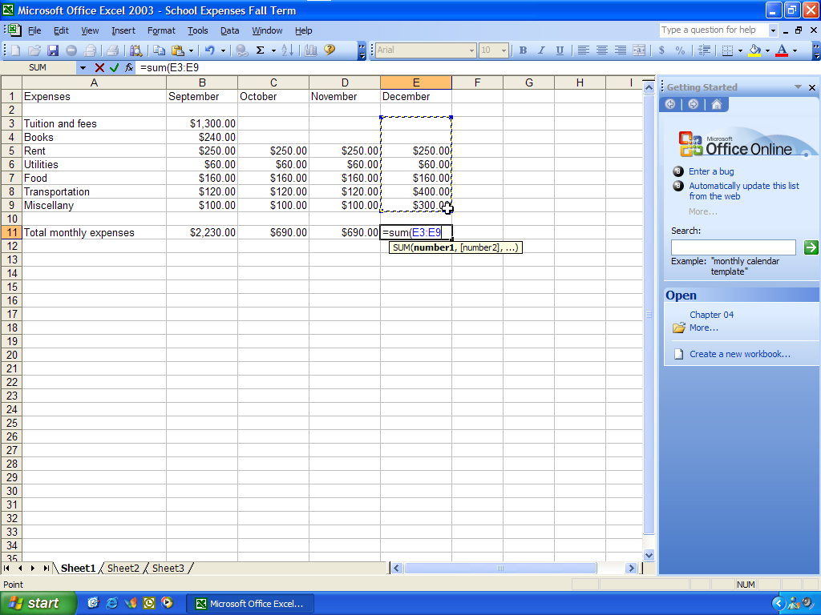
VII.
II.
VI.
V.
IV.
III.

I. A. Excel window
II. B. Row
III. C. Cell
IV. D. Labels
V. E. Function
VI. F. Column
VII. G. Values
Answers: F, B, C, E, A, D, G Reference: The Spreadsheet Difficulty: Moderate

- Choose the order of steps that a user usually follows to work with a word processed document:
I. Typically Step 1 A. Save document
II. Typically Step 2 B. Edit text
III. Typically Step 3 C. Format document
IV. Typically Step 4 D. Print document
V. Typically Step 5 E. Proofead document
VI. Typically Step 6 F. Enter text
Answers: F, B, C, E, A, D Reference: Word Processing Tools and Techniques Difficulty: Moderate

