Atoms and Starlight

Multiple Choice
Identify the letter of the choice that best completes the statement or answers the question.

____ 1. Absolute zero is
a. | zero degrees Celsius.
b. | the temperature at which atoms have no remaining energy from which we can extract heat.
c. | the temperature at which water freezes.
d. | both a and c
e. | none of the above

____ 2. The neutral hydrogen atom consists of
a. | one proton and one neutron.
b. | one proton.
c. | one proton, one neutron, and one electron.
d. | one proton and one electron.
e. | an isotope and an ion.

____ 3. The process of removing an electron from a stable nucleus is known as
a. | ionization.
b. | Doppler broadening.
c. | collisional broadening.
d. | a red shift.
e. | quantum mechanics.

____ 4. The lowest energy level in an atom is
a. | the absolute zero temperature.
b. | the ground state.
c. | the ionization level.
d. | responsible for Doppler shifts.
e. | the energy level from which the Paschen Series of hydrogen originates.

____ 5. A plot of the continuous spectra of five different stars are shown in the figure below. Based on these spectra, which of the stars is the hottest?

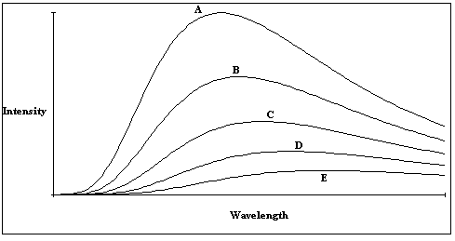

a. | Star A
b. | Star B
c. | Star C
d. | Star D
e. | Star E

____ 6. An atom that is excited
a. | is also ionized.
b. | is an isotope.
c. | has had its electron moved to the lowest energy level.
d. | can emit a photon when the electron moves to a lower energy level.
e. | can emit a photon when the electron moves to a higher energy level.

____ 7. The table below lists the color index for each of several stars. Which star in this table would have the lowest temperature?

Star Name | Color Index
α Boo | +1.23
γ Peg | -0.23
β Leo | +0.08
α Leo | -0.11
χ Peg | +1.57

a. | α Boo
b. | γ Peg
c. | β Leo
d. | α Leo
e. | χ Peg

____ 8. The table below lists the color index for each of several stars. Which star in this table would be the hottest?

Star Name | Color Index
α Boo | +1.23
γ Peg | -0.23
β Leo | +0.08
α Leo | -0.11
χ Peg | +1.57

a. | α Boo
b. | γ Peg
c. | β Leo
d. | α Leo
e. | χ Peg

____ 9. The table below lists the color index for each of several stars. Which star in this table would be the brightest?

Star Name | Color Index
α Boo | +1.23
γ Peg | -0.23
β Leo | +0.08
α Leo | -0.11
χ Peg | +1.57

a. | α Boo
b. | γ Peg
c. | β Leo
d. | α Leo
e. | Color index is not related to brightness.

____ 10. A(n) _______________ contains two or more atoms that are bound together by sharing electrons with each other.
a. | nucleus
b. | ion
c. | proton
d. | electron cloud
e. | molecule

____ 11. In the diagram below, which of the transitions would absorb a photon with the smallest energy?

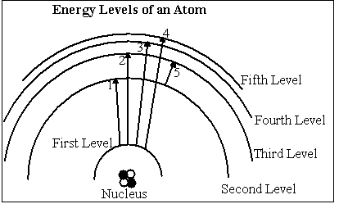

a. | Transition 1
b. | Transition 2
c. | Transition 3
d. | Transition 4
e. | Transition 5

____ 12. In the diagram below, which of the transitions would absorb a photon with the shortest wavelength?

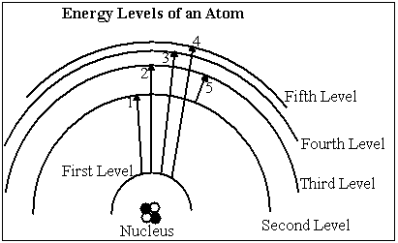

a. | Transition 1
b. | Transition 2
c. | Transition 3
d. | Transition 4
e. | Transition 5

____ 13. The _______________ of a gas is a measure of the average speed of the particles in the gas.
a. | heat
b. | composition
c. | temperature
d. | blue shift
e. | binding energy

____ 14. The two most abundant elements in the sun are
a. | nitrogen and oxygen.
b. | hydrogen and helium.
c. | sulfur and iron.
d. | carbon and hydrogen.
e. | carbon and nitrogen.

____ 15. You are standing near a railroad track and a train is moving toward you at 60 mph and blowing his horn. What will you notice as the train moves past you.
a. | As the train approaches, the horn will sound lower in pitch than when it is moving away.
b. | As the train approaches, the horn will sound higher in pitch than when it is moving away.
c. | There will be no change in the pitch of the horn as it moves by.
d. | The horn will get louder as the train moves away from me.
e. | The horn will get quieter as the train moves toward me

____ 16. The spectra of two stars indicate that they are of the same spectral type. However, Star A has a very broad line profile for the H_{γ} line while Star B has a very narrow line profile for H_{γ}. What might this tell us about the two stars.
a. | Star A is hotter than star B.
b. | Star B is hotter than star A.
c. | Star A has a higher density than Star B.
d. | Star B is moving away from us faster than Star A.
e. | Star A is moving away from us faster than Star B.

____ 17. Which of the following can be determined by using the Doppler effect?

I. | The speed at which a star is moving away from an observer.
II. | The transverse velocity of a star.
III. | The radial velocity of a star.
IV. | The speed at which a car is traveling toward an observer.

a. | I & IV
b. | II & III
c. | II & IV
d. | I & III
e. | I, III, & IV

____ 18. The diagram below illustrates a light source, a gas cloud, and three different lines of sight. Along which line of sight would an observer see an emission spectrum?

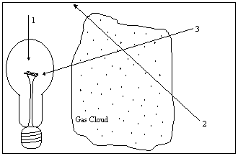

a. | 1
b. | 2
c. | 3
d. | 2 and 3
e. | none of them

____ 19. The table below lists the spectral types for each of five stars. Which star in this table would have the lowest temperature?

Star Name | Spectral Type
α For | F8
ο Cet | M7
35 Ari | B3
γ Tri | A0
Per | O7

a. | α For
b. | ο Cet
c. | 35 Ari
d. | γ Tri
e. | Per

____ 20. The table below lists the spectral types for each of five stars. Which star in this table would have the highest temperature?

Star Name | Spectral Type
α For | F8
ο Cet | M7
35 Ari | B3
γ Tri | A0
Per | O7

a. | α For
b. | ο Cet
c. | 35 Ari
d. | γ Tri
e. | Per

____ 21. The table below lists the spectral types for each of five stars. Which star in this table would have the have the strongest hydrogen lines?

Star Name | Spectral Type
α For | F8
ο Cet | M7
35 Ari | B3
γ Tri | A0
Per | O7

a. | α For
b. | ο Cet
c. | 35 Ari
d. | γ Tri
e. | Per

____ 22. Why don't we see hydrogen Balmer lines in the spectra of stars with temperatures of 3200 K?
a. | There is no hydrogen in stars this cool.
b. | The stars are hot enough that most of the hydrogen is ionized and the atoms cannot absorb energy.
c. | These stars are so cool that nearly all of the electrons in the hydrogen atom are in the ground state.
d. | Stars of this temperature are too cool to produce an absorption spectrum.
e. | Stars of this temperature are too hot to produce an absorption spectrum.

____ 23. The absorption lines in the visible portion of the spectrum of a star that are produced by hydrogen are from the
a. | Lyman series.
b. | Balmer series.
c. | Paschen series.
d. | isotopes of hydrogen.
e. | ions of hydrogen.

____ 24. The radiation emitted from a star has a maximum intensity at a wavelength of 300 nm. What is the temperature of this star?
a. | 300 K
b. | 100 K
c. | 900,000,000 K
d. | 90,000 K
e. | 10,000 K

____ 25. The radiation emitted from a star has a maximum intensity at a wavelength of 500 nm. What is the temperature of this star?
a. | 6,000 K
b. | 5,000 K
c. | 1.510⁹ K
d. | 500 K
e. | 10,000 K

____ 26. At what wavelength would a star radiate the greatest amount of energy if the star has a surface temperature of 60,000 K?
a. | 50 nm
b. | 500 nm
c. | 300 nm
d. | 1.810¹¹ nm
e. | 180 nm

____ 27. At what wavelength would a star radiate the greatest amount of energy if the star has a surface temperature of 10,000 K?
a. | 10 nm
b. | 100 nm
c. | 300 nm
d. | 1.010⁴ nm
e. | 3.010¹⁰ nm

____ 28. The sun has a surface temperature of approximately 5,800 K. At what wavelength does the maximum energy radiated by the sun occur?
a. | 5,800 nm
b. | 300 nm
c. | 174 nm
d. | 520 nm
e. | 3,000 nm

____ 29. One star has a temperature of 10,000 K and another star has a temperature of 5000 K Compared to the cooler star, how much more energy per second will the hotter star radiate from each square meter of its surface?
a. | 16 times
b. | 2 times
c. | 110¹⁶ times
d. | 625 times
e. | 6.310¹⁴ times

____ 30. If σ in the Stefan-Boltzmann law is equal to 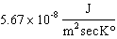, how much energy is radiated each second by one square meter of a star whose temperature is 10,000 °K?
a. | 5.6710⁻¹² J
b. | 5.6710⁻⁸ J
c. | 5.6710⁻⁴ J
d. | 300 nm
e. | 300,000,000 nm

____ 31. The H_{γ} line has a wavelength of 434.0 nm when observed in the laboratory. If the H_{γ} line appears in a stars spectrum at 434.5 nm, what is the radial velocity of the star?
a. | 346 km/sec away from the observer.
b. | 346 km/sec toward the observer.
c. | 1.310⁸ m/sec away from the observer.
d. | 1.310⁸ m/sec toward the observer.
e. | The radial velocity of the star can not be determined from this information.

____ 32. The binding energy of the first level in an atom is 2.210⁻¹⁸ J, and the binding energy of the second energy level is 1.610⁻¹⁸ J. What is the energy of the photon that is emitted if an electron moves from the second level to the first?
a. | 3.310⁻¹⁸ J
b. | 3.510⁻³⁶ J
c. | 1.4 J
d. | 3.510⁻¹⁸ J
e. | 6.010⁻¹⁹ J

True/False
Indicate whether the sentence or statement is true or false.

____ 33. The nucleus of the hydrogen atom consists of a single neutron.

____ 34. Blue stars are hotter than red stars.

____ 35. Isotopes of the same element have the same number of protons.

____ 36. Hydrogen alpha is the longest wavelength Balmer line.

____ 37. An absorption spectrum is also called a bright line spectrum.

____ 38. Stars of spectra type K have strong Balmer lines.

____ 39. The Doppler effect is sensitive only to motion along the line of sight.

____ 40. An atom that has lost an electron is called an ion.

____ 41. The Lyman series lines of hydrogen all lie in the infrared.

____ 42. Hydrogen lines are weak in the spectra of hot stars because many of the hydrogen atoms have their electrons in levels above the second level.

Answer Section

MULTIPLE CHOICE

1. ANS: B

2. ANS: D

3. ANS: A

4. ANS: B

5. ANS: A

6. ANS: D

7. ANS: E

8. ANS: B

9. ANS: E

10. ANS: E

11. ANS: E

12. ANS: D

13. ANS: C

14. ANS: B

15. ANS: B

16. ANS: C

17. ANS: E

18. ANS: B

19. ANS: B

20. ANS: E

21. ANS: D

22. ANS: C

23. ANS: B

24. ANS: E

25. ANS: A

26. ANS: A

27. ANS: C

28. ANS: D

29. ANS: A

30. ANS: C

31. ANS: A

32. ANS: E

TRUE/FALSE

33. ANS: F

34. ANS: T

35. ANS: T

36. ANS: T

37. ANS: F

38. ANS: F

39. ANS: T

40. ANS: T

41. ANS: F

42. ANS: T

