Visual Anatomy & Physiology
Chapter 1 An Introduction to Anatomy and Physiology

Multiple-Choice Questions

1) Gross anatomy refers to
A) features seen under a light microscope.
B) features seen with an electron microscope.
C) features seen clearly with a dissecting microscope.
D) features clearly visible with the unaided eye.
E) cutting open to visualize structures.
Answer: D

2) The study of macroscopic anatomy requires
A) microscopic technique.
B) tissue sampling.
C) understanding function.
D) visual inspection of large structures.
E) correct sequencing of events.
Answer: D

3) A massage therapist is palpating surface features of a client. This is an example of the study of
A) anatomy.
B) microscopy.
C) sonography.
D) physiology.
E) pathology.
Answer: A

4) A cytologist is visualizing the nucleus of a cell. What type of microscope is being used?
A) electron
B) light
C) dissecting
D) scanning
E) inverted
Answer: B

5) A cardiologist is reading an EKG. This is an example of the study of
A) anatomy.
B) microscopy.
C) sonography.
D) physiology.
E) pathology.
Answer: D

6) A microscopist is viewing a very small organelle, the ribosome, which measures about 20 nanometers across. What microscopic instrument is being used?
A) electron
B) light
C) dissecting
D) fluorescent
E) inverted
Answer: A

7) A respiratory therapist is measuring lung volumes of a patient. This is an example of the study of
A) anatomy.
B) microscopy.
C) sonography.
D) physiology.
E) pathology.
Answer: D

8) Studying anatomical detail is significant because
A) memorization is an important skill.
B) each anatomical detail has an effect on function.
C) physiology imposes functional limits.
D) anatomy limits health choices.
Answer: B

9) What structural anatomical details impose physiological function of the elbow joint?
A) The cylindrical humerus interlocks with an ulnar depression, forming a hinge.
B) The biceps can only contract in one direction.
C) Perpendicular movements are allowed by ligaments.
D) Radius and ulna cannot slide against one another.
E) Bone is a structurally sound tissue that resists torsion.
Answer: A

10) The most complex level of organization listed below is
A) chemical.
B) tissue.
C) organ.
D) cellular.
E) organism.
Answer: E

11) The least complex level of organization listed below is
A) chemical.
B) tissue.
C) organ.
D) organ system.
E) cell.
Answer: A

12) The smallest unit of life is
A) chemical.
B) tissue.
C) organ.
D) cell.
E) organelle.
Answer: D

13) Two or more tissues working together to perform functions is a(n)
A) cell.
B) organ.
C) tissue.
D) molecule.
E) organelle.
Answer: B

14) A group of cells and cellular products working together is called a(n)
A) cell.
B) organ.
C) tissue.
D) molecule.
E) organelle.
Answer: C

15) The smallest stable units of matter are called
A) cells.
B) organs.
C) tissues.
D) atoms.
E) molecules.
Answer: D

16) Which choice correctly represents multiple levels of organization from least to most complex?
A) Cell : Tissue : Chemical : Organ : Organ System
B) Cell : Tissue : Chemical : Organism : Organ System
C) Tissue : Chemical : Organ System : Organism : Organ
D) Chemical : Tissue : Cell : Organ System : Organism
E) Chemical : Cell : Tissue: Organ System : Organism
Answer: E

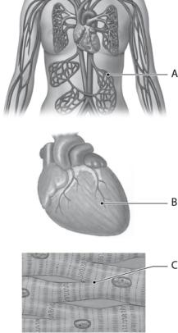
Figure 1.1

Use Figure 1.1 to answer the following questions:

17) The area labeled "A" is a representation of which level of organization?
A) cell
B) tissue
C) molecule
D) organ system
E) organ
Answer: B

18) The area labeled "B" is a representation of which level of organization?
A) cell
B) tissue
C) molecule
D) organ system
E) organ
Answer: E

19) The area labeled "C" is a representation of which level of organization?
A) cell
B) tissue
C) molecule
D) organ system
E) organ
Answer: B

20) The body system that defends against infection and disease is called
A) reproductive.
B) urinary.
C) lymphatic.
D) endocrine.
E) muscular.
Answer: C

21) The body system that moves and supports the body is called
A) reproductive.
B) urinary.
C) lymphatic.
D) endocrine.
E) muscular.
Answer: E

22) The body system that eliminates excess water, salts, and waste is called
A) reproductive.
B) urinary.
C) nervous.
D) cardiovascular.
E) muscular.
Answer: B

23) The body system that produces sex cells and hormones is called
A) reproductive.
B) urinary.
C) nervous.
D) cardiovascular.
E) muscular.
Answer: A

24) The body system that directs immediate response to stimuli is called
A) reproductive.
B) urinary.
C) nervous.
D) endocrine.
E) muscular.
Answer: C

25) The body system that directs long-term response to stimuli is called
A) reproductive.
B) urinary.
C) nervous.
D) endocrine.
E) muscular.
Answer: D

26) The body system that supports and protects soft tissues is called
A) reproductive.
B) skeletal.
C) nervous.
D) digestive.
E) muscular.
Answer: B

27) The body system that processes food is called
A) reproductive.
B) skeletal.
C) nervous.
D) digestive.
E) muscular.
Answer: D

28) The body system that includes the heart, blood, and vessels is called
A) reproductive.
B) urinary.
C) nervous.
D) cardiovascular.
E) muscular.
Answer: D

29) Which of the following is NOT a function of the skeletal system?
A) mineral storage
B) support
C) protection of soft tissues
D) directs response to stimuli
E) form blood cells
Answer: D

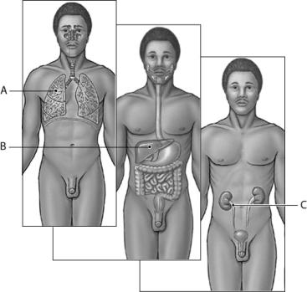
Figure 1.2

Use Figure 1.2 to answer the following questions:

30) The body system labeled "A" is named
A) reproductive.
B) digestive.
C) urinary.
D) respiratory.
E) cardiovascular.
Answer: D

31) The body system labeled "B" is named
A) reproductive.
B) digestive.
C) urinary.
D) respiratory.
E) cardiovascular.
Answer: B

32) The body system labeled "C" is responsible for
A) reproductive.
B) digestive.
C) urinary.
D) respiratory.
E) cardiovascular.
Answer: C

33) Humans maintain a constant internal environment called
A) homeostasis.
B) homeotics.
C) anatomy.
D) physiology.
E) pathology.
Answer: A

34) Which of the following principles serves as the central theme for physiology?
A) homeostasis
B) pathology
C) anatomy
D) physiology
E) unity
Answer: A

35) The type of feedback that provides stability for an organism is
A) positive.
B) negative.
C) pathologic.
D) effective.
E) receptive.
Answer: B

36) The type of feedback that accelerates processes toward completion is
A) positive.
B) negative.
C) pathologic.
D) effective.
E) receptive.
Answer: A

37) A cell or organ that responds to commands of the control center is termed a(n)
A) receptor.
B) thermoregulator.
C) control center stimulus.
D) stimulus.
E) effector.
Answer: E

38) Which of the following is NOT a component of all typical homeostatic mechanisms?
A) receptor
B) effector
C) control center
D) stimulus
E) thermostat
Answer: E

39) When body temperature rises, the temperature control center will signal
A) vasoconstriction to prevent blood circulation to body extremities.
B) vasodilation to encourage blood circulation to body extremities.
C) positive feedback mechanisms to further increase temperature.
D) acceleration of clotting mechanisms.
E) release of blood thinners.
Answer: B

40) Which of the following is NOT a normal response to temperature increases in the body?
A) Activity increases in the temperature control center of the brain.
B) Skin temperature receptors send signals to the control center.
C) Blood vessels near body surfaces dilate and increase blood flow.
D) Blood vessels near body surfaces constrict and reduce blood flow.
E) Sweat glands are stimulated.
Answer: D

41) During labor, muscle contractions pushing the baby stimulate stretch receptors that in turn trigger more contractions. What type of feedback is involved?
A) positive
B) negative
C) pathologic
D) effective
E) receptive
Answer: A

Bloom's Taxonomy: Application

42) An eponym is a(n)
A) pathological anatomical condition.
B) anatomical feature with no known physiological role.
C) Latin anatomical term.
D) commemorative name for an anatomical feature.
E) Greek prefix.
Answer: D

43) The Latin root describing a joint is
A) chondro-.
B) arthro-.
C) neuro-.
D) vas-.
E) pulmo-.
Answer: B

44) The Latin root describing cartilage is
A) chondro-.
B) arthro-.
C) neuro-.
D) vas-.
E) pulmo-.
Answer: A

45) The Latin root describing lungs is
A) chondro-.
B) arthro-.
C) neuro-.
D) vas-.
E) pulmo-.
Answer: E

46) The Latin root describing kidneys is
A) chondro-.
B) arthro-.
C) nephr-.
D) hypo-.
E) pulmo-.
Answer: C

47) The Latin root used to signify "a state above" is
A) chondro-.
B) arthro-.
C) nephr-.
D) hypo-.
E) hyper-.
Answer: E

48) A person lying down in anatomical position face up is
A) pelvic.
B) pubic.
C) prone.
D) supine.
E) palmar.
Answer: D

49) The anatomical term for chin is
A) otic.
B) optic.
C) mental.
D) brachial.
E) thoracic.
Answer: C

50) The anatomical term for ear is
A) otic.
B) optic.
C) mental.
D) brachial.
E) thoracic.
Answer: A

51) The anatomical term for kneecap is
A) otic.
B) optic.
C) patellar.
D) inguinal.
E) palmar.
Answer: C

52) The anatomical term for groin is
A) otic.
B) optic.
C) patellar.
D) inguinal.
E) palmar.
Answer: D

53) The anatomical term for the back of the knee is
A) sural.
B) popliteal.
C) patellar.
D) inguinal.
E) palmar.
Answer: B

54) The anatomical term for the calf is
A) sural.
B) popliteal.
C) patellar.
D) inguinal.
E) palmar.
Answer: A

55) Why do anatomists prefer locating organs within abdominopelvic regions rather than quadrants?
A) It is less confusing.
B) It is more precise.
C) It is simpler yet useful.
D) It provides more insight into physiology.
Answer: B

56) A nurse wants to inject a shot into your brachial region. What body part do you uncover?
A) hip
B) buttock
C) elbow
D) upper arm
E) thigh
Answer: D

57) A physician is examining a patient's calcaneal region. What type of specialist is she?
A) ear, nose, and throat
B) foot
C) dental
D) urology
E) internal
Answer: B

58) A body is discovered face down in an alley. The police report indicates the body was found in what position?
A) prone
B) supine
C) anterior
D) posterior
E) ventral
Answer: A

59) The directional term that references away from an attached base is
A) anterior.
B) posterior.
C) superficial.
D) distal.
E) proximal.
Answer: D

60) The directional term that references the front surface of the body is
A) anterior.
B) posterior.
C) superficial.
D) distal.
E) proximal.
Answer: A

61) The directional term that references being furthest from the body surface is
A) anterior.
B) posterior.
C) superficial.
D) superior.
E) deep.
Answer: E

62) A sagittal section separates into
A) superior and inferior portions.
B) right and left portions.
C) ventral and dorsal halves.
D) anterior and posterior halves.
Answer: B

63) The lungs are located ________ to the heart.
A) medial
B) lateral
C) superior
D) inferior
E) proximal
Answer: B

64) The elbow is located ________ to the shoulder.
A) medial
B) lateral
C) distal
D) proximal
E) inferior
Answer: C

65) The patellar region is located ________ to the popliteal region.
A) superior
B) medial
C) lateral
D) anterior
E) posterior
Answer: D

66) The cranial cavity is ________ to the ventral cavity.
A) anterior
B) posterior
C) superior
D) inferior
E) lateral
Answer: C

67) Which sectioning does NOT cut parallel to the long axis?
A) sagittal
B) frontal
C) coronal
D) midsagittal
E) transverse
Answer: E

68) A lead pencil is cut in two equal pieces with a transverse plane. When you examine the cross section, what do you see?
A) three horizontal long pieces; the middle is darker than the outer sides
B) a circle with a darker dot in the middle
C) a circle with a lighter dot in the middle
D) two horizontal lines
E) a cylinder
Answer: B

Bloom's Taxonomy: Analysis

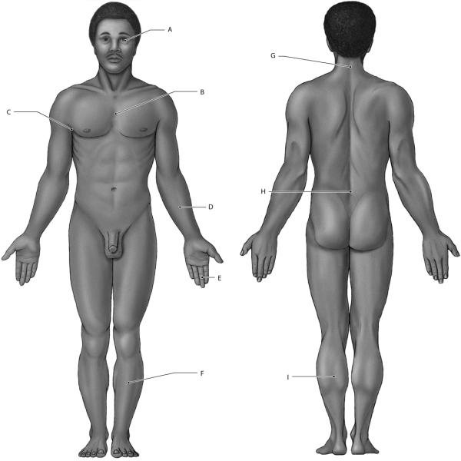
Figure 1.3

Use Figure 1.3 to answer the following questions:

69) Identify the region labeled "A".
A) nasal
B) ocular
C) optic
D) otic
E) buccal
Answer: B

70) Identify the region labeled "B".
A) mediastinum
B) thoracic
C) ventral cavity
D) diaphragm
E) mammary
Answer: B

71) Identify the region labeled "C".
A) axillary
B) mental
C) brachial
D) thoracic
E) viscera
Answer: A

72) Identify the region labeled "D".
A) brachial
B) carpal
C) digital
D) antebrachial
E) axillary
Answer: D

73) The directional term that describes the location of structure "E" with respect to structure "D" is
A) inferior.
B) superior.
C) medial.
D) proximal.
E) distal.
Answer: E

74) The directional term that describes the location of structure "F" with respect to structure "I" is
A) anterior.
B) posterior.
C) superior.
D) inferior.
E) proximal.
Answer: A

75) Identify the region labeled "G".
A) cephalic
B) cervical
C) ventral
D) buccal
E) cranial
Answer: B

76) Identify the region labeled "H".
A) cervical
B) lumbar
C) thoracic
D) gluteal
E) olecranal
Answer: B

77) The directional term that describes the location of structure "G" with respect to structure "H" is
A) mediastinum.
B) ventral.
C) dorsal.
D) superior.
E) inferior.
Answer: D

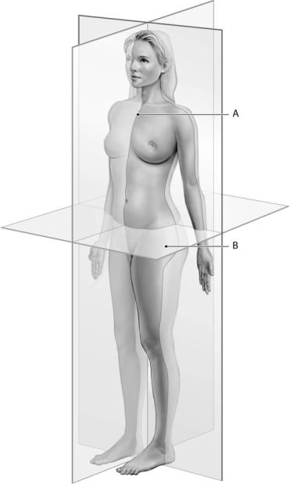
Figure 1.4

Use Figure 1.4 to answer the following questions:

78) The cut labeled "A" produces a ________ sectioning.
A) coronal
B) sagittal
C) transverse
D) proximal
E) distal
Answer: B

79) The cut labeled "B" produces a ________ sectioning.
A) coronal
B) sagittal
C) transverse
D) proximal
E) distal
Answer: C

80) The structure that separates the thoracic and abdominopelvic cavities is the
A) mediastinum.
B) pericardial cavity.
C) ventral cavity.
D) diaphragm.
E) viscera.
Answer: D

81) Which term is the MOST inclusive description of body cavities?
A) thoracic
B) abdominopelvic
C) peritoneal
D) ventral
E) mediastinum
Answer: D

82) The smallest subdivision of the ventral cavity is called the
A) pericardial cavity.
B) thoracic cavity.
C) mediastinum.
D) pelvic cavity.
E) abdominal cavity.
Answer: A

83) A unique feature of the kidneys and pancreas is that they reside
A) in the abdomen.
B) ventrally.
C) in the pericardium.
D) retroperitoneally.
E) in the pelvis.
Answer: D

84) The mass of connective tissue that separates the two pleural cavities is the
A) pericardial cavity.
B) pelvic cavity.
C) mediastinum.
D) retroperitoneum.
E) diaphragm.
Answer: C

85) Which of the following is a function of a body cavity?
A) protect delicate organs from shock
B) constrict size of internal organs
C) constrict shape of internal organs
D) organize organs
E) provide functional boundaries
Answer: A

86) The advantage of licensure for sonographers is
A) most states do not allow unlicensed sonographers to practice.
B) malpractice insurance is higher for unlicensed sonographers.
C) employers prefer to hire licensed sonographers.
Answer: C

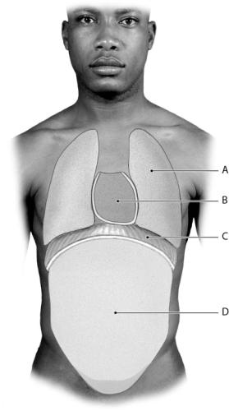
Figure 1.5

Use Figure 1.5 to answer the following questions:

87) The area labeled "A" is the ________ cavity.
A) abdomino-pelvic
B) mediastinum
C) pericardial
D) dorsal
E) pleural
Answer: E

88) The area labeled "B" is the ________ cavity.
A) abdomino-pelvic
B) mediastinum
C) pericardial
D) dorsal
E) pleural
Answer: C

89) The structure labeled "C" is called the
A) abdomino-pelvic.
B) mediastinum.
C) diaphragm.
D) dorsal.
E) thoracic cavity.
Answer: C

90) The area labeled "D" is the ________ cavity.
A) abdomino-pelvic
B) mediastinum
C) pericardial
D) dorsal
E) pleural
Answer: A

Essay Questions

1) Name three types of microscopes, including information on scale and use.
Answer: Dissecting scopes are used to visualize tissues that are difficult to visualize with the unaided eye. Light microscopes allow anatomists to visualize the basic details of cell structure, including the larger organelles, such as the nucleus. Electron microscopes allow researchers to visualize molecules, and smaller organelles that are only nanometers in width.

2) Historically, were the first studies of the human body anatomical or physiological? Why?
Answer: The first studies of the human body were anatomical, as early scientists attempted to visualize and classify the structural features of the human body. Often anatomical studies were necessarily performed on cadavers. Later understanding of the functional capacity of each structure was realized as sophisticated techniques and/or equipment became available. Structural knowledge (anatomy) is visual, while functional knowledge (physiology) requires insight and understanding of interactions.

3) Explain why the concept of an "organ system" can be considered an artificial designation.
Answer: Each organ system is interdependent upon the other organ systems, through communication and integration. Pathology within one system will adversely affect the other systems.

4) Give at least three examples of organ systems that interact with the skeletal system.
Answer: 1. The muscular system and the skeletal system work together (often referred to as the musculoskeletal system) to perform movement for the organism. Muscles supply contraction, while bones supply attachment points and fulcrums. 2. The cardiovascular system relies on the skeletal system to house red marrow that is responsible for providing blood cells. 3. The skeletal system contains the skull, which protects the central nervous system from damage. 4. The skeletal system contains the pectoral girdle and ribs, providing support and protection for the visceral organs of the digestive, respiratory, and cardiovascular system. 5. Bones serve as a storage repository for calcium. The urinary and endocrine system work in concert to control calcium levels within the body, either depositing or resorbing calcium as needed.

Bloom's Taxonomy: Analysis

5) Define homeostasis, and state why it is a central concept for physiology.
Answer: Homeostasis is the presence of a stable environment inside the body, despite changing environments outside the body. Homeostatic regulation includes temperature, pH, minerals, electrolyte levels, water, glucose levels and many other aspects of physiology. Physiological systems constantly adjust to maintain homeostasis. Failure to maintain homeostasis will lead to illness or death.

Bloom's Taxonomy: Application

