Nutrition for Life
The Human Body: Are We Really What We Eat?

Multiple Choice Questions

1) ________ are organs that are grouped together to perform an integrated function.
A) Molecules
B) Tissues
C) Systems
D) Organelles
Answer: C

2) The ________ is most responsible for prompting individuals to seek food.
A) stomach
B) small intestine
C) hypothalamus
D) mouth
Answer: C

3) Which physiological trigger(s) will result in the sensation of hunger?
A) low glucose levels
B) high glucose levels
C) release of the chemical messengers leptin and serotonin
D) eating a meal with a high satiety value
Answer: A
Page Ref: 43

4) Hunger is best described as:
A) a physiological desire to find food and eat.
B) a psychological desire to find food and eat.
C) eating that is often driven by environmental cues.
D) eating that is often driven by emotional cues.
Answer: A

5) Which of the following is NOT a regulator of satiety in the body?
A) GI tract
B) hypothalamus
C) hormones
D) kidneys
Answer: D
Page Ref: 43
6) Which of the following snacks will have the highest satiety value, assuming the calories and relative size are similar?
A) slice of whole-grain bread
B) piece of cheese
C) glass of whole milk
D) glass of skim milk
Answer: B
Page Ref: 43

7) The smallest units of matter that cannot be broken down by natural means are:
A) atoms.
B) molecules.
C) cells.
D) lipids.
Answer: A
Page Ref: 40

8) The human body is organized into the following structural levels (smallest to largest):
A) molecules: atoms: organs: systems: tissues: cells.
B) atoms: molecules: cells: tissues: organs: systems.
C) organs: tissues: molecules: systems: atoms: organs.
D) atoms: cells: systems: tissues: molecules: organs.
Answer: B
Page Ref: 41

9) Cell membranes are:
A) very rigid and resistant to all noncellular molecules.
B) semi-permeable.
C) the organelles responsible for ATP production.
D) chemical messengers that are secreted into the bloodstream by a gland.
Answer: B
Page Ref: 40

10) In which organelle is the cell's DNA located?
A) nucleus
B) mitochondria
C) cell membrane
D) cytoplasm
Answer: A

11) The "powerhouses" of the cell that produces energy from food molecule are the:
A) mitochondria.
B) ribosomes.
C) nuclei.
D) cytoplasm.
Answer: A

12) What is the term that describes the process by which the foods we eat are broken down into smaller components by either mechanical or chemical means?
A) digestion
B) absorption
C) elimination
D) peristalsis
Answer: A
Page Ref: 44

13) Which of the following is NOT a role that the liver plays in digestion and absorption of nutrients?
A) Filters the blood removing potential toxins such as alcohol and drugs.
B) Secretes insulin and glucagon to assist in the regulation of blood glucose concentrations.
C) Receives the products of digestion from the small intestine and releases nutrients depending on body needs.
D) Synthesizes bile to assist in the digestion and absorption of fat.
Answer: B

14) Most digestion and absorption occurs in the:
A) stomach.
B) esophagus.
C) small intestine.
D) mouth.
Answer: C

15) Juanita eats her breakfast and his GI tract will now begin the process of digesting and absorbing the nutrients from this meal. What is the order in which each of the organs of the GI tract will work to achieve this process?
A) mouth: esophagus: small intestine: stomach: large intestine
B) mouth: esophagus: stomach: small intestine: large intestine
C) mouth: stomach: esophagus: small intestine: large intestine
D) mouth: stomach: esophagus: large intestine: small intestine
Answer: B

16) The mechanical and chemical digestion of food is initiated in the:
A) mouth.
B) small intestine.
C) stomach.
D) esophagus.
Answer: A
-46
17) Salivary amylase is a(n):
A) hormone.
B) antibody.
C) bicarbonate.
D) enzyme.
Answer: D
Page Ref: 46

18) Which best explains why carbohydrate digestion ceases when food reaches the stomach?
A) Carbohydrate is completely digested in the mouth.
B) Salivary amylase cannot function in the acid environment of the stomach.
C) Carbohydrate is completely absorbed in the esophagus.
D) Intestinal bacteria are needed for carbohydrate digestion.
Answer: B
Page Ref: 46

19) Which of the following is NOT a component of the gastric juices?
A) hydrochloric acid
B) pepsin
C) insulin
D) gastric lipase
Answer: C

20) What is chyme?
A) ulcerations of the esophageal lining
B) healthy bacteria of the small intestine
C) mixture of partially digested food, water, and gastric juices
D) substance that allows for the emulsification of dietary lipid
Answer: C

21) A primary function of the mucus in the stomach is to:
A) neutralize stomach acid.
B) activate pepsinogen to form pepsin.
C) protect stomach cells from digestion.
D) emulsify fats.
Answer: C

22) Which of the macronutrients is NOT broken down chemically in the stomach?
A) protein.
B) carbohydrate.
C) fat.
D) vitamin C.
Answer: B

23) Proteins that induce chemical changes to speed up body processes are called:
A) hormones.
B) peptides.
C) enzymes.
D) chymes.
Answer: C

24) The brush border is located in the:
A) esophagus.
B) stomach.
C) small intestine.
D) large intestine.
Answer: C

25) What is the name of the sphincter that separates the esophagus and the stomach?
A) pyloric
B) gastroesophageal
C) ileocecal
D) rectal
Answer: B

26) The last section of the small intestine that connects to the ileocecal valve is called the:
A) bile duct.
B) duodenum.
C) jejunum.
D) ileum.
Answer: D

27) Responding to the presence of fat in our meal, the gallbladder releases a substance called:
A) lipase.
B) pepsin.
C) chyme.
D) bile.
Answer: D

28) Which of the following organs is responsible for the manufacturing and secretion of insulin and glucagon, as well as many digestive enzymes?
A) liver
B) stomach
C) pancreas
D) gallbladder
Answer: C
29) The fingerlike projections of the small intestine that increase surface area and allow for the absorption of nutrients are called:
A) villi.
B) lacteals.
C) sphincters.
D) diverticuli.
Answer: A

30) Immediately after absorption, what circulatory system carries most of the fat-soluble nutrients?
A) vascular
B) mesenteric
C) lymphatic
D) enterohepatic
Answer: C

31) Which large vessel transports absorbed nutrients to the liver?
A) portal vein
B) pulmonary vein
C) aorta
D) subclavian vein
Answer: A

32) In which organ does the majority of water absorption occur?
A) mouth
B) stomach
C) small intestine
D) large intestine
Answer: D

33) Collectively, the nerves of the gastrointestinal tract are referred to as:
A) peptic nerves.
B) hepatic nerves.
C) enteric nerves.
D) gastric nerves.
Answer: C
Page Ref: 53

34) If a person has GERD, the ________ is malfunctioning.
A) gallbladder
B) pancreas
C) epiglottis
D) gastroesophageal sphincter
Answer: D
Page Ref: 56
35) What is the primary cause of peptic ulcers?
A) stress
B) H. pylori bacteria
C) prolonged use of aspirin
D) eating too many spicy foods
Answer: B
Page Ref: 57

36) Which of the following would be an appropriate treatment approach for someone who has GERD?
A) surgical removal of the gallbladder
B) omission of all lactose foods
C) antibiotic therapy
D) lose weight and quit smoking
Answer: D
Page Ref: 56

37) Which of the following statements best describes irritable bowel syndrome (IBS)?
A) an erosion of the gastrointestinal tract caused by the overproduction of hydrochloric acid
B) an immune response resulting from the ingestion of an allergen
C) a hypersensitivity to wheat resulting in diarrhea and bloating
D) a bowel disorder that interferes with the colon; no definite cause is known
Answer: D
Page Ref: 61

38) Mary experiences anaphylactic shock after eating a peanut butter sandwich. What is the most appropriate treatment for Mary?
A) IV glucose
B) Tylenol or another pain medication
C) antibiotics
D) epinephrine
Answer: D
Page Ref: 59

39) What are probiotics?
A) specialty foods to which nutrients have been added
B) antibiotics that are specific to harmful bacteria while protecting healthful bacteria
C) live microorganisms naturally found in or supplemented to food products
D) foods known to have disease-fighting effects
Answer: C
Page Ref: 54

40) Which of the following food sources is a rich source of probiotics?
A) whole-wheat bread
B) yogurt
C) orange juice
D) calcium supplements
Answer: B
Page Ref: 54
True/False Questions

1) Atoms are the smallest units of matter.
Answer: TRUE
Page Ref: 40

2) The cell's nucleus is the organelle responsible for producing energy from food molecules.
Answer: FALSE

3) Hunger is the physical sensation that drives humans to eat.
Answer: TRUE

4) The primary organ producing the sensation of hunger is the stomach.
Answer: FALSE

5) Foods containing carbohydrate have the highest satiety value.
Answer: FALSE
Page Ref: 43

6) Overall, very little digestion occurs in the human mouth.
Answer: TRUE
Page Ref: 46

7) Typically, ingested food remains in the stomach for 2 hours prior to traveling to the small intestine.
Answer: TRUE

8) The pancreas is the largest digestive organ.
Answer: FALSE

9) The small intestine is the longest portion of the human GI tract.
Answer: TRUE

10) The majority of nutrient absorption takes place in the stomach.
Answer: FALSE

11) Since they do not require further digestion, dietary vitamins and minerals are small enough to be absorbed by the gastrointestinal tract.
Answer: TRUE
-51
12) The presence of any bacteria in the large intestine indicates a potentially serious systemic allergic reaction that can be fatal if left untreated.
Answer: FALSE
Page Ref: 53

13) The most common symptom of GERD is chronic diarrhea.
Answer: FALSE
Page Ref: 56

14) Irritable bowel syndrome is more common among women than men.
Answer: TRUE
Page Ref: 61

15) The sigmoid colon is the first segment of the large intestine.
Answer: FALSE

16) Food allergies cause an immune response by the body.
Answer: TRUE
Page Ref: 59

17) Most instances of constipation are caused by intestinal bacteria.
Answer: FALSE
Page Ref: 61

18) Diarrhea and dehydration are the most serious potential reactions when consuming an allergenic food product.
Answer: FALSE
Page Ref: 59

19) Untreated diarrhea can be fatal in young children.
Answer: TRUE
Page Ref: 61

20) Currently, the only treatment for celiac disease is a diet free of wheat, barley, & rye.
Answer: TRUE
Page Ref: 60

Short Answer Questions

1) The ________ is the liquid within an animal cell.
Answer: cytoplasm

2) ________ is the physiological sensation that encourages us to seek out food.
Answer: Hunger

3) The ________ is the region of the forebrain where physiological signals are translated into thirst and hunger messages.
Answer: hypothalamus

4) Secreted from many glands of the body, ________ are chemical messengers that trigger a physiological response.
Answer: hormones
Page Ref: 43

5) The macronutrient with the highest satiety value is ________.
Answer: protein
Page Ref: 43

6) The ________ is the smallest unit of life that exhibits the properties of growth, reproduction, and metabolism.
Answer: cell
Page Ref: 40

7) ________ are the smallest units of matter in nature.
Answer: Atoms
Page Ref: 40

8) A(n) ________ is a functional grouping of similar cells.
Answer: tissue

9) ________ are tight rings of muscles that control the movement of food through the organs of the gastrointestinal tract.
Answer: Sphincters

10) The human GI tract is approximately ________ feet long.
Answer: 30

11) Chemical digestion begins in the ________.
Answer: mouth
Page Ref: 46

12) Carbohydrate digestion begins in the ________ and protein digestion begins in the ________.
Answer: mouth; stomach
Page Ref: 46 and 48

13) Once food is swallowed, the ________ keeps it from entering the trachea.
Answer: epiglottis
Page Ref: 46

14) ________ is the wavelike contractions that move food along the GI tract.
Answer: Peristalsis
Page Ref: 47
15) The major site of nutrient absorption in the body is the ________.
Answer: small intestine

16) ________ is produced by the liver and stored in the gallbladder; emulsifies fats in the small intestine.
Answer: Bile

17) The ________ is a term that describes the microvilli of the small intestine's lining, which greatly increase its absorptive capacity.
Answer: brush border

18) ________ nerves are the nerves of the GI tract.
Answer: Enteric
Page Ref: 53

19) The semifluid mass consisting of partially digested food, water, and gastric juices is called ________.
Answer: chyme

Matching Questions

Match the following items.

1) Cell
Page Ref: 40

2) Nucleus

3) Mitochondria

4) Cell membrane
Page Ref: 40-42

5) Cytoplasm

6) Atom
Page Ref: 40

A) Gatekeeper
B) Smallest unit of life
C) Smallest unit of matter
D) Organelles that converts nutrients into energy
E) Fluid material of the cell
F) DNA material found here

Answers: 1) B 2) F 3) D 4) A 5) E 6) C
Using the figure, label A - J.
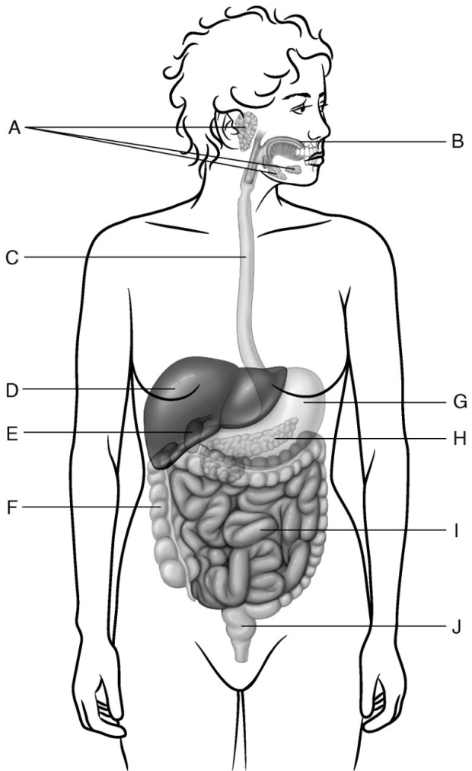

7) ________ Gallbladder
Answer: E

8) ________ Small intestine
Answer: I

9) ________ Esophagus
Answer: C
Page Ref: 47

10) ________ Liver
Answer: H

11) ________ Pancreas
Answer: D

12) ________ Large intestine
Answer: F
-53
13) ________ Stomach
Answer: G

14) ________ Salivary glands
Answer: A
Page Ref: 46

15) ________ Mouth
Answer: B
Page Ref: 46

16) ________ Rectum
Answer: J
Page Ref: 53

17) ________ Secretes digestive enzymes, insulin, and glucagon
Answer: H

18) ________ Most digestion and absorption occurs here.
Answer: I

19) ________ Most water is absorbed here.
Answer: F
-53

20) ________ Stores bile
Answer: E

Essay Questions

1) Starting at the mouth and ending at the rectum, describe the process of human digestion and absorption.

2) Describe the symptoms and treatment of irritable bowel syndrome (IBS).

3) Describe the lining of the small intestine. How does its unique structure contribute to the process of nutrient absorption?

4) What is the difference between a food intolerance and a food allergy?
Questions from Chapter Boxes

1) Probiotics have been shown to be effective in treating all of the following health problems EXCEPT:
A) Travelers' diarrhea
B) Irritable bowel syndrome
C) Childhood eczema
D) Diabetes mellitus
Answer: D

2) When traveling outside the country, which of the following are good strategies to help prevent Travelers' diarrhea?
A) Drink only brand-name bottled beverages.
B) Do not eat raw meat, fish or shellfish.
C) Avoid eating food purchased from street vendors.
D) All of the above are good strategies to help prevent Travelers' diarrhea.
Answer: D

3) Because the activity of probiotics in the GI tract is short-lived, they need to be consumed on a daily basis to be effective.
Answer: TRUE

4) Alcohol, stress, and spicy foods are the leading causes of peptic ulcers.
Answer: FALSE

5) What are probiotics and how are they involved in keeping us healthy?

Questions from Chapter Boxes

1) Bile reacts with fats in a similar way as soap does.
Answer: TRUE

2) Probiotics have been shown to be effective in treating
A) traveler's diarrhea.
B) food allergies.
C) gastroesophageal reflux disease (GERD).
D) diabetes mellitus.
Answer: A

3) Traveler's diarrhea is caused by
A) food allergies.
B) stress.
C) antibiotic overuse.
D) viral or bacterial infections.
Answer: D

4) One appetizing and safe alternative to barley for people with celiac disease is
A) wheat.
B) gluten.
C) Job's tears.
D) rye.
Answer: C

5) Because the activity of probiotics in the GI tract is short-lived, they need to be consumed on a daily basis to be effective.
Answer: TRUE

6) Which of the following food sources is a rich source of probiotics?
A) whole-wheat bread
B) yogurt
C) orange juice
D) calcium supplements
Answer: B

7) The emerging field of nutrigenomics studies how nutrition and environment can affect gene function.
Answer: TRUE

8) What are probiotics and how are they involved in keeping us healthy?

9) List the eight major allergenic foods. Explain how and why the U.S. Food and Drug Administration (FDA) regulates these ingredients in packaged foods.

