Chapter 7 - Assisting With Examinations & Treatments
Chapter 7 - Lesson 5
Rehabilitation

Rehabilitation

In a broad sense, animal rehabilitation is repair of an injured animal and treatment for disabilities caused by a physical impairment. Optimal physical rehabili-tation is intended to enhance and aid in the recovery of animals with injuries, long-term degenerative condi-tions, or recovering from surgical procedures. Patients at higher risk of complications or residual problems after injury or surgery may require rehabilitation. Animal rehabilitation is a complex field of veterinary medicine that requires an accurate assessment of the patient’s physical problems. Physical therapy pro-cedures promote health and fitness and enhance the quality of life. The goal is to reduce and manage pain, to bring patients back to full health, and return them to their previous state.

The practice of rehabilitation in veterinary medicine requires the expertise of specialists in many disci-plines of anatomy and physiology, including ortho-pedics (skeletal system), neurology (nervous system), mycology (muscular system), cardiology (cardiovas-cular system), biomechanics, and pain management. Veterinary rehabilitation services provide treatment of various types of issues, such as trauma (muscle, tendons, ligaments), orthopedic injury (bones, joints), neurological injury (peripheral nerves, spinal cord), osteoarthritis (aging), debilitating metabolic diseases (diabetes, hypothyroidism), obesity (overweight), and postoperative care following orthopedic surgery.

The benefits of rehabilitation for animal patients are:

- Patients become mobile after a severe orthopedic or neurologic injury.

Rehabilitation used to improve balance.
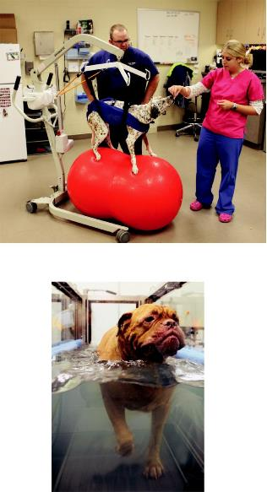

Underwater treadmill reduces the impact on the joints.

- Patients safely use a painful limb after an injury or surgery.
- Improve and prolong the quality of life of geriat-ric and arthritic patients.
- Achieve weight loss in overweight and obese ani-mals.
- Manage acute and chronic pain.

- Increase fitness of athletic and working animals.

- Provide ambulatory assistance to patients who need ambulation carts (mobile support), orthotic devices (splints), or prostheses (limbs).

Clinical services include:

- Therapeutic exercise Underwater treadmill Land treadmill Manual therapy Theraball

- Massage therapy

- Stretch therapy

- Cold pack therapy

- Moist heat therapy

- Acupuncture

- Neuromuscular electrical stimulation

- Low-level laser therapy

- Therapeutic ultrasound

- Focused shockwave therapy

- Pulsed electromagnetic therapy

- Hyperbaric oxygen therapy

- Ambulation carts, orthotic devices, prostheses

Purposes of therapeutic exercises are:

- Theraball

To help with balance and strength

- Underwater treadmill Low impact exercise Reduces load on painful joints

Water pressure reduces swelling and edema (hydrotherapy)
Water resistance improves muscular and cardiovascular systems
Water float enables exercises

- Land treadmill

Encourages use of limbs

Reduces stress and pain

- Manual therapy

To mobilize joints

Low level laser therapy directs biostimulative energy to body cells. In turn the body cells convert it into chemical energy that promotes natural healing and pain relief. Pulsed neuromuscular electrical stimula-tion utilizes low-frequency currents to help relieve acute and chronic pain and help prevent muscle at-rophy from orthopedic and neurological diseases. Acupuncture is the insertion of needles into defined acupoints in the body to treat pain.

Ambulation carts are devices designed to support limbs of non-ambulatory animals. Ambulation carts are custom fitted for patients to provide support during locomotion. Splints are orthotic devices used to pro-tect an injured or disabled limb. Prostheses are inter-nal or external devices used to replace missing limbs. Surgical implantation of internal devices is known as osseointegration. Patients and their caretakers must be trained to use these prosthetic devices to achieve the intended result.

References

Altanta Animal Rehabilation & Fitness Hospital Web-site. http://atlantaanimalrehab.com/

Animal Rehabilitaion & Wellness Hospital Website http://www.arwi.com/

Bassert, J. M., & McCurnin, D. M. (2010). McCurnin's clinical textbook for veterinary technicians (7th ed.). St. Louis, MO: Saunders Elsevier.

California Animal Rehabilation (CARE) Hospital Website http://www.calanimalrehab.com/

Questions

- Define rehabilitation of animals.

- Explain the knowledge and experience veterinar-ians should have to specialize in rehabilitation.
- List the types of animal health issues that can ben-efit from rehabilitation.
- List the benefits of rehabilitation for animal pa-tients.
- List the clinical services associated with rehabili-tation.
- Explain the purposes of therapeutic exercises.

