Chapter 10 - Infectious Diseases
Chapter 10 - Lesson 7

Infectious Diseases: Special Senses & Generalized Conditions

Eyes

The special sense organs most commonly affected with disease in animals are the eyes and ears. The other sense organs involving (taste, smell, touch) are less important in terms of causing clinical disease in animals.

Keratoconjunctivitis is an inflammation of the eye-ball’s surface (cornea) and the eyelid’s lining (con-junctiva). This bacterial infection may affect one or both eyes. Keratitis is the inflammation of the cornea. Severe keratitis is evident when the cornea is opaque or cloudy with occasional ulcers. Corneal ulcers can be diagnosed using fluorescence dye. Conjunctivitis, the inflammation of the conjunctiva, is always present with or without keratitis. Symptoms of conjunctivitis include reddening of the eyelids and the animal rub-bing its eyes. The eye condition is painful and causes the animal to squint and shy away from sunlight. The obvious overflow of tears may become mucopuru-lent (mucus with pus) and may dry to a crusty matter. Pinkeye is a common name for infections keratocon-junctivitis.

Ears

Otitis externa is a bacterial infection of the external ear canal. It is characterized by inflammation and reddening of the epithelium, drainage, and itching. Scratching the ear with a foot or rubbing on carpet or grass are signs of otitis. Ear infections are common in dogs and cats, but uncommon in large animals. Predis-posing factors, such as small external opening of ear

Conjunctivitis.
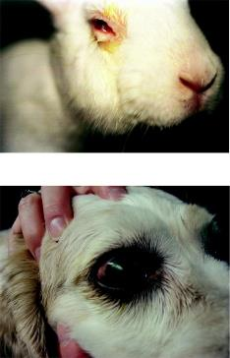

Corneal ulcer, photo: Joel Mills.
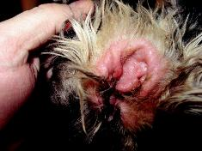

Otitis externa, photo: Joel Mills.

canal, excessive hair in the ear canal, flopped ears, and warm humid weather, contribute to recurrence. Otitis interna is an infection of the internal portions of the ear canal. Infection may result from otitis externa, or may be caused by systemic disease. In cattle, my-coplasma bacterial infections may cause otitis in-terna, with animals showing signs of head tilt or ears drooping.

Generalized Conditions

Generalized conditions caused by bacteremia, septice-mia, or toxemia are related to various abnormalities, such as anemia, encephalitis, hepatitis, pneumonia, nephritis, and gastroenteritis.

Clostridial diseases are examples of conditions most commonly affecting the digestive, musculoskeletal, and nervous systems of ruminants, primarily cattle. Clostridia are spore-forming bacteria that naturally inhabit the soil and intestinal tract of animals. Patho-genic spores may be acquired by ingestion or wound contamination. Latency (dormancy) such as the spores normally occurs in healthy invaded tissues. Recrudes-cence (breaking out of dormancy) of the spores and de-velopment into active, multiplying bacteria are related to trigger factors of decayed tissue, muscle exertion and damage, and diet change and overload. Bacteria that cause tetanus and malignant edema enter through a wound, multiply and produce toxins in decayed tis-sues without oxygen (anaerobic). Diseases caused by clostridial species can be divided into two categories: those caused by active invasion of the tissues with production of toxins, and those characterized by tox-emia resulting from the absorption of toxins produced by bacteria within the intestines (enterotoxemia) or by ingested pre-formed toxins in food (botulism). These toxins may directly destroy the associated tissues as in gas gangrene (black, gaseous dead tissue), tetanus (lockjaw), and botulism (food poisoning). They may also be absorbed into the bloodstream (toxemia), re-sulting in sudden death of the animal. Results of labo-ratory examinations of post-mortem tissue samples reveal the specific clostridial condition as the cause of death. Vaccination is necessary to protect against the wide-spread prevalence of this bacterial disease group. Tetanus bacterial spores ingested by male ru-minants may remain inactive in the testicles and scro-tum. Band castration creates a decayed, anaerobic environment which activates the latent bacteria to re-crudesce and produce tetanus.

Clostridium tetani bacteria.
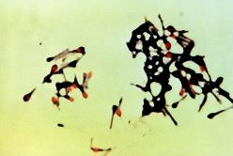
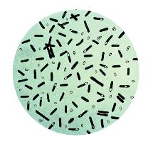

Clostridium botulinum.

These are the common and scientific names of Clos-tridium and associated triggers of disease:

- Blackleg (C. chauvoei) – fast growth and ex-ertion injury of leg muscles

- Blackgut (C. perfringens B) – diet change and overload of intestines

- Blackgut (C. perfringens C) – diet change and overload of intestines

- Blackgut (C. perfringens D) – diet change and overload of intestines

- Blackneck (C. sordellii) – traumatic injury of neck muscles

- Blackliver (C. novyi) – fluke larval migration of liver
- Redwater (C. hemolyticum) – fluke larval mi-gration of liver

- Malignant edema (C. septicum) – anaerobic wound and needle contamination of muscles

- Tetanus (C. tetani) – anaerobic wound con-tamination of muscles and band castration

- Botulism (C. botulinum) – contaminated de-cayed food

Leptospirosis is a systemic bacterial disease of do-mestic and wild animals. It is classified as a zoonotic disease. Leptospirosis bacteria are shed in the urine. Transmission occurs by ingesting urine-contaminat-ed food and licking urine-contaminated haircoats. In young animals the clinical symptoms include acute fe-ver, anemia, icterus, hemoglobinuria (blood pigment in brown colored urine), and death. Adult animals experience chronic infections that lead to infertility, abortions, stillbirth, and mastitis. Laboratory proce-dures for detection of leptospirosis of animals include serological and urine tests. Vaccination is important to provide protection for those at high risk.

Systemic mycoses are fungal diseases that infect body systems of animals and humans, such as the integu-mentary, respiratory, and digestive systems. These fungal diseases include aspergillosis, histoplasmosis, candidosis, blastomycosis, coccidioidomycosis, and sporotrichosis. They are serious diseases that result in severe tissue damage and are resistant to chemo-therapy. Diagnosis of this condition uses radiography, culture, serology, and skin immunologic tests.

Leptospirosis in kidney.
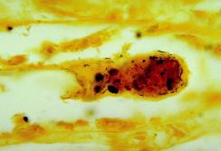
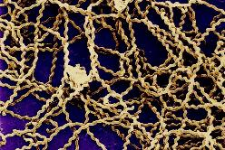

Leptospira sp. bacteria.

Reference

Kahn, C. M. (Ed.). (2010). The Merck veterinary manual (10th ed.). Whitehouse Station, NJ: Merck.

Questions

- Describe predisposing factors of ear infections.

- Describe the following abnormal conditions:

  - Enterotoxemia

  - Toxemia

  - Mucopurulent

  - Gangrene

- List some of the infections bacteria can cause in the ears and eyes of animals.
- List some of the generalized infections systemic bacteria can cause in animals.
- List some of the generalized infections systemic fungi can cause in animals.

Activities

- Observe a variety of animals diagnosed with eye infections and record the presence or absence of clinical symptoms.

- Observe a variety of animals diagnosed with ear infections and record the presence or absence of clinical symptoms.

- Observe a variety of animals diagnosed with generalized systemic infections and record the presence or absence of clinical symptoms.

