**Veterinary Science CDE Exam Questions**

**Multiple Choice**

*Identify the choice that best completes the statement or answers the question.*

1. The term for lying on the side is
2. Cranial c. dorsal
3. ventral d. lateral recumbency
4. The term for toward the nose
5. medial c. rostral
6. distal d. prosimal
7. The term *caudal* means
8. toward the head c. toward the stomach
9. toward the nose d. toward the tail
10. A sheep is called a
11. bovine c. caprine
12. porcine d. ovine
13. ­­­­The term *anorexia* means
14. tired or inactive c. difficulty urinating
15. not eating d. vomiting
16. ­The suffix *–stomy* means
17. to make an incision c. to suture to
18. to create a new opening d. to remove
19. The term *cysto-* refers to the
20. urinary bladder c. urinalysis
21. urine d. uterus
22. Which description demonstrated direct supervision?
23. The supervisor only needs to be physically on the premises.
24. The supervisor needs to be on the premises and near enough to be of assistance.
25. The supervisor doesn’t need to be on the premises, just familiar enough with the animal to have left instructions for its care.
26. The supervisor needs to be in the same room.
27. What is the definition of “ethics”?
28. Laws passed by the government
29. Any behavior that is acceptable to you and your friends
30. Your religious beliefs
31. Rules and principles that govern proper conduct
32. Which of the following statements are true regarding confidentiality of medical records and

cases?

1. Medical records and cases are ethically considered confidential
2. It is ok for information to be shared with anyone associated with the hospital
3. It is ok to share medical information with your own family members
4. Veterinary medical records and case information are not confidential, only human medical records are confidential.
5. Which of the following is NOT a breach of contract between a veterinarian and a client?
6. A client refuses to pay for services that were approved in a consent form.
7. A boarding dog escapes from the hospital premises.
8. A veterinarian guarantees a cure and the patient dies.
9. All of the above are breaches in contract.
10. Which federal agency is responsible for overseeing the manufacture and distribution of drugs

used in animals?

1. Food and Drug Administration (FDA)
2. Animal Welfare Administration (AWA)
3. Drug Enforcement Agency (DEA)
4. Occupational Safety and Health Administration (OSHA)
5. The jugular vein is located
6. On the inside of the front leg c. on either side of the neck
7. Inside the thigh on the rear leg d. in the tail
8. The gestation length for a dog is
9. 30 c. 72
10. 63 d. 96
11. Which of the following is a bacterial disease?
12. Leptospirosis c. ringworm
13. Coccidiosis d. giardiasis
14. Which of the following is a viral disease?
15. Coccidiosis c. rabies
16. Tetanus d. rocky mountain spotted fever
17. A parasite that lives on hair is called
18. Flea c. mite
19. Tick d. lice
20. Cats have an average of ______________muscles in the body
21. 100 c. 300
22. 200 d. 400
23. _________can build up in the cat’s stomach due to excessive grooming
24. Bacteria c. antibodies
25. Hairballs d. weight
26. Cats go through a polyestrus cycle every _____days.
27. 5-7 c. 14-21
28. 10-14 d. 15-16
29. The total number of eggs in a nest at one time is called a:
30. Brood c. group
31. Flock d. clutch
32. What is used to determine the gender of a bird?
33. Feather sample c. DNA test
34. Blood sample d. all of the above
35. “Wet tail” causes the following in hamsters:
36. Weight loss c. nasal discharge
37. Diarrhea d. all of the above
38. Which of the following is NOT a ruminant?
39. Sheep c. elk
40. Bison d. ostrich
41. The term for a cow or dairy animal in labor is called:
42. Freemartin c. springing
43. Freshening d. heifer
44. What is the gestation length of a cow?
45. 180 days c. 195 days
46. 283 days d. 205 days
47. Which of the following diseases is a reproductive disease that may cause sterility and abortion

in cattle?

1. Leptospirosis c. brucellosis
2. Bovine viral diarrhea d. displaced abomasums
3. Which of the following metabolic conditions causes low blood sugar?
4. Ketosis c. grass tetany
5. Bloat d. mastitis
6. Which of the following diseases is tested with a Coggins test?
7. Equine herpes virus c. Equine Infectious Anemia
8. Equine encephalomyelitis d. tetanus
9. What is the gestation length of a horse?
10. 365 days c. 340 days
11. 283 days d. 300 days
12. What age should a horse have all of its adult teeth in place?
13. 5 years c. 6 years
14. 2 years d. 4 years
15. Which of the following diseases is caused by Clostridium?
16. Rabies c. Influenza
17. Swamp fever d. Tetanus
18. Which of the following is NOT a part of the horse?
19. Fetlock c. poll
20. Shank d. pastern
21. What areas of the teeth may need routine floating?
22. Cups c. wolf teeth
23. Molars d. points
24. A common procedure that is used for the purpose of identification is
25. Tail docking c. snaring
26. Ear notching d. castration
27. A reproductive disease in swine that is highly contagious and has no cure is:
28. Brucellosis c. dermatitis
29. Leptospirosis d. pseudo rabies
30. What is the gestation length of sheep?
31. 148-150 days c. 135-138 days
32. 140-142 days d. 114-116 days
33. Which type of digestive system do goats have?
34. Monogastric c. nonruminant
35. Ruminant d. avian
36. What is the gestation length of goats?
37. 100-135 days c. 148-151 days
38. 168-171 days d. 90-100 days
39. What is the incubation time of chickens?
40. 11 days c. 18 days
41. 21 days d. 15 days
42. What disease causes respiratory distress that may make a bird twist its neck?
43. Marek’s disease c. Newcastle disease
44. Infectious bronchitis d. Avian influenza
45. The study of the functions of the human body is called
46. Anatomy c. pathology
47. Physiology d. histology
48. The type of tissue that lines internal organ structures and serves as a protective layer is called
49. Connective c. mucular
50. Nervous d. epithelial
51. What type of joint rotates around a fixed point?
52. Ball and socket joint c. hinge joint
53. Fibrous joint d. pivot joint
54. Which of the following IS part of the appendicular skeleton?
55. Skull c. femur
56. Mandible d. ribs
57. Which of the following is the name of the second cervical vertebra?
58. Axis c. atlas
59. Cervix d. coccyx
60. Which of the following fractures causes a break in a bone that stays in place?
61. Compound c. greenstick
62. Subluxation d. simple
63. The elbow is an example of what type of joint?
64. Fibrous c. ball & socket
65. Pivot d. hinge
66. Hip dysplasia is common in which dog breed
67. German Shepherd c. beagle
68. Poodle d. pug
69. Intervertebral disc disease is common in which dog breed?
70. Corgi c. bichon
71. Great Dane d. Dalmatian
72. Which of the following animals is NOT a ruminant?
73. Pig c. goat
74. Bison d. cow
75. Herbivores would eat which of the following
76. Corn c. beef
77. Chicken d. pork
78. Wavelike motion of the digestive tract.
79. Papillae c. peristalsis
80. Mucosa d. fundus
81. Substance created by the liver.
82. bile c. glucose

b. mucosa d. trypsin

1. A condition resulting from fluid loss in the body is
2. digestion c. dehydration
3. peristalsis d. diabetes
4. A swollen and painful abdomen is a sign of
5. bloat c. overeating
6. constipation d. dehydration
7. The thin inner layer of heart muscle is called
8. myocardium c. epicardium
9. endocardium d. pericardium
10. A condition characterized by a lack of oxygen and blood reaching the tissues is
11. shock c. cardiac arrest
12. arrhythmia d. myocardial infarction
13. Inflammation of the lungs is a characteristic of
14. pneumonia c. bordetella
15. asthma d. heaves
16. A tear in the chest muscle allowing muscle to protrude through is called
17. pleural friction rub c. diaphragmatic hernia
18. heaves d. roaring
19. A respiratory infection caused by transport of livestock is called
20. bordatella c. asthma
21. shipping fever d. heaves
22. Which of the following is a building block of protein that forms in chains?
23. Fatty acids c. amino acids
24. Lipids d. enzymes
25. Which of the following is an example of a mineral?
26. B12 c. D
27. Sunlight d. iron
28. Which of the following organs produces bile?
29. Liver c. gallbladder
30. Kidney d. pancreas
31. Which of the following diets is used for an animal that is showing or hunting?
32. Maintenance diet c. growth diet
33. Reproduction diet d. work diet
34. Which of the following is a type of roundworm?
35. Trichuris vulpine c. ancylostoma caninum
36. Toxocara cati d. dirofilaria immitis
37. Which of the following parasites can cause a skin condition in humans called *cutaneous larval*

*migrans?*

1. Roundworm c. hookworm
2. Whip worm d. heartworm
3. A parasite that is flat and segmented, living in the small and large intestine is called
4. Strongyles c. giardia
5. Coccidian d. tapeworm
6. A parasite known to cause Lyme disease is
7. Tick c. mite
8. Flea d. fly
9. Which animal is at the greatest risk of developing West Nile Virus from the bite of a mosquito?
10. Cat c. goat
11. Horse d. dog
12. Which of the following is the most common source of coccidian?

a. water contamination c. bird droppings

b. food contamination d. rabbit droppings

1. Which of the following adult parasites is visible to the naked eye?
2. Roundworm c. hookworm
3. Whipworm d. coccidian
4. Which of the following insects spread heartworm disease?
5. Ticks c. mosquitos
6. Fleas d. flies
7. Which of the following types of behaviors is used to teach a young horse to lift its feet by

touching and handling the feet shortly after birth?

1. Modeling c. instinctive
2. Imprinting d. conditioning
3. Which of the following is a term for when an animal eats its own waste materials?
4. Coccidian c. pheromone
5. Maternal d. coprophagia
6. What type of aggression is displayed when an animal protects its owner?
7. Dominance aggression c. fear aggression
8. Territorial aggression d. redirected aggression
9. Which of the following factors should be considered when handling animals?
10. Temperature c. teamwork
11. Stress d. all of the above

e. None of the above.

1. Which of the following restraint equipment should not be used on cats?
2. Rabies pole c. anesthesia chamber
3. Muzzle d. squeeze cage
4. Which of the following is not an example of a veterinary safety device?
   1. Scavenger hose for anesthesia c. sterile surgery gloves
   2. Medical waste bag d. all of the above
5. Which of the following is not a class of veterinary hazards?
6. Biological hazard c. chemical hazard
7. Sharps hazard d. physical hazard
8. Which of the following agents is used to treat cancer?
9. Zoonosis c. chemotherapy
10. Bacteria d. all of the above
11. Which of the following items is available to determine hazardous ingredients and treatment

protocols for products?

1. OSHA binder c. MSDS binder
2. Right-to-know station d. none of the above
3. Which of the following is not an example of an aseptic practice?
4. Wearing exam gloves
5. Treating patients in isolation before treating surgical patients
6. Wearing a gown in the isolation ward
7. Washing hand after removing gloves
8. Which of the following is not a class of sanitation?
9. Aseptic technique c. sterilization
10. Disinfecting d. cleaning
11. Which of the following agents is used to disinfect?
12. Alcohol c. chlorhexidine
13. Iodine d. all of the above
14. Which of the following is the typical time a mercury thermometer needs to be in the rectum until

reading?

1. 1 minute c. 60 seconds
2. 30 seconds d. both A and C
3. Which of the following is a term for hair loss?
4. Alopecia c. anastomosis
5. Anorexia d. atrophy
6. Which of the following is the definition of arrthymia?
7. Difficulty breathing c. abnormal heart beat
8. Swishing sound within the heart d. sound of cellophane within the heart
9. Which of the following is also the heart rate?
10. Temperature c. respiration
11. Pulse d. weight
12. Which of the following is NOT a cause of stress?
13. Change in diet c. infectious disease
14. Change in environment d. all of the above cause stress
15. Which of the following is the definition of hyperplasia?
16. Increased amounts of tissue c. lack of tissue
17. Decreased amounts of tissue d. abnormal tissue
18. Which of the following is a term for a vaccine?
19. Biological c. supplemental
20. Pharmaceutical d. nosocomial
21. Which of the following is a purpose for bandaging?
22. Protection c. immobilization
23. Prevention of movement d. all of the above
24. Which of the following size syringes should be used to administer a 1 ml amount of substance?
25. 10 ml syringe c. 12 ml syringe
26. 3 ml syringe d. 6 ml syringe
27. Which of the following is the reason for tapping the end of the syringe after filling it?
28. To remove air bubbles c. to mix the syringe contents
29. To read the syringe level d. all of the above
30. Which of the following is the reason for aspirating the syringe prior to injection?
31. To remove air bubbles c. to make certain the syringe is not in a blood vessel
32. to not produce pain d. all of the above
33. Which of the following is a site for an IM injection?
34. Quadricep muscles c. pectoral muscles
35. Hamstring muscles d. all of the above
36. Which of the following animals may get ear mites?
37. Dogs c. cats
38. Rabbits d. all of the above
39. Which of the following defines the term efficacy?
40. The amount of a drug c. the trade name of a drug
41. The strength and life of a drug d. the dosage of a drug
42. Which of the following is NOT a route of giving medications?
43. By mouth c. ophthalmic
44. Aural d. dram
45. Which of the following is NOT a sign of pain?
46. Vocal c. eating and drinking well
47. Restless d. chewing at incision
48. Which of the following is NOT a statement referring to surgical preparation of the

patient?

1. The surgical margin should extend an inch for the incision location
2. The surgical scrub should be done in a clockwise circular motion
3. The surgical scrub should be done working from the center outward
4. The surgical area should be clipped with #40 blades
5. Which of the following agencies usually regulate exotic species?
   1. Department of Wildlife c. Department of Treasury
   2. Department of Agriculture d. Department of State
6. What is the correct genus for Goats
   1. Ovine c. Bovine
   2. Caprine d. Porcine
7. What is the correct genus for Cattle
   1. Avian c. Bovine
   2. Caprine d. Ovine
8. Ovine is the correct genus for what animal
   1. Goat c. Sheep
   2. Cattle d. Horses
9. A young female horse under three is called a
   1. Filly c. Mare
   2. Colt d. Foal
10. A newborn horse is called a
    1. Filly c. Colt
    2. Foal d. Mare
11. A mature female pig that has had a litter is called a
    1. Sow c. Ewe
    2. Gilt d. Boar
12. A mature female sheep is called a
    1. Heifer c. Sheep
    2. Doe d. Ewe
13. A mature female goat is called a
    1. Ewe c. Doe
    2. Heifer d. Wether
14. A pullet is a:
    1. Mature female chicken c. Young female chicken
    2. Mature male chicken d. Young male chicken
15. A wether is a
    1. Castrated Goat c. Castrated Chicken
    2. Intact male Sheep d. Castrated Horse
16. Mature female cattle are called
    1. Heifers c. Steers
    2. Cows d. Calfs
17. A mature intact male horse is called a
    1. Stallion c. Stud
    2. Gelding d. Steer
18. A young male chicken is called:
    1. Roster c. Pullet
    2. Cock d. Cockerel
19. A gelding is a
    1. Stud c. Castrated Goat
    2. Castrated Horse d. Castrated Goat
20. What does the label A represent on the Canine skeleton?

A

D

C

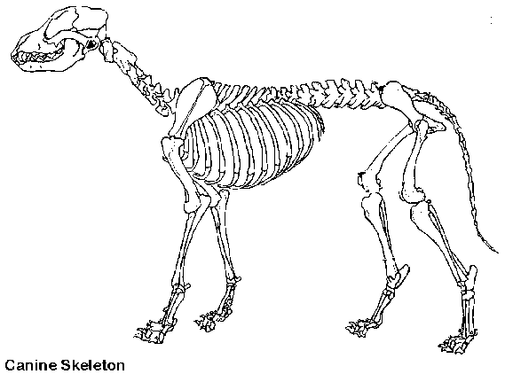

* 1. Skull c. Pelvis

B

* 1. Scapula d. Vertebrae

1. What does the label B represent on the Canine skeleton?
2. Tibia c. Femur
3. Fibula d. Humerus
4. What does the label C represent on the Canine skeleton?
   1. Radius c. Pelvis
   2. Ulna d. Fibula
5. What does the label D represent on the Canine skeleton?
6. Ribs c. Skull

E

1. Vertebrae d. Pelvis
2. What does the label E represent on the Canine skeleton?
   1. Phalanges c. Tibia
   2. Scapula d. Ulna
3. A Collie is in what grouping of dogs
   1. Working c. Toy
   2. Herding d. Sporting
4. Which of the following breeds is in the Non-Sporting group?
   1. Pug c. Labrador
   2. Poodle d. German Sheppard
5. Bone is made up of:
   1. Calcium, phosphorus, and collagen fibers c. Marrow, cartilage and tendons
   2. Vitamins A, B, and C d. Nitrogen, phosphorus and potassium
6. What is the function of bone marrow?
   1. Produces blood cells. c. Provides movement
   2. Provides support d. All of the above
7. Where is bone marrow found?
   1. In the hollow shaft of long bones c. In the hollow shaft of short bones
   2. In the hollow shaft of flat bones d. In the hollow shaft of joints
8. X-rays are used to take a special photograph called a
   1. Photograph c. X-ray
   2. Radiograph d. Bone scan
9. Swine and Humans have what type of digestive systems?
   1. Monogastric c. Ruminant
   2. Monogastric rumination d. Polygastric
10. Rabbits and Horses have what type of digestive system?
    1. Avian digestion c. Hindgut fermenter
    2. Hindgut rumination d. Ruminant
11. Cattle have what type of digestive systems?
    1. Monogastric c. Hindgut Fermenter
    2. Ruminant d. Monogastric Rumination
12. Which one of these digestive organs is found only in the bird?
    1. Cecum c. Crop
    2. Stomach d. Gall Bladder
13. The muscular tube connecting the mouth to the stomach is called the
    1. Stomach c. Pharynx
    2. Esophagus d. Trachea
14. The majority of absorption of nutrients in non-ruminants takes place here
    1. Stomach c. Omasum
    2. Rumen d. Small Intestine
15. The major role of this organ in the digestive process is to provide bile salts to the small

intestine and detoxify the blood.

* 1. Gall Bladder c. Liver
  2. Pancreas d. Kidney

1. Simple stomachs are called
   1. Monogastrics c. Ruminants
   2. Singular Stomachs d. Gastritis
2. In the ruminant which compartment of the stomach looks like a honeycomb
   1. Abomasum c. Cecum
   2. Reticulum d. Rumen
3. Continuous regurgitation, chewing and swallowing is called
   1. Digestion c. Eructation
   2. Rumination d. Mastication
4. Very muscular organ, used to grind food in birds is called the
   1. Crop c. Beak
   2. Gizzard d. Proventiculus
5. Wavelike motions that propel food through the esophagus are called what?
   1. Peristalsis c. Eructation
   2. Rumination d. Anastalsis
6. How many stomach compartments does a cow have?
   1. One c. Three
   2. Two d. Four
7. What is mastication and why is it important?

B

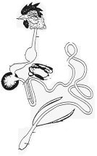

* 1. Chewing; to increase surface area of food for easier digestion
  2. Chewing; to decrease surface area of food for easier digestion
  3. Swallowing; to increase wavelike motions
  4. Swallowing; to decrease wavelike motions

1. This is produced excessively in anticipation of food.
   1. Bile c. Mucous
   2. Saliva d. Acid
2. What does the label B represent on the Avian digestive system?
   1. Crop
   2. Proventiculus
   3. Gizzard

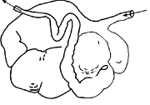

* 1. Ceca

1. What does the label A represent on the Ruminant digestive system?
   1. Abomasum c. Rumen

A

* 1. Omasum d. Reticulum

1. What does the label C represent on the Monogastric digestive system?

C

C

* 1. Pancreas c. Large Intestine

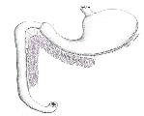

* 1. Stomach d. Liver

1. What does the label D represent on the Hindgut fermenter digestive system?
   1. Cecum c. Stomach

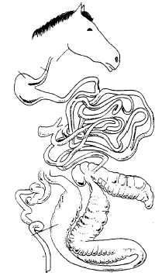

* 1. Large Intestine (Colon) d. Rumen

1. What is the main function of carbohydrates?
   1. Growth and repair of cells c. Assist in taste recognition
   2. Provide Energy d. Medium for chemical reactions

D



1. Accounts for 70% or more of the composition of animals?
   1. Blood c. Fat
   2. Skin d. Water
2. Corn, wheat, oats, and barley are considered what type of carbohydrates?
   1. Protein carbohydrates c. Simple Sugar
   2. Fatty carbohydrates d. Starch
3. Which nutrient contains the greatest amount of energy?
   1. Water c. Fats
   2. Minerals d. Vitamins
4. This nutrient is essential because it is needed throughout life for growth and repair and

is used for energy only if needed.

* 1. Carbohydrates c. Fats
  2. Protein d. Minerals

1. Which of the following is a fat-soluble vitamin?
   1. Vitamin C c. Vitamin B6
   2. Vitamin A d. Vitamin B12
2. Which of the following is a water-soluble vitamin?
   1. Vitamin E c. Vitamin A
   2. Vitamin D d. Vitamin C

Protein consists of strings of building blocks called?

* 1. Amino chains c. Acetic acids
  2. Amino acids d. RNA

Which of the following is a trace mineral?

1. Zinc c. Calcium

b.Sodium d. Phosphorus

1. Which of the following is a macro mineral?

B

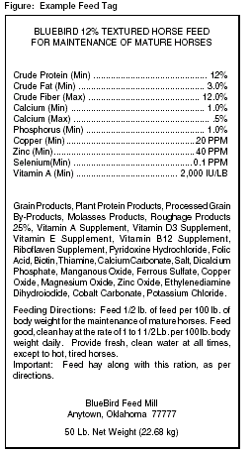

* 1. Sodium c. Copper
  2. Zinc d. Selenium

1. Label A represents what on the example feed tag?
   1. Name of Feed
   2. Use of Feed

C

* 1. Ingredients
  2. Manufacturer

1. Label B represents what on the example feed tag?
   1. Guaranteed Analysis c. Use of Feed
   2. Name of Feed d. Manufacturer
2. Label C represents what on the example feed tag?
   1. Use of Feed c. Ingredients
   2. Manufacturer of Feed d. Manufacturer
3. The entire coat of wool shorn from the sheep at one time is called
   1. Fiber c. Fleece
   2. Staple d. Wool

A

1. What does the label A represent on the sheep?
   1. Loin c. Wither
   2. Hip d. Neck
2. What does the label B represent on the sheep?
   1. Poll c. Muzzle
   2. Face d. Neck

B

1. What does the label C represent on the sheep?

A

* 1. Twist c. Loin

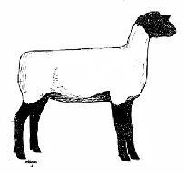

* 1. Dock d. Rump

C

1. What does the label D represent on the sheep?
   1. Cannon Bone c. Hoof
   2. Pastern d. Hock
2. What is the purpose of the marking harness?

D

* 1. Identifies which rams are ready for breeding
  2. Provides a signal of which ewes were bred and when
  3. For cosmetic purposes
  4. Identifies which ewes are ready for breeding

1. What is the purpose of docking the tails of sheep?
   1. Sheep do not have tails naturally.
   2. To help keep the sheep clean from manure
   3. For appearance only
   4. In order to show sheep at shows
2. What does the label A represent on the chicken?

D

A

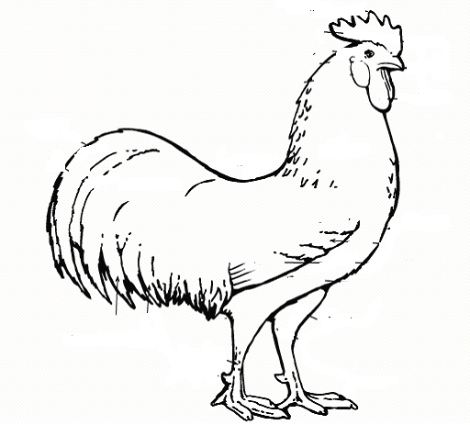

* 1. Breast

B

* 1. Wattle
  2. Comb
  3. Saddle

1. What does the label B represent on the chicken?

E

* 1. Breast c. Comb
  2. Wattle d. Saddle

1. What does the label D represent on the chicken?
   1. Breast c. Comb
   2. Wattle d. Saddle
2. What does the label E represent on the chicken?
   1. Breast c. Comb
   2. Wattle d. Saddle
3. Chickens raised for meat production are called:
   1. Cornish Game c. Broilers
   2. Layers d. Poultry
4. When chicks become too hot they:
   1. They lay down or pile into corners of the brooder
   2. They chirp a lot and huddle together
   3. They are evenly spaced under the heat lamp

C

* 1. They chirp a lot and pile into the corners of the brooder

A



1. What does the label A represent on the hog?
   1. Ham c. Loin

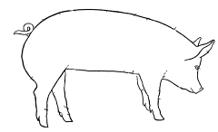

* 1. Jowl d. Stifle

1. What does the label B represent on the hog?
   1. Ham c. Jowl
   2. Rump d. Back
2. What does the label C represent on the hog?
   1. Ham c. Stifle
   2. Rump d. Back

B

1. In the universal ear notching system of hogs, what does the right ear number represent?
   1. Individual Pig number c. Litter number
   2. The Sows number d. Number of piglets in the litter
2. Name the type of hog operation that raises hogs from birth to slaughter weight
   1. Breeding Stock c. Finishing Operations
   2. Farrowing Operations d. Farrow to Finish
3. Name the type of hog operation that purchases weaned piglets and raises them to market weight
   1. Seedstock c. Finishing Operations
   2. Farrowing Operations d. Farrow to Finish

*Sassy is an 18-month-old (1 ½ years) female horse who measures 10 hands. Please answer the following three questions regarding Sassy.*

1. How many inches is Sassy?
   1. 14 inches c. 40 inches
   2. 24 inches d. 42 inches
2. At this size what type of horse would Sassy be considered
   1. Horse c. Pony
   2. Short Horse d. Draft
3. According to her age and sex Sassy would be called a?
   1. Filly c. Stallion
   2. Mare d. Gelding
4. Measurement term used in horses from ground to withers.
   1. Foot c. Yard
   2. Hand d. Inches
5. A pony can not be greater than:
   1. 14 hands c. 12 hands
   2. 14.2 hands d. 10 hands
6. The breed of horse commonly used for harness racing in Michigan.
   1. Quarter horse c. Standardbred
   2. Thoroughbred d. Arabian
7. What does the label A represent on the horse?
   1. Shoulder c. Forearm
   2. Chest d. Neck
8. What does the label B represent on the horse?

C

E

D

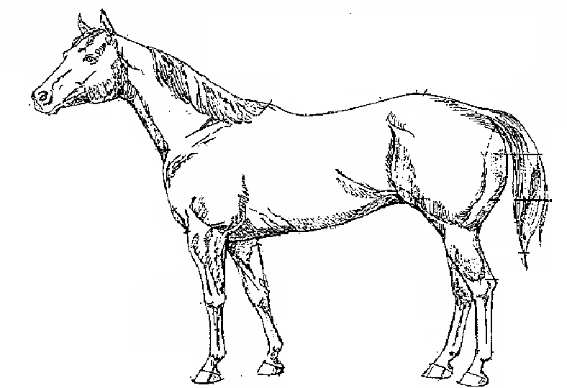

* 1. Gaskin c. Pastern
  2. Cannon bone d. Coronet

A

1. What does the label C represent on the horse?
   1. Withers c. Loin
   2. Croup d. Hock

B

1. What does the label D represent on the horse?
   1. Loin c. Back
   2. Croup d. Withers
2. What does the label E represent on the horse?
   1. Stifle c. Fetlock
   2. Gaskin d. Croup
3. The term for away from the midline is
   1. medial c. Proximal
   2. lateral d. Distal
4. The term that refers toward the back area or above is
   1. ventral c. cranial
   2. dorsal d. caudal
5. The term that means toward the head is
   1. ventral c. cranial
   2. dorsal d. caudal
6. Disease of heart muscle is
   1. Cardiopathy c. cardiovalvopathy
   2. cor pulmonale d. cardiomyopathy
7. Heart enlargement is
   1. cardiac swelling c. cardiac dilation
   2. cardiac augmentation d. cardiomegaly
8. The blood vessels that carry blood from the heart to the lungs are the
   1. pulmonary veins c. vena cava
   2. pulmonary arteries d. aorta
9. The contraction phase of the heartbeat is the
   1. septum c. systole
   2. diastole d. tachvcardia
10. The myocardium receives its blood supply from the
    1. aorta c. vena cava
    2. coronary arteries d. subclavian artery
11. The organism that causes heartworm is:
    1. *Dirofilaria immitis c. Giardia*
    2. *Taenia pisiformis* d. Protozoa
12. The most common endoparasite of puppies and kittens is:
    1. Flea c. mite
    2. Roundworm d. protozoa
13. What parasite transmits Lyme disease?
    1. *Dirofilaria immitis* c. Lice
    2. Heartworm d. Tick
14. To remove a tick you should:
    1. Use a match to burn the tick off c. Pour alcohol on the tick, then pull it off
    2. Cut the tick off with a knife d. Use tweezers to grasp the head and pull straight out
15. Label this external parasite.

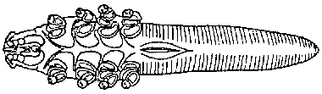

* 1. Flea c. Walking Dandruff
  2. Demodex d. Ear mite

1. Which phylum does the flea belong to:
   1. Platyhelminthes c. Arthropoda
   2. Nematoda d. Sacrodina
2. Which of the following is not a mite?
   1. Otodectes c. Demodex
   2. Cheyletiella d. Ixodes
3. What is the intermediate host of Dipylidium?
   1. Mice c. Ticks
   2. Flea d. Mite
4. The suffix -cyte means
   1. Cell c. Breathing
   2. Water d. Disease
5. The abbreviation ‘stat’ means
   1. Difficulty c. New
   2. Immediately d. Many
6. The prefix ‘Hydr/o’ means
   1. Ear c. Water
   2. Lake d. Eating/swallowing
7. The abbreviation ‘DOB’ means
   1. Date of Belonging c. Date of Birth
   2. Death of Bunny d. Dead on Birth
8. The abbreviation ‘DSH’ means
   1. Domestic Short Hair c. Do Save Horse
   2. Dog Short Hair d. Domestic Soft Hair
9. The suffix ‘–lysis’ stands for what
   1. Pertaining to c. Deficiency of
   2. Destruction of d. Many
10. The suffix ‘–penia’ stands for what
    1. Pertaining to c. Deficiency of
    2. Destruction of d. Many
11. The abbreviation ‘ml’ also could be stated as
    1. cl c. cd
    2. cc d. mc
12. The term ‘ad lib’ means
    1. Many c. as many as you want
    2. pertaining to d. in the water
13. The prefix ‘post’ means
    1. before c. after
    2. during d. next day
14. The hormone testosterone is produced by the:
    1. Epididymis c. Scrotum
    2. Leydig cells d. Seminiferous Tubules
15. The hormone that is produced by the developing follicles on the ovary.
    1. Estrogen c. Progesterone
    2. Prostaglandins d. Testosterone
16. Meiosis in male for sperm production takes place here:
    1. Prostate c. Epididymis
    2. Seminiferous tubules d. Vas deferens
17. Prostaglandins are released from what organ if fertilization does not take place.
    1. Uterus c. Infundibulum
    2. Oviduct d. Ovary
18. Name the stage of estrous in which the egg is released into the infundibulum.
    1. Proestrus c. Metestrus
    2. Estrus d. Diestrus
19. Squeeze chutes are a form of restraint most often used with _______________.
    1. Cattle, horses, and sheep c. Cats and dogs
    2. Cats d. reptiles
20. __________________ is a steam-pressure sterilizer that uses heat to destroy

microorganisms on instruments.

* 1. A retort c. An asepsis
  2. A radiator d. An autoclave

1. The root word or combining form of the medical term that regers to the lung is

__________.

* 1. Derm or dermat c. Pulmo or pulmon
  2. Cardi d. Thorac

1. Docking is the removal of an animal’s _______________.
   1. Testicles c. Horns
   2. Tail d. Claws
2. Baby dogs are born in groups of 1 to 10 puppies, known as ____________________.
   1. Broods c. Litters
   2. Orphans d. Bitches
3. _________________ exams are often used to determine the presence of internal parasites in dogs.
   1. Fecal c. Ear
   2. Mouth d. Skin
4. Which type of tissue covers body surfaces and lines body cavities as skin?
   1. Nervous tissue c. Muscular tissue
   2. Connective tissue d. Epithelial tissue
5. Bone that has the appearance of visible spaces within it is known as _________ bone.
   1. Cancellous c. Haversian
   2. Woven d. Compact
6. The study of the functions of the cells, tissues, organs, and systems of an organism is _______________.
   1. Anatomy c. Homeostasis
   2. Physiology d. Botany
7. Cell ______________ is the differences that allow cells to perform unique activities.
   1. Multiplication c. Division
   2. Physiology d. Specialization
8. A cat should be ___________ to protect it against diseases such as rabies and feline

leukemia.

* 1. Spayed c. Vaccinated
  2. Neutered d. Washed

1. Which of the following is a multicellular organism that lives in or on another animal,

from which it receives its nutrients?

* 1. A bacteria c. A protozoa
  2. A parasite d. A virus

1. A *balling gun* is used to deliver medications ______________.
   1. Orally c. Topically
   2. Rectally d. Subcutaneously
2. _______________ are immune substances produced in the body, allowing animals to

withstand exposure to disease.

* 1. Biologicals c. Antibodies
  2. Disinfectants d. Antibiotics

1. Which of the following types of disease is related to a physical injury to the animal?
   1. Contagious c. Morphological
   2. Nutritional d. Physiological
2. Soaking items in a chemical disinfectant until they are used is called ___________.
   1. Ultrasound c. Filtration
   2. Cold sterilization d. Cleaning
3. Removing particles from the air using physical barrier is called _________.
   1. Ultrasound c. Filtration
   2. Cold sterilization d. Cleaning
4. Passing high frequency sound waves through a solution to create a vibration that scrubs an object to remove debris is called ____________________.
   1. Ultrasound c. Filtration
   2. Cold sterilization d. Cleaning
5. ___________ are biohazard materials such as needles, scalpel blades, and syringes that must be disposed of in red, sealed containers labeled with the biohazard symbol.
   1. Radioactive material c. MSDS
   2. Dosimeters d. Sharps
6. ____________________ lists information about a chemical including manufacturer information, hazard ingredients, physical and chemical characteristics, fire and explosion hazard data, health hazard data, precautions for safe handling and use and control measures.
   1. Pesticide Label c. Inventory Sheet
   2. Material Safety Data Sheet d. Order sheet
7. To remove a tick you should ______________.
   1. Use a match to burn the tick off c. Pour alcohol on the tick, then pull it off
   2. Cut the tick off with a knife d. Use tweezers to grasp the head and pull straight out
8. The clinical signs of heartworm are: __________.
   1. Vomiting, deep cough, anemia c. Deep cough, irregular heart beat, exercise intolerance
   2. Anemia, deep cough, irregular heart beat d. irregular heart beat, anemia, exercise intolerance
9. One disease that is transmitted by the tick is called _________.
   1. Rocky Mountain Spotted Fever c. Salmonella
   2. Toxoplasmosis d. Ringworm
10. What parasite transmits Lyme disease?
    1. *Dirofilaria immitis* c. Lice
    2. Heartworm d. Tick
11. The organism that causes heartworm is called _________.
    1. *Dirofilaria immitis c. Giardia*
    2. *Taenia pisiformis* d. Protozoa
12. The most common endoparasite of puppies and kittens is called _________.
    1. Flea c. Mite
    2. Roundworm d. Protozoa

EXTRA Questions

QUESTION: 8

What patient parameters can be checked to determine depth of anesthesia?

A. Eye position

B. Jaw muscle tone

C. Palpebral reflex

D. All of the above

Answer: D

QUESTION: 9

A young Shih Tzu presents to the clinic with what appears to be a "popped" out eye. The correct

ophthalmologic term is:

A. Enophthalmos.

B. Buphthalmus.

C. Proptosis.

D. Glaucoma.

Answer: C

QUESTION: 10

The normal reddish/brown vaginal discharge that occurs immediately following parturition is

called:

A. Lochia.

B. Meconium.

C. Estrus.

D. None of the above.

Answer: A