Introduction to Business Research

Module 1

Learning Summary
This module has attempted to introduce the EBS DBA and specifically the EBS DBA research element. The candidate should now have a basic understanding of:
- the aims and objectives of the EBS DBA programme;
- the basic structure of the EBS DBA programme;
- the basic concept of a doctoral thesis and what this entails;
- the various stages in the development of a doctoral thesis;
- the basic distribution of people involved in supervision and assessment;
- the primary timescales involved in the development and submission of the thesis;
- the basic contents and format of the three DBA Introduction to Business Research courses.
The following section briefly summarises the primary learning outcomes from each section included in this module.

The EBS DBA
- The EBS DBA programme is based on the EBS Strategic Focus Wheel as developed by Professor Alex Roberts.
- The Strategic Focus Wheel (SFW) is based on the concept that strategies have to be made to work. It is one thing to develop a detailed strategy but it is quite another to implement that strategy and make it work. Strategy implementation is a highly complex process involving a large number of potentially disruptive influences from inside and outside the organisation.
- The SFW requires the use of reliable tools in order to improve the likelihood of successful implementation. These tools are project management and strategic risk management. They effectively act as enablers for making strategies work.
- The SFW comprises Strategic Planning, Making Strategies Work, Project Management and Strategic Risk Management.
- The primary aim of the EBS DBA programme is to centre on these four disciplines and generate an understanding of how they interrelate in terms of converting a strategic plan into a successful set of strategic outcomes.
- The secondary aim of the DBA is to produce applied business research professionals who can use their doctoral-level skills at senior executive level in a business environment.
- In line with general practice in the US, the Edinburgh Business School DBA allows doctoral candidates some choice in course structure with alternative balances of taught and research elements.
- This flexibility is necessary to allow candidates to develop their preferred balance between the ‘taught’ (subject-specific courses) and research (thesis) elements. The ‘taught’ courses comprise 11 subject-specific self-contained courses.
- The DBA research (thesis) element comprises a thesis of around 50 000 words with an upper limit of around 60 000 words excluding appendices.
- In exceptional circumstances, where the candidate can show that he or she is capable of generating a doctoral thesis of extraordinary merit, the EBS DBA Research Committee may allow the candidate to complete a larger thesis, typically containing around 70 000 with an upper limit of 80 000 words. In such cases the number of subject-specific taught courses to be taken may be reduced to nine.
- In both cases, the research element is conducted to full doctoral-level standard. The shorter thesis does not imply a lower standard.
- The subject-specific courses element comprises the three compulsory advanced core courses, three compulsory business research courses, and either three or five elective advanced courses.
- Candidates who elect to complete a 70 000-word research thesis in the research element are required to complete three electives in the subject-specific courses element. Candidates who elect to complete a 50 000-thesis in the research element are required to complete five electives in the subject-specific courses element.
- The three compulsory advanced core courses are listed below.
  - Making Strategies Work
  - Project Management
  - Strategic Risk Management
- The three compulsory research methods courses are listed below.
  - Introduction to Business Research 1: The Research Proposal.
  - Introduction to Business Research 2: The Literature Review, Synthesis and Research Hypothesis.
  - Introduction to Business Research 3: The Research Method, Data Collection, Analysis, Results and Writing Up.
- The current elective advanced courses are listed below.
  - Competitive Strategy.
  - Mergers and Acquisitions.
  - Leadership.
  - Stakeholder Management.
  - Alliances and Partnerships.
  - Corporate Governance.
  - Corporate Venturing.
- The thesis should generally contain the sections listed below.
  - The development of a research proposal.
  - The development of a literature review.
  - The development of a theory or hypothesis.
  - The development of a research method.
  - Data collection and analysis.
  - The generation of results and conclusions.
- As with virtually all European and US doctoral theses, the DBA thesis is assessed at a viva voce or oral examination. The candidate presents the thesis before an internal (Heriot-Watt University) and an external (non-Heriot-Watt University) examiner.
- The examination concludes with a recommendation from the examiners, who may award the degree of DBA or recommend the award of the degree subject to minor alterations. In some cases major alterations may be required before the thesis is accepted.

The EBS DBA Thesis
- In order to satisfy the examiners the DBA thesis must comply with the following Heriot-Watt University regulation:
‘The thesis shall form a contribution to the knowledge of the subject and afford evidence of originality, shown either by the discovery of new facts or by the exercise of independent critical power.’
- The thesis is developed in three stages as listed below.
  - Stage 1: The research proposal.
  - Stage 2: The literature review, synthesis and research hypothesis.
  - Stage 3: The research method, data collection, analysis, results and writing up.

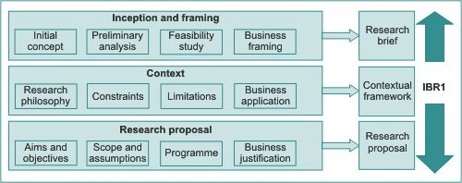
- The candidate works with a research supervisor in stages 2 and 3.
- The preliminaries section includes the abstract, title page, acknowledgements list of contents, list of figures and tables and list of appendices.
- The literature review is intended to show that the candidate has critically reviewed all the relevant published research in the appropriate areas.
- The literature review draws together the various separate themes covered in the literature review chapter, and generates a summary of the literature forming a basis for the research theory or hypothesis.
- The pilot study is a small-scale preliminary study carried out in order to evaluate the research method and/or to evaluate the suitability of the research theory or hypothesis.
- The research method consists of the procedures to be adopted in collecting and analysing the research data.
- The literature reappraisal and theory development section is intended to reappraise the literature in the light of the research findings with the intention of using any additional material in support of, or development of, the basic and formal theories.
- The DBA Research Committee comprises member of the EBS faculty. The committee is responsible for appraising candidate research proposals and literature reviews.
- The internal examiner is typically a member of the EBS faculty or is a member of another faculty within Heriot-Watt University The internal examiner is responsible for examining the doctoral thesis in order to ensure that it is of sufficient standard in terms of academic rigour to award the degree.
- Supervisors are external (non-Heriot-Watt) specialists who are selected on the basis of their expertise and (if possible) geographical location. Supervisors work with the candidate during stages 2 (literature review) and 3 (fieldwork, data collection and analysis and writing up).
- 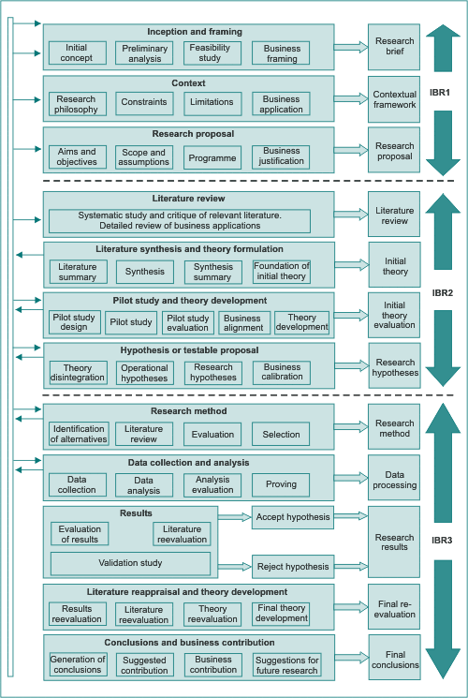

Timescales for Completion
- The DBA comprises five progression gateways. These gateways are listed below.
  - Gateway 1: Entry to the course.
  - Gateway 2: Completion of the subject-specific courses element.
  - Gateway 3: Completion of the research proposal.
  - Gateway 4: Completion of the literature review.
  - Gateway 5: Completion of the thesis and successful viva voce.
- The recommended gateway completion times for the full-time mode are shown below.
  - Gateways 2 and 3: 12 months from start.
  - Gateway 4: 18 months from start.
  - Gateway 5: 36 months from start.
- The recommended gateway completion times for the distance learning and part-time mode are shown below.
  - Gateway 2: 18 months from start.
  - Gateway 3: 24 months from start.
  - Gateway 4: 36 months from start.
  - Gateway 5: 72 months from start.
- Candidates can accelerate or delay gateways. Candidates who extend the research element gateways are liable for additional research element fees.

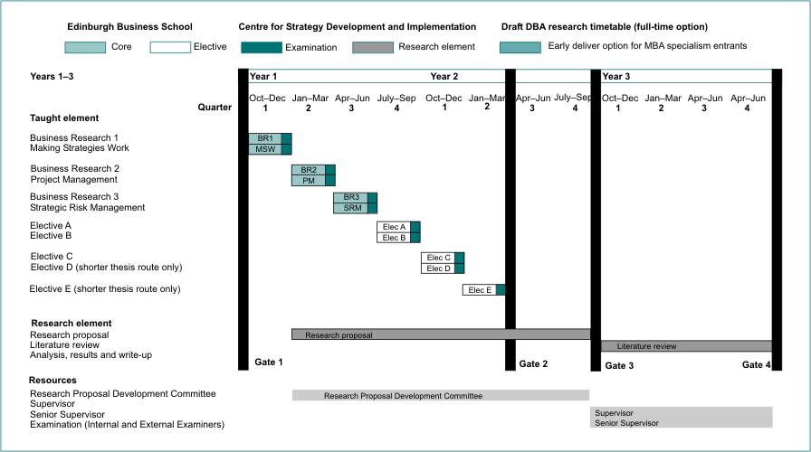
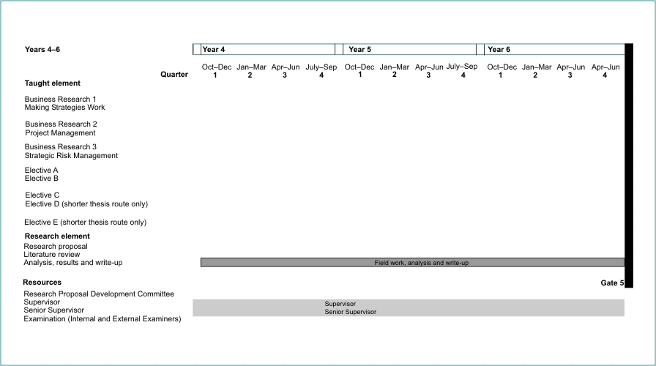

The Introduction to Business Research Courses
- The Introduction to Business Research courses act as a bridge between the assumed zero research awareness of the candidate and the knowledge that can be provided by the experienced supervisor.
- The Introduction to Business Research courses are designed to develop understanding of applied business research in the same sequence in which the thesis is developed.

Module 2

Learning Summary
The candidate should now understand:
- the concept of a programme plan;
- how to break the research programme down into research work packages;
- how to estimate the time required for each work package;
- how to develop a research programme;
- how to establish milestones and checkpoints;
- the importance of personal progress reviews;
- how to handle delays and make trade-offs;
- what to do if the programme goes badly wrong.
The following section briefly summarises the primary learning outcomes from each section that is included in this module.

Establishing Research Aims and Objectives
- Research aims and objectives act as the foundation of the research programme.
- The aim refers to the desired end product.
- The objectives refer to the actions necessary to achieve the aim.
- Generally each aim comprises a series of objectives.
- A research hypothesis generally mirrors the aim.
- An operational hypothesis normally mirrors the objectives.
- A research hypothesis usually comprises a series of operational hypotheses.
- The research aims and objectives do not have to be represented as hypotheses. Some researchers develop a research theory whereas others develop a research question.
- In order to achieve an aim, objectives are met. The objectives are usually achieved through a series of activities or work packages.
- Work packages are sometimes arranged in sequence and sometimes in parallel.
- Once set, aims and objectives should not be changed unless this is absolutely unavoidable.
- If changes to aims and objectives must be made, the changes should be minor.
- If major changes are proposed, there could be objections from both the supervisor and the EBS Research Committee.
- Major changes are likely to involve both abortive work and major additional work.
- Research is both dynamic and concerned with the unknown.
- New objectives may be discovered some way into the research programme.
- There is often a requirement for a series of tactical responses in order to keep the development of the research correctly aligned with the objectives.
- 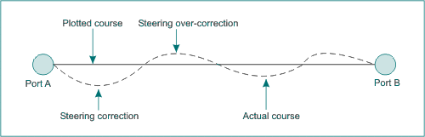

The Research Work Breakdown Structure
- The WBS is a representation of the research programme, broken down into work packages.
- This is necessary in order to derive individual work units that can be independently planned and controlled.
- The WBS is the starting point in the generation of a research schedule.
- Most WBS breakdowns progress to a maximum of about six levels.
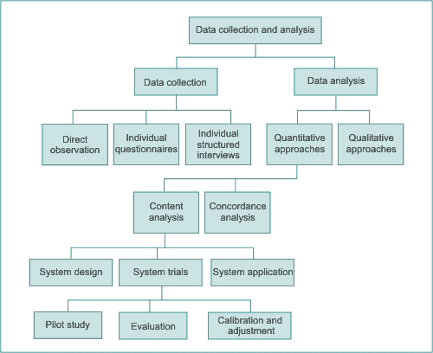

Estimating the Time Required to Complete a Research Work Package
- It is difficult to estimate research activity duration accurately because the full extent of the work is difficult to assess.
- Research nearly always takes longer to complete than was expected.
- The dynamic nature of research coupled with the unknown element promotes estimating inaccuracy.
- The typical times allowed for each element of an average research thesis are as shown below.
  - Preliminaries: a few days.
  - Introduction: a few days.
  - Literature review: six months.
  - Literature synthesis and generation of hypotheses: a few days.
  - Pilot study and theory/hypothesis and refinement: three months.
  - Research method: three months.
  - Analysis: six months.
  - Results: one month.
  - Literature reappraisal and theory development: one month.
  - Conclusions and suggestions for further research: a few days.
- Spare time in one form or another should always be allowed to take unforeseen events into account.

The Research Schedule
- A research schedule simply shows the following information.
  - the work packages that are required in order to complete the programme;
  - the sequence in which these work packages are to be carried out;
  - when each work package should start and finish.
- This information allows the candidate to track his or her actual progress against planned progress and isolate where actual progress is ahead or behind programme.
- Where there is a delay, depending on the importance or criticality of the delay, some form of corrective action may need to be initiated.
- The research schedule should ideally be prepared using commercial project planning software.
- Most software packages represent the schedule as a Gantt chart.
- Most software packages provide a tracking facility where actual progress can be compared with planned progress.
- The schedule should be checked and updated on a regular basis.

Milestones and Gateways
- Milestones are indicators. They are generally used to identify the end of a work package or series of work packages.
- Gateways are progression points. Normally there is a series of events or activities that have to be completed before the research can pass through a gateway.
- A schedule usually contains more milestones than gateways.
- Interdependency occurs where activities are dependent on each other.
- Sequential interdependency occurs where a series of activities have to be carried out in a set sequence.
- Reciprocal interdependency occurs where a series of different activities has to be completed before the overall programme can move forward.
- Pooled interdependency occurs where a series of different activities have to be completed and the results combined or pooled before the next activity can begin.
- Typical gateways in the research schedule include:
  - the completion of the research proposal;
  - the completion of the literature review;
  - the completion of the research element including the thesis.

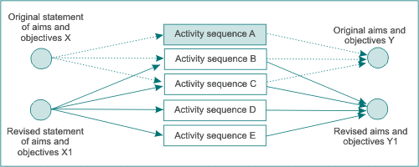

Personal Progression Review
- A personal progression review (PPR) is a simple way of monitoring progress up to a particular point in time.
- PPRs can be held at more or less any time throughout the research programme.
- Major PPRs should be held at significant gateways.
- Minor PPRs should be held at the end of each milestone.
- PPRs provide an important tool in assessing how well the research programme is progressing.
- PPRs are useful for highlighting areas to be brought to the attention of the supervisor.

Delays, Contingencies and Responses to Major Progress Problems
- No matter how carefully a research programme is scheduled, and irrespective of how reliable the monitoring and control system is, most programmes will experience events that cause delays.
- In some cases the resulting delays could be insignificant, whereas in other cases the consequences of a delay could impact directly on the successful progression of the research programme.
- One way of addressing the possibility of a delay is to build spare time into each work package.
- This approach may be a disadvantage where work progresses on schedule up to a fixed activity point and where there are no parallel activities.
- Spare time can be built into a programme with increased parallelisation. This arrangement gives the same net time reserve within a more flexible response option framework.
- Time reserves can also be built in using block buffers or whole activities with a zero work requirement. These should be placed towards the end of the schedule.
- Overlapping activities through parallelisation can lead to very high information processing demands at certain points in the schedule.
- If a peak information-processing demand exceeds processing capacity, a delay could result.
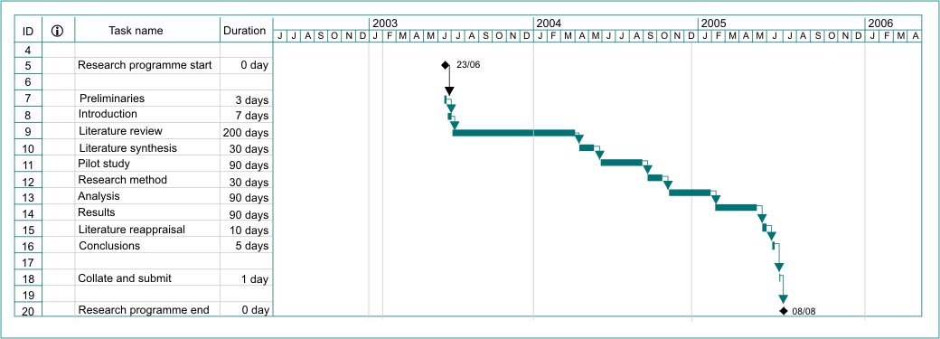
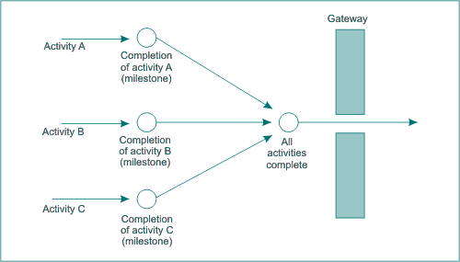
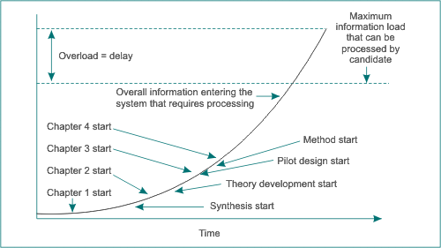

Module 3

Learning Summary
This module has reviewed the two major paradigms within business and management research, positivism and phenomenology. The principal characteristics, advantages and disadvantages of both paradigms have been outlined. Both provide frameworks within which candidates can conduct their research. It is also possible to combine methodologies drawn from both paradigms in the same study and to triangulate the findings.
Karl Popper's role in establishing the hypothetico-deductive method, whereby science progresses by formulating theories, deducing hypotheses, and using observations to test these hypotheses in an attempt to falsify them, is crucial. It is important to be aware of the fundamental differences between the deductive and inductive approaches and to understand how to formulate a new hypothesis.
The candidate should now:
- understand the key characteristics of the two major research paradigms, positivism and phenomenology;
- be able to explain the differences between verification and falsification;
- be able to explain the differences between the deductive and the inductive approaches to research;
- understand the nature of a hypothesis and be able to formulate a null hypothesis;
- be able to explain how the grounded theory approach is implemented.
The following section briefly summarises the primary learning outcomes from each section included in this module.

Research Paradigms
- Western philosophy contains four primary branches. These are:
  - Metaphysics
  - Epistemology
  - Ethics
  - Aesthetics
- Metaphysics is the study of ultimate reality.
- Epistemology is the study of origins, validity and the ultimate limits of knowledge.
- Ethics is the study of morality and rational judgement.
- Aesthetics is the study of beauty in architecture and the fine arts.
- The candidate's own beliefs about the world are reflected in:
  - the research topic chosen;
  - the way in which the research is designed;
  - how data are collected and analysed;
  - the way in which the thesis is written.
- A paradigm is basically a set of beliefs within which a research programme is developed.
- Paradigms evolve as new theories are introduced that supplant or extend existing theories.
- Paradigms are time related.
- The two primary research paradigms are positivism and phenomenology.

Positivism
- Positivism asserts that society can be analysed and understood logically and rationally.
- Positivism is basically concerned with ‘what’ happens.
- Positivism seeks to explain and predict what happens in the social world by searching for regularities and causal relationships between its constituent elements.
- A causal relationship is one where two entities are linked by a relationship in which the action of one causes an effect in the other.
- Operationalisation allows the testing of hypotheses with empirical data.
- Positivism assumes that there are independent causes that lead to observed effects, and that it is feasible to model the observed phenomena.
- Positivism proposes that meaningful statements are restricted to those that can be verified by observation.
- A deductive theory is a theory that attempts to explain why something happens as observed.
- Realism represents the commonsense view that when researchers describe something, that thing really exists. If it exists it can be viewed objectively.

Verification and Falsification
- It is not always possible to prove that a scientific proposition is definitely correct.
- Even if every single observation confirms the assertions put forward by a theory, it is still logical to suggest that the researcher can never be absolutely certain there will never at any time in the future be some additional observations that might demonstrate instances in which the theory does not hold.
- In most cases it is it is easier to disprove (falsify) a theory than it is to prove it.
- Ideally a hypothesis should be falsifiable.
- It is preferable to test an idea by showing that it is probably wrong. An idea should not be regarded as scientific unless it is falsifiable.
- Theories, therefore, should be formulated in a way that makes it easy to test them for possible rejection.

Phenomenology
- Phenomenology is the main alternative paradigm to positivism.
- Phenomenology is concerned primarily with ‘why’ things happen.
- The principal school of thought within phenomenology is transcendental phenomenology, which views positivism and its claim of freedom from prejudice as a conceit.
- Ethnomethodology is concerned to learn about the ways in which people order and make sense of their everyday activities.
- Phenomenology advocates the study of direct experience taken at face value.
- Phenomenologists do not consider the world to consist of an objective reality. Each situation is viewed as unique, and the meaning is a function of circumstances and the individuals involved.
- Phenomenology confronts the issue that people are not mere objects but essentially human with different values and beliefs who experience the world in idiosyncratic ways that positivism is ill-equipped to understand.
- Researchers within the phenomenological paradigm are not objective but are part of what they observe, bringing their own values, cultural beliefs, and prejudices into the research arena.

Comparisons Between Positivism and Phenomenology
- Positivism usually requires a reductionist approach to data and the variables being studied, and a simplification of some variables.
- Concentrating upon a restricted subset of data means that positivists can provide only a fleeting and somewhat partial view of events, opinions and beliefs.
- Phenomenologists maintain that the social world can be comprehended only from the perspective of the individuals who are directly involved in the activities that are to be studied.
- Phenomenological researchers assume that an organisation can be understood only by interacting and becoming part of the activities being re- searched.
- In the phenomenological approach, there are no prescribed categories. They emerge from the data through an interactive process.
- The phenomenological approach is holistic and not reductionist, thereby permitting more complex problems to be investigated.
- Neither the positivist nor the phenomenological approach should be thought of as better than the other. They are better at different things.
- The major advantage of the positivist hypothesis-testing approach is that there is initial clarity about what is to be investigated, and therefore information can be collected speedily.

Deductive and Inductive Theory
- The deductive research approach involves the development of a conceptual and theoretical structure prior to its testing through empirical observation.
- Deductive researchers use deductive argument to infer the particular from the general.
- Deductive reasoning is based on lines of reasoning where one term follows on from another. An example is a syllogism where a premise and a conclusion are linked by a middle term that combines the two.
- Inductionist researchers infer general truths from the particular.
- The inductive approach, in contrast to the deductive one, starts from observed data and then seeks to discover patterns from which a theory is developed to explain the relationships between the objects observed.
- Inductive researchers argue that theory that develops from empirical evidence is more likely to explain the data.
- Inductive reasoning is based upon the premise that nature is orderly and uniform. If one instance after another supports a conclusion, and no instance of similar circumstances refutes the conclusion, then belief in the conclusion is strengthened.

Grounded Theory
- Researchers using grounded theory develop an inductive theory through comparative method, which means studying the same event in different settings.
- Grounded theory effectively mirrors the natural human reasoning process.
- Grounded theory rejects the process of theorising before conducting the research.
- The grounded theory approach is appropriate for capturing the complexities of the context in which activity takes place, and could be readily applied to investigate issues such as decision-making, change, and individual and group behaviour in organisations.
- The grounded theory researcher focuses upon the study of patterns of behaviour and meaning that account for variation in interaction around a substantive problem in order to arrive at conceptually based explanations for the processes operating within the substantive problem area.

Table 3.2 Key features of the positivist and phenomenological paradigms
Assumption |  | Positivism |  | Phenomenology
Ontological |  | Reality is objective and singular, external to the researcher. |  | Reality is socially constructed and subjective.
Epistemological |  | Researcher is independent from that being researched. |  | Researcher interacts with that being researched.
Axiological |  | Value-free and unbiased. |  | Science is driven by human interest and is value-laden and biased.
Rhetorical |  | Formal, based on set definitions, impersonal voice. |  | Informal. Evolving decisions. Personal voice.
Methodological |  | Deductive process of hypothesising relationships.  Aims to identify causal explanations and laws.  Static design, a priori categorisation.  Reductionist: uses precise specific and restricted data.  Concepts operationalised in a way that enables evidence to be measured quantitatively. Simplification of variables.  Reliability is high. Validity is low. |  | Develops theories through induction from data.  Tries to understand phenomena.  Emerging design categories identified during research process.  Inclusive: examines totality of situation.  Data are rich and subjective.  Tends to produce qualitative data using multiple methods.  Reliability is low. Validity is high.
Generalisation |  | Context free.  Uses large samples of sufficient size to generalise about regularities in populations. |  | Context-bound.  Patterns and theories developed for understanding.  Generalises from one setting to another.
Table 3.3 Advantages and disadvantages of positivism and phenomenology
 |  | Positivism |  | Phenomenology
Advantages | • | Economical collection of large amounts of | • | Facilitates understanding of how and why
 |  | data | • | Enables researcher to respond to changes
 | • | Large samples permit generalisation to |  | that occur during the research
 |  | populations | • | Examines totality of situation
 | • | Precise data, easily comparable | • | Facilitates more comprehensive
 | • | Theoretical framework for the research at the outset |  | understanding of phenomenon
 | • | Studies are replicable
 | • | Easier for researcher to retain control of the research process
Disadvantages | • | Inflexible – research often cannot be | • | Data collection can be time consuming
 |  | amended once data collection has started | • | Data analysis is complex
 | • | Weak at understanding social processes | • | Interpretation of data may be difficult
 | • | Reductionist – simplification of reality | • | Researcher has to cope with the
 | • | Seldom understands meanings people |  | uncertainty
 |  | attach to social processes |  | that clear patterns may not emerge
 | • | Ignores many variables | • | Generally perceived as less credible by firms, public organisations and non-researchers
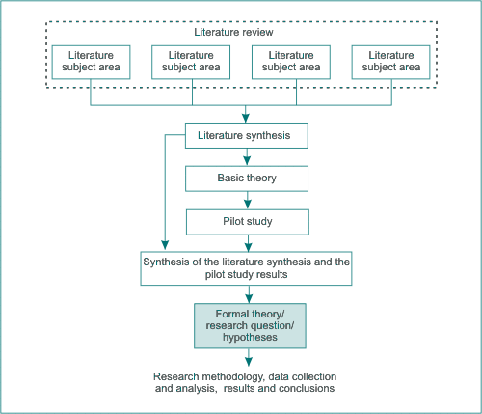

Module 4

Learning Summary
This module has attempted to explain:
- what applied business research is;
- how applied business research differs from academic research;
- the concept of preferred and allowable research fields;
- the concept of aligning preferred and allowable fields;
- the consequences and implications of committing to a research field;
- how to establish scope and limitations;
- how to generate a research problem;
- some basic approaches to the identification of possible research topics;
- how to develop a research question;
- the significance of research questions, theories and hypotheses;
- the concept of operational and research hypotheses.
The following section briefly summarises the primary learning outcomes from each section included in this module.

The Concept of Applied Business Research
- Most of the world's research is carried out by universities, private companies and governments.
- Business research tends to be less structured than engineering or scientific research.
- Applied business research can make a real difference to the way in which companies perform.
- The aims and objectives form the basis for the design of the subsequent research programme.
- The research field is the broad general area with which the research is concerned.
- The research scope is effectively the defined boundaries of the research.
- The research topic is the specific area the candidate focuses on.
- The research question is developed from the research topic and is necessary in order to allow a researcher to design the research programme.
- The question could take the form of a question (literally) or could appear as a hypothesis or even as a model or tool.
- The initial objectives are developed from the research question.
- The final research aims and objectives are developed from the initial objectives after a process of appraisal.

Identifying Possible Business Research Areas
- The preferred field is the field that the candidate would ideally like to develop.
- The allowable field is the preferred field modified by restrictions or limitations that are imposed by the practicalities that impact on the research programme.
- Availability could be affected by the consent or otherwise of key people to contribute.
- There is an element of risk involved in accepting a research field.
- The candidate usually has a range of potential fields to choose from, each of which has a different risk profile.
- In some cases where the risk profile is sufficiently high, it may be necessary to choose an alternative field.
- The outcome field is the final field that emerges and the one that subsequently acts as a basis for the research.
- A longitudinal case study is designed to run over a relatively long period of time.
- A cross-sectional case study is designed to develop a ‘snapshot’ of characteristics at one particular point in time.
- Cross-sectional case studies are often used to support longitudinal case studies.
- The research should be applied and have as much commercial potential as possible.

Generating a Specific Research Problem
- In order to develop a research programme, it is essential to begin by identifying some kind of question requiring an answer, or a problem requiring a solution that can be developed into a research programme.
- The development of a set of aims and objectives from a research field uses a basic WBS-based approach.
- The generation of good, viable research questions or problems is among the most difficult, yet important, parts of the research programme.
- The research topic must:
  - meet the University's criteria;
  - be feasible, meaningful and clearly defined;
  - be as applied as possible;
  - be achievable within the available time, and within the candidate's financial constraints.
- Selecting a problem requires creative imagination to think of new questions or to investigate old questions from a different perspective.
- Brainstorming can be used as a tool to assist in the generation or potential research topics.
- SWOT analysis can be used to show the relative positive and negative aspects of a particular research topic.
- The research objective can be reflected in a research question, model or hypothesis.
- Questions can be based on ‘what’ issues rather than ‘why’ issues.
- ‘Why’ issues tend to be more demanding but usually generate more valuable outcomes.

Operational and Research Hypotheses
- Hypotheses are usually derived directly from the initial research objectives.
- Hypotheses are usually based around a null hypothesis and an alternative hypothesis.
- Research hypotheses are often wide ranging and refer to the research aim outcomes.
- Operational hypotheses are more focused and usually relate to specific variables.
- Operational hypotheses are often used in support of research hypotheses.
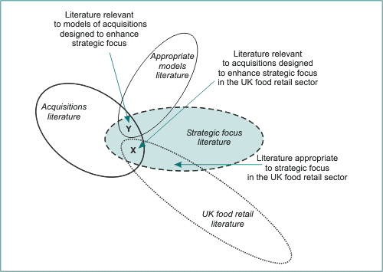

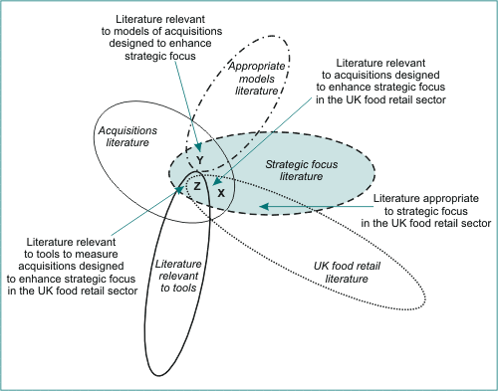

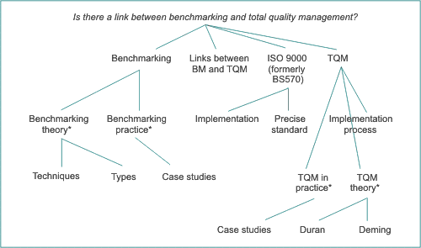

Module 5

Learning Summary
The candidate should now have an understanding of:
- the importance of developing a research strategy;
- the differences between cross-sectional and longitudinal research;
- the different research methodological approaches that are known;
- the advantages and disadvantages of the different research methodologies;
- the concepts of reliability, validity and generalisability;
- the six types of triangulation;
- the concept of a pilot study;
- the required awareness of the research methods available to be able to design a suitable research method for the current research.
The following section briefly summarises the primary learning outcomes from each section included in this module.

Research Strategy
- Research strategy is the general plan used when answering the research question(s) set.
- The research strategy contains clear objectives, considers the constraints such as time, money, access to data, and location, and specifies choice of paradigm and methodological approach, including data sources.
- Empirical research is guided by the results of observation or experiment.
- Theoretical research reflects on ideas and develops a different perspective that may subsequently come to be regarded as a new theory.
- The empirical and theoretical approaches should not be considered as being entirely distinct.
- Empirical and theoretical approaches are frequently combined in research.
- Research may be based on:
  - testing an existing theory;
  - adapting an existing theory for testing;
  - developing a new theory for testing.
- All research should be based on a research strategy.

Cross-Sectional Research
- Cross-sectional research is an approach usually, but not exclusively, associated with a positivist paradigm.
- Cross-sectional research is usually designed to obtain and analyse information about phenomena in different contexts, but at a specific point in time.
- Cross-sectional research seeks to understand differences between various members of a study population such as companies, regions and countries at one moment in time.
- Relevant data are collected only once before the analysis stage, and the data are usually statistical.
- Cross-sectional studies are inexpensive and reductionist, but are of limited value in explaining why statistical relationships exist between variables as they do not take into account the influence of external factors that could have caused the observed correlation.

Longitudinal Research
- A longitudinal study extends over a period of time and involves analysing the dynamics of a phenomenon by making repeated observations.
- Although longitudinal research is generally associated with a positivist methodology, a qualitative approach may be adopted.
- There are practical problems in conducting any longitudinal study, the most notable being attrition and non-response.

Research Methodologies
- A research methodology is a body of methods.
- A method is a procedure or process for achieving an object.
- Methodology is concerned with:
  - the data to be collected;
  - sample design;
  - locations from where data are collected;
  - whether to adopt a cross-sectional or longitudinal approach;
  - how to collect the data;
  - how to analyse data.
- The primary methodological approaches are:
  - field experiments;
  - large scale surveys;
  - forecasting and futures research;
  - action research;
  - case studies;
  - historical research;
  - ethnography;
  - in-depth surveys;
  - participant and non-participant observation;
  - feminist perspective.
- Field experiments are carried out in the real world rather than in a laboratory.
- A survey is a positivist approach and is widely used in business and management research.
- Survey research is based on drawing a sample from a population.
- Forecasting is associated with the statistical techniques of regression and time series analysis.
- Action research is designed to find an effective way of bringing about a conscious change in a partly controlled environment.
- Action research may be chosen as the most appropriate approach by EBS DBA students.
- A case study has been defined by Yin (1989) as:
an empirical inquiry that investigates a contemporary phenomenon within its real life context, when the boundaries between phenomena and context are not clearly evident, and in which multiple sources of evidence are used. It is particularly valuable in answering who, why and how questions in management research.
- Case studies are especially useful in gaining an understanding of the context of the research and detailed insights into the processes of interest
- Historical research is the critical investigation of events, developments and experiences of the past, the careful weighing of evidence of the validity of sources of information on the past, and the interpretation of the weighed evidence.
- The collection of historical data can be used as an effective data collection technique in historical research.
- Ethnography is a phenomenological methodology derived from cultural anthropology in which the researcher becomes a full working member of the group being studied.
- In ethnography the research takes place over a long period of time, often many months, usually in only one setting, perhaps on a factory floor or in an office, and involves intensive study and direct participation in the activities of that particular organisation.
- The purpose of in-depth surveys is to collect detailed evidence from a relatively small sample through one or more interviews.
- In participant observation methodology the researcher faces choices varying from complete immersion in the social setting, by adopting the role of a full participant in the lives of subjects, to that of spectator, in which the researcher only observes events and thereby avoids becoming involved in interactions with subjects.
- The feminist perspective has come to represent an important methodological approach. In part it has rested on gender differences and how they relate to the analysis of social and economic organisations.

Reliability, Validity and Generalisability
- Reliability is an assessment of the extent to which research measures what it is actually designed to measure.
- Reliability can be compromised by:
  - subject error;
  - subject bias;
  - observer error;
  - observer bias.
- Validity is the extent to which differences found with a measuring instrument reflect true differences among those being tested.
- There are three types of validity.
  - content validity;
  - criterion-related validity;
  - construct validity.
- Generalisability is a measure of the extent to which the research findings based on a sample can be applied to the population as a whole.

Research Design
- The research programme should be carefully designed so that it achieves what is required.

Choosing Methodologies
- There are numerous different methodologies.
- Some methodologies are more suited to positivist research approaches.
- Some methodologies are more suited to phenomenologist research
approaches.
- Some methodologies are more suitable for use under both approaches.
- Triangulation is the process of using different methodologies to provide the same research findings.

The Concept of a Pilot Study
- The pilot study is primarily intended to provide an evaluation of the proposed research method and theory.
- The pilot study should ideally use a different data set from the main longitudinal and cross-sectional studies (where appropriate).
- The results of the pilot study should be carefully considered in the design of the main research programme.
Table 5.3 Research methodologies and their philosophical bases
Research methodology | Positivist | Phenomenological
Action research |  | Strictly interpretivist
Case studies | Scope to be either | Scope to be either
Ethnographic |  | Strictly interpretivist
Feminist perspective |  | Mostly interpretivist
Field experiments | Scope to be either | Scope to be either
Forecasting and futures research | Positivist with some room for interpretation
In-depth surveys |  | Mostly interpretivist
Large-scale surveys | Positivist with some scope for interpretation
Participant observer |  | Strictly interpretivist

Module 6

Learning Summary
This module has attempted to develop an understanding of the processes involved in preparing the research proposal. The candidate will appreciate that the preparation of the research report is a complex and involved process, and it should not be approached lightly. The research proposal should be prepared to the standard layout discussed in the text. Research proposals vary widely in terms of content and emphasis. There is no single style or approach that should be used as the specific detail will vary, depending on the nature of the research.
The candidate should by now have a basic idea of how to prepare the research proposal itself and what should be included in each section. The candidate should remember that it is very difficult to write a good research proposal first time around, and there is a high probability that the research committee will reject any given research proposal and will require alterations to be made. In most cases any such alterations may hopefully be minor.
The candidate should now be able to:
- understand what is required to produce an acceptable research proposal;
- understand the primary likely sections of the research proposal;
- define the research intentions in sufficient detail to satisfy the EBS Research Committee;
- describe any major hurdles to be overcome in gaining access to organisations in order to conduct the research;
- anticipate any ethical problems likely to arise in carrying out the research;
- write a research proposal;
- make modifications to the research proposal if required.
The following section briefly summarises the primary learning outcomes from each section that is included in this module.

Problems of Access
- Candidates must consider the issue of access when designing the research strategy.
- Access to many organisations is becoming more difficult, in part because they have become deluged by requests to cooperate in research projects.
- Candidates should not simply assume that a sufficient number of companies or other sources of data will be prepared to cooperate.
- Where possible the candidate should carefully check access availability well beforehand.
- Where relevant the candidate should seek to obtain letters of support from key contributors and include these as part of the research proposal.
- Even if a company agrees to provide access, employees may restrict their cooperation and/or the level of information they are prepared to divulge.
- Commercial confidentiality is often an important issue with companies.
- In some cases it may be necessary to issue a confidentiality agreement in order to protect a company's interests.
- DBA theses can be classified as restricted access if necessary. This means that access to the thesis is limited to readers who are approved.

Research Ethics
- Ethics refer to the appropriateness of the candidate's behaviour in relation to the rights of those who are the subject of his or her research.
- It is important to be sensitive to the impact of the work on those who grant access and those affected by the results.
- A statement on research ethics is required as part of the research proposal.
- Ideally the researcher should adopt a disinterested, value-free attitude when collecting and analysing data and writing up the results.
- Samples must be established honestly, which means they may yield results that will not support the candidate's preconceived views.

Writing the Research Proposal
- The research proposal should be written on A4 paper and should follow the format given on the EBS DBA template provided.
- The candidate should think about the research proposal very carefully before starting work. If necessary the mentor should be approached for guidance and general advice.
- A typical format for the research proposal is given below.
  - Abstract
  - Summary
  - Background (literature review)
  - Research questions, aims, objectives and hypotheses
  - The research paradigm and theoretical framework
  - Research methodology
  - Sample design and details of the data collection process
  - Accessibility
  - Research ethics
  - Deliverables
  - Significance
  - The resources required to implement the research
  - A timetable indicating the expected completion date for each part of the research
  - References, bibliography, letters of support and appendices
- The abstract is a short and precise summary of the proposal. It should contain around 200 words.
- Abstracts of theses are often used in research catalogues to provide a flavour of what is involved in the research.
- The abstract is usually written last.
- The summary is perhaps the most important part of the research proposal.
- The summary should follow the same line of thought as the abstract but contain more detail.
- The summary should generally be a minimum of about 300 words and a maximum of about 1000 words.
- The background provides an overview of the previously published work by other researchers. It is basically a mini literature review for the research proposal.
- The background should place the current research proposal in the context of the existing literature, particularly in relation to any gaps in the literature and how the current research is positioned in relation to these gaps.
- The background should normally be a minimum of around 500 words and a maximum of around 1000 words.
- The research questions, aims, objectives and hypotheses section should cover each of the named areas in as much detail as possible.
- The links between the research questions, aims and objectives, and the hypotheses should be made clear.
- The research paradigm and theoretical framework section should make clear the intended paradigm and the theoretical framework behind the research questions, aims, objectives and hypotheses.
- The paradigm(s) and the theoretical framework of the work must be clearly stated together with an outline of the research strategy and a general plan of how the research questions will be addressed.
- The research paradigm and theoretical framework section is a relatively short section and generally contains between about 300 and 500 words.
- The research methodology section should give sufficient detail on the proposed research methodologies for the pilot and main studies.
- The research methodology section should detail the research methods used, and should justify the choice of a particular methodology.
- This research methodology section should normally be a minimum of around 500 words and a maximum of around 1000 words.
- The sample design and data collection process section should furnish details of the design and identify the research population.
- All sources of data involving documents, archival material, questionnaires, interviews and observations should be identified. If case studies are involved, the basis of the case selection should be made clear, as should the method of within-case sampling.
- The sample design and details of the data collection process section can normally be completed in less than 500 words.
- The candidate should make it clear that he or she has thought carefully about the accessibility of the data required for the research.
- The accessibility section should include a comprehensive listing of the proposed sources of data and a clear summary of the degree of accessibility secured.
- In some cases it may be appropriate to refer to direct letters of support (see below) in this section.
- The research ethics section summarises the candidate's approach to research ethics.
- Candidates are required to make a judgement about the validity of additional resources as part of the research ethics consideration.
- The deliverables section summarises the results of the research in terms of what will actually be available for the use of other researchers, public and private companies, and anybody else who may have a use for the findings.
- The deliverables are the ‘goods’ generated by the research.
- Deliverables can include the thesis, research papers, textbooks, conference papers and a range of other possible elements.
- The significance section should make clear the significance of the research in relation to the existing knowledge base and the likely applications of the results.
- The resources required to implement the research should summarise any assumptions on resource availability, in terms both of people and of equipment.
- Any proposed assistance should be stated.
- The timetable of expected completion dates should show start and finish times for each main activity.
- The duration shown for each activity should be reasonable.
- The timetable should be flexible, as unexpected delays are always likely to occur.
- The references, bibliography, letters of support and appendices section should contain any remaining material.
- Additional appendices can be developed and included in this section if required.
- The completed research proposal should inform the EBS Research Committee of:
  - what the candidate wants to do;
  - why he or she wishes to do it,
  - what the candidate is attempting to achieve;
  - how he or she intends to achieve it;
  - the timescales and work elements required.

Evaluating the Research Proposal
- The research proposal should be carefully evaluated before it is submitted.
- The candidate should ensure that the research proposal is original to the extent that it will make a contribution to knowledge.
- The candidate should ensure that the research proposal contains research objectives that have been translated into hypotheses expressing relationships between variables and able to be tested empirically.

Submitting the Research Proposal
- Candidates should check any appropriate deadlines carefully. The EBS Research Committee meets at regular intervals. The candidate should check for any submission deadlines for any given committee meeting.
- Research proposals have to be submitted well before the actual committee meeting because the research proposals have to be circulated to the committee members well in advance of the relevant meeting so that they have time to read and consider the contents.
- The research committee can make two possible decisions on a research proposal.
  - The research committee accepts the research proposal.
  - The research committee rejects the proposal.
- If the research proposal is not rejected the candidate can pass the second gateway in the EBS DBA programme and start the literature review.
- Non-rejection by the research committee means that the committee considers the research proposal to be of a sufficient standard, and to carry sufficient promise and potential, to justify allowing the candidate to proceed to the literature review.
- The research committee may reject the proposal. Rejection may occur because one or more of the areas contained in the research proposal are not addressed correctly.
- Candidates should appreciate that it is very difficult to write a near-perfect research proposal. In most cases the research committee will require some form of amendment. Such amendment could range from minor corrections to major adjustments.
- The candidate should study the report of the research committee vary carefully before making any amendments to the research proposal.

