Mergers and Acquisitions study guide

This module has attempted to develop a basic understanding of the implementation process from the point of view of the various primary integration areas. The text has considered the implementation process from a number of points of view, from technical considerations to people issues. After having read the text it should be apparent that successful implementation is very difficult to achieve because mergers and acquisitions are very complex, and because they are carried out under conditions of significant change. Successful implementations, however, do occur. A sound grasp of, and attention to, the issues covered in this text is likely to help this occur in a controlled manner.

- The reader should now understand:

  - the basics of monitoring and control;

  - how synergies can be exploited as part of the integration process;

  - some of the common barriers to successful integration;

  - the importance of maintaining morale and commitment;

  - the significance of balancing mindsets;

  - the significance of contractual changes;

  - the relationship between time, cost and performance;

  - the potential use of trade-offs.

- The primary learning outcomes from each section are listed below.

Some Common Questions about Plan Execution

- Implementation planning can be extremely complex and difficult.

- A significant proportion of mergers and acquisitions initially ‘go astray’ at some point during implementation.

- Implementation processes go off track for numerous reasons. In complex plans it is almost impossible for all aspects of the plan to be followed exactly as desired. In practice there will always be some degree of divergence.

- Typical sources of implementation problems include:

  - changes that are imposed on the implementation as it is executed;

  - errors or omissions in the original plan;

  - inaccurate estimating as the original plan was being developed;

  - changes that are introduced optionally.

- The activities that are most likely to go wrong during the implementation process include those that are:

  - most difficult to plan;

  - most difficult to analyse accurately during estimating;

  - over- or under-resourced;

  - dependent on other activities;

  - most subject to internal and external change.

- As things go wrong during implementation the main consideration is to detect these errors and put appropriate corrective actions in place as quickly as possible.

- It is common practice in companies for relatively inexperienced and unqualified people to be put in charge of individual mergers and acquisitions. These people are often excellent mangers, but they are often in the merger manager role for the first time and they frequently lack adequate experience.

- Increasingly there is a need for consultant professional merger project managers to provide comprehensive project management services for the merger planning and implementation processes and from inception to completion.

Some Common Misconceptions about Plan Execution

- There is a common misconception that execution is relatively straightforward while the real complexity lies in the planning aspects. This is not the case as the execution element has a requirement for a constant and immediate tactical response.

- Merger plans can in fact be more difficult to implement than numerous other types of plan because of the high levels of complexity and change involved. In addition, the execution process may disrupt the entire organization.

- It is not sufficient to simply stick to an agreed plan. In reality, plans become superseded by events and can quickly become obsolete. In order to implement successfully there is always a necessity for an informed and reliable tactical response to unforeseen change.

- A contract does not guarantee anything. It provides certain recourse in the event of one party defaulting on the terms and conditions of the contract, but it does not actually enforce anything.

- Contractual terms and conditions can often be changed, although this depends on the form of contract and the provisions for variation.

Monitoring and Control

- All implementation processes rely on some kind of monitoring and control system.

- The basic components of a monitoring and control system are:

  - a starting point;

  - a desired end point;

  - a progression curve;

  - a current value;

  - analysis of current against projected values;

  - corrective action;

  - monitoring;

  - re-evaluation.
Figure 10.1 Actual against planned implementation performance
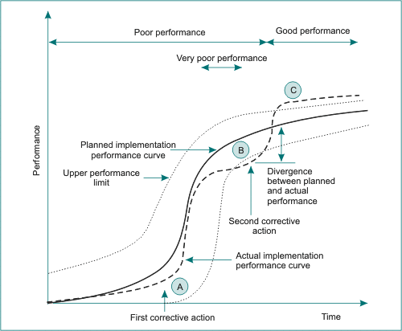

- Most monitoring and control systems allow for some degree of variance from the planned curve. Minor variances may be ignored. Most systems feature an alarm bell that rings when the variance gets to a certain predetermined level.

- In using a monitoring and control system, the primary approach is to match actual progress with projected progress, identify variances and then initiate corrective action in order to correct the variance. This should be followed by a period in which the effects of the corrective action are monitored in order to evaluate how effective they have been in correcting the variance.

Achieving Integration

- Integration is the process of merging the individual components of each of the merging organizations.

- Integration can be a very expensive process and it can affect the organizations concerned at every level. In some cases the integration process can cost enormous sums of money.

- In general, in order to achieve a successful integration the integration manager should ensure that:

  - an organization-wide approach is used;

  - permanent merger integration teams are formed and charged;

  - merger integration teams are involved in the negotiations;

  - integration is carried out as quickly as possible;

  - communications are maintained at the most effective level possible;

  - key people do not migrate;

  - all opportunities are fully exploited;

  - the best possible strategic fit is achieved;

  - quick wins are developed and broadcast as widely as possible;

  - appropriate authority is demonstrated;

  - compatibility with existing systems is assured;

  - where there are two standards, the higher standard is adopted as the norm.

- Merging organizations sometimes ‘give up’ on achieving full integration as some aspects may be far more difficult and complex than was originally envisaged.

Achieving Synergies

- It is often more difficult to achieve a particular synergy than was envisaged in the evaluation and planning stages.

- Synergy development is often held back by organizational resistance. Examples of such resistance include:

  - process resistance;

  - organizational resistance;

  - people resistance;

  - cultural resistance;

  - contractual resistance.

- In order for synergies to be successfully implemented there is a need for accurate and realistic implementation planning and also for very effective integration management.

- There is not a great deal that the integration manager can do about process incompatibilities. These should have been picked up during the preliminary analysis, and any incompatibilities should have been allowed for in the plan and also in the analysis of potential synergies.

- The same reasoning applies to incompatibilities in the distribution or supply network, etc. However, during implementation it is still possible to do something about organizational, people and cultural resistance.

- Communication is an essential element in reducing cultural resistance and in facilitating the development of cultural synergies.

- Throughout the integration process the merger integration team should constantly monitor the following:

  - underlying staff discontent;

  - senior staff migration;

  - clashes in emerging culture.

Common Problem Areas and Tactical Responses

- Some typical common barriers to integration are:

  - cultural barriers;

  - retention uncertainty;

  - team weaknesses;

  - poor project management;

  - speed;

  - poor coordination;

  - failure to sell;

  - impatience;

  - boundary blurring;

  - objective misalignment.

- Barriers can be considered at four levels:

  - strategic issues;

  - people issues;

  - contractual issues;

  - technical issues.

- Strategic issues relate to assumptions or aims that were considered at during the formulation of the strategic plan and which are subject to change after the implementation plan has been finalized. These factors are characteristically external and are beyond the control of the implementation planners.

- There are numerous sources of change that can affect the successful outcome of the strategy, such as those listed below.

  - The strategy could have been incorrectly planned.

  - The original objectives may have been incorrectly assessed.

  - The original objectives may have now changed.

  - Technical issues.

  - Unforeseen events may impact on the implementation of the strategy.

  - New strategies may have evolved.

- Post-plan, people issues can be extensive and numerous. They can range from general disillusionment with the merger through to outright hostility and industrial action.

- Figure 10.2 Performance control curve
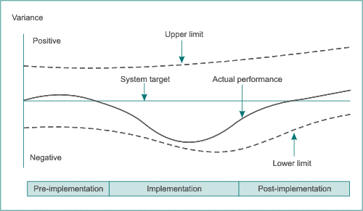

- In general terms people are more complex and variable than processes. Unlike most processes, people have an element of unpredictability. They are also able to learn from past experience, and this learned information can affect current problem analysis and decision-making.

- Mergers and acquisition involve considerable change. Departments may be merged or realigned, and the work that individual people do and are responsible for may change significantly in extent, approach and scope. One obvious consequence of this degree of change during the implementation phase is confusion.

- In general terms people who are confused are:

  - less efficient, both individually and as team members;

  - slower to adapt;

  - slower to learn new practices and approaches;

  - more likely to resist change;

  - more likely to be subject to stress;

  - more likely to originate conflict.

- Confusion tends to have an inverse proportionality to communications. The more effective the communications system, the less confusion there will be within the workforce.

- Employee confusion and cultural differences can to some extent be addressed by the use of clear and detailed organizational mapping tools.

- The integrated organizational structure should be carefully designed before the implementation process begins, and the end roles and responsibilities of each section should be clearly defined.

- Where possible the proposed end structure should be disseminated throughout the organization for inspection and discussion.

- Work process integration is concerned with getting the various people and processes to work together for the first time.

- Formal training programs are often used to combat confusion. A good SIT manager has his or her ‘ear to the ground’ and uses the organizational formal and informal communications effectively.

- In acquisitions it is common practice for operational procedures and processes to be imposed on the acquired company. In this case training courses may be initiated by the acquiring company so that the newly acquired employees become initiated into the retained procedures and processes of the acquiring company.

- Most large companies operate in-house and external training as part of their staff development programs so the process merely involves extending these existing courses to include the new employees.

- Cultural assessments attempt to measure or evaluate the cultural characteristics of the organization through a combination of different techniques.

- The changes to the HR aspects are often so significant that there is a general requirement for the introduction of new formal personnel policies. The culture of the acquiring company may require employment contract terms and conditions that are not currently used in the employment contracts of the acquired company.

- An implementation review group is a method of ensuring that communications are as open as possible and for making sure that areas of concern among employees are effectively communicated back to senior management.

- Implementation review groups should be established as early as possible in the process, and the frequency of meeting should be increased during the immediate pre-close and post-close phases. The groups should be established at all levels and should come under the control of a review groups manager.

- Implementation review group comments should be assembled into frequent reports that are fed back to senior management. These reports should highlight:

  - the most frequently occurring concerns;

  - how these concerns are varying over time;

  - any new concerns that are emerging;

  - relationships or links between concerns,

  - patterns in concern development;

  - a summary of what actions have been taken in response to previous concerns;

  - a summary of how effective previous corrective actions have been.

- A merger integration survey should be used to monitor the ongoing performance and progress of the integration process. It is important to use this survey to detect any ongoing problems that were not detected as part of the due diligence process.

- The management of performance through the disruption of the integration process is best achieved by the use of a quality management system. This system would usually be established and executed by the MTT with individual inputs from the various specialist integration teams (SITs). Most quality management systems incorporate six main sections. This classification is sometimes referred to at the performance management ‘six-pack’:

  - Performance policy.

  - Performance objectives.

  - Performance assurance.

  - Performance control.

  - Performance plan and review.

  - Performance audit.

- Generally a good performance plan will:

  - be compatible with the overall project work breakdown structure (WBS);

  - establish realistic targets of performance for the various levels;

  - identify and clearly state performance success and failure criteria;

  - provide clear time and cost objectives for implementation;

  - establish risk profiles for each component;

  - identify individual responsibilities for monitoring and control;

  - constantly monitor to ensure that the organization works within performance acceptability parameters;

  - provide regular reviews and reports to senior management.

- In addition, the plan (and review) has to be dynamic. It does not operate within a fixed system, and it has to be able to respond to changes in the production system and client base.

- Typically the plan has to:

  - relate the performance management system to customer requirements;

  - evolve in direct response to changes in the production system and client base.

- It is generally advisable to establish and maintain a suitable performance audit system. The audit system acts to ensure that the various sections of the performance management system are correctly calibrated and are actually measuring and evaluating correctly.

- The audit process usually has an internal and external element.

- The internal element involves a centralised internal audit function. This function could be provided by an individual or by a team.

- The external element usually involves external specialist consultants who provide professional performance audit services.

- Cultural inertia will usually always be encountered, no matter how carefully the merger or acquisition is planned and implemented. The extent to which cultural inertia becomes significant depends really upon the characteristics of the change.

- There are a number of ways in which organizational cultures can combine following a merger or acquisition. These include:

  - direct imposition;

  - mutual combination;

  - accepted dichotomy;

  - reluctant dichotomy;

  - operational symbiosis.

- Cultural inertia is a measure of the relative reluctance of employees to accept such cultural changes. Cultural change causes disruption, it takes time, and it causes confusion and (usually) resentment. People often oppose it unless they can see good and immediate reasons for making the effort.

- In the case of an acquisition the acquirer's mindset is already more or less made up. The acquirer tends to adopt the role of conqueror (to some extent). People who are employees of the acquiring company tend to assume a sense of superiority. Even in a merger of equals there is likely to be one company that assumes the lead role, and similar mindsets can occur.

- In the case of long-term acquirers a type of group think can develop where employees of the acquiring company assume that their organization, products, sales etc. must be better than those of the acquired or secondary company.

- In the case of the acquired's mindset, employees of acquired companies often feel a sense of loss or grief. The inevitable feeling that they are employed by the weaker company and that they have been overtaken and consumed by a larger whole develops a sense of shock and in some cases bereavement.

- Contractual issues normally should not cause too much of a problem, provided the merger contract has been assembled with due care and consideration and all external contracts (such as professional services contracts with external consultants) have also been adequately researched and prepared.

- The primary post-implementation-planning contractual issue problems tend to revolve around the due diligence process.

- The largest single source of contractual problems in a merger or acquisition is project change that requires a corresponding contractual change.

- Once the terms of conditions of contract have been prepared and agreed by both parties they are fixed and cannot be changed by either party without the consent of the other party. However, some forms of contract do make provision for variations to terms and conditions provided any such changes are mutually agreed and are made according to some kind of structured formal procedure.

- Mutually agreed variations may occur where some aspect of the merger or acquisition process change and both parties agree to change a contractual term. An example could be a major fire that occurs during the merger process.

- Contractual risks that occur after the deal is signed are likely to be standard business risks of the merged company.

- Most merger contracts contain a termination provision where a party that wishes to withdraw is liable to pay a withdrawal fee.

- In most forms of merger contract:

  - notice of termination generally has to be given in writing;

  - the party that is being terminated against must generally be given the opportunity of remedying whatever breach has occurred before the termination takes effect;

  - some form of notice period has to be observed;

  - both parties are liable to settle any outstanding debts to each other that apply at the date of termination.

- Nearly all technical issues result from changes that are made (either intentionally from within the system or imposed from the outside) after the implementation plan has been agreed. Typical internal changes include variations in:

  - project scope;

  - project aims and objectives;

  - resources availability;

  - extended due diligence.

- Phasing or fast tracking has the effect of offering further time reductions without necessarily incurring any additional costs. Phasing and fast tracking as practices obviously carry a series of implications:

  - The practice of overlapping activities calls for excellent management systems.

  - The process consumes the available time slack within the schedule.

  - The overall risk profile of the process increases.

  - People have a natural tendency to do things in a sequence.

- Cost overruns tend to be detected by the project cost control system. This uses earned value analysis working in conjunction with a computerized database estimating system to monitor actual costs against budgeted costs for the various work packages that are involved in the acquisition or merger.

Figure 10.6 Typical time–cost crash curve (standard representation)
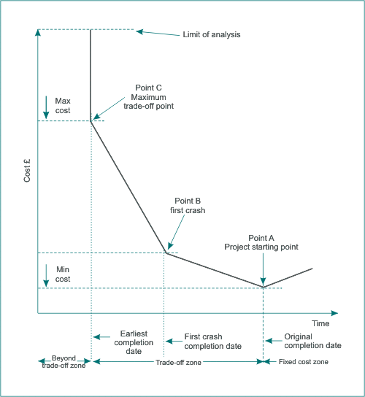

- Merger projects often tend to be reduced in status as a function of time. As a result resource levels tend to fall away more quickly than they should do.

- Resource depletion is a classical source of implementation failure.

