Mergers and Acquisitions

Module 1 Introduction 1/1
1.1 The Concept of Mergers and Acquisitions 1/2
1.2 Why Companies Merge and Acquire 1/4
1.3 Integration and Conglomeration 1/8
1.4 The Merger and Acquisition Lifecycle 1/11
1.5 Measuring the Success of Mergers and Acquisitions 1/15
1.6 A Brief History of Mergers and Acquisitions 1/18

Module 2 Strategic Focus 2/1
2.1 Introduction 2/2
2.2 Some Common Questions about Mergers and Acquisitions 2/4
2.3 Some Common Misconceptions about Mergers and Acquisitions 2/9
2.4 Business Strategy and Corporate Strategy 2/13
2.5 National and International Regulators 2/38
2.6 The Concept of Strategic Focus 2/42
2.7 Aligning Focus With Performance 2/47
2.8 Change and Strategic Drift 2/61
2.9 Characteristics Mapping 2/87

Module 3 Why Mergers Fail 3/1
3.1 Introduction 3/2
3.2 Some Common Questions about Mergers and Acquisitions 3/3
3.3 Some Common Misconceptions 3/5
3.4 Merger Failure Drivers 3/8
3.5 The Development of a Process Model 3/50
3.6 Characteristics of a Successful Merger 3/57
3.7 Rules for Avoiding an Unsuccessful Merger 3/59

Module 4 Valuation 4/1
4.1 Introduction 4/2
4.2 Why Firms Merge 4/4
4.3 Valuation Methods 4/12
4.4 Growth Opportunities 4/34
4.5 Appendix 1: Determining Cash Flows from Accounting Numbers 4/50
4.6 Appendix 2: Accounting Treatment of Acquisitions 4/53
4.7 Appendix 3: Tax Depreciation 4/55

Module 5 Bid Tactics 5/1
5.1 Introduction 5/2
5.2 Bidding and Resisting as a Game 5/11
5.3 Offensive and Defensive Tactics 5/15
5.4 Northern Electric Case Study 5/37

Module 6 Due Diligence 6/1
6.1 Introduction 6/2
6.2 Critical Value Drivers 6/10
6.3 The Value of New Information 6/17
6.4 Due Diligence Checklists 6/23
6.5 Materiality 6/25
6.6 Sampling 6/28

Module 7 The Concept of Implementation 7/1
7.1 Introduction 7/2
7.2 Some Common Questions about Merger Implementation 7/3
7.3 Some Common Misconceptions about Merger Implementation 7/6
7.4 The General Concept of Implementation 7/11
7.5 Identifying Synergies 7/16
7.6 The Implementation Process 7/22
7.7 Implementation Risk Management 7/41
7.8 The Concept of Disintegration and Reintegration 7/53
7.9 Managerial Levers 7/55
7.10 Transformation Tools 7/58

Module 8 Project Management as a Tool for Managing the Implementation Process 8/1
8.1 Introduction 8/2
8.2 Some Common Questions about Project Management 8/3
8.3 Some Common Misconceptions about Project Management 8/7
8.4 The Overall Implementation Process 8/8
8.5 Project Management 8/18
8.6 Project Management as a Tool for Managing the Overall Acquisition or Merger Process 8/49

Module 9 Developing the Implementation Plan 9/1
9.1 Introduction 9/2
9.2 Some Common Questions about Implementation Planning 9/4
9.3 Some Common Misconceptions about Implementation Planning 9/7
9.4 The Concept of the Implementation Strategic Project Plan 9/11
9.5 Project Aims and Objectives and Preliminaries 9/15
9.6 Merger Team and Human Issues 9/17
9.7 Merger Contracts and Procurement 9/46
9.8 Project Schedule and Cost Plan 9/59
9.9 Resources 9/81
9.10 The Implementation Risk Management System 9/83

Module 10 Executing the Implementation Plan 10/1
10.1 Introduction 10/2
10.2 Some Common Questions about Plan Execution 10/2
10.3 Some Common Misconceptions about Plan Execution 10/7
10.4 Monitoring and Control 10/10
10.5 Achieving Integration 10/12
10.6 Achieving Synergies 10/18
10.7 Common Problem Areas and Tactical Responses 10/21

Appendix 1 Answers to Review Questions A1/1
Appendix 2 Practice Final Examinations A2/1
Appendix 3 Statistical Tables A3/1
Appendix 4 Examination Formula Sheet A4/1

1 - Introduction

1.1 The Concept of Mergers and Acquisitions 1/2
1.1.1 Introduction 1/2

Affected by regional factors
- Company, employment, community law
- Community standards, custom practices
- Regulations, protectionism
Government controls affect level of competition

1.1.2 Mergers and Acquisitions 1/3

Difference: Merger – process of negotiation not necessary in acquisition
Acquisition: friendly or hostile
White knight – friendly takeover to prevent hostile takeover
Dawn raid – minimise share price increase by buying stock quickly

1.2 Why Companies Merge and Acquire 1/4
1.2.1 Introduction 1/4

Rationale: higher-level reasoning
Driver: mid-level operational influences

1.2.2 Some Underlying Rationales 1/5

Strategic rationale – to achieve strategic objectives
- Acquisition not central to objective; alternative might be R&D
Speculative rationale – acquired as a commodity
- Buy, develop, sell
- Risk: people may leave
- Splitting company may be an option
Management failure rationale – only recourse to address strategic variance
Financial necessity rationale – restore shareholder confidence
Political rationale – government instructions, or legislative prevention of alternatives (e.g. acquisition in other country)

1.2.3 Merger Drivers 1/7

Requirement for specialist skills/resources
National/international stock markets (target price decline, or acquirer increase)
Globalisation
National and international consolidation
Diversification
Industry and sector pressures
Capacity reduction (of sector)
Vertical integration
Increased management effectiveness and efficiency
New market or customer base
Drive to buy into growth sector or market

1.3 Integration and Conglomeration 1/8
1.3.1 Introduction 1/8
1.3.2 Vertical Integration 1/9

Advantages:
- Combined processes
- Reduced risk
- Configuration management
  - more effectively controlled
- Quality management
- Reduced negotiation
- Proprietary and intellectual property
- Individualism (maintain brand status)

1.3.3 Horizontal Integration 1/11
1.3.4 Conglomeration 1/11

1.4 The Merger and Acquisition Lifecycle 1/11
1.4.1 Introduction 1/11
1.4.2 Typical Lifecycle Phases 1/12

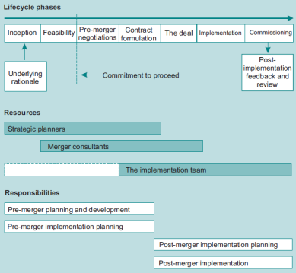
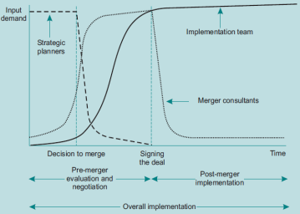

Contract – defines rights and obligations of all parties
Integration team should be involved as early as possible
- Largely operational people

1.5 Measuring the Success of Mergers and Acquisitions 1/15
1.5.1 Introduction 1/15

Criterion:
- No liquidation: high success
- Short-term financial improvement: low success
- Long-term synergy: mixed success

1.5.2 Short-term Measures of Success 1/15

After announcement:
- Acquirer price static or fall
- Target increase
  - Pre-announcement rumours
  - Inflationary premium

1.5.3 Long-term Measures of Success 1/15

Factors:
- Payment method
  - Equity based: good if economy buoyant
- Implementation
  - Timescale not kept, changed plans

1.5.4 Some Scenarios for Failure 1/16

Inability to agree terms
Overestimation of true target value
Target too large, relative to acquirer
Failure to realise synergies
External change
Inability to implement change
Shortcomings in implementation and integration
Failure to technological fit
Conflicting cultures
Weak central core in target

1.6 A Brief History of Mergers and Acquisitions 1/18
1.6.1 Introduction 1/18
1.6.2 Merger Waves 1/18

1895-1905: Railroad wave
1918-1930: Automobile wave
1955-1970: Conglomerate wave
1980-1990: Mega-merger wave
1994-: Globalisation wave
- Mature industries, low growth, low interest rates, high growth in technologies
- Common currencies, global view, deregulation, privatisation, internet and electronic communications

Learning Summary 1/21
Review Questions 1/25

2 - Strategic Focus

2.1 Introduction 2/2

Strategic planning concern with value chain
- Bridge between raw materials and customer demands
Methods to address deficiency
- Acquire organisation
- Acquire products, services
- Acquire departments, sections
- Form strategic alliance

Strategic focus improves success
- Targets characteristics related to acquirer
- Acquisition not disruptive to focus of acquirer

2.2 Some Common Questions about Mergers and Acquisitions 2/4
2.2.1 Introduction 2/4
2.2.2 Ten Questions 2/4

Why do companies merge?
- Improve competitive advantage.
- Strategic and financial buyers
How to mergers differ from alliances?
- Alliance: companies can choose level of disclosure; no single company
Why do many mergers fail?
- Poor implementation (integration); cultural problems

2.2.3 Summary 2/9

2.3 Some Common Misconceptions about Mergers and Acquisitions 2/9
2.3.1 Introduction 2/9

Misconceptions:
- Mergers are standard practice
- Easy to assess and execute
- Targets oppose acquisition
- Divested companies always re-bought
- Once acquired, easily absorbed
- Mergers more easily integrated than acquisitions

2.3.2 Some Common Misconceptions 2/9
2.3.3 Summary 2/12

2.4 Business Strategy and Corporate Strategy 2/13
2.4.1 Introduction 2/13
2.4.2 The Strategic Rationale 2/13

Strategic assumptions
- Related acquisitions that strengthen core activity are likely to succeed
- Unrelated acquisitions distribute market risk
- Funding growth companies with mature activities increases long-term revenue

Mergers also means to attract shareholders
- Which type? What timing?, Best way?

2.4.3 Strategic Alternatives: Alliances and Partnerships 2/21

Binding together in substantive manner
- Long-term, interdependency, joint control, continued contribution to parent
- Joint venture, licensing, joint R&D, technology trade, buyer-customer relationship

Resource-based view
- Alliance pools core competencies
  - Finance, Technology, People, Production, Management, Brand
- Best use of alliances is with firms that have different resources

Risk-based view
- Alliances are cheaper than M&A and more quickly implemented
- Can be established for certain duration
- Primary risk: hidden agend
- Risk headings:
  - Partner risk: degree of cooperation
  - Outcome risk: strategic objective may not be achieved.

2.4.4 Strategic Fit 2/24

Areas of strategic fit
- Production, culture, customers, support, brand, resources

Considerations for high degrees of strategic fit:
- Research and development: compatible approaches to innovation, joint willingness to implement findings
- Long-term implementation: capability transfer
- Establishment: unwise to abandon established position due to low grow, low risk (predictable returns)
- Familiarity: Trial run with strategic alliance
- Risk: mergers are expensive and disruptive

2.4.5 Unrelated Diversification 2/29

Focused company: concentrate on one sector or industry
Diversified companies: span range of sectors

Unrelated diversification
- No strategic fit, common production, value chain, core processes, strategic themes

Advantages:
- Diversified market risk
- Range of investment options
- Footholds in growth industries
- Potential synergies

Disadvantages:
- Manage and control
  - Problem detection and correction
  - Tracking operations
- Enterprise-wide risk management
- Retaining top staff
- Identify and exploit enterprise-wide strategies

2.4.6 Divestiture and De-merger 2/31

Acquired company does not fulfil purpose
- Key staff, integration, cultural resistance, sector attractiveness
Options
- Sell the company
- Set up the company as independent entity and spin off
- Put company into liquidation

2.4.7 Turnaround 2/33

When subsidiary is in trouble turnaround may be preferable to divestiture
- Long-term strategy (vital to long-term success)
- Restoration of subsidiary profitability possible (deadline)
- Portfolio balance
- Portfolio restructuring
  - Where loss-making subsidiaries are essential to long-term achievement of objectives

2.4.8 Multinational Diversification 2/35

Significant differences in business practice between countries:
- Ethics, practices, legal standards, regulations, customer preferences, competitor strengths
- Problems being eroded through globalisation
  - Driven by growing power of IT

Advantages:
- Relocation to low-cost locations
- Tax subsidies, exchange rates, interest rates
- Economy of scale
- Customer proximity
- Global innovation

2.4.9 Mergers and Acquisitions or Strategic Alliances? 2/36

Considerations:
- Cost, time, risk, synergies, integration

2.4.10 The Ideal Strategic Merger? 2/37

Characteristics beneficial to merger:
- Detailed investigation
- Compatible core activities
- Friendly
- No large-scale debt increase
- Both parties accustomed to change: reliable change management system
- Both: commitment to constant innovation

2.5 National and International Regulators 2/38
2.5.1 Introduction 2/38

Merger may affect price of goods and services
- Regulators preserve sector competition

2.5.2 Regulatory Bodies 2/39

UK: Office of Fair trade and Competition Commission
Dichotomy between EU and US
- EU (ECC) overturned several merger decisions
- US influenced by corporate demand
- Threshold (US much lower than EU to consider regulation)
- Impact of member states (national bodies for smaller mergers)
- Definition of market
- Philosophy: US if single company at 40%, EU if top two companies 40%

2.6 The Concept of Strategic Focus 2/42
2.6.1 Introduction 2/42

Strategic focus: attention around core competencies

2.6.2 The Elements of Strategic Focus 2/42

Strategic Focus Wheel:
- Strategic Planning
- Making strategies work
- Project management
- Strategic risk management

Stage 1: Identify focus area
- Existing organisation
- Environmental conditions
- Problem areas
- Core competencies and purpose

Stage 2: Strategic Planning
- Establish long-term strategic objectives

Stage 3: Strategic change
- Cascade function
  - Break down activities to smaller components to enable specific control
  - Strategic project plan
- Important issues
  - All organisation levels understand need and method of change
  - Breakdown of objectives
  - Individual and functional objectives aligned with corporate
  - Objectives clearly communicated
  - Organisational change managed through project management tools

2.7 Aligning Focus With Performance 2/47
2.7.1 Introduction 2/47

Acquisition rectifies deficiencies in value chain or introduced new elements for revised chain

2.7.2 The Value Chain 2/47

Supply chain: efficient movement of raw materials through production from suppliers through the company intro products sold downstream.
1990s: producers were able to source from wider range of suppliers and plan strategically
- Reduced supply costs and time to market
Outsourcing one significant cost reduction
- Challenge: reduced visibility; solution IT
Automated stock replenishment; vendor-managed inventory
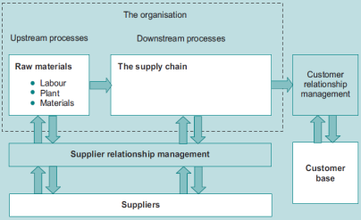
Integrative elements in value chain
- Supply chain management
- Customer relationship management
- Supplier relationship management
Allow value chain to be fully flexible and responsive

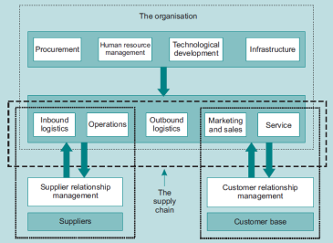

Porter:
Primary activities
- Inbound logistics
- Operations
- Outbound logistics
- Marketing/sales
- Service
Secondary activities
- Procurement
- HR
- Technological development
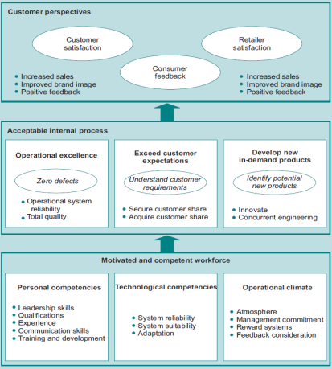
- Infrastructure

2.7.3 Strategy and Performance Measurement 2/51

Kaplan and Norton: Balanced Scorecard
- Financial perspectives
  - Cashflow, earnings, ROA, costs...
- Customer perspectives
  - Satisfactions, feedback, image
- Internal business processes
  - excellence
- Learning and growth (innovation)
Principles
- Cause and effect relationships
- Outcome measures and performance drivers
- Linkage to financial considerations

2.8 Change and Strategic Drift 2/61
2.8.1 Introduction 2/61

Strategy is set of objectives with plan for achievement
Contingency plans for long-term internal and external changes
Long acquisition process:
- Impact of unexpected changes more pronounced
- E.g. technological innovation of competition

2.8.2 Change and Strategic Drift 2/62

Strategy can be incorrectly planned
- Detect and realign
- Conditions of turbulence
  - Means-ends-ways: capabilities and opportunities
- Risks:
  - Strategic realignment, corrective response, cascade events
Original objectives incorrectly assessed
- Reassessment considerations
  - Strategic alignment
  - Objective definition (still not correct)
  - Corrective error
  - Corrective impetus
  - Resource consumption
  - Customer attitude
Original objectives may have changed
Unforeseen events may impact on implementation
- Reserve depletion
- Responsive strategy implementation realignment
New strategies may have evolved
- Strategy/sub-strategy misalignment
- Implementation system absorption (sub-strategy upsets balance)

Merger itself can cause strategic drift!

Some strategies allow variance envelope
- Contracts over time

Control of strategic drift depends on early detection

Susceptibility of organisation to drift depends on:
- Incomplete commitment to strategy
- Strong authority culture
- Individuals central to power culture resist change
- Poor communications system
- Ignored warning signs (internal conflict, poor performance)

Internal drift monitoring:
- Phased strategic review
- Analysis of critical success factors
- Analysis of key performance indicators
- Analysis of critical business activities
- Supporting issues
  - Process realignment (rewards, incentives...)

External drift monitoring
- Outside organisational control, complex, large impact, interdependent with internal drift drivers
- Customer demand, competitor behaviour, interest/exchange rates, innovation, statutes
- Develop Key Environmental Indicators
- More difficult to monitor than internal drift: larger range of variables, more unforeseeable events

2.8.3 Scenario Planning 2/75

Evaluate range of possible future environment conditions (states of nature)
- Best, mid, worst case
  - Environmental evolution with regard to strategic objectives
- E.g. drivers for growth and sector attractiveness
  - Competition level, innovation, R&D;
  - Consumer demand, market saturation, regulation, controllable change
- Tabulate both likelihood of increase/decrease and weight for each driver

2.9 Characteristics Mapping 2/87
2.9.1 Introduction 2/87

Assets target’s fit

2.9.2 The Concept of Characteristics Mapping 2/88

Break down acquirer and target into key functions
- Degree of difference
- Extent of change required
- Likelihood of achieving change
- Extent to which change is required

Change required:
- Basis for subsequent change planning; broken down into action plans

Likelihood (Issues)
- Cost, culture, timescale, technology, loss of personnel, basic incompatibility
- Important consequences for risk management

2.9.3 The Process of Characteristics Mapping 2/95

Considerations
- Size
  - Turnover
  - Employees
- Financial position
  - Gearing
  - Cash flow
  - Profitability
  - Board of directors (experience, expertise)
- Organisation
  - Structure (functional, product)
  - Staff promotions (sped)
- Products and selling
  - Product portfolio (size)
  - Products
  - Average sales value
  - Selling characteristics
  - Growth rate
  - Market share
  - Likely product life cycle stage
  - Customer base
- New products
  - Sources (licensed, R&D)
  - R&D pipeline
- Production capability
  - Cost base (compared to industry)
  - Degree of automation
  - Capacity
  - Degree of control
- Administration (competence)
- Internal controls (strong/weak, financial/strategic)

Risk profile for acquisition
- Two dimensional map of required changes:
  - Y: Impact of change failure
  - X: Likelihood of change failure

Situation:
- Acquirer has business strategy to maintain/increase competitive advantage
- Considered impact of regulatory bodies
- Assessed high-level strategic fit of target
- Established strategic focus of organisation
- Aligned production processes to objectives
- Consider impact of future internal/external changes
- Aligned performance measures to strategic objectives
- Assessed degree of strategic fit
  - Determined key actions, timescales, costs to achieve desired degree of fit

Learning Summary 2/104
Review Questions 2/112

3 - Why Mergers Fail

3.1 Introduction 3/2

Most mergers fail to achieve objectives

3.2 Some Common Questions about Mergers and Acquisitions 3/3

What is failure?
- Cost of integration reduces shareholder values
- Timescale too long to isolate merger effects
Why do they go wrong?
- Not planned in sufficient detail
- Loss of senior manager interest after early stages
Why allowed to fail?
- Senior management focus on vision rather than finishing
How widespread?
- Short-term: most mergers fail to add shareholder value
- Achieving long-term strategic objectives: results half-half
Most common problem
- Erosion of management interest
Sector variation
- Similar success failure across sectors/industries
Failure drivers
- Culture, IT
- Relative importance depends on company (e.g. large employee base more susceptible to culture)

3.3 Some Common Misconceptions 3/5

Misconceptions
- Greater market power (may be eroded)
- Merged company will be stronger
- Creates scale economies (integration problems)
- Creates shareholder value
- Stimulates innovation
  - Frequent acquisition encourages financial rather than strategic controls
- Once merged, that’s it
- Acquired only by other companies (VCs)
- Always hostile

3.4 Merger Failure Drivers 3/8
3.4.1 Introduction 3/8
3.4.2 Shareholder Rejection 3/8

Shareholders of both companies must vote by majority in favour

3.4.3 Negotiation Failure 3/9

Inability to agree on mutually acceptable terms and conditions

3.4.4 Regulator Block 3/11

Regulators can be national, international, sector-specific
Objections if detrimental to competition

3.4.5 Strategic Failure 3/12

Lack of valid strategic rationale and focus
- Insufficient alignment
- Better success if companies produce related products
  - Skills and assets complement

Lack of valid implementation and integration strategies
- Objectives: inaccurate, unachievable, contradictory, obsolete
- Implementation plan: incomplete, unreliable assumptions, inflexible
- Implementation: changed priorities, withdrawn resources, imposed changes, cost limits, unforeseen issues
- Break down process into separate work packages and plan each

Multiple acquisition and lack of control
- Unrelated acquisitions
- Difficult to maintain control across range of organisations
  - Common benchmarking and performance appraisal

Hostility
- Predators may withdraw if target board rejects
- Alternatively they may campaign to shareholders
- Hostility strongest when share ownership is concentrated

3.4.6 Cultural Failure 3/20

Cultural failure
- Cultural strength can be foreseen:
  - Turnover, unfair dismissal claims, harassment claims, conflict and stress
  - Employee feedback, motivation, energy commitment
  - Misalignment between production and strategic goals
  - Pressure to consolidate

Ineffective cultural integration
- Largest cultural failure
- Degree of integration depends on extent of transitional change in organisational structures
- Employee vulnerability leads to demotivation
- Approaches
  - Principal leader (most appropriate candidate)
  - Coalition (less efficient)
  - Delegation (impartial consultant: time consuming, less commitment)
  - Broadcast (time consuming)

Ineffective communication
- As soon as possible after announcement
- Set case for merger; address concern areas
  - Merit-based appointments, formal application, post advertising
  - Selection process, dispute handling

Ineffective HR control
- Most mergers result in job losses
- Three phases when people might leave
  - Announcement, negotiation/deal, implementation
- HR is just as vulnerable as rest of organisation

3.4.7 Financial Failure 3/25

1 - Inaccurate target evaluation and excess premium
- Industry attractiveness
- Company competitive position
- Sources of competitive advantage

Calculations similar to strategy evaluation; two differences
- Productive capacity: merger does not add to net assets in industry
- Competitive reduction: purchase price not equal to book value; additional integration costs

VCA: Value created by acquisition
- Break-even: Asking price = stand-alone value of target (t) + VCA
- VCA may be perceived differently between asker and target
- Value distributed between both
- Premium all or part of value created

When potential acquisition is known target share prices often inflated
Target floor price determined by what else is available within the market (other bidders)
- Acquirer must consider attitude of target more than vice versa
Maximum price:
- Either break even or less if other targets with same VCA available for less (opportunity cost)
- May be higher if necessary component of strategy (willing to take loss on particular business)

2 – Unrealistic synergy realization

3 – Lack of Financial Stack and poor debt position
- Companies use combination of cash, debt and stock to finance

3.4.8 Integrative Failure 3/31

Management team selection and project management
- Not suitable
Change experience and flexibility
- Previous experience => better at analysis and flexible in execution

3.4.9 Information Technology Failure 3/31

IT systems unique
Legacy sub-systems = ok within organisational boundary
Issues
- Staff (opposition)
  - Centralised
  - Suppliers and Subcontractors may also need to change
- Hardware
- Software
- Operational system (e.g. call centre)
Detailed risk analysis
Potential synergies

Evaluation phases
- Due diligence
  - Functional analysis of existing system
  - Technical analysis
  - Documentation
  - Customer feedback
- Pre-implementation planning
  - Transition window; milestones
  - Provision gaps

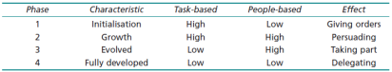
3.4.10 Leadership Failure 3/36

1 – Inappropriate leadership style

Primary behaviours:
- Directive, supportive, participative, reward

Leadership traits
- Decision-making, problem-solving, Interpersonal, communications, factor-balancing skills
- Ability to integrate new members; resolve conflict

2 – Inappropriate team-building
- Establish commitment
- Develop team spirit
- Obtain resources
- Establish goals, success criteria
- Formalise senior management support
- Demonstrate leadership (monitoring, control)
- Develop open communications
- Apply reward and retribution system
- Control conflict

3.4.11 Risk Management Failure 3/44

1 – Ineffective risk identification and analysis
- Risks vary according to lifecycle
2 – Ineffective risk management, monitoring and control
- Customer dissatisfaction, employee resentment, local community
- Pre-deal
  - Strategic fit
  - Impact on all stakeholders
  - Vulnerabilities in loss of customers
  - Cost increases (complex IT)
  - Test returns expected
  - Characteristics mapping: required changes
- Due diligence
  - Detailed stakeholder analysis
    - Cultures, philosophies, social responsibility, corporate governance
  - Customer base overlaps
  - Competitive actions
  - Floor value and synergy value
- Implementation
  - Customer satisfaction
  - Supplier commitment
  - Effective communications
  - Monitoring and control: effective, quick execution
  - Monitor employee migration

3.4.12 The Globalisation Issue 3/47

1 – Implications of globalisation
- Supporters: encourage democracy and free trade
- Opponents: exploited less-developed countries
- Emergence of super-companies

2 – Issues with international mergers
- Failure rate higher
  - Concentrate more on mechanics than on culture
  - Increasingly problematic with high cultural disparity
- Increasing trend
  - Single currency
  - Stimulated by privatisation
- Differences in authority systems (EU, US)

3.5 The Development of a Process Model 3/50
3.5.1 Introduction 3/50
3.5.2 The Development of the Process Model 3/50

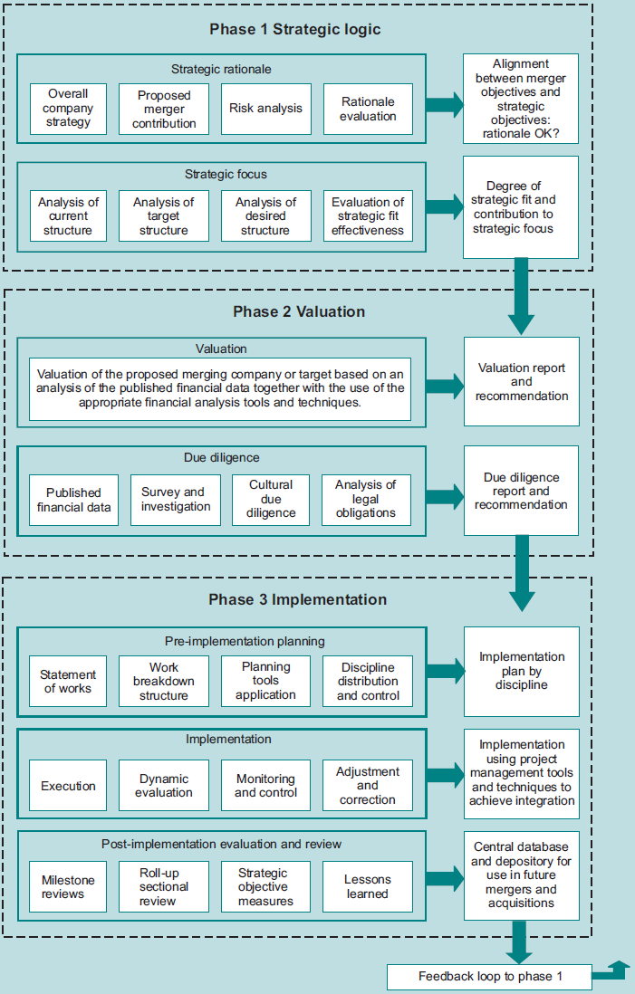

3.5.3 The Mergers and Acquisitions Process Model 3/52

3.6 Characteristics of a Successful Merger 3/57

Target:
- Reinforces strategic focus
- Works in related areas
- Innovative with unique skills
- Thoroughly researched
Acquirer
- Has previous merger experience
- Low debt position; plenty of cash
- Proper implementation systems

Both
- Change management experience
- Mutual agreement
- Employee acceptance
- Communications

3.7 Rules for Avoiding an Unsuccessful Merger 3/59

Learning Summary 3/60
Review Questions 3/65

4 - Valuation

4.1 Introduction 4/2

Positive NPV criterion
Most acquisitions are friendly but still require financial task of valuation

4.1.1 The Merger Process 4/3

Target equity can be exchanged for
- Acquirer shares, cash, other securities

Alternative is to buy part of assets
- Attractive if target has undesirable liabilities

4.2 Why Firms Merge 4/4

NAM = [V_{AB} - (V_{A} + V_{B}) – P_{B} - E

NAM: Net outcome of merging
V: Values of A, B, AB
P_{B}: Gain to target shareholders
E: acquisition costs

4.2.1 Estimating Economic Gains and Costs from Mergers 4/5

Gain = PV(AB) – [PV(A) = PV(B)]
Cost = Actual cash price – PV (B)
NPV = Gain-Cost > 0

Sellers do considerably better than buyers

If Shareholders in target are given fraction φ
- Cost = φPV(AB) – PV(B)

4.2.2 Rights and Wrongs in Valuation 4/9

Wrong approach: forecast future cash flows from target
- Upward bias as manager overvalue business
Correct approach
- Start with stand-alone values
- Add benefits less costs of transactions
- Reduced valuation to identifying changes (cuts costs, enhanced revenues)

Advantages
- Economies of scale and scope
- Cheap/rapid road to market share
- Release surplus cash, realise tax benefits

4.3 Valuation Methods 4/12

Two approaches: comparables, fundamental valuation
Comparables
- Compare against known-value firms against key criteria (e.g. size, ratios)
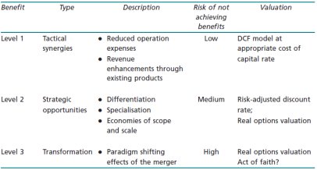
Fundamental
- Discounted cash flows
- Contingent valuation: real options

Different elements have different risks
- Considered in discount rates

4.3.1 Comparable Companies 4/13

Typical indicators:
- Size, industry, products, business trends, future prospects

Problem:
- Identify comparable firms (difficult if unique)
- Market overvaluation transferred into assessment

Multiples and ratios:
- Revenue/sales multiple (price : sales)
- Multiple of earnings (p/e ratio)
- Multiple of cash flow
- Multiple of EBIT
- Multiple of EBITDA
- Price per unit of resource (acreage, barrels, customers...)
Comparable transactions
- Multiple of book value paid
- Multiple of replacement cost paid
- Premium paid (acquisition : pre-acquisition price)

Benefits:
- Commonsense
- Derived from well-established accounting values
- Uses known transactions from market
- Widely used for legal cases
- Can be used for privately owned firms
Limitations
- Difficult to find companies
- Comparator companies may differ
- Multiples differ in results

4.3.2 Comparable Transactions 4/17

Price for corporate control
- Difficult to find comparable transactions

4.3.3 Discounted Cash Flow 4/18

Elements
- Future net cash flow profile
- Estimate cost of capital
- Time horizon
- Terminal value

Challenges:
- Models acquisition as existing entity
  - Ignores strategic challenges to business model
  - May be adjusted using Monte Carlo simulation or scenario analysis
- Ignores strategic flexibility
  - Real options theory

4.3.4 DCF Valuation 4/21

Starting point is current market value
Add value drivers
- Increased efficiencies, asset management, better utilisation, marketing, deduplication

Exit price calculation
- Multiple – apply multiple to post-exit cash flows
- Pricing model: V = FCF / (r – g)

Sensitivity analysis
- Sales growth, margins, asset management

4.3.5 Cost of Capital 4/25

Cost of equity: combination of dividends received and capital appreciation
Cost of debt: weighted average of yields to maturity

WACC: portion of debt x debt rate + portion of equity x equity rate

Applying WACC:
- Constant Capital Structure (CCS): assumes constant debt/equity ratio
- Adjusted Present Value: find equity return and model effects of acquisition (tax)
- Where acquisition is large with substantial side-effects, APV is preferred

4.4 Growth Opportunities 4/34

Opportunities (e.g. new technology) similar to options
- Right but not obligation to pursue

4.4.1 Real Option Valuation 4/35

DCF assumes an initial investment decision followed by passive interest in outcome

Real options in uncertain environment
- Expand, defer/learn, disinvest/downsize
- Flexibility option
  - Many firms structure their production for scalable output

Real options valuation (ROV) models contingent decisions
- Decision depends on parameter that is uncertain but becomes more certain over time
- Binomial option pricing model
- Black-Scholes-Merton
- Complexity should not obscure basic rationale – valuation not exact

Learning Summary 4/46
4.5 Appendix 1: Determining Cash Flows from Accounting Numbers 4/50
4.6 Appendix 2: Accounting Treatment of Acquisitions 4/53
4.7 Appendix 3: Tax Depreciation 4/55
Bibliography 4/56
Review Questions 4/57

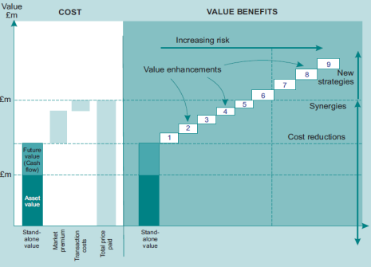
5 - Bid Tactics

5.1 Introduction 5/2

Managers often carries away by excitement

5.1.1 Setting the Reserve Price 5/3

Immediate critical decision: absolute maximum price
- Positive net advantage of merging (NAM)

Market value will be combination of safe (asset value)
- and future predictable cash flows
Positive NAM will require value enhancements
- Differ in riskiness
- More the bidder pays, the riskier the takeover
- Bottom end – prior market value

Disciplined approach:
- Allow itself to be outbid rather than overpay

5.1.2 Setting Objectives 5/6

Mechanics: bidder makes offer
- Few cases: only for assets

Process is auction
- Managers in target concerned at losing jobs
- Managers in acquirer driven by ambitions

5.1.3 Market Reaction to Takeover Moves 5/8

Abnormal Return (AR)
- Difference between actual and expected return
- Cumulative Abnormal Return (CAR) – sum of AR over period
Initial movement in share price is reliable predictor of subsequent performance of takeover

5.2 Bidding and Resisting as a Game 5/11

Parties with interest:
- Bidding firm:
  - Managers, shareholders, other stakeholders
- Target
  - Managers, shareholders, employees, customers, suppliers, others
- General public
  - Consumers, State, local government and municipalities
Principal actors are managers and shareholders of both firms
- Tendency for shareholders to support management
- Management in acquirer have incentive to carry through
- Management in target have incentive to resist
- Game theory:
  - Dominant strategy for both is to exploit; even though optimal strategy for both is to cooperate
    - Solutions: trust, penalise managers with suboptimal stance; leadership
    - Golden parachutes

5.3 Offensive and Defensive Tactics 5/15

US partial tender is legal, not in UK
Acquirer decision: negotiate or go hostile
- Bear hug: force target management to consider offer

Hostile options:
- See support of shareholders in annual general meeting (replace management)
  - Proxy fight
- Offer directly to target’s shareholders

5.3.1 Financial Advisors 5/19

Both sides will use investment banks, brokers, accountant, public relations and other professional firm

5.3.2 Duty of Directors 5/19

Directors required to act in interests of shareholders
- Conflict of interest
- US: business judgement rule (must be able to demonstrate best interest of shareholders)
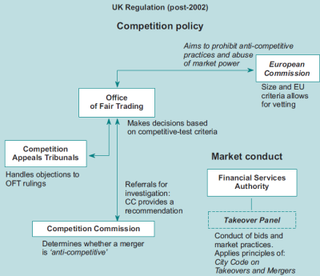
5.3.3 Role of Regulation 5/20

Regulation:
- Effect on competition, anti-trust (public policy issue)
- Merger process regulation (securities and company law)

1 – UK regulation process

Market conduct:
- Self-regulating panel of takeovers and mergers
- Adoption of legal framework may inhibit takeovers
  - Frivolous legal challenges

2 – Market regulation

Opposing views:
- Mergers are anti-competitive
- Mergers activity is expression of competitive process

Consideration:
- Strengthens dominant position
- Effect on concentration
- HHI / H Index: sum of squares of market shares
  - If between 1000 and 1800 and increase of 100
- Concentration ratio: market share of larges m firms
  - Four largest over 40%
- Determine boundaries of industry

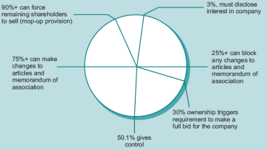
Authorities may:
- Reject takeover
- Accept
- Accept conditional to meeting agreed remedies

3 – Merger process regulation

UK Takeover code:
- Shareholders in given class treated equally
- Sufficient information to shareholders
- High standards of care in documents/advertisements
- Board of directors of target in interests of shareholders
- Avoid false market in target shares
Panel can set binding decisions in cases of dispute

5.3.4 Takeover Defences 5/30

Target may put obstacles in bidders way
- Get better price
- Management judgement of better performance stand-alone
- Management seeks to preserve own benefits

Protection mechanisms
- Run firm efficiently
Vulnerabilities
- Low stock price, low P/E ratio
- Excess cash, unused debt, steady cash flow
- Easily disposed business units
- Few shares controlled by management, dissatisfies institutional investors
Additional factors
- Assets that can be collateral for borrowing

Defence: self-uglification
- Raise cost and complexity
- Poison pill / shark repellants
  - Contingent rights to buy additional shares when individual builds up significant stake
  - Disenfranchising voting rights beyond certain percentage
- Not in the interests of shareholders – in the interests of management

5.3.5 Deterrence and Poison Pills as a Game 5/32

Provisions
- Management severance payments
- Board of directors may issue new shares
- Prohibitions on board of director consideration of certain offers

Poison pills serve to deter counter-bidders when two firms have already agreed to merge
- If they do proceed they may have to pay more

Terminology:
- Break fee – penalty for aborting negotiation
- Dawn raid – aggressive share buying to build stake prior to takeover
- Pacman defence – counter attack – target seeks to acquire acquirer
- Bear hug: force target management to negotiate through attractive formal offer
- White knight: friendly bid to thwart hostile takeover by other
- Grey knight: similar to white knight but with less clear bidder intentions
- Black knight: hostile third party contender
- Crown jewels: sell high valued assets to combat hostile takeover
- Lady Macbeth: Black knight pretending to be white
- Poison pill: contingency defences making it difficult to be acquired
- Put into play: information that a particular firm may be available
- Supermajority: (UK) ability to change memorandum of association
- Tender offer (US): offer of bidder/raider to purchase common stock
- Greenmail: threat of takeover tender in order to extract premium for buyout of own shares

5.4 Northern Electric Case Study 5/37
5.4.1 The First Bid 5/37
5.4.2 The Second Bid 5/39
5.4.3 Some Conclusions 5/44

Learning Summary 5/45
Bibliography 5/48
Review Questions 5/49

6 - Due Diligence

6.1 Introduction 6/2

Due diligence: taking care
- Caveat emptor – buyer beware
- Mitigate risks

Transactional due diligence: once target acquired but prior to finalising transaction
- Confirm preliminary information, assets, liabilities
- Assess degree of strategic fit

Strategic due diligence: confirm value drivers
Regulatory due diligence: verify going concern value

6.1.1 Due Diligence Objectives 6/3

Pitfalls of stand-alone approach
- Ignores future plans
- Insufficient experience to assess value drivers
- Inadequate attention to value chain
- No feedback of results in integration plan

Integration-based approach
- Check on value drivers
- Involve senior members
- Assess benefits and risks
Assessment within context of business strategy
- Clear vision of merger objectives
- Identify challenges
- Impact of integration plans on revenue and market share
- Soft issues: morale, culture, staff retention
- Special factors: tax, regulation, governance
Requirements
- Assess to right operational team
- Clear benchmarks for processes, performance, outcomes

Rules
- Define outcomes of due diligence process: scope, depth, requirements
  - Will minimise the risk of subsequent problems
- Checklists of key information and critical value factors to determine merger success

Actions:
- Carefully define initial due diligence parameters
- Select and brief due diligence team
- Identify issues likely to be deal-breakers early
  - Dishonesty, poor controls, financial misstatements
  - Serviceability, customer/employee retention
  - Undisclosed contingent liabilities (pensions)
- Perform detailed due diligence investigation

6.1.2 Risk-based Due Diligence Approach 6/7

Consider riskiness of elements as guide where to concentrate effort
- Experience of due diligence team
- Ex-target employees in team
- Target’s internal controls
- Reliability of past information provided by target
- Significant changes in management information and accounting systems
- Auditors involved in preparing target financial statements
- Keys value areas of confirm
- Standard operating procedures
- Documentary evidence of compliance

6.1.3 Time Constraints 6/8

Urgent need to resolve uncertainty
- Continuing uncertainty will damage target value
  - Client defection

6.1.4 Planning the Due Diligence Process 6/9

State scope, objectives, period of coverage; nature and extent of due diligence
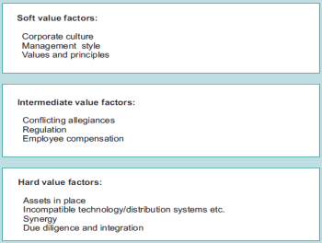
Greater reliance on synergies => importance of integration element

Legal and business elements
- Pension funding, environmental or product liabilities

6.2 Critical Value Drivers 6/10

Risks from acquisition: will it be able to deliver key value drivers
- Additional growth
- Strategic assets: technology, R&D
- Reduced costs, capex
- Market power
- Efficient use of working capital

Failure causes:
- Soft factors
- Inadequate post-acquisition planning

6.2.1 Corporate Disruption 6/13

Jargon is based on conflict (poison, shark, war, knight...)
Perceptions of win-loss
- Transfer of assets, power
- May result in loss of focus, strategic direction
- Poorly managed takeovers => denial, mistrust, blame mentality

Even friendly mergers have destabilising effect
- Acquirer believes it can improve resource efficiency through change

6.2.2 Cultural Factors 6/14

Organisation’s culture
- Management structure and reporting relationships
- Values, traditions, norms, beliefs, behaviour patterns

6.2.3 Cross-Border Factors 6/16

Management and business practices
Different laws, regulations
Geographic split, maintaining control
Divergent platforms, management practices, market perception

6.2.4 Reviewing the Structure of the Deal 6/17

6.3 The Value of New Information 6/17

Due diligence: opportunity for target to add their estimates based on private information
- Review acquirer’s thinking

6.4 Due Diligence Checklists 6/23

Corporate and organisational
- Basic corporate information, Company history and records, Future expectations for the company, Subsidiaries
Business descriptions
- Operations, Traffic, shipping and transportation, Suppliers, Products, Research and development, Production processes, Sales
- Marketing and distribution, Strategic planning, Financial documents and financial statements, Audits and controls, Projections
- Financial data, Liabilities, Accounts receivable and payable, Banks and credit arrangements, Financial ratios
- Insurance and fidelity bonds, Securities,
Tax matters
- Tax impact of transaction, Real estate and personal property taxes, Tax returns, tax status, and audits, Lists and schedules
Directors and key executives, employees, benefit plans, labour disputes
- Work force information, Unions and union activities, Personnel, Benefit/Retirement plans, Plan liability and funding
Properties, leases, insurance
- Real estate, Equipment, Inventory, Intellectual property rights, Patents, trademarks, copyrights, trade secrets
Contracts and agreements
- Licences, Contract violations, Copies of all agreements
Litigation and disputes
- Governmental compliance, Sensitive payments and activities, Anti-trust
Acquisition documents and sales of securities
- Consents, Insider matters, Filings and reports, Transactions with directors, key executives, etc
Environmental liabilities and related matters
- Plants and facilities, Permits and governmental regulation, Documentation, Environmental activities
Foreign matters
- Countries where the company has exposure, Foreign laws and risk, Laws relating to cross-border transactions
Transitional matters
- Strategic analysis, Company assets, Personnel

6.5 Materiality 6/25

Relative significance/importance of particular matter
Examples of measures
- Criticality of processes
- Nature of customers, overlap
- Cost of system or operation
- Potential cost of errors
- Number of products, transactions
- Nature and quantities of materials
- Service-level agreements
- Penalties for failure to comply with legal, safety, contractual, public health

6.5.1 Quantitative Materiality 6/26

Criterion based on numeric threshold (e.g. ½ to 2 per cent)

6.5.2 Qualitative Materiality 6/26

Important despite low numeric value
- Potential effect on trends
- Compliance
- Subjective
- May become material over time

6.5.3 Determining Materiality 6/27

Material if it would influence the decision
- Size, nature, impact
- Cumulative effects

Immaterial items may impair clarity of report

6.6 Sampling 6/28
6.6.1 Types of Sample 6/29

Census: complete examination
Simple random sample
Stratified sample (separate samples of designated stata)
Cluster sampling: complete census of clusters
Systematic sampling: e.g. every k elements
Judgment sampling : selected by analysis
Convenience sampling: e.g. local companies

Judgement and convenience sampling include bias.

6.6.2 Statistical Sampling Versus Other Methods 6/32

DDR = IR x CR x ARR x SR
Due diligence risk
Inherent risk
Control Risk
Detection risk (DR=ARRxSR)
Analytical review risk
Sample risk

6.6.3 Understanding the Sampling Criteria 6/33

Relationship between confidence level, precision (confidence interval), sampling process and acceptable level of error

6.6.4 Value Sampling 6/35

Sampling interval = monetary error / reliability factor

Learning Summary 6/36
Bibliography 6/39
Review Questions 6/40

7 - The Concept of Implementation

7.1 Introduction 7/2

Implementation – putting into effect

Initial appraisal considers:
- Work phases
- Work packages
- Teams
- Progress assurance
- Transition tools

7.2 Some Common Questions about Merger Implementation 7/3
7.2.1 Introduction 7/3
7.2.2 Questions 7/3

Most senior managers have no experience planning and managing project
Implementation generates requirement for tactical capability
- Unforeseen events generate need for change. Implies change risk
Implementations fail due to lack of flexibility, Ineffective communication
One person should be charged with managing the entire process
Inexperienced managers underestimate time and effort
Knowledge transfer between mergers is low
External consultants may not be as familiar with organisational characteristics

7.2.3 Summary 7/6

7.3 Some Common Misconceptions about Merger Implementation 7/6
7.3.1 Introduction 7/6
7.3.2 Some Common Misconceptions 7/7

Infrequency makes difficult to learn from them
Affect human loyalties; people feel threatened
More established a company is the more difficult to change administration/operation
Many unforeseen events (human, legal)

7.4 The General Concept of Implementation 7/11
7.4.1 Introduction 7/11

Acquisition phases:
- Strategic evaluation
  - Strategy, success criteria, fit, value creation logic, strategic risk
  - Target search, sound out stakeholders
- Operational evaluation and negotiation
  - Financial appraisal, bid, negotiation, contract, consent, due diligence, closure
  - Operational risk profile
- Implementation
  - Technical, organisational, cultural integration
  - Optimisation, management and control, corrective actions
  - Conclusion, evaluation, feedback

7.4.2 Implementation Requirements 7/12

Value creation
- Combination and increased efficiency of
  - Operational support, functional resources, research and development, management skills
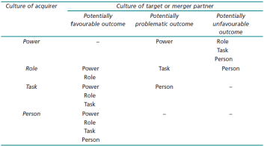
  - Scale economies
Integration level
- Total
- Autonomous
- Semisymbiotic – slow merge
- Holding – separate with planned spin-off
Culture treatment
- Types: power, role, task, person
- Degree of integration and implementation effort depends on
  - Integration level
  - Types of organisational culture

7.5 Identifying Synergies 7/16
7.5.1 Introduction 7/16

Formation of linkages across merged organisation
Improve competitive advantage
- Complete value chain restructuring to add greater value
- Cost reduction

7.5.2 The Concept of Synergy 7/16

More creative resource use through sharing
- If used effectively and efficiently then synergy results

True synergy: direct sharing of resources
- Combination of specialisations give new larger whole
- Learning curve
Costs:
- Associated cost of management
  - Higher utilization means more contention
- Cost of process interruption

Apparent synergy
- Not as easily quantified
- Complexity of human synergy

7.5.3 Synergy as an Implementation Objective 7/20

- Identify and exploit true and apparent synergies
- Create and exploit new synergies
- Discover and exploit unforeseen synergies

7.6 The Implementation Process 7/22
7.6.1 Introduction 7/22
7.6.2 The Concept of Implementation 7/22

Requirement for flexibility and tactical response capability
Moving goalposts:
- New synergies, risks
- Internal resistance
- Priority changes

Team dedicated to merger
- Multi-functional
- Retain functional responsibility
- Often working together for first time

7.6.3 Implementation Phases 7/24

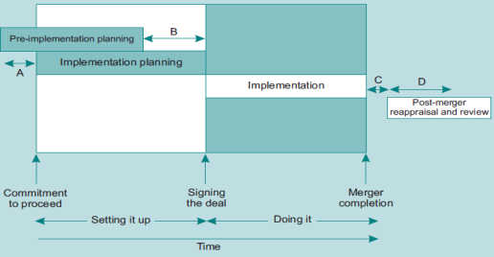

7.6.4 Implementation Elements 7/27

Some elements mechanistic (due diligence) other more volatile (shareholder vote)

Initial concept and strategy formulation
- Sector over-capacity
- Buying into new markets
- Buying new technology
- Geographic expansion
- Sector boundary erosion
Pre-implementation planning
Informal discussion/approaches
Preliminary evaluation (Premium)
Commitment to proceed
Shareholder brief
Design
- Market, supplier, business strategy; organisational structure, IT, HR provisions
Merger negotiations and contract negotiations
Shareholder vote
Final agreement; sign deal
Disintegration
Implementation management
Due diligence
Merger integration survey
Formation of new company
Disposal of old companies
Share redistribution
Competency mapping
Capability mapping
Integration
Commissioning
Post-merger survey
Post-merger evaluation
Post-merger re-evaluation and feedback

7.6.5 Critical Success Factors and Hazards 7/38

Critical success factors
- Enterprise-wide risk management
- Enterprise-wide interdependency and connectivity
- Competency balance
- Business and organisational information management
- Standard system design architecture and programming

Hazards:
- Objective misalignment
- Inadequate customer care
- Disproportionate internal focus (ignore important external events)
- Key competency erosion
- Organisational conflict
- Merger implementation rate (too many, too fast)

7.7 Implementation Risk Management 7/41
7.7.1 Introduction 7/41
7.7.2 The Concept of Implementation Risk Management 7/41

First, second level equations of risk
Risk profile, map
Quadrant 1: high impact, high likelihood
Quadrant 2: high impact, low likelihood
Quadrant 3: low impact, high likelihood
Quadrant 4: low impact, low likelihood

Risk is dynamic and will vary over time

7.7.3 The Implementation Risk Management Process 7/47

Risk framework stages:
- Context, identification, classification, analysis, evaluation, appetite response, monitoring and review

Risk options:
- Reduce, transfer, avoid, more information, retain

7.8 The Concept of Disintegration and Reintegration 7/53
7.8.1 Introduction 7/53
7.8.2 Disintegration and Reintegration 7/53

Disintegration: process of breaking down project into components
- Smaller components offer more control
Reintegration

7.9 Managerial Levers 7/55
7.9.1 Leadership 7/55

High level of change creates uncertainty which puts more demands on leader
Multidisciplinary teams

7.9.2 Objective Definition and Goal-Setting 7/56

Set as early as possible
Linked to organisational goals

7.9.3 Formal and Informal Communications 7/56

Access to meetings for all members
Specify which issues have priority
Engenders trust

7.10 Transformation Tools 7/58
7.10.1 Introduction 7/58

Political selection/staffing may lack rigour of competency-based assessment

7.10.2 Competency Modelling 7/59

Competency characteristics
- Knowledge, understanding, skill, social role, personal traits, motives
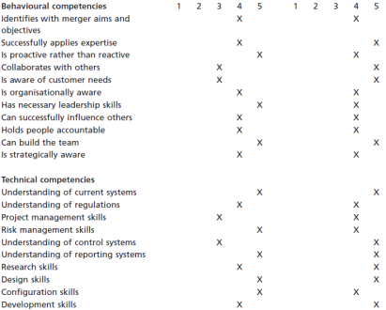
Individual contributor competencies
- Behavioural
  - Team, leadership, communications
- Technical

Individual Competency actions:
- Training
- Redistribution
- Recruitment
- Improved communications, discussion

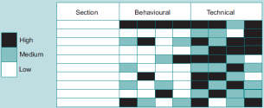

Organisational actions:
- Train, hire, redefine business areas

7.10.3 Merger Integration Survey 7/71

Identify significant people issues
- Satisfaction, motivation, commitment, cohesion,
- Authority, communication, power structure
- Perceptions about job security, reporting, operational quality

Learning Summary 7/72
Review Questions 7/80

8 - Project Management as a Tool for Managing the Implementation Process

8.1 Introduction 8/2
8.2 Some Common Questions about Project Management 8/3
8.2.1 Introduction 8/3
8.2.2 Some Questions 8/3
8.2.3 Summary 8/6

8.3 Some Common Misconceptions about Project Management 8/7
8.3.1 Introduction 8/7
8.3.2 Some Misconceptions 8/7

8.4 The Overall Implementation Process 8/8
8.4.1 Introduction 8/8
8.4.2 The Merger as a Project 8/9
8.4.3 Common Obstacles to Successful Implementation 8/14

8.5 Project Management 8/18
8.5.1 Introduction 8/18
8.5.2 The Concept of Project Management 8/18
8.5.3 Human Issues 8/22
8.5.4 Project Planning and Control 8/33
8.5.5 Project Cost Control 8/44

8.6 Project Management as a Tool for Managing the Overall Acquisition or Merger Process 8/49
8.6.1 Introduction 8/49
8.6.2 Setting Up an Acquisition/Merger Strategic Project Plan 8/49
8.6.3 Baselines 8/52
8.6.4 Monitoring and Control Techniques 8/52
8.6.5 Project Variance Analysis Reporting (PVAR) and Response 8/54
8.6.6 Response Monitoring and Realignment 8/55
8.6.7 Trade-Off Analysis as a Pre-Implementation Realignment Tool 8/55
8.6.8 Example 8/56

Learning Summary 8/68
Review Questions 8/83

9 - Developing the Implementation Plan

9.1 Introduction 9/2

Relationship between detail of planning and success of project
- As detail becomes available number of unknown factors decreases => reduces risk
- Reduces amount of contingency planning required

9.2 Some Common Questions about Implementation Planning 9/4
9.2.1 Introduction 9/4
9.2.2 Some Questions 9/4

Often lack of adequate knowledge base around mergers
Most difficult single element is people
If plan is too detailed it becomes complex and difficult to use

9.3 Some Common Misconceptions about Implementation Planning 9/7
9.3.1 Introduction 9/7
9.3.2 Some Common Misconceptions 9/7

9.4 The Concept of the Implementation Strategic Project Plan 9/11
9.4.1 Introduction 9/11

Standard SPP attempts to address standardisation problem of all types of projects worldwide

9.4.2 The Function of Implementation Planning 9/11

Plan is link between vision and execution
Management and control system
- Identifies variance
- Evaluates performance

9.4.3 The Implementation Strategic Project Plan 9/12

Elements
- Project aims, objectives, preliminaries, initiation
  - How the project objectives align to strategic objectives
- Team and human issues
  - Consider two organisations, learning curve
- Contracts and procurement
- Schedules and cost plans
- Resources
- Risk management

9.5 Project Aims and Objectives and Preliminaries 9/15
9.5.1 Introduction 9/15

Initial objectives will be used eventually to evaluate success of project
- Should be achievable/feasible

9.5.2 Project Aims and Objectives 9/16

Aligned to organisational objectives
Broken down into WBS

9.5.3 Project Preliminaries 9/16

Companies, board structure/members, new organisational structure, merger teams, closure date,
Processes procedures for authorization, accountability
Insurances, obligations, external consultants, IPR

9.6 Merger Team and Human Issues 9/17
9.6.1 Introduction 9/17
9.6.2 Establishing the Merger Teams 9/17

MPT: Merger project team: responsibility for planning and executing merger implementation
MIT: Merger integration team: represents senior management; ensures MPT in line with strategic objectives
MTT: Merger transition team: interface with customers to ensure merger considers them and builds new customers

MPT:
- Multidisciplinary, heterogeneous
- Short lifespan
- Secondary to functional team
  - Functional sentience
- Earlier assembled the better
- Important that they take ownership
  - High involvement, dialogue

MIT:
- Two level
  - Upper level senior managers
  - Lower level functional managers
- Single level possible but authority differences affect efficiency
- Two-level known as clutch arrangement
- MIT1
  - Success criteria, objectives, competency profiles, strategic fit, resources
  - Broadcast status, organisation-wide communications, monitoring, control
  - Major decisions
- MIT2
  - Ensure operational and cultural differences are overcome

Specialist integration teams (SIT) in individual departments

Merger Transition Team ensures that
- No disruption in supplies to customers
- No customer confusion
- No loss of customers
- Full consideration of potential competitor actions
- Potential for exploiting opportunities, synergies
Constitution:
- Transition manager with several in-house (or external) consultants

9.6.3 Performance Control Systems 9/30

1 – First meeting
2 – Allocate individual responsibilities
- Task responsibility matrix (TRM)
3 – Establish meetings and interaction procedure
- Composite project plan (tentative)
4 – Establish authorization and approval system
- Dates and times of gateway meetings
5 – Establish change control system
- Variation order requests (VOR) => variation order; included in information management system, configuration management system
6 – Establish appropriate team-building programme
- Natural interdependency (pooled, reciprocal interdependencies)
- Advantages of empowerment: sentience, creativity, trust, focus, communications

9.6.4 Organisational Human Issues 9/38

Managing resistance
- Reasons for resistance
  - Disruptive, increased effort, reduction in authority, reduced security/career, new colleagues

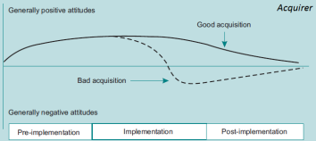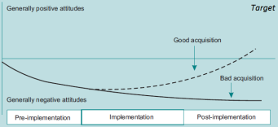

Causes of resistance amplification:
- Poor formal communications; sense of inequality, unmanaged threat perception, poor organisation, management
- Well developed informal communications, internal cohesion, trade unions, process-driven systems
Reduced resistance can also be:
- Apathy, resignation, fear of consequences

Organisation-wide communication system
- To all stakeholders.

Obtaining buy-in is important: involve people from both organisations in changes
Policy of continuous involvement
Senior management exposure is important

9.7 Merger Contracts and Procurement 9/46
9.7.1 Introduction 9/46

Highest level: merger contract
Lowest level: individual consultancy and supply contracts for work packages
Acquisition there is less need for formal negotiation than in merger

9.7.2 The Merger Contract 9/47

No single format or structure

1 – The merger
- Companies
- Closure
- Directors
- Capital provisions (exchange ratio)
- Surrender of share certificates
- Corporate records (ledgers...)
2 – Stockholder representation and warranty
- Capitalisation and voting rights
- Consents and approvals
- Agreements
- Absence of undisclosed liabilities
- Obligations to related parties
- Title to property and assets
- Trademarks
- Arbitration and litigation
- Taxation
- Employment and professional services contracts
- Research and development (safeguards)
- Environmental and safety law
- Securities law
3 – Company representation and warranties
4 – Additional agreements
- Information statement
- Stockholder approval
- Access to information
- Expenses
- Public disclosure
- Approvals
- Immediate disclosure
- Maintenance and conduct of business
5 – Conditions precedent
- All relevant actions that have to be taken before the deal can go through
6 – Closure
- Dates, deliverables (records, certificates)
7 – Indemnification
8 – General provisions
- Time limits, communications (written), governing law, severability
- Assignment (to 3rd party), entire agreement, counterparts, publicity
9 – Appendices

9.8 Project Schedule and Cost Plan 9/59
9.8.1 Introduction 9/59
9.8.2 Disintegration 9/59

Level 1: overall project (i.e. the merger)
Subsequent levels broken down in 2-20 parts
Repeated until sufficient detail for accurate planning

9.8.3 Work Breakdown Structure 9/61

Example is budget plan
Often referred to cost breakdown structure (CBS)
- Const centre identifiers known as cost account codes
- Controlled and monitored through cost account code system (CACS)

9.8.4 Action Plan 9/62

Based on TRM and WBS project manager develops action plans for key areas:
- Critical path
- Pooled/reciprocal interdependencies
- High risk/impact
Action plan contains
- Objectives, performance measures, constraints
- Tasks, costs, responsibilities

9.8.5 Precedence Diagram 9/65
9.8.6 Draft Master Schedule 9/65

Program Evaluation and Review Technique (PERT) more common than Critical Path Method (CPM)
- Non-deterministic

9.8.7 Project Master Schedule and Cost Plan 9/70

Cost Plan: CBS same structure as WBS
Gantt chart
Earned Value Analysis (EVA)

9.9 Resources 9/81
9.9.1 Introduction 9/81

Non-availability can be crucial factor in achieving objectives

9.9.2 Managing Resources 9/81

Dual-key system provides backup
Project manager determines
- Who, when, how long, what activities

9.10 The Implementation Risk Management System 9/83
9.10.1 Introduction 9/83

Risk management system does not entirely eliminate risk

9.10.2 Implementation Risk 9/84

Internal risks:
- Staff unavailable, plan omissions, objective misalignment, estimating errors, lack of expertise
External risks
- External consultants, legal delays/errors, competitor actions, subcontractors, suppliers
Internal more foreseeable than external

Market and static risk

9.10.3 Implementation Risk Management 9/87

Identify, classify, analyse, decide, initiate response, monitor

Due diligence focus:
- Organisational: effectiveness of existing risk management systems
- Financial: claims against financial statements; risk financing
- Technical: ongoing liabilities, environmental risk

9.10.4 Contingency Planning 9/90

Business Continuity Plan
- Part of organisational RMS, but also beyond it (safety net)
- Reserve for unforeseen risk to allow normal production to continue
  - Disaster recovery concentrates on operational/technical elements; BCP also considers processes, networks etc
  - Financial, technical (redundancy), people
- No standard format
  - Reserves, procedures/systems, organisational support and resource allocation
- WBS/OBS isolate most critical functions
  - Classified into risk criticality hierarchy (RCH)
- Preliminaries, scope (cannot protect against all impacts)
- Regular testing, fire drills
- Hierarchy: CEO chairs Strategic Steering Committee (SSC) -> BCMT (Management Team) -> Functional Response Team (FRT)
- Operational processes:
  - Detection, alert, activate, mobilise resources, consider DR, Initiate DR, monitor performance
  - Programmed sequential recovery
- Benchmark effectiveness of BCP
- Sustainability requirements
  - Enterprise-wide, senior sponsorship, dedicated staffing, perceived effectiveness

Contingency Planning
- Identify and deal with disruptive impact on organisation-wide basis
- Combination of top-down, bottom-up
  - Top-down: organisation-wide
  - Bottom-up: detailed knowledge of operational processes
- Contingency Planning Team (CPT)
  - Contingency Plan Manager (CPM)
  - Specific Functional Contingency Managers (SFCM)
  - Support specialists
  - Reports to executive management team (should include CEO/CFO)
- Process:
  - Identify functional divisions
  - Assess interrelationships
  - Assign responsibilities in each function
  - Develop processes
  - Assess and review
- Risk Assessment
  - Each KBA assigned a risk criticality factor (RCF) based on probability and impact
- Contingency Plan
  - Set of responsive procedures
  - Carry out what-if analysis
  - Consider implications of extending plans enterprise wide
  - Consider value chain
- Scenario planning
  - Compromise of building, suppliers, people, management team, KBA itself
- Possible format
  - Control code, associative name, TRM, KBA, function, risk assessment, activation triggers, risk quantification, closure
  - Survival processes: competitor arrangement, internal arrangement, bypass duplication, buy-in, no cover

Crisis Plan
- Emergency procedures to maintain survival of organisation when risk impact reaches critical level
- Crisis Management Team (CMT), function-specific management teams (FSCMT)
- Activation can be automatic or semi-automatic
- Drill levels
  - Test, indicative, full simulation, full

Learning Summary 9/106
Review Questions 9/124

10 – Executing the Implementation Plan

10.1 Introduction 10/2
10.2 Some Common Questions about Plan Execution 10/2
10.2.1 Ten Questions 10/2
10.2.2 Summary 10/6

10.3 Some Common Misconceptions about Plan Execution 10/7
10.3.1 Introduction 10/7
10.3.2 Some Common Misconceptions 10/7
10.3.3 Summary 10/9

10.4 Monitoring and Control 10/10
10.4.1 Introduction 10/10
10.4.2 Monitoring and Control 10/10

Elements:
- Starting point (zero expenditure)
- Desired end point (series of characteristics for each element in organisation)
- Progression curve
- Current value
- Analysis of current versus projected values
- Corrective action
- Monitoring
- Re-evaluation

10.5 Achieving Integration 10/12
10.5.1 Introduction 10/12

Integration preceded by:
- Company name, CEO identity, HQ location, functions/processes to be merged

10.5.2 Successful Integration 10/13

Organisation-wide approach
Permanent integration teams (knowledge capture and re-use)
Experienced and committed staff
Acceptance of flexible and tactical response
Inclusion of MIT in merger negotiations
Maximisation of integration rate (speed)
Effective communication
Retention of key employees
Full exploitation of opportunity
Optimisation of strategic fit
Achievement of quick wins
Use of authority (senior project sponsor)
Exploiting compatibility with existing systems
Adoption of higher standards (better versus larger)

10.6 Achieving Synergies 10/18
10.6.1 Introduction 10/18
10.6.2 Implementing Synergies 10/18

Difficult lies in overcoming resistance over existing areas:
- Processes, organisational structure, personnel, culture, contract

Accurate, realistic implementation planning
Communication
Constant monitoring
- Discontent, staff migration, culture clashes

10.7 Common Problem Areas and Tactical Responses 10/21
10.7.1 Introduction 10/21

Some elements obsolete as soon as plan is complete
Responses largely tactical

10.7.2 Common Barriers to Integration 10/21

Typical barriers:
- Cultural barriers
- Retention uncertainty
- Integration Team weaknesses
- Poor project management (lack of experience)
- Speed
- Poor coordination
- Failure to sell
- Impatience (expectation of immediate benefits)
- Boundary blurring
- Objective misalignment

Classification
- Strategic issues
- People issues
- Contractual issues
- Technical issues

Strategic
- Strategy, objectives incorrect; objectives changed, unforeseen events, new strategies

People Issues
- Confusion: responsibility, objectives, motivation, commitment
  - Transitional organisational mapping, work process integration, training
- Maintaining performance and commitment
  - Performance Policy, objectives, assurance, control, plan/review, audit
- Balancing opposing mindsets and convincing people

Contractual issues
- Not normally a major problem if contract assembled with due care
- Contractual variation is biggest issue
- Warranties and claims on indemnification (implied and express)
- Termination and recovery of losses
- Contractual issues generally: usually all contractual liabilities are transferred to new company

Technical issues
- Post-implementation time and cost trade-offs (crash curve); concurrency, fast-tracking
- Resource depletion
  - Inflate team, tie in key people, extend senior-management commitment

Learning Summary 10/64
Review Questions 10/73

Calculations and Notes

Posterior probabilities: New information (6/17)
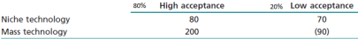EV (Niche) = $78, EV (Mass) = $142
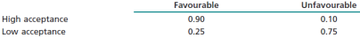

F: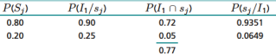 U: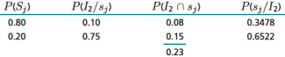
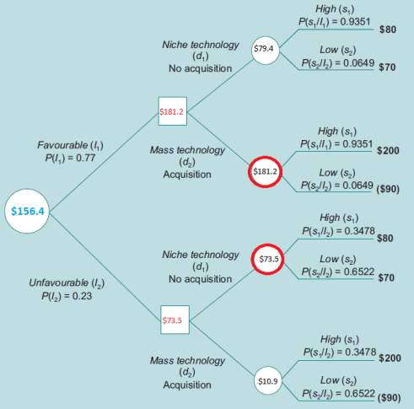

EV (Old Information) = $142
EV (Perfect information) = .8($200) x .2 ($70) = $174
EV (New information) = $156.4

VPI = $32, VNI = $14.4
Decision efficiency improvement = 14.4/32 = 45%

Precision: (6/34)
90% of observations within 1.65 standard deviations of the mean (normal distribution)
90% | 1.65
95% | 1.95
99% | 2.58
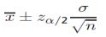
x: mean
α: confidence level (for 90%, α = .1)
n: sample size
σ: standard deviation size
z: value of Z that corresponds to α/2 on the normal table (Z[1.65] = .05)

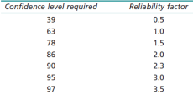
Reliability factor (6/36) [monetary errors]:
Reliability-factor = -ln(1-confidence-level) [ln(.1)=-2.3]
Sampling interval = max-error/reliability factor
Sample size = reliability-factor x (total-transaction/max-error)
= total-transaction / max-error

APV: Use ungeared equity rate for Base NPV, subtract equity issue, debt issue costs
ITS for each year is tax rate * interest, discount at debt rate, add ITS to above

Binomial: u: ratio going up, d: ratio going down, p: probability of up, r: risk-free (e.g. 0.035), a: ¬1+

Cash Flow:
Sales
- Cost of Sales
= Gross Margin
- SGA
- Depreciation
= EBIT
- Interest
= EBT
- Tax
=Net earnings

Net Income
+ Depreciation
+ Interest paid
-Change in working Capital
- Capex
= Cash flow

Change in working capital = Y/Y difference in current assets – current liabilities
Capex = Y/Y difference in fixed assets + depreciation

TV: FCF(x+1) with WACC(x)
Competition authorities
Cost with share exchange...

PM benefits:
- Structured approach; set of tools for managing change, manage risk
Merger as project
- specific aims and objectives;
- numerous, complex objectives
- multidisciplinary team;
- finite lifespan;
- not the primary function of the organisation;
- fixed time and cost limits;
- relatively complex in function
- concerned with change.

statement of work (SOW): eval of goals and performance of org
Time and cost limits
Definitive statement of
contracts have to be developed
which departments are to merge
which systems are to be combined
which organisational structures are to be modified and how

work breakdown structure (WBS): SOW is taken and broken down into different levels of components.
to a level of detail where it can be separately planned and controlled.

Project Logic Evaluation; Precedence Diagram
The WBS is then advanced using either resource driven or logic driven evaluation to form a precedence diagram.
DMS: The precedence diagram is then charged with time and cost information to form a draft master schedule
PMS: This is then modified using trade-off analysis to form the project master schedule (PMS)

PM: allows breakdown, monitoring/control, tradeoffs,
Risk Management: map, monitor risks
Human issues: leadership, communications

Characteristics Map:
General:
- Attitude: Friendly, Hostile
- Turnover: Relative size
- Employees: Sales/Employee comparison
Financial Position:
- Growth
- (Balance Sheet)
- Gearing: Funding options
- Cash Flow: Timescale for repayment of funding; target problems?
- Profitability: influence on margin
Board of directors: Experience, absorption; professional/traditional; skill to manage
Organisation:
- Structure: Functional... (same or not); culture clash
- Staff promotions: Speed, comparison; target defections
Products and Selling:
- Product portfolio: similarity, overlap, economies; cross-sell; balance portfolio
- Products: similarity
- Value of sales: similarity, scale options
- Service-Installation: subcontracted
- Geographic coverage: increase coverage or share
- Selling Characteristics: skills, skill transfer
- Growth Rate: % per year
- Market Share, Market position:
- Market life cycle: portfolio balance
- Customer base: overlap, opportunity
New Products:
- Sources: own development, acquired; influence on external dependency
- R&D pipeline: benefits?
- Degree of automation: high, low; cost reduction potential
- Capacity: spare -> use?
- Degree of control
Administration: professional; cost reductions?
Internal controls: financial, strategic; match?
Strategy elements:
- Expansion direction (domestic, international); overstretch?
- Rationale: lowering dependency; seeking growth?
(Operations):
- Logistics
- IT
(Distribution):

Assessment: fit, funding, risk attitude, underlying rationales

Financing criteria: gearing, cash, target stake, tax, control
Bid cash: target value constant; risk of overbid greater
Rationale:
- Strategic (core, growth), financial necessity (confidence), management failure (variance), speculative, political

Levels of synergy:
- tactical (low-risk), strategic opportunity (medium), business transformation (high-risk)
- Deduplication, economies

Risks:
- Shareholder, regulator rejection; negotiation failure
- Cultural integration
- Customer loss
- Strategic misalignment
- Strategic, operational, change, unforeseeable

Bidding strategies:
- friendly, hostile (dawn raid, bear hug)
Defense:
- White knight, competition authorities; self-uglification, poison pills/shark repellents

Failure reasons:
- excessive price, implementation, cultural integration, contract; strategic drift?

Cultural integration challenges:
- - Preoccupation, confusion, priorities, pressure/stress
- - cultural inertia: direct imposition, mutual combination, accepted dichotomy, reluctant dichotomy, operational symbiosis

Due diligence
- - Supplier arrangements
- - Sales agreements (are they transferable, etc.)
- - Check on age, composition and type of assets; real estate, plant, machinery, etc.
- - Check on key employee contracts (specify tie-in agreements?)

Merger lifecycle: Strategic Eval, Financial Eval, Implementation
- Planning phase (PM tools)
- Execution: (Track variances...)
- Application: full integration complete
- Post-application evaluation and feedback: KCR

External consultant benefits:
- Experience, specialisation, risk transfer, resources, flexibility

Implementation (between strategic eval and steady-state mgment) sub-phases:
- Implementation planning
- Cultural, organisational, technical integration
- Optimising strategic focus and fit
- Management and control of integration process
Strategic steering group (SSG). The SSG acts as the focus group. It ensures that the aims and objectives of the merger remain focussed and aligned with the overall strategic objectives of the merged organisations. It is staffed by senior managers under the control of an executive. In this case it would be primarily concerned with the successful implementation of identified synergies during integration.

Merger integration team 1 (MIT1). This team acts as the interface between senior managers and the integration process that is handled by MIT2 (see below). MIT1 is normally lead by a director, in this case probably from Company A. In this case it will be staffed by senior managers from each of the functional units of both companies. The function of MIT1 is to set overall aims and objectives with timescales for each of the organisational units involved.

Merger integration team 2 (MIT2). This team co-ordinates and manages the various specific integration teams (see below). MIT2 is normally lead by a senior manager (probably also from Company A) and is staffed by representatives (possible deputy section heads) from the various organisational units plus any specialist merger consultants that are involved. MIT2 acts as the main report for the various SITs. MIT2 reports any serious integration problems to MIT1.

Specific integration teams (SITs). A SIT is established for each separate organisational unit as defined by the merger project WBS. In the car example there would be a SIT for Human Resources, one for It and another for Marketing and so on. A SIT is normally lead by a SIT manager who is usually a senior member of the appropriate unit. The SIT also contains representatives of the appropriate unit from Company A and Company B.

Merger transition team (MTT). The MTT acts in parallel with the conversion teams. It is typically headed by a senior manager from marketing and includes representatives from all units that have are stakeholders to sales. The main function of the MTT is to ensure that production remains as efficient and effective as possible during the integration transition process. In particular the MTT is concerned with ensuring that customers are not lost during the integration process.

Review and feedback teams (RFTs). These teams are essential for effective communications and feedback. Communication is central to the merger integration process and it is essential that as much information as possible circulates around the system. This acts as a damper on rumours and informal speculation (which in turn lead to confusion, disillusionment and potential stress and conflict). RFTs are established for each grouping of employees within the organisation.

