Organization Development
3 Diagnosing Groups and Jobs
Figure 25: Comprehensive Model for Diagnosing Organizational Systems
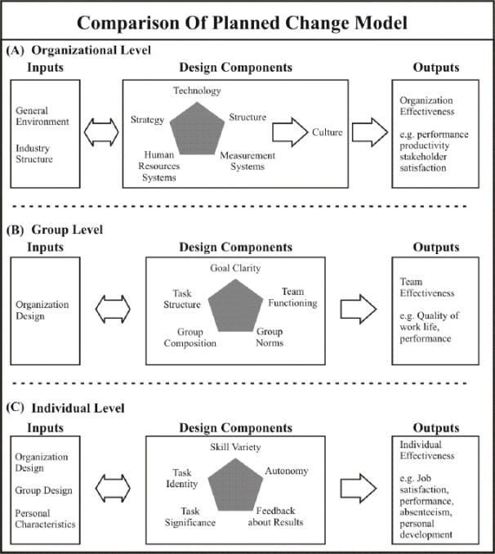

Individual-Level Diagnosis:
The lowest level of organizational diagnosis is the individual job or position. An organization consists of numerous groups; a group, in turn, is composed of several individual jobs. This section discusses the inputs, design components, and relational fits for diagnosing jobs. The model shown in Figure 25(C) is similar to other popular job diagnostic frameworks, such as Hackrnan and Oldhamn’s job diagnostic survey and Herzberg’s job enrichment model.

Inputs:
Three major inputs affect job design: organization design, group design, and the personal characteristics of job holders.

Organization design is concerned with the larger organization within which the individual job is the smallest unit. Organization design is a key part of the larger context surrounding jobs. Technology, structure, measurement systems, human resources systems, and culture can have a powerful impact on the way jobs are designed and on people’s experiences in jobs. For example, company reward systems canorient employees to particular job behaviors and influence whether people see job performance as fairly rewarded. In general, technology characterized by relatively uncertain tasks and low
Interdependency is likely to support job designs allowing employees flexibility and discretion in performing tasks. Conversely, low-uncertainty work systems are likely to promote standardized job designs requiring routinized task behaviors.

Group design concerns the larger group or department containing the individual job. Like organization design, group design is an essential part of the job context. Group task structure, goal clarity, composition, performance norms, and group functioning serve as inputs to job design. They typically have a more immediate impact on jobs than do the larger, organization-design components. For example, group task structure can determine how individual jobs are grouped together — as in groups requiring coordination among jobs or in ones comprising collections of independent jobs. Group composition can influence the kinds of people who are available to fill jobs. Group performance norms can affect the kinds of job designs that are considered acceptable, including the level of job holders’ performances. Goal clarity helps members to prioritize work, and group functioning can affect how powerfully the group influences job behaviors. When members maintain close relationships and the group is cohesive, group norms are more likely to be enforced and followed.
Personal characteristics of individuals occupying jobs include their age, education, experience, and skills and abilities.
All of these can affect job performance as well as how people react to job designs. Individual needs and expectations can also affect employee job responses. For example, individual differences in growth need — the need for self-direction, learning, and personal accomplishment — can determine how much people are motivated and satisfied by jobs with high levels of skill variety, autonomy, and feedback about results. Similarly, work motivation can be influenced by people’s expectations that they can perform a job well and that good job performance will result in valued outcomes.

Design Components:
Figure 25(C) shows that individual jobs have five key dimensions: skill variety, task identity, task significance, autonomy, and feedback about results.

Skill variety identifies the degree to which a job requires a range of activities and abilities to perform the work. Assembly-line jobs, for example, generally have limited skill variety because employees perform a small number of repetitive activities. Most professional jobs, on the other hand, include a great deal of skill variety because people engage in diverse activities and employ several different skills in performing their work.

Task identity measures the degree to which a job requires the completion of a relatively whole, identifiable piece of work. Skilled craftspeople, such as tool-and- die makers and carpenters, generally have jobs with high levels of task identity. They are able to see a job through from beginning to end. Assembly-line jobs involve only a limited piece of work and score low on task identity. Task significance identifies the degree to which a job has a significant impact on other people’s lives. Custodial jobs in a hospital are likely to have more task significance than similar jobs in a toy factory because hospital custodians are likely to see their jobs as affecting someone else’s health and welfare.

Autonomy indicates the degree to which a job provides freedom and discretion in scheduling the work and determining work methods. Assembly-line jobs generally have little autonomy: the work pace is scheduled, and people perform programmed tasks. College teaching positions have more autonomy: professors usually can determine how a course is taught, even though they may have limited say over class scheduling.
Feedback about results involves the degree to which a job provides employees with direct and clear information about the effectiveness of task performance. Assembly-line jobs often provide high levels of feedback about results, whereas college professors must often contend with indirect and ambiguous feedback about how they are performing in the classroom.
Those five job dimensions can be combined into an overall measure of job enrichment. Enriched jobs have high levels of skill variety, task identity, task significance, autonomy, and feedback about results. They provide opportunities for self-direction, learning, and personal accomplishment at work. Many people find enriched jobs internally motivating and satisfying.

Fits:
The diagnostic model in Figure 25(C) suggests that job design must fit job inputs to produce effective job outputs, such as high quality and quantity of individual performance, low absenteeism, and high job satisfaction. Research reveals the following fits between job inputs and job design:
- Job design should be congruent with the larger organization and group designs within which the job is embedded. Both the organization and the group serve as a context for individual jobs powerful or positions. They tend to support and reinforce particular design jobs. Highly differentiated and integrated organizations and groups that members to self-regulate their behavior fit enriched permit jobs.
These larger organizations and groups promote autonomy, flexibility, and innovation at the individual job level. Conversely, bureaucratic organizations and groups relying on external controls are congruent with job designs scoring low on the five key dimensions. Both organizations and groups reinforce standardized, routine jobs. As suggested earlier, congruence across different levels of organization design promotes integration of the organization, group, and job levels. Whenever the levels do not fit each other, conflict is likely to emerge.

- Job design should fit the personal characteristics of the jobholders if they are to perform
effectively and derive satisfaction from work. Generally, enriched
jobs with fit people strong growth needs. These people derive satisfaction andaccomplishment fromaccomplishment fromjobs involving skill variety, autonomy, and feedback about results.
Enriched jobs also fit people possessing moderate to high levels of task-relevant skills, abilities, and knowledge. Enriched jobs generally require complex information processing and decision making; people must have comparable skills and abilities to perform effectively. Jobs scoring low on the five job dimensions generally fit people with rudimentary skills and abilities and with low growth needs.

Simpler, more routinized jobs requiring limited skills and experience fit better with people who place a low value on opportunities for self- direction and learning. In addition, because people can grow through education, training, and experience, job design must be monitored and adjusted from time to time.

