Organization Development
3 What an “ideal” effective, healthy organization would look like?
Numbers of writers and practitioners in the field have proposed definitions which, although they differ in detail, indicate a strong consensus of what a healthy operating organization is.
An effective organization is one in which:
- The total organization, the significant subparts, and individuals, manage their work against goals and plans for achievement of these goals.

- Form follows function (the problems, or task, or project, determines how the human resources are organized).
- Decisions are made by and near the sources of information regardless of where these sources are located on the organization chart.

- The reward system is such that managers and supervisors are rewarded (and punished) comparably for:
Short-term profit or production performance, Growth and development of their subordinates, and creating a viable working group.

- Communication laterally and vertically is relatively undistorted. People are generally open and confronting. They share all the relevant facts including feelings.
- There is a minimum amount of inappropriate win/lose activities between individuals and groups. Constant effort exists at all levels to treat conflict, and conflict situations, as problems subject to problem-solving methods.
- There is high “conflict” (clash of ideas) about tasks and projects, and relatively little energy spent in clashing over interpersonal difficulties because they have been generally worked through.

- The organization and its parts see themselves as interacting with each other and with a larger environment. The organization is an “open system.”
- There is a shared value, and management strategy to support it, of trying to help each person (or unit) in the organization maintains his (or its) integrity and uniqueness in an interdependent environment.

- The organization and its members operate in an “action-research” way. General practice is to build in feedback mechanisms so that individuals and groups can learn from their own experience.

The only constant is Change:
Although many organizations have been able to keep pace with the changes in information technology, few firms have been able to adapt to changing social and cultural conditions. In a dynamic environment, change is unavoidable. The pace of change has become so rapid that it is difficult to adjust to or compensate for one change before another is necessary. Change is, in essence, a moving target. The technological, social, and economic environment is rapidly changing, and an organization will be able to survive only if it can effectively respond to these changing demands. As we move into the twenty first century, increases in productivity of 100 percent, not 10 percent, will be required for corporations to compete effectively.

Given this increasingly complex environment, it becomes even more critical for management to identify and respond to forces of social and technical change. In attempting to manage today’s organizations, many executives find that their past failures to give enough attention to the changing environment are how creating problems for them. In contrast 3M Corporation has developed an outstanding reputation for innovation. 3M is big but acts small. 3M’s 15 percent rule allows its people to spend up to 15 percent of the work week on anything as long as it is product related. The most famous example to come out of this is Post-it note.

The Organization of the Future:
The fundamental nature of managerial success is changing. The pace of this change is relentless, and increasing past sources of competitive advantage, such as economies of scale and huge advertising budgets, is no longer as effective in the new competitive landscape. Moreover, the traditional managerial approach can no longer lead a firm to economic leadership. (See the OD in Practice what Trilogy Software is doing to become a successful company of the future.)

Today’s managers need a new mind set – one that values flexibility, speed, innovation, and the challenge that evolves from constantly changing conditions. Virtual organizations can spring up overnight as networks of free agents combine expertise for a new project or produce. Nothing could be more flexible, ready to turn on a dime and grab any new opportunity. Management theorists believe that to be successful in the next century, organizations will require changes of the kind in the figure 2 They suggest that predictability is a thing of the past,

and that the winning organization of today and tomorrow, it is becoming increasingly clear, will be based upon quality, innovation, and flexibility.
These successful firms will share certain common traits including:

- Faster – more responsive to innovation and change
- Quality conscious – totally committed to quality
- Employee involvement – adding value through human resources
- Customer oriented – creating niche markets
- Smaller – made up of more autonomous units

Figure: 02
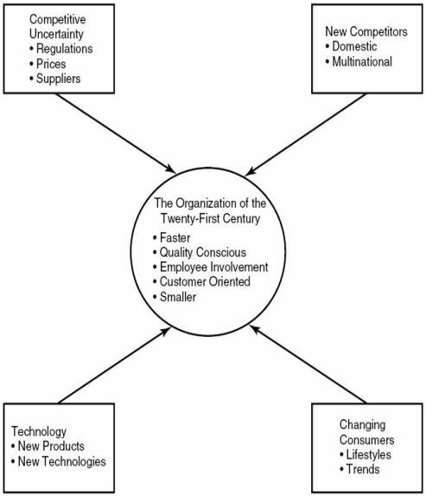
OD in Practice: Trilogy Software – A New Kind of Company:
A dropout of Stanford, Joe Liemandt, formed a small software company, Trilogy Software Inc., in Austin, Texas, in 1989. Starting with a small investment, the company grew from 400 to 1000 employees within a short span of four years. Today, Trilogy is among the world’s largest privately held software companies and is a leading provider of industry-specific software.
To call all those who work for Trilogy as “workers” would be wrong. They are all shareholders. They are all managers. They are all partners.

The founder, since its start, knows one thing that is Trilogy depends on talented people. He also knows that people can go anywhere, join any of the competitive companies, which means that his biggest competitive headache isn’t companies. His biggest worry is holding onto people. “There is nothing more important than recruiting and developing people,” he says. “That’s my number-one job. Trilogy is going head-to-head with Microsoft and other biggies in the talent war.

They have a very clear teachable point of view of what Trilogy is and what they practice. They know how to energize people, how to make courageous decisions. The CEO personally teaches a large portion of the classes held for Trilogy’s employee recruitment and development program – the glue that binds.
Trilogy has some unusual practices, including perks like speedboat for water skiing available to all employees, fully stocked kitchens on every floor, and parties every Friday. And there are spontaneous awards, such as a sports car for good work and trip to a Las Vegas. The CEO once took the entire company on a week-long, all-expense-paid trip to Hawaii. Bonuses are given to top performers that are equal to 50 or 100 percent of their regular salaries.

The economy is fostering new kinds of organizations with new kinds of practices and operating rules for pulling people together. These companies offer many of the advantages of free agency; flexibility in how, when, and where you work; compensation linked to what you contribute; freedom to move from project to project. However, they also offer the advantages of belonging to an organization in which mutual commitment builds continuity.

