Chapter 2 – The Constitution

Overview
The Framers of the Constitution sought to create a government capable of protecting liberty and preserving order. The solution they chose—one without precedent at that time—was a government based on a written constitution that combined the principles of popular consent, separation of powers, and federalism.
Popular consent was most evident in the procedure for choosing members of the House of Representatives. However, popular consent was limited by the requirements that senators be elected by their state legislatures and presidents by the Electoral College. Powers were separated among branches that then had to cooperate to effect change. Thus, separation of powers was joined to a system of checks and balances. The Framers hoped this system would prevent tyranny, even by a popular majority.
Federalism came to mean a system in which both the national and state governments had independent authority. Allocating powers between these two levels of government and devising means to ensure that neither large nor small states would dominate the national government required the most delicate compromises at the Philadelphia convention. The Framers’ decision to protect the institution of slavery was another compromise, which presumably helped to ensure the Constitution’s ratification by states engaged in the slave trade.
In the drafting of the Constitution and the struggle for its ratification, the positions people took were determined by a variety of factors. In addition to their economic interests, these included profound differences of opinion over whether the state governments or the national government would be the best protector(s) of personal liberty.

Chapter Outline
- Introduction
- The goal of the American Revolution was liberty.
II. The Problem of Liberty (THEME A: THE POLITICAL PHILOSOPHY OF THE FOUNDERS)
- Colonists were focused on traditional liberties:
- the right to bring legal cases before independent judges;
- the right to not have to quarter troops in their homes;
- the right to trade without burdensome restrictions; and
- the rights to pay no taxes that had not been established without direct representation.
- The colonists came to see independence as possible because they had lost confidence in the British constitution.
A. The colonial mind
- Believed that men seek power because they are ambitious, greedy, and easily corrupted
- Believed in a higher law embodying natural rights
- Life
- Liberty
- Property (Jefferson changed this to “pursuit of happiness”)
- A war of ideology, not economics
- Declaration of Independence cited specific complaints against George III for violating unalienable rights.
B. The real revolution
- The “real” revolution was the radical change in belief about what made authority legitimate and liberties secure.
- Government exists by consent of the governed, not by royal prerogative.
- Political power is to be exercised by direct grant of power in a written constitution.
- Human liberty exists prior to government, and government must respect liberty.
- Legislative branch created as superior to executive branch because the legislature directly represents the people.
C. Weaknesses of the confederation (Articles of Confederation):
- Could not levy taxes or regulate commerce
- Sovereignty, independence retained by states
- One vote in Congress for each state
- Nine of thirteen votes in Congress required for any measure
- Delegates to Congress chosen and paid by state legislatures
- Little money coined by Congress
- Army small and dependent on independent state militias
- Territorial disputes between states led to open hostilities
- No national judicial system
- All thirteen states’ consent necessary for any amendments.
III. The Constitutional Convention (THEME B: THE CONSTITUTIONAL CONVENTION)
A. The lessons of experience
1. State constitutions
- Pennsylvania: Radically democratic, but trampled minority rights—government was too strong.
- Massachusetts: Less democratic: directly elected governor, but electors and officials had to own property; clear separation of powers.
2. Shays’s Rebellion (Massachusetts)
- Brought fear that states were about to collapse from internal dissension
B. The Framers
- Fifty-five (55) attending: men of practical affairs, including Continental army veterans and members of the Congress of the Confederation
- Absent: Thomas Jefferson, John Adams, Samuel Adams, Patrick Henry
- An entirely new constitution was written, although the gathering was authorized only to revise Articles.
- Primary concern was with defense of liberty as a natural right (based in Lockean reasoning).
- Doubt that popular consent alone could guarantee liberty: Fear of tyranny of the majority
- “A delicate problem:” How could government be strong enough to preserve order but not threaten liberty?
IV. The Challenge
A. The Virginia Plan
- Strong national government organized into three branches
- Bicameral legislature
- Executive and members of the national judiciary to be chosen by legislature
- Council of revision (executive and some judiciary branch members) with veto power; legislature could override the veto.
- Two key features of the plan:
- national legislature with supreme powers; and
- one legislative house, elected directly by the people.
B. The New Jersey Plan
- Submitted as alternative to Virginia Plan
- Generated from a fear that legislative representation would be based on population, allowing the more populous states always to outvote the less populous states
- Sought to amend rather than replace the Articles of Confederation
- Proposed one vote per state, so Congress would be the creature of the state governments
- Protected small states’ interests while enhancing power of national government
C. The Great Compromise (or Connecticut Compromise)
- House of Representatives based on population and directly elected by people
- Senate composed of two members per state and elected by state legislatures
- Reconciled interests of large and small states: the former would dominate the House of Representatives, the latter would dominate the Senate.
V. The Constitution and Democracy
- Founders did not intend to create direct democracy.
- Physical impossibility in a vast country
- Founders also mistrusted popular passions and were concerned to secure minority rights.
- Intended instead to create a republic, a government by representation
- Popular rule only one element of new government
- State legislators to elect senators
- Electors to choose president
- Two kinds of majorities: voters (for example, the House of Representatives) and states (for example, the Senate)
- Judicial review another limitation, though one not necessarily intended by Founders
- Amendment process
A. Key principles
- Separation of powers: among branches of the national government
- Federalism: power divided between national and state governments
- Three categories of governmental powers
- Enumerated powers: Given exclusively to the national government; include power to print money, declare war, make treaties, conduct foreign affairs
- Reserved powers: Given exclusively to the states; include power to issue licenses and to regulate commerce wholly within a state
- Concurrent powers: Shared by both national and state governments; include collecting taxes, building roads, borrowing money, establishing courts
- Checks and balances allow national institutions to check each others’ powers (see How Things Work box).
B. Government and human nature
- Founders’ central belief: People would seek their own advantage, in and out of politics.
- Government based on popular consent was possible, but not inevitable.
- Aristotelian view (championed by Samuel Adams): Government should improve human nature by cultivating virtue.
- Madisonian view: Cultivation of virtue would require a government too strong, too dangerous; self-interest should be freely pursued within limits.
- Factionalism could be harnessed to provide a source of unity and guarantee liberty.
- Separation of powers enables each branch to check the others.
- Federalism enables one level of government to check another.
VI. The Constitution and Liberty
- Whether proposed constitution respected personal liberties was a primary debate during ratification.
- Required ratification by conventions in at least nine states—the most democratic feature of the Constitution
- Ratification process was technically illegal—the Articles, which still governed, could be amended only with unanimous agreement of the thirteen states
- Framers knew that unanimity was not possible—the North Carolina and Rhode Island conventions initially rejected the Constitution
A. The Antifederalist view
- Liberty could be secure only in small republics.
- Otherwise national government would be distant from people, becoming tyrannical
- Strong national government would use powers to annihilate state functions.
- Nation needed—at best, a loose confederation of states with most of the power wielded by the state legislatures
- If there was a strong national government, there should be many more restrictions on it.
- Madison’s response (Federalist No. 10 and No. 51): Personal liberty safest in large (extended) republics
- Coalitions were then more likely to be moderate because there would be a greater diversity of interests to be accommodated.
- Government should be somewhat distant from the people to be insulated from their passions.
- The Federalist counterargument to the objections of the Antifederalists included:
  - A focus on representative over direct democracy
  - The development of a large diverse republic rather than a small concentrated one, so that diverse economic and cultural interest would mitigate against the formation of homogeneous and potentially tyrannical majorities
- Reasons for the absence of a bill of rights
- Several guarantees already in Constitution
- Right of habeas corpus
- No bill of attainder
- No ex post facto law
- Trial by jury in criminal cases
- Citizens of each state guaranteed the privileges and immunities of citizens of every other state
- No religious tests for federal office
- No state could pass a law impairing the obligation of contracts
- Most states had bills of rights
- Intent in writing the Constitution was to limit federal government to specific powers.
B. Need for a bill of rights
- Ratification impossible without one
- Promise by key leaders to obtain one
- Bitter struggle for ratification, narrowly successful
- Twelve amendments approved by Congress; 10 ratified by the states and went into effect in 1791
C. The Constitution and slavery
- Slavery was addressed in three provisions of the Constitution:
- House of Representatives apportionment—the “three-fifths compromise;”
- Congress could not prohibit slave trade before 1808; and
- fugitive slave clause.
- Necessity of compromise: The Constitution would not have been ratified, and slavery would have continued under the Articles of Confederation with no prospective challenge possible.
- Great (or Connecticut) Compromise favored smaller (mostly) northern states by giving equal representation to each state in the Senate, but it also favored southern, slave-holding states
  - The three-fifths apportionment would have 33 rather than 47 House seats.
  - This led to the domination of the new government by southern-born presidents, House leadership, and the Supreme Court until the Civil War.
- Legacy: Civil war, social and political catastrophe
VII. The Motives of the Framers
A. Economic interests
- Economic interests of Framers varied widely.
- Charles Beard: Those who supported the Constitution expected to benefit economically from it. However, the economic interests of the Framers themselves did not dominate the convention.
- No clear division along class lines found by historians in the 1950s
- More recent research (1980s) suggests state economic considerations outweighed personal considerations.
- Excluding the grave and enormous exception of slave holders, most delegates who voted to ratify the Constitution were not motivated by economic interest.
- Economic interests and ratification
- Economic factors played larger role in state-ratifying conventions.
- More likely to vote in favor of ratification: Merchants, urban, owners of western lands, holders of government IOUs, and non–slave owners
- Less likely to vote in favor of ratification: Farmers, nonholders of government IOUs, and slave owners
B. The Constitution and equality
- Contemporary critics: Government today is too weak.
- Bows to special interests that foster economic inequality
- Changing views of liberty and equality are reflected in this criticism.
- Framers were more concerned with political inequality; they wanted to guard against political privilege.
- The Founding debate over church and state
  - Contrasting religious beliefs influenced the debate between Federalist and Anti-federalist concerning the relationship of religion and government.
      - Antifederalists represented views similar to those of today’s religious conservatives. They attacked the Constitution’s ban on religious tests for holding public office and the First Amendment’s prohibition of the establishment of a national religion.
      - Federalists took a different position, arguing that the Constitution should permit religious pluralism. They did not advocate a total separation between church and state, but they did favor a government that promoted a balance among different religions, with no one group using the power of government to persecute members of other religions.
VIII. Constitutional Reform—Modern Views
A. Reducing the separation of powers
- Urgent problems cannot be solved—gridlock.
- Also, government agencies are exposed to undue interference from legislators and special interests.
- Proposed remedy: President should be more powerful and held accountable to voters.
- Proposed remedies to allow government to be more proactive and decisive:
- allow Congress members to serve concurrently in Cabinet;
- allow president to dissolve Congress and call for a special election;
- empower Congress to call for a special presidential election before the end of a president’s term when the president has lost the nation’s confidence;
- require presidential and congressional candidates to run as a team in each congressional district;
- establish a single six-year term for president; and
- lengthen terms in House to four years, so elections would be concurrent with the presidential election.
- Results uncertain, worse from these reforms?
B. Making the system less democratic
- Government does too much, not too little.
- Attention being given to special interest claims rather than long-term values
- Proposals to cut back on government activism:
- Limit amount of taxes collected.
- Require a balanced budget.
- President gained enhanced rescission authority (a delimited line-item veto) in 1996; this was overturned in 1998.
- Adopt a new line-item proposal that would address constitutional concerns by requiring Congress to approve presidential cuts with a “fast-track” majority vote.
- Limit the authority of federal courts.
- Changes unworkable or open to evasion?
C. Who is right?
- Constitution not based on abstract reasoning or unproven factual arguments
- Crucial questions to ask when considering Constitutional reform:
- How well has it worked in history?
- How well has it worked compared with the constitutions of other democratic nations?

- WHO GOVERNS?
1. What is the difference between a democracy and a republic?
2. What branch of government has the greatest power?
- TO WHAT ENDS?
1. Does the Constitution tell us what goals the government should serve?
2. Whose freedom does the Constitution protect?

The Problem of Liberty

- The Colonial Mind
  - Men will seek power because they are ambitious, greedy and easily corrupted
- The Real Revolution
- Weaknesses of the Confederation
  - Articles of Confederation 1781

Signing the Declaration of Independence, painted by John Trumbull.

In 1775, British and American troops exchange fire in Lexington, Massachusetts, the first battle of the War of Independence.

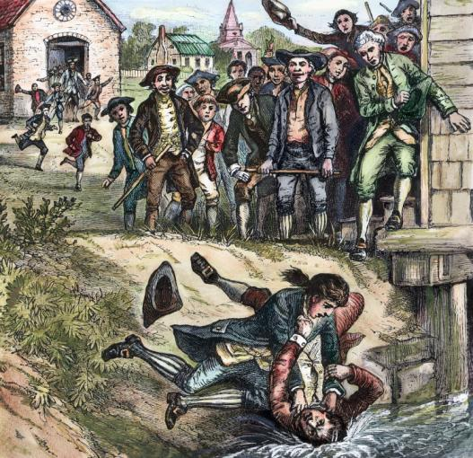
Shays’s Rebellion in western Massachusetts in 1786–1787 stirred deep fears of anarchy in America. The ruckus was put down by a hastily assembled militia, and the rebels were eventually pardoned.

The Constitutional Convention
- The Lessons of Experience
  - State Constitutions
  - Shays’s Rebellion
- The Framers
  - 55 delegates, RI did not send a delegate

The Challenge
- The Virginia Plan–proposal to create a strong national government
- The New Jersey Plan–proposal to create a weak national government
- The Compromise
  - popularly elected house based on state population
  - state elected Senate, with two members for each state

Independence Hall in Philadelphia.

The Constitution and Democracy

- Republican Form of Government
  - Key Principles
    - Federalism
    - Enumerated powers
    - Reserved powers
    - Concurrent powers
- Government And Human Nature
  - Separation of powers
  - Checks and balances

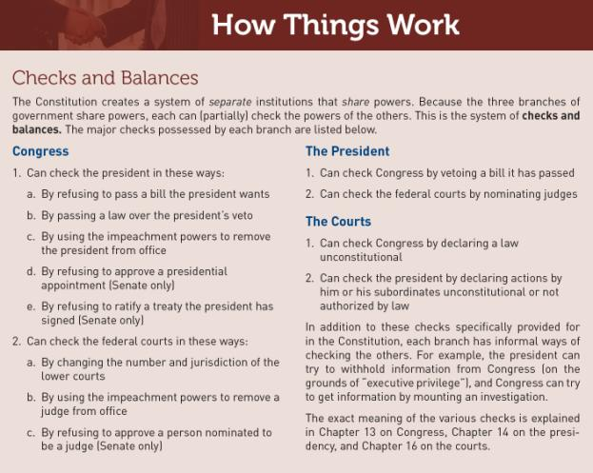

The Constitution and Liberty
- The Antifederalist View
- Need for a Bill of Rights
- The Constitution and
Slavery

Ratification of the Federal Constitution by State Conventions, 1787-1790

Liberties Guaranteed in the Original Constitution

- Writ of habeas corpus protected
- No bills of attainder
- No ex post facto laws
- Right of trial by jury

Liberties Guaranteed in the Original Constitution (cont’d)
- Citizens of each state entitled to the privileges and immunities of the citizens of every other state
- No religious test or qualification for holding federal office
- States cannot pass laws impairing the obligation of contracts.

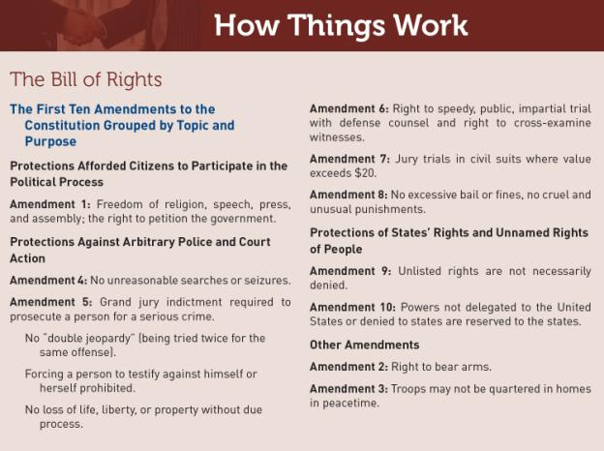
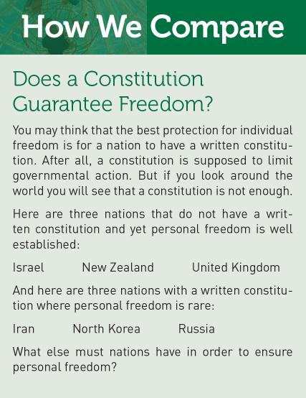
The Motives of the Framers

- Economic Interests
- The Constitution and Equality

Constitutional Reform: Modern Views
- Reducing the Separation of Powers
  - Increase presidential authority
  - Lengthen terms for members of the U.S. House of Representatives

- Making the System Less Democratic
  - Balanced Budget Amendment
  - Line-item veto

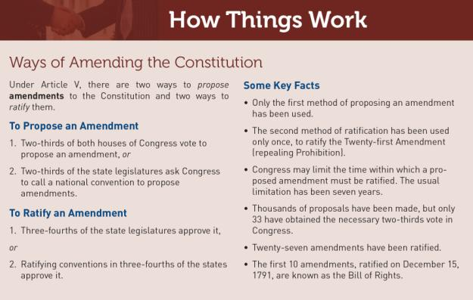
Who Is Right?
Don’t answer yet!
- Study the government’s historical evolution
- Study how the government works and why it has produced the policies you see
- Study the practices of other nations

In an excellent TV series, John Adams and George Washington discuss politics in the 18th century.

Who Is Right?
Now, let us have a discussion and intelligent argument about how best to achieve our wants and give expression to our beliefs.

WHAT WOULD YOU DO?
MEMORANDUM
To: Elizabeth Anthony, Arkansas state senate majority leader
From: George Morris, chief of staff
Subject: Proposal for a New Constitutional Convention
In the 1990s, Arkansas and several other states approved term limits for their members of Congress, but the Supreme Court ruled in 1995 that states do not have this authority. Now term-limit advocates are pursuing a broader strategy, calling for states to approve legislation that would require Congress to consider several amendment proposals, including term limits and abolishing the Electoral College to permit the direct popular election of the president. The Arkansas General Assembly passed such a bill last week, and several senators in your party have declared their support.

Arguments for:
1. Since the Twenty-second Amendment restricts presidents to two terms, members of Congress should face similar limits.
2. Term limits will ensure that national leaders do not become career politicians.
3. The public favors the direct popular election of the president; this constitutional convention would make possible abolishing the Electoral College.

Arguments against:
1. Limiting members of Congress to two terms would increase the power of lobbyists, congressional staffers, and administrative officials.
2. The Electoral College encourages a two-party system; a direct popular vote for the president would require runoff elections if no candidate won a majority.
3. The Constitutional Convention of 1787 was held in secret and involved only a few dozen people; today it would be heavily covered by the press and involve hundreds, perhaps thousands of people. No one knows what changes it might make.

Your decision:
Favor legislation?
Oppose legislation?

