Chapter 3 - Federalism

Overview
How one evaluates federalism depends in large part on the value one attaches to the competing criteria of equality and participation. Federalism means that citizens living in different parts of the country will be treated differently. This applies not only to spending programs (such as welfare), but also to legal systems (where civil rights may be differentially protected or criminal sentencing may vary). Yet federalism also means that citizens have more opportunities to participate in decision making. It allows people to influence what is taught in the schools and to decide where highways and other government projects will be built. Indeed, differences in public policy—that is, unequal treatment—are largely the result of wider participation in decision making. It is difficult, perhaps even impossible, to have more of one of these values without having less of the other.
States participate actively both in determining national policy and in administering national programs. Moreover, they reserve to themselves or to localities within them important powers over such public services as schooling and law enforcement and such important public decisions as land use. In a unitary system, these powers are exercised by the national government.
From the 1930s to the present, United States politics and public policy became decidedly more nationalized, with the federal government, and especially the federal courts, imposing increasingly uniform standards on the states. These usually took the form of mandates and conditions of aid. Begun in the 1960s and 1970s, efforts to reverse this trend by shifting to revenue sharing and block grants were only partially successful. In the mid-1990s, the Supreme Court began to review the doctrine of state sovereignty, and the effort to devolve power from Washington to the states gained momentum. Yet the overall impact of these efforts appears to be minimal. Federal spending on social programs, adjusted for inflation, is at its highest levels since World War II, and Congressional control over spending programs has prompted more regulation of state and local governments.

Chapter Outline
- Introduction
- Federalism: Then and Now
- Antifederalists opposed the Constitution on the grounds that it gave too much power to the federal government.
- Antifederalist concerns have been somewhat realized by the American experience. Over time the federal government has taken on responsibilities that were originally the province of state government.

II. Why Federalism Matters
- Federalism can be defined as a political system in which the national government shares power with local governments (state governments in the case of the United States, but other subnational governments in the case of federal systems including Australia, India, and Switzerland).
- Shared power between national and state governments allows both to influence public policy.
- Federalism influences important policy areas, including taxation, education, transportation, crime and punishment, and civil liberties.
- Political conflicts between national and state governments persist over time.
- Intergovernmental disputes over slavery were intensified by lack of unity among the states.
- Debate over the regulation of business and social welfare programs centered on whether the federal government had the right to intervene in these affairs.
III. The Founding
A. A bold, new plan
- Founders believed that neither national nor state government would have authority over the other, because power comes from the people, who shift their support to keep the two in balance.
- New plan had no historical precedent.
- Tenth Amendment was added as an afterthought to clarify the limits of the national government’s power.
- Tenth Amendment has had limited applicability, but has recently been used by the Supreme Court to give new life to state sovereignty.
B. Elastic language
- Precise definitions of powers are politically impossible due to competing interests; for example, commerce.
- Hamilton’s view: National supremacy, because the Constitution was the supreme law of the land
- Jefferson’s view: States’ rights with the people as ultimate sovereign; the national government was likely to be the principal threat to individuals’ liberties.
IV. The Debate on the Meaning of Federalism (THEME A: WHO GOVERNS WHAT; FEDERALISM AND CONSTITUTIONAL LAW)
A. The Supreme Court speaks
- Hamiltonian position espoused by Chief Justice John Marshall
- McCulloch v. Maryland (1819) settled two questions.
- Could Congress charter a national bank? Yes, because of the “necessary and proper” (elastic) clause, even though this power is not explicitly in the Constitution.
- Could states tax such a federal bank? No, because national powers were supreme and therefore immune to state challenge.
- Later battles related to federal taxes on state and local bond interest.
B. Nullification
- “Nullification”: states had the right to declare null and void a federal law that they believed violated the Constitution.
- Authors: James Madison (Virginia Resolutions), Thomas Jefferson (Tennessee Resolutions), and John C. Calhoun
- Question settled by the Civil War: The federal union is indissoluble, and states cannot nullify federal law; position was later confirmed by the Supreme Court.
C. DUAL FEDERALISM
- Dual federalism: Both national and state governments are supreme in their own spheres, which should be kept separate.
- Example: interstate versus intrastate commerce
- Early, product-based distinctions were unsatisfactory,
- Still, the Supreme Court does seek some distinction between what is national and what is local, although it is not entirely consistent in its support of state sovereignty.
- Doctrine of dual federalism is still argued, however―and sometimes successfully.
D. State sovereignty
- Supreme Court has strengthened states’ rights in several recent cases.
- United States v. Lopez (1995), guns in schools
- United States v. Morrison (2000), overturned Violence Against Women Act of 1994, stating that attacks against women do not substantially affect interstate commerce.
- Printz v. United States (1997), background checks on gun purchasers
- Supreme Court has also strengthened the Eleventh Amendment, protecting states from suits by residents of other states or citizens of foreign nations.
- Alden v. Maine (1999), compliance with federal fair-labor laws
- Federal Maritime Commission v. South Carolina Ports Authority (2002), states did not agree to become mere appendages of national government.
- But, not all decisions have supported state sovereignty.
- State can do what is not prohibited by the Constitution or preempted by federal policy, if it is consistent with its own constitution.
- Police power—generally recognized; refers to those laws and regulations, not otherwise unconstitutional that promote health, safety, and morals.
- Existence of the State is guaranteed by the federal government.
- No state can be divided without its consent.
- Each state must have two representatives in the senate.
- Every state is assured of a republican form of government.
- Powers not granted to Congress are reserved to the states.
- Cities, towns, and counties have no such protections.
- They exist at the pleasure of the state government, so there is no struggle over sovereignty (Dillon’s Rule).
- See the Politically Speaking box: The Terms of Local Governance.
- Current conflicts are mostly over federal grants or federal mandates, which require states to meet certain standards before they can receive federal funds.
V. Governmental Structure
- Introduction
- Federalism: a political system with local government units, as well as a national government, that can make final decisions regarding some governmental activities and whose existence is protected.
- Local governments are able to make decisions on at least some matters without regard to the preferences of the national government.
- Examples of federal governments: United States, Canada, India, Germany, Switzerland, Australia
- Unitary government
- All local governments are subservient to the national government.
- Local governments can be altered or abolished by the national government.
- Local governments have no final authority over any significant federal government activities.
- Examples of unitary governments: France, Britain, Italy, Sweden
- Special protection of subnational governments in federal system due to:
- constitution of country;
- habits, preferences, and dispositions of citizens; and
- distribution of political power in society.
- National government largely does not govern individuals directly, but compels states to do so in keeping with national policy.
- Federalism: Good or Bad?
- Negative views: Federalism blocks progress and protects powerful local interests.
- Laski: The states are “parasitic and poisonous.”
- Riker: Federalism facilitated the perpetuation of racism.
- Positive view―Elazar: Federalism contributes to governmental strength and political flexibility and fosters individual liberty.
- Federalism has good and bad effects.
- Different political groups with different political purposes come to power in different places.
- Federalist No. 10: small political units are more likely to be dominated by single political faction, which allows all relevant interests to be heard, somewhere.
A. Increased political activity
- Most obvious effect of federalism: It facilitates political mobilization.
- Federalism decentralizes authority, lowering the cost of political organization at the local level.
B. What the states can do
  - Play a key role in social welfare, public education, law enforcement, criminal justice, health and hospitals, and roads and highways; also in managing water supplies
  - State constitutions are more detailed and sometimes confer more rights than the federal one in the above matters.
  - State constitutions open one or more of three doors to direct democracy.
- State constitutions allow for some form of legislation by initiative.
- About half the states permit the referendum.
- Twenty states permit the recall, whereby voters can remove an elective official from office.
  - Existence of states is guaranteed by the federal Constitution.
VI. Federal-State Relations (THEME B: WHO GOVERNS NOW; THE CONTEMPORARY POLITICS OF FEDERALISM)
- What Washington legally may do is not the same as what politics may require.
A. Grants-in-aid
- Grants show how political realities modify legal authority.
- Land grants began before Constitution; cash grants to states began in 1808.
- Grants dramatically increased in scope in twentieth century.
- Prevailing constitutional interpretation until late 1930s was that the federal government could not spend money for purposes not authorized by the Constitution—grants were a way around this.
- Grants were attractive to state officials for various reasons.
- Federal budget surpluses (nineteenth and early twentieth centuries)
- Federal income tax increased revenues.
- Federal control of money supply
- Appeared as “free” money for state officials, who did not have to be responsible for federal taxation.
- Required broad congressional coalitions with wide dispersion of funds, because every state had an incentive to seek grant money (example: post-9/11 “fair-share” security funding formulas)
B. Meeting national needs
- 1960s shift in grants-in-aid
- From what states demanded . . .
- . . . To what federal officials considered important as national needs
- Federal grants to state and local governments increased.
- Purpose of federal funds changed.
C. The intergovernmental lobby
- Hundreds of state and local officials lobby in Washington
- The Big 7:
- U.S. Conference of Mayors;
- National Governors Association;
- National Association of Counties;
- National League of Cities;
- Council of State Governments;
- International City/County Management Association; and
- National Conference of State Legislatures.
- Purpose: To get more federal money with fewer strings
- Since 1980, their success has been more checkered.
D. Categorical grants
- Categorical grants are made for specific purposes defined by federal law; they often require local matching funds.
- Block grants (sometimes called special revenue sharing or broad-based aid) were devoted to general purposes with few restrictions; states preferred block to categorical grants.
- Neither block grants nor revenue sharing achieved the goal of giving the states more freedom in spending.
- These did not grow as fast as categorical grants.
- Number of strings increased, even on these programs.
- Block grants grew more slowly than categorical grants because of the differences between the political coalitions that supported each.
- Federal officials, liberal interest groups, organized labor tend to distrust state government; categorical grants give the national government more power.
- Categorical grants are matters of life or death for various state agencies.
- Supervising committees in Congress favored growth of categorical grants.
E. Rivalry among the states
- Intense debate regarding whether the federal government is helping some regions at the expense of others
- Snowbelt (Frostbelt) versus Sunbelt states: Debate focuses on allocation formulas written into federal laws.
- Difficulty determining where funds are actually spent and their effect, though
- With numerous grants distributed on the basis of population, the census takes on monumental importance.
VII. Federal Aid and Federal Control
- Federal controls on state governmental activities
- Conditions of aid: Tell state governments what they must do if they wish to receive grant money; traditional control.
- Mandates: Tell state governments what they must do.
A. Mandates
- Mandates: The federal rules that states or localities must obey generally have little or nothing to do with federal aid.
- Civil rights
- Environmental protection
- May or may not be funded
- Mandates are more likely in policy areas that receive less federal funding.
- Waivers exempt some parties from federal mandates.
- Mandates may also make it difficult for state/local governments to raise revenues, borrow funds, and privatize public functions; some may expose them to financial liability.
- Controversial mandates may result from court decisions (for example, state prisons, school desegregation plans).
B. Conditions of aid
- Attached to grants
- Conditions range from specific (apply to particular programs) to general (cover all or most grants).
- Divergent views of states and federal government on costs and benefits of these conditions; each side attempts to bargain to pass on most of the cost to the other sides
VIII. A Devolution Revolution?
- President Reagan asked Congress to consolidate numerous categorical grants into large block grants.
- The 1994 election of Republican majorities in House and Senate led to devolution initiatives that sought to reduce the number of federal regulations and shift responsibility for programs to the states.
- Result of devolution initiatives
- Aid to Families with Dependent Children (AFDC) was converted to block-grant program, Temporary Assistance for Needy Families (TANF) in 1996.
- Medicaid was not converted to block grant.
- Federal spending increased—did not decrease; 2006 inflation-adjusted per household spending levels are highest since World War II.
- More, not fewer, rules and regulations overall
- Little change in congressional preemption of state laws
- By 2011, financial situations of states have changed dramatically.
- States face increasing financial pressure to meet pension obligations for public employees.
- Several state governors have proposed restricting public unions’ collective bargaining abilities.
- This would allow states to reduce budgets by reducing public employee benefits.
- The Government Accountability Office has documented extensive duplication of services across federal agencies and between the federal government and state governments.
- Reduction of duplications could reduce “waste”.
- Debate rages over definition of what constitutes “waste”.
IX. Congress and Federalism
- Congress members represent conflicting constituencies; won’t always agree with governors and mayors.
- Parties once linked legislators to local groups; their erosion increases political competition,

- Other Information:
  - Requirements and Sanctions
    - Crosscutting Requirements
      - Attached to almost all federal grants
      - Pertain to nondiscrimination, environmental protection, planning and coordination, labor standards and public access to government information.
      - Today there are 60 crosscutting requirements
      - They are requirements that “cut across” all grants
    - Crossover Sanctions
      - These impose national sanctions or penalties in one area to influence state or local policy in another area
      - Drinking age and highway monies are an example
      - In 1996, the health and Human Services issued a ruling threatening states with loss of federal grants to fight drug and alcohol abuse unless the reduced access to cigarettes by teens
  - Other issues that promote devolution
    - The rise of deficits and deficit reduction programs led by Congresses with Republican majorities
    - Welfare and Medicaid (two block grant programs that were not created to be just that)
    - Other important activities that are given to the states (as a general rule)
      - Public education
      - Law enforcement and criminal justice
      - Health and hospitals
      - Roads and highways
      - Public welfare
      - Control over the use of public land and water supplies
  - Other avenues states use (to promote devolution and a direct democracy)
    - Initiatives – allows voters to place state legislative measures directly on voting ballots
    - Referendums – enable voters to reject a measure adopted by the state legislature
  - Other forms of devolution
    - Second-order devolution – a flow of power and responsibility from the states to the local governments
    - Third-order devolution – the increased role of nonprofit organizations and private groups in policy implementation.
- Safeguards for States
  - Full Faith and Credit Clause (page A11)
    - Located in Article IV, Section I
    - Requires each state to formally recognize the documents and judgments handed down by courts in other states.
    - This helps coalesce (combine) the state laws under a national umbrella
  - Privileges and Immunities Clause (page 11)
    - Located in Article IV, Section 2
    - Unifies the states by assuring that all citizens are treated equally when they travel from state to state
  - Extradition (page A11)
    - Located in Article IV, Section 2
    - Requires the return (extradition) of fugitive criminals arrested in one state to the state in which the crime was committed for prosecution, although it has developed as a discretionary (unrestricted) decision

- WHO GOVERNS?
1. Where is sovereignty located in the American political system?
2. How is power divided between the national government and the states under the constitution?
- TO WHAT ENDS?
1. What competing values are at stake in federalism?
2. Who should decide which matters ought to be governed mainly or solely by national laws?

Why Federalism Matters
- Federalism is a system in which the national government shares power with state/local governments.
- State governments have the authority to make final decisions over many governmental actions.
- The most persistent source of political conflict is between national and state governments.

Figure 3.1 Lines of Power in the Federal System of Government
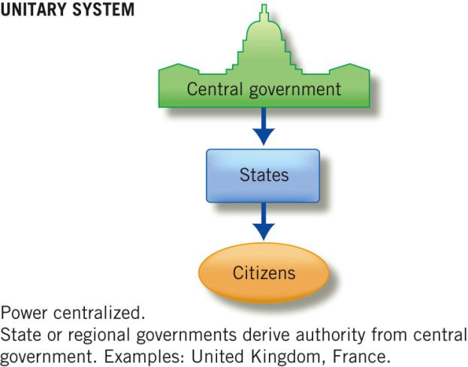

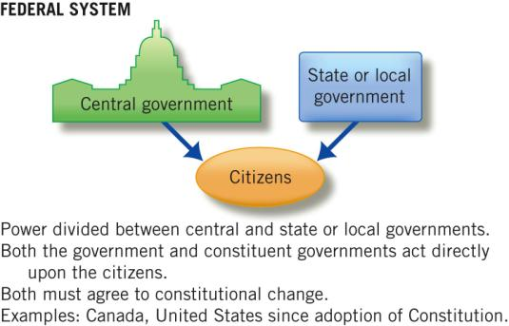

Figure 3.1 Lines of Power in the Federal System of Government

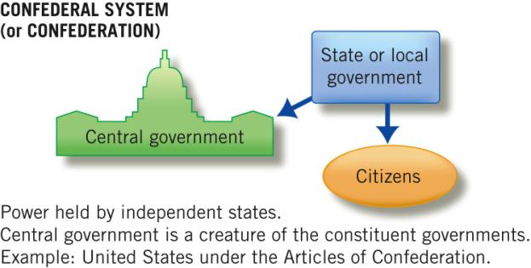

The Founding
- A Bold New Plan: A “federal republic” for which there was no precedent
- Elastic Language
Congress shall have the power to “make all
laws which shall be necessary and proper for
carrying into execution the foregoing powers.”
-from Article I

Benjamin Franklin, Thomas Jefferson, Livingston Adams, and Roger Sherman writing the Declaration of Independence.

The Debate on the Meaning of Federalism

- The Supreme Court Speaks
- Nullification
- Dual Federalism
- State Sovereignty

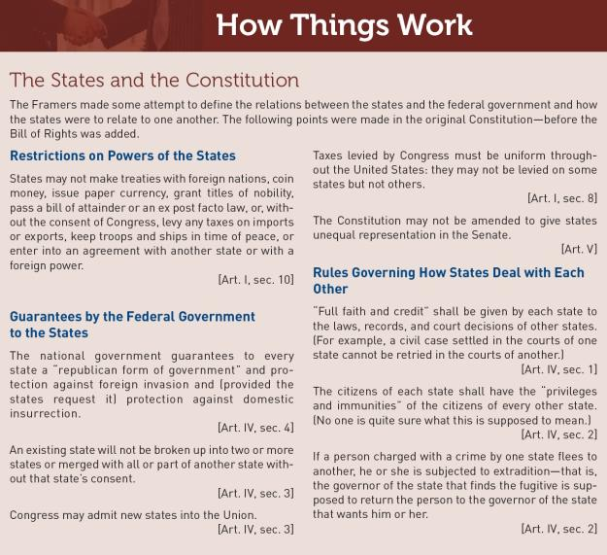

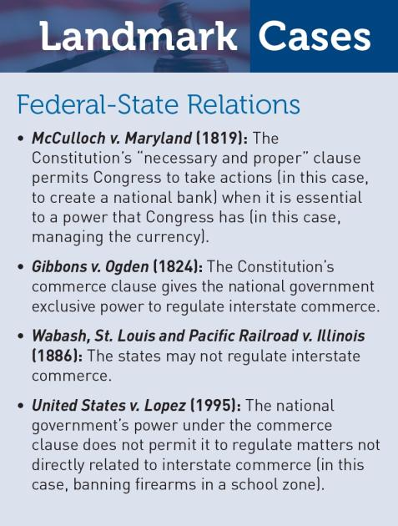

Governmental Structure
- Federalism: Good or Bad?
- Increased Political Activity
- What the States can do
  - Initiative
  - Referendum
  - Recall

Federalism has permitted experimentation. Women were able to vote in the Wyoming Territory in 1888, long before they could do so in most states.

Federal-State Relations
- Grants-In-Aid
- Meeting National Needs
- The Intergovernmental
Lobby
- Categorical Grants
- Rivalry Among the
States

Some of the nation’s greatest universities,
such as Penn State, began as land-grant colleges.

Federal Grants to State and Local Governments (2009)
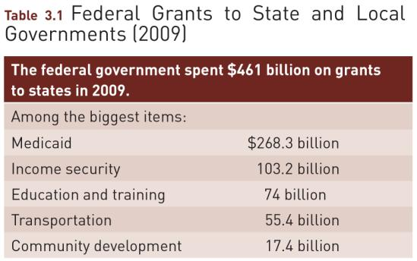

An airline passenger stands inside a device that
searches electronically for any contraband.

Figure 3.2 The Changing Purpose of Federal Grants to State and Local Governments
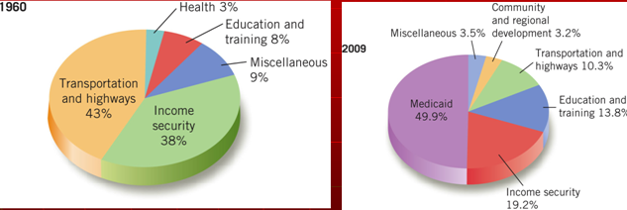

Then-Governor Mitt Romney inspecting a roof
that collapsed in “the Big Dig”—the tunnel under
downtown Boston.

Federal Aid and Federal Control
- Mandates
- Conditions of Aid
- A National Guardsman watches over the U.S.-Mexico border in Arizona. The Guardsmen cannot make arrests but can call the Border Patrol.

A Devolution Revolution?

- Devolution shifts many federal functions to the states.
- Most Americans favor devolution, but not if that means cuts in government programs that benefit most citizens.
- What have been the consequences of devolution?

- By 2011, many states have lost budget surpluses and face debts.
- This leads states to consider which responsibilities are theirs and which belong to the federal government.
- How will states address their long-term debts?

Congress and Federalism
WHY IS THERE SO MUCH POLITICAL AND POLICY DIVERSITY IN THE UNITED STATES?
- State and local governments have retained certain constitutional protections.
- Members of Congress think of themselves as representatives of localities to Washington, not as representatives of Washington to the localities.

WHAT WOULD YOU DO?

MEMORANDUM
To: Secretary of Education Julie Dew
From: White House special assistant Jack Patrick
Subject: National curriculum for elementary and secondary schools
As promised in her campaign platform, the president would like to expand upon the No Child Left Behind Act to develop a national curriculum for all elementary and secondary-school children, beginning with high school, to better prepare students for the twenty-first century work force. The major arguments for and against this proposal follow; will you present the initiative and address states’ concerns at the National Governors Association next week?

Arguments for:
1. American jobs in the twenty-first century will require advanced skills in literacy, mathematics and information technology that all schools must teach.
2. Variations in state curriculum standards leave students ill-prepared for college which increasingly is a necessary credential for long-term employment.
3. If the national government does not invest in creating a uniform school curriculum now, then increased funding will be needed for remedial instruction later.

Arguments against:
1. States are better able to determine educational standards that will prepare their diverse populations for the work force than the federal government.
2. Imposing a national curriculum will stifle state and local creativity in education and will be so basic that it will make little difference in college preparation.
3. The national government has a history of imposing educational mandates on states with insufficient funding and governors are skeptical of receiving sufficient funding to successfully implement a national curriculum for students with varying needs.

WHAT WOULD YOU DO?
Your decision:
Support bill?
Oppose bill?

