Chapter 4 – American Political Culture

Overview
The United States system of government is supported by a political culture that fosters a sense of civic duty, takes pride in the nation’s constitutional arrangements, and provides support for the exercise of essential civil liberties (albeit sometimes out of indifference more than principle). In recent decades, people’s mistrust of government officials (though not of the system itself) has increased, and confidence in officials’ responsiveness to the popular will has declined.
Although Americans value liberty in both the political system and the economy, they believe equality is important principally in the political realm. In economic affairs, although a few people wish to see equality of results, many support equality of opportunity and inequality of results.
Not only is the American culture generally supportive of democratic rule, it also has certain distinctive features that make the American way of governing different from other democracies. Americans are preoccupied with their rights. This fact, combined with a political system that encourages the vigorous exercise of rights and claims, gives political life in the United States an adversarial character. Unlike the Japanese or the Swedes, Americans do not generally reach political decisions by consensus, and they often do not defer to the authority of administrative agencies. U.S. politics, more than that of many other nations, has protracted conflict at every stage.

Chapter Outline
- Introduction
- Alexis de Tocqueville wrote a two-volume study titled Democracy in America that continues to be one of the defining texts of American political culture.
- De Tocqueville argued that democracy endured in the United States because of geography, laws, and “the manners and customs of the people.”
- He concluded that the attitude of Americans about the merits of democracy was fundamental to its success here.
- People in the United States may have very different views today of what democracy means for policymaking, but they continue to display the same veneration for democracy that de Tocqueville identified more than 175 years ago.
II. Political Culture (THEME A: WHAT IS “AMERICAN POLITICAL CULTURE”?)
- Constitutional differences among the United States, Great Britain, and France
- Written constitution (United States, France); unwritten constitution (Great Britain)
- Separation of powers (United States); unified powers (Great Britain, France)
- Presidential system (United States); semipresidential system (France); parliamentary system (Great Britain)
- Demographic differences among the United States, Great Britain, and France
- United States is larger and more diverse
- Over 300 million citizens
- English is dominant language, but millions speak Spanish
- Over 25 percent are non-Hispanic whites
- Over 80 percent identify as Christians, split between Catholics and Protestants
- Great Britain and France have similar demographic characteristics.
- About 60 million each
- Growing foreign-born populations
- Homogenous religious population
- Differences among the political cultures of the United States, Great Britain, and France
- Democracy favored in each country
- Americans more likely to favor political equality than economic equality
- Americans embrace political equality at earlier age.
- Reasons for America’s democratic success
- Abundant territory with greater opportunities for land acquisition
- No feudal aristocracy, minimal taxes, and ability to expand westward
- Land cultivated through small, independent farms
- “Moral and intellectual characteristics” or “political culture” favors democratic rule
A. The Political System
- Elements of the American view of the political system
- Liberty (rights)
- Equality (equal vote; equal chance to participate and succeed)
- Democracy (Government is accountable to the people.)
- Civic duty (Take community affairs seriously and become involved when possible.)
- Individual responsibility (Individuals are responsible for their own actions and well-being.)
- Some questions about U.S. political culture
- How do we know people share these beliefs?
- Before polls, beliefs were inferred from books, speeches, political choices, and so on.
- Personality tests and comparative polling confirm these shared beliefs are not held in all nations.
- How do we explain behavior inconsistent with these beliefs?
- People take actions contrary to their beliefs in everyday life; self-interest and social circumstance also shape behavior.
- Beliefs are still important and may cause changes in behavior.
- Why is there so much political conflict in U.S. history?
- Broad values may not be applicable to specific controversies.
- Beliefs contradict one another and are not consistently interpreted.
- Most consistent evidence of a common political culture is the use of the terms Americanism or American way of life and un-American
B. The Persistence of Conflict
- Despite ending slavery, endorsing civil rights, and expanding free discussion, Americans still have areas of political conflict.
  - Among the persistent areas of disagreement are abortion, morality, religion, immigration, and affirmative action.
  - Some believe in absolute moral principles, whereas others believe in a relativistic value system where moral choices should reflect situational conditions.
- Conflicts arise over the definition of good citizenship. Two contrasting definitions of citizenship are offered.
  - Some argue that persons who pay their taxes, obey the law, and support the military are good citizens.
  - In contrast, good citizens are skeptical of government, join protest movements, and boycott products they do not like.
- These views tend to reflect age differences. Older Americans who grew up during the Great Depression or World War II are more likely to favor the first view of good citizenship. Younger persons born between 1964 and 1984 and with college educations tend to favor the latter definition.
- Distrust between these two generations persists.
  - Members of the older generation feel that members of the younger group are alienated, distrustful, self-centered, and lacking in clear moral guidance.
  - Members of the next generation, the children of baby boomers, argue that older people are rigid, conformists, overly supportive of the status quo, and too pro-military.
- Overall, Americans still love their country. When polled, 91 percent of whites, 80 percent of blacks, and 91 percent of Hispanics said they either love this country “very much” or “extremely” so.
C. The Economic System
- Americans support free enterprise, but see limits on marketplace freedom.
- Americans believe in equality of opportunity in the economy but not equality of result.
- Americans have a widely shared commitment to economic individualism.
III. How We Compare: Comparing America with Other Nations
- Americans like their own country.
- Seventy-one percent of Americans are proud to be American, compared with only 21 percent of Germans who are proud to be German.
- A majority of Europeans believe that forces beyond an individual’s control determine that individual’s success in life. Americans emphasize the importance of individual initiative in the achievement of personal success.
- Americans have a much deeper belief in the importance of God for morality, compared with their European counterparts.
- Americans have very different views about important things compared with Europeans.
A. The Political System
- Sweden has a well-developed democracy, but its political culture is more deferential than participatory.
- Almost all adults vote in national elections, but few participate in any other way.
- Swedes defer to government experts and specialists.
- They rarely challenge governmental decisions in court.
- They believe in “what is best” more than “what people want.”
- They value equality as much as (or more than) liberty.
- They value harmony and observe obligations.
- Japan has a wholly different history and set of traditions.
- The Japanese value good relations with colleagues, group decisions, and social harmony.
- They emphasize importance of being sensitive to personal needs of others, avoiding conflict, reaching decisions through discussion rather than application of rules.
- Tremendous importance is given to respecting hierarchy.
- Americans
- Americans tend to assert rights.
- They emphasize individualism, competition, equality, following rules, and treating others fairly but impersonally.
- Cultural differences affect political and economic systems.
- A classic study reported in 1959–60, that U.S. and British citizens had a stronger sense of civic duty and competence than the citizens of Germany, Italy, or Mexico.
- Civic duty: A belief that one has an obligation to participate in civic and political affairs.
- Civic competence: A belief that one can affect government policies.
- Subsequent research comparing Americans and Europeans
- Americans lag in voting rates but not in other forms of participation.
- Americans have more confidence in government institutions.
- Americans acknowledge flaws but still report being “very patriotic.”
B. THE Economic system
- Swedes tend to favor equal pay and top limit on incomes.
- Americans favor economic freedom over equality.
- Americans are less likely to think that hard work goes unrewarded.
- Americans are less likely to think that government should guarantee citizens a basic standard of living.
C. The CiviC Role of Religion
- Impact of religion on political culture
- Effect of religion on civic life
- Americans are more likely than Europeans to believe in God, pray daily, and acknowledge a clear standard of right and wrong.
- Religious people donate more money and time to charitable organizations than nonreligious people do.
- Effect of religion on politics
- Religious beliefs are important in the American founding.
- Both liberals and conservatives use the pulpit to promote political change.
- Candidates for national office in most other contemporary democracies rarely mention religion; U.S. candidates frequently invoke religious themes.
IV. The Sources of Political Culture (THEME B: DIVISIONS IN AMERICAN POLITICAL CULTURE)
- Historical roots
- American Revolution was essentially over liberty—asserting rights.
- Animating spirit of the Constitution was the effort to reconcile personal liberty with social control.
- The adversarial spirit of political culture reflects a long-standing distrust of authority that stems from the belief that human nature is fundamentally depraved (original sin).
- The Jeffersonian transition in 1800 reconciled the need for and suspicion of government.
- It legitimated the role of the opposition party.
- Demonstrated that liberty and political change can coexist
- Legal-sociological factors
- Widespread (not universal) participation permitted by Constitution
- Absence of an established national religion made religious diversity inevitable.
- Religious diversity is a source of cleavage.
- Absence of established religion facilitated the absence of political orthodoxy.
- Protestant heritage emphasizes personal achievement:
- a believer has to work hard;
- save money;
- obey the secular law; and
- do good works.
- Max Weber described this as the “Protestant ethic” (work ethic).
- Miniature political systems were produced by the churches’ congregational organizations, so civic and political skills could develop.
- Family instills the ways Americans think about the world and politics.
- Greater freedom of children and equality among family members leads to . . .Belief in rights and acceptance of diverse views in decision making.
- High degree of class consciousness absent
- Class consciousness: Thinking of oneself as a worker whose interests are in opposition to those of management, or vice versa.
- Most people consider themselves middle class.
- Message of Horatio Alger stories is still popular: that success is available to people who work hard.
A. The culture war
- Cultural clashes in America battle over values
- Two cultural “camps” are defined by James Davison Hunter.
- Orthodox camp:
- usually consists of fundamentalist Protestants and evangelical Christians;
- believes that moral values are derived from the commands of God or the laws of nature; and
- perceives morality as clear, unchanging, and independent of personal preferences.
- Progressive camp:
- usually consists of liberal Protestants and people with no strong religious beliefs;
- believes that personal freedom is as important as, or more important than, traditional moral rules; and
- perceives moral rules as complex, changeable, and dependent on individual preferences.
- Culture war differs from political disputes in three ways:
- money is not at stake;
- compromises are almost impossible; and
- conflict is more profound.
- Two views on importance of culture war to politics
- Morris Fiorina: Culture war is a “myth”; political leaders are polarized, but most Americans occupy a middle position on policy issues.
- Alan Abramowitz: People are more likely to choose party affiliations based on policy positions; growing percentages of Americans are politically engaged.
- Data suggests that popular attitudes about issues are deeply polarized.
V. Mistrust of Government
- Overall steady decline in number of Americans who trust government since late 1950s; increases seen only during Reagan presidency and period following 2001 terrorist attacks
- Causes
- Vietnam (1960s)
- Watergate (1970s)
- Clinton impeachment (1990s)
- War in Iraq (2000s)
- Necessary to view this crisis in context
  - Level of trust in 1950s may have been abnormally high.
  - May have been fewer catalysts to express patriotism in 1960s and 1970s
  - Events of 9/11 provided reason for extraordinary outburst of patriotic fervor.
- Americans have a reduced level of confidence in government; only 12 percent of Americans have a lot of confidence in Congress.
- Americans have a declining sense of confidence in churches, public schools, newspapers, unions, and big business.
- The military is the only institution in which public confidence has increased.
- Declining trust in political institutions and leaders may increase support for nonincumbent candidates.
A. Civil Society
- Civil Society is that collection of private, voluntary groups that, being independent of the government and the commercial marked, make human cooperation easier and provide ways of holding the government accountable for its actions.
      - Americans are more likely to join voluntary groups than are people in other democracies.
    - These organizations teach people how to cooperate, develop community-serving skills, and increase social capital.
    - Social capital refers to connections people have with each other through friendship, personal contact, and group effort.
- Importance of Social Capital
      - Robert Putnam argues that the greater the amount of trust among group/community members, the easier it is to achieve common goals such as improving a neighborhood or combating intolerance, which in turn produces useful projects.
      - Some worry that social capital may be decreasing, as people are less likely to join voluntary associations. Americans once bowled in leagues; now they bowl alone. Americans no longer participate in the PTA, the NAACP, or the VFW. Now they stay at home and watch television.
- There are three qualifications to this argument.
      - Americans join more groups than do people in other democracies.
      - A general measure of civil health, combining group membership with informal human contact, has increased.
      - In ethnically and racially diverse communities, Americans “hunker down.” They do not trust their neighbors, contribute to charities, cooperate with others, or join voluntary groups.
VI. Political Tolerance
- Minimal level of tolerance crucial to democratic politics
- Allows free discussion of ideas
- Levels of American political tolerance
- Most Americans agree in the abstract with freedom of speech, majority rule, and right to circulate petitions.
- Most Americans would deny these rights in concrete cases.
- Americans are generally becoming more tolerant.
- Most Americans believe that the nation is too tolerant of harmful behaviors; defense of common moral standards is more important than protection of individual rights.
- Still, most are willing to allow expression by those with whom they disagree.
- How do very unpopular groups survive?
- Most people do not act on their beliefs
- Officeholders and activists are more tolerant than the general public.
- Usually no consensus exists on whom to persecute.
- Courts are sufficiently insulated from public opinion to enforce constitutional protections.
- WHO GOVERNS?
1. Do Americans trust their government?
2. Why do we accept great differences in wealth and income?
- TO WHAT ENDS?
1. Why does our government behave differently than governments in countries with similar constitutions?

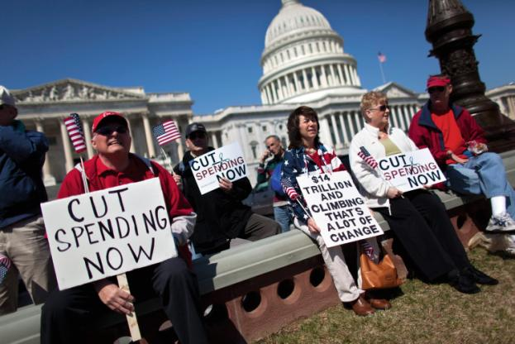

Political Culture
Political culture is a patterned and sustained way of thinking about how political and economic life ought to be carried out.

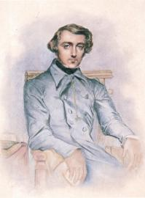
Alexis de Tocqueville wrote Democracy in America, a profound analysis of our political culture.

At the height of immigration to this country, there was a striking emphasis on creating a shared political culture. Schoolchildren, whatever their national origin, were taught to salute this country’s flag.

- The Political System
- The Persistence of Conflict
- The Economic System

- Three Questions Concerning The American Political System:
- How do we know that the American people share these beliefs?
- How can we explain the existence in our society of behavior that is obviously in conflict with these beliefs?
- Why has there been so much political conflict in our history?

The Persistence of Conflict
In the 1950s Senator Joseph McCarthy of Wisconsin was the inspiration for the world “McCarthyism” after his highly publicized attacks on alleged communists working in the federal government.

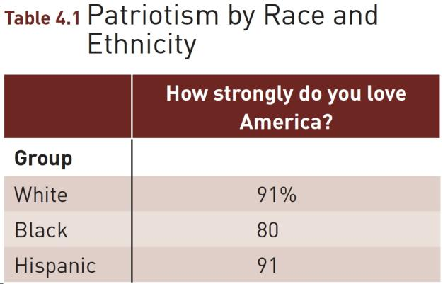

The Economic System
- Americans tend to support:
- The “free enterprise system”
- Government regulations that keep some firms from becoming too powerful and to correct specific abuses
- “Equality of opportunity”, but not “equality of results”

Comparing America with Other Nations
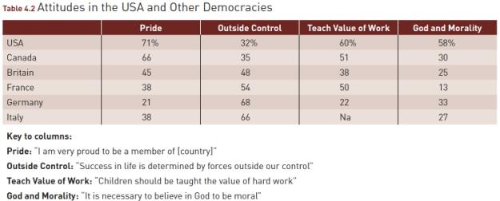

The Political System

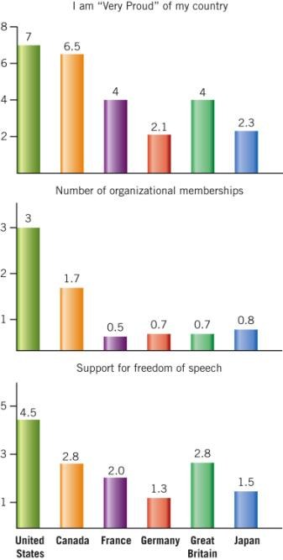

Comparing America with Other Nations
- The Political System
- The Economic System
- The Civic Role of Religion

A chaplain offers a prayer at a meeting of the U.S. Congress. Though having such a chaplain may strike you as violating the separation of church and state,
the Supreme Court has upheld it on grounds of “tradition.”

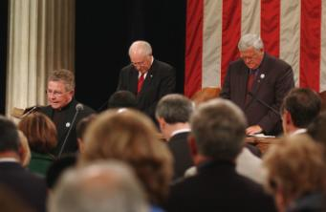

The Economic System

United States

- Less likely to believe in giving workers equal pay
- Less likely to favor putting a top limit on income
- Ratio between the income of an executive vs. menial worker: 15 to 1

Sweden

- More likely to believe in giving workers equal pay
- More likely to favor putting a top limit on income
- Ratio between the income of an executive vs. menial worker: 2 to 1

The Civic Role of Religion
- Average American compared to the average European is more likely to:
- Believe in God
- Pray on a daily basis
- Acknowledge clear standards of right and wrong
- Religious people in the US:
- Donate more money to charities than secular folks
- More likely to give money and donate time to non-religious organizations than secular folks

The Sources of Political Culture
- Personal Liberty vs. Social Control
- Class Consciousness
- The Culture War
  - Orthodox – a belief that morality and religion ought to be of decisive importance.
  - Progressive – a belief that personal freedom and solving social problems are more important than religion.

Union members protest Wisconsin Governor Scott Walker’s plan to restrict their collective bargaining rights. They did not stomp on a police officer.
.

People stomp on a police officer in Rome as part of
their demand for a change in the Italian government.

Figure 4.2 Trust in the Federal Government, 1958–2004
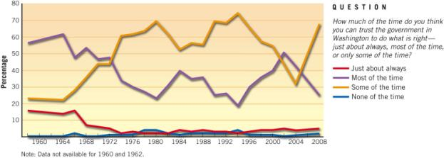
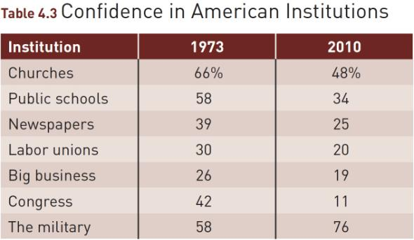

Mistrust of Government

Civil society is that collection of private, voluntary groups that – independent of the government and the commercial market – make human cooperation easier and provide ways of holding the government accountable for its actions.

Figure 4.3 The American Civic Health Index, 2009
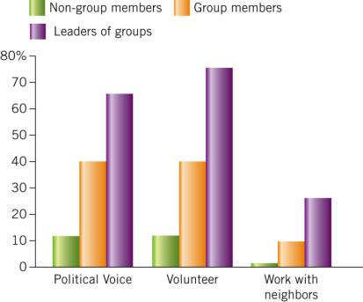
Source: America’s Civic Health Index: Broken Engagement (Washington, D.C.: National Citizenship Conference and Saguaro Seminar, September 2006), p. 6. Reprinted by permission of the National Conference of Citizenship.

Political Tolerance
In order for democracy to work, citizens must have a political culture that allows the discussion of ideas and the selection of rulers in an atmosphere reasonably free of oppression.

WHAT WOULD YOU DO?
MEMORANDUM
To: White House Chief of Staff Omar McField
From: Secretary of Education, Alexandra Clark
Subject: Civic education in schools
The decline in political knowledge that Americans have about our governmental system is alarming. We need to work in partnership with Congress and the states to promote civic education in secondary schools. In her upcoming state of the union message, the President needs to make a case for high school civics education and endorse the creation of a bipartisan task force to develop guidelines for such classes.

Arguments for:
1. A recent survey finds that only about six of ten Americans can name the vice president and more than half believe incorrectly that the Supreme Court prohibits public school classes that compare religions.
2. Schools have a responsibility to teach students the principles of American constitutionalism, such as federalism and separation of church and state.
3. If the federal government does not take the initiative in promoting civics education, then states will develop their own standards, which will weaken understanding of our shared political principles.

Arguments against:
- Civics education needs to be incorporated into existing courses, not taught separately.
2. Individuals need to take responsibility for understanding the political system in which they live.
3. Based on their individual historical experiences, states are better prepared than the federal government to determine how the underlying principles of American politics should be taught in their classrooms.

Your decision:
Support ?
Oppose ?

