Chapter 5 – Civil Liberties

Overview
Like most issues, civil liberties problems often involve competing interests—in this case, conflicting rights or conflicting rights and duties. Groups may mobilize to argue for their interests. Like some other issues, civil liberties concerns can also arise from the successful appeals of a policy entrepreneur. These appeals have sometimes restricted liberty, as when popular fears are aroused during or just after a war or attack.
Civil liberties are foundational to political beliefs and political culture in the United States. Among the most important protections are those in the First Amendment: What is speech? How much of it should be free? How far can the state go in aiding religion? How do Americans strike a balance between national security and personal expression? The zigzag course followed by the courts in judging these matters has, on balance, tended to enlarge freedom of expression.
Also important has been the struggle to strike a balance between the right of society to protect itself from criminals and the right of all people to be free from unreasonable searches and coerced confessions. As with free speech cases, the courts have generally broadened the rights, this time at some expense to the police. In more recent years, though, the Supreme Court has qualified some of its exclusionary rule protections.
The resolution of these issues by the courts is political in the sense that there are competing opinions about what is right or desirable. In this competition of ideas and values, federal judges, though not elected, are often sensitive to strong currents of popular opinion. When no strong national mood is discernible, the opinions of elites influence judicial thinking.
At the same time, courts resolve political conflicts in a manner that differs in three important respects from the resolution of conflicts by legislators and executives. First, the relative ease with which one can enter a court facilitates challenges to accepted standards. An unpopular political or religious group may have little or no access to a legislature, but it will have substantial access to the courts. Second, judges often settle controversies about rights not simply by deciding the case at hand but by formulating a general rule to cover other, similar cases. This means that the law tends to become more consistent and better known, but the rules may also be inappropriately applied. For example, a definition of obscenity or fighting words may suit one situation, but be inadequate in another. Third, judges interpret the Constitution, whereas legislatures often consult popular preferences or personal convictions. Still, though their own beliefs influence how judges read the Constitution, its language constrains almost all of their decisions.
Taken together, the desire to find and announce rules, the language of the Constitution, and the personal beliefs of judges have led to a general expansion of civil liberties. As a result, even allowing for temporary reversals and frequent redefinitions, any value that is thought to hinder freedom of expression and the rights of the accused has generally lost ground to the claims of the First, Fourth, Fifth, and Sixth Amendments.

Chapter Outline
- Introduction
- The politics of civil liberties
- The Framers believed that the Constitution limited government—what was not specifically allowed was obviously not allowed
- States ratifying constitutions demanded the addition of the Bill of Rights.
  - The Bill of Rights was seen as specific restrictions on federal government actions.
  - The Bill of Rights was not originally understood as applying to state government actions.
- Civil liberties: Protections the Constitution provides against the abuse of government power.
- Civil rights: Protecting certain groups against discrimination.
- In practice, there is no clear line between civil liberties and civil rights.
II. Culture and Civil Liberties
A. Rights in conflict
- The Constitution and the Bill of Rights contain a list of competing rights and duties.
- Sheppard case: free press versus fair trial
- New York Times and the Pentagon Papers: common defense versus free press
- Kunz anti-Jewish speeches: free speech versus public order
- Struggles over rights follow a pattern similar to interest-group politics in economic issues.
- War has been the crisis that has most often restricted the liberty of some minority.
- Sedition Act of 1798, following the French Revolution
- Espionage and Sedition Acts, directed against German Americans during World War I
- Smith Act (1940): Made it illegal to advocate the overthrow of the U.S. government
- Internal Security Act of 1950: Required members of the Communist Party to register with the government
- Communist Control Act of 1954: Declared the Communist Party to be part of a conspiracy to overthrow the government
- Supreme Court usually upheld this legislation, though its importance abated as war or crisis passed.
- Some use is still made of sedition laws, although the Supreme Court has increasingly protected political speech
B. Cultural conflicts
- Original settlement by white European Protestants meant that “Americanism” was equated with their values.
- Conflicts about the meaning of some constitutionally protected freedoms surround the immigration of “new” ethnic, cultural, and/or religious groups.
- Jews offended by crèches at Christmas
- English-speakers often prefer monolingual schools.
- Gay men are prohibited from serving as Boy Scout troop leaders.
- Differences even within a single cultural tradition (for example, pornography)
C. Applying the Bill of Rights to the states
- Before Civil War, Constitution and Bill of Rights were understood to apply only to federal government—not to state governments.
- Change began after Civil War with the Fourteenth Amendment (1868).
- Due process clause: “No state shall deprive any person of life, liberty or property without due process of law.”
- Equal protection clause: “No state shall deny to any person within its jurisdiction the equal protection of the laws.”
- Supreme Court used these two clauses to apply certain rights to state governments.
- 1897: Said no state could take private property without just compensation.
- 1925 (Gitlow): Declared federal guarantees of free speech and free press also applied to states
- 1937 (Palko v. Connecticut): Certain rights must apply to the states because they are essential to “ordered liberty” and are “fundamental” to our system of justice.
- Decisions began the process of incorporation: Applying some (but not all) federal rights to the states.
- Bill of Rights is now generally applied to the states except for:
- Third Amendment: Quartering troops
- Fifth Amendment: Right to be indicted by grand jury
- Seventh Amendment: Right to jury trial in civil cases
- Eighth Amendment: Ban on excessive bail and fines
- The Second Amendment that protects “the right of the people to keep and bear arms” may or may not apply to the states.
- In a 2008 case that arose in the District of Columbia, the Supreme Court ruled the federal government did not have a right to ban the private possession of firearms. Raises two questions:
- Will the ban be incorporated, via the Fourteenth Amendment to the states? Cases have arisen to test the issue.
- Will government still be able to regulate the purchase and use of guns? Court precedents would suggest that the answer is yes.
III. Interpreting and Applying the First Amendment (THEME A: FIRST AMENDMENT RIGHTS)
A. Speech and National Security
- Blackstone: Press should be free of prior restraint (censorship), but then must accept the consequence if a publication is improper or illegal.
- Sedition Act of 1798 followed Blackstone’s view, with improvements.
- Jury trial, not a judge’s decision
- Defendant would be acquitted if it could be proved that information was truthful.
- Congress defines limits of expression: 1917–18.
- Treason, insurrection, forcible resistance to federal laws, encouraging disloyalty in the armed services are not protected by the First Amendment.
- Upheld in Schenck (1919) via “clear and present danger” test (authored by Justice Oliver Wendell Holmes)
- Holmes dissented in cases that subsequently applied this test, believing that its conditions had not been met.
- Change in national-state relationship: Gitlow (1925)
- Supreme Court initially denied that due process clause made the Bill of Rights applicable to the states.
- Change occurred in Gitlow (1925), when due process clause was applied to protect “fundamental personal rights” from infringement by the states.
- Supreme Court moved toward more free expression after World War I but with some deference to Congress during times of crisis.
- Supreme Court upheld the convictions of Communists under the Smith Act.
- By 1957, to be punished, the speaker must use words “calculated to incite” the overthrow of the government.
- By 1969 (Brandenburg), speech calling for illegal acts is protected, if the acts are not “imminent.”
- In 1977, American Nazi march in Jewish community is held to be lawful.
- In 1992, Minnesota law that made it a crime to display hate symbols or objects was overturned.
IV. What Is Speech?
- Some kinds of speech are not fully protected.
A. Libel
- Libel: Written statement defaming another by false statement.
- Slander: Defamatory oral statement.
- Author or publisher engaging in libel may be sued for civil damages.
- Public figures must show the words were written with “actual malice”—with reckless disregard for the truth or with knowledge that the words were false.
B. OBSCENITY
- Obscene materials may be regulated by the state.
- No enduring and comprehensive definition of obscenity
- 1973 definition: Judged by “the average person, applying contemporary community standards” to appeal to the “prurient interest” or to depict “in a patently offensive way, sexual conduct specifically defined by applicable state law” and lacking “serious literary, artistic, political, or scientific value”
- Balancing competing claims remains a problem: Freedom versus decency
- Localities decide whether to tolerate pornography but must comply with strict constitutional tests if they decide to regulate it.
- Protection is extended to almost all forms of communication; for example, nude dancing is marginally protected.
- Court overruled Indianapolis statute: Court ruled the legislature cannot show preference for one form of expression over another (women in positions of equality versus women in positions of subordination).
- Zoning ordinances for adult theaters and bookstores have been upheld: Regulate use of property rather than expression.
- Internet regulation ruled unconstitutional by the Supreme Court.
C. Symbolic speech
- Cannot claim protection for an otherwise illegal act on the grounds that it conveys a political message (for example, burning a draft card)
- However, statutes cannot make certain types of symbolic speech illegal: For example, flag burning is protected speech.
V. Commercial and Youthful Speech
- Corporations and organizations usually have same rights as individuals.
- Corporations and interest groups have First Amendment rights.
- Businesses that cater to “vice” also have First Amendment rights.
- Restrictions can be placed on commercial speech (advertising); however, the regulation must be narrowly tailored and serve the public interest.
- McCain-Feingold campaign finance reform changed the parameters of acceptable political speech for corporations and other organizations.
  - Organizations could not pay for “electioneering communications” that “refer” to a specific candidate on radio or television sixty days before an election.
  - Supreme Court upheld this law, saying ads that only mentioned, but did not “expressly advocate” a candidate were ways of influencing the election.
- Young people (minors) may have less freedom of expression than adults.
- Hazelwood (1988) allowed that a school newspaper can be restricted.
- Private speech may be protected, but speech associated with school-sponsored activities may be controlled if speech interferes with school’s educational mission.
VI. Church and State
A. The free-exercise clause
- Relatively clear meaning: No state interference, similar to speech
- Ensures that no law may impose particular burdens on religious institutions
- Example: Hialeah, FL, cannot ban animal sacrifices by Santerians because killing animals is not generally illegal.
- But there are no religious exemptions from laws binding all other citizens, even if that law oppresses a group’s religious beliefs.
- Some conflicts between religious freedom and public policy continue to be difficult to settle.
- Conscientious objection to war, military service
- Refusal to work Saturdays (Seventh-Day Adventists)
- Refusal to send children to public school beyond eighth grade (Amish)
B. The establishment clause
- Jefferson’s view: There is a “wall of separation” between church and state.
- Ambiguous phrasing of First Amendment requires Supreme Court interpretation.
- Supreme Court interpretation: No governmental involvement, even if the involvement would be nonpreferential
    - Case in New Jersey in 1947 allowed parents of Catholic schoolchildren to be reimbursed for the cost of busing their children to schools because the busing business is a religiously neutral activity.
    - Since 2000, it has been unconstitutional for a student to lead a prayer at a public high school football game because the student was using public-address equipment provided by the school, by a student body representative, under the supervision of school faculty pursuant to school policy. However, in the same ruling the Court made it clear that public school students could pray voluntarily during school provided the school or government did not sponsor that prayer.
    - The Court has since struck down school prayer, teaching of “creationism” in public schools, in-school released time for religious instruction.
    - The Court has allowed certain kinds of aid to parochial schools and denominational colleges.
    - The Court has also allowed voucher money to go to parochial schools, on the grounds that the aid is going not to a specific school but rather to the families, who were then free to choose a school.
    - Government involvement in religious activities is constitutional if it meets the following tests:
- it has a secular purpose;
- its primary effect neither advances nor inhibits religion; and
- it does not foster excessive government entanglement with religion.
- Supreme Court rulings, however, remain complex and shift in regard to the establishment clause.
VII. Crime and Due Process (THEME B: CRIMINAL DUE PROCESS)
A. The exclusionary rule
- The challenge of evidence in the courtroom
- Most nations allow all evidence into trial, later punishing any police misconduct.
- The United States excludes improperly obtained evidence from trial.
- Exclusionary rule: Evidence gathered in violation of the Constitution cannot be used in a trial.
- Implements the Fourth Amendment (freedom from unreasonable searches and seizures) and the Fifth Amendment (protection against self-incrimination)
- Mapp v. Ohio (1961): Supreme Court began to use the exclusionary rule to enforce a variety of constitutional guarantees.
B. Search and seizure
- When can reasonable searches of individuals be made?
- With a properly obtained search warrant: An order from a judge authorizing the search of a place and describing what is to be searched and seized; judge can issue only if there is probable cause.
- Incident to an arrest
- What can the police search, incident to a lawful arrest?
- The individual being arrested;
- Things in plain view; and
- Things or places under the immediate control of the individual.
- What about an arrest of someone in a car?
- Answer changes almost yearly
- Recent cases have allowed police to search under more relaxed “reasonable suspicion” standard.
- Court attempts to protect a “reasonable expectation of privacy.”
C. Confessions and self-incrimination
- Constitutional ban originally was intended to prevent torture or coercion.
- Extended to people who are unaware of their rights, particularly their right to remain silent in both the courtroom and the police station.
- Miranda case: Confession is presumed to be involuntary unless suspect fully informed of rights.
- Protection does not apply if, while in jail, a suspect confesses a crime to another inmate who turns out to be an undercover officer.
D. Relaxing the exclusionary rule
- Positions taken on the rule:
- Any evidence should be admissible.
- Exclusionary rule has become too technical to deter police misconduct effectively.
- Rule is a vital safeguard for liberties.
- Courts began to adopt the second position, allowing some exceptions to the rule.
- Limited coverage (for example, police have greater freedom to question juveniles)
- Incorporation of the “good-faith exception”
- “Overriding considerations of public safety” may justify questioning people without first reading them their rights.
- Evidence that would “inevitably” have been found is admissible.
E. Terrorism and Civil Liberties
- USA Patriot Act meant to increase federal government’s powers to combat terrorism.
- Government may tap any telephone used by a suspect, rather than obtaining a separate order for each phone.
- Government may tap, with a court order, Internet communications.
- Government may seize, with a court order, voice mail.
- Investigators can share information learned in grand jury proceedings.
- Any noncitizen may be held as a security risk for seven days, longer if certified to be a security risk.
- Federal government can track money across U.S. borders and among banks.
- This provision eliminates the statute of limitations on terrorist crimes and increases penalties.
- Executive order then proclaimed a national emergency; any noncitizen believed to be a terrorist, or to have harbored a terrorist, will be tried by a military court.
- A military trial is carried on before a commission of military officers and not a civilian jury.
- The tribunal can operate in secret if classified information is used in evidence.
- Two-thirds of the commission must vote to find the accused guilty.
- Suspect may appeal only to the secretary of defense or the president.
- Can the people the United States captures be held without giving them access to the courts?
- Traditional answer from World War II era: Spies sent to this country were “unlawful combatants.”
- American citizens detained while working with the enemy (that is, the Taliban) were entitled to hearing before neutral decision maker to challenge the basis for their detention.
      - 2006 law authorized military commissions to try alien enemy combatants.
      - Commission will be composed of at least five military officers.
      - Defendants will be given certain fundamental rights, such as to see evidence, testify.
      - Appeals can be presented to Court of Military Review, federal appeals court for District of Columbia, then U.S. Supreme Court.
      - Recently, President Obama has ordered the closing of the Guantánamo Bay prison. The problem: What do we do with the inmates? President George W. Bush released 420 of 700. Fifty remain in the prison, with no country willing to take them.
- Patriot Act renewed in 2006; nearly all provisions were made permanent.
- Real ID Act requires all states to comply with federal standards when issuing drivers’ licenses.
F. SEARCHES WITHOUT WARRANTS
- Warrantless telephone taps were allowed for foreign spies.
- Limited by Congress in 1978 (Foreign Intelligence Surveillance Act); president must ask special court to approve electronic eavesdropping requests, but evidentiary standard much lower than the standard for regular criminals.
- Federal courts in agreement that as commander in chief, president has “inherent authority” to conduct warrantless searches to obtain foreign intelligence information.
- In 2008, Congress passed a bill allowing the government to intercept foreign communications with people in the United States, with the approval of the Foreign Intelligence Surveillance Act (FISA) court.
- Private and Internet companies that aided in this were exempted from lawsuits, so long as they received “substantial evidence” that the program was authorized by the President.

- WHO GOVERNS?
1. Why do the courts play so large a role in deciding what our civil liberties should be?
- TO WHAT ENDS?
  - Why not display religious symbols on government property?
  - If a person confesses to committing a crime, why is that confession sometimes not used in court?
  - Does the Patriot Act reduce our liberties?
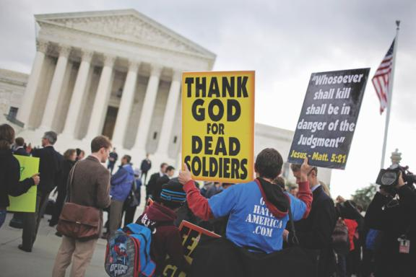

Culture and Civil Liberties

- Rights in Conflict
- Cultural Conflicts
- Applying the Bill of Rights to the States

Rights in Conflict

- Examples:
  - Right to a fair trial vs. freedom of the press (Sam Sheppard case)
  - US Government’s obligation to “provide for the common defense” vs. freedom of the press (“Pentagon Papers case”)
  - Freedom of speech vs. preservation of public order (Carl Kunz case)

- Acts of the U.S. Congress restricting civil liberties during wartime:
  - Sedition Act of 1798
  - Espionage and Sedition Acts 1917‒1918
  - Smith Act 1940
  - Internal Security Act 1950

An Hispanic girl studies both English
and Spanish in a bilingual classroom.

Culture Conflicts

- Examples:
  - Religious displays on public property
  - Is bilingual education constitutionally required?
  - May private associations make their own rules concerning the right to “associate freely?”
  - Balancing community sensitivities vs. personal self-expression

Figure 5.1 Annual Legal Immigration, 1850–2010

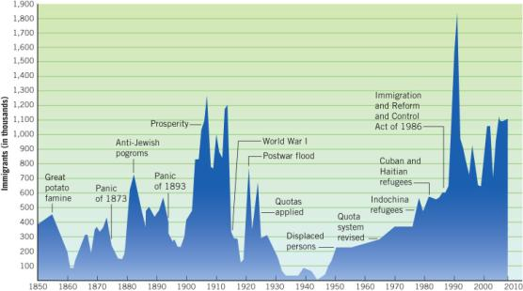

Applying the Bill of Rights to the States

  - Due process of law
  - Equal protection of the law
  - Selective incorporation

- Second Amendment examples:
  - District of Columbia v. Heller (2008)
  - McDonald v. Chicago (2010)

Interpreting and Applying the First Amendment
- Freedom of expression
- Freedom of religion
- Prior restraint
- Clear-and-present danger test

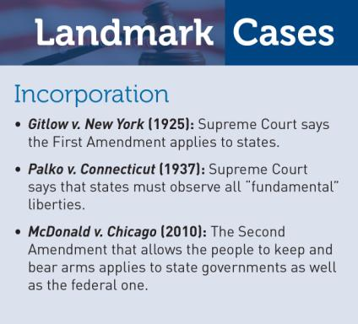

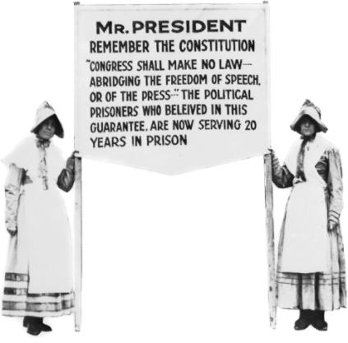
Women picketed in front of the White House, urging President Warren Harding to release political radicals arrested during his administration.

What is Speech?
- Forms of speech not automatically given constitutional protection:
- Libel
- Obscenity
- Symbolic Speech
- False Advertising

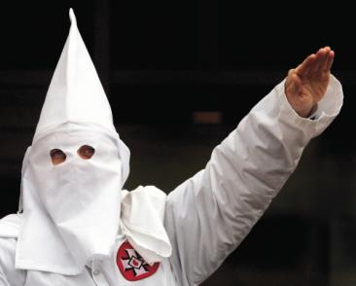
A Ku Klux Klan member uses his constitutional right to free speech to utter “white power” chants in Skokie, Illinois.

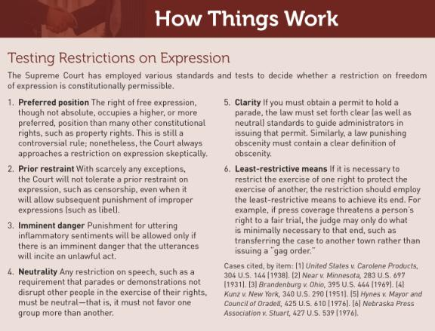

“Symbolic speech”: when young men burned their draft cards during the 1960s to protest the Vietnam War, the Supreme Court ruled that it was an illegal act for which they could be punished.

Commercial and
Youthful Speech

- Corporations
- Interest Groups
- Youth

Public schools cannot organize prayers, but private ones can.

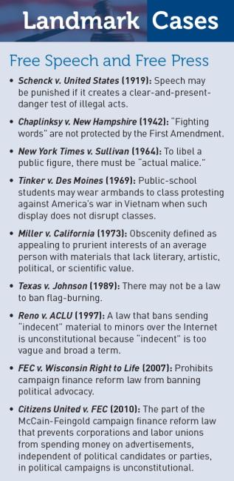

Church and State
- The Free Exercise Clause: Congress shall make no law prohibiting the “free exercise” of religion
- Establishment Clause: Congress shall make no law “respecting an establishment of religion”
- Wall of Separation Theory: Court ruling that government cannot be involved with religion

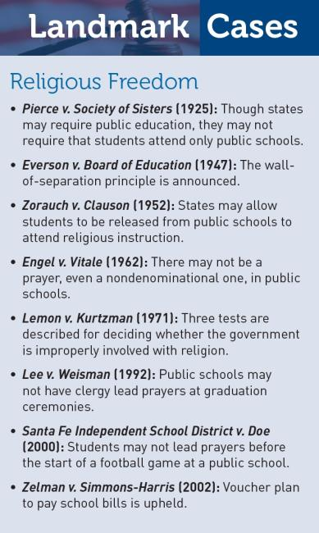

How We Compare: Church and State

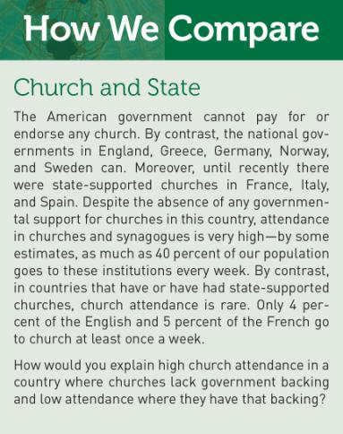

Crime and Due Process

- The Exclusionary Rule
  - Mapp v. Ohio
- Search and Seizure
  - Search warrants
  - Giving permission for a search
  - Arrest
  - “In plain view” and “under immediate control”

- Confessions and Self-Incrimination
- Relaxing the Exclusionary Rule
- Terrorism and Civil Liberties
- Searches without Warrants

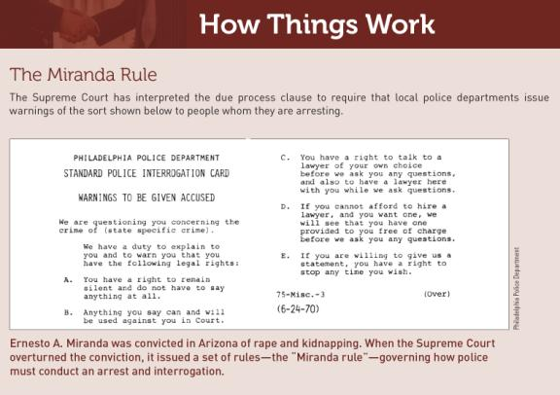

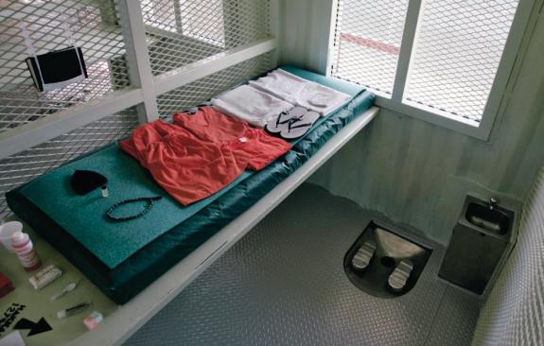

Inside a cell at the terrorist prison in Guantanamo, where Muslim inmates receive a copy of the Koran,a chess set, and an arrow pointing toward Mecca. p. 119

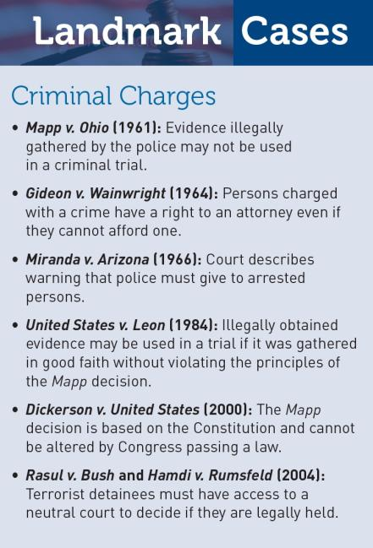

WHAT WOULD YOU DO?

MEMORANDUM
To: Rebecca Saikia, Supreme Court Justice
From: David Wilson, law clerk
Subject: Patriot Act and libraries
The Patriot Act allows the FBI to seek the records of possible terrorists from banks, businesses, and libraries. Many libraries claim this will harm the constitutional rights of Americans. You support these rights, but are also aware of the need to protect national security.

Arguments supporting the Patriot Act:
1. The Patriot Act does not target individuals who have not violated a criminal law and who do not threaten human life.
2. For the FBI to collect information about borrowers, it must first obtain permission from a federal judge.
3. Terrorists may use libraries to study and plan activities that threaten national security.

Arguments against the Patriot Act:
1. Freedom of speech and expression are fundamental constitutional guarantees that should not be infringed.
2. The law might harm groups engaged in peaceful protests.
3. The law allows the government to delay notifying people that their borrowing habits are being investigated.

Your decision:
Uphold this provision ?
Overturn this provision ?

