Chapter 7 – Public Opinion

Overview
It is difficult to speak of “public opinion” in the United States. This is partly because there are many publics, with many different opinions. It is also partly because opinions on all but relatively simple topics tend to be uninformed, unstable, and sensitive to different ways of asking poll questions.
The chief sources of political opinion are the family, religion, information media, and schooling. Once, occupation (or income) was a central determinant of opinion, but with the spread of higher education, the connection between occupational status (or income) and opinion is no longer quite so close. Today, greater cleavages in opinion are related to social class (in which schooling is an important component) and region.
Political ideology guides political opinion, but measuring ideology is often difficult. Typically, Americans do not use ideological terminology when reporting or discussing their political opinions, and most survey instruments are incapable of fully measuring the relationship between ideology and political opinion. Furthermore, survey participants are often reluctant to share their ideological opinions if they perceive those opinions to be socially or morally unacceptable.
Political elites are much more likely to display a consistent ideology, whether liberal or conservative. Elites are important because they have a disproportionate influence on public policy. They also influence mass opinion through the dissemination of information and the evocation of political norms.

Chapter Outline
I. Introduction
- Public opinion refers to how people think or feel about particular things.
II. Public Opinion and Democracy
- Should government leaders do what the people want?
- Reasons for discrepancies between public opinion and government policies
- Constitutional structure limits influence of public opinion:
- Purpose of government is not to do what the people want; purpose is found in the six items mentioned in the Preamble to the Constitution
- Government structure contains several checks on public opinion: representative government, federalism, separation of powers, and independent judiciary.
- Discerning public opinion is difficult.
III. What Is Public Opinion?
- Public Opinion: How people think or feel about particular things.
- People do not spend a great deal of time thinking about politics; results:
- High levels of public ignorance: For example, Monetary Control Bill ruse
- Despite being poorly informed, citizens are quite good at using cues (limited information) to determine which candidates and positions reflect their values or interests.
- Public opinion is less fickle than previously thought.
A. How polling works (THEME A: PUBLIC OPINION POLLING)
- Need to pose reasonable questions that are worded fairly
- Have to ask people about things for which they have some basis to form an opinion.
  - Random sampling is necessary to ensure a reasonably accurate measure of how the entire population thinks or feels.
  - Sampling error reflects the difference between the results of two surveys or samples.
  - Exit polls—interviews with randomly selected voters conducted at polling places on Election Day—have proven quite accurate.
  - Polling techniques
- For populations over 500,000, pollsters need to make about 15,000 phone calls to reach 1,065 respondents, ensuring the poll has a sampling error of only ±3 percent.
- Polling firms can economize by using smaller than ideal samples but this reduces the reliability of the poll.
- Low response rates harm reliability.
B. How opinions differ
- Opinion saliency: Some people care more about certain issues than other people do.
- Opinion stability: The steadiness or volatility of opinion on an issue
- Opinion-policy congruence: The level of correspondence between government action and majority sentiment on an issue
- Political socialization: The process by which personal and other background traits influence one’s views about politics and government
- Children tend to share parents’ political orientations.
- Opinion seems to vary in ways associated with class, race, religion, gender, and other characteristics.
- But people with similar family histories, religious affiliations, formal educations, and job experiences do not think or vote exactly the same way.
- Mass and elite opinions differ
- Elites know more about politics.
- Elites are more likely to hold a consistent set of opinions about the policies government ought to pursue.
IV. Political Socialization
A. GENES AND THE FAMILY
- The role of family
  - Majority of high school students know and support the party affiliation of their parents.
- Genetic background explains much of our political ideology.
  - Studies of identical versus fraternal twins show that identical twins (who share same genetic makeup) are more likely to hold the same political views than fraternal twins (who share one-half of the same genetic makeup).
  - Some research indicates that one-third of differences about political beliefs come from genetic sources. Only one-tenth of these differences come from family influence.
- Although genetics can explain only one-half of our political beliefs, the remaining half is affected by our life experiences, friendships, and education.
- However, genetics does not explain party preference, which is still heavily influenced by the political affiliation of our parents.
  - In recent years, fewer people identify with a political party, so partisan preference is more difficult to pass along to children.
    - Age-related differences also appear in opinions on several issues, such as gay marriage, women’s rights, government vouchers for education, and investment of Social Security contributions in stock market accounts. A majority of 18–24-year-olds think elected officials have priorities that differ from their own. Most believe politics does impact their lives.
  - Younger voters typically exhibit less partisanship; they are more likely to be independent.
  - Clear political ideologies are passed on in only a few families.
B. Religion
- Most Americans remain somewhat or deeply religious but question the role of religion in politics.
- Differences between religions are quite complicated, and vary with particular issues.
- Religious influences on public opinion are pronounced with respect to social issues, like abortion or gay rights.
- Opinions about politics vary not only across but also within religious traditions.
C. The gender gap
- Gender gap is the difference in political views between men and women.
- Differences in voting behavior between men and women:
- Wide gender gaps exist between men and women on several issues. Women favor universal healthcare, same-sex marriage, while being less likely than men to favor military interventions. From 1920 to 1980, fewer women voted than men; since 1980, women have voted at somewhat higher rates than men.
- Women are a larger proportion of the voting-age population.
- Women are more likely to support Democratic candidates.
      - Between 1980 and 2008, women were more likely to support Democratic presidential candidates.
      - The Democratic Party places greater emphasis on issues that women believe matter most.
V. Cleavages in Public Opinion (THEME B: GROUP CLEAVAGES, POLITICAL ATTITUDES, AND POLITICAL IDEOLOGY)
A. SOCIAL CLASS
- Social class: Ill defined in United States, though recognized in specific cases (for example, truck drivers and investment bankers)
- Social class less important in United States than in Europe; extent of cleavage has declined in both places.
- Class differences on political views and voting patterns narrowed considerably during the 1940s, 1950s, and 1960s.
- Class differences that remain: Unskilled workers are more likely to be Democrats than affluent white-collar workers.
- Noneconomic issues now define liberal and conservative.
- Moral, symbolic, and foreign-policy issues do not divide the rich and poor in the same way.
B. Race and ethnicity
- African Americans
- Overwhelmingly Democratic
- Younger blacks are slightly more likely to identify with Republicans and to support government school voucher programs.
- Continuing differences between white and black attitudes on policy questions
- Areas of agreement between whites and blacks on policy issues
- Latinos and Asians
- Scant public opinion information for Latinos and Asian Americans
- Latinos tend to identify as Democrats, though not as strongly as African Americans.
- Asians are even more identified with the Republican Party than are whites.
- Asian opinion on issues of order more like Anglo opinion than like black or Hispanic opinion.
- Latinos are somewhat more liberal than Anglos or Asians, but less liberal than African Americans.
- Important differences within Asian and Hispanic groups.
- Broad areas of agreement between Latinos and non-Hispanic whites
C. Region
- White southerners were once more conservative than other regions regarding aid to minorities, legalizing marijuana, school busing, and rights of the accused.
- White southerners were similar to other regions regarding economic issues.
- Historically, the South is more accommodating to business interests (and less accommodating to organized labor) than the North.
- Southerners are now significantly less Democratic than they were for most of the twentieth century.
- No Democratic presidential candidate has won a majority of white Southern votes since Lyndon Johnson did so in 1964. In 2008, Barack Obama won with one-half the white vote nationally while only receiving 30 percent of the white vote in the South.
- Since 1980 the population has shifted from the North and East to the South and West. Florida and Texas have gained 12 Congressional seats. The Northeast has become more Democratic but with shrinking representation in the House.
VI. Political Ideology
- Political Ideology: A more or less consistent set of beliefs about what policies government ought to pursue.
- Measuring ideology
- Measured in two different ways:
- Seeing how frequently people use broad political categories to describe or justify their own views and preferences
- Seeing to what extent a citizen’s policy preferences are consistent over time or are based on consistent principles
- Self-identification survey averages do not yield much information about ideology.
- Most Americans do not think about politics in an ideological manner.
- Limitations of polling make it difficult to uncover ideological preferences.
- Some people are reluctant to reveal socially or morally unacceptable positions.
A. Mass Ideologies: A Typology
- Pollsters use survey data to characterize ideology through the identification of key values.
- “Liberals” and “disadvantaged Democrats” represent one-third of registered voters and one-fourth of the general public.
- Various combinations of conservatives and “Republican enterprisers” represent almost one-half of registered voters and over 40 percent of the general public.
- Nearly one in five Americans are cynical about or are indifferent to politics.
B. Liberal and Conservative elites
- Liberal and Conservative Elites: Those who have a disproportionate amount of some valued resource
- Elites (usually known as activists) display greater ideological consistency.
- They have more information and more interest in politics than most people, so they may see more relationships among the issues.
- Their peers reinforce this consistency.
VII. Political Elites, Public Opinion, and Public Policy
- Elites influence public opinion in two ways:
- Raise and frame political issues
- State norms by which to settle issues and define policy options
- Limits to elite influence on the public
  - Elites do not define economic, crime, and other problems that are rooted in personal experience.
  - Elites contradict and disagree with each other, limiting their influence.
- In recent elections the impact of the Internet on campaigns has increased the debate as to how much influence elites have on the political process.

- WHO GOVERNS?
  - How does public opinion in America today vary by race, gender, and other differences?
  - What is political ideology, and how does it affect political behavior and influence public policy?
- TO WHAT ENDS?
  - What role did the Framers of the Constitution think public opinion should play in American democracy?
  - When, if ever, should public policies mirror majority opinion?

Why Does Government Policy Often Appear At Odds With Public Opinion?
- The Framers of the Constitution did not try to create a government that would do from day to day “what the people want.”
- They created a government for the purpose of achieving certain substantive goals.

Public Opinion and Democracy
The Framers of the Constitution created a government to achieve certain goals:
“to form a more perfect Union, establish Justice, ensure domestic Tranquility, provide for the common defense, promote the general Welfare, and secure the Blessing of Liberty.”
– Preamble to the Constitution

Do We Really Know What The Public Thinks?
- It is not easy to know what the public thinks.
- A few simple, clear-cut and widely discussed issues may allow for some degree of certainty.
- But, with many lesser-known issues that certainty may be missing.

What Is Public Opinion?
- University of Cincinnati Study of the “Monetary Control Bill”
- Corporation and Marketing Firms Efforts
- Political Scientists Get On Board
- Recent Studies

- How Polling Works
  - Poll
  - Random sample
  - Sampling error
  - Exit polls

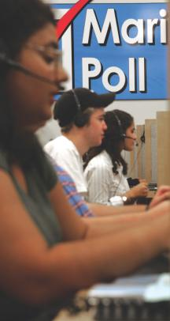

Students at Marist College in New York call people in the state with poll questions.

- How Opinions Differ
  - Opinion saliency
  - Opinion stability
  - Opinion-policy
congruence
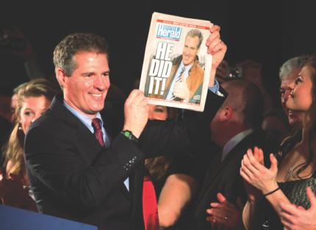
Republican Scott Brown wins the election to fill the Senate seat once held by Ted Kennedy. He must stand for reelection in 2012.

Political Socialization
- Political socialization – process by which background traits influence one’s political views
- Genes and the Family
- Religion
- The Gender Gap

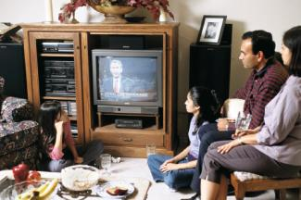
Children grow up learning, but not always following, their parents’ political beliefs.

Young Adults on Politics and Politicians

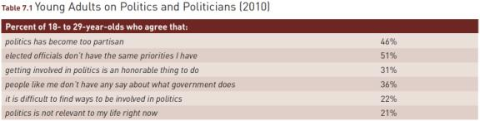
Source: Institute of Politics, The 17th Biannual Youth Survey on Politics and Public Service, John F. Kennedy School of Government, Harvard University, Spring 2010.

- Opinions by Four Christian Groups on Four Issues

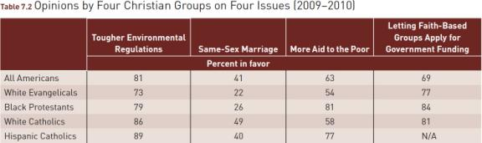
Source: Adapted from Pew Forum on Religion and Public Life, American Views on Religion, Politics, & Public Policy, 2010, pp. 37, 41, and 46, and “Faith-Based Programs Still Popular, Less Visible,” November 16, 2009, p. 2.

- Worship Service Attendance and the Probability of Voting Democratic (2000–2008)

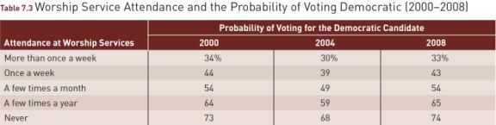
Source: Pew Forum on Religion and Public Life, American Views on Religion, Politics & Public Policy, 2010, p. 85.

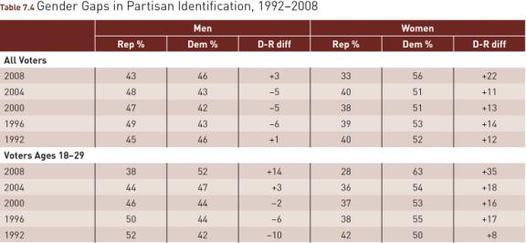
Source: Pew Research Center for the People & the Press, Gen Dems: The Party’s Advantage Among Young Voters Widens, April 28, 2008.

Cleavages in Public Opinion
- Social Class
- Race and Ethnicity
- Region

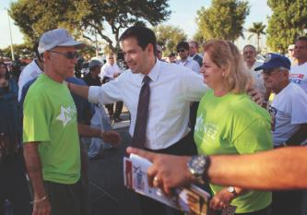
Marco Rubio, the Hispanic son of exiles from Cuba, is a conservative Republican elected from Florida to
the United States Senate in 2010.

Political Ideology
- Political Ideology - A more or less consistent set of beliefs about what policies government ought to pursue.
- Mass Ideologies: A Typology
- Liberal and Conservative Elites

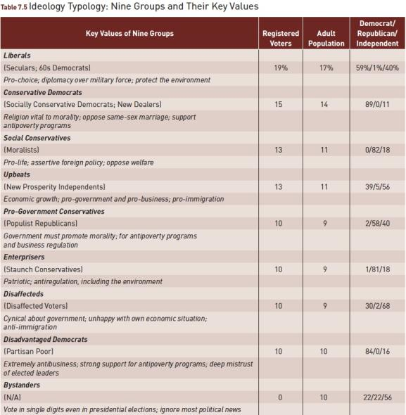
Source: Adapted from “Profiles of the Typology Groups: Beyond Red and Blue,” Pew Research Center for the People and the Press, 2005.

Political Elites, Public Opinion, and Public Policy
- Political elites – persons with a disproportionate share of political power.
- Elites raise and frame political issues.
- Elites state the norms by which issues should be settled.

WHAT WOULD YOU DO?

M E M O R A N D U M
To: Bill Byron, U.S. Senator
From: Dan Joyce, legislative assistant
Subject: Vote on path to citizenship bill
Your state has only a small illegal immigration problem, but voters have concerns both about maintaining law and order, and providing economic opportunities and a “path to citizenship” for people who have resided in this country for many years. As you contemplate both your vote on the bill and your possible presidential bid as a Republican, note that public opinion on the subject is divided by party, race, ethnicity and religion. For example, an August 2010 Pew poll asked about priorities in dealing with illegal immigration: 47% of Republicans, 34% of Independents, and 21% of Democrats cited “better border security;” 41% of Hispanics, versus 19% of White evangelicals cited “creating a path to citizenship”

Arguments for:
1. Your state contains a small but slowly growing proportion of first-generation Americans, who favor a “path to citizenship” for immigrants who have lived in this country for years, regardless of their legal status.
2. Illegal immigrants often take menial jobs that nobody else wants, and contribute to the U.S. economy by paying taxes and buying goods and services.
3. A “path to citizenship,” with fines and other penalties for being in the country illegally, is the most realistic option for individuals who have family and other long-term ties in the United States.

Arguments against:
1. Your party leaders oppose comprehensive immigration reform, saying that enhanced border security must be a higher priority.
2. Illegal immigrants take jobs away from native-born Americans and cost more in public services, such as education and emergency health care, than they contribute to the economy.
3. People who entered the country illegally must not be rewarded for breaking the law, and enforcement can be effective with sufficient resources.

Your decision:
Vote for bill?
Vote against bill?

